Altered resting-state functional connectivity within corticostriatal and subcortical-striatal circuits in chronic pain
Authors:
Su Hyoun Park, PhD; Anne K. Baker, PhD; Vinit Krishna; Sean C. Mackey, MD. PhD; Katherine T. Martucci, PhD*
SUPPLEMENTARY FIGURES

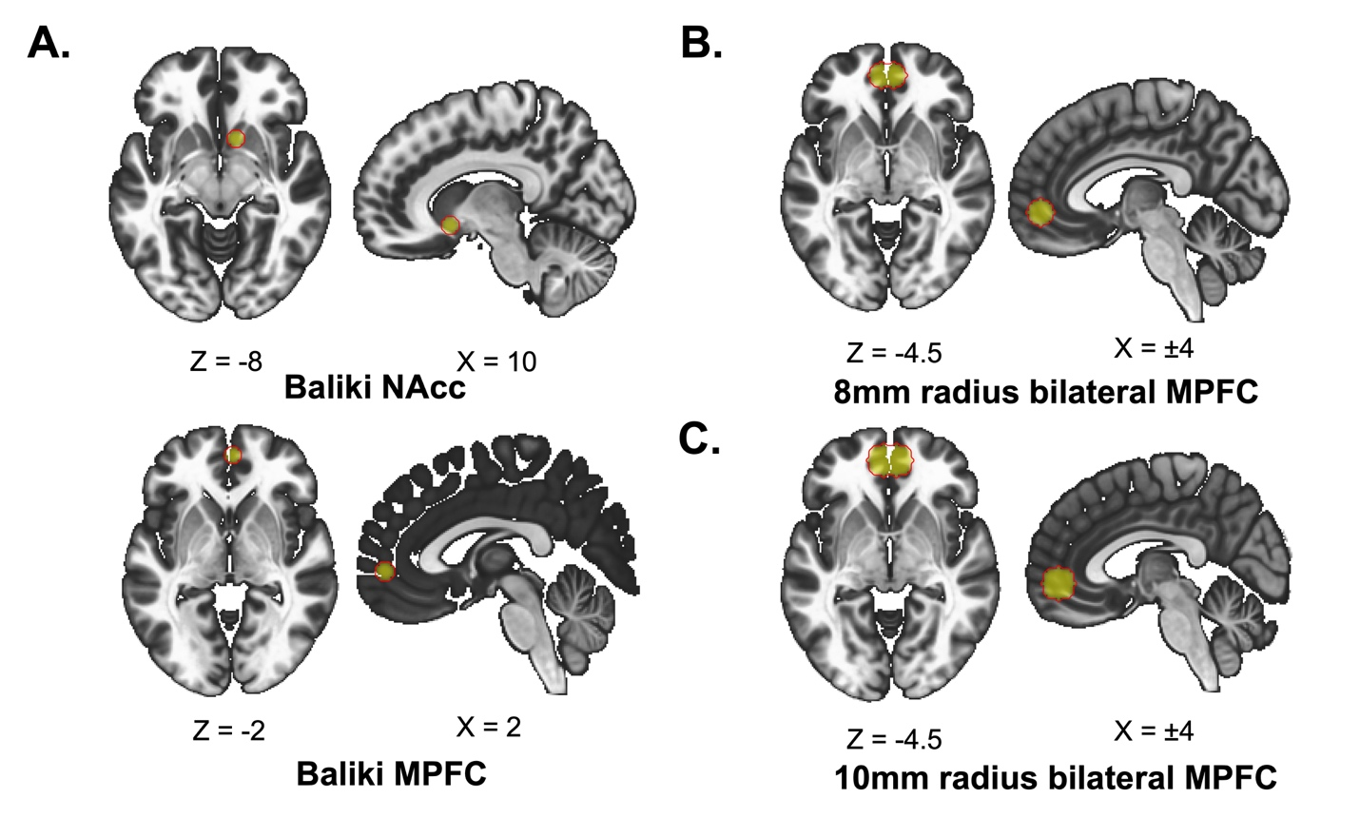

Supplementary Figure S1. Additional MPFC and NAcc Volumes of Interest (VOIs) for Exploratory Analyses. A) The VOIs used by Baliki et al. 2012, which include 5-mm radius spheres centered at [10, 12, -8] for the right NAcc VOI (top) and at [2, 52, -2] for the right MPFC VOI (bottom). B) Bilateral MPFC VOI created from partially overlapping spheres centered at [±4, 50, -4.5] each with 8-mm radius. C) Bilateral MPFC VOI created from partially overlapping spheres centered at [±4, 50, -4.5] each with 10-mm radius. Abbreviations: NAcc, nucleus accumbens; MPFC, medial prefrontal cortex.

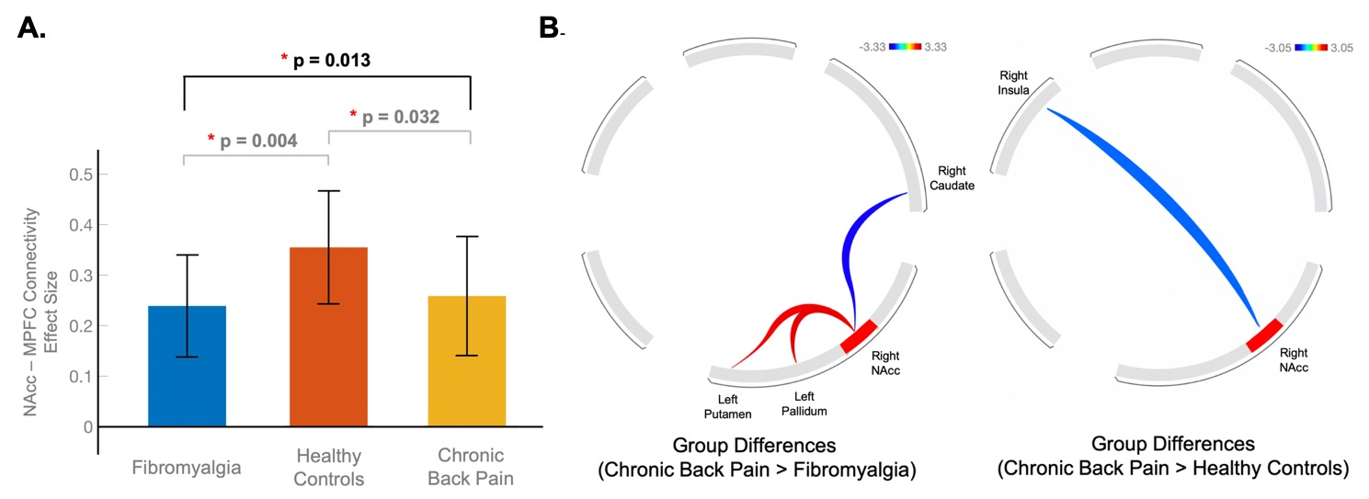

Supplementary Figure S2. Corticostriatal and Mesolimbic Circuit Comparison Across Fibromyalgia vs. Chronic Back Pain vs. Healthy Controls. A) NAcc-MPFC connectivity (measured as Fischer’s r-to-z transformed correlation coefficients) in patients with fibromyalgia and healthy controls (our dataset) and a separate cohort of patients with chronic back pain from the OPP database (openpain.org). Unlike our primary analysis comparing NAcc-MPFC connectivity between patients with fibromyalgia and healthy controls, only age and pain duration were included as covariates. Study site information was not included as a covariate due to unstated information regarding study site(s) involved in the collection of the chronic back pain dataset. One-way ANCOVA revealed significant effects among the three groups, F(2, 95) = 4.49, p = 0.013. As shown by the post-hoc t-tests, NAcc-MPFC connectivity in patients with chronic back pain and fibromyalgia was significantly decreased as compared to controls (chronic back pain > controls: t(95) = -2.16, p = 0.032; fibromyalgia > controls: t(95) = -2.95, p = 0.004). Error bars indicate the 95% confidence interval. B) Connectivity between the right NAcc and 12 mesolimbic brain regions in chronic back pain vs. fibromyalgia and healthy controls. Left: Compared to fibromyalgia, patients with chronic back pain showed greater connectivity of the right NAcc with the left ventral pallidum (t(59) = 2.75, p-uncorrected = 0.007, p-FDR corrected = 0.047) and left putamen (t(59) = 2.83, p-uncorrected = 0.006, p-FDR corrected = 0.047), but reduced connectivity with the right caudate (t(59) = -2.15, p-uncorrected = 0.03, p-FDR corrected = 0.14). Right: As compared to healthy controls, patients with chronic back pain showed decreased connectivity of the right NAcc with the right insula (t(64) = -2.17, p-uncorrected = 0.033, p-FDR corrected = 0.38). Abbreviations: OPP, Open Pain Project; NAcc, nucleus accumbens; MPFC, medial prefrontal cortex, ANCOVA, analysis of covariance; FDR, false discovery rate.

SUPPLEMENTARY TABLES

Supplementary Table S1. Demographic Information for Patients with Fibromyalgia, Patients with Chronic Back Pain, and Healthy Controls. Limited demographic information was available on openpain.org for chronic back pain patients. “Other” refers to race other than Asian, Caucasian, African American, Hispanic or Latina, Pacific Islander or Alaskan, or Native American. Education levels are divided into “High School” (up to or through high school), “College/University” (up to or through college/university), and “Advanced Degrees” (post college/university). One patient (fibromyalgia) and 3 healthy controls did not report their income level.

 | Stanford University |  | Duke University
 | Fibromyalgia | Healthy Controls | Fibromyalgia | Healthy Controls | Chronic Back Pain
Total Participants | 17  (all female) | 17  (all female) | 15  (all female) | 20  (all female) | 31  (female N=13)
Righthanded | 16 | 16 | 14 | 19 | 31
Self-Identified Race
American Indian/Alaska Native | 0 | 0 | 0 | 1 | N/A
African American | 0 | 0 | 2 | 2 | N/A
Asian | 2 | 7 | 0 | 0 | N/A
Caucasian | 13 | 9 | 12 | 17 | N/A
Other | 2 | 1 | 1 | 0 | N/A
Hispanic or Latina Ethnicity | 3 | 1 | 1 | 1 | N/A
Employment Status
Part-time employed | 3 | 2 | 0 | 1 | N/A
Full-time employed | 6 | 11 | 12 | 14 | N/A
Unemployed | 8 | 4 | 3 | 5 | N/A
Income Level
$0–$29,999 | 5 | 0 | 4 | 3 | N/A
$30,000–$59,999 | 3 | 2 | 4 | 5 | N/A
$60,000 or more | 8 | 13 | 7 | 11 | N/A
Education Level
High School | 3 | 0 | 1 | 0 | N/A
College/University | 11 | 8 | 10 | 13 | N/A
Advanced Degree | 3 | 9 | 4 | 7 | N/A

Supplementary Table S2. Age and Questionnaire Measures in Patients with Fibromyalgia and Healthy Controls. Data from patients with fibromyalgia (N=32) and healthy controls (N=37) are shown for cognitive, affective, and/or behavioral and clinical questionnaires - see text for description of questionnaires used. Due to a few incomplete questionnaires, the number of participants for each measure varies slightly from the total participant counts. Data are presented for descriptive purposes only and therefore the P values shown are not corrected for multiple comparisons. Abbreviations: sd, standard deviation; PANAS, Positive and Negative Affect Schedule; BAS, Behavioral Activation Scale; BIS, Behavioral Inhibition Scale; POMS, Profile of Mood States; PROMIS, Patient-Reported Outcomes Measurement Information System; STAI, State Trait Anxiety Inventory; BDI, Beck Depression Inventory; FAF, Fibromyalgia Assessment Form; BPI, Brief Pain Inventory.

 | Fibromyalgia |  | Healthy Controls |  | P-Value
 | N | Mean±sd | N | Mean±sd
Age | 32 | 41.9±12.7 | 37 | 48.4±10.6 | 0.089
Positive Affect (PANAS) | 32 | 26±7.3 | 37 | 34.9±6.8 | < 0.001
Negative Affect (PANAS) | 32 | 20.4±6.8 | 37 | 14.2±4.4 | < 0.001
Behavioral Drive (BAS) | 32 | 11.9±3.8 | 37 | 12.2±3.9 | 0.742
Behavioral Fun (BAS) | 32 | 11.5±3.4 | 37 | 12.5±3.4 | 0.231
Behavioral Reward (BAS) | 32 | 18.2±4.3 | 37 | 18.0±4.5 | 0.875
Behavioral Inhibition (BIS) | 32 | 25.2±6.0 | 37 | 20.4±6.1 | 0.0016
Total Mood Disturbance (POMS) | 32 | 21.9±17.7 | 37 | −2.5±8.1 | < 0.001
Fatigue (PROMIS) | 32 | 65.5±7.3 | 37 | 46.5±7.9 | < 0.001
Trait Anxiety (STAI) | 32 | 49.0±8.3 | 37 | 35.8±9.0 | < 0.001
State Anxiety (STAI) | 32 | 40.6±8.4 | 36 | 29.1±7.2 | < 0.001
Depression (BDI) | 31 | 16.3±8.8 | 36 | 3.4±5.2 | < 0.001
Number of Pain Areas (FAF) | 32 | 13.0±4.0 | 37 | 0.9±1.4 | < 0.001
Pain Severity (BPI) | 32 | 5.2±2.0 | 37 | 0.1±0.6 | < 0.001
Pain Interference (BPI) | 32 | 22.6±20.9 | 37 | 1.4±4.3 | < 0.001

Supplementary Table S3. A One-Way ANCOVA for Each of the Mesolimbic Connections Across Fibromyalgia vs. Chronic Back Pain vs. Healthy Controls. Results of one-way ANCOVAs between the right NAcc and 12 brain regions within mesolimbic circuits in three groups. Age and pain duration were included as covariates. Abbreviations: ANCOVA, analysis of covariance; NAcc, nucleus accumbens; ACC, anterior cingulate cortex, FDR, false discovery rate.

Connectivity between  the right NAcc and the: | F-Value  F(2, 95) = | P-uncorrected | P-FDR corrected
Left Ventral Pallidum | 4.83 | 0.010 | 0.120
Left Putamen | 3.61 | 0.030 | 0.184
Right Caudate | 3.09 | 0.050 | 0.200
Right Amygdala | 2.34 | 0.102 | 0.306
Left Thalamus | 1.47 | 0.235 | 0.433
Right Insula | 1.41 | 0.248 | 0.433
Right ACC | 1.40 | 0.252 | 0.433
ACC | 1.12 | 0.329 | 0.473
Left Insula | 0.96 | 0.385 | 0.473
Left Hippocampus | 0.94 | 0.394 | 0.473
Right Thalamus | 0.80 | 0.452 | 0.493
Left Caudate | 0.01 | 0.993 | 0.993

