Supplementary Materials:
SUPPLEMENTARY TABLE I
Patient ID | Sex/  Age (y) |  | Seizure Onset Zone |  | Etiology |  | Seizure Type |  | No. of Seizures |  | iEEG electrodes (depth/strip/grid) |  | iEEG recording time (h) |  | Post-surgery Outcome
Study_006 | M / 25 | Left Frontal |  | Cryptogenic |  | CP |  | 5 |  | 0 / 8 / 48 |  | 27 |  | n/a
Study_010 | F / 13 | Left Frontal |  | Cryptogenic |  | CP / GTC |  | 2 |  | 0 / 8 / 48 |  | 304 |  | n/a
Study_011 | F / 34 | Right Temporal |  | Cryptogenic |  | CP |  | 3 |  | 0 / 36 / 48 |  | 84 |  | n/a
Study_012-2 | M /33 | Right Temporal Orbitofrontal |  | Cryptogenic |  | CP / GTC |  | 26 |  | 0 / 24 / 60 |  | 277 |  | ILAE-I
Study_014 | F / 33 | Left Frontal |  | Cryptogenic |  | CP |  | 8 |  | 0 / 16 / 88 |  | 136 |  | n/a
Study_016 | F / 36 | Right Temporal Orbitofrontal |  | Meningitis |  | CP / GTC |  | 3 |  | 0 / 16 / 48 |  | 141 |  | ILAE-IV
Study_019 | F / 33 | Left Temporal |  | Cryptogenic |  | CP / GTC |  | 14 |  | 8 / 28 / 60 |  | 136 |  | ILAE-V
Study_020 | M / 10 | Right Frontal |  | Cryptogenic |  | CP / GTC |  | 8 |  | 0 / 16 / 40 |  | 120 |  | ILAE-IV
Study_021 | M / 16 | Right Temporal Orbitofrontal |  | Cryptogenic |  | CP / GTC |  | 11 |  | 0 / 8 / 96 |  | 155 |  | ILAE-I
Study_023 | M / 16 | Left Temporal-Occipital |  | TBI |  | CP |  | 3 |  | 8 / 16 / 64 |  | 48 |  | ILAE-I
Study_026 | M / 9 | Left Frontal |  | Cryptogenic |  | CP |  | 17 |  | 0 / 32 / 64 |  | 70 |  | ILAE-I
Study_028 | M / 5 | Left Parietal |  | Cryptogenic |  | GTC |  | 3 |  | 0 / 16 / 80 |  | 40 |  | ILAE-IV
Study_037 | F / 62 | Right Frontal |  | TBI |  | CP |  | 8 |  | 0 / 16 / 64 |  | 215 |  | n/a
Study_038 | M / 58 | Left hippocampus, L mediofrontal |  | TBI |  | CP /  GTC |  | 9 |  | 8 / 32 / 48 |  | 88 |  | ILAE-I
HUP_64 | M / 20 | Left Frontal |  | Dysplasia |  | SP / GTC |  | 1 |  | 0 / 24 / 68 |  | 307 |  | ENGEL-I
HUP_65 | M / 36 | Right Temporal |  | Cryptogenic |  | CP |  | 3 |  | 0 / 16 / 64 |  | 304 |  | n/a
HUP_68 | F / 26 | Right Temporal |  | Meningitis |  | CP / GTC |  | 5 |  | 0 / 24 / 64 |  | 310 |  | ENGEL-I
HUP_70 | M / 32 | Left Perirolandic |  | Cryptogenic |  | SP |  | 8 |  | 0 / 14 / 64 |  | 160 |  | n/a
HUP_72 | F / 27 | Left Frontal |  | Cryptogenic |  | GTC |  | 1 |  | 0 / 52 / 0 |  | 314 |  | n/a
HUP_73 | M / 39 | Anterior Right Frontal |  | Meningitis |  | CP / GTC |  | 5 |  | 0 / 56 / 0 |  | 146 |  | ENGEL-I

Patient ID= unique identifier in the iEEG Portal database (Azarion et al., Epilepsia, 55:2028-37, 2014). TBI= traumatic brain injury. CP= complex partial seizure. GTC= generalized tonic-clonic seizure. SP= simple partial seizure. n/a= Patient did not undergo surgery.
-------------------------------------------------------------------------------------------------------------------------------------------------

Supplementary Table 2: Electrodes Designations as SOZ and PSZ
Map* | Patient ID | SOZ electrodes | PSZ electrodes
A | Study_006 | LG: 7, 15, 16, 23, 24 | LG: 6, 8, 14, 22, 30-32
B | Study_010 | LG: 6, 7, 13, 14 | LG: 4, 5, 8, 12, 15, 16, 20-24
C | Study_011 | IA: 2, 3; IP: 3, 4; RG: 44, 45 | IA: 1, 4; IP: 2; RG: 35-38, 43, 46
D | Study_012-2 | LG: 8, 9, 14, 15; RMT:2-7; RIT: 2-7 | LG: 1-4 7, 10, 13, 16, 19-22; RMT: 1, 8; RIT: 1,8
E | Study_014 | LFG: 18-20, 26-28, 35, 36 | LFG 9-13, 17, 21, 25, 29, 33, 34, 37, 42-45
F | Study_016 | RTG: 1, 5, 9, 22; ROF: 2-4 | RTG: 2, 6, 10, 13, 14, 17-19, 21, 23; ROF: 1
G | Study_019 | LT: 1-3, 7, 15, 16, 21, 22 | LT: 4, 8-10, 13, 14, 17, 19, 20, 23, 26-29
H | Study_020 | RAG: 7-10, 14-16 | RAG: 1-5, 11, 13, 17, 19-23
I | Study_021 | RFG: 41-44, 46-48; RAT: 2-3 | RFG: 33-40, 45; RAT: 1, 4
J | Study_023 | LTG: 10, 11, 18 , 19, 58, 59 | LTG: 1-4, 9, 12, 17, 20, 25-28, 49-52, 57, 60
K | Study_026 | LFG 15, 24, 29, 30, 33, 34, 41, 46, 51-54, 58-61 | LFG 6-8, 14, 16, 21- 23, 25-27, 29, 32, 35, 42-47, 49, 50, 55, 57, 62
L | Study_028 | LPG: 44, 51-53, 61 | LPG: 42, 43, 45, 46, 50, 54, 58-62
M | Study_037 | RFS: 2; RPG: 35-37, 43-45 ,62-64 | RFS: 1, 3; RPG: 26-30, 34, 38, 42, 46, 50-56, 61
N | Study_038 | LG: 11, 12, 19, 20, 27, 28 | LG: 2-5, 10, 13, 18, 21, 26, 29, 34-37
O | HUP_64 | LG: 15, 22, 23, 30, 31, 38, 39 | LG: 6-8, 13, 14, 16, 21, 24, 29, 30, 32,37, 45-48
P | HUP_65 | RG: 1-7, 9, 10, 17, 18; RAT: 2-4 | RG: 11-16, 19, 25-27; RAT: 1
Q | HUP_68 | RG: 2-4, 10-14; RST: 3-4 | RG: 1, 5-7, 9, 15, 17-23; RST: 2
R | HUP_70 | LG: 12-15, 20-23, 28, 29 | LG: 3-8, 11, 16, 19, 24, 27, 40, 35-38
S | HUP_72 | LPP: 3-6 | LPP: 1-2
T | HUP_73 | ROF: 1-5 | ROF: 6-8
* See Figure S1 with maps of electrode placements.

Supplementary Figure S1.
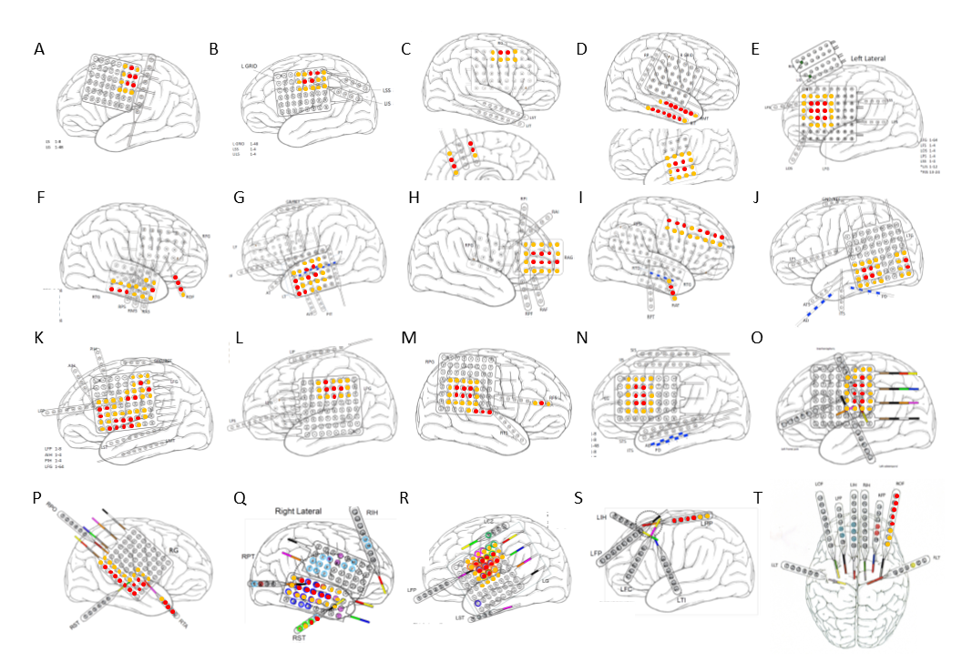
Supplemental Figure S1: Electrode placement diagrams from the iEEG Portal. Electrodes marked in red are designated as SOZ, and electrodes in orange are PSZ. A. Study006. B. Study010. C. Study011 (uninvolved mesial strips not shown) D. Study012. E. Study014. F. Study_016. G. Study019 H. Study020. I. Study021. J. Study023. K. Study026. L. Study028. M. Study037. N. Study038. O. HUP064 (uninvolved LH strip not shown). P. HUP065 Q. HUP 68 (uninvolved LH strip not shown). R. HUP070. S. HUP072 (mirror image strip placement over RH not shown). T. HUP073.

