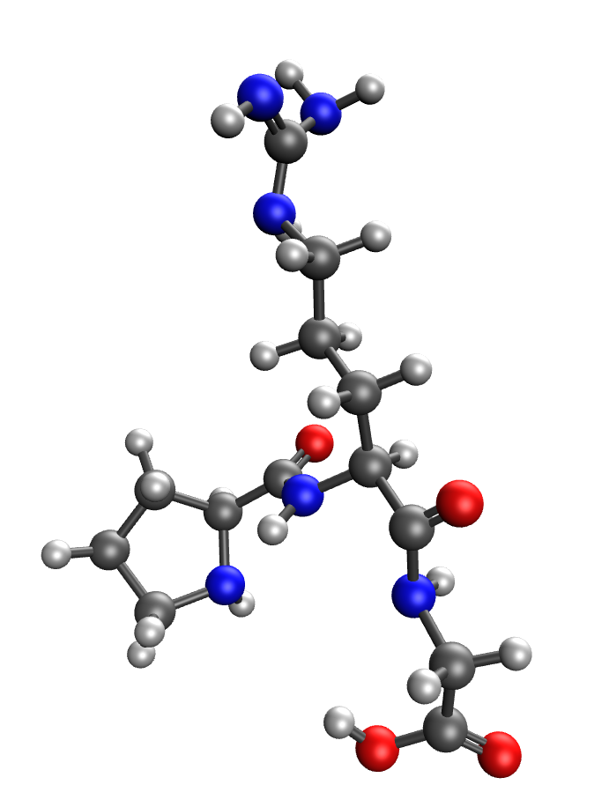 | 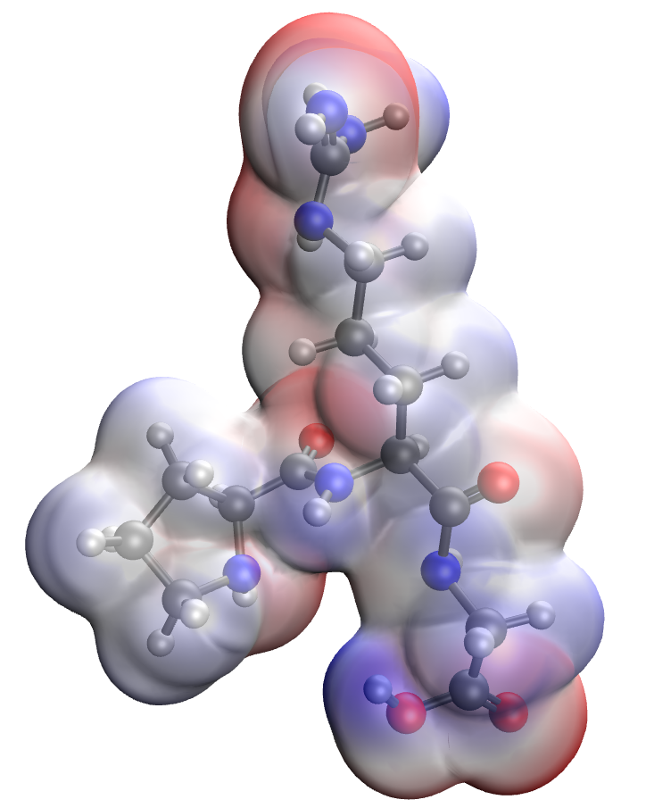
a | b
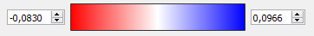
c
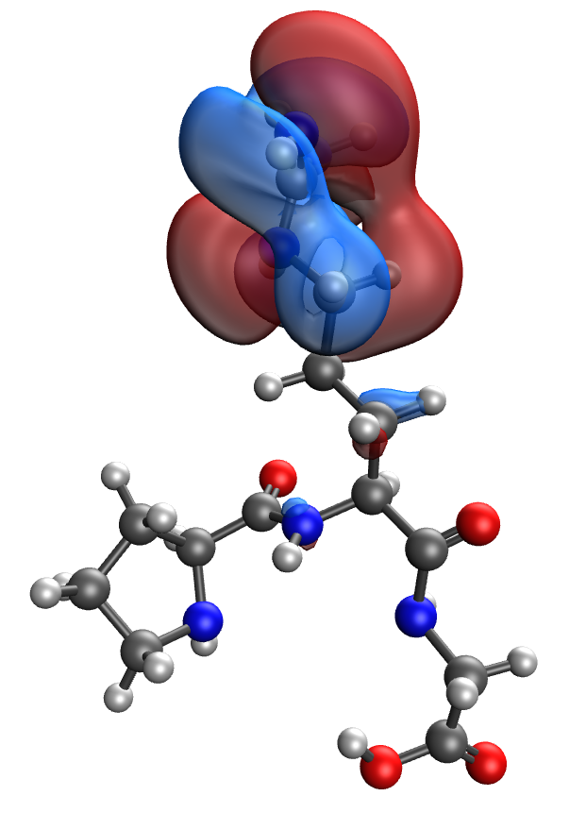 | 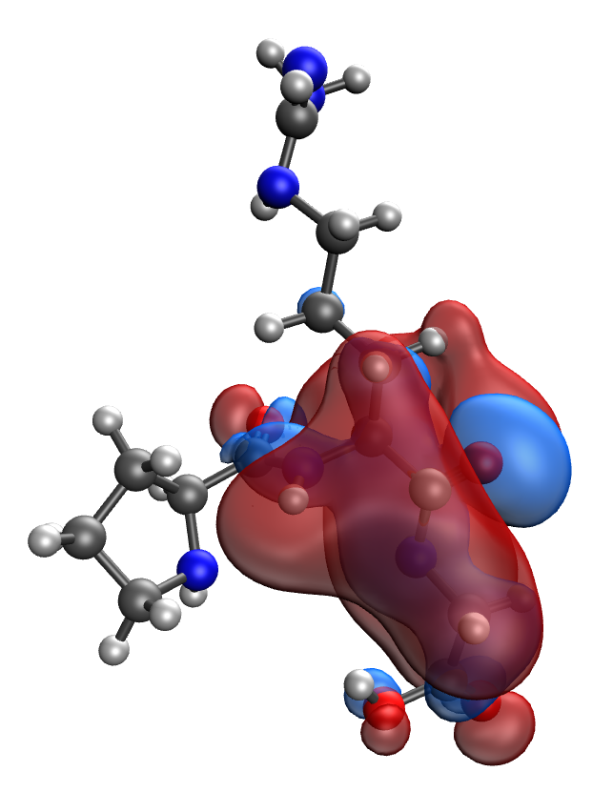
d | e
Fig. S1. Results of the quantum-chemical simulation of the Pro-Arg-Gly gelatin segment: a model of the molecular complex (a), the distribution of electron density (b), electronic density distribution gradient (c), HOMO (d), LUMO (e)
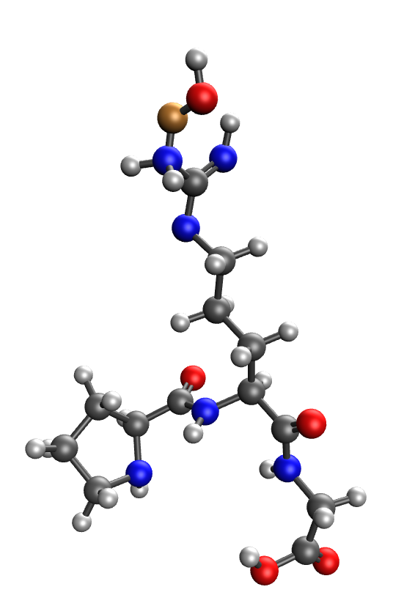 | 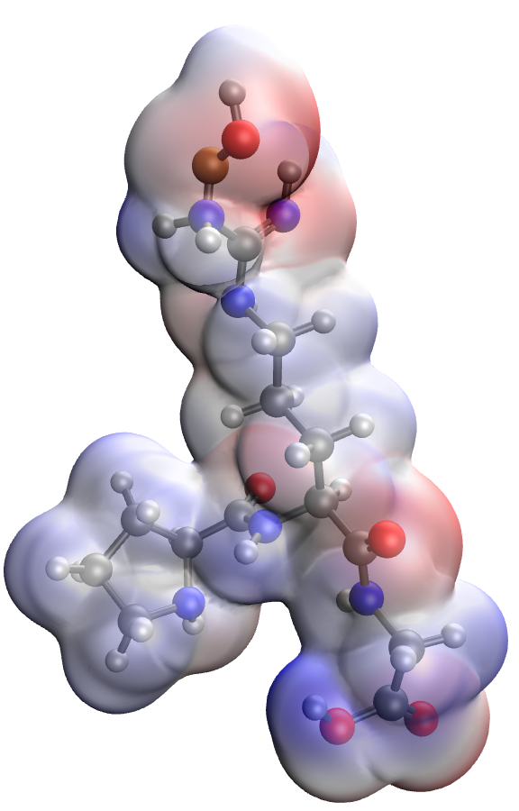
a | b
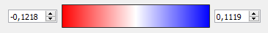
c
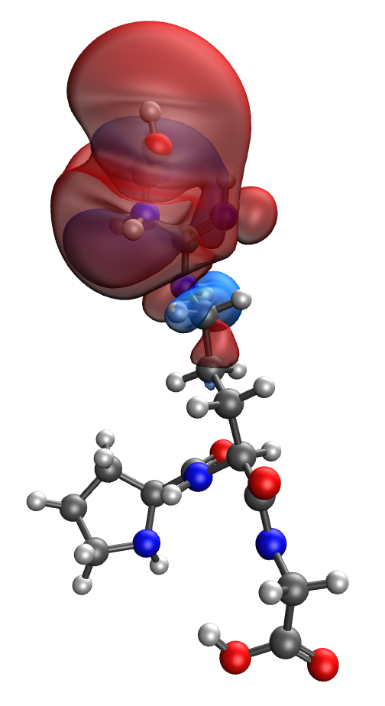 | 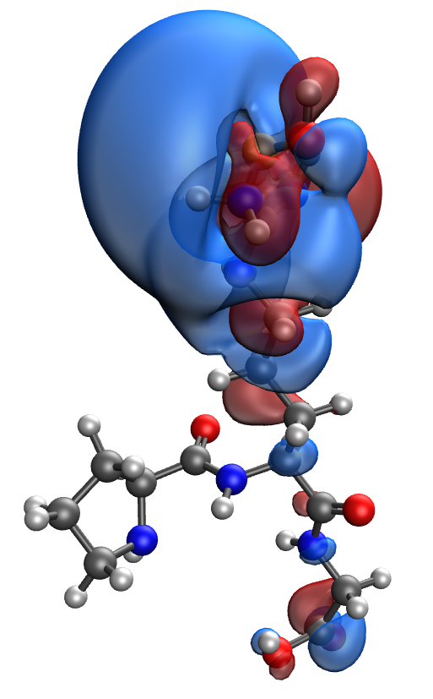
d | e
Fig. S2. Results of the quantum-chemical simulation of the Pro-Arg-Gly gelatin segment, bonded with CuO molecule: a model of the molecular complex (a), the distribution of electron density (b), electronic density distribution gradient (c), HOMO (d), LUMO (e)
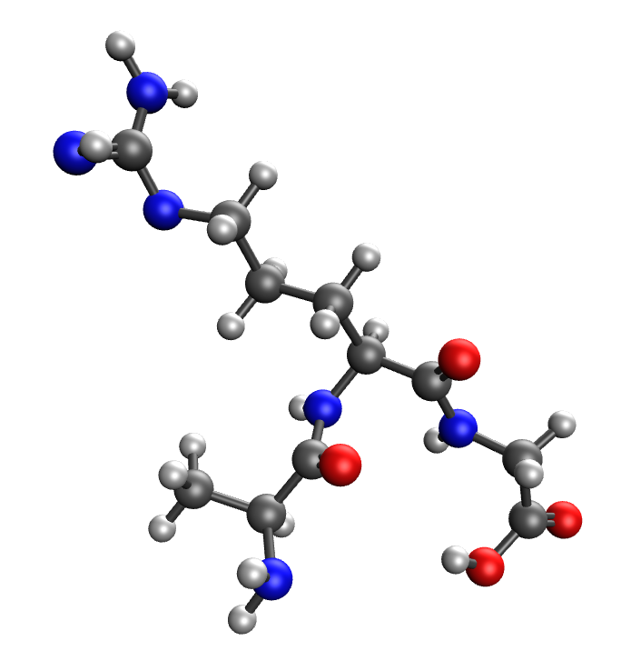 | 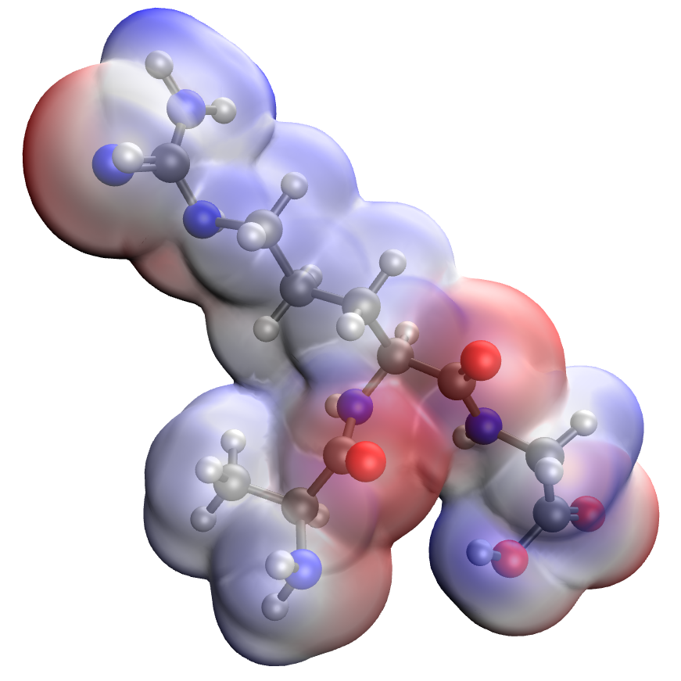
a | b
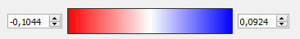
c
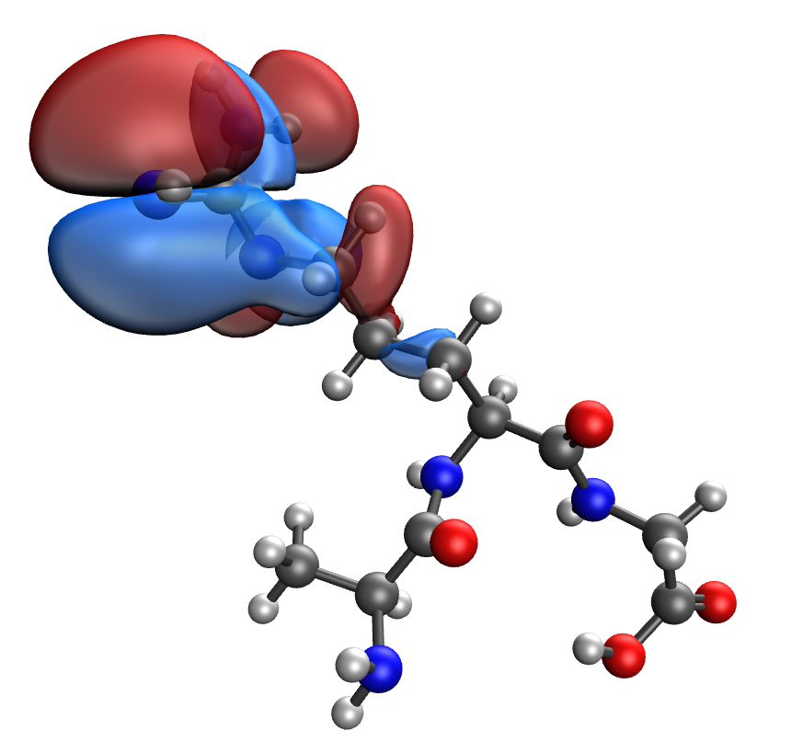 | 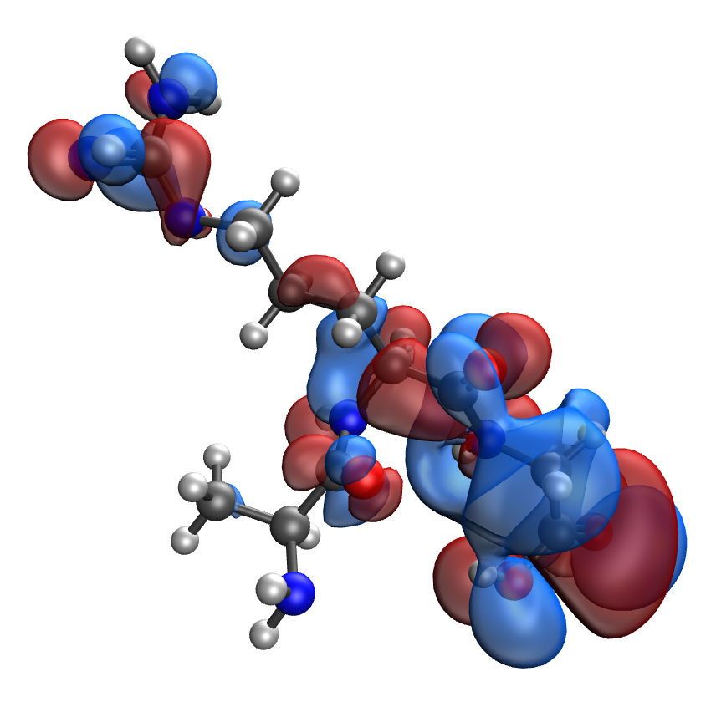
d | e
Fig. S3. Results of the quantum-chemical simulation of the Ala-Arg-Gly gelatin segment: a model of the molecular complex (a), the distribution of electron density (b), electronic density distribution gradient (c), HOMO (d), LUMO (e)

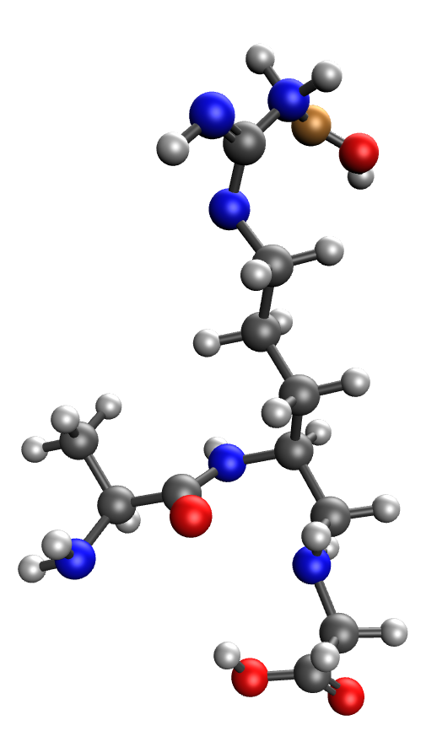 | 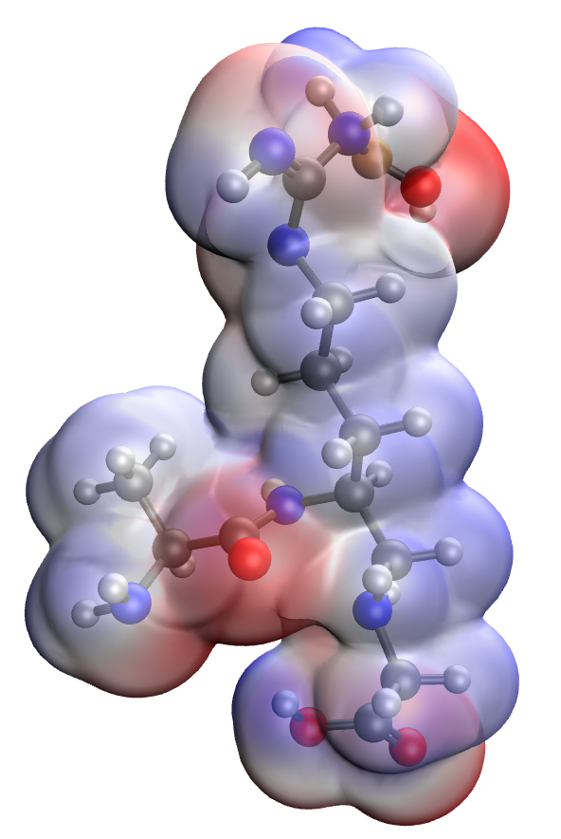
a | b
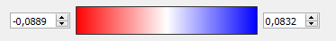
c
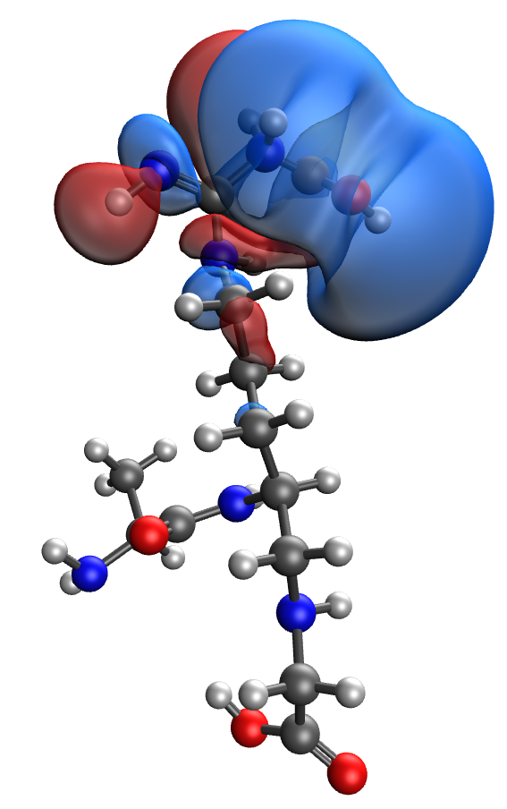 | 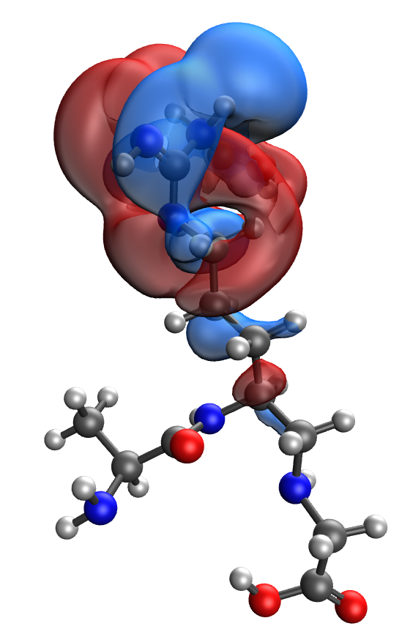
d | e
Fig. S4. Results of the quantum-chemical simulation of the Ala-Arg-Gly gelatin segment, bonded with CuO molecule: a model of the molecular complex (a), the distribution of electron density (b), electronic density distribution gradient (c), HOMO (d), LUMO (e)

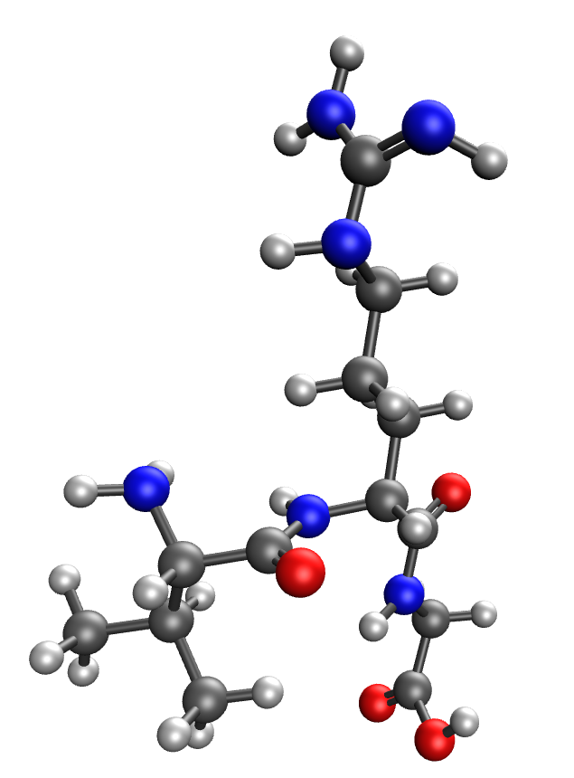 | 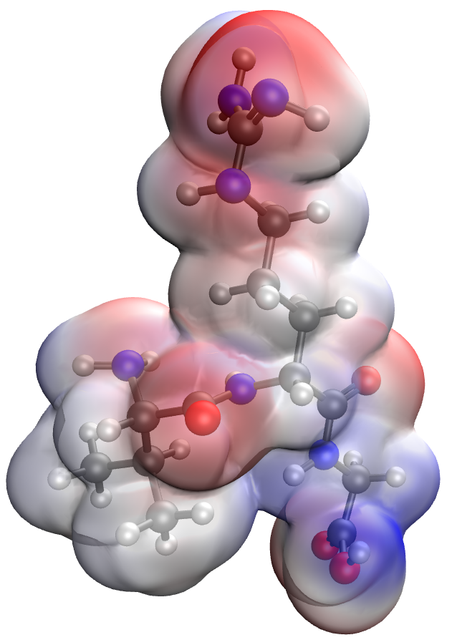
a | b
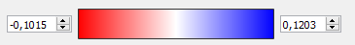
c
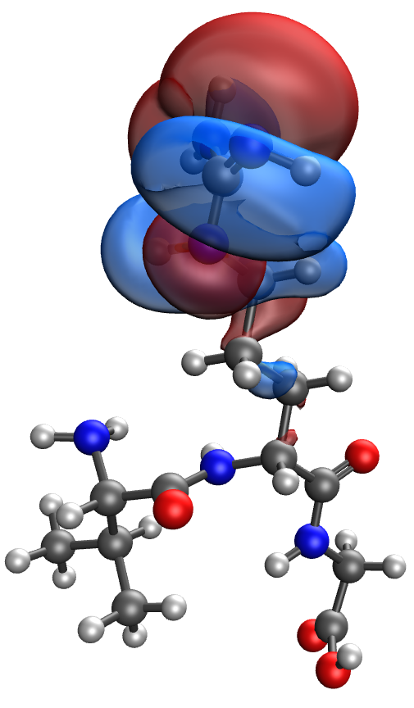 | 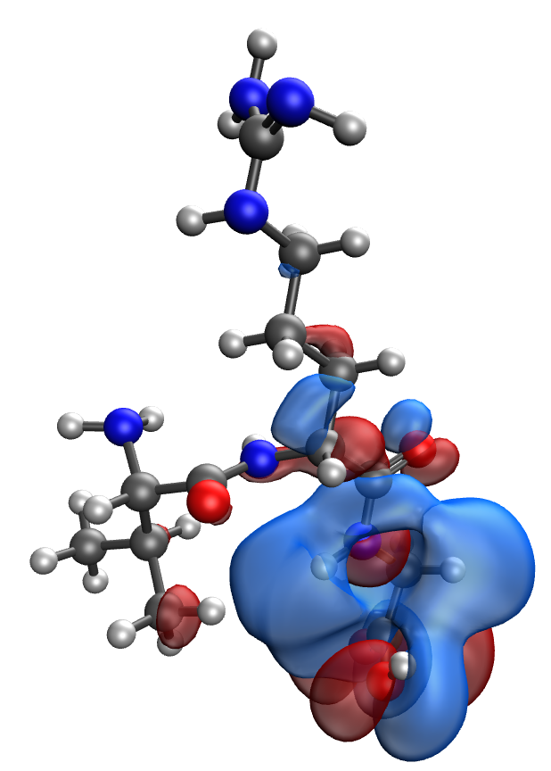
d | e
Fig. S5. Results of the quantum-chemical simulation of the Val-Arg-Gly gelatin segment: a model of the molecular complex (a), the distribution of electron density (b), electronic density distribution gradient (c), HOMO (d), LUMO (e)

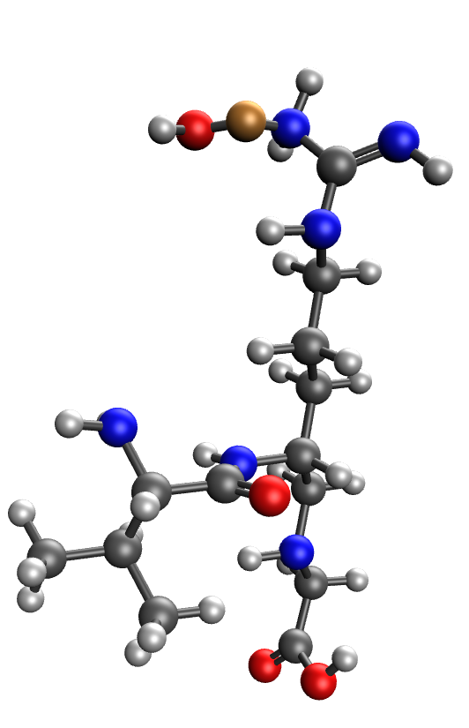 | 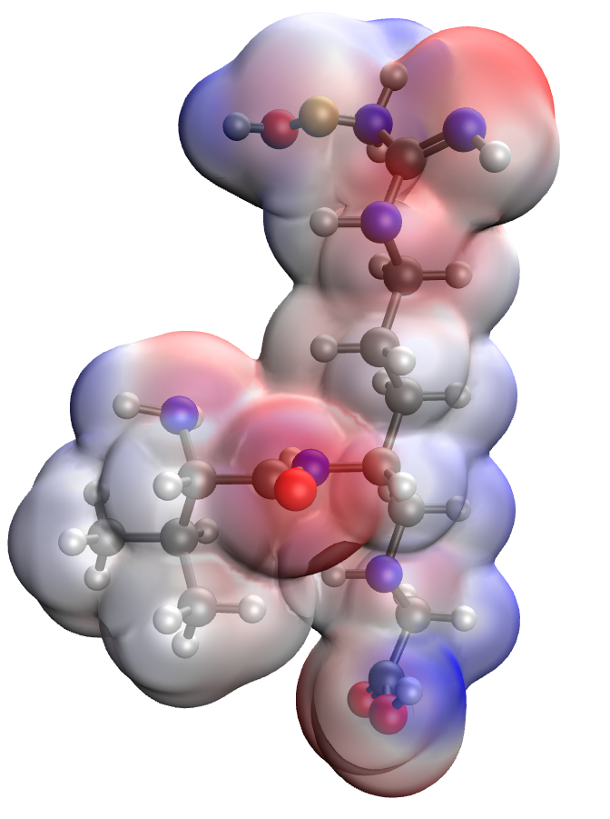
a | b
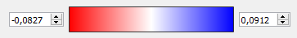
c
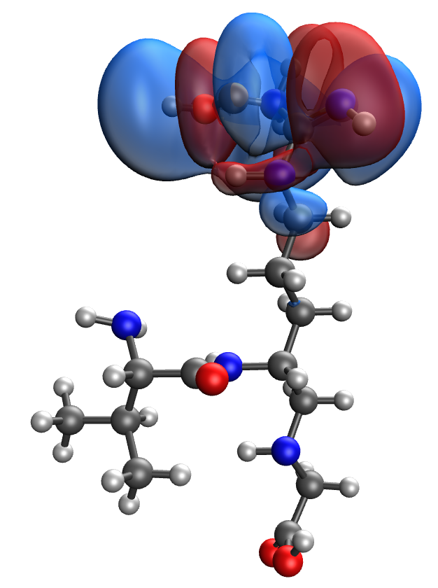 | 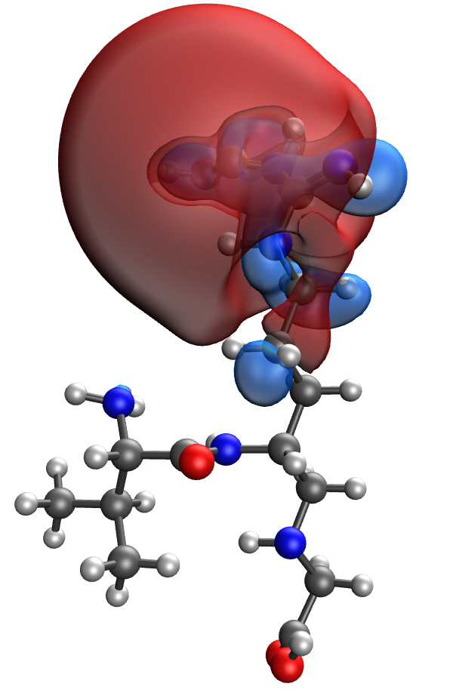
d | e
Fig. S6. Results of the quantum-chemical simulation of the Val-Arg-Gly gelatin segment, bonded with CuO molecule: a model of the molecular complex (a), the distribution of electron density (b), electronic density distribution gradient (c), HOMO (d), LUMO (e)

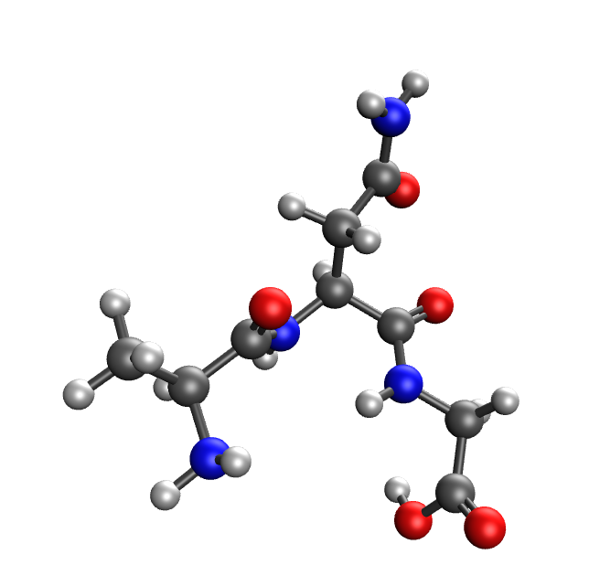 | 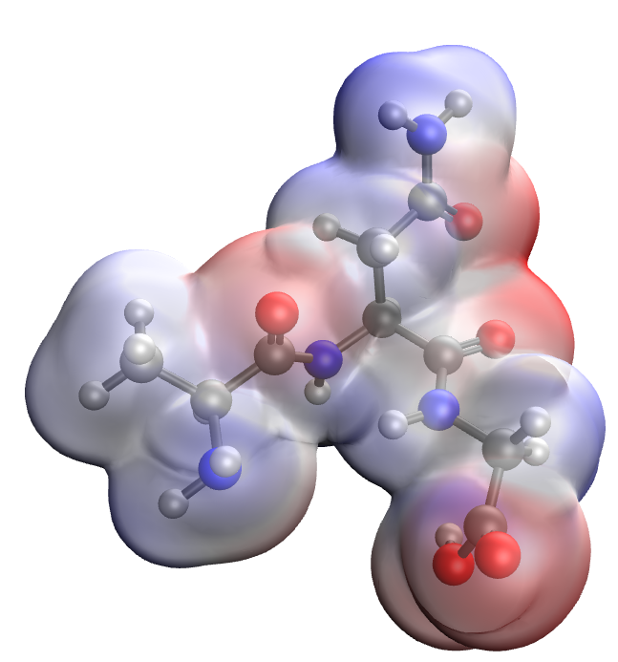
a | b
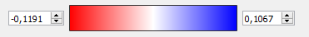
c
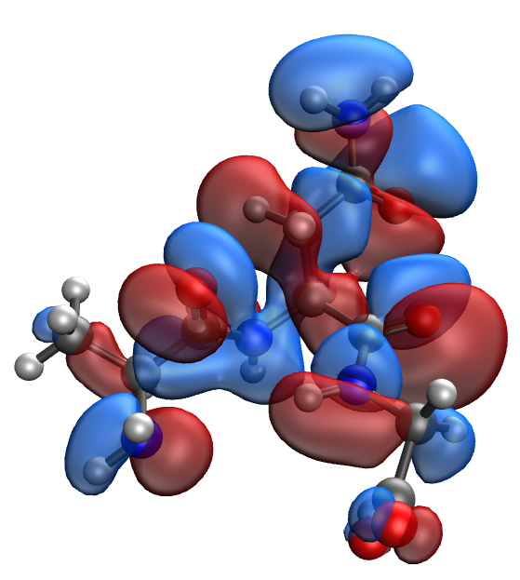 | 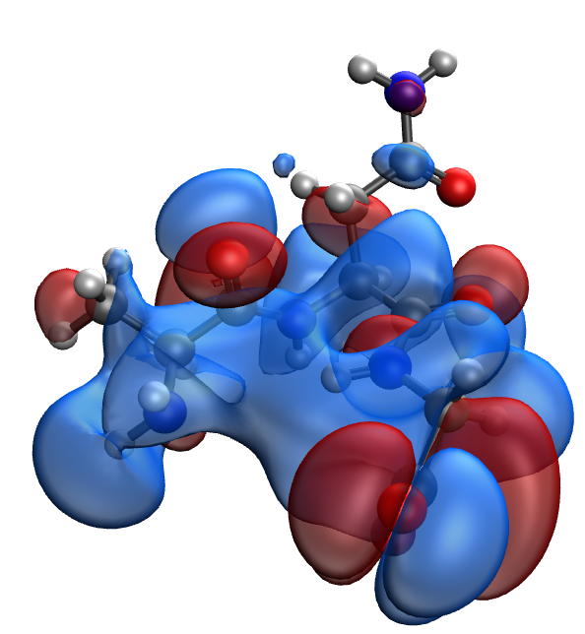
d | e
Fig. S7. Results of the quantum-chemical simulation of the Ala-Asn-Gly gelatin segment: a model of the molecular complex (a), the distribution of electron density (b), electronic density distribution gradient (c), HOMO (d), LUMO (e)

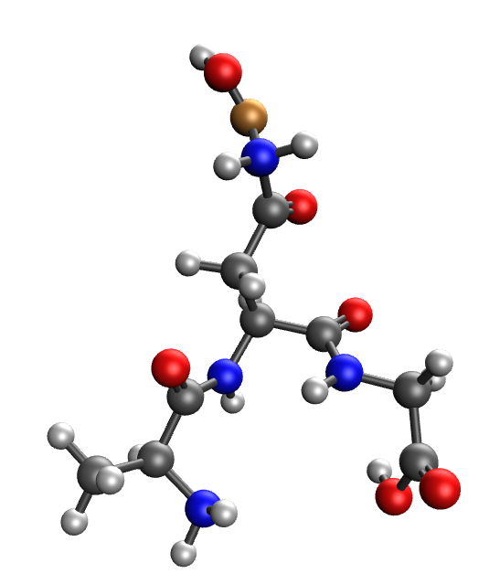 | 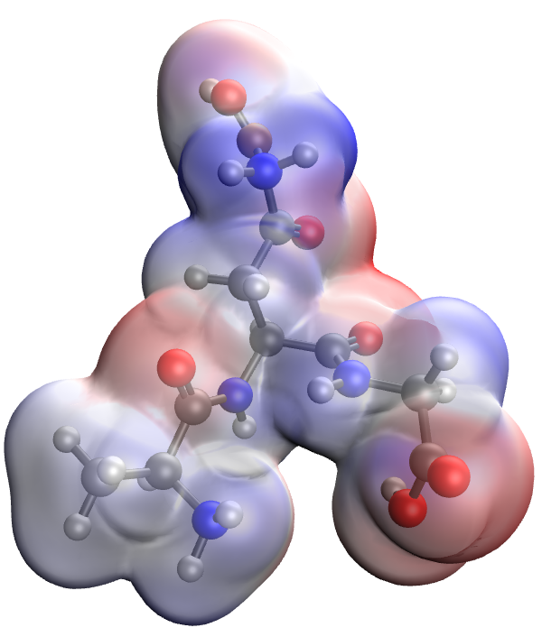
a | b
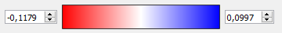
c
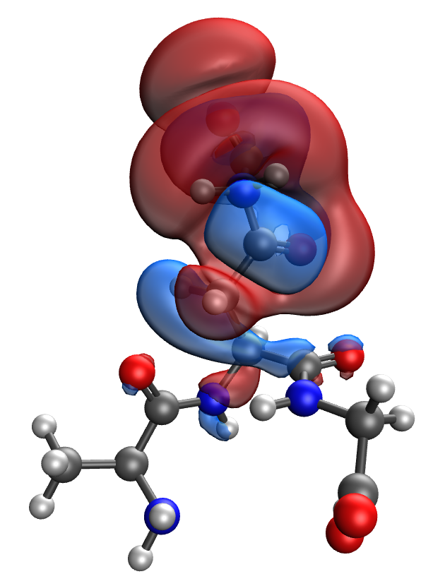 | 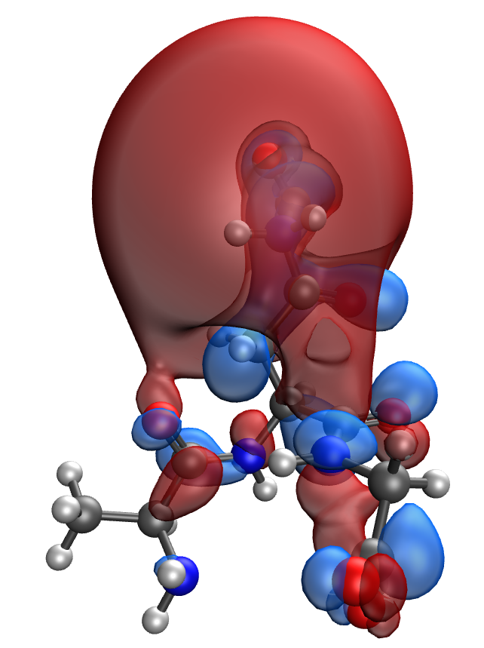
d | e
Fig. S8. Results of the quantum-chemical simulation of the Ala-Asn-Gly gelatin segment, bonded with CuO molecule: a model of the molecular complex (a), the distribution of electron density (b), electronic density distribution gradient (c), HOMO (d), LUMO (e)

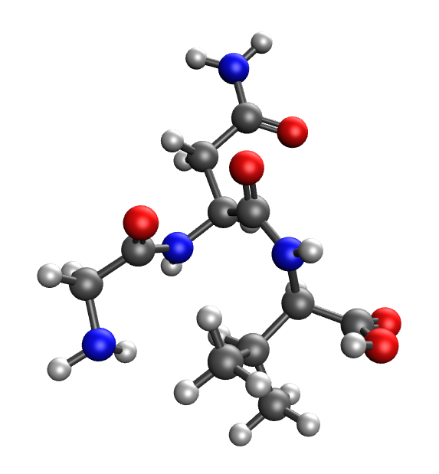 | 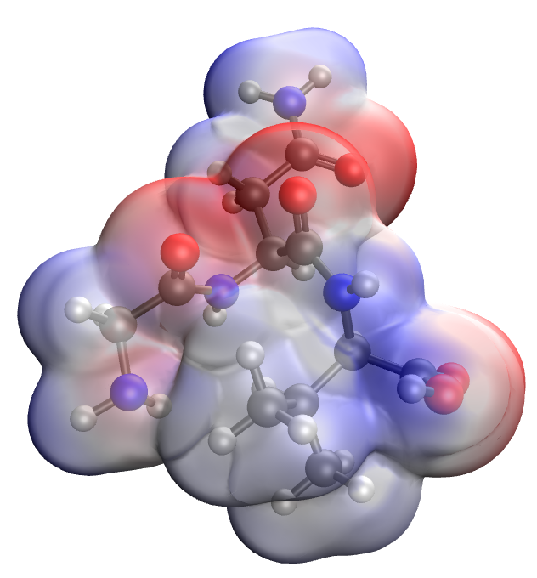
a | b
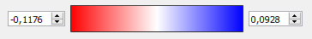
c
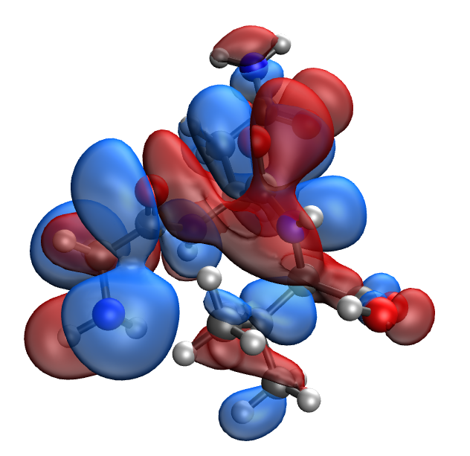 | 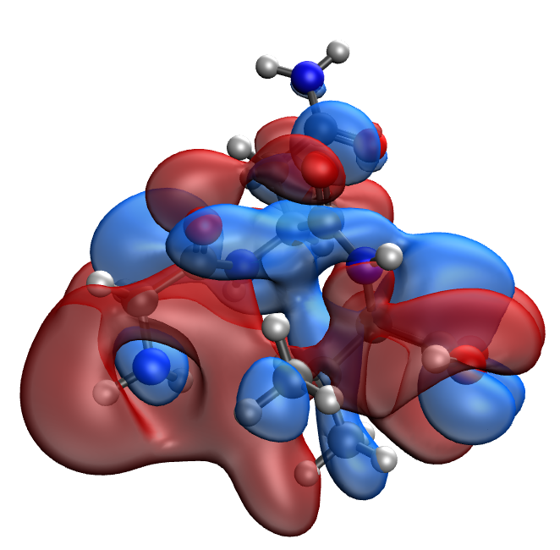
d | e
Fig. S9. Results of the quantum-chemical simulation of the Gly-Asn-Val gelatin segment: a model of the molecular complex (a), the distribution of electron density (b), electronic density distribution gradient (c), HOMO (d), LUMO (e)

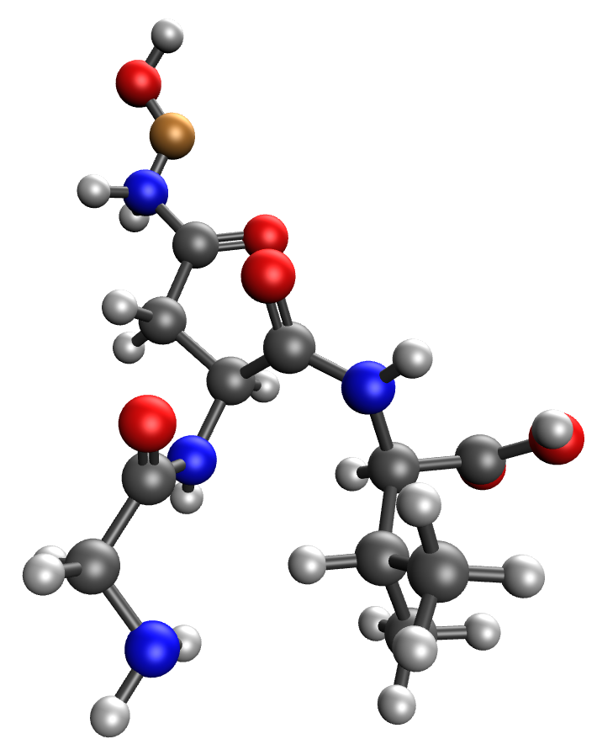 | 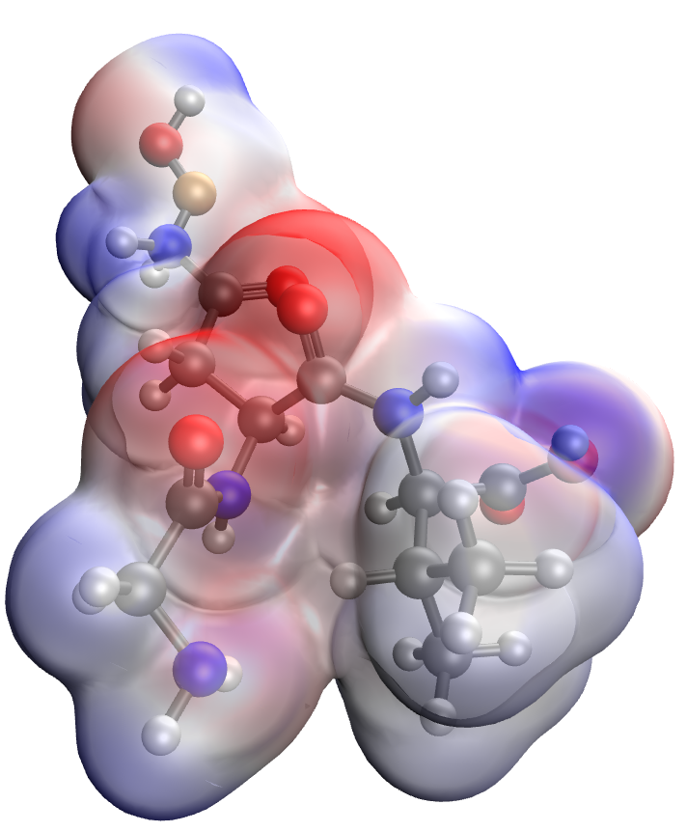
a | b
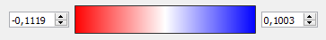
c
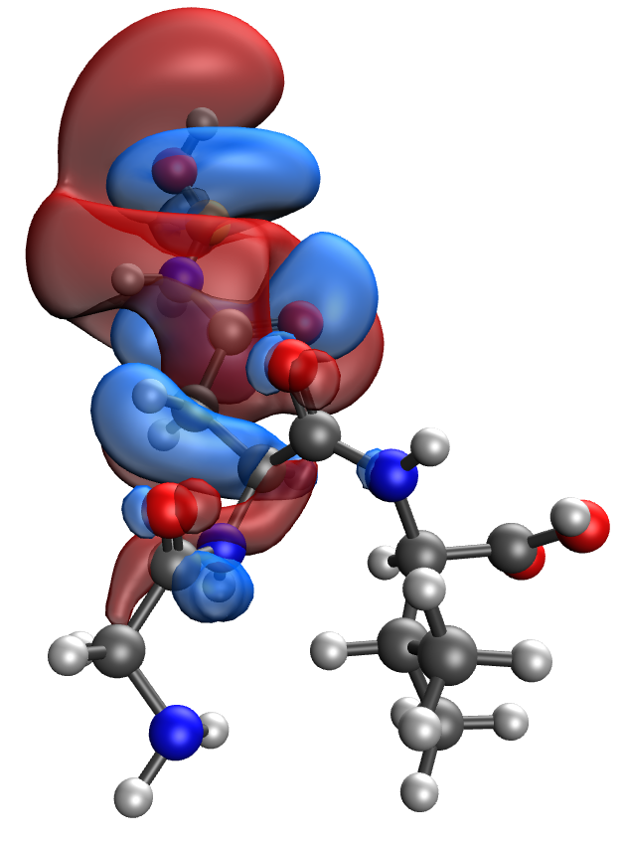 | 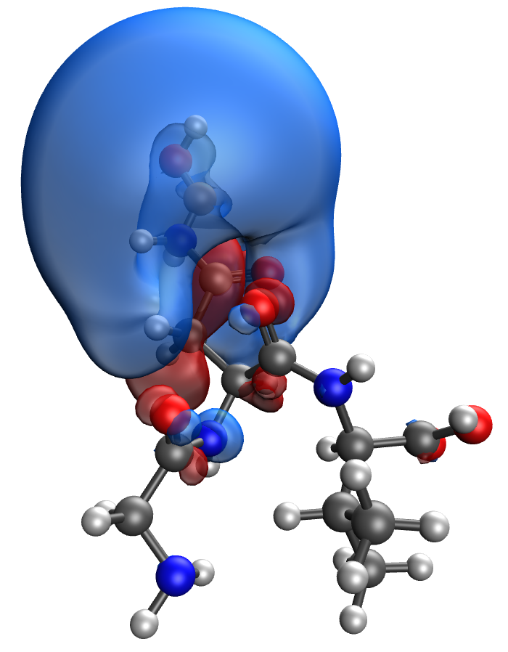
d | e
Fig. S10. Results of the quantum-chemical simulation of the Gly-Asn-Val gelatin segment, bonded with CuO molecule: a model of the molecular complex (a), the distribution of electron density (b), electronic density distribution gradient (c), HOMO (d), LUMO (e)

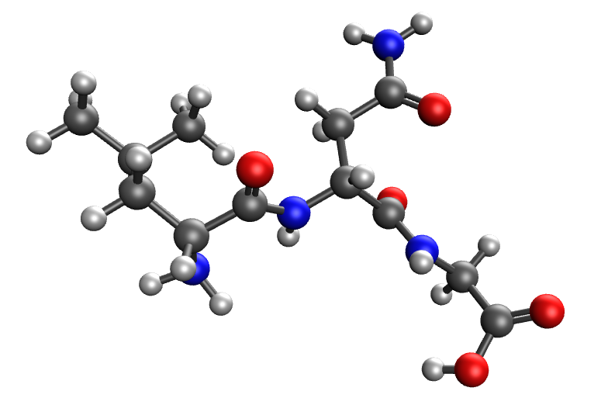 | 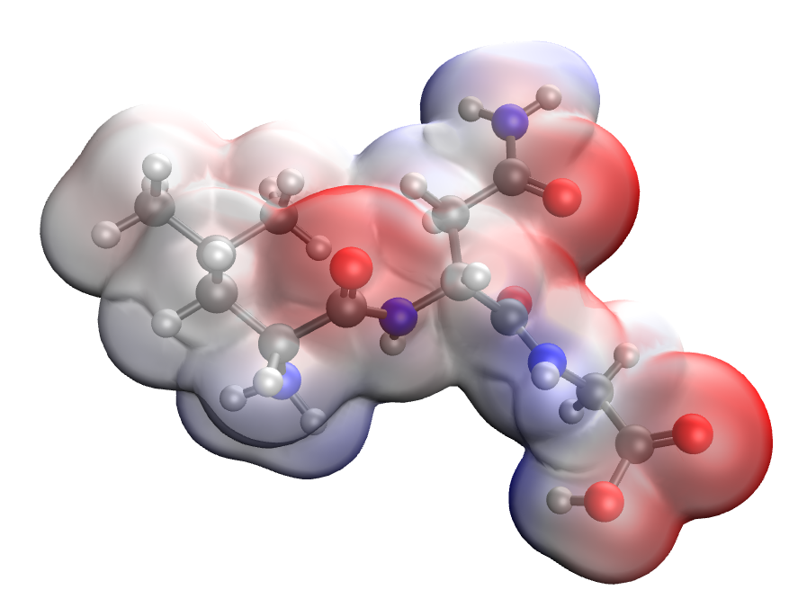
a | b
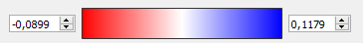
c
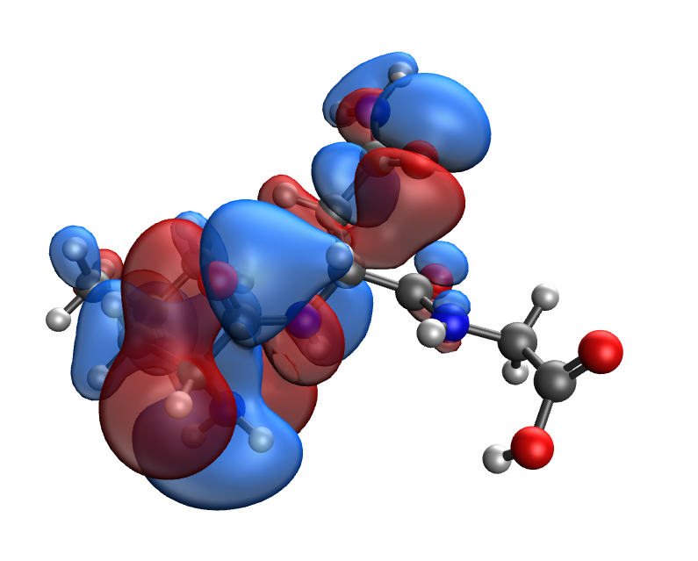 | 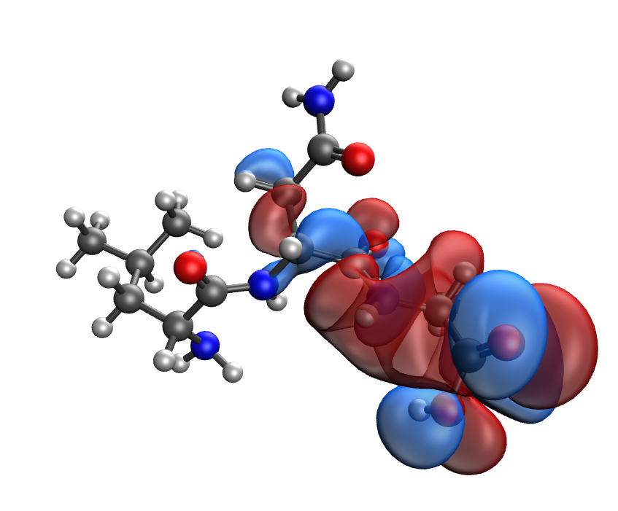
d | e
Fig. S11. Results of the quantum-chemical simulation of the Leu-Asn-Gly gelatin segment: a model of the molecular complex (a), the distribution of electron density (b), electronic density distribution gradient (c), HOMO (d), LUMO (e)

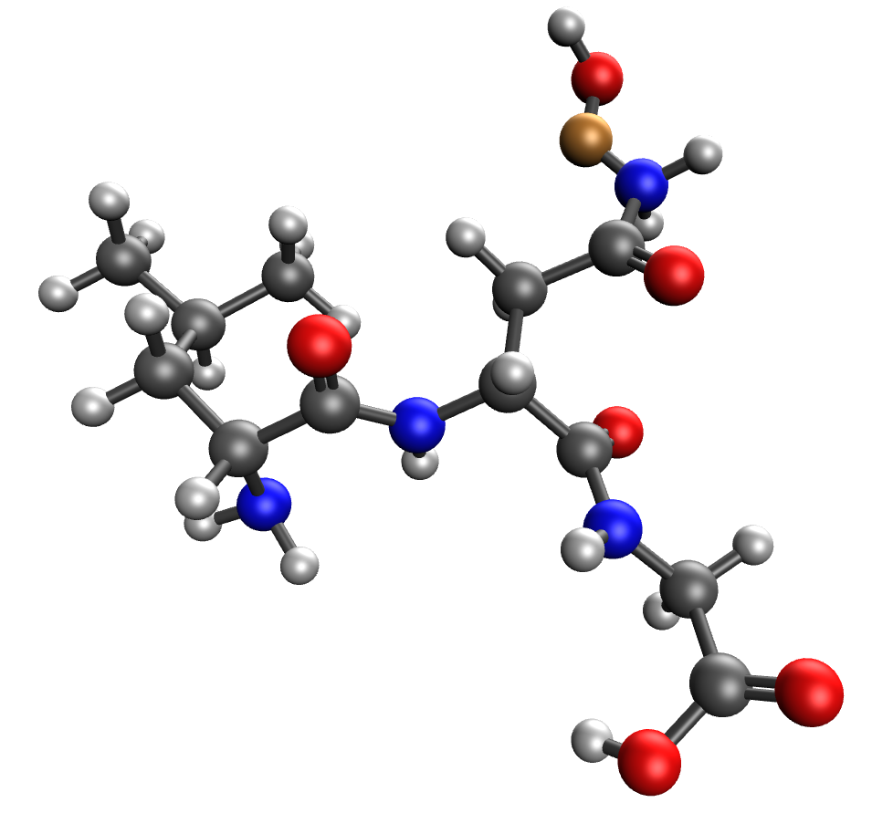 | 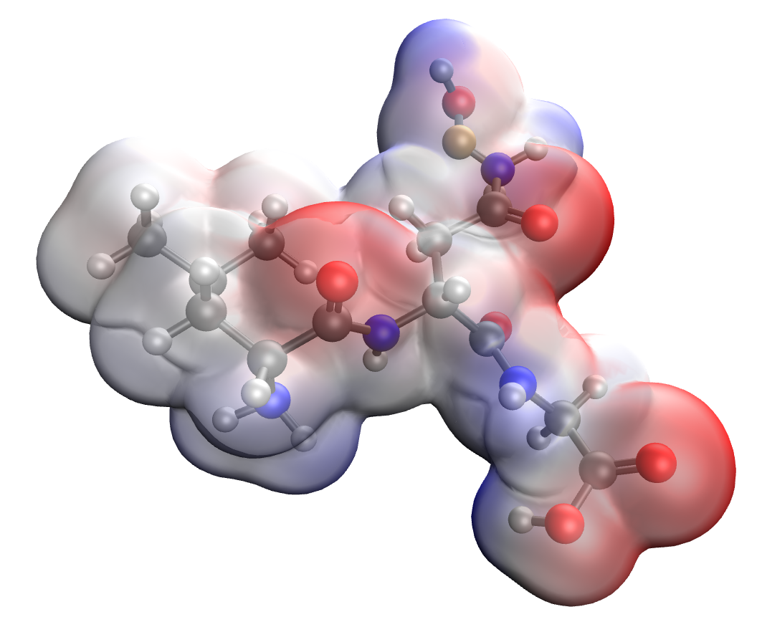
a | b
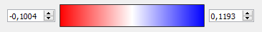
c
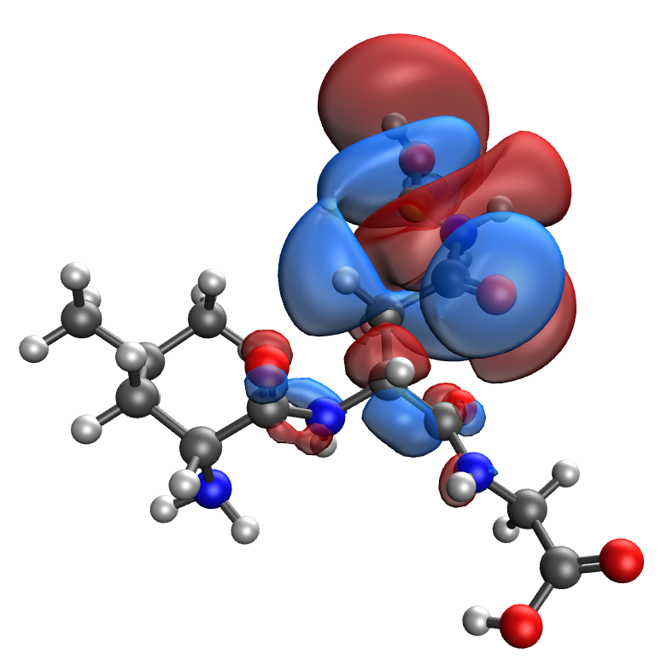 | 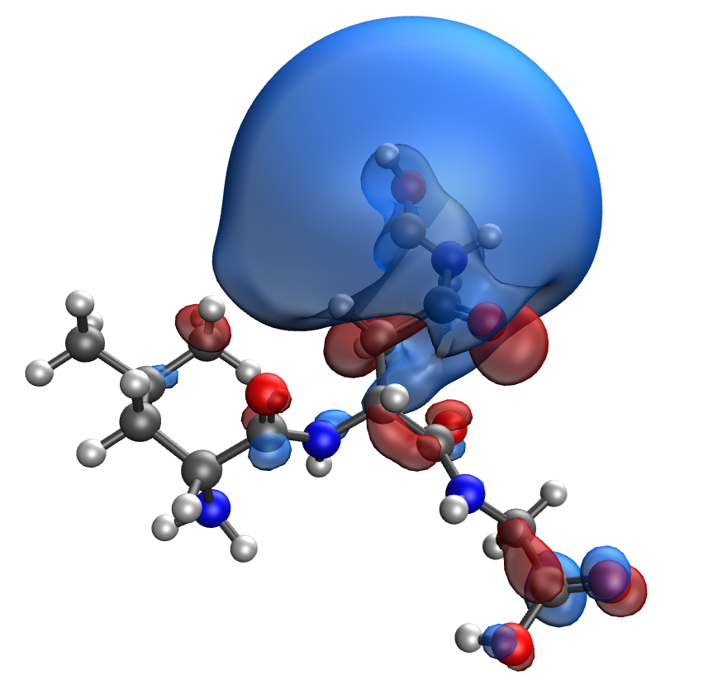
d | e
Fig. S12. Results of the quantum-chemical simulation of the Leu-Asn-Gly gelatin segment, bonded with CuO molecule: a model of the molecular complex (a), the distribution of electron density (b), electronic density distribution gradient (c), HOMO (d), LUMO (e)

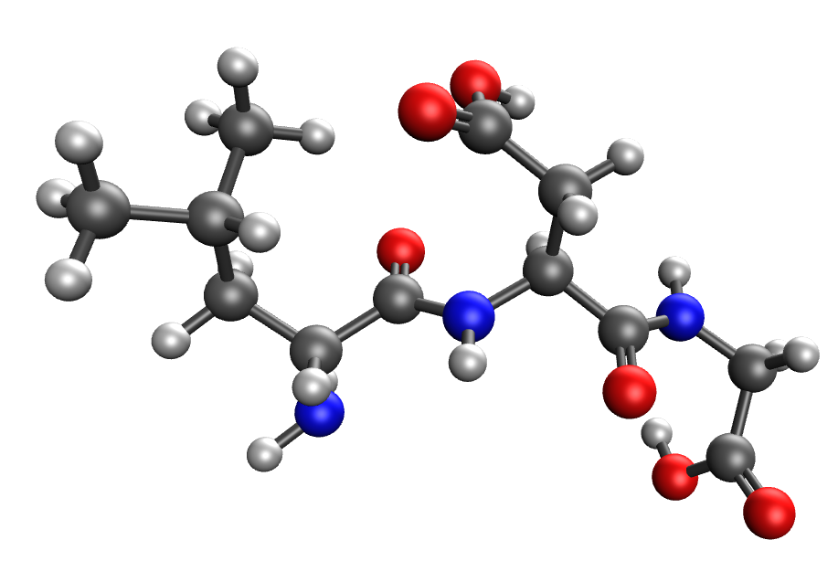 | 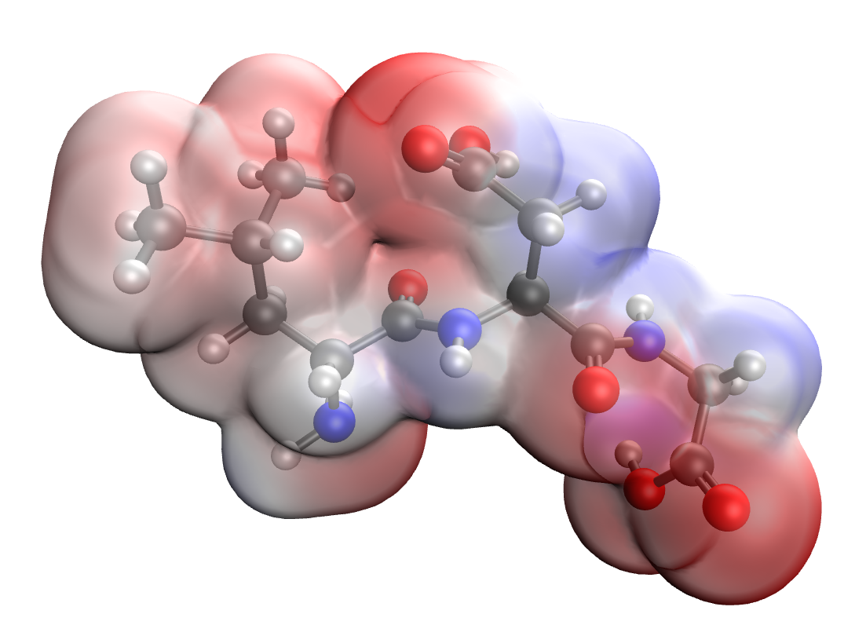
a | b
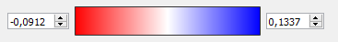
c
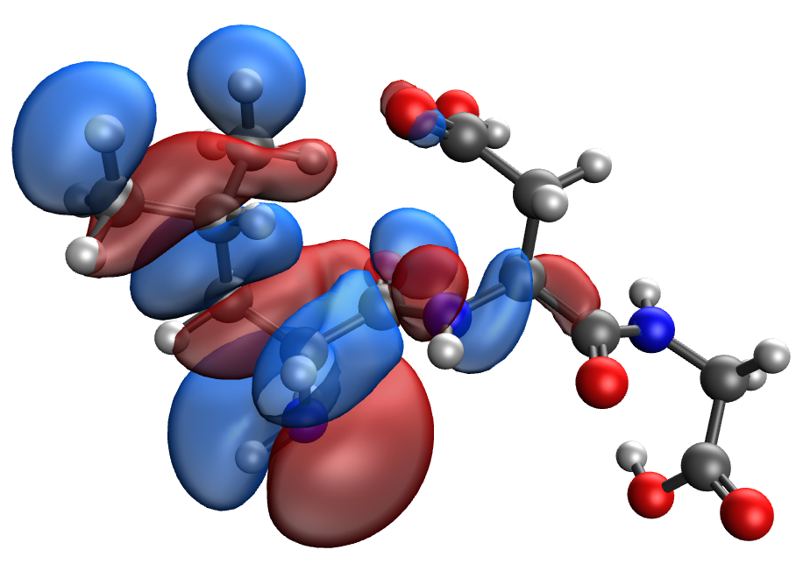 | 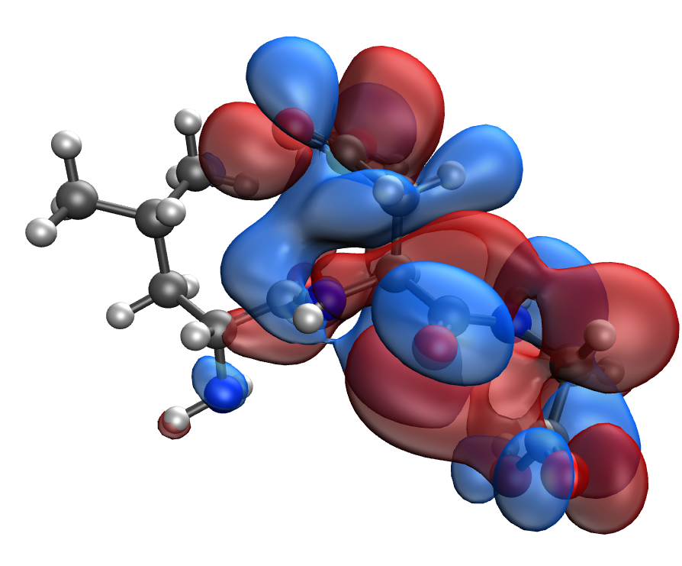
d | e

Fig. S13. Results of the quantum-chemical simulation of the Leu-Asp-Gly gelatin segment: a model of the molecular complex (a), the distribution of electron density (b), electronic density distribution gradient (c), HOMO (d), LUMO (e)

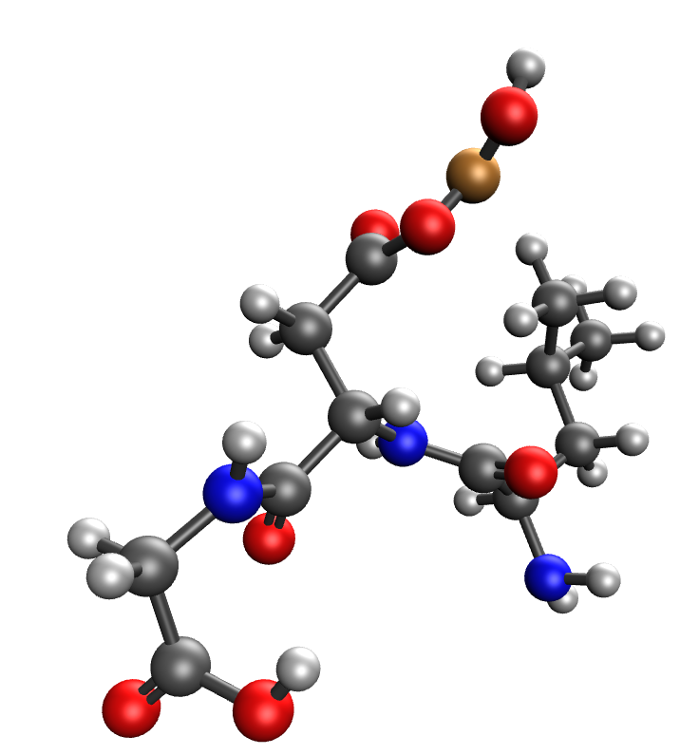 | 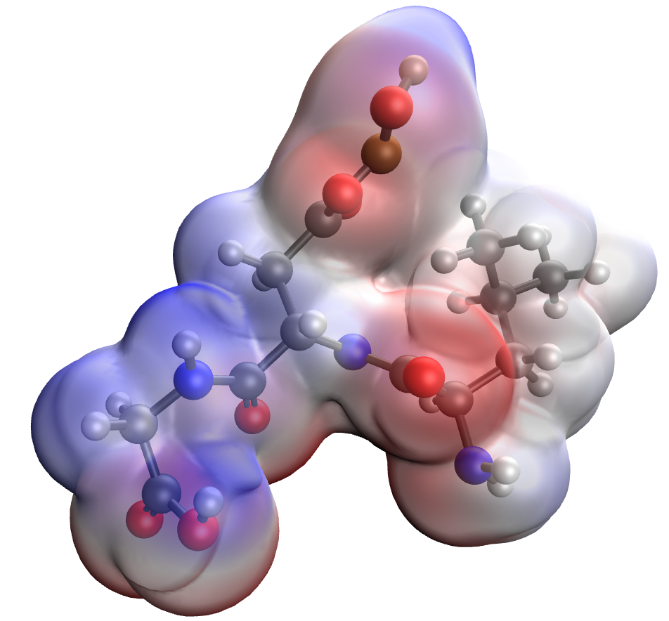
a | b
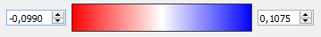
c
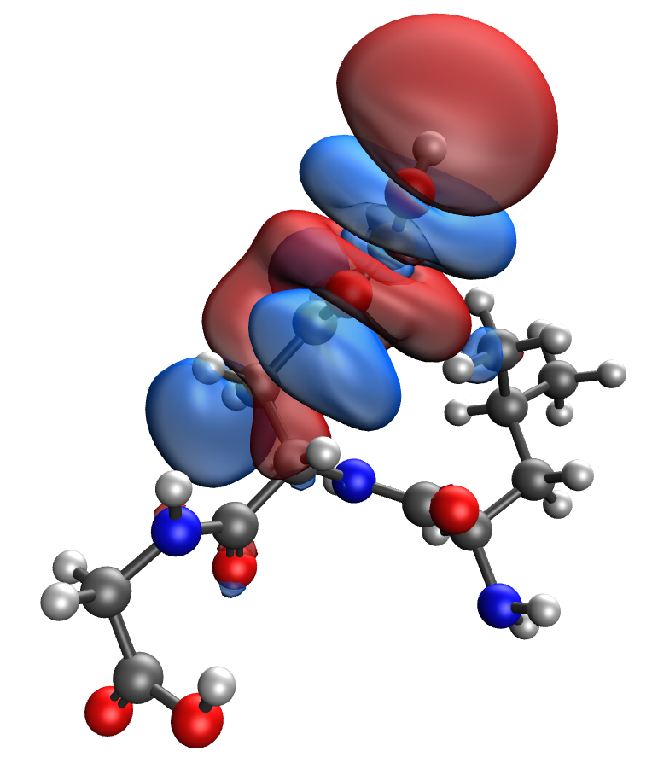 | 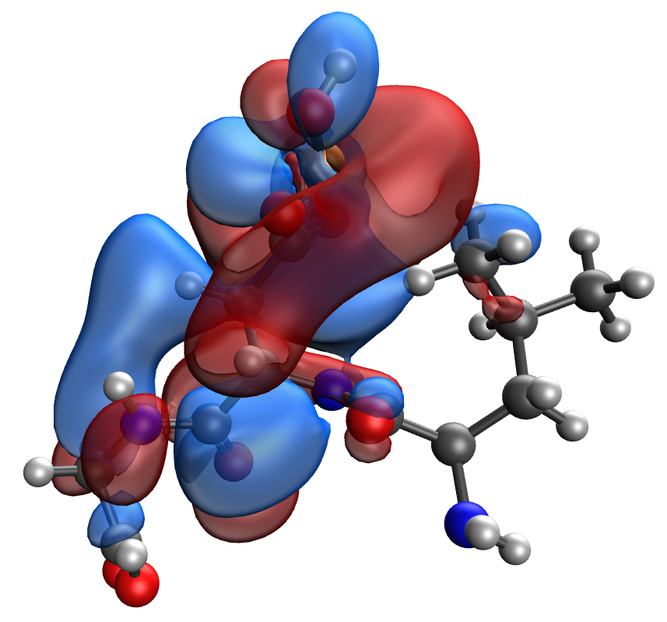
d | e
Fig. S14. Results of the quantum-chemical simulation of the Leu-Asp-Gly gelatin segment, bonded with CuO molecule: a model of the molecular complex (a), the distribution of electron density (b), electronic density distribution gradient (c), HOMO (d), LUMO (e)

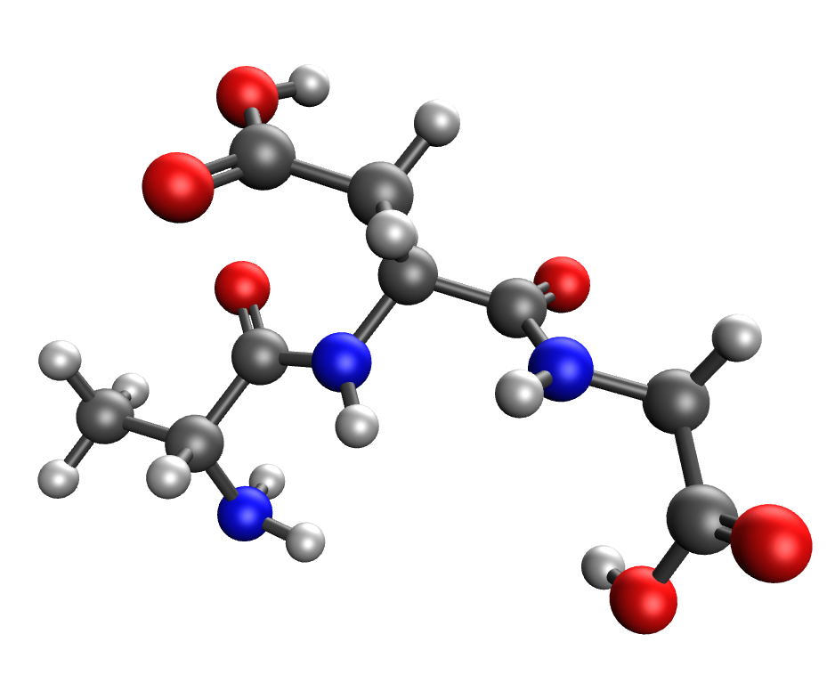 | 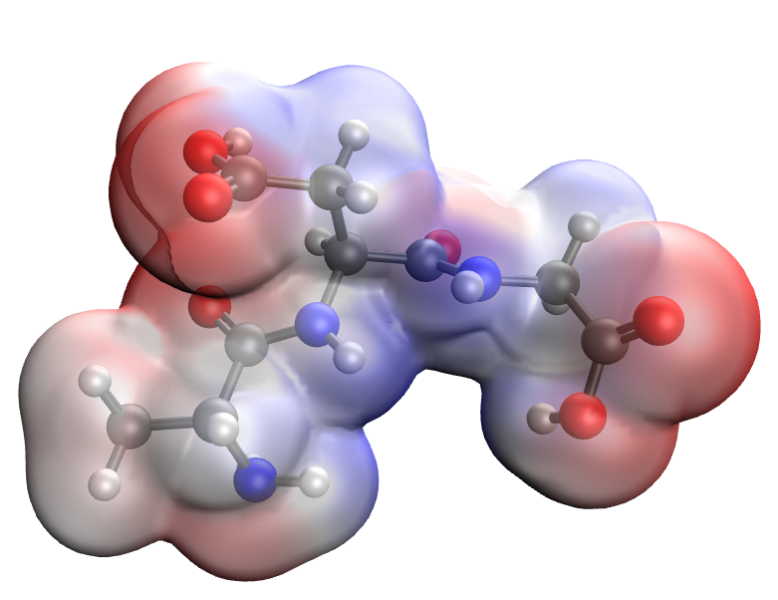
a | b
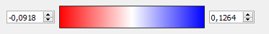
c
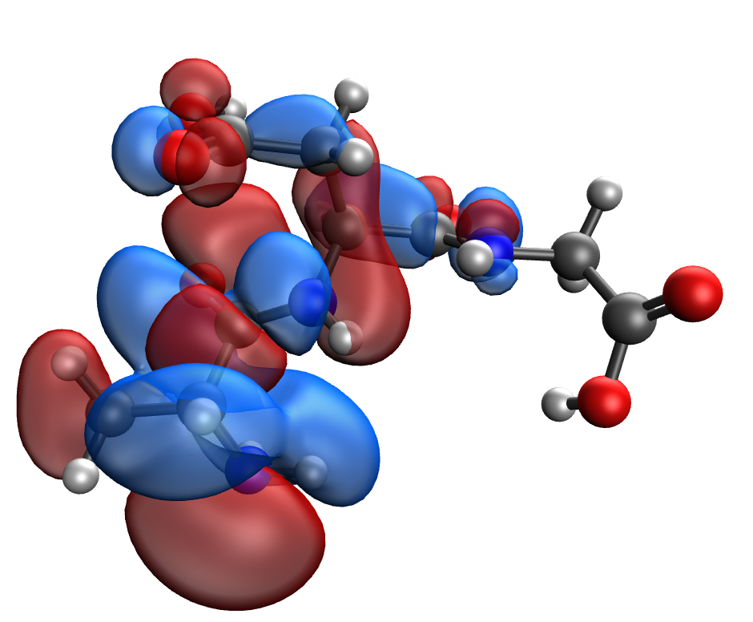 | 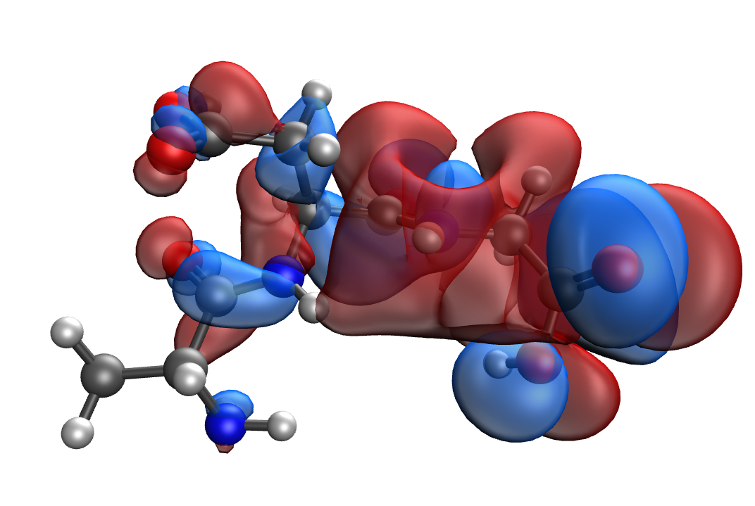
d | e
Fig. S15. Results of the quantum-chemical simulation of the Ala-Asp-Gly gelatin segment: a model of the molecular complex (a), the distribution of electron density (b), electronic density distribution gradient (c), HOMO (d), LUMO (e)

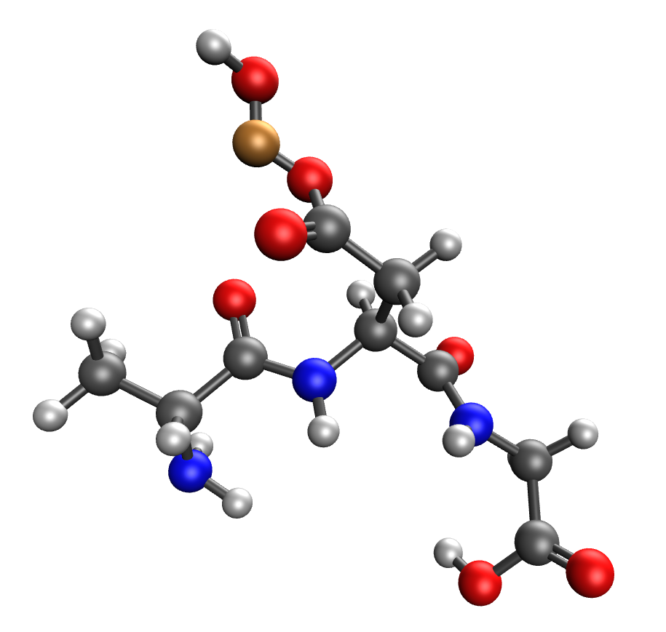 | 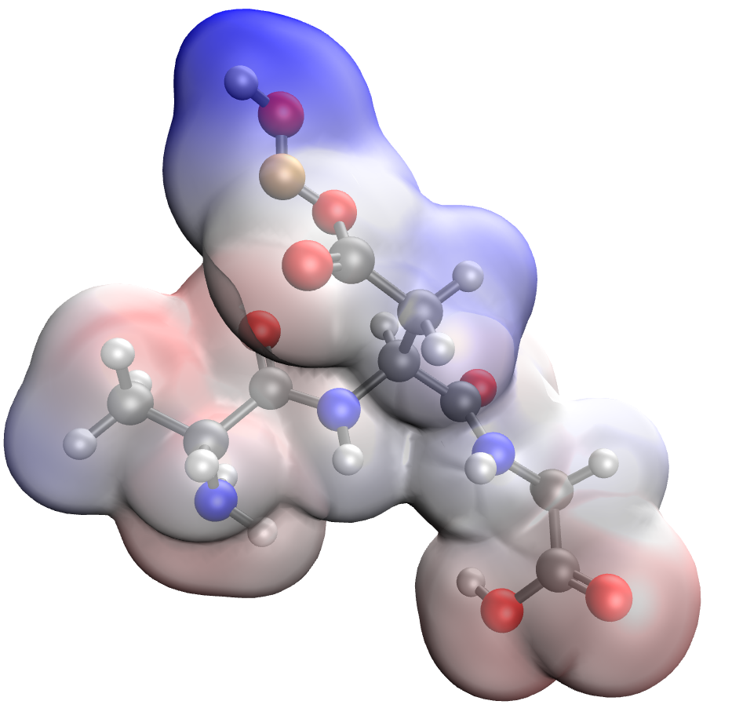
a | b
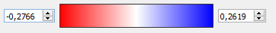
c
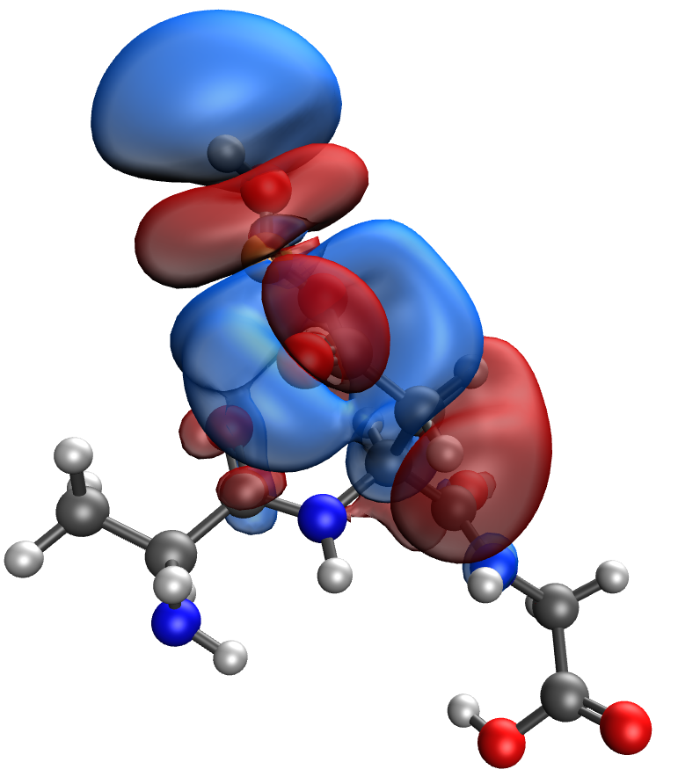 | 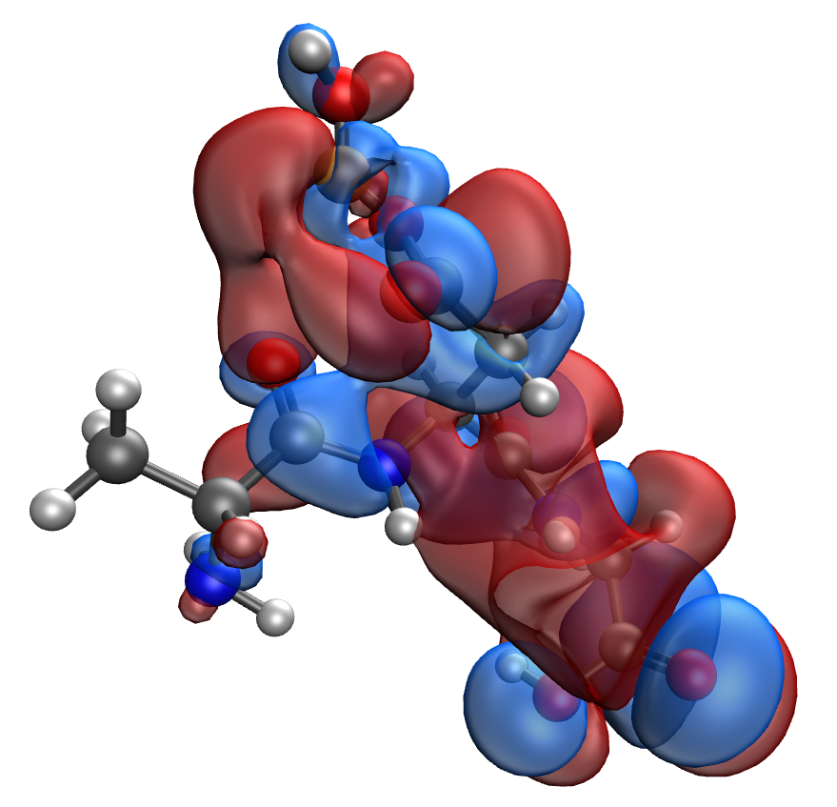
d | e
Fig. S16. Results of the quantum-chemical simulation of the Ala-Asp-Gly gelatin segment, bonded with CuO molecule: a model of the molecular complex (a), the distribution of electron density (b), electronic density distribution gradient (c), HOMO (d), LUMO (e)

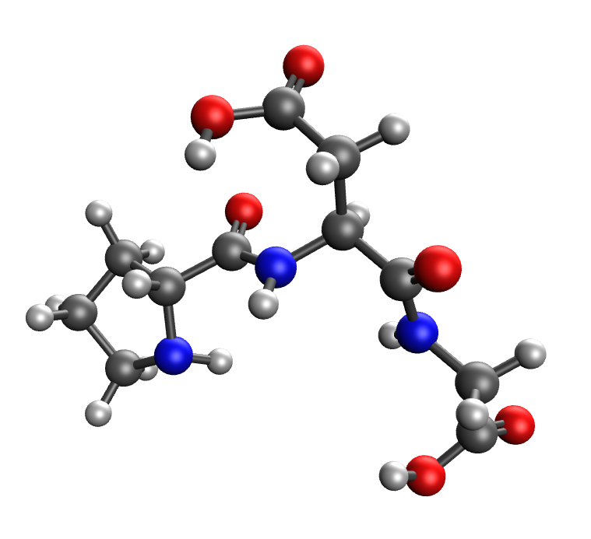 | 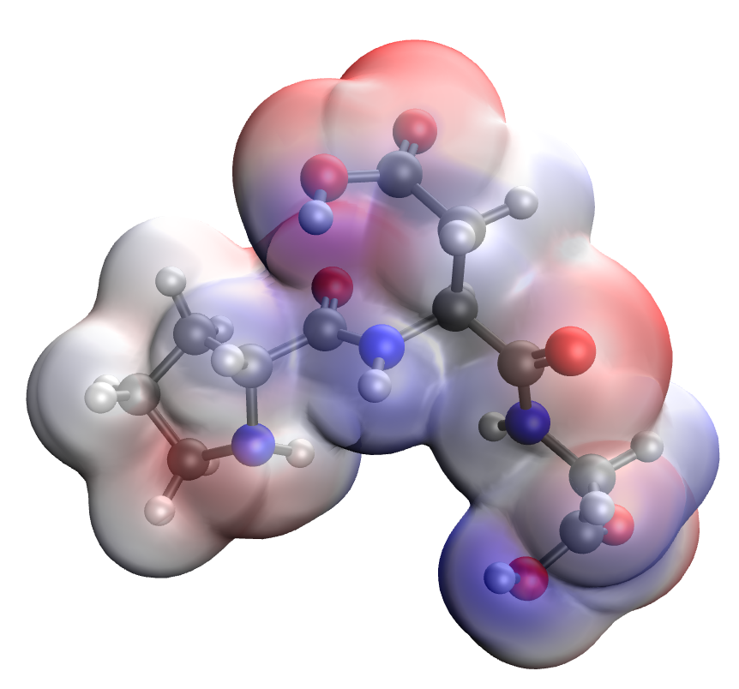
a | b
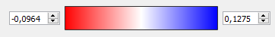
c
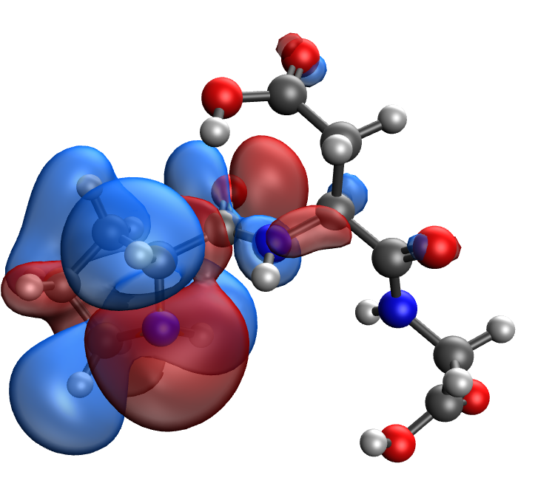 | 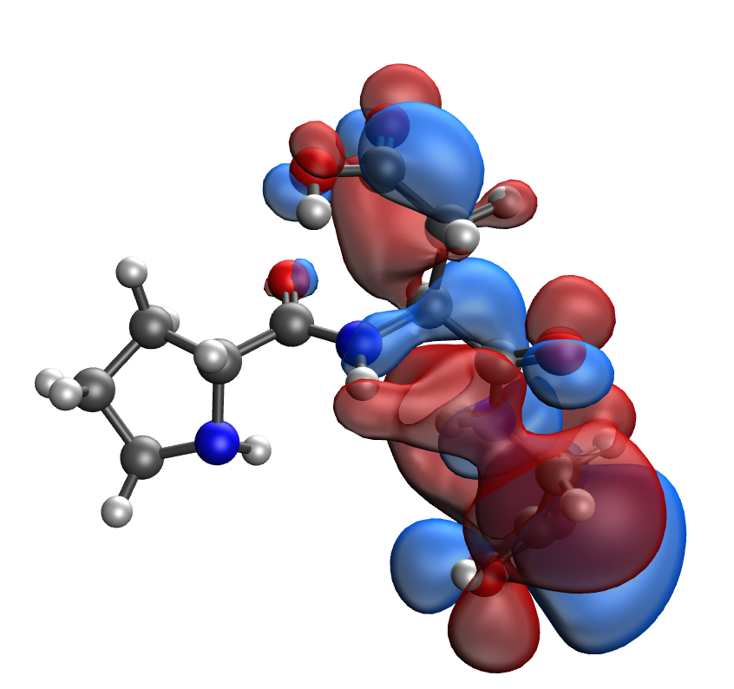
d | e
Fig. S17. Results of the quantum-chemical simulation of the Pro-Asp-Gly gelatin segment: a model of the molecular complex (a), the distribution of electron density (b), electronic density distribution gradient (c), HOMO (d), LUMO (e)

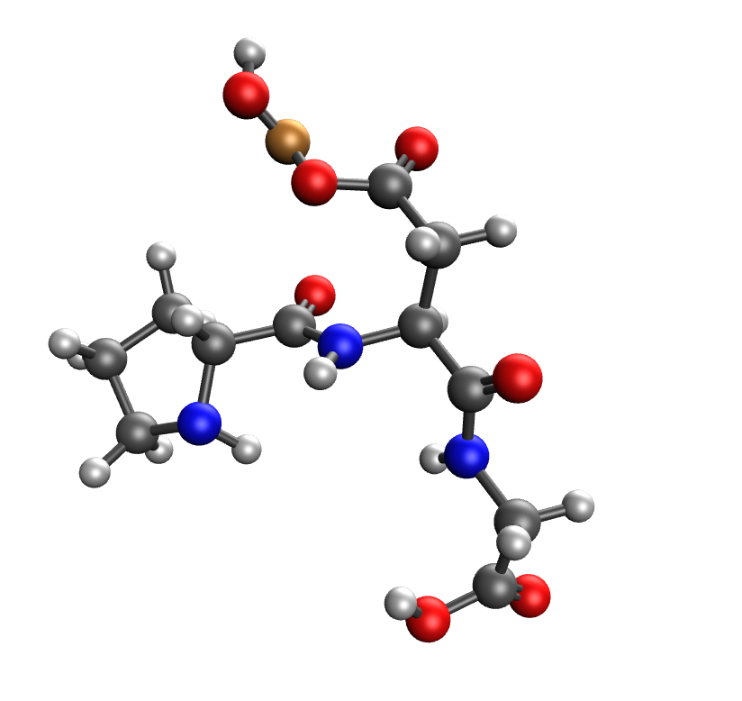 | 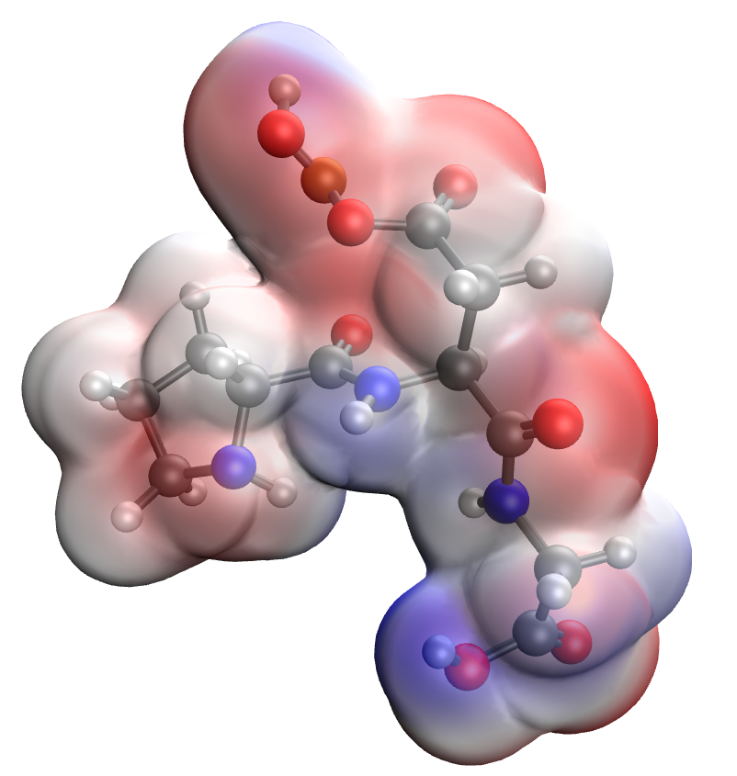
a | b
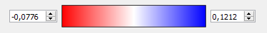
c
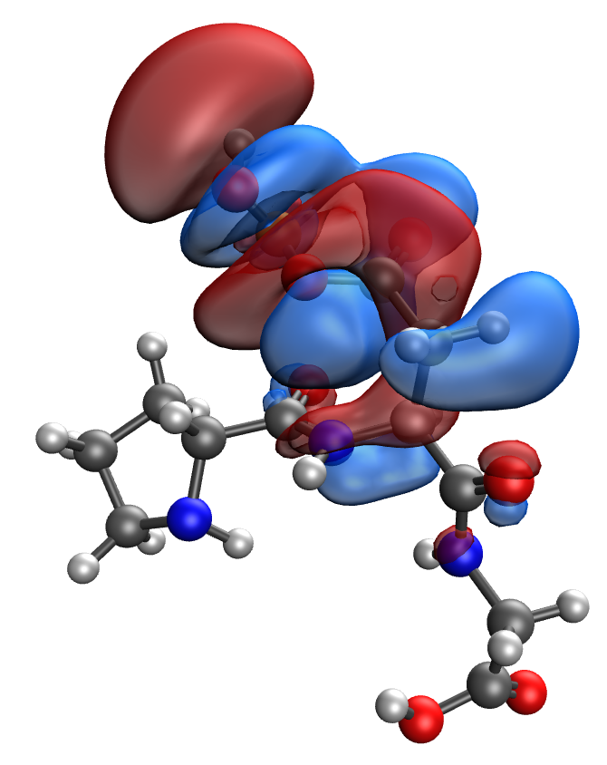 | 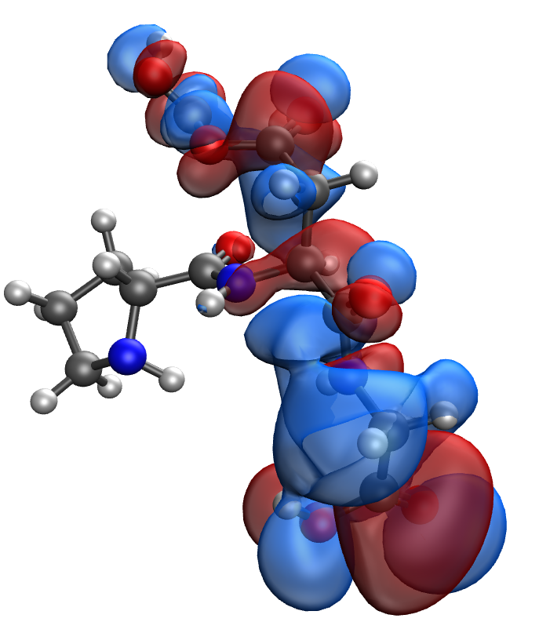
d | e
Fig. S18. Results of the quantum-chemical simulation of the Pro-Asp-Gly gelatin segment, bonded with CuO molecule: a model of the molecular complex (a), the distribution of electron density (b), electronic density distribution gradient (c), HOMO (d), LUMO (e)

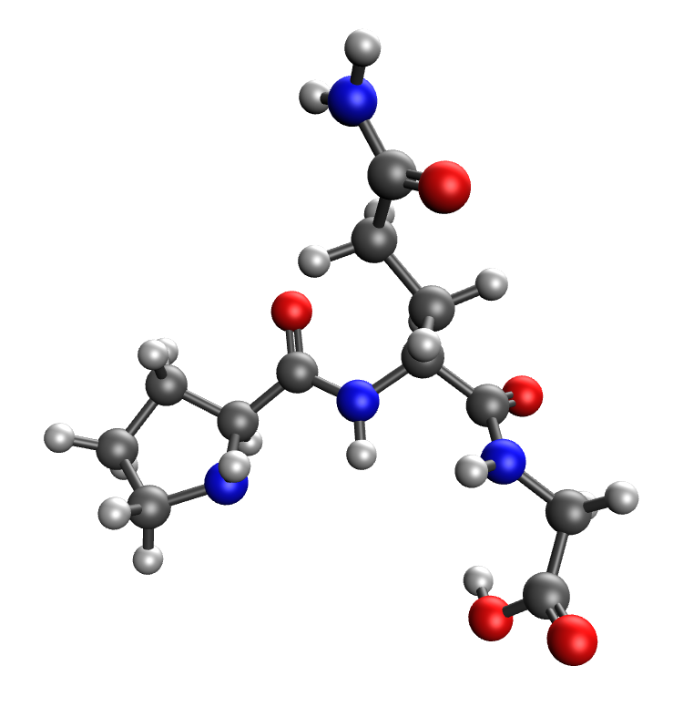 | 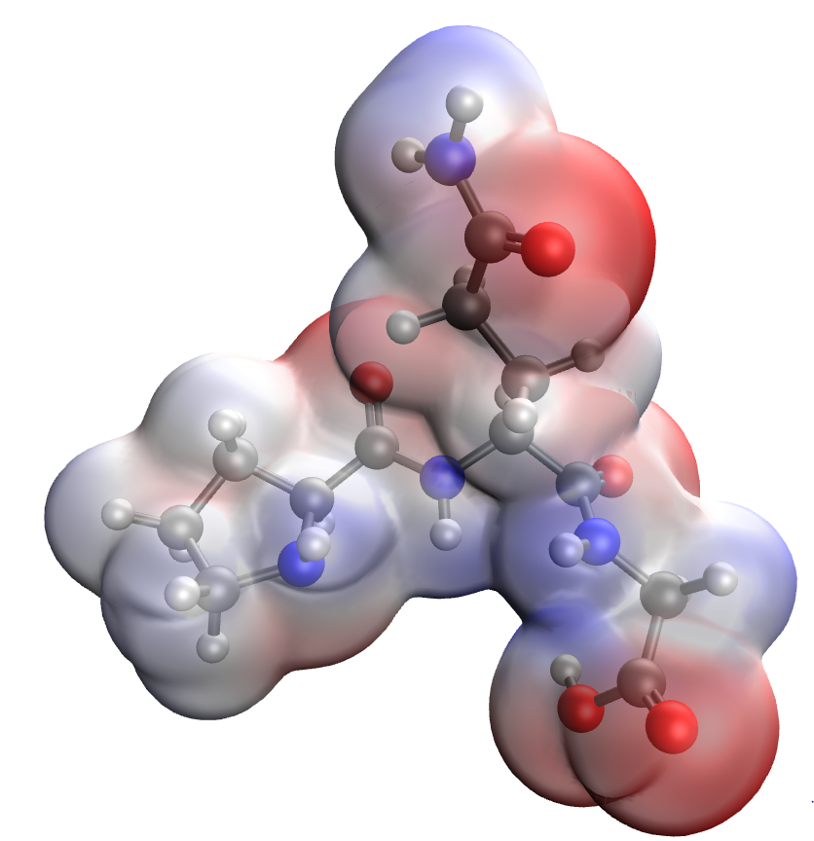
a | b
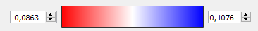
c
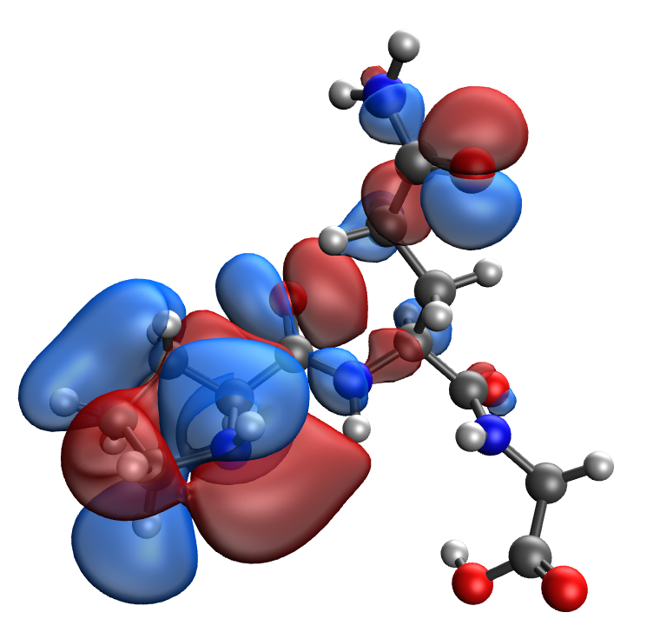 | 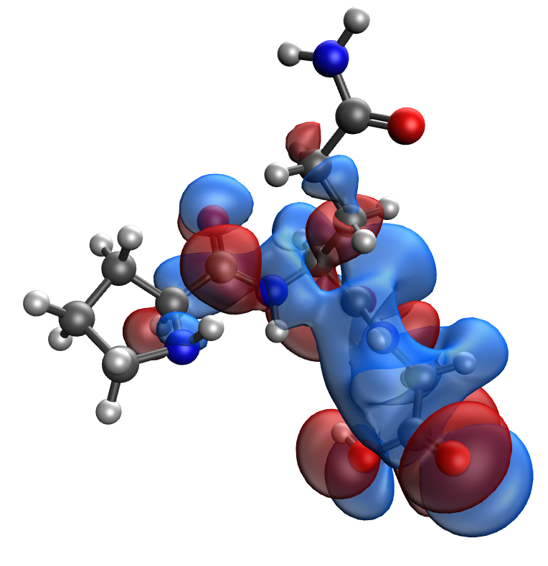
d | e
Fig. S19. Results of the quantum-chemical simulation of the Pro-Gln-Gly gelatin segment: a model of the molecular complex (a), the distribution of electron density (b), electronic density distribution gradient (c), HOMO (d), LUMO (e)

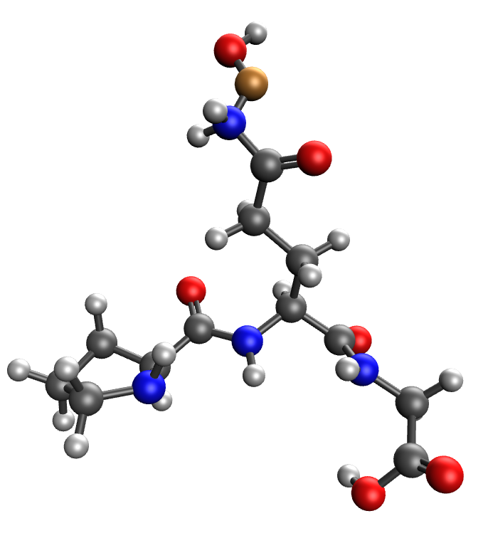 | 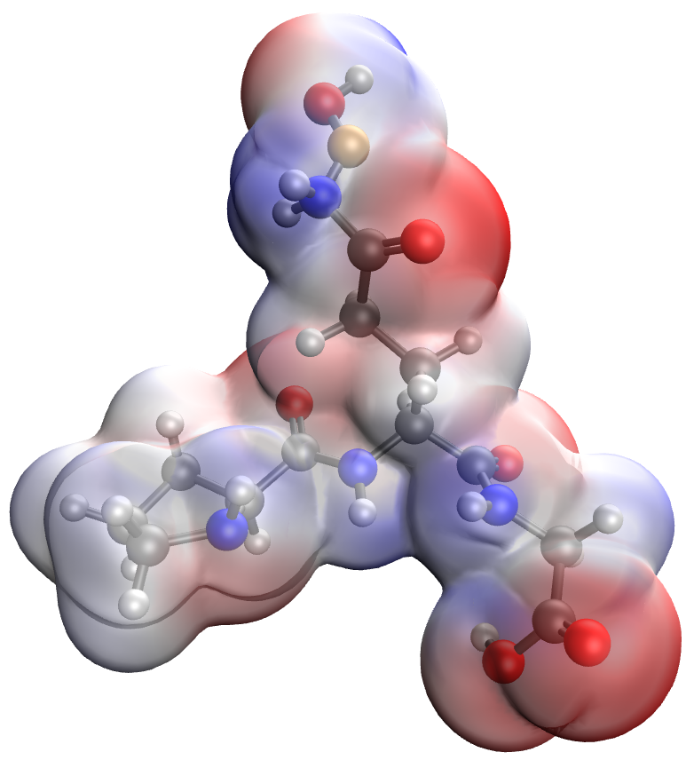
a | b
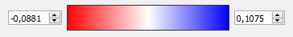
c
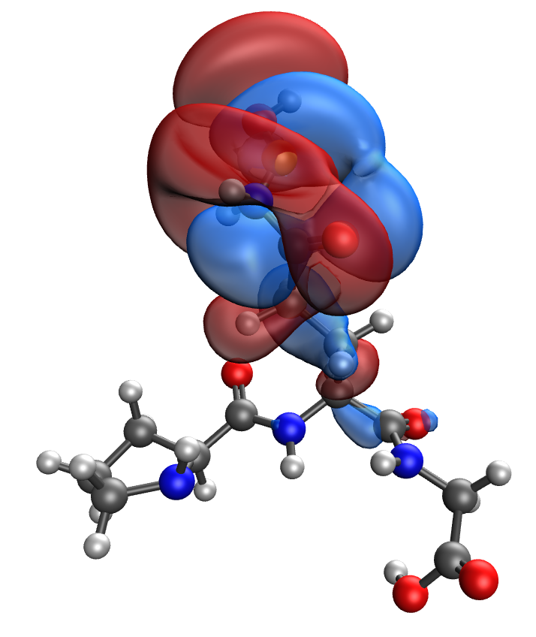 | 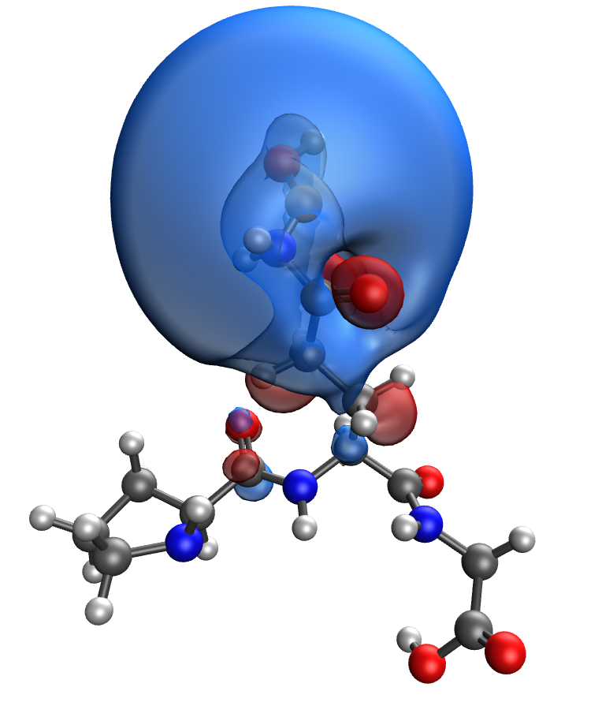
d | e
Fig. S20. Results of the quantum-chemical simulation of the Pro-Gln-Gly gelatin segment, bonded with CuO molecule: a model of the molecular complex (a), the distribution of electron density (b), electronic density distribution gradient (c), HOMO (d), LUMO (e)

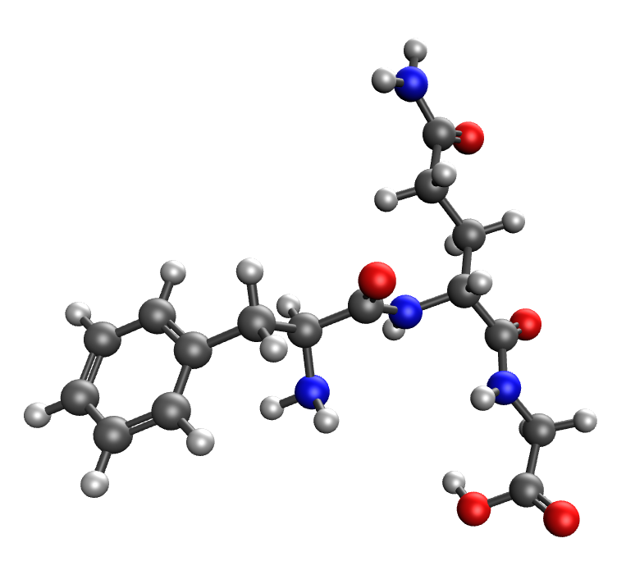 | 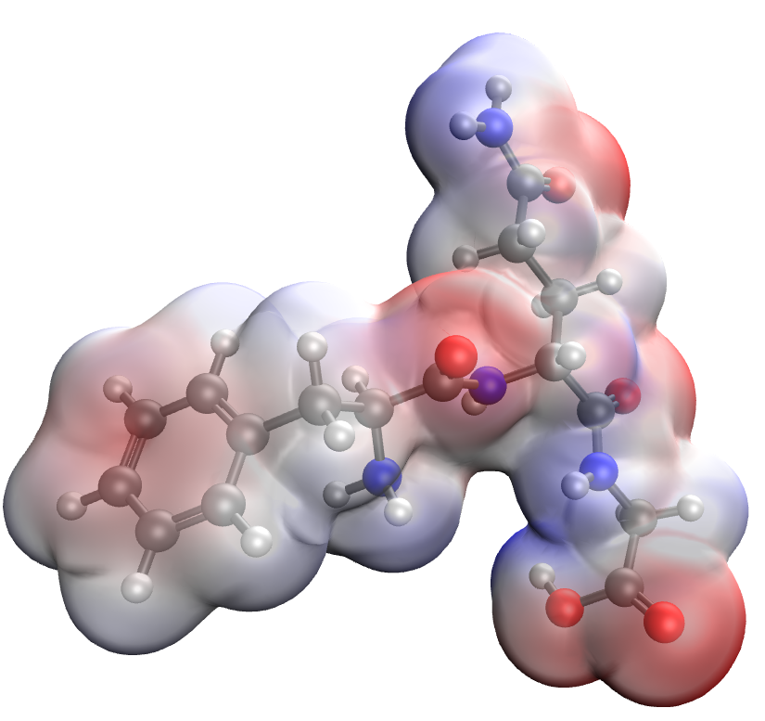
a | b
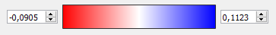
c
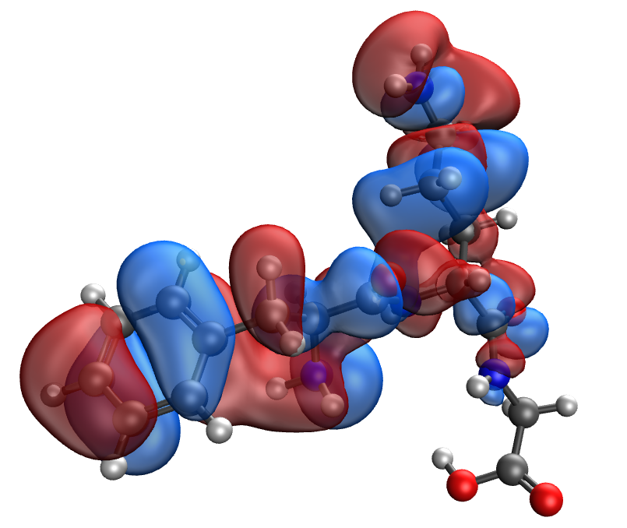 | 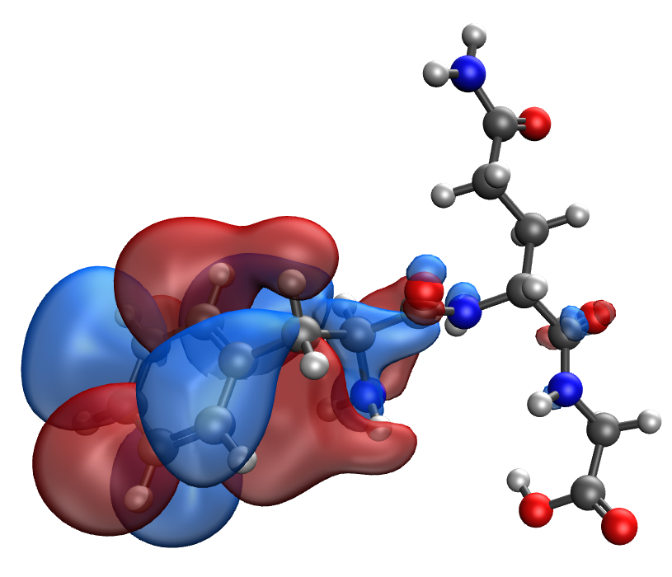
d | e
Fig. S21. Results of the quantum-chemical simulation of the Phe-Gln-Gly gelatin segment: a model of the molecular complex (a), the distribution of electron density (b), electronic density distribution gradient (c), HOMO (d), LUMO (e)

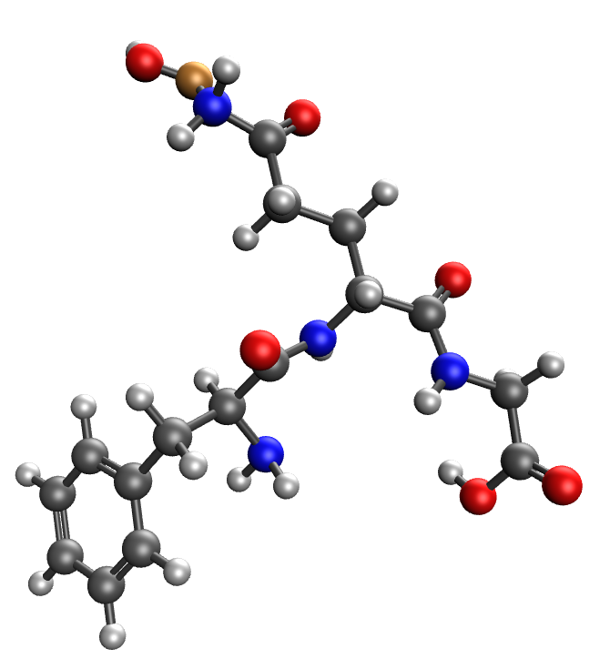 | 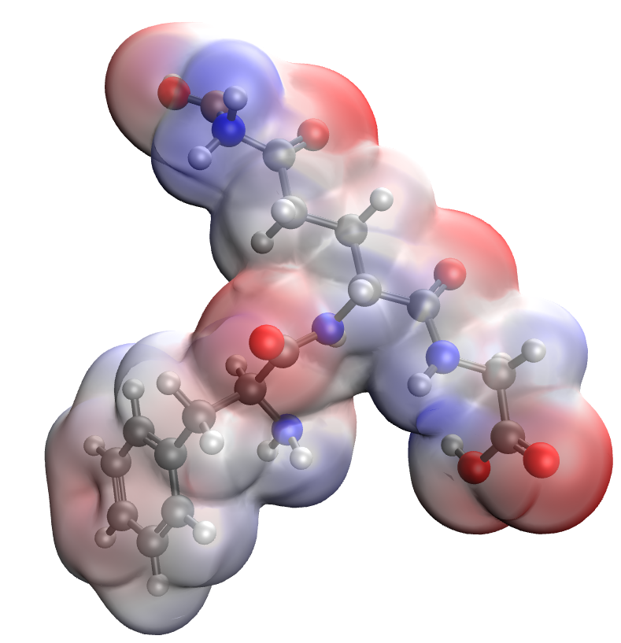
a | b
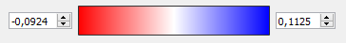
c
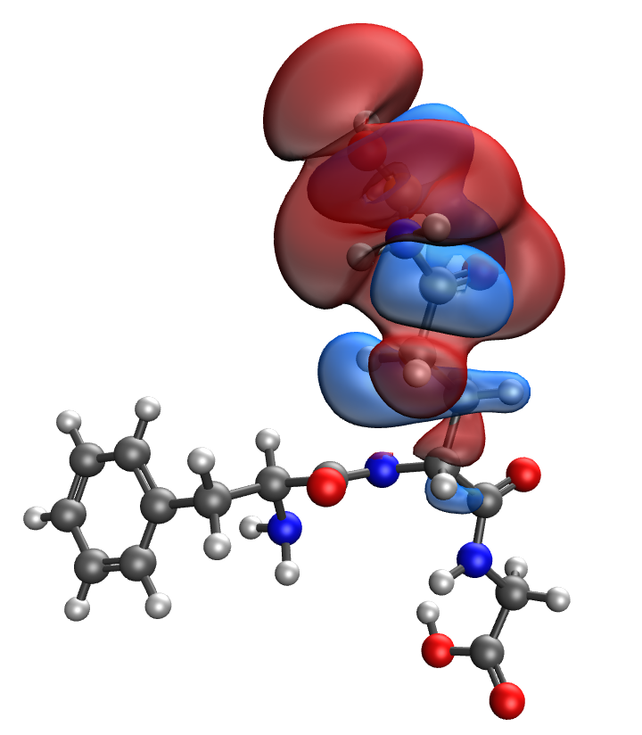 | 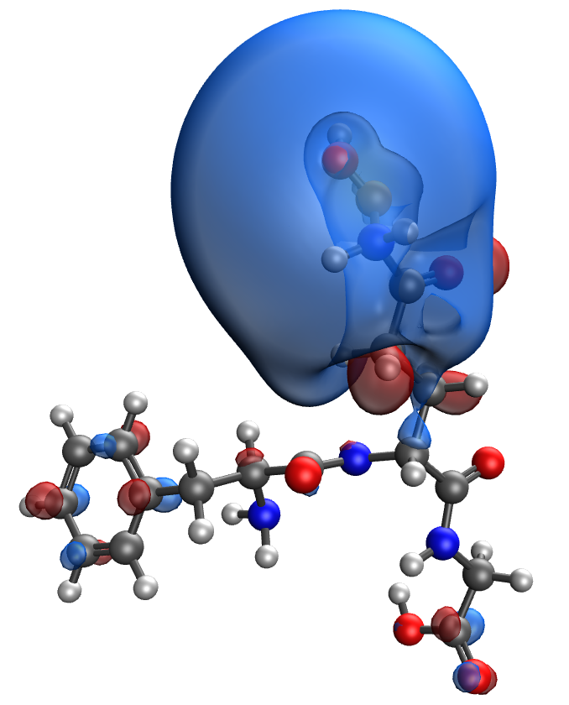
d | e
Fig. S22. Results of the quantum-chemical simulation of the Phe-Gln-Gly gelatin segment, bonded with CuO molecule: a model of the molecular complex (a), the distribution of electron density (b), electronic density distribution gradient (c), HOMO (d), LUMO (e)

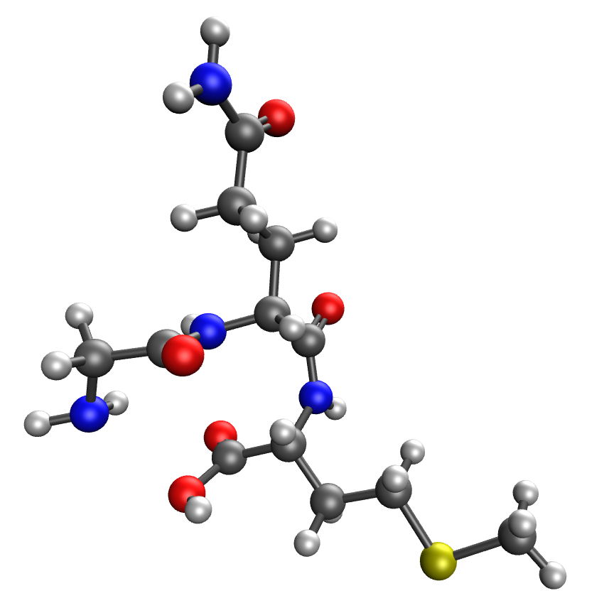 | 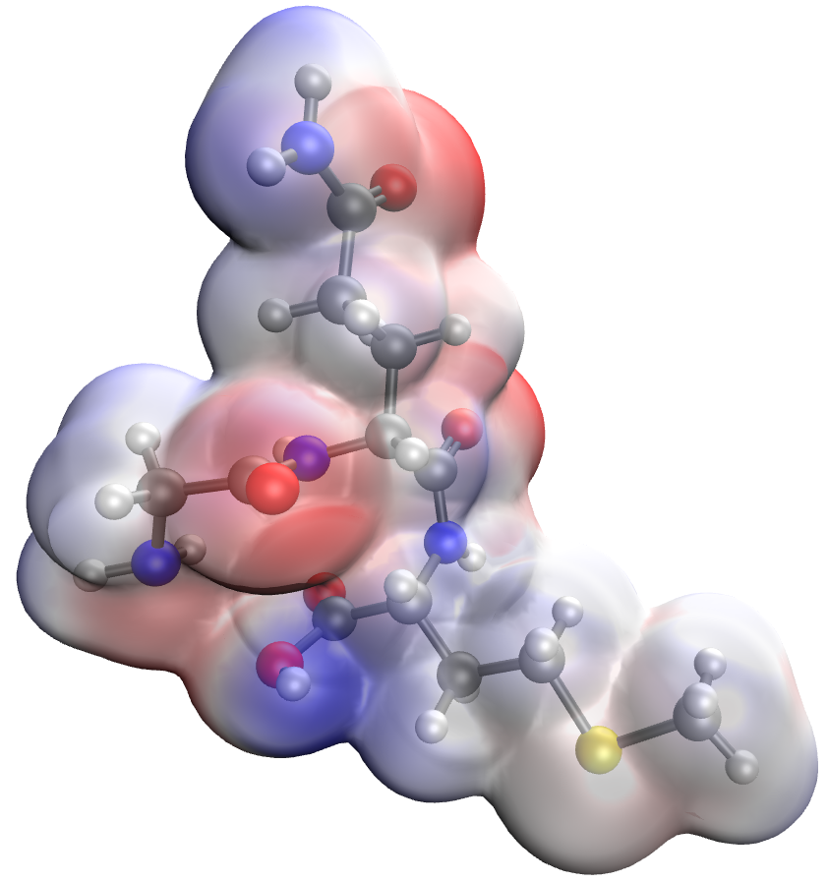
a | b
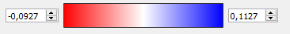
c
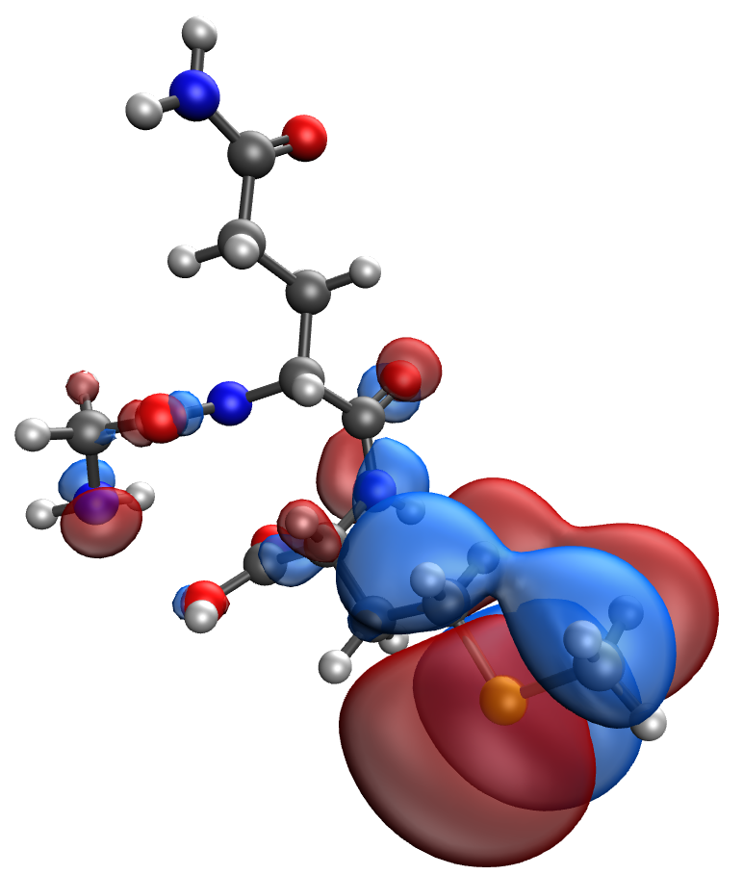 | 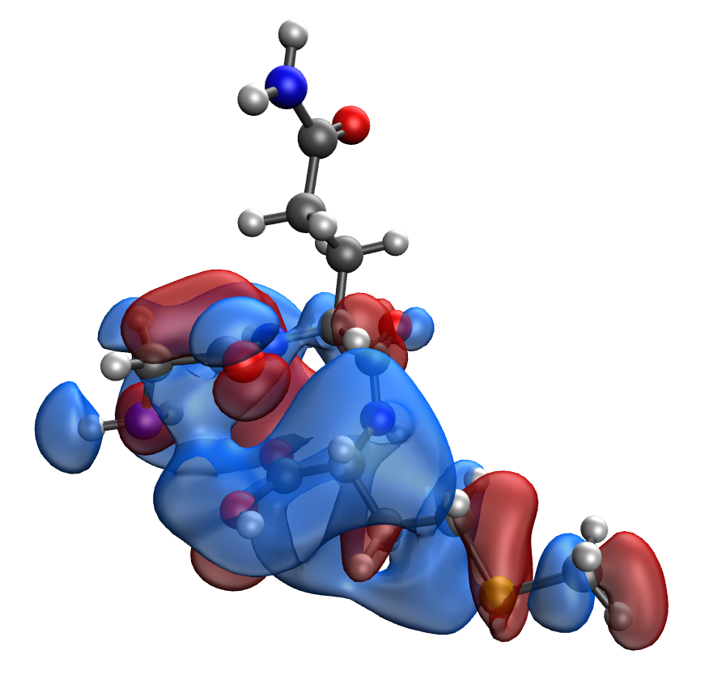
d | e
Fig. S23. Results of the quantum-chemical simulation of the Gly-Gln-Met gelatin segment: a model of the molecular complex (a), the distribution of electron density (b), electronic density distribution gradient (c), HOMO (d), LUMO (e)

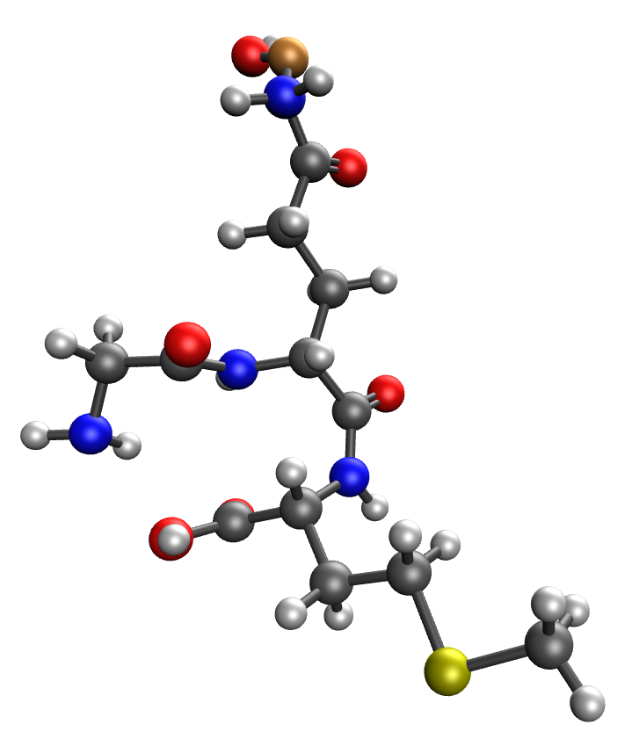 | 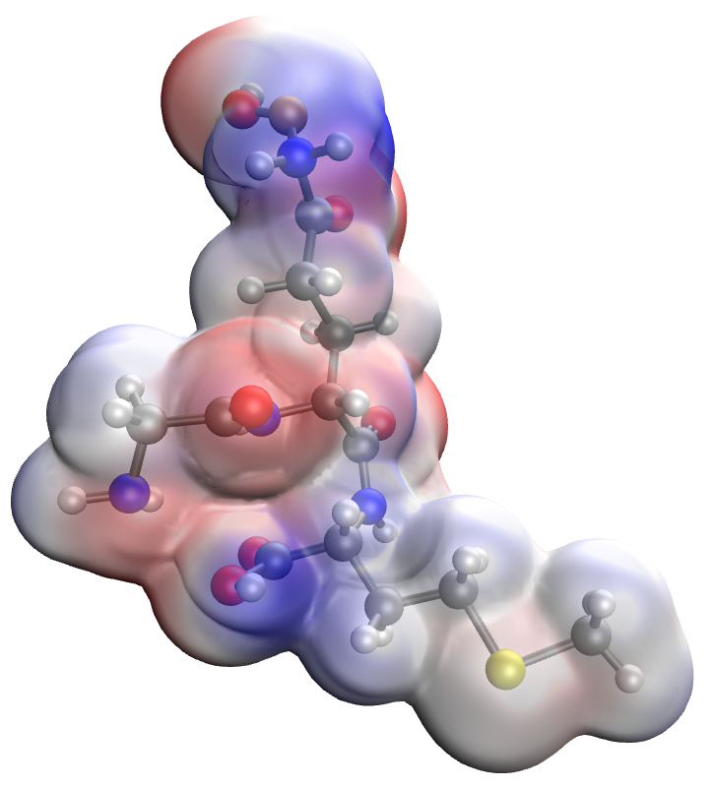
a | b
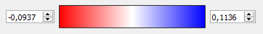
c
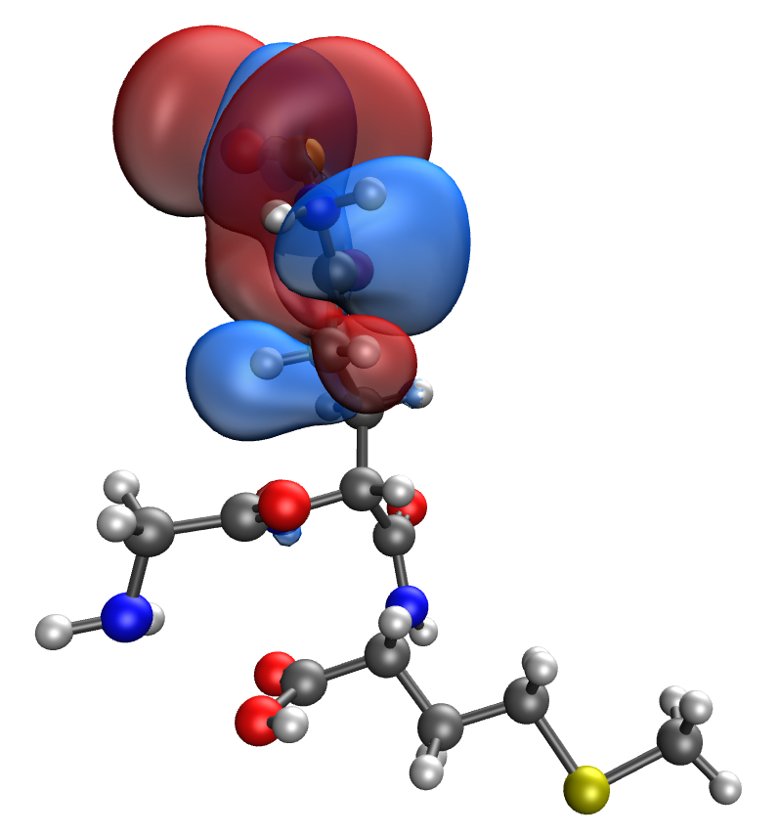 | 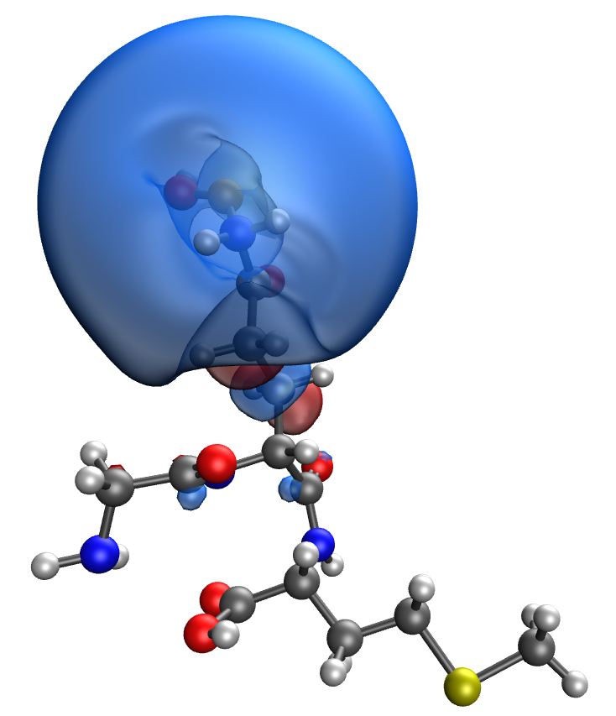
d | e
Fig. S24. Results of the quantum-chemical simulation of the Gly-Gln-Met gelatin segment, bonded with CuO molecule: a model of the molecular complex (a), the distribution of electron density (b), electronic density distribution gradient (c), HOMO (d), LUMO (e)

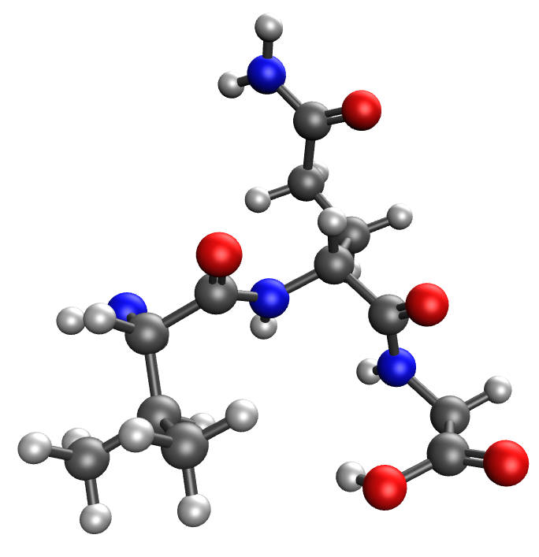 | 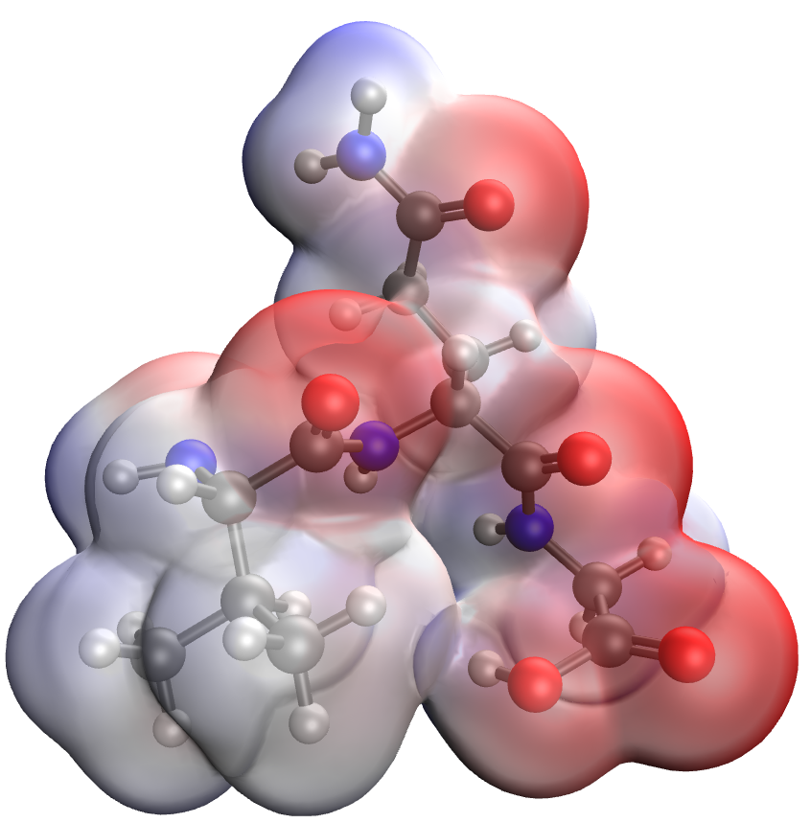
a | b
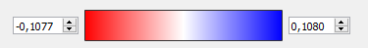
c
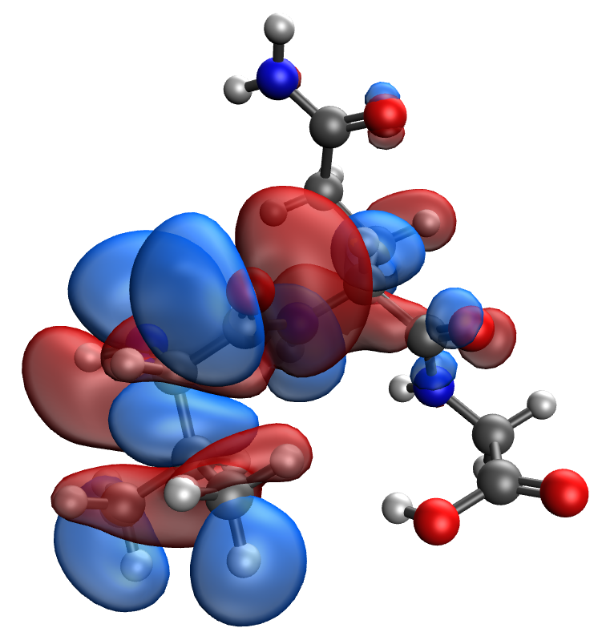 | 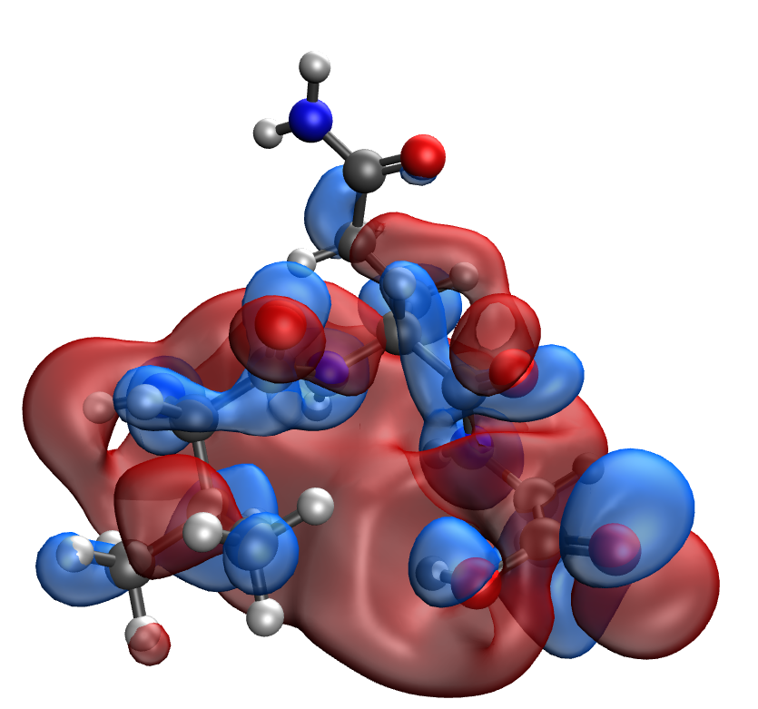
d | e
Fig. S25. Results of the quantum-chemical simulation of the Val-Gln-Gly gelatin segment: a model of the molecular complex (a), the distribution of electron density (b), electronic density distribution gradient (c), HOMO (d), LUMO (e)

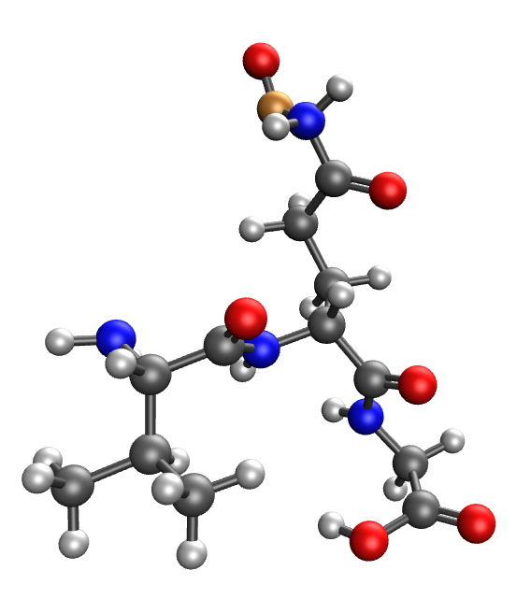 | 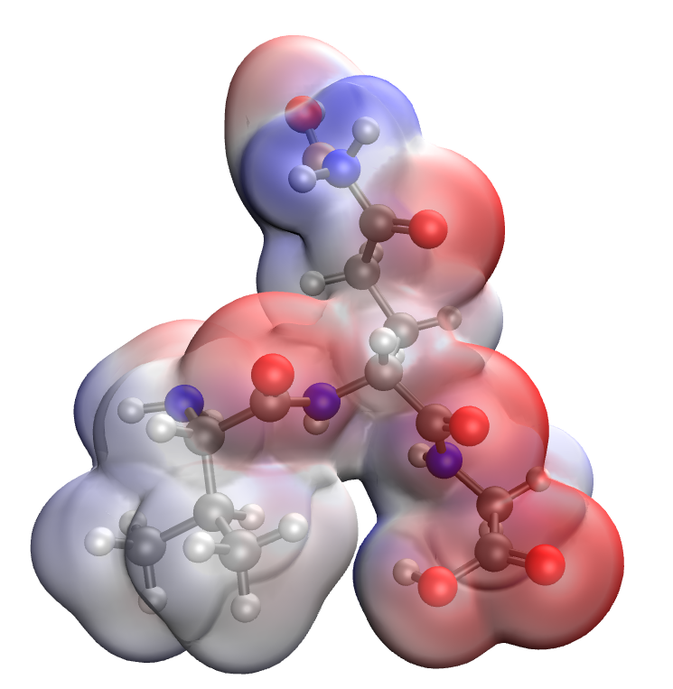
a | b
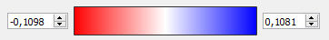
c
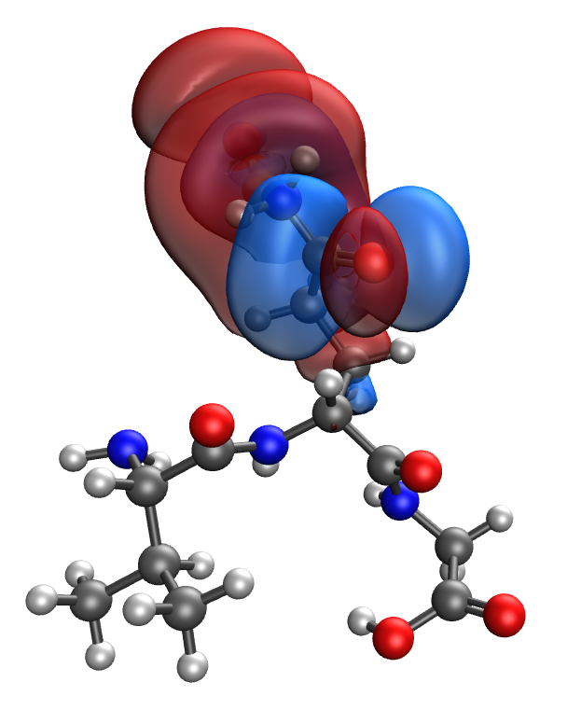 | 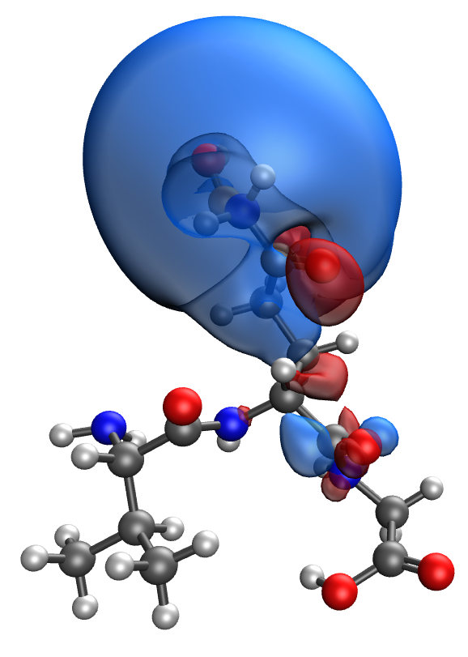
d | e
Fig. S26. Results of the quantum-chemical simulation of the Val-Gln-Gly gelatin segment, bonded with CuO molecule: a model of the molecular complex (a), the distribution of electron density (b), electronic density distribution gradient (c), HOMO (d), LUMO (e)

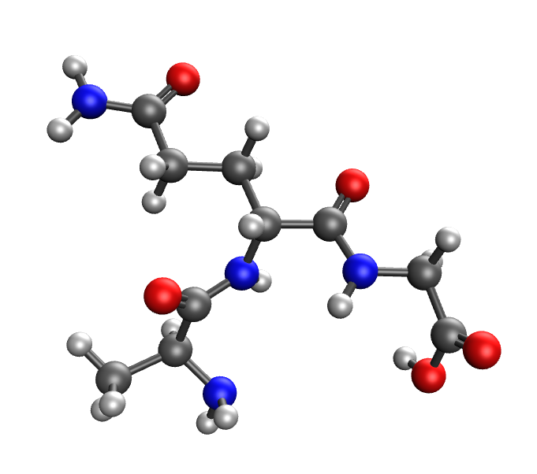 | 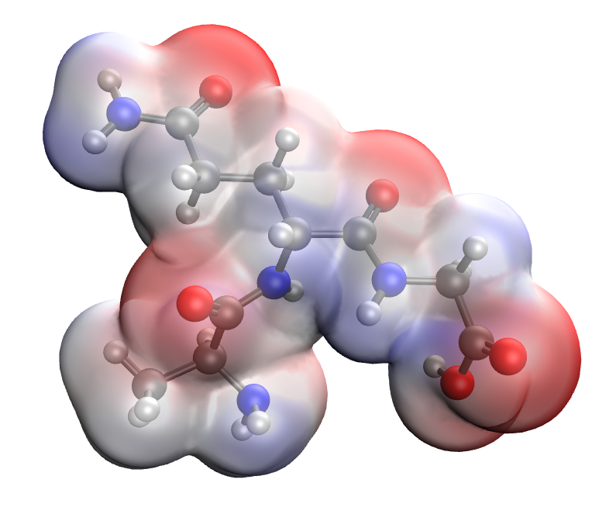
a | b
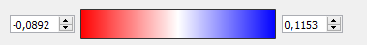
c
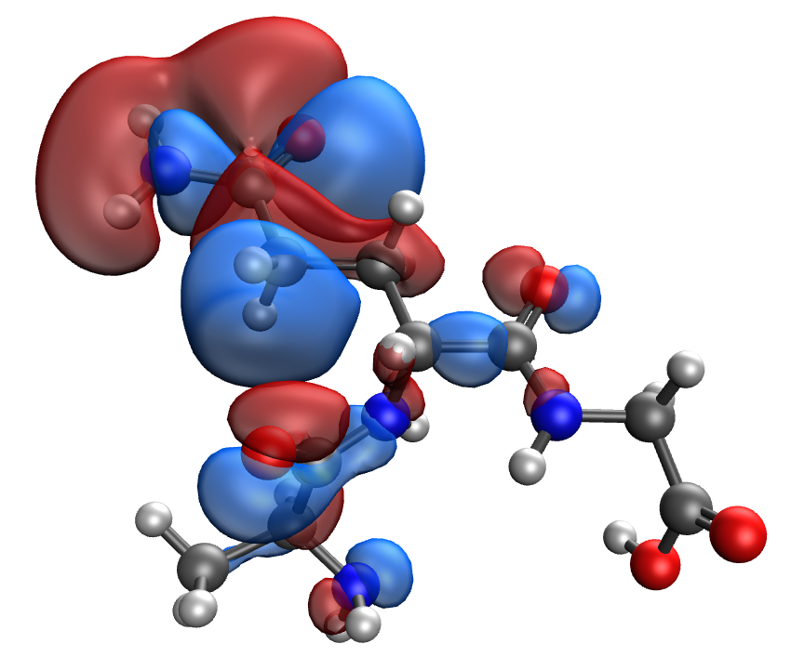 | 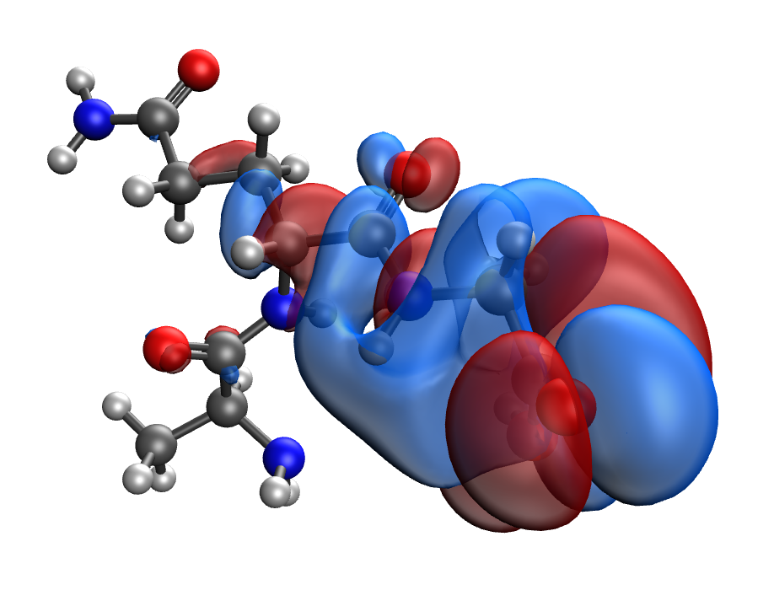
d | e
Fig. S27. Results of the quantum-chemical simulation of the Ala-Gln-Gly gelatin segment: a model of the molecular complex (a), the distribution of electron density (b), electronic density distribution gradient (c), HOMO (d), LUMO (e)

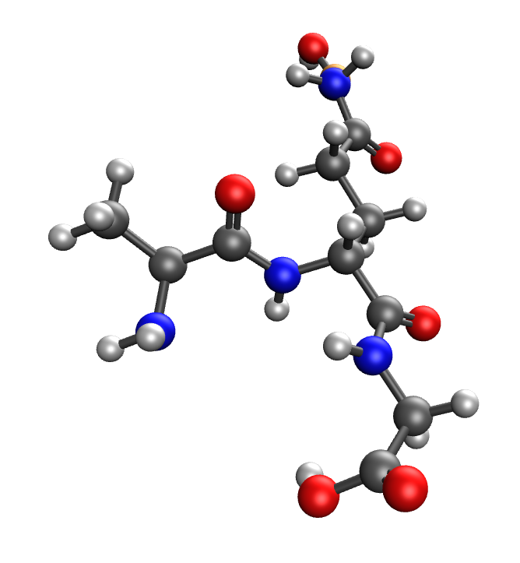 | 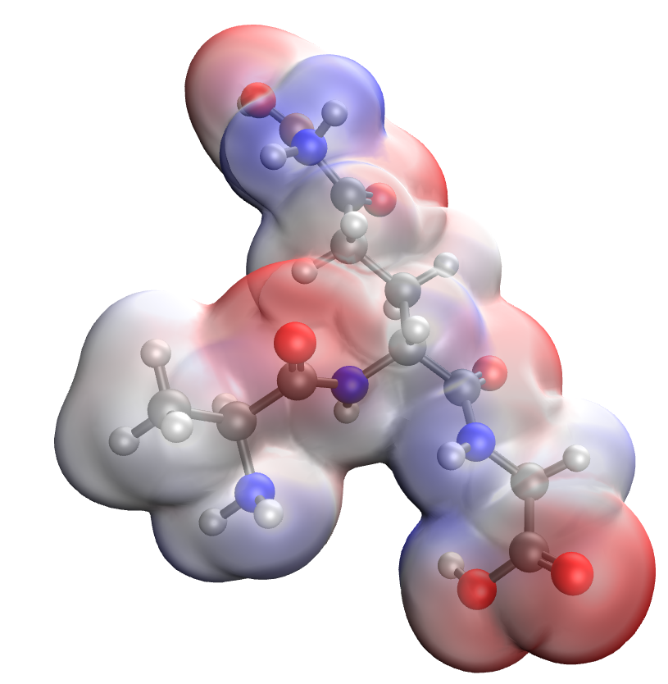
a | b
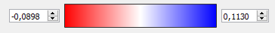
c
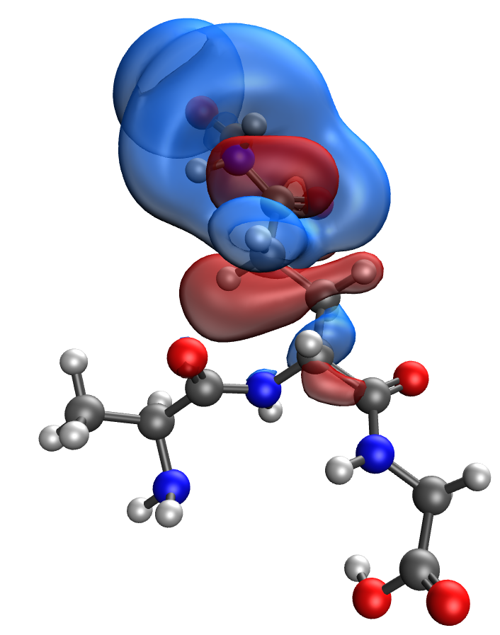 | 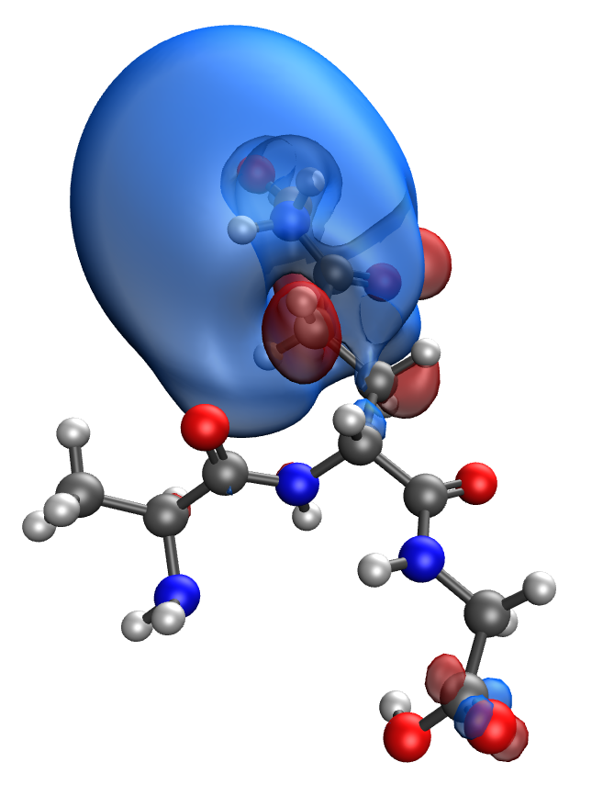
d | e
Fig. S28. Results of the quantum-chemical simulation of the Ala-Gln-Gly gelatin segment, bonded with CuO molecule: a model of the molecular complex (a), the distribution of electron density (b), electronic density distribution gradient (c), HOMO (d), LUMO (e)

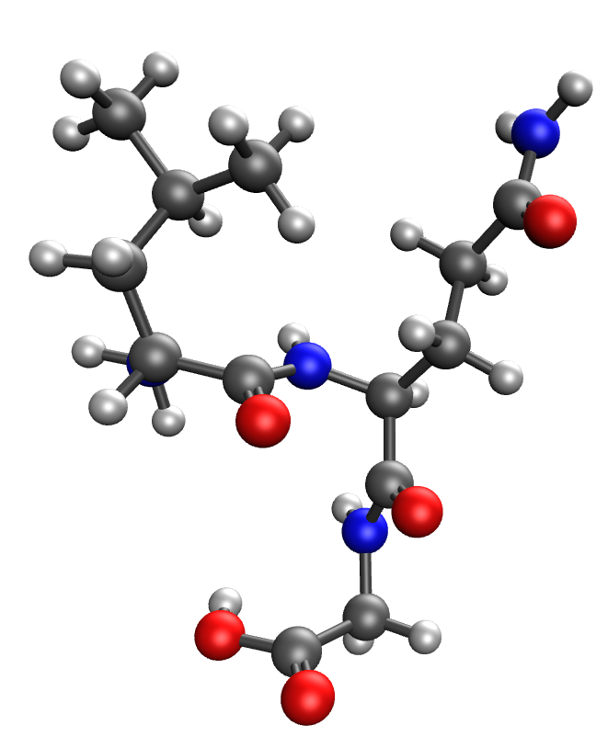 | 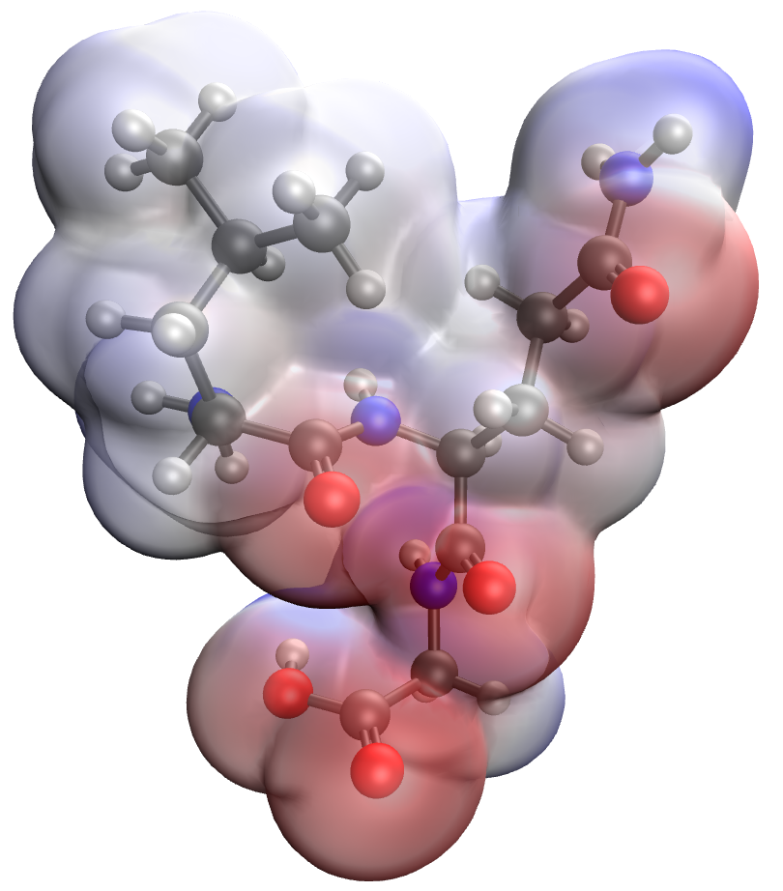
a | b
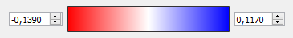
c
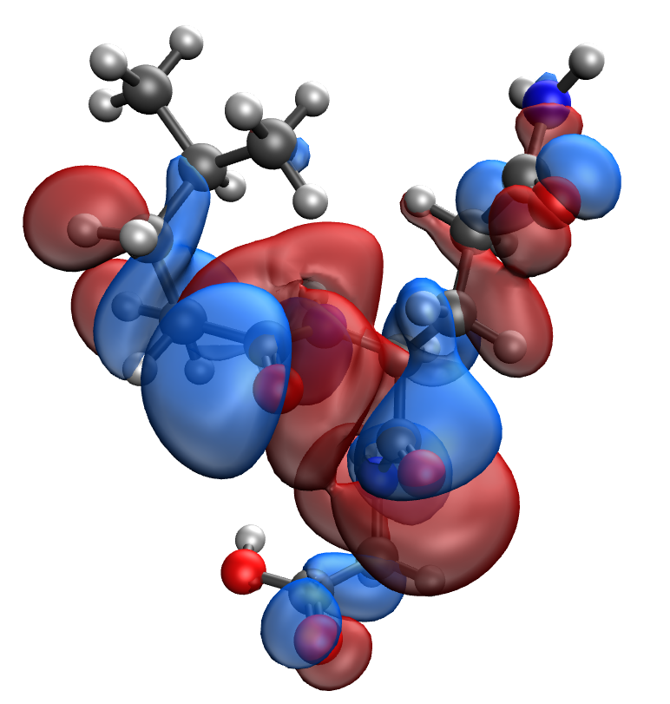 | 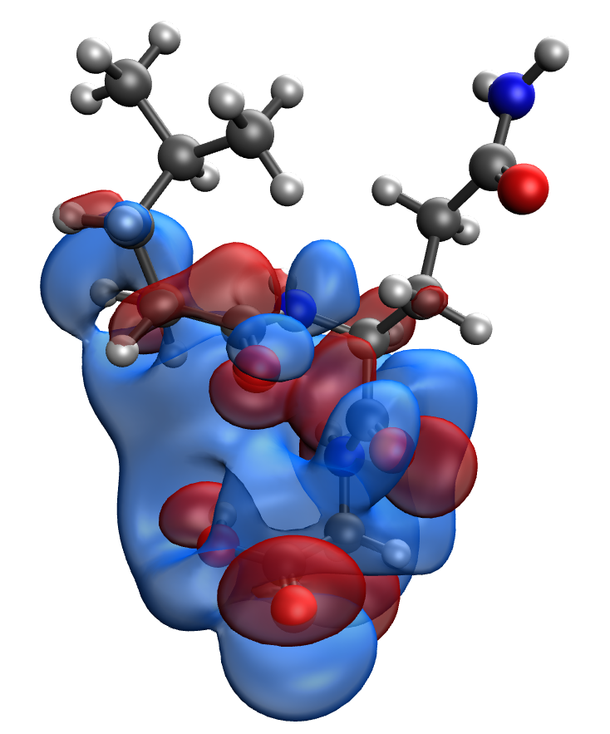
d | e
Fig. S29. Results of the quantum-chemical simulation of the Leu-Gln-Gly gelatin segment: a model of the molecular complex (a), the distribution of electron density (b), electronic density distribution gradient (c), HOMO (d), LUMO (e)

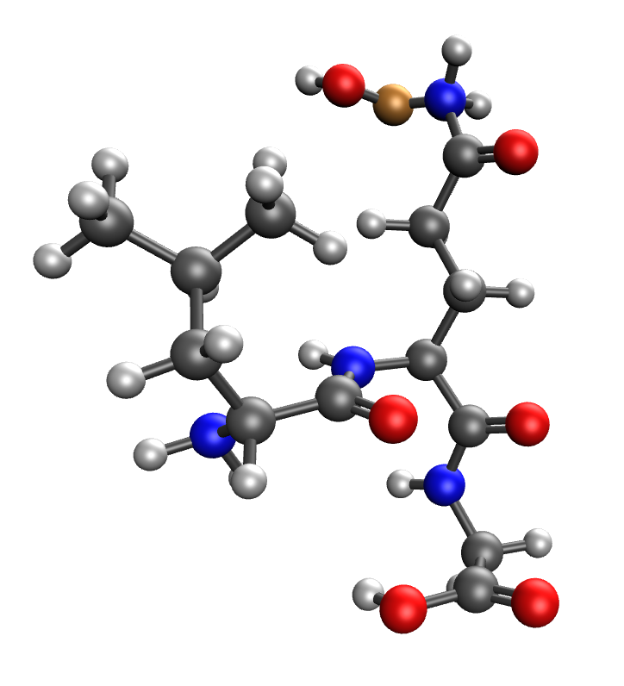 | 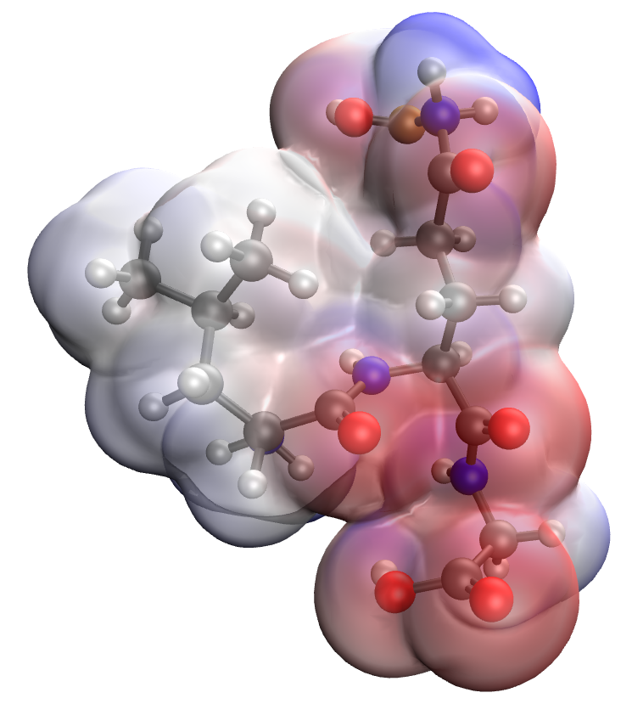
a | b
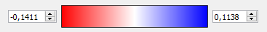
c
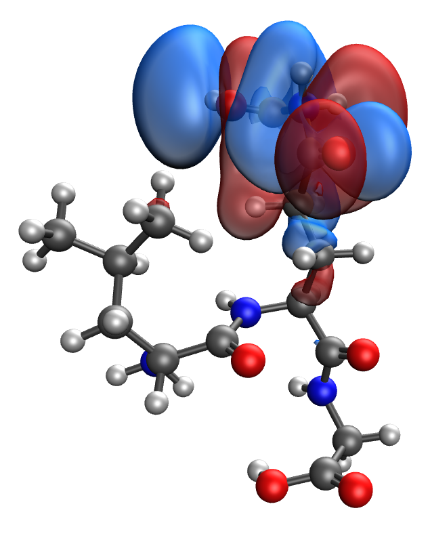 | 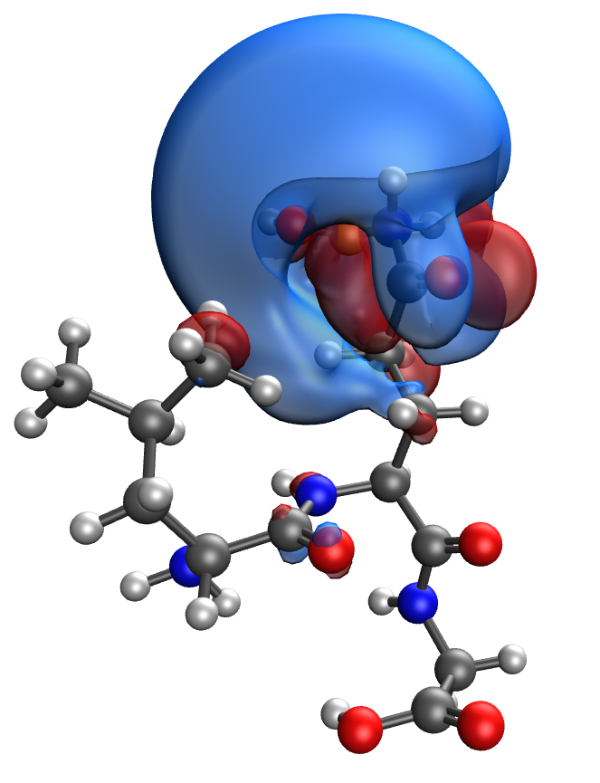
d | e
Fig. S30. Results of the quantum-chemical simulation of the Leu-Gln-Gly gelatin segment, bonded with CuO molecule: a model of the molecular complex (a), the distribution of electron density (b), electronic density distribution gradient (c), HOMO (d), LUMO (e)

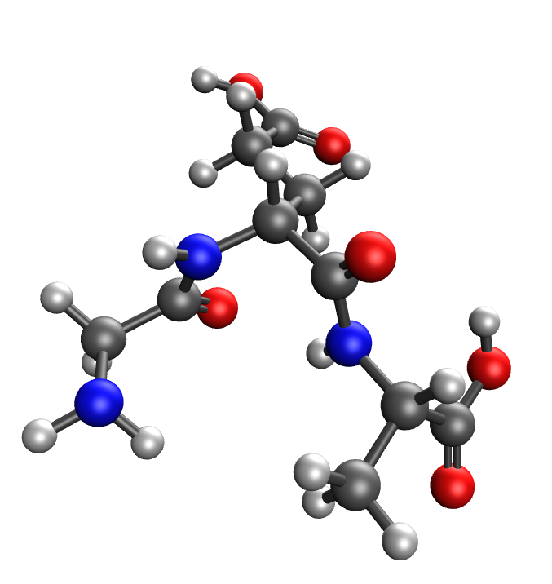 | 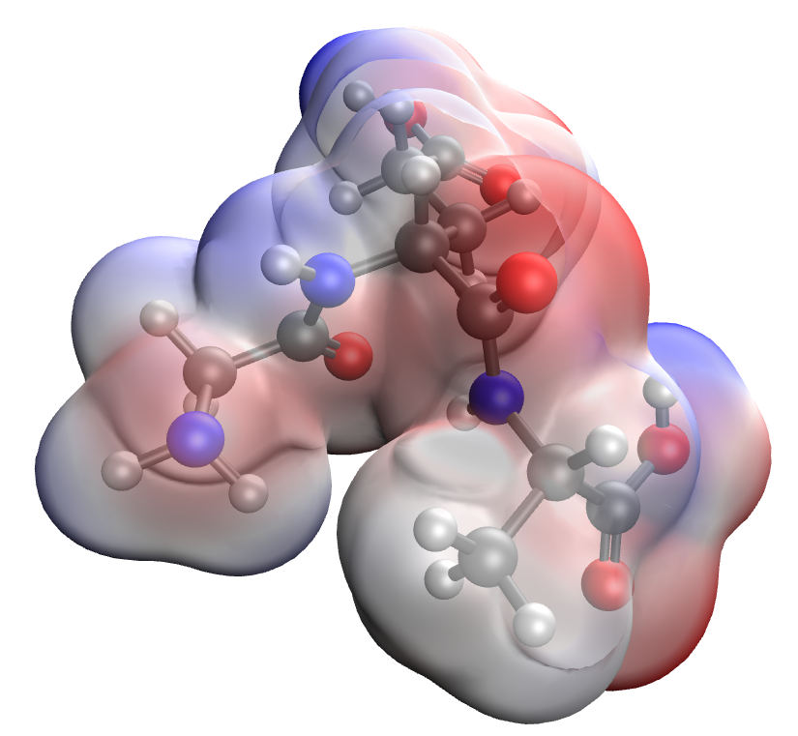
a | b
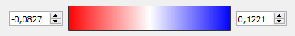
c
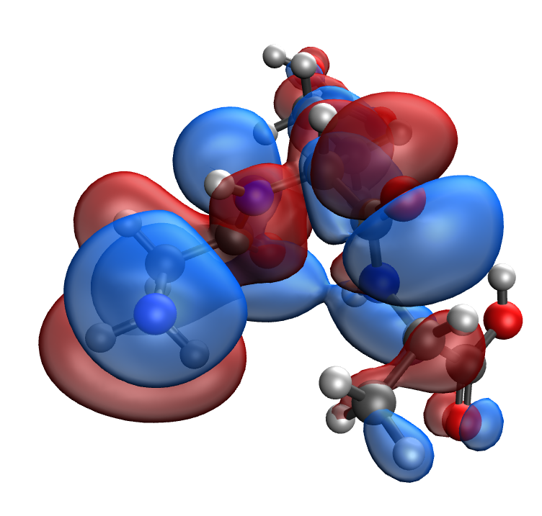 | 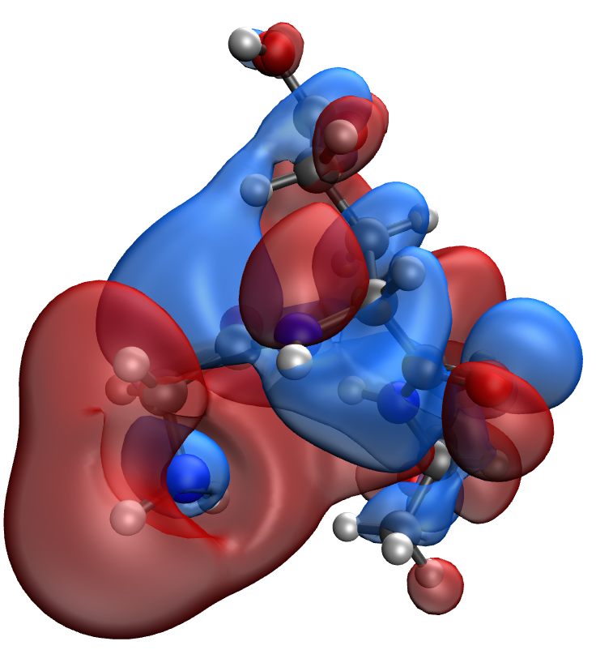
d | e
Fig. S31. Results of the quantum-chemical simulation of the Gly-Glu-Ala gelatin segment: a model of the molecular complex (a), the distribution of electron density (b), electronic density distribution gradient (c), HOMO (d), LUMO (e)

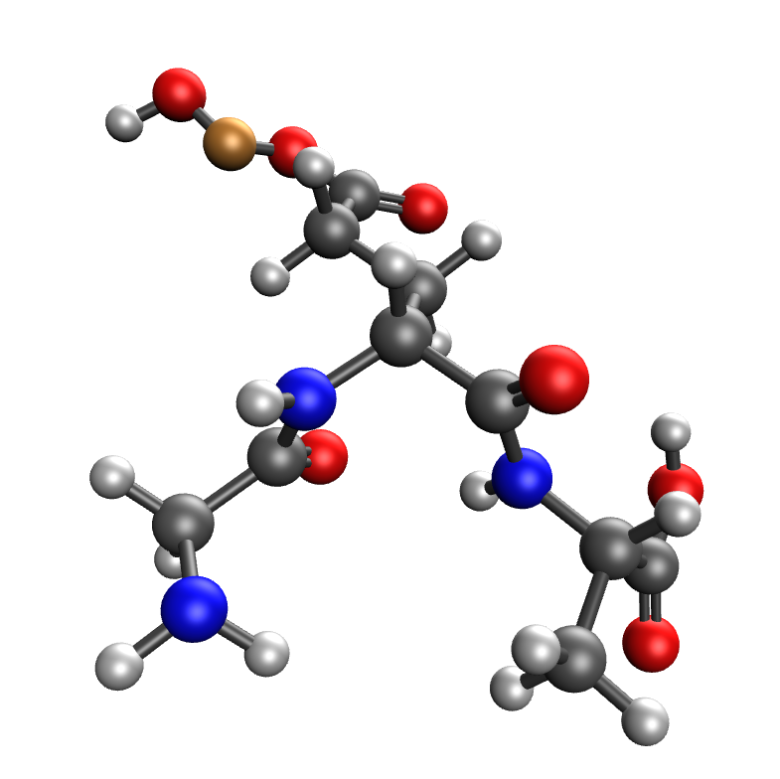 | 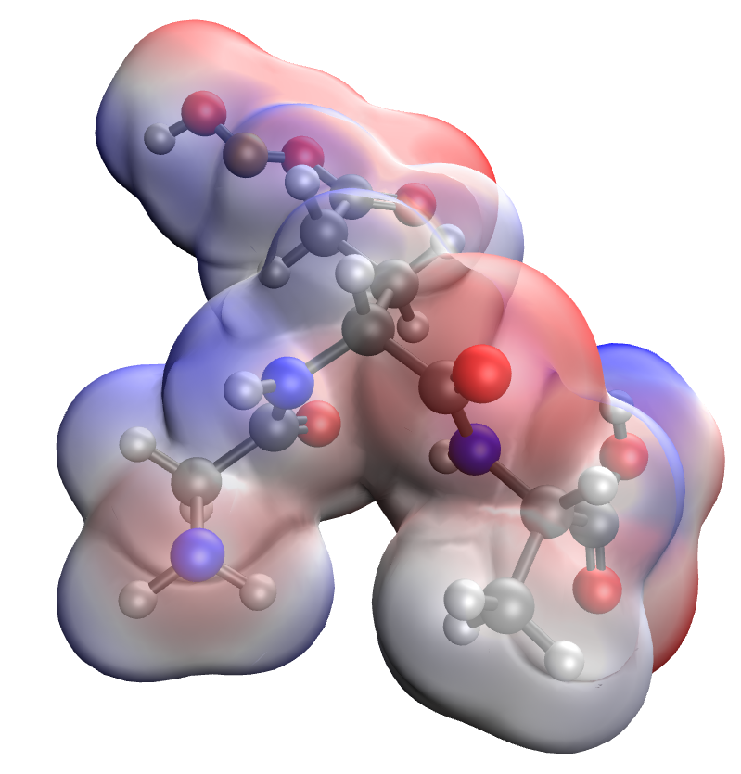
a | b
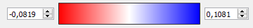
c
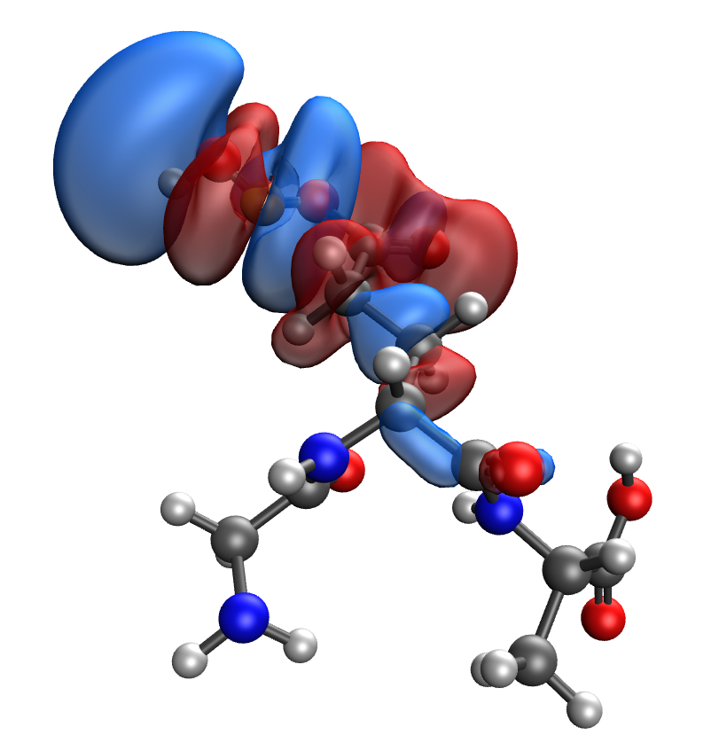 | 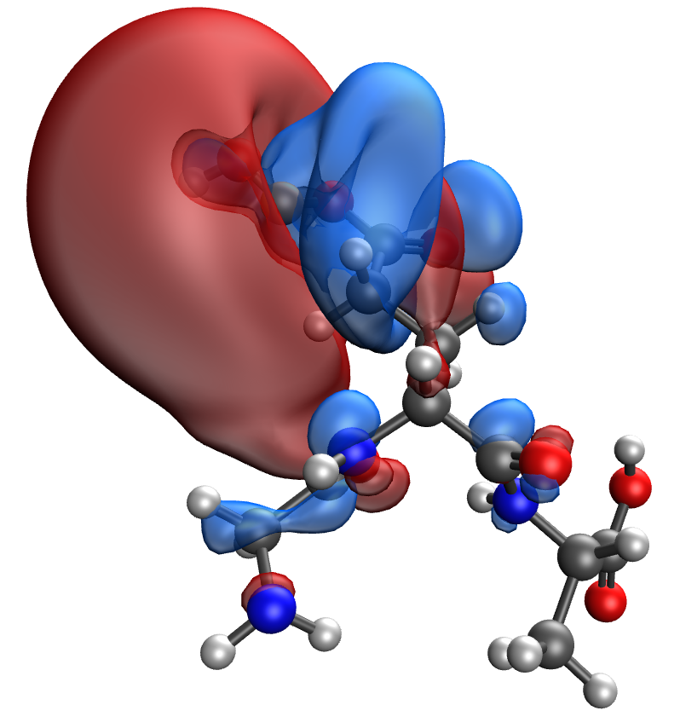
d | e
Fig. S32. Results of the quantum-chemical simulation of the Gly-Glu-Ala gelatin segment, bonded with CuO molecule: a model of the molecular complex (a), the distribution of electron density (b), electronic density distribution gradient (c), HOMO (d), LUMO (e)

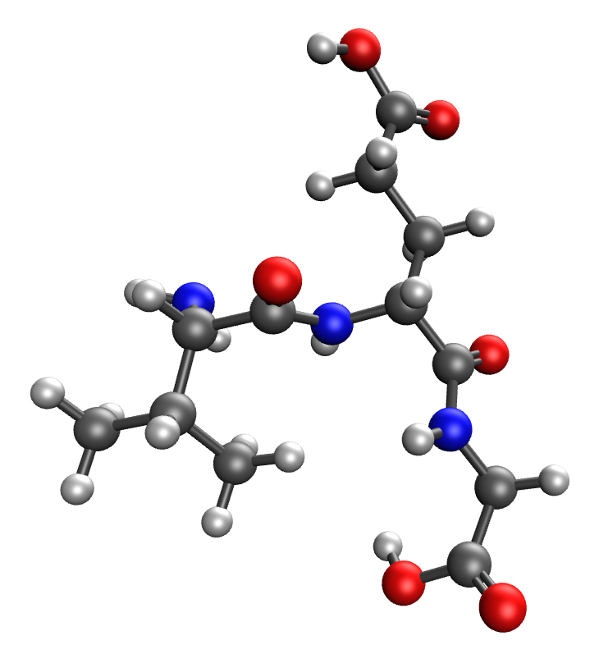 | 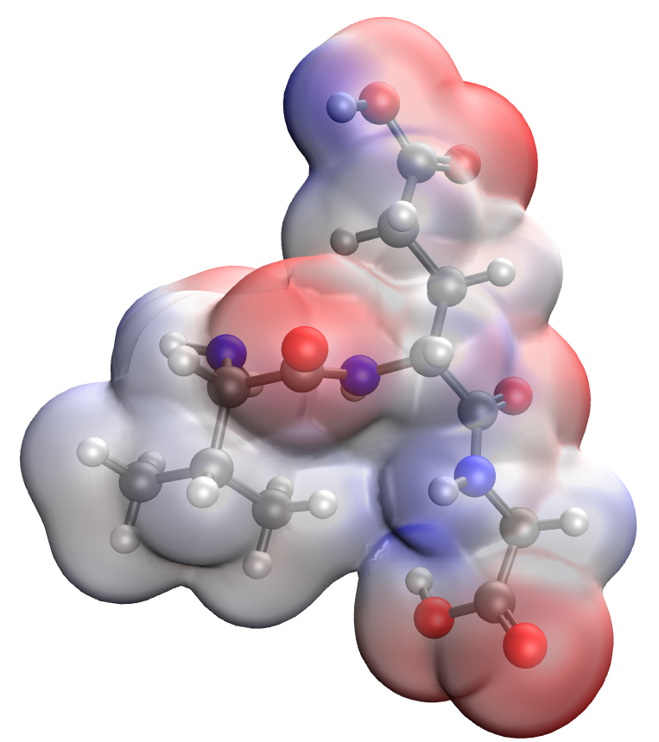
a | b
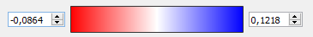
c
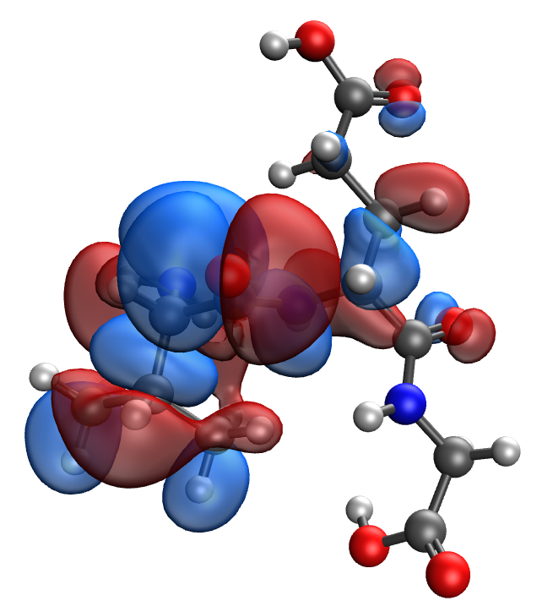 | 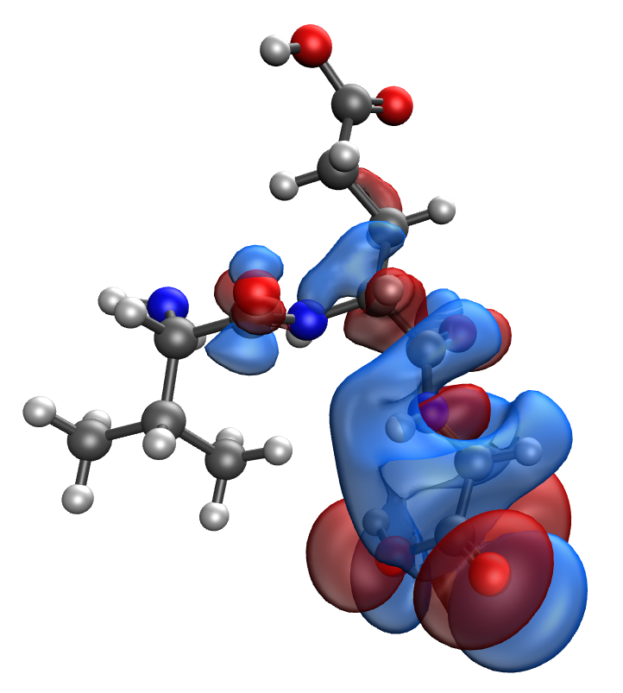
d | e
Fig. S33. Results of the quantum-chemical simulation of the Val-Glu-Gly gelatin segment: a model of the molecular complex (a), the distribution of electron density (b), electronic density distribution gradient (c), HOMO (d), LUMO (e)

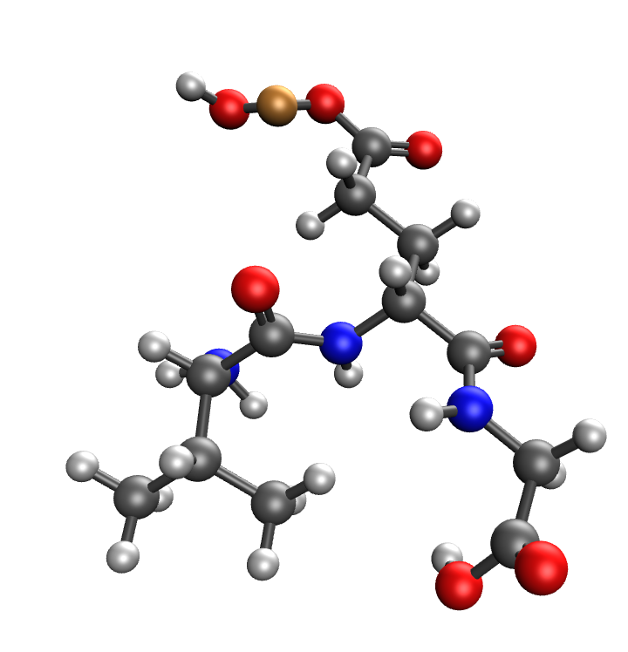 | 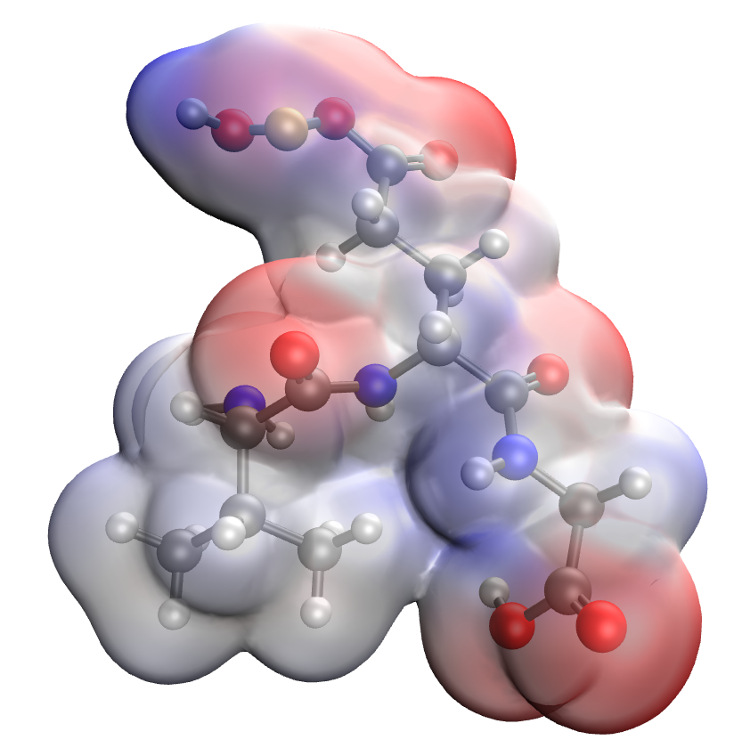
a | b
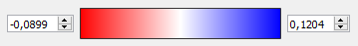
c
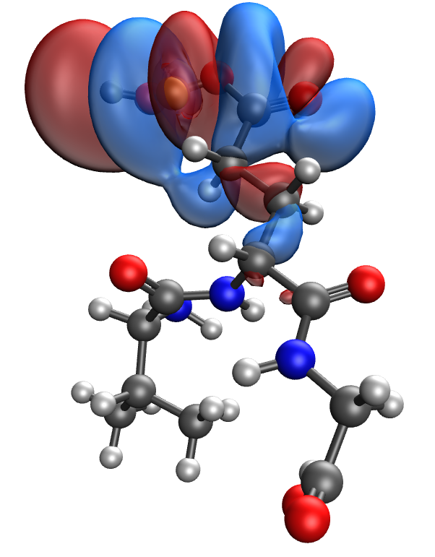 | 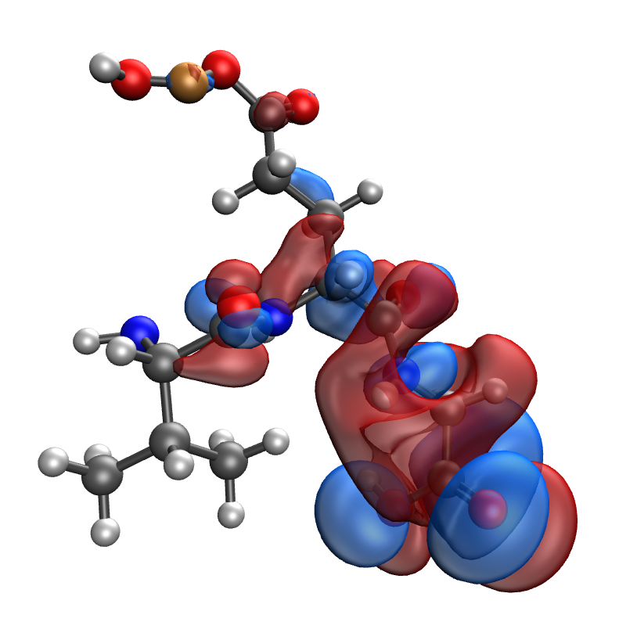
d | e
Fig. S34. Results of the quantum-chemical simulation of the Val-Glu-Gly gelatin segment, bonded with CuO molecule: a model of the molecular complex (a), the distribution of electron density (b), electronic density distribution gradient (c), HOMO (d), LUMO (e)

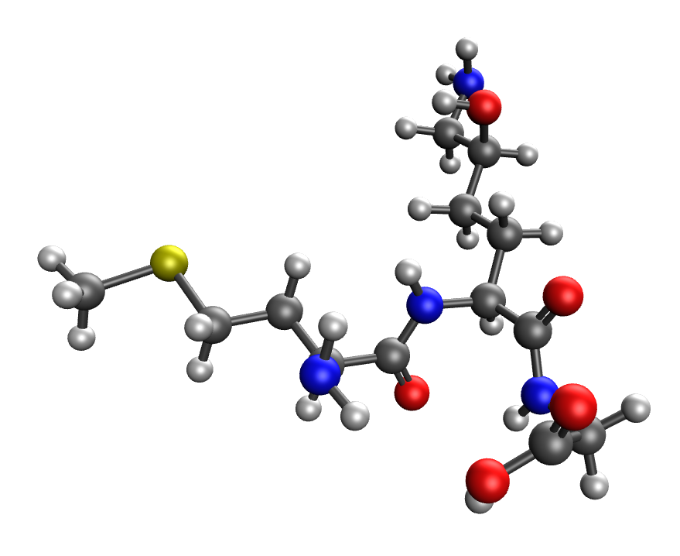 | 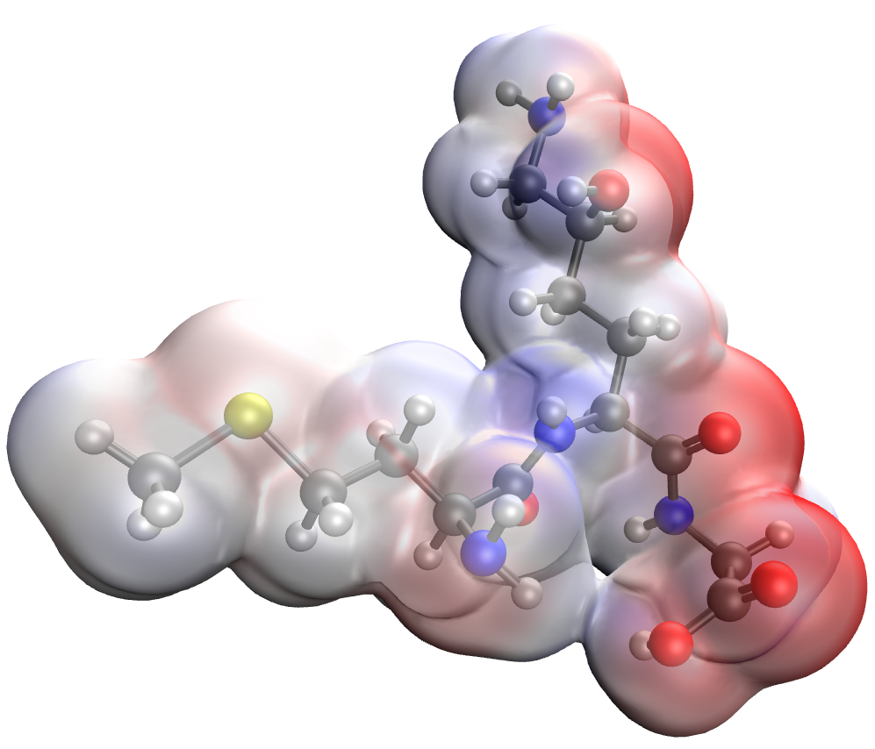
a | b
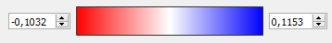
c
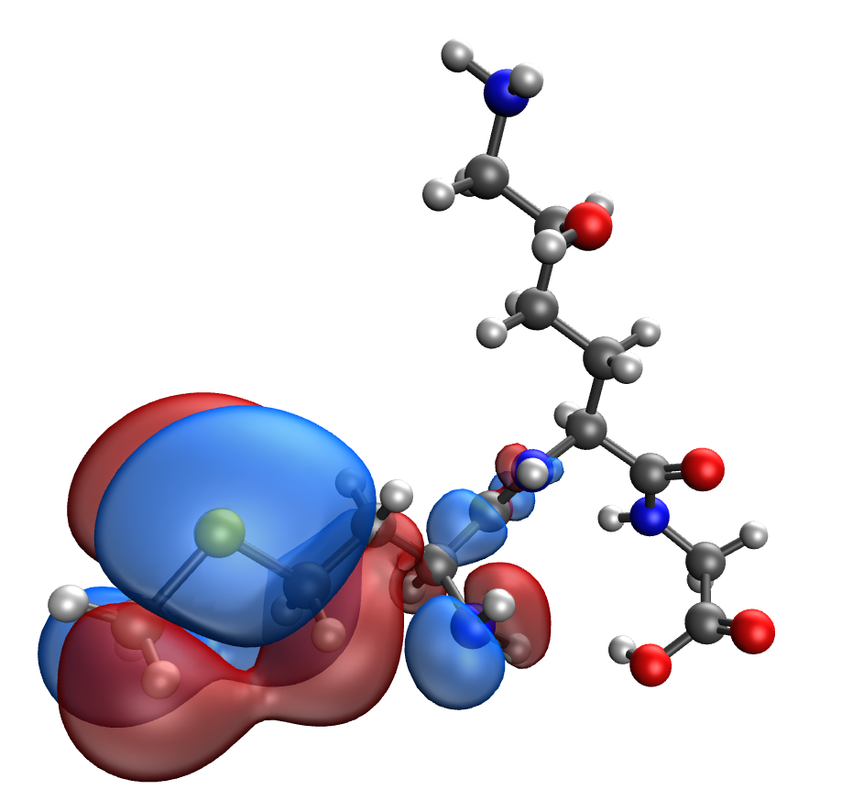 | 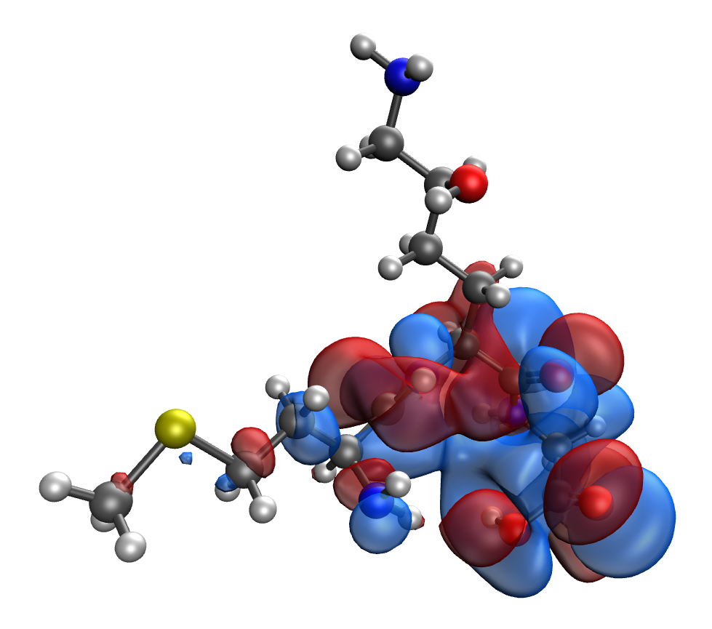
d | e
Fig. S35. Results of the quantum-chemical simulation of the Met-Hyl-Gly gelatin segment: a model of the molecular complex (a), the distribution of electron density (b), electronic density distribution gradient (c), HOMO (d), LUMO (e)

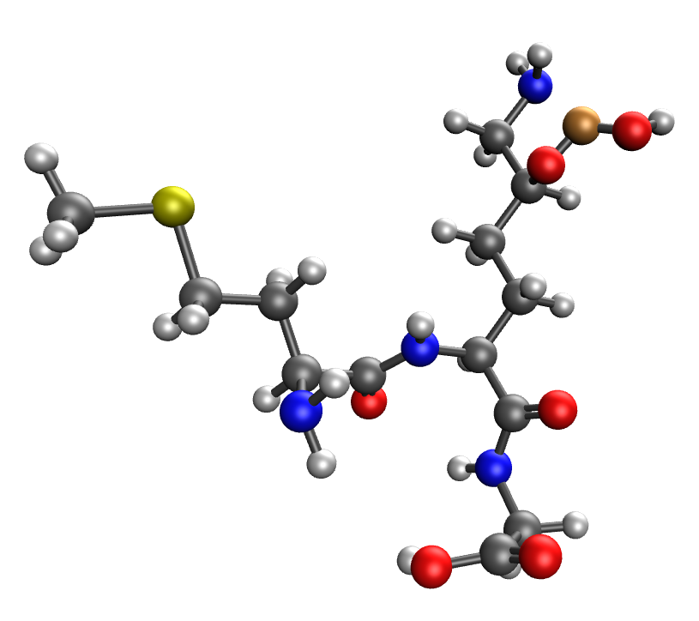 | 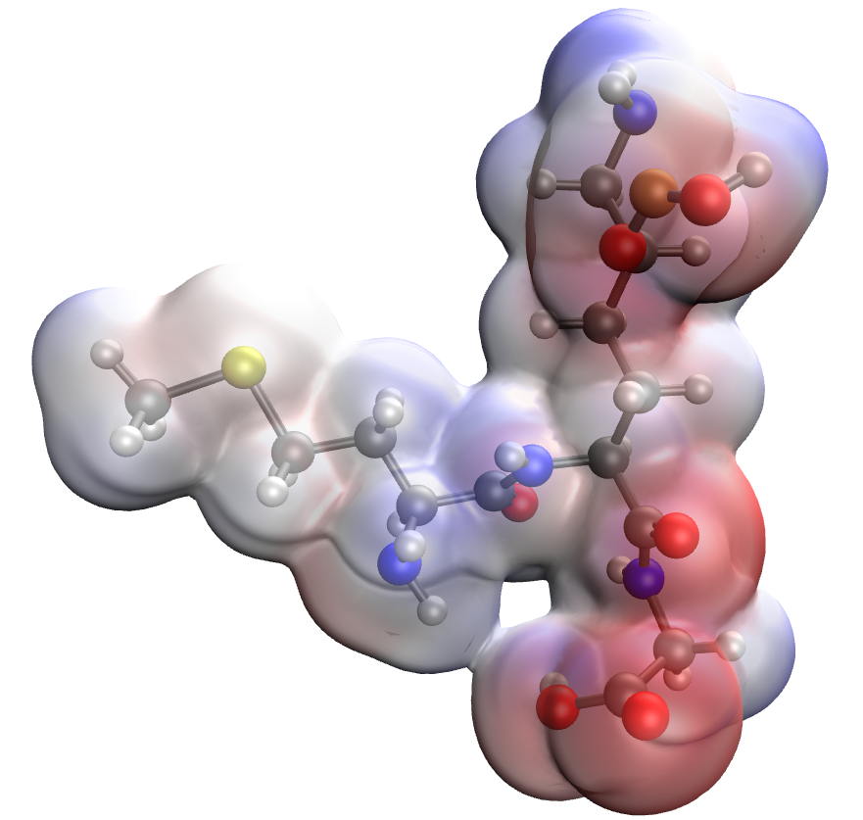
a | b
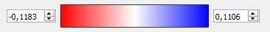
c
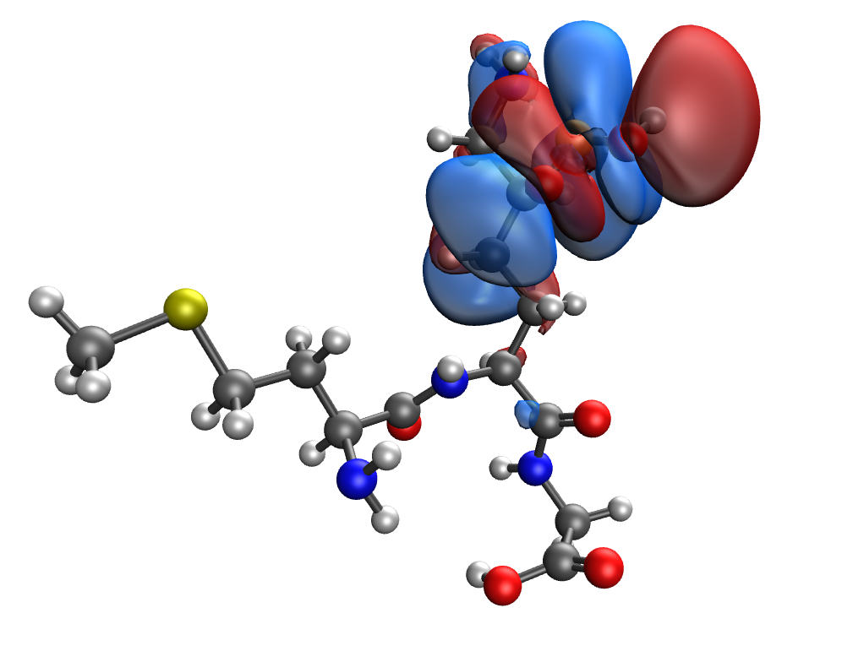 | 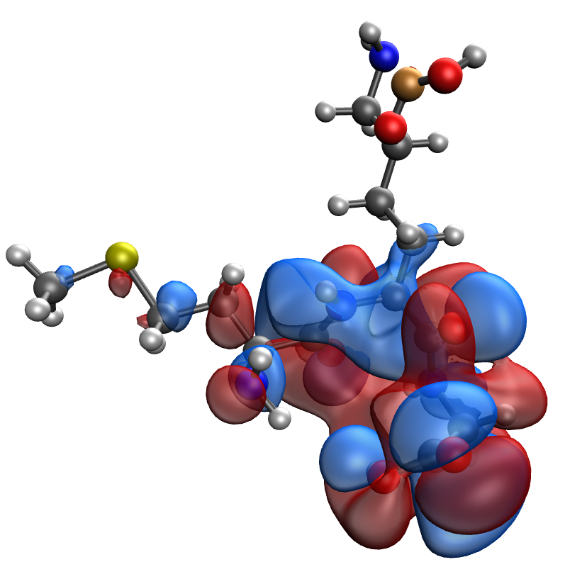
d | e
Fig. S36. Results of the quantum-chemical simulation of the Met-Hyl-Gly gelatin segment, bonded with CuO molecule: a model of the molecular complex (a), the distribution of electron density (b), electronic density distribution gradient (c), HOMO (d), LUMO (e)

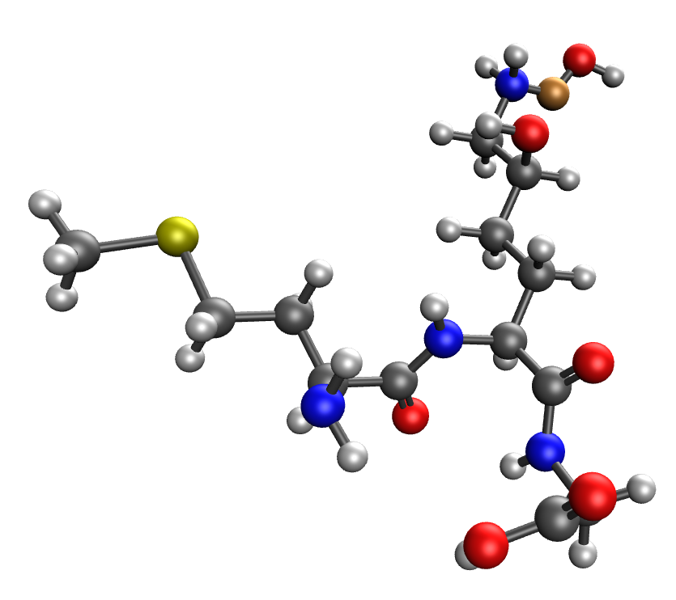 | 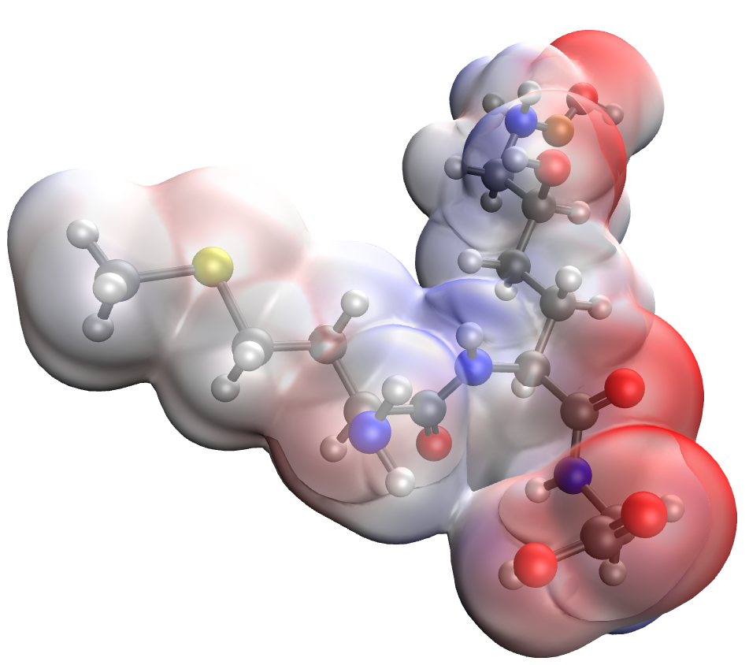
a | b
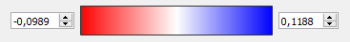
c
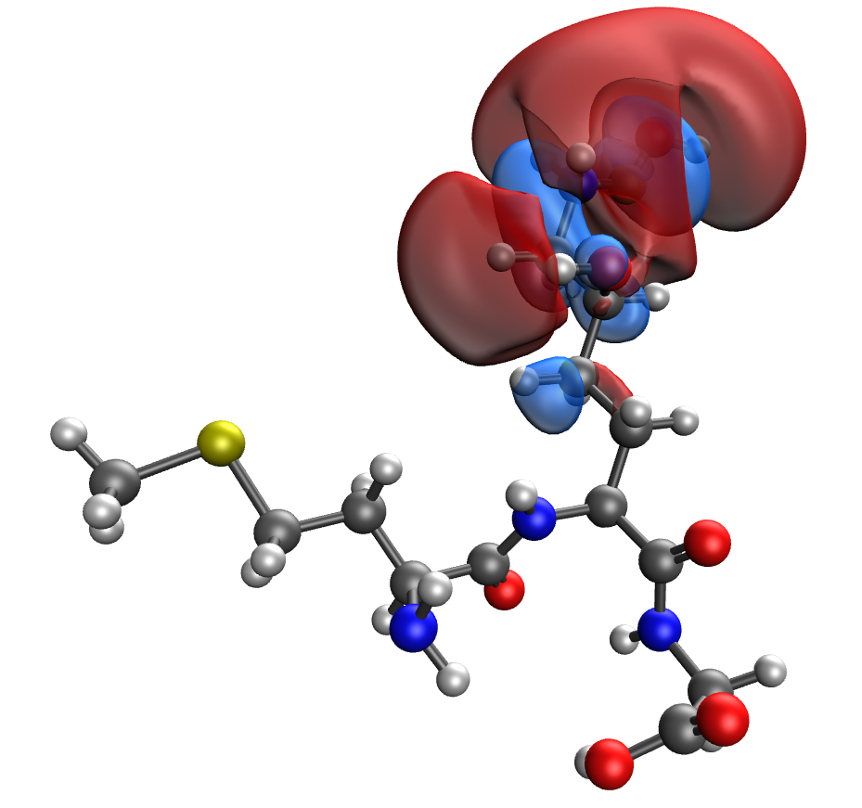 | 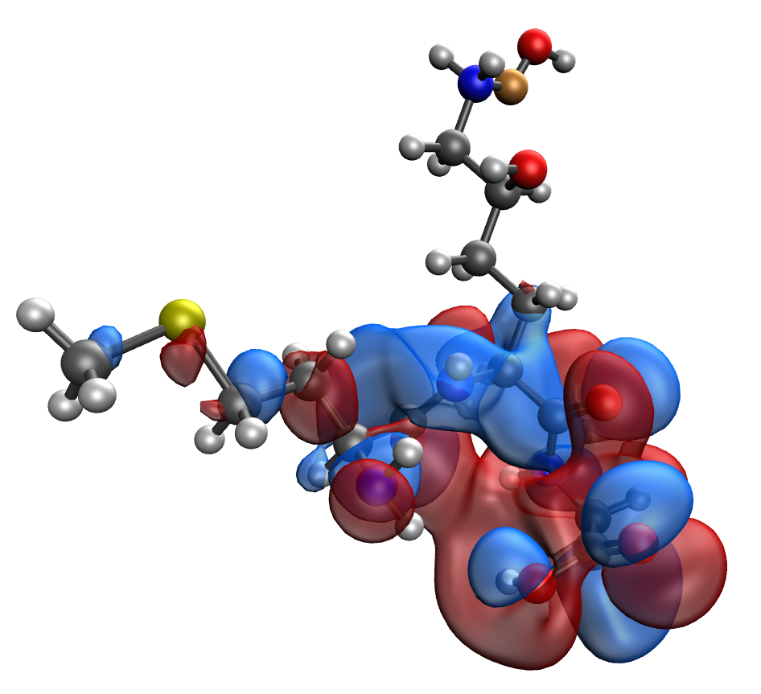
d | e
Fig. S37. Results of the quantum-chemical simulation of the Met-Hyl-Gly gelatin segment: a model of the molecular complex (a), the distribution of electron density (b), electronic density distribution gradient (c), HOMO (d), LUMO (e)

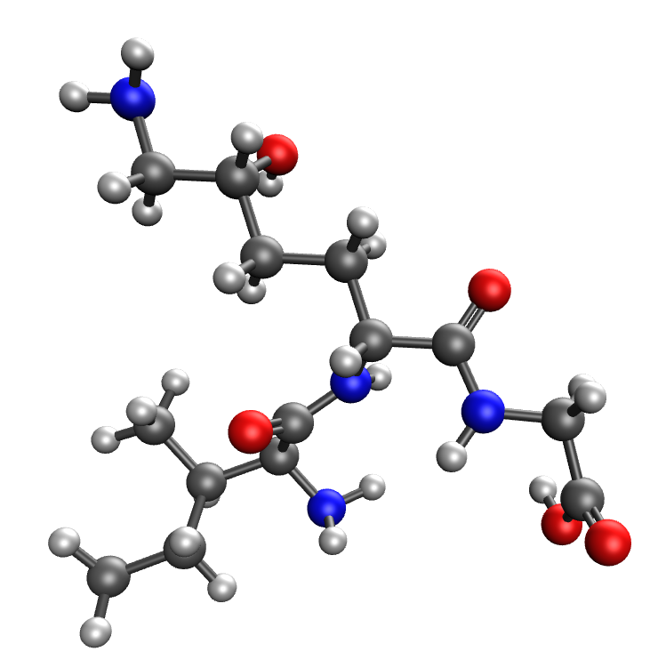 | 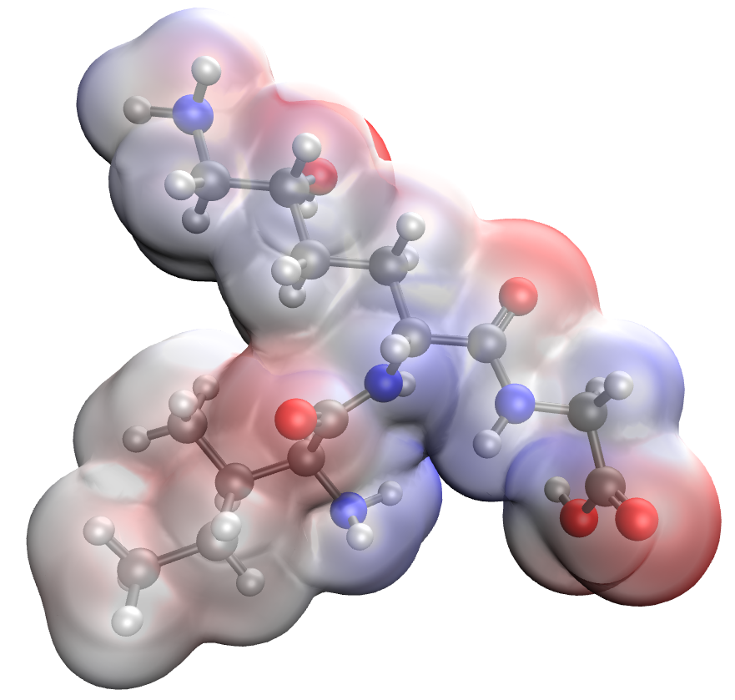
a | b
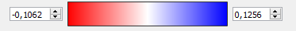
c
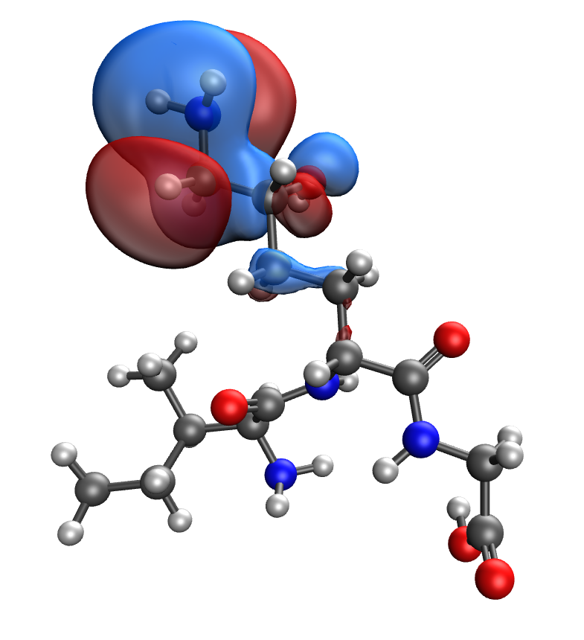 | 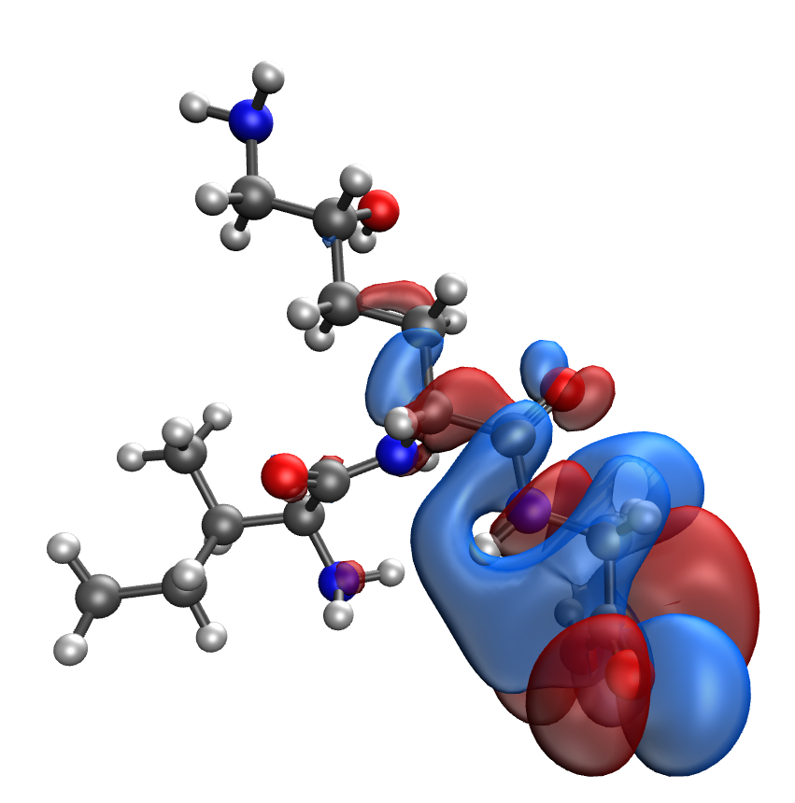
d | e
Fig. S38. Results of the quantum-chemical simulation of the Ile-Hyl-Gly gelatin segment, bonded with CuO molecule: a model of the molecular complex (a), the distribution of electron density (b), electronic density distribution gradient (c), HOMO (d), LUMO (e)

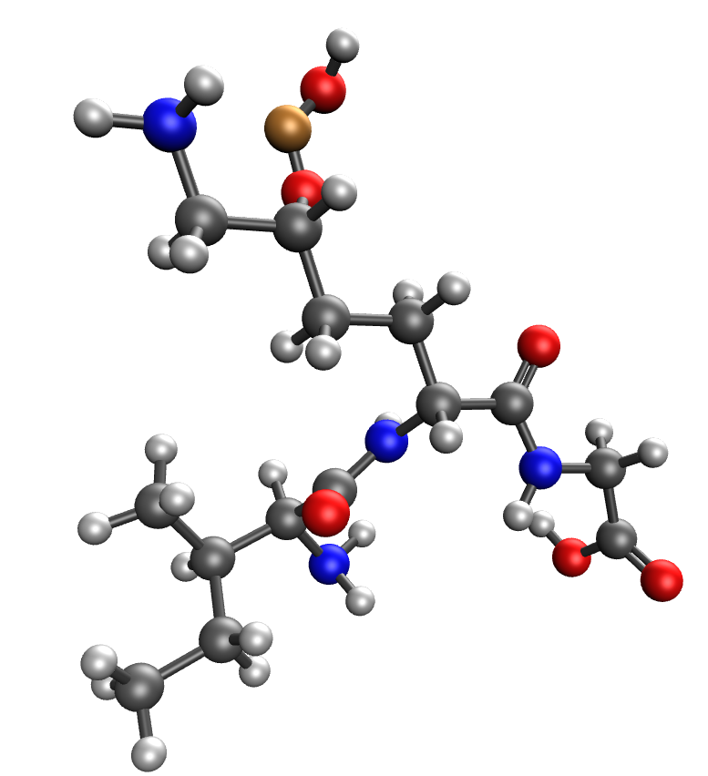 | 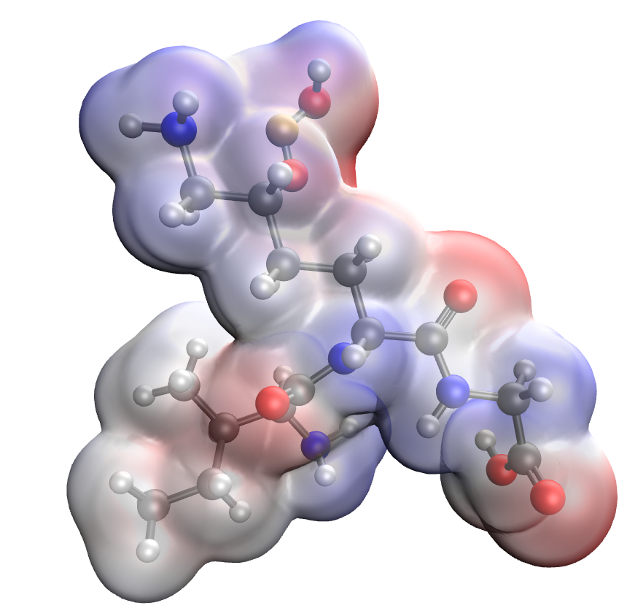
a | b
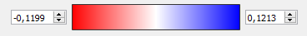
c
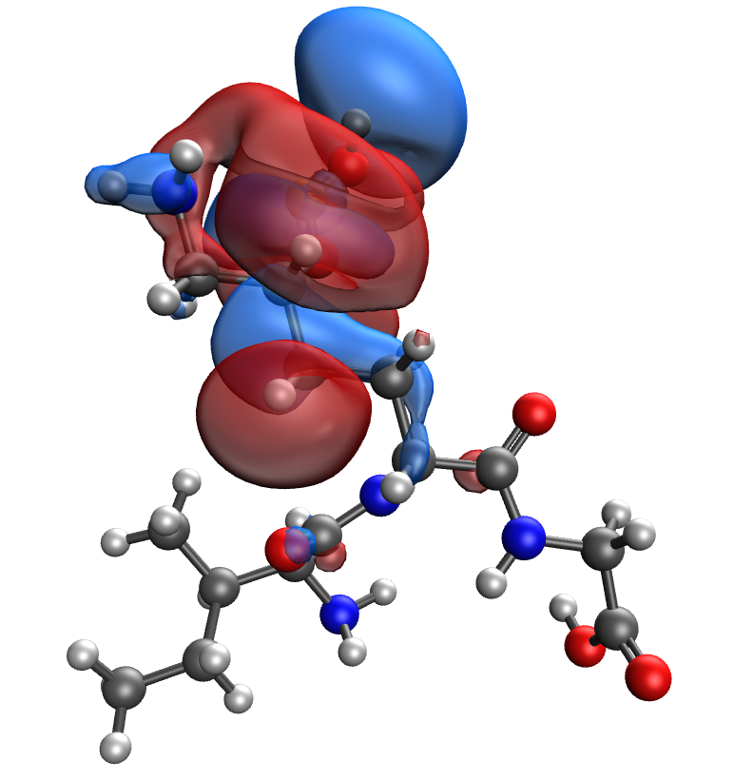 | 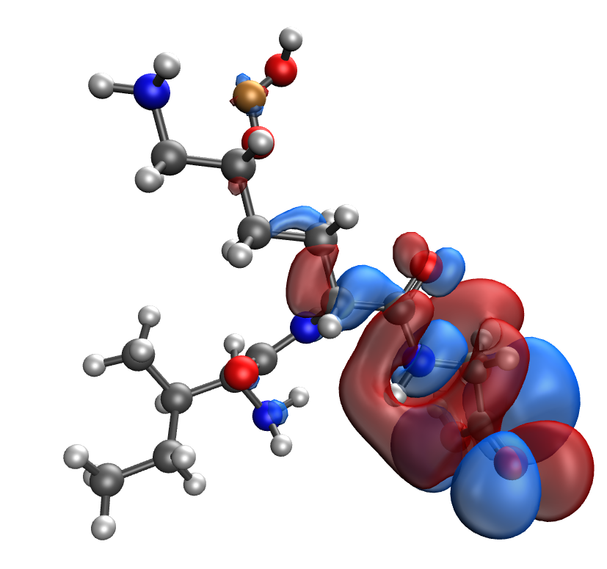
d | e
Fig. S39. Results of the quantum-chemical simulation of the Ile-Hyl-Gly gelatin segment: a model of the molecular complex (a), the distribution of electron density (b), electronic density distribution gradient (c), HOMO (d), LUMO (e)

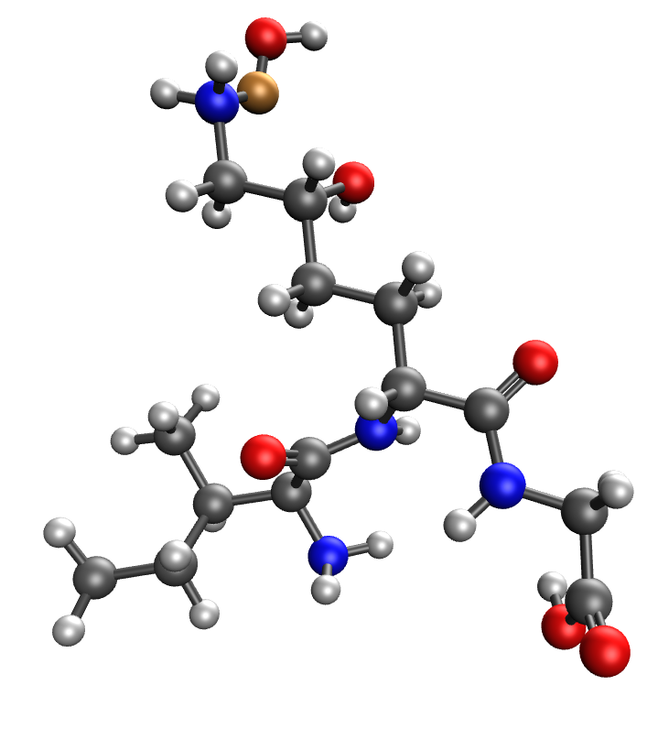 | 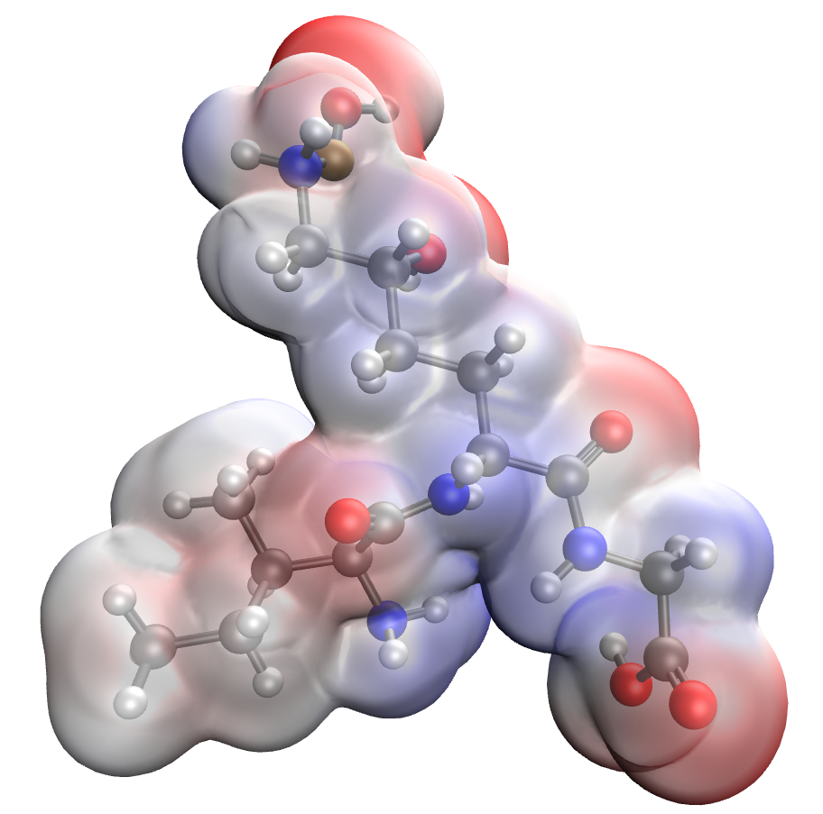
a | b
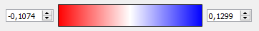
c
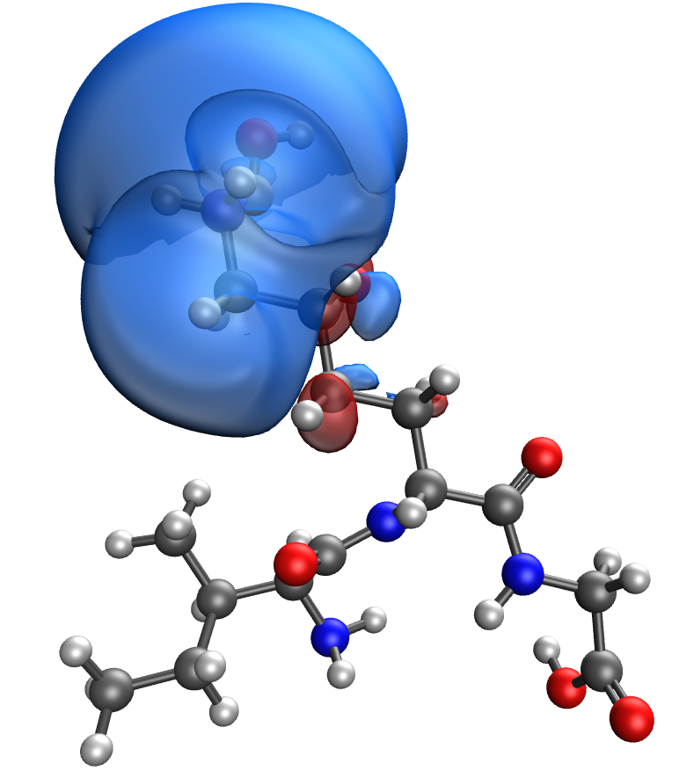 | 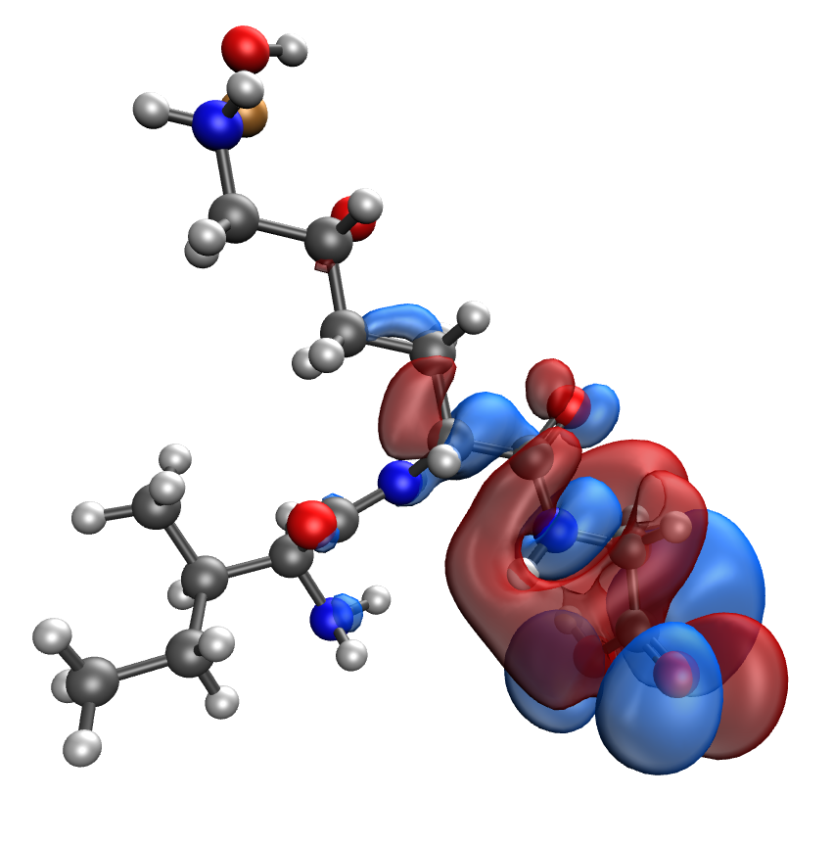
d | e
Fig. S40. Results of the quantum-chemical simulation of the Met-Hyl-Gly gelatin segment, bonded with CuO molecule: a model of the molecular complex (a), the distribution of electron density (b), electronic density distribution gradient (c), HOMO (d), LUMO (e)

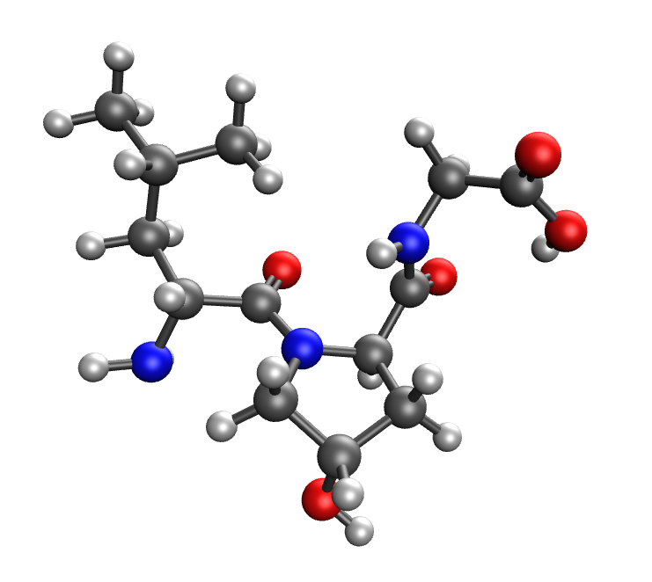 | 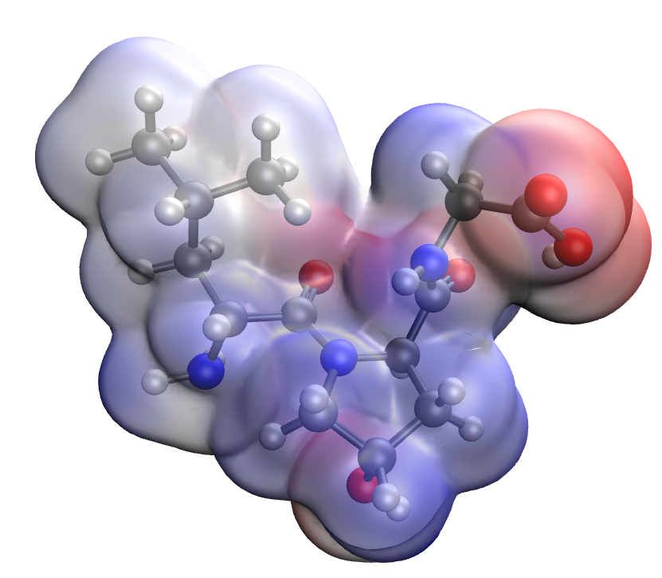
a | b
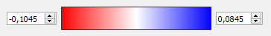
c
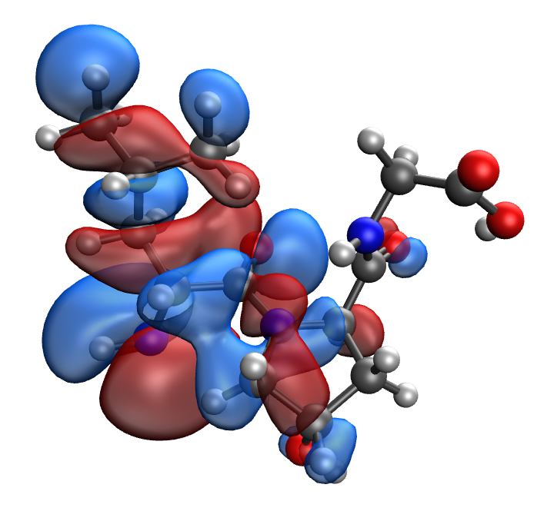 | 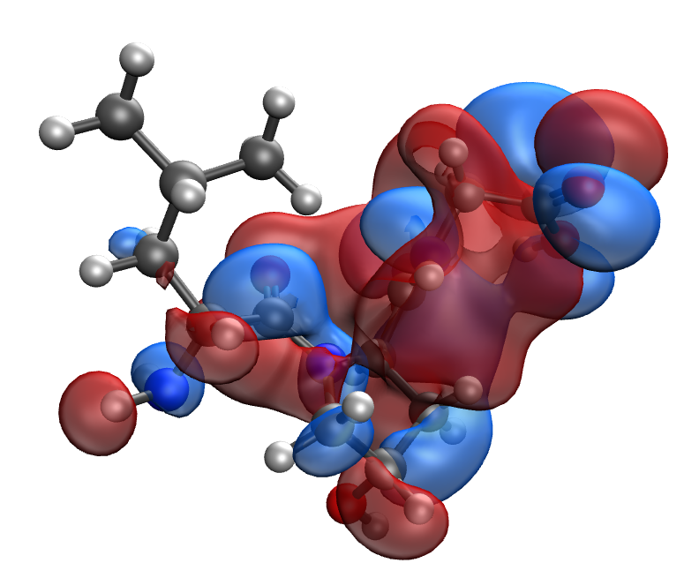
d | e
Fig. S41. Results of the quantum-chemical simulation of the Leu-Hyp-Gly gelatin segment: a model of the molecular complex (a), the distribution of electron density (b), electronic density distribution gradient (c), HOMO (d), LUMO (e)

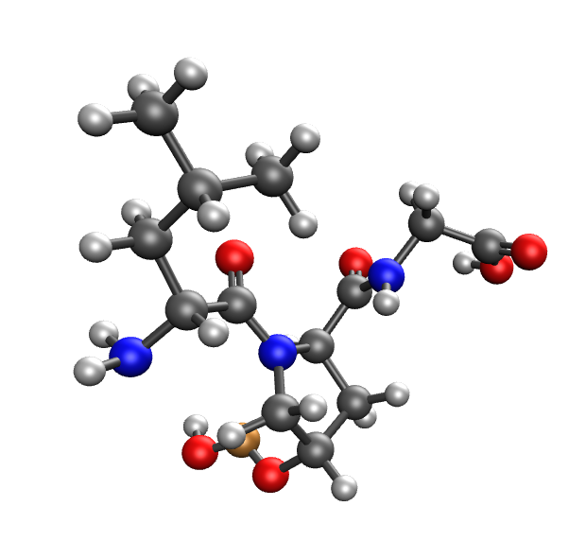 | 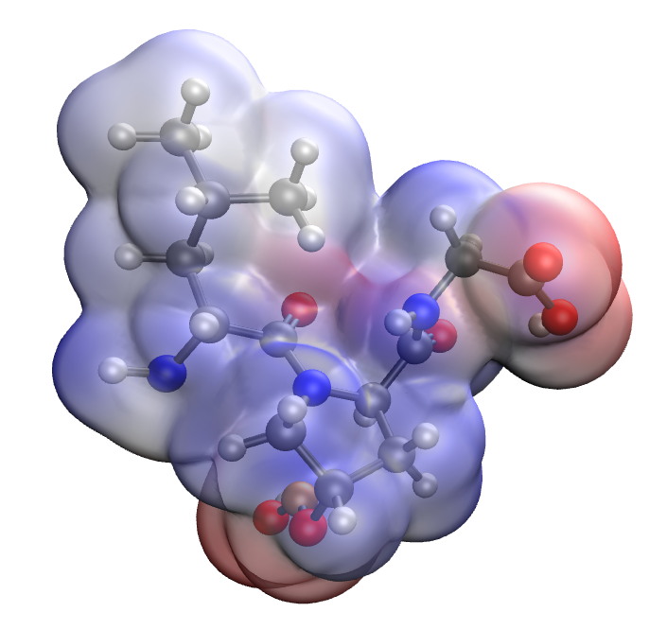
a | b
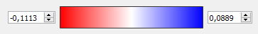
c
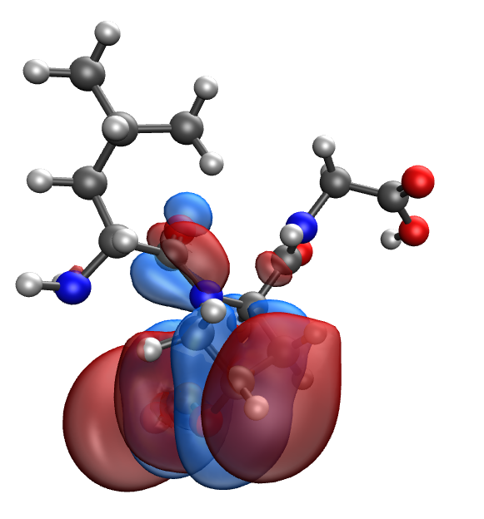 | 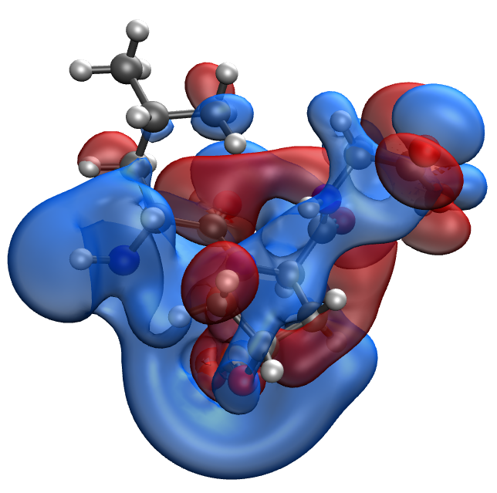
d | e
Fig. S42. Results of the quantum-chemical simulation of the Leu-Hyp-Gly gelatin segment, bonded with CuO molecule: a model of the molecular complex (a), the distribution of electron density (b), electronic density distribution gradient (c), HOMO (d), LUMO (e)

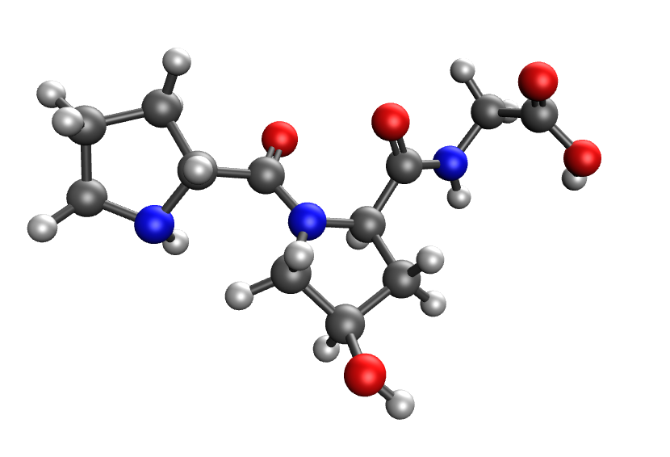 | 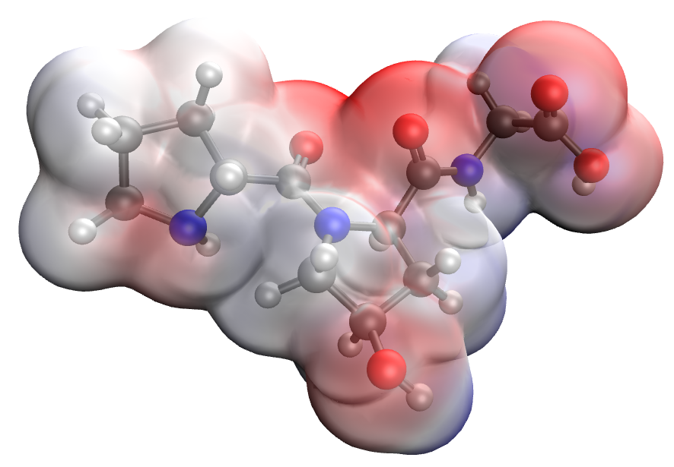
a | b
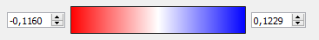
c
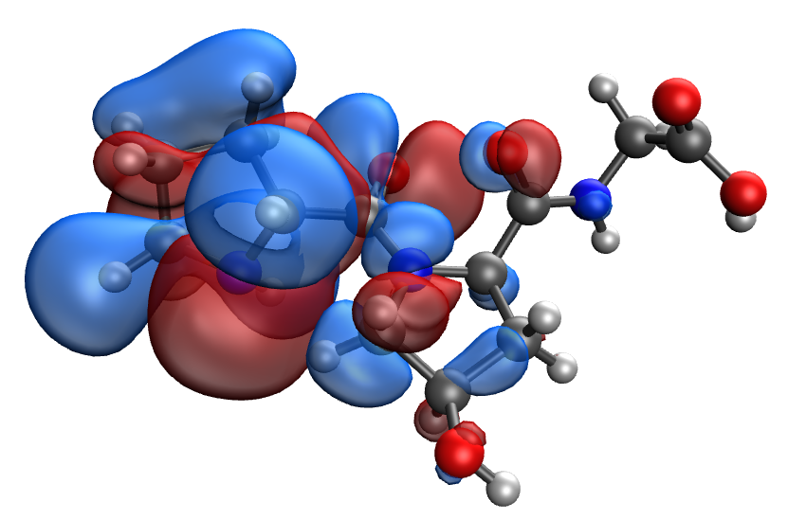 | 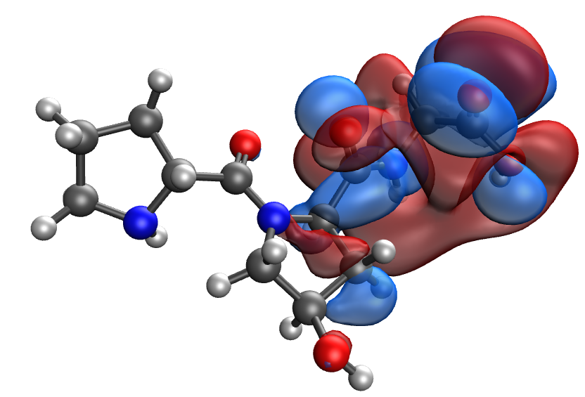
d | e
Fig. S43. Results of the quantum-chemical simulation of the Pro-Hyp-Gly gelatin segment: a model of the molecular complex (a), the distribution of electron density (b), electronic density distribution gradient (c), HOMO (d), LUMO (e)

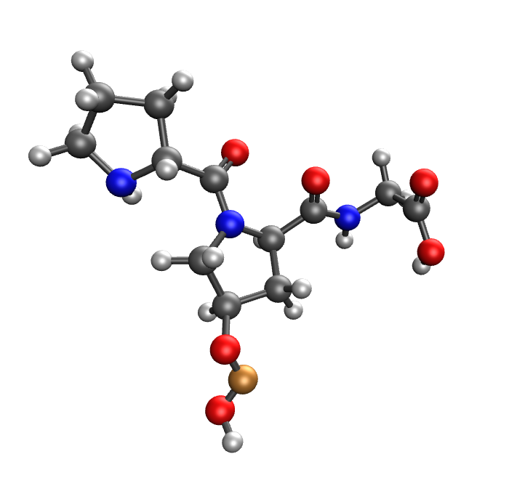 | 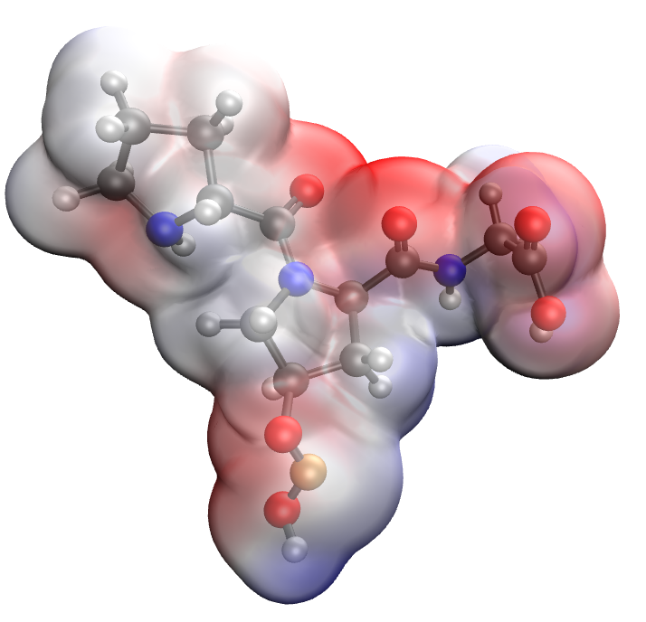
a | b
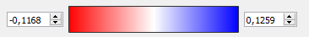
c
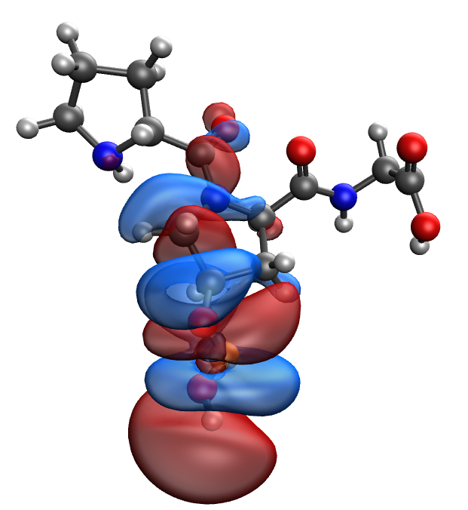 | 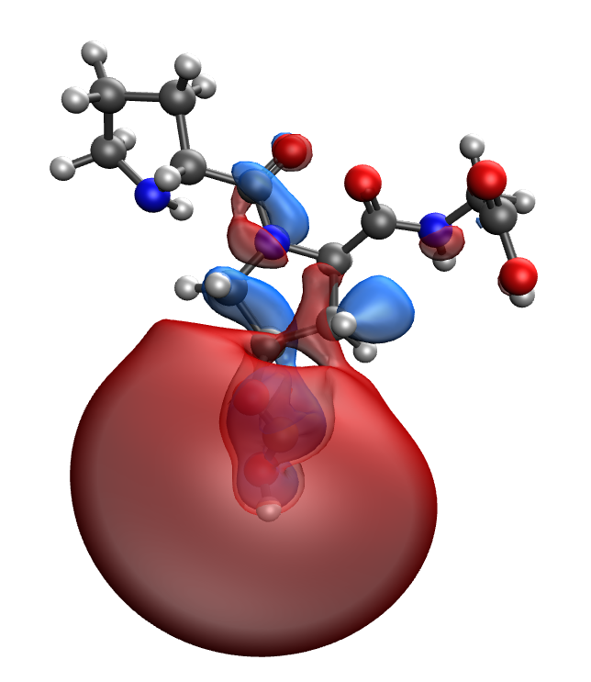
d | e
Fig. S44. Results of the quantum-chemical simulation of the Pro-Hyp-Gly gelatin segment, bonded with CuO molecule: a model of the molecular complex (a), the distribution of electron density (b), electronic density distribution gradient (c), HOMO (d), LUMO (e)

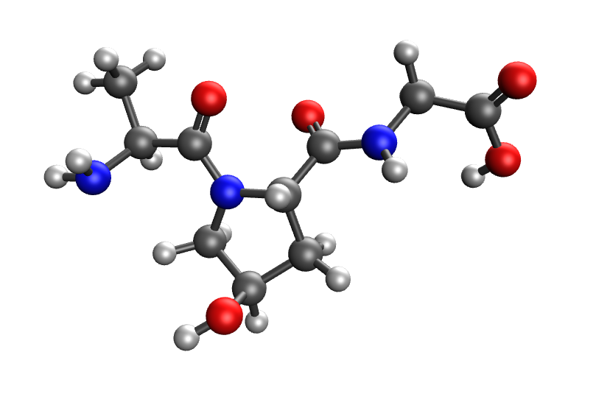 | 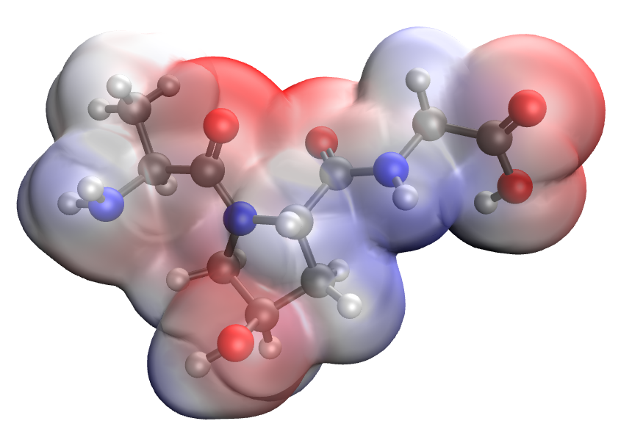
a | b
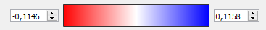
c
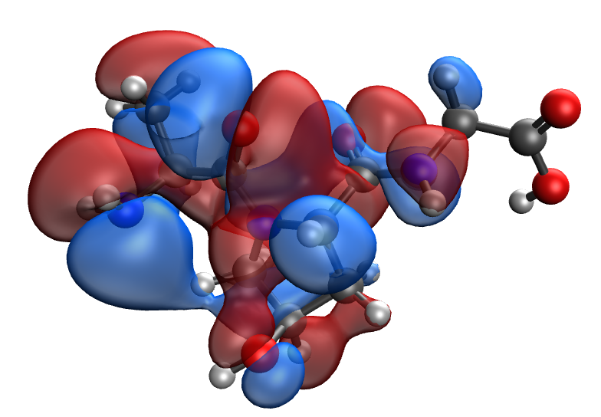 | 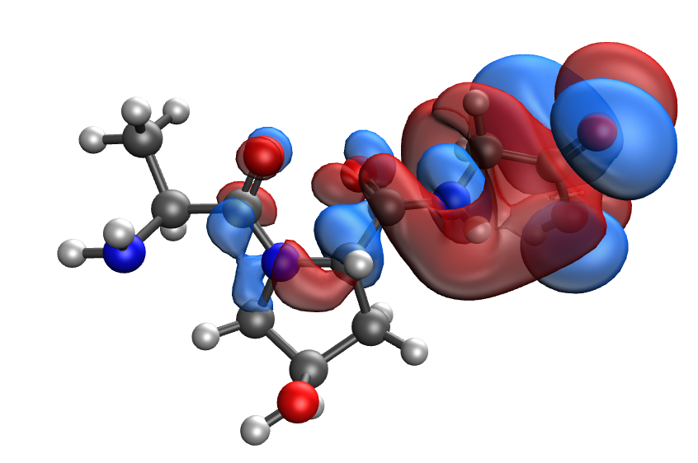
d | e
Fig. S45. Results of the quantum-chemical simulation of the Ala-Hyp-Gly gelatin segment: a model of the molecular complex (a), the distribution of electron density (b), electronic density distribution gradient (c), HOMO (d), LUMO (e)

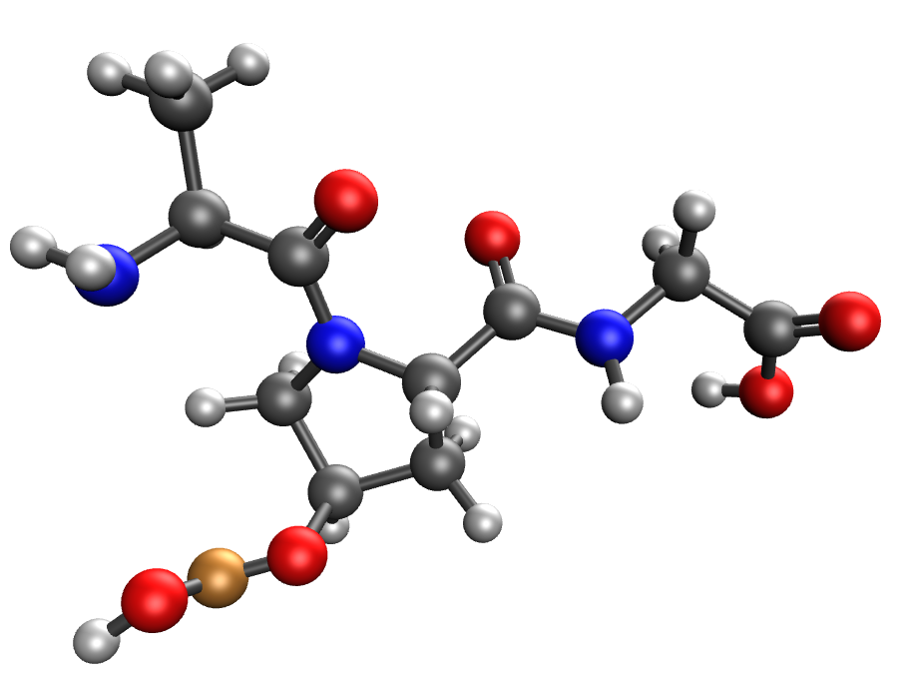 | 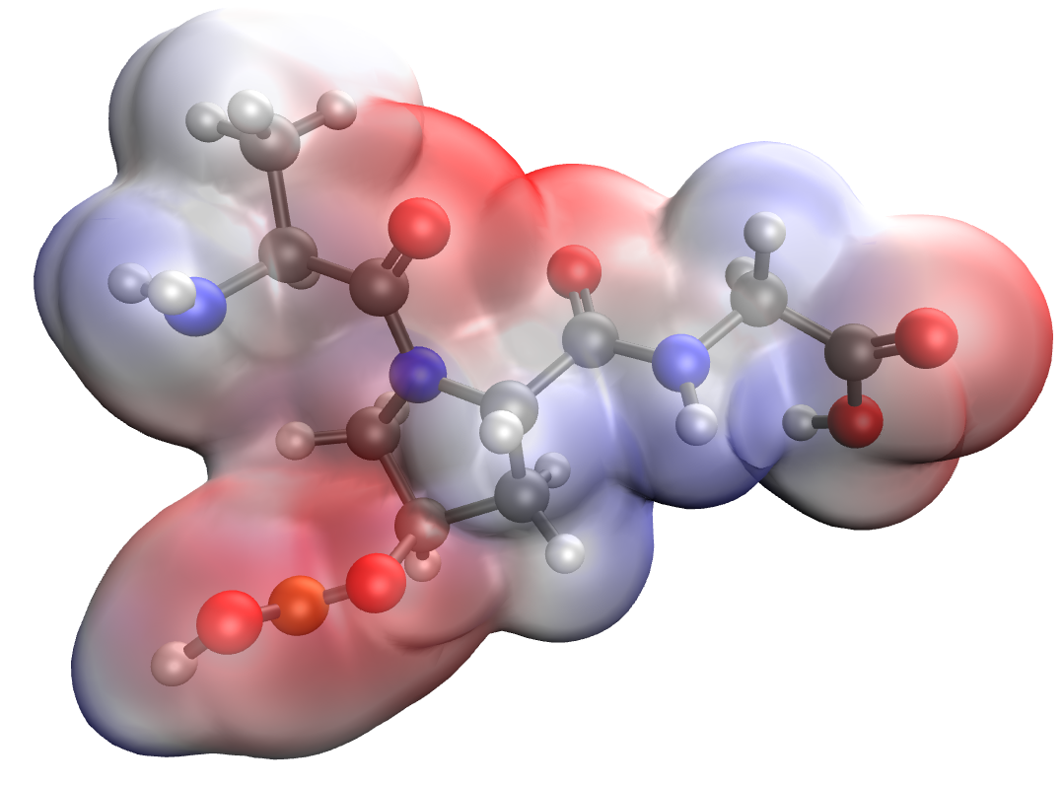
a | b
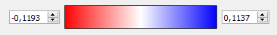
c
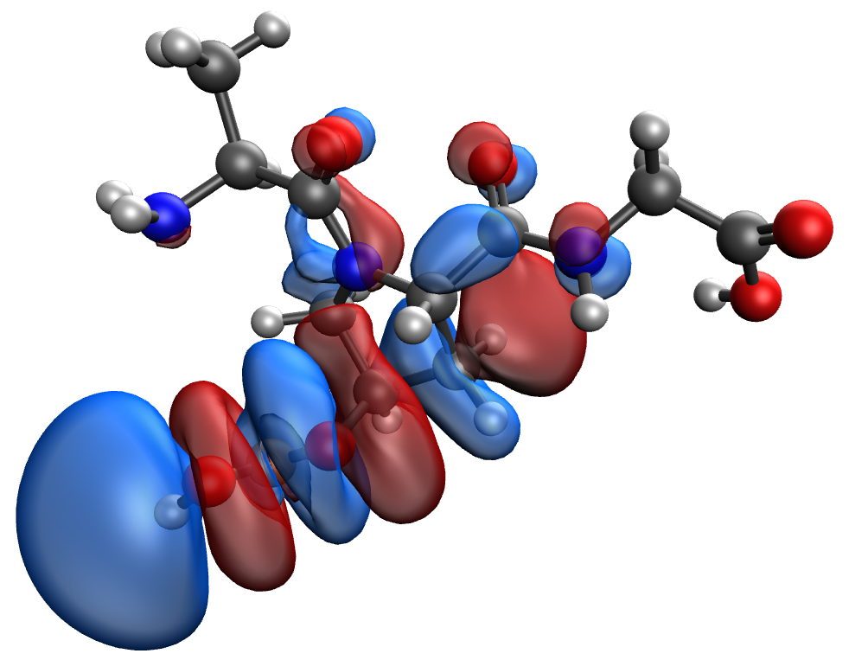 | 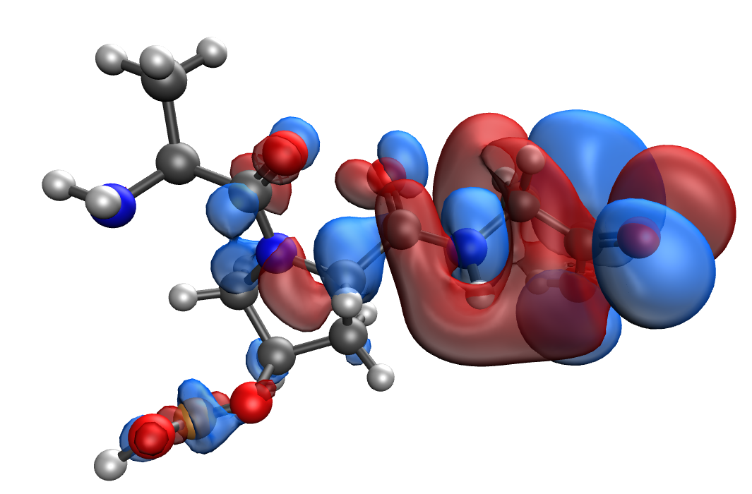
d | e
Fig. S46. Results of the quantum-chemical simulation of the Ala-Hyp-Gly gelatin segment, bonded with CuO molecule: a model of the molecular complex (a), the distribution of electron density (b), electronic density distribution gradient (c), HOMO (d), LUMO (e)

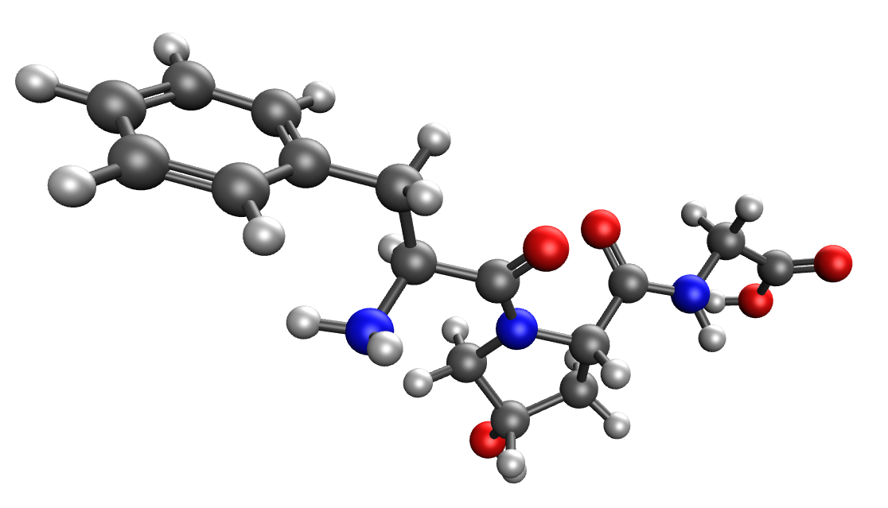 | 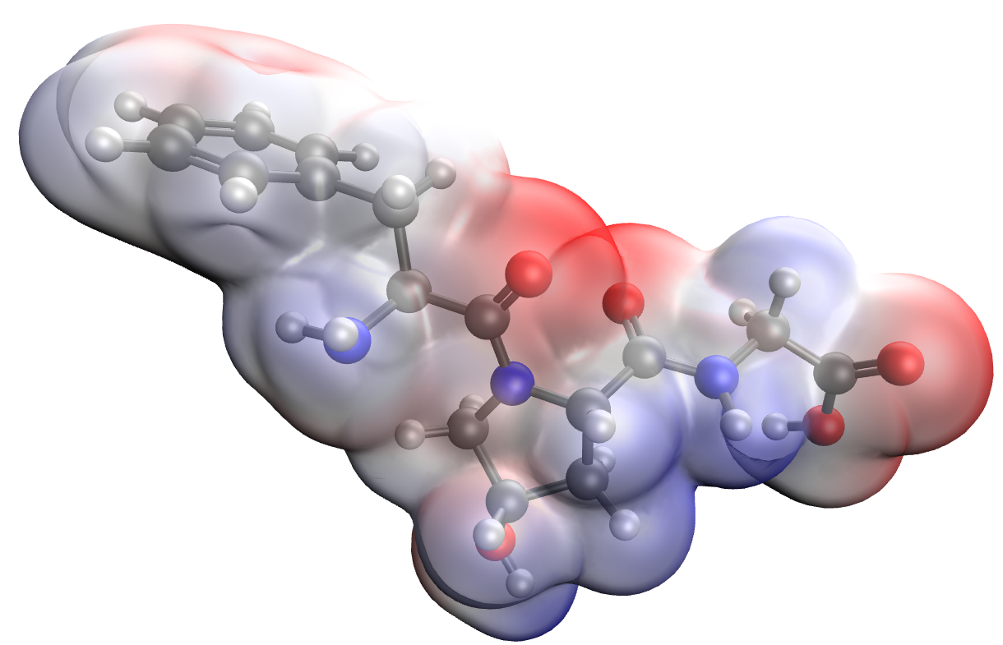
a | b
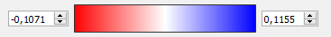
c
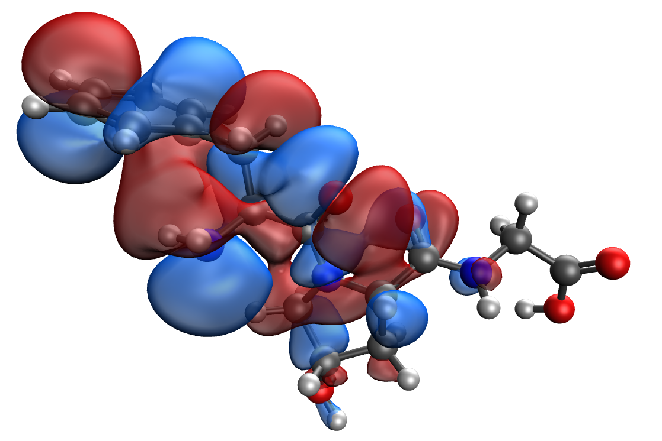 | 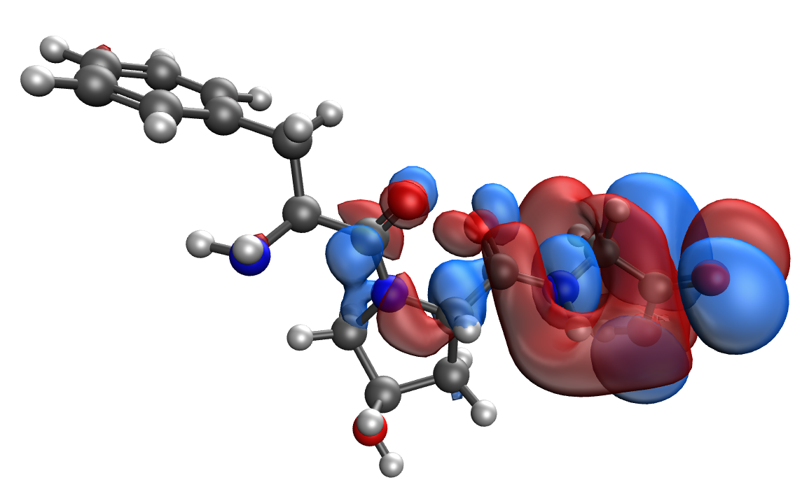
d | e
Fig. S47. Results of the quantum-chemical simulation of the Phe-Hyp-Gly gelatin segment: a model of the molecular complex (a), the distribution of electron density (b), electronic density distribution gradient (c), HOMO (d), LUMO (e)

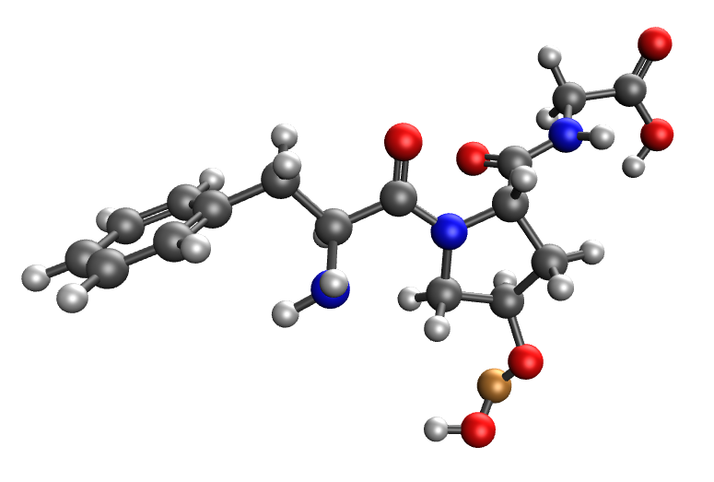 | 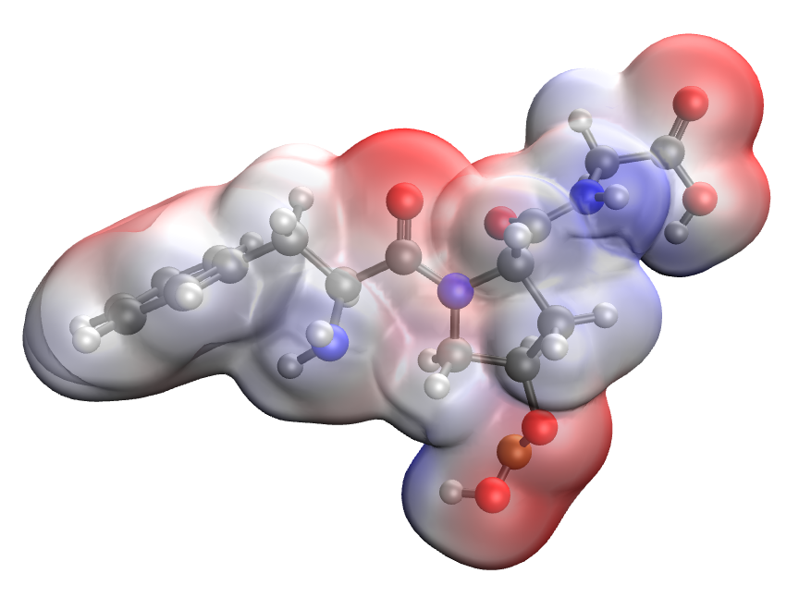
a | b
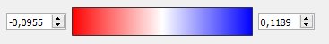
c
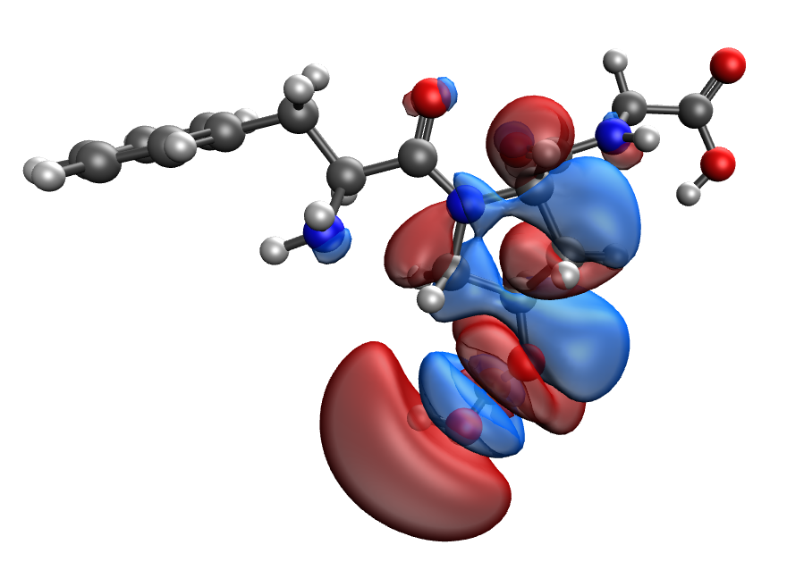 | 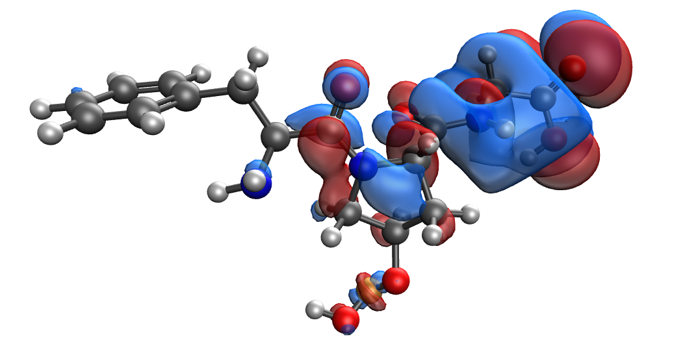
d | e
Fig. S48. Results of the quantum-chemical simulation of the Phe-Hyp-Gly gelatin segment, bonded with CuO molecule: a model of the molecular complex (a), the distribution of electron density (b), electronic density distribution gradient (c), HOMO (d), LUMO (e)

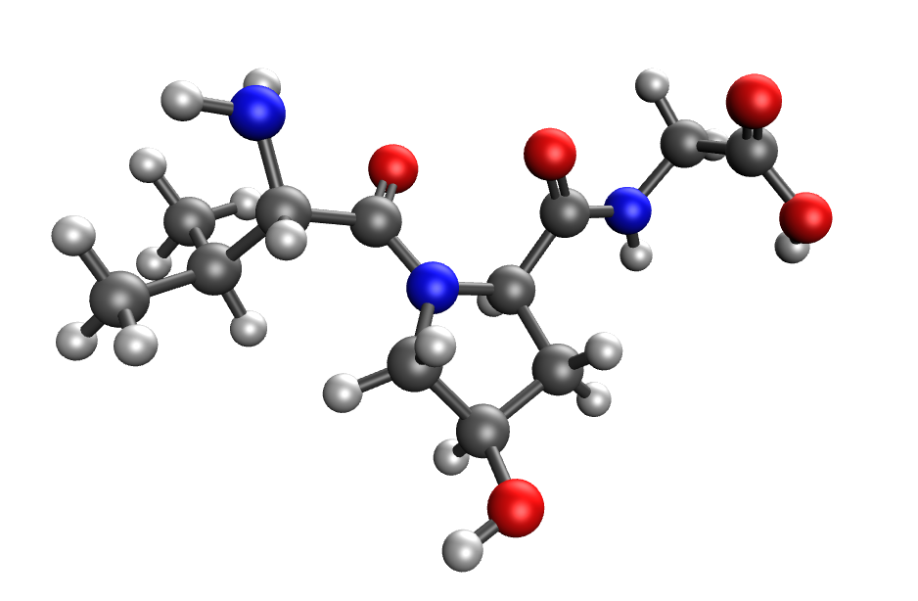 | 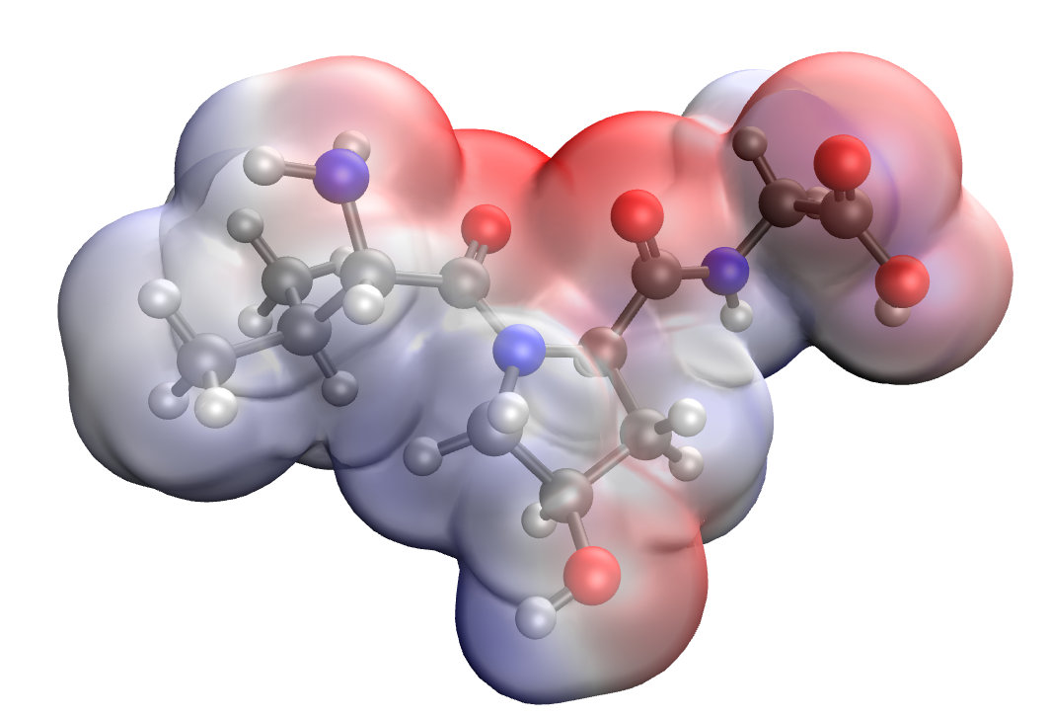
a | b
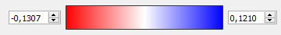
c
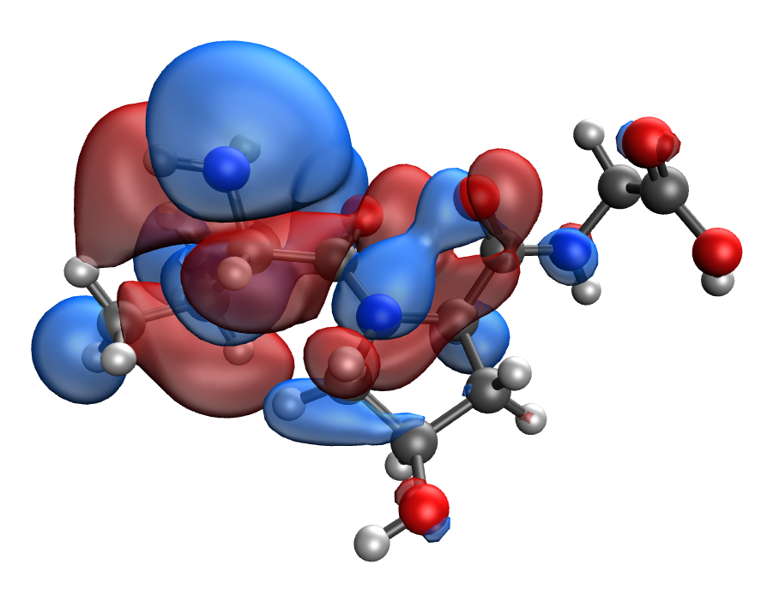 | 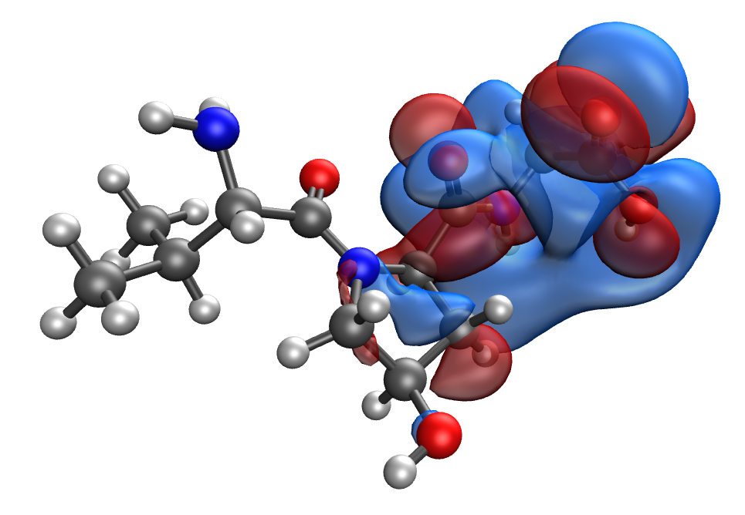
d | e
Fig. S49. Results of the quantum-chemical simulation of the Val-Hyp-Gly gelatin segment: a model of the molecular complex (a), the distribution of electron density (b), electronic density distribution gradient (c), HOMO (d), LUMO (e)

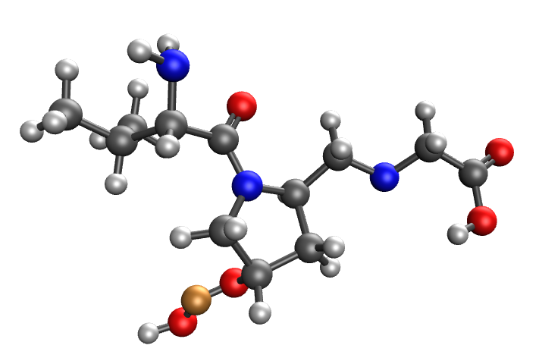 | 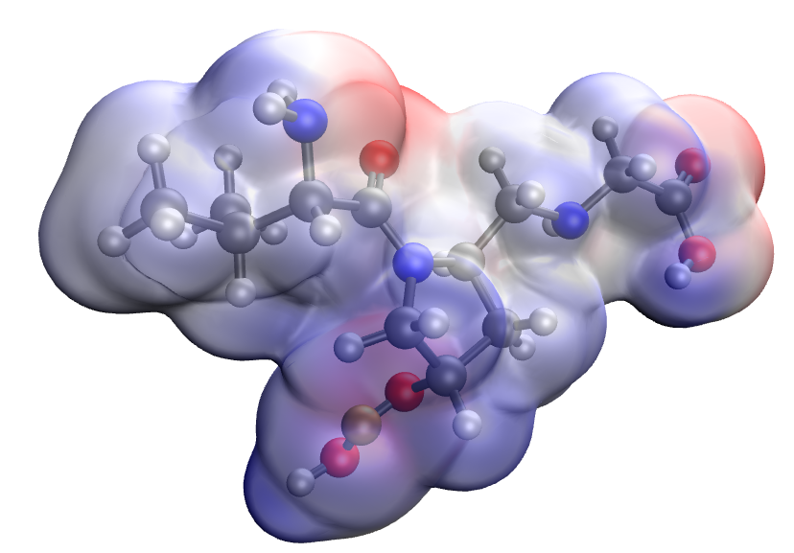
a | b
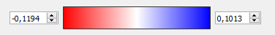
c
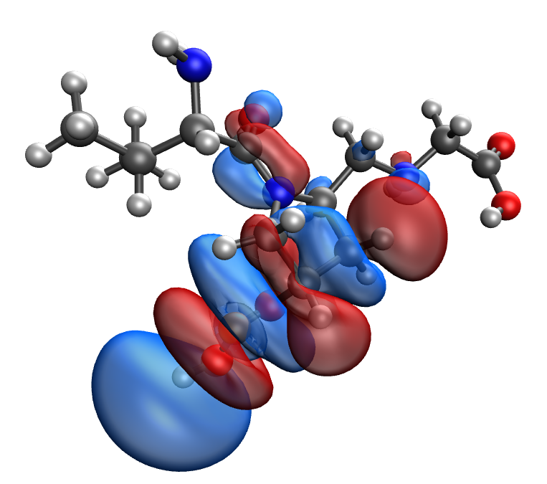 | 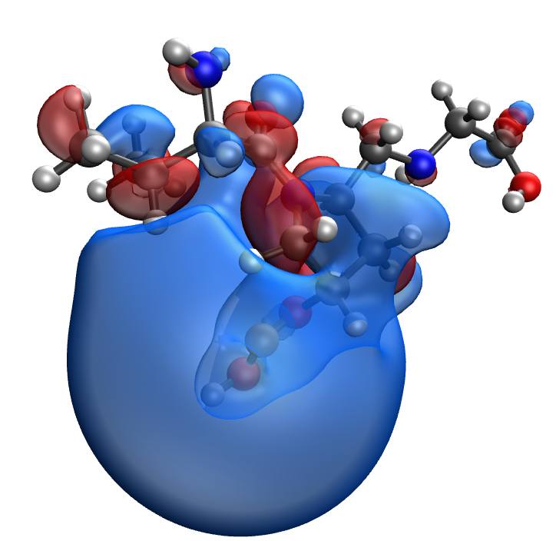
d | e
Fig. S50. Results of the quantum-chemical simulation of the Val-Hyp-Gly gelatin segment, bonded with CuO molecule: a model of the molecular complex (a), the distribution of electron density (b), electronic density distribution gradient (c), HOMO (d), LUMO (e)

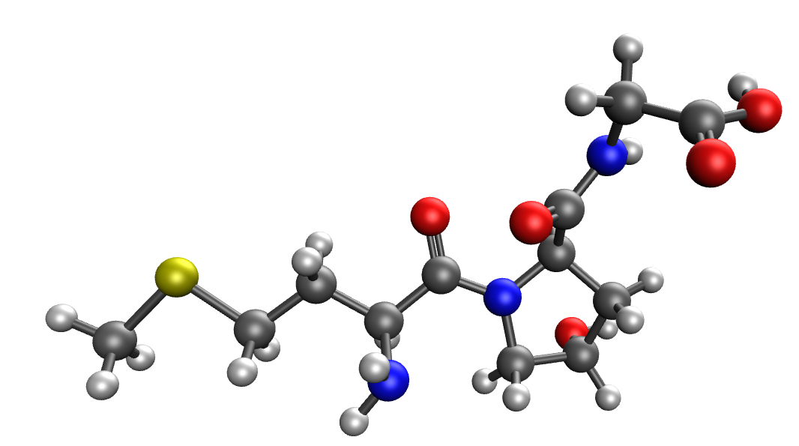 | 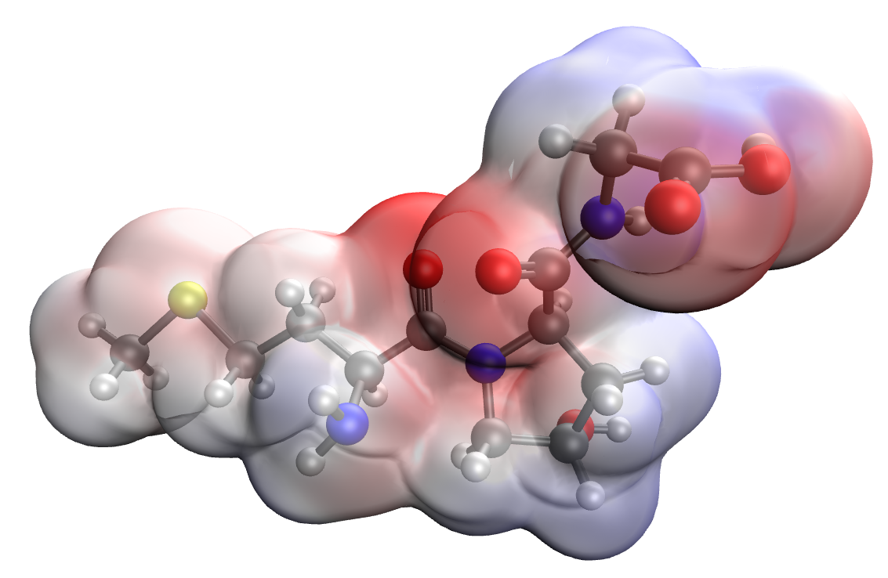
a | b
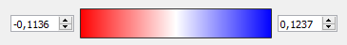
c
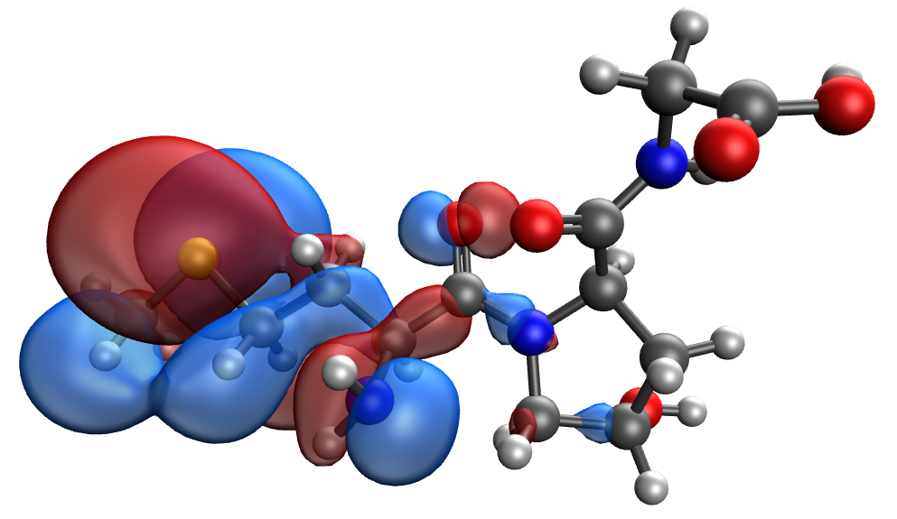 | 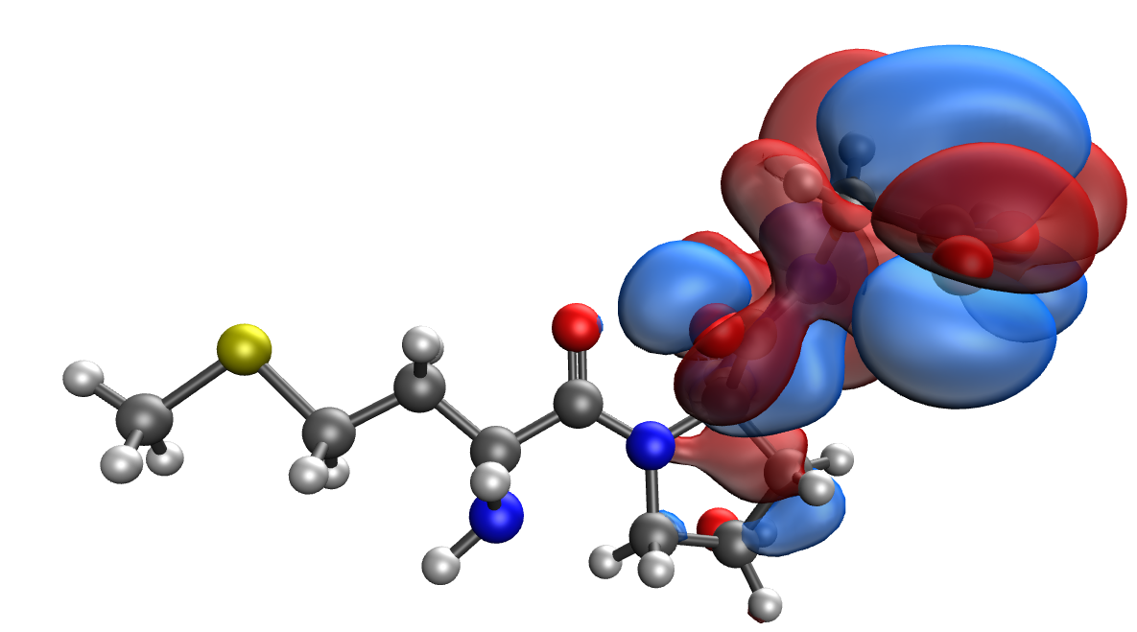
d | e
Fig. S51. Results of the quantum-chemical simulation of the Met-Hyp-Gly gelatin segment: a model of the molecular complex (a), the distribution of electron density (b), electronic density distribution gradient (c), HOMO (d), LUMO (e)

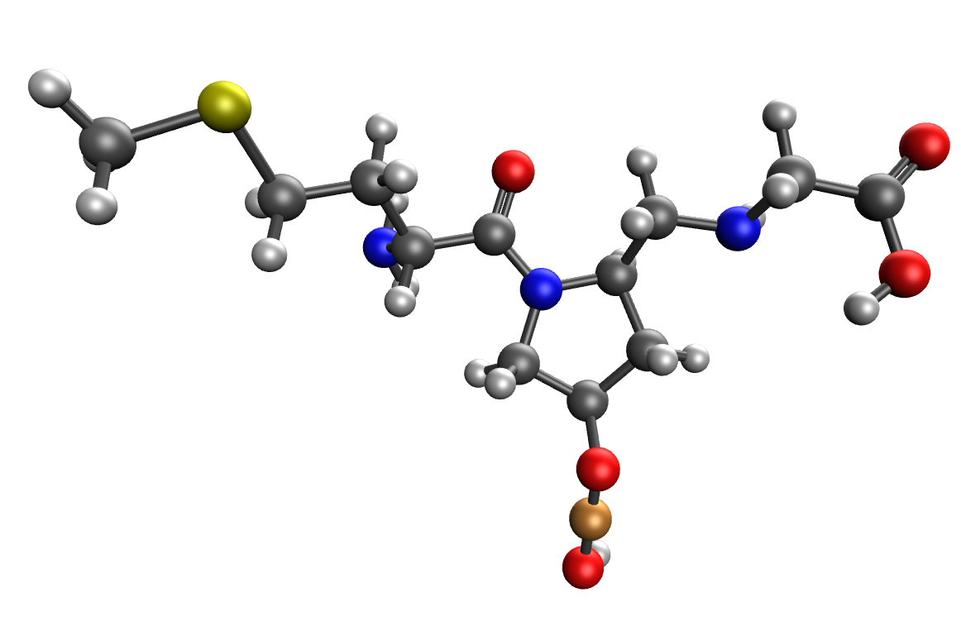 | 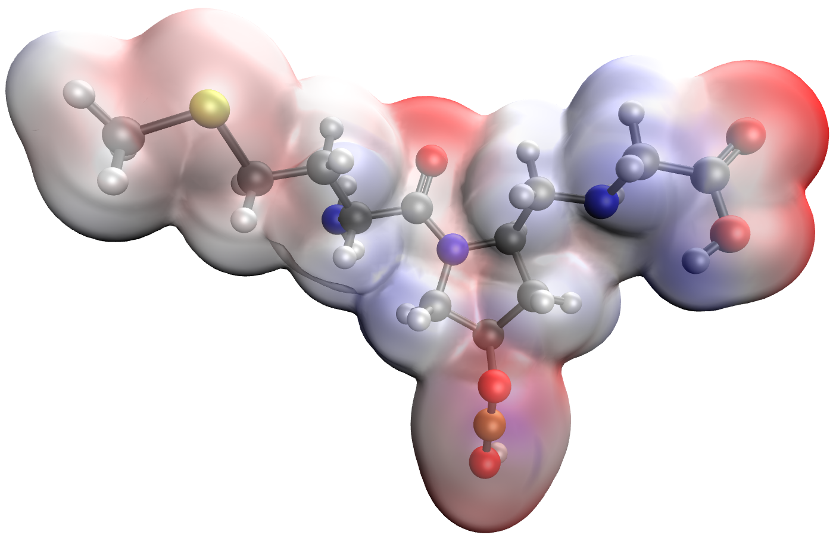
a | b
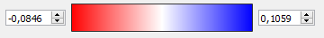
c
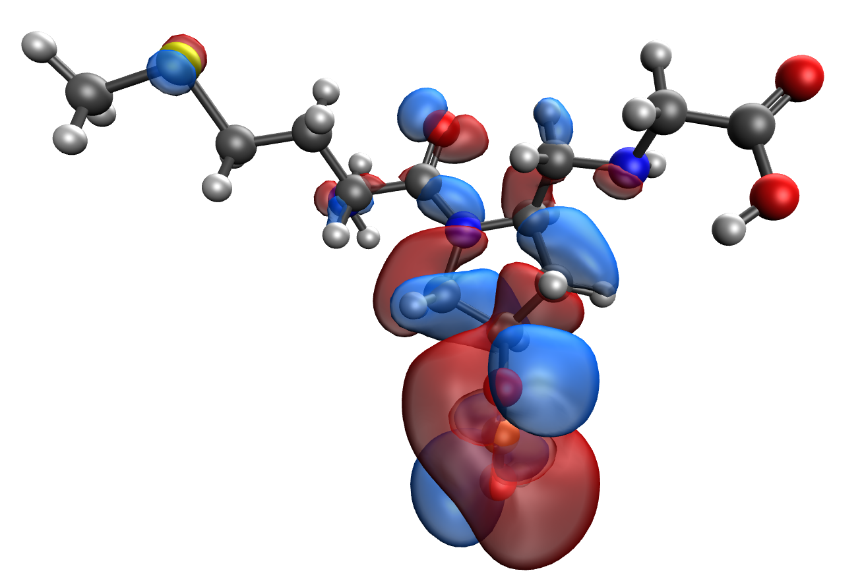 | 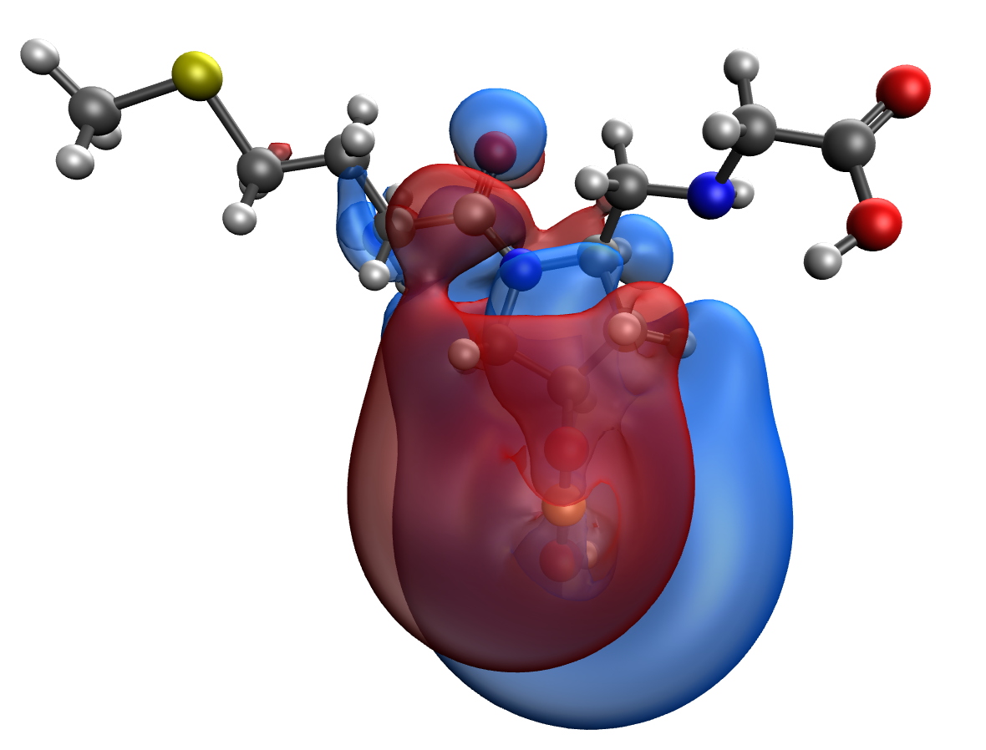
d | e
Fig. S52. Results of the quantum-chemical simulation of the Met-Hyp-Gly gelatin segment, bonded with CuO molecule: a model of the molecular complex (a), the distribution of electron density (b), electronic density distribution gradient (c), HOMO (d), LUMO (e)

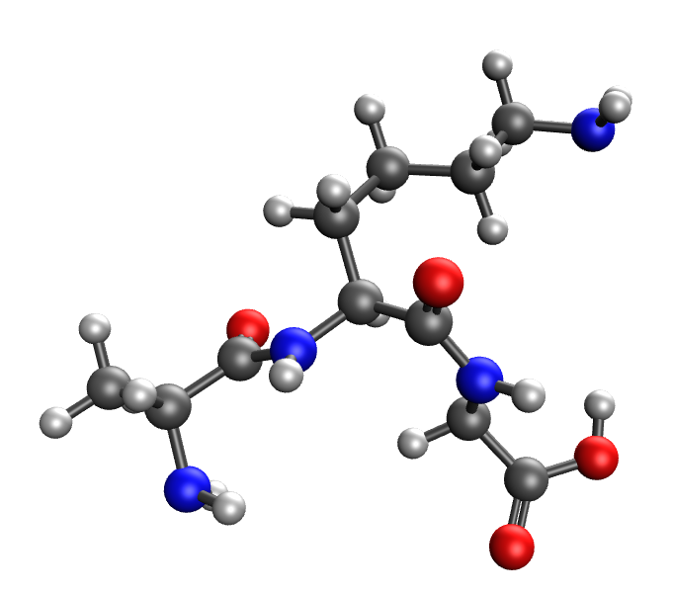 | 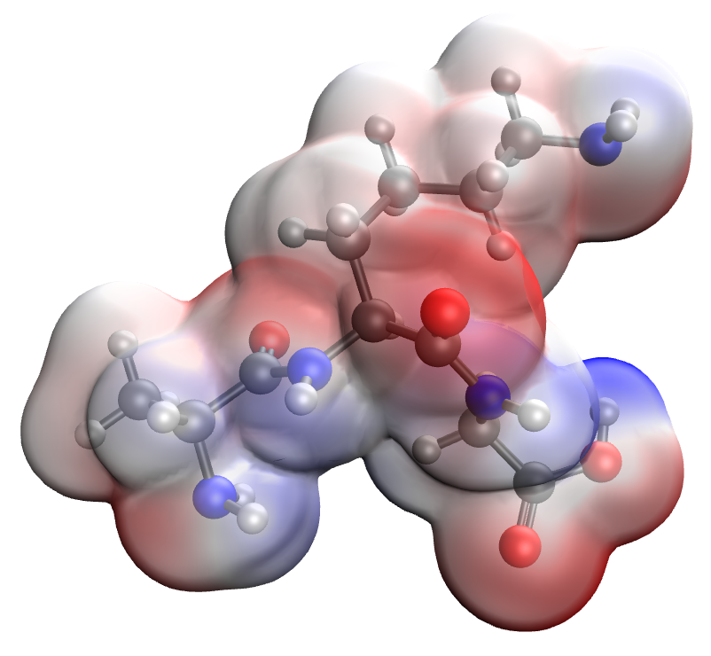
a | b
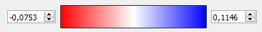
c
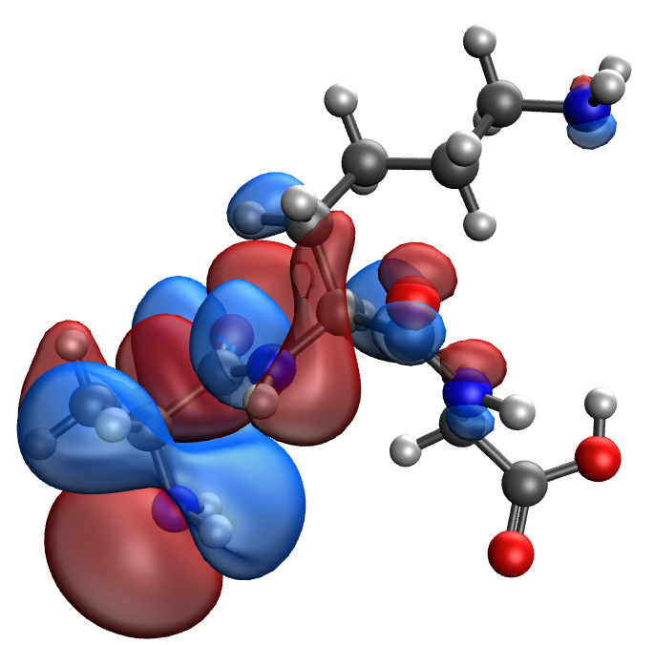 | 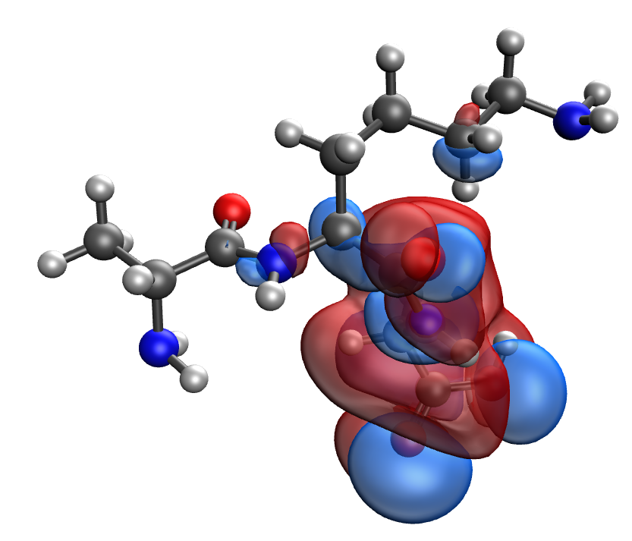
d | e
Fig. S53. Results of the quantum-chemical simulation of the Ala-Lys-Gly gelatin segment: a model of the molecular complex (a), the distribution of electron density (b), electronic density distribution gradient (c), HOMO (d), LUMO (e)

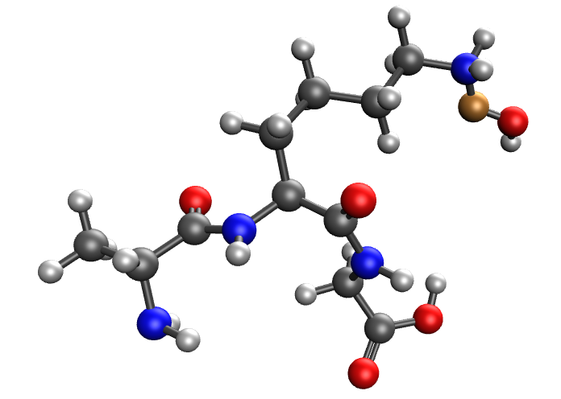 | 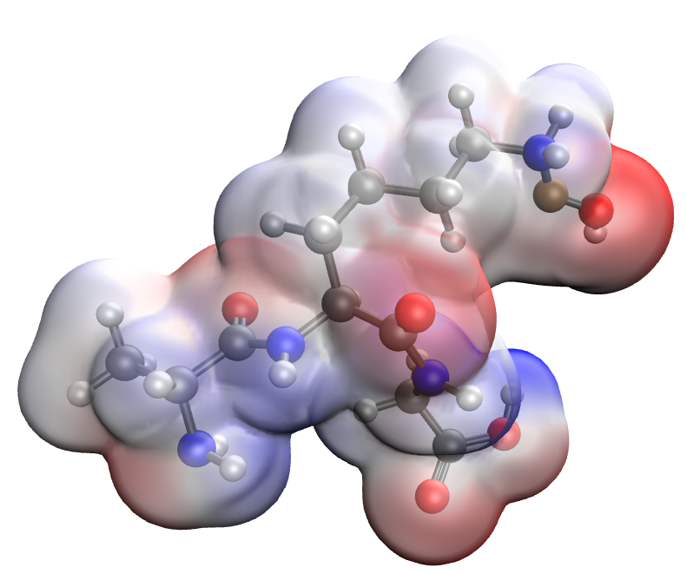
a | b
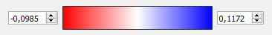
c
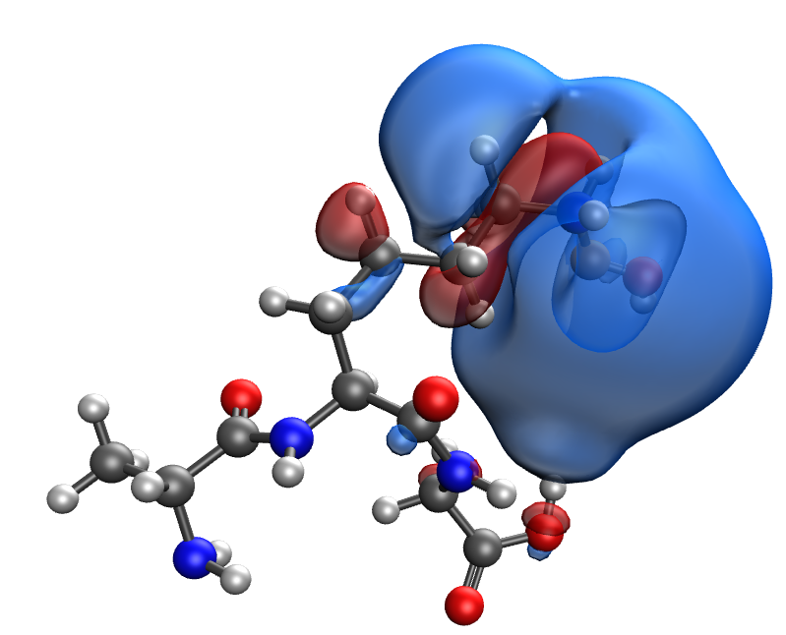 | 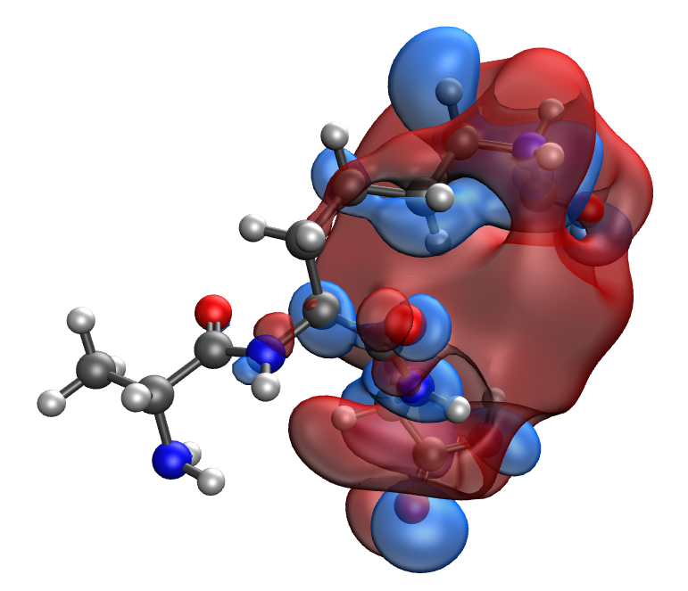
d | e
Fig. S54. Results of the quantum-chemical simulation of the Ala-Lys-Gly gelatin segment, bonded with CuO molecule: a model of the molecular complex (a), the distribution of electron density (b), electronic density distribution gradient (c), HOMO (d), LUMO (e)

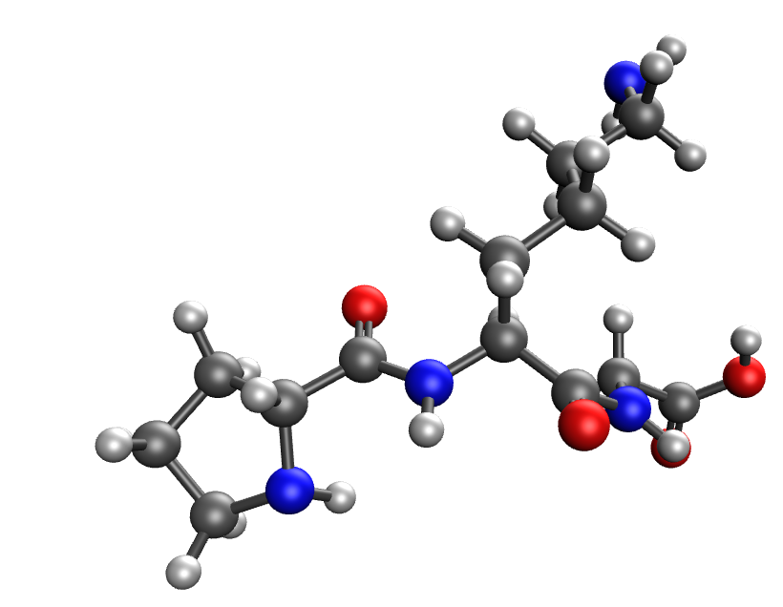 | 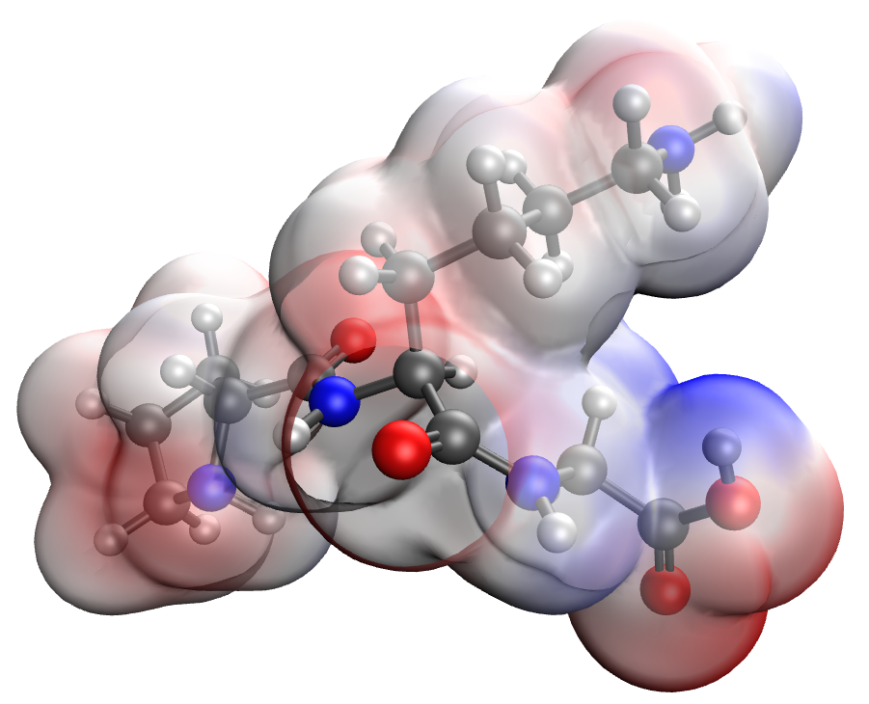
a | b
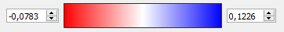
c
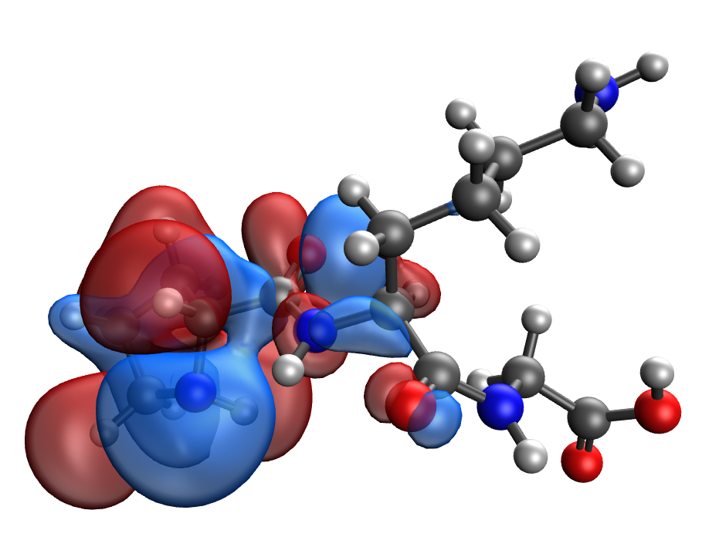 | 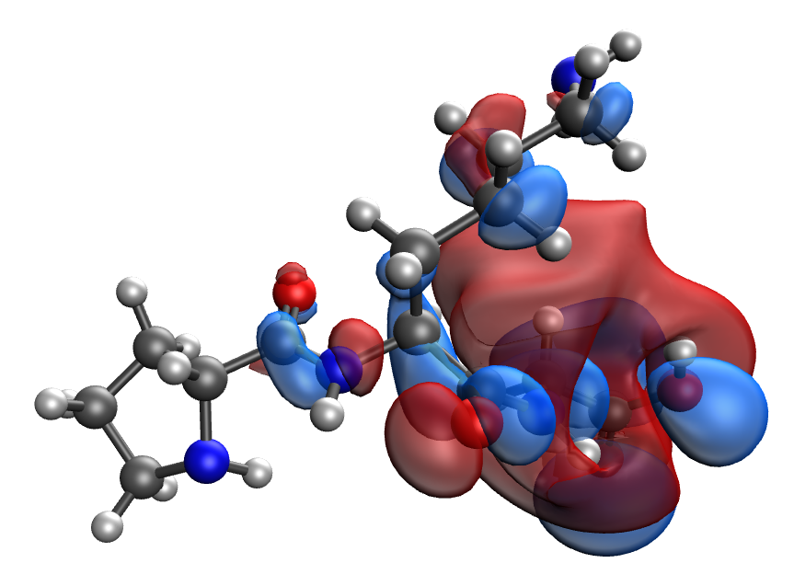
d | e
Fig. S55. Results of the quantum-chemical simulation of the Pro-Lys-Gly gelatin segment: a model of the molecular complex (a), the distribution of electron density (b), electronic density distribution gradient (c), HOMO (d), LUMO (e)

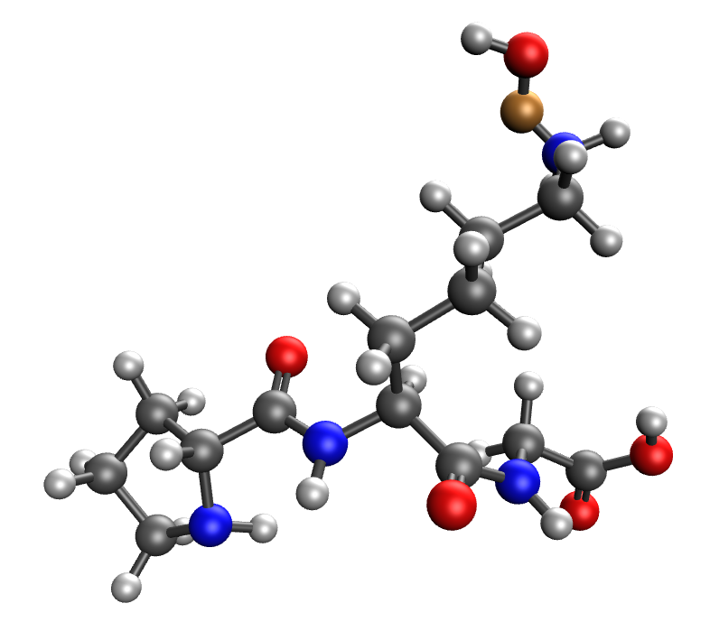 | 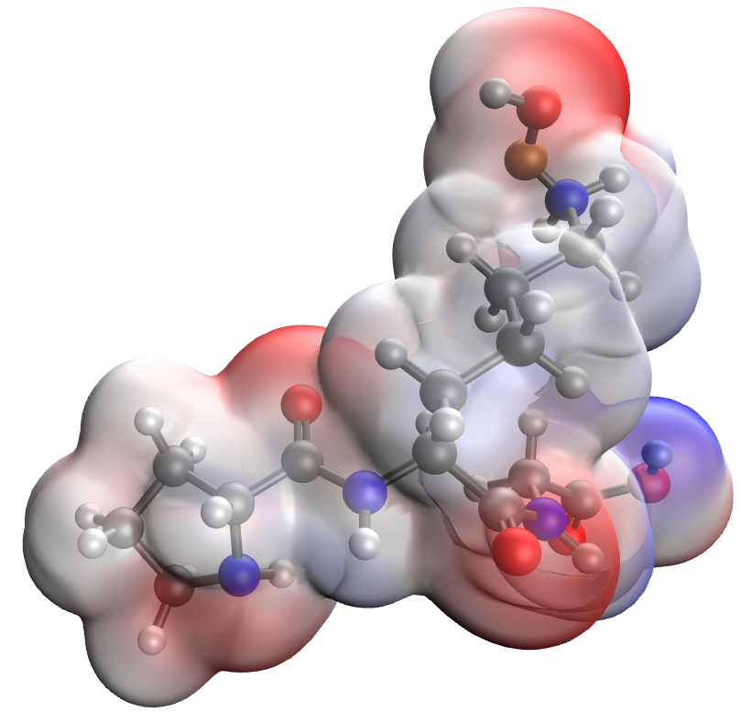
a | b
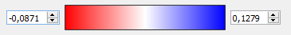
c
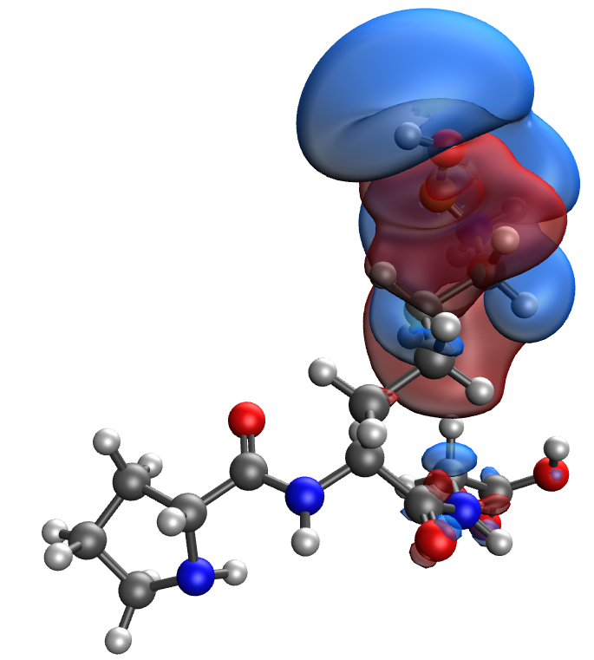 | 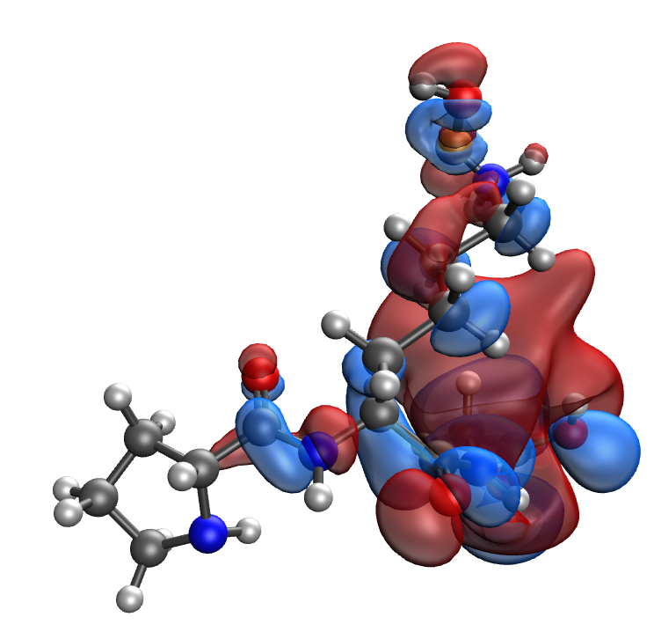
d | e
Fig. S56. Results of the quantum-chemical simulation of the Pro-Lys-Gly gelatin segment, bonded with CuO molecule: a model of the molecular complex (a), the distribution of electron density (b), electronic density distribution gradient (c), HOMO (d), LUMO (e)

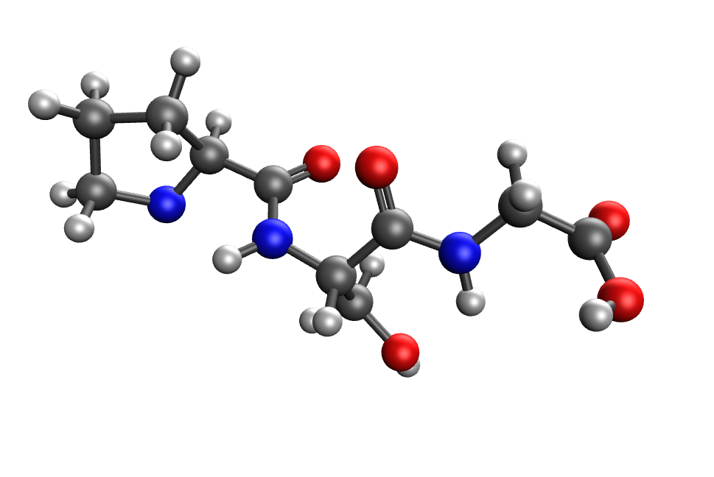 | 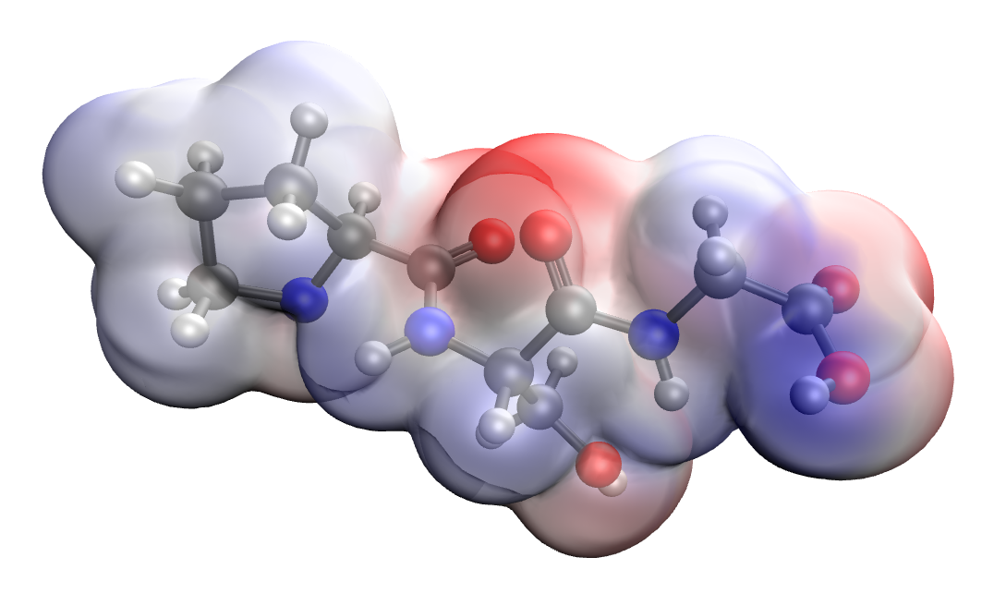
a | b
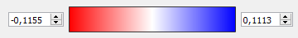
c
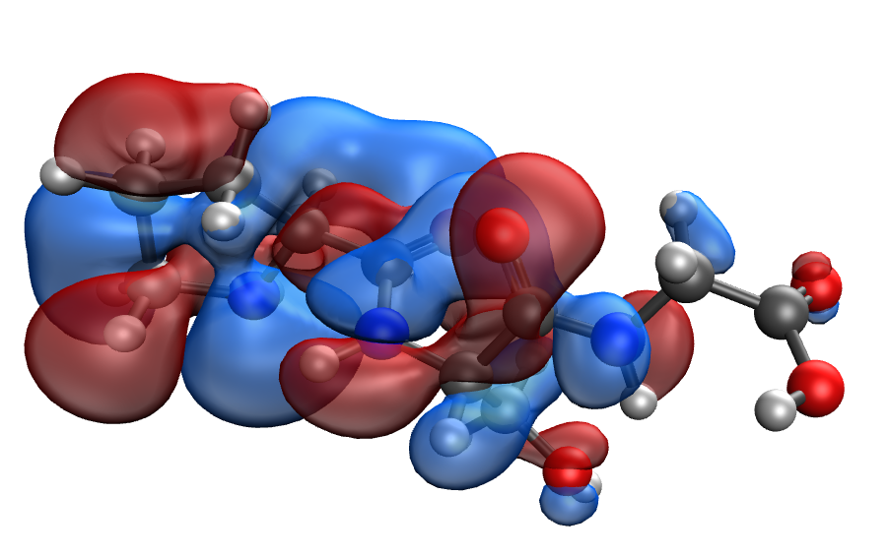 | 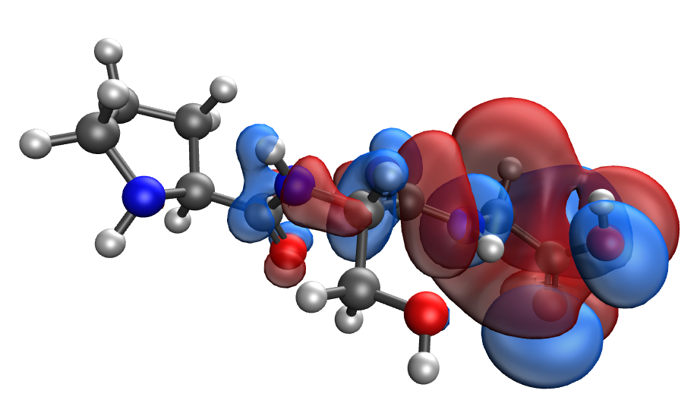
d | e
Fig. S57. Results of the quantum-chemical simulation of the Pro-Ser-Gly gelatin segment: a model of the molecular complex (a), the distribution of electron density (b), electronic density distribution gradient (c), HOMO (d), LUMO (e)

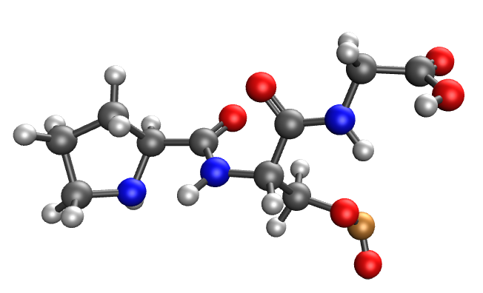 | 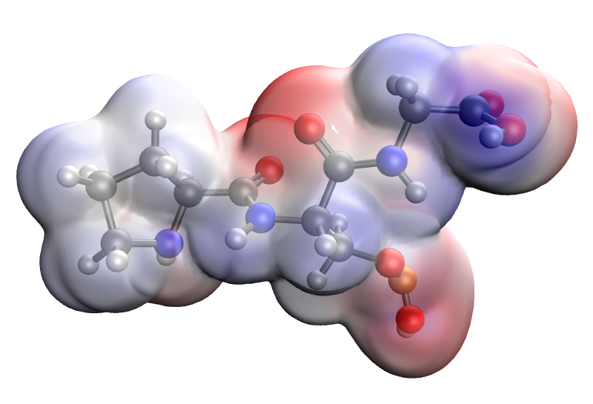
a | b
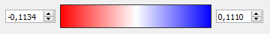
c
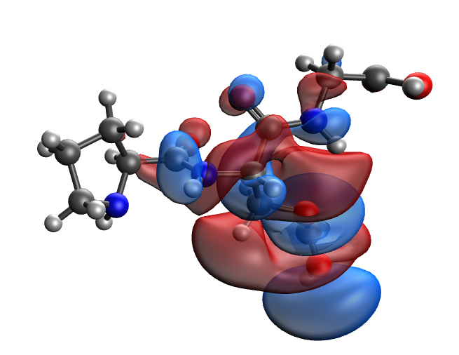 | 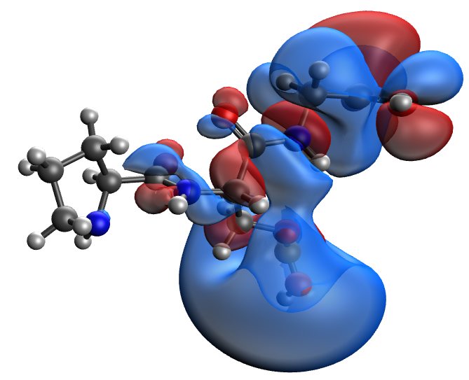
d | e
Fig. S58. Results of the quantum-chemical simulation of the Pro-Ser-Gly gelatin segment, bonded with CuO molecule: a model of the molecular complex (a), the distribution of electron density (b), electronic density distribution gradient (c), HOMO (d), LUMO (e)

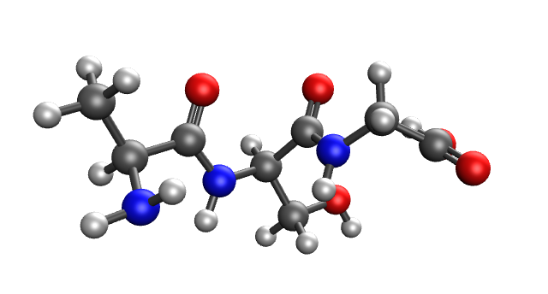 | 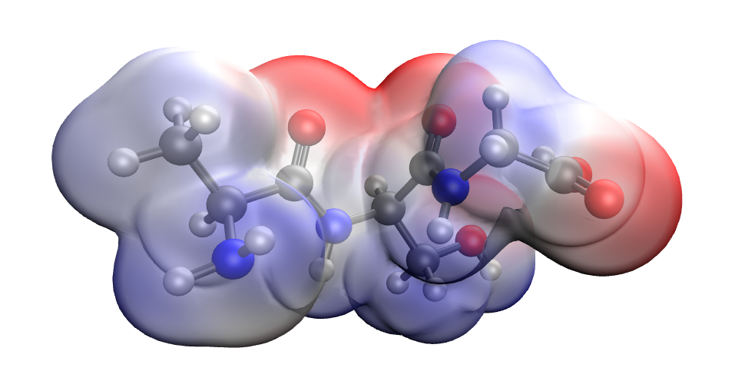
a | b
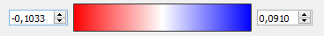
c
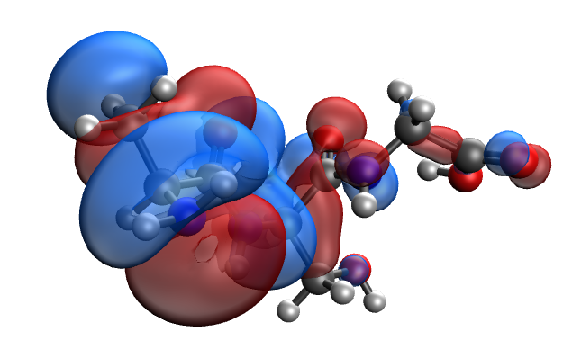 | 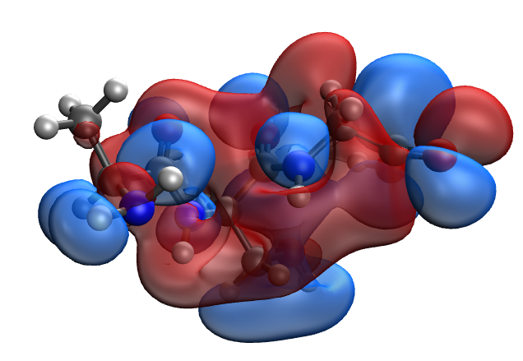
d | e
Fig. S59. Results of the quantum-chemical simulation of the Ala-Ser-Gly gelatin segment: a model of the molecular complex (a), the distribution of electron density (b), electronic density distribution gradient (c), HOMO (d), LUMO (e)

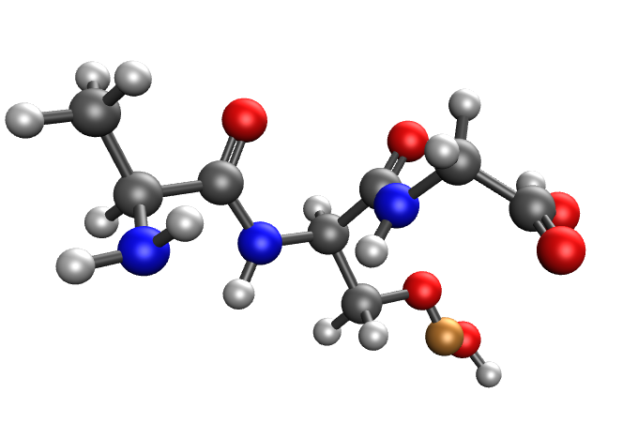 | 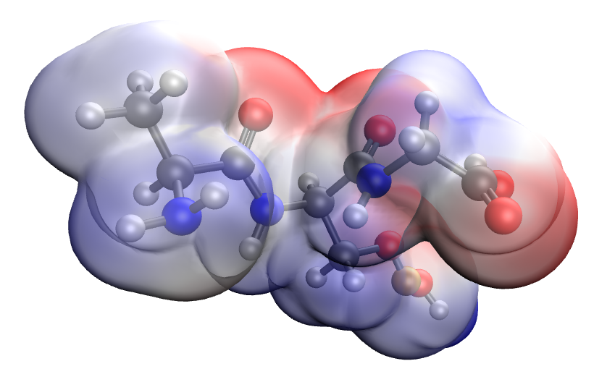
a | b
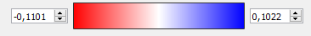
c
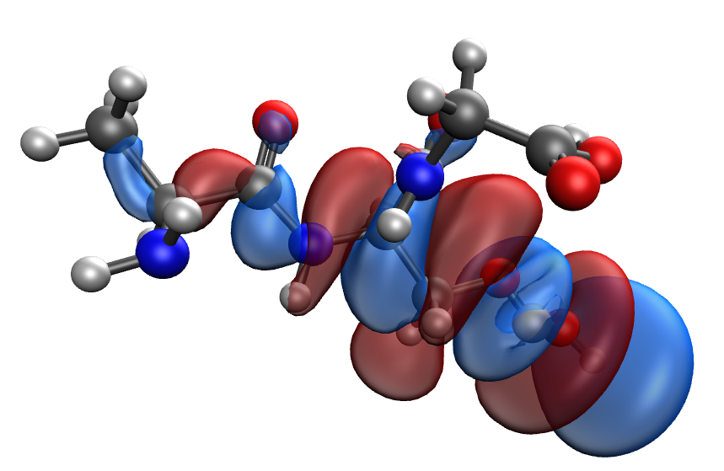 | 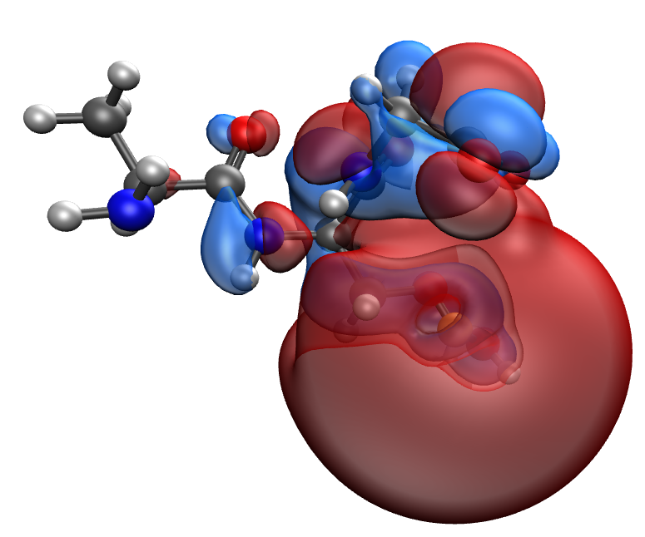
d | e
Fig. S60. Results of the quantum-chemical simulation of the Ala-Ser-Gly gelatin segment, bonded with CuO molecule: a model of the molecular complex (a), the distribution of electron density (b), electronic density distribution gradient (c), HOMO (d), LUMO (e)

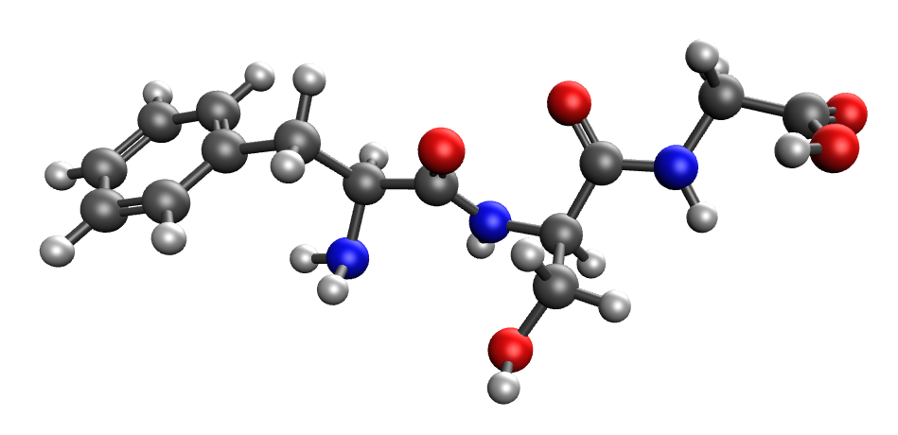 | 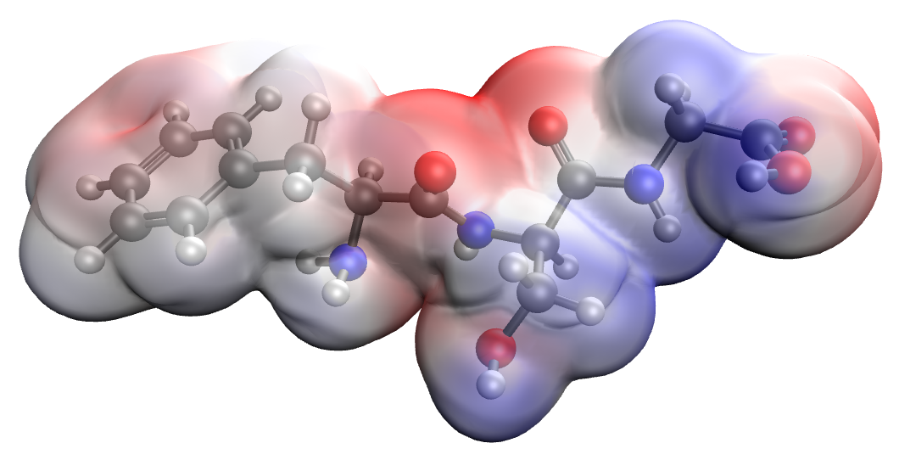
a | b
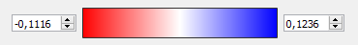
c
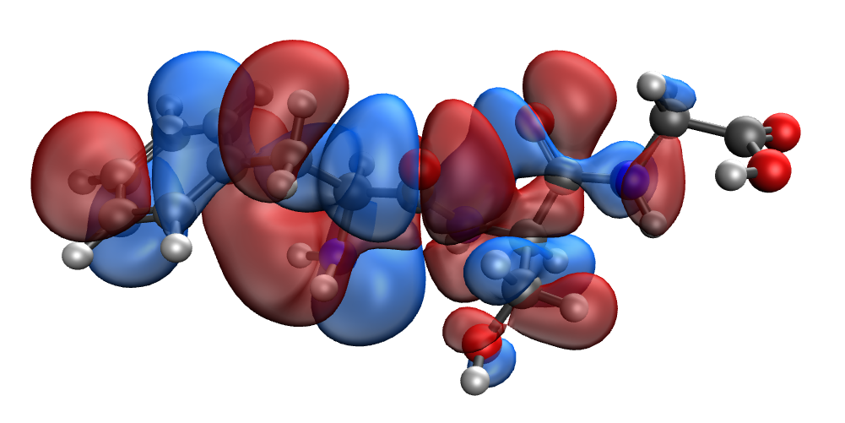 | 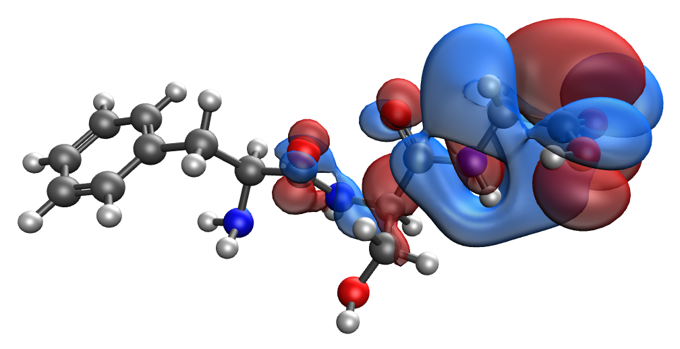
d | e
Fig. S61. Results of the quantum-chemical simulation of the Phe-Ser-Gly gelatin segment: a model of the molecular complex (a), the distribution of electron density (b), electronic density distribution gradient (c), HOMO (d), LUMO (e)

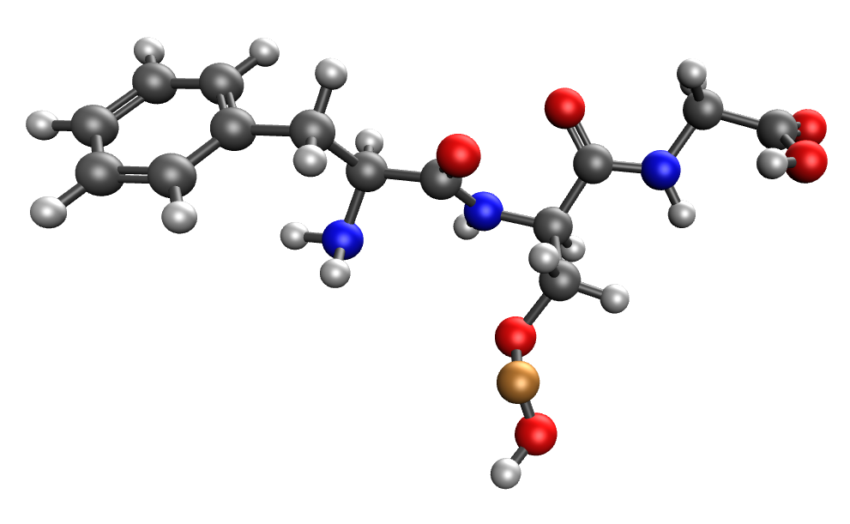 | 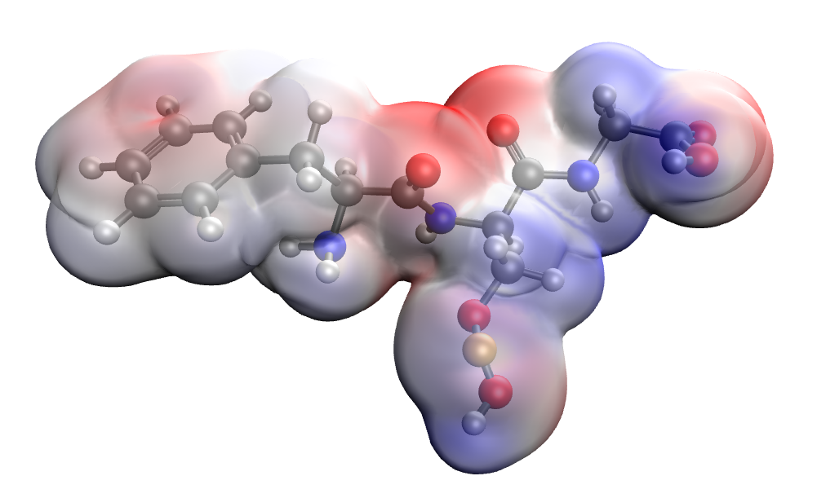
a | b
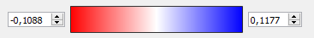
c
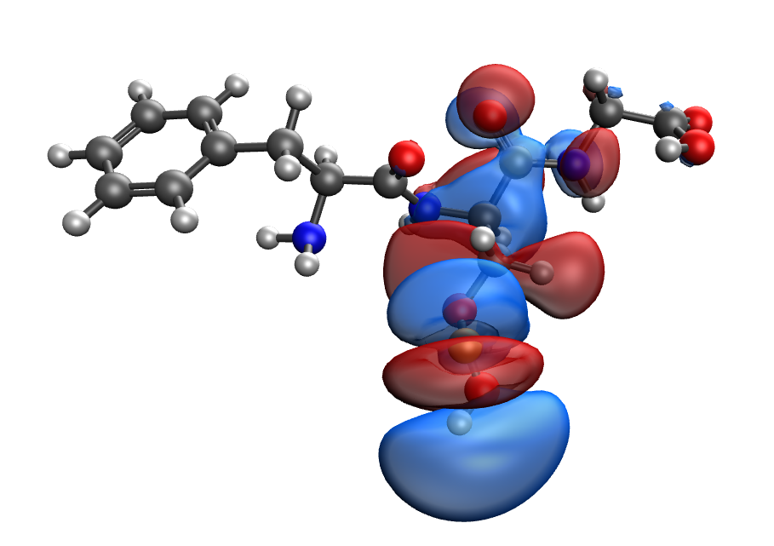 | 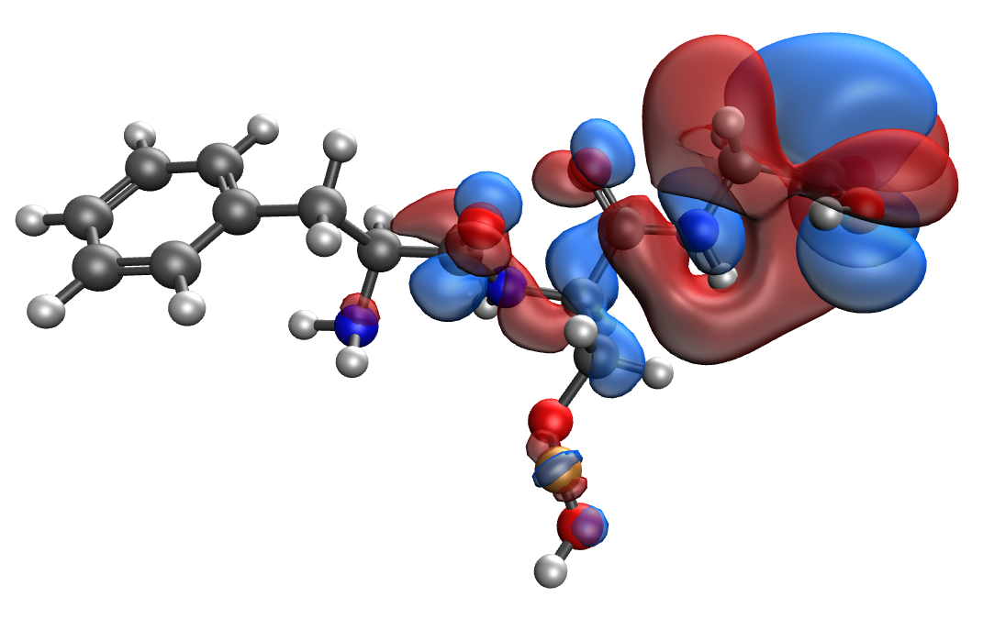
d | e
Fig. S62. Results of the quantum-chemical simulation of the Phe-Ser-Gly gelatin segment, bonded with CuO molecule: a model of the molecular complex (a), the distribution of electron density (b), electronic density distribution gradient (c), HOMO (d), LUMO (e)

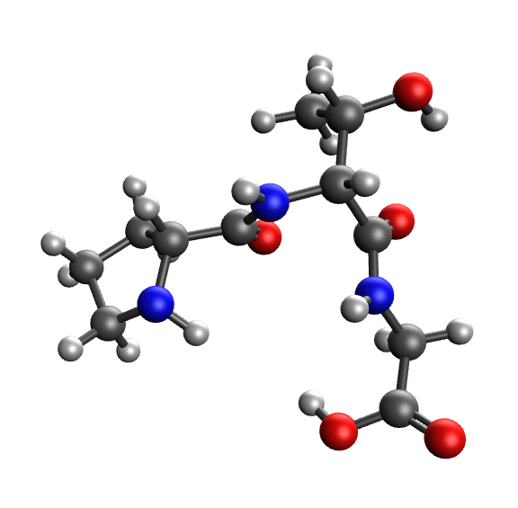 | 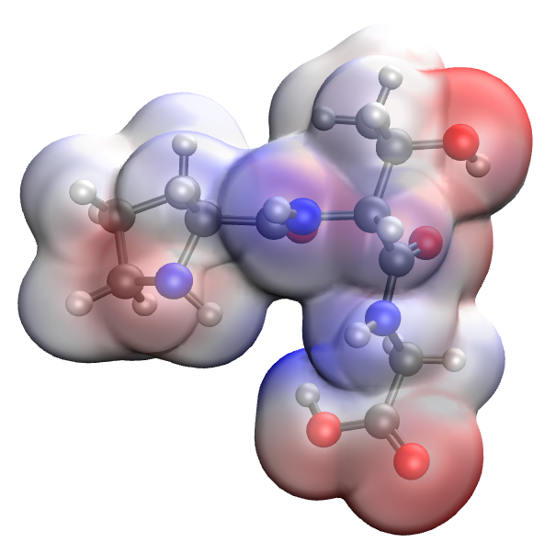
a | b
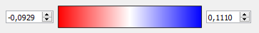
c
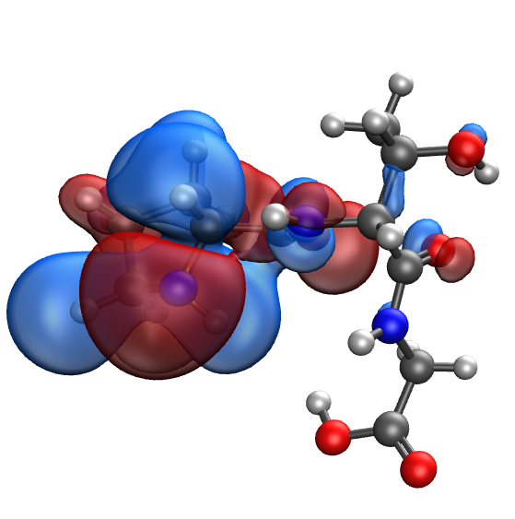 | 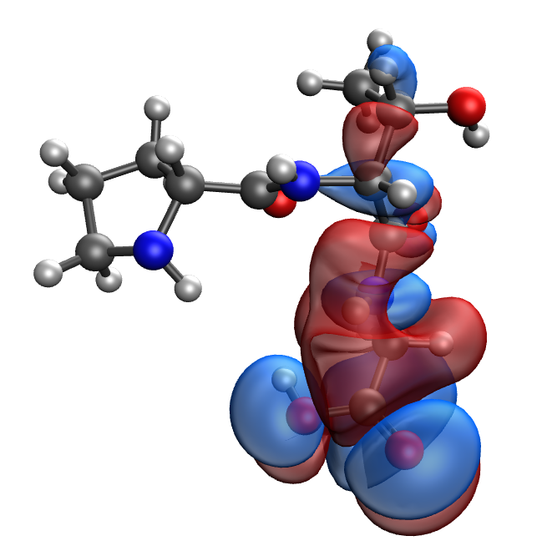
d | e
Fig. S63. Results of the quantum-chemical simulation of the Pro-Thr-Gly gelatin segment: a model of the molecular complex (a), the distribution of electron density (b), electronic density distribution gradient (c), HOMO (d), LUMO (e)

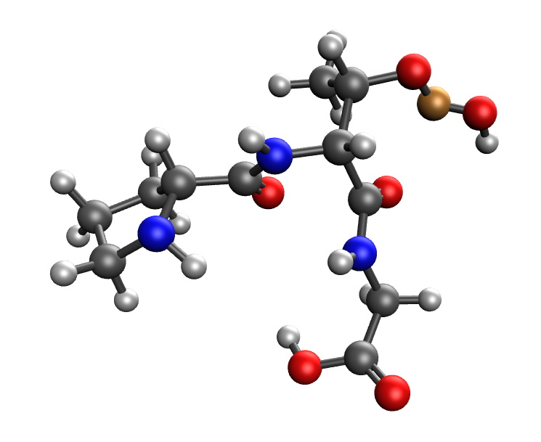 | 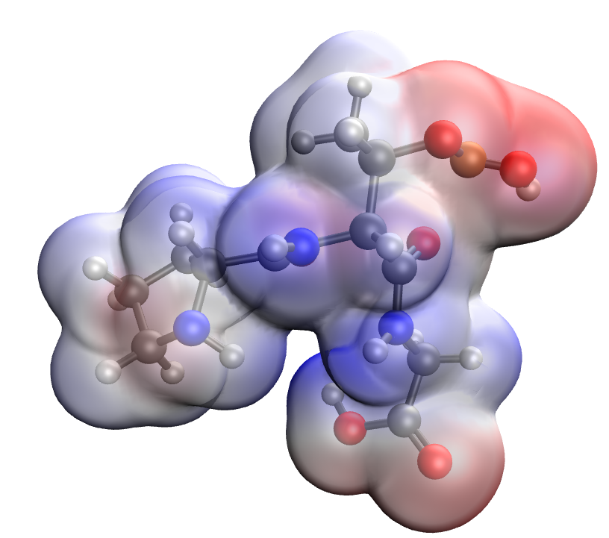
a | b
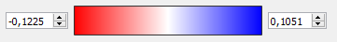
c
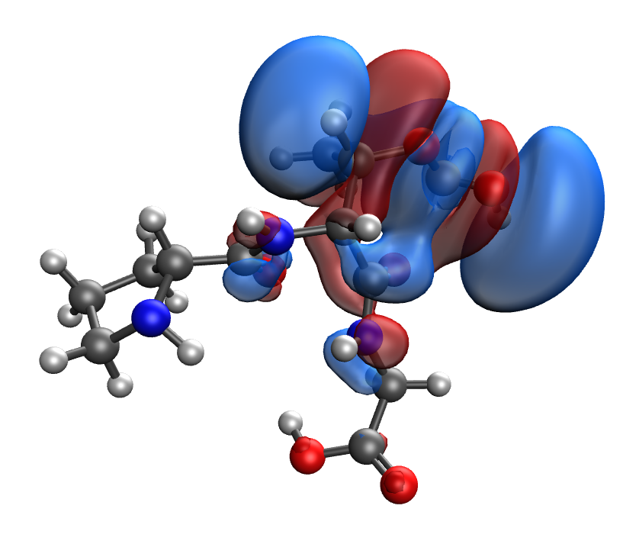 | 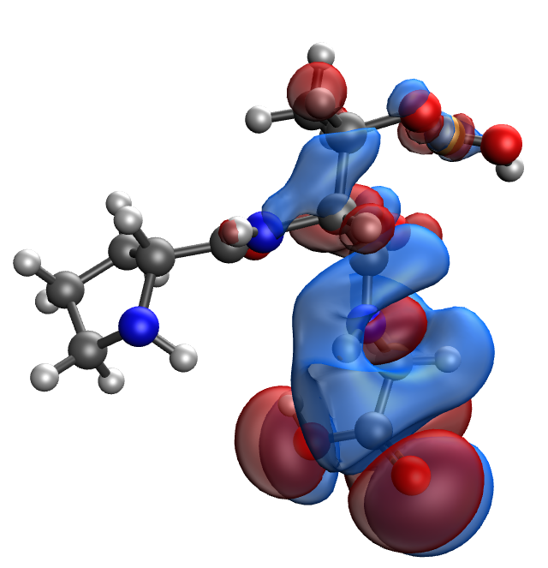
d | e
Fig. S64. Results of the quantum-chemical simulation of the Pro-Thr-Gly gelatin segment, bonded with CuO molecule: a model of the molecular complex (a), the distribution of electron density (b), electronic density distribution gradient (c), HOMO (d), LUMO (e)

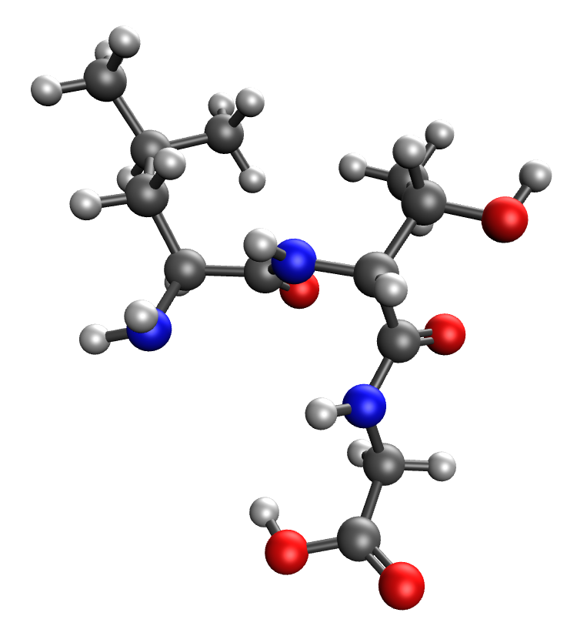 | 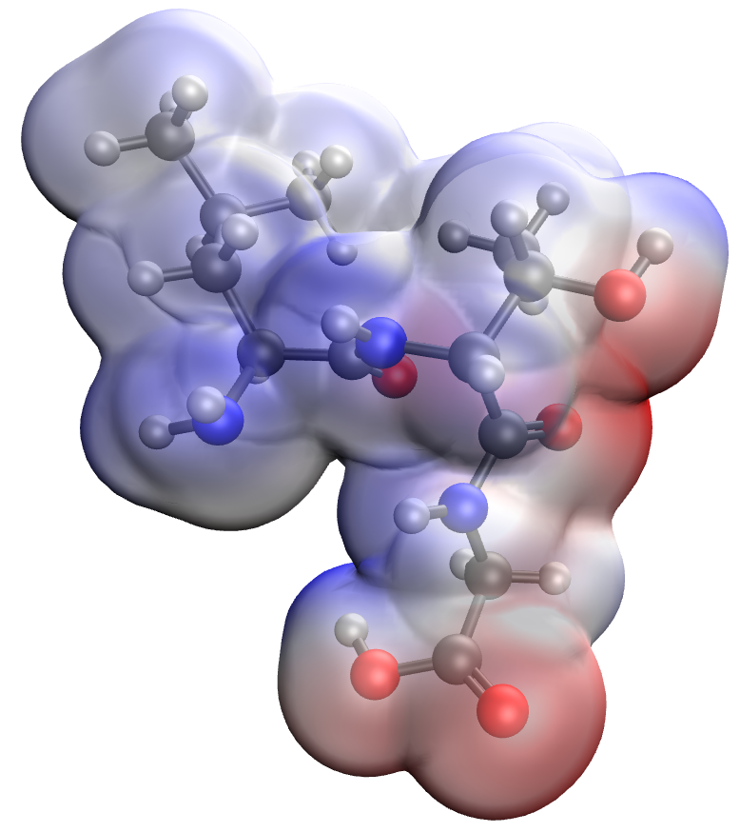
a | b
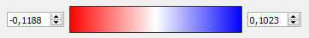
c
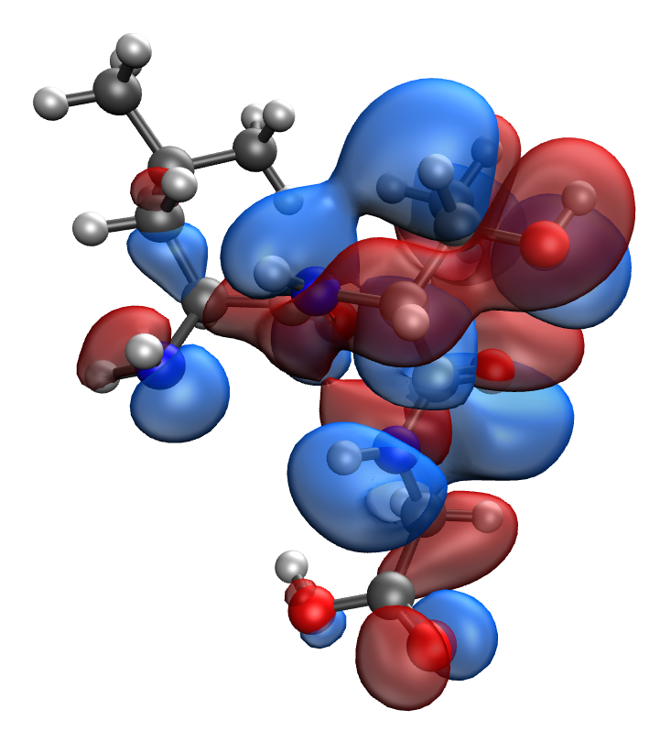 | 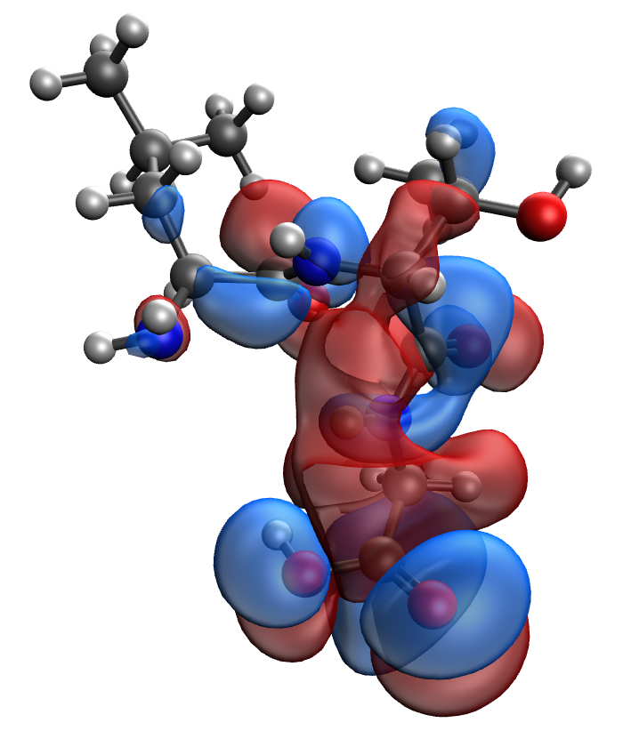
d | e
Fig. S65. Results of the quantum-chemical simulation of the Leu-Thr-Gly gelatin segment: a model of the molecular complex (a), the distribution of electron density (b), electronic density distribution gradient (c), HOMO (d), LUMO (e)

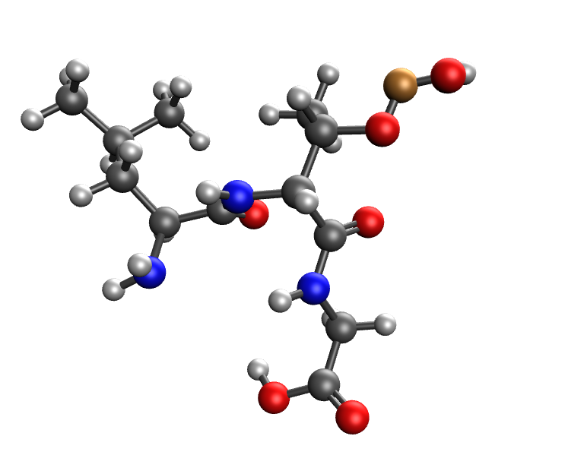 | 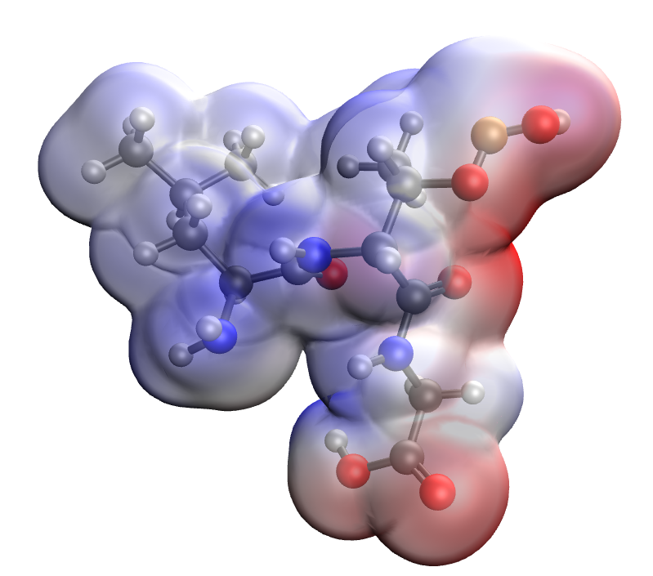
a | b
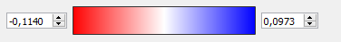
c
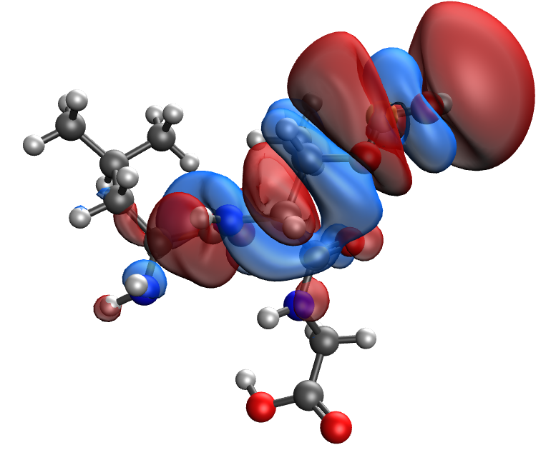 | 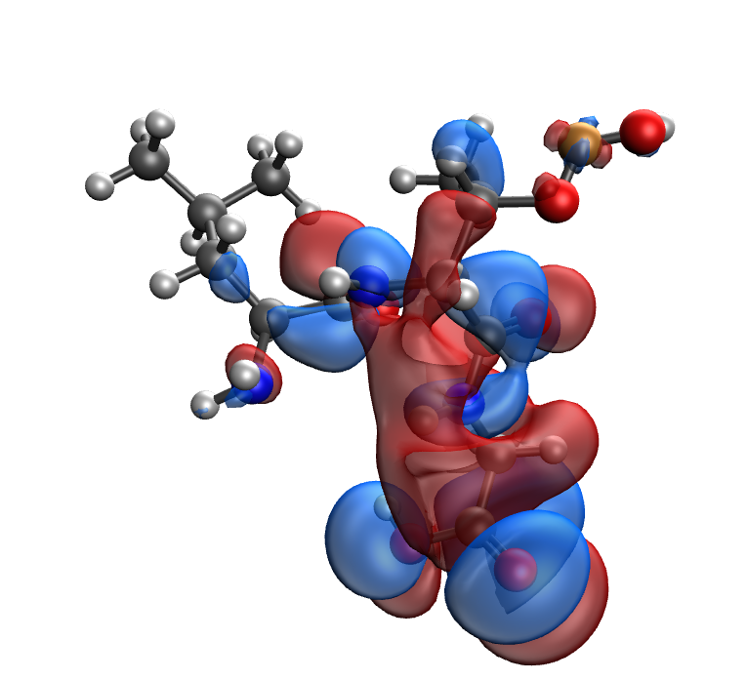
d | e
Fig. S66. Results of the quantum-chemical simulation of the Leu-Thr-Gly gelatin segment, bonded with CuO molecule: a model of the molecular complex (a), the distribution of electron density (b), electronic density distribution gradient (c), HOMO (d), LUMO (e)

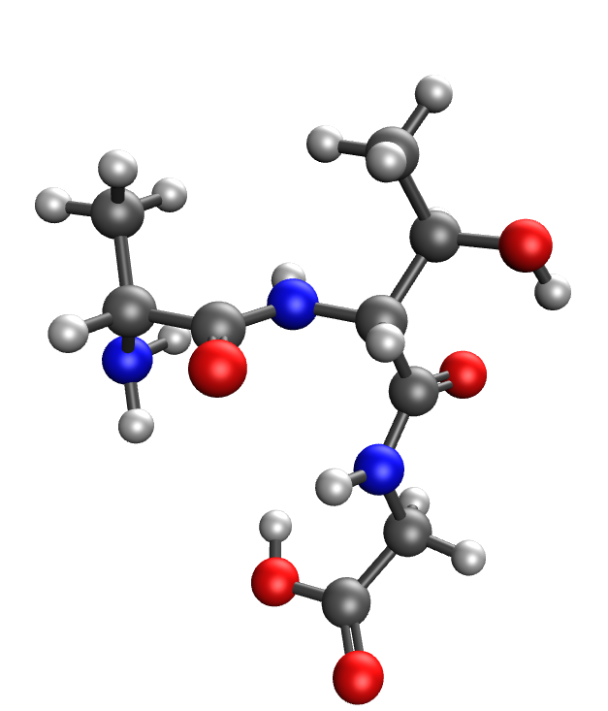 | 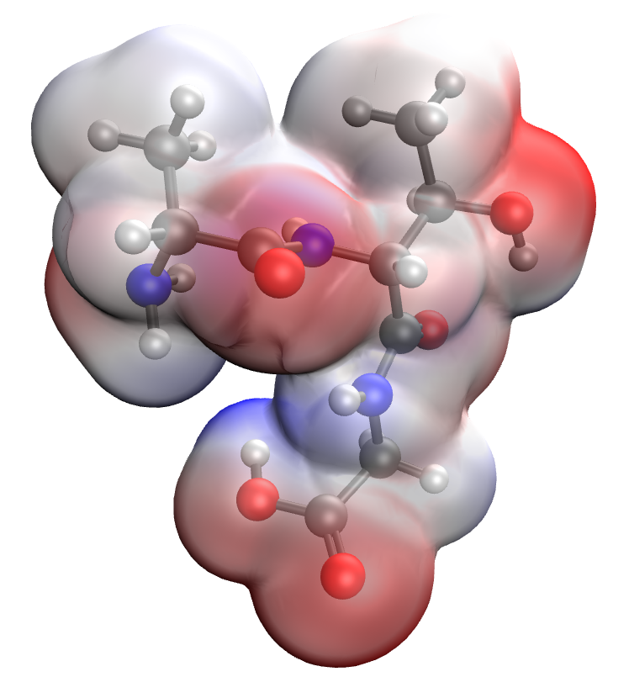
a | b
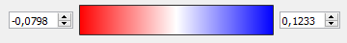
c
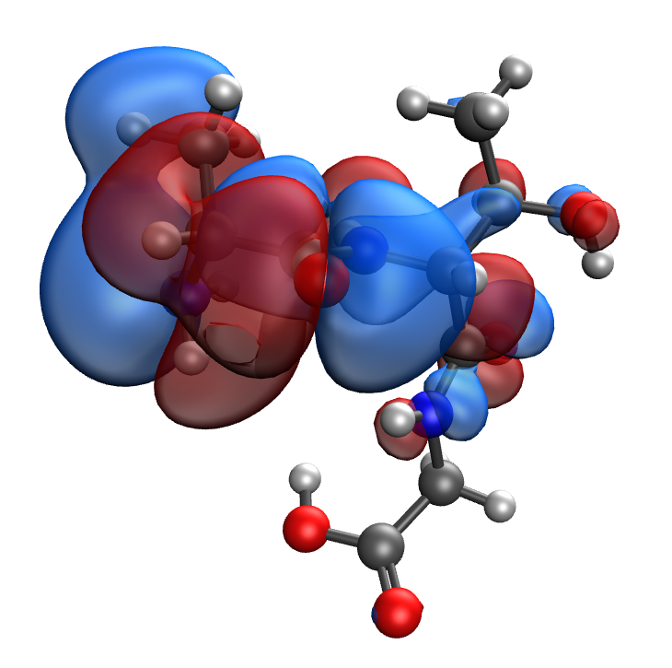 | 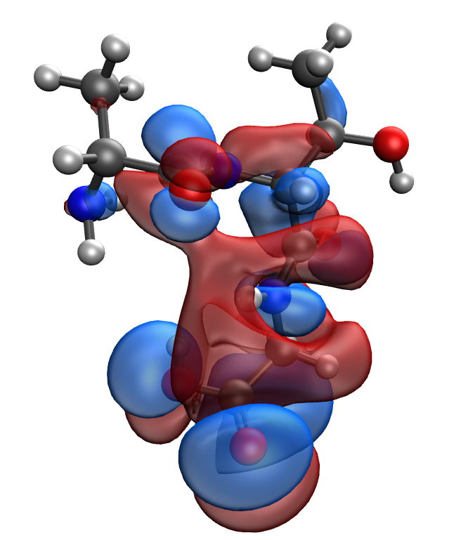
d | e
Fig. S67. Results of the quantum-chemical simulation of the Ala-Thr-Gly gelatin segment: a model of the molecular complex (a), the distribution of electron density (b), electronic density distribution gradient (c), HOMO (d), LUMO (e)

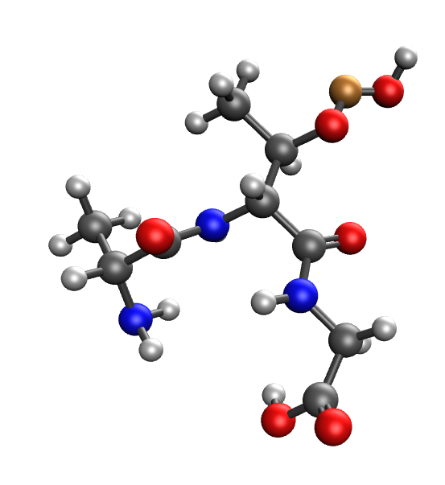 | 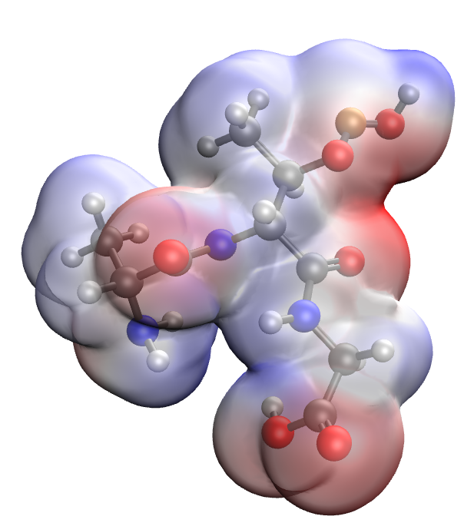
a | b
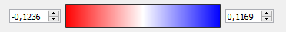
c
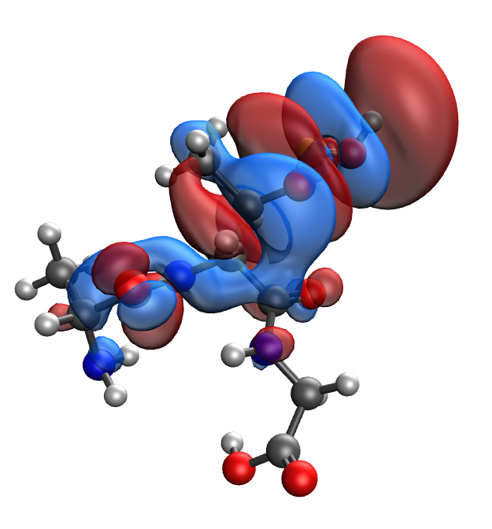 | 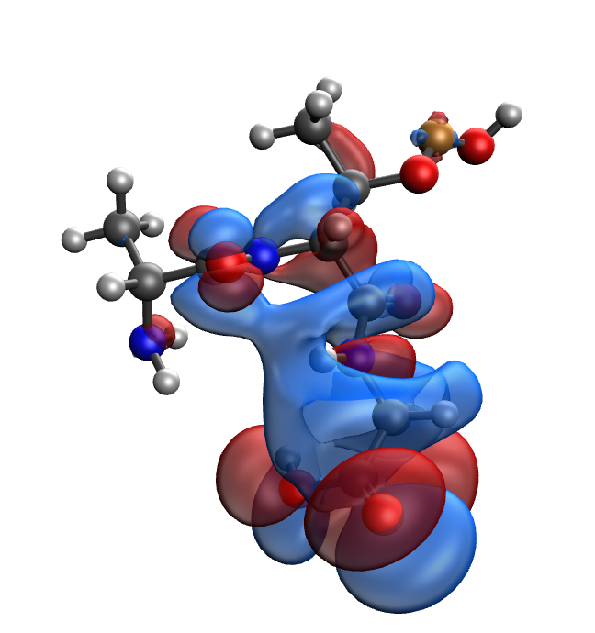
d | e
Fig. S68. Results of the quantum-chemical simulation of the Ala-Thr-Gly gelatin segment, bonded with CuO molecule: a model of the molecular complex (a), the distribution of electron density (b), electronic density distribution gradient (c), HOMO (d), LUMO (e)

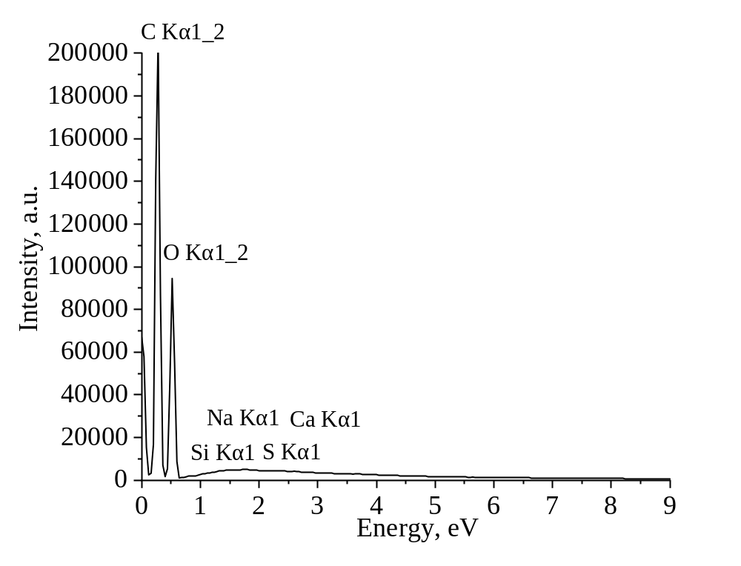
Fig. S69. Energy-dispersive spectrum of methylcellulose film (control)
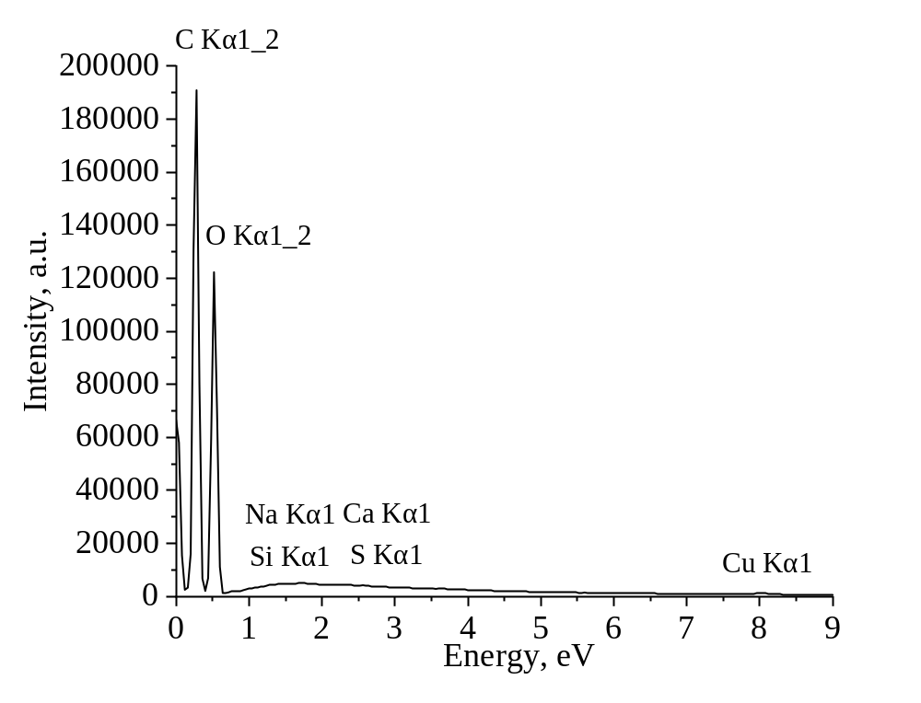
Fig. S70. Energy-dispersive spectrum of methylcellulose film modified with 0.2% CuO nanoparticles
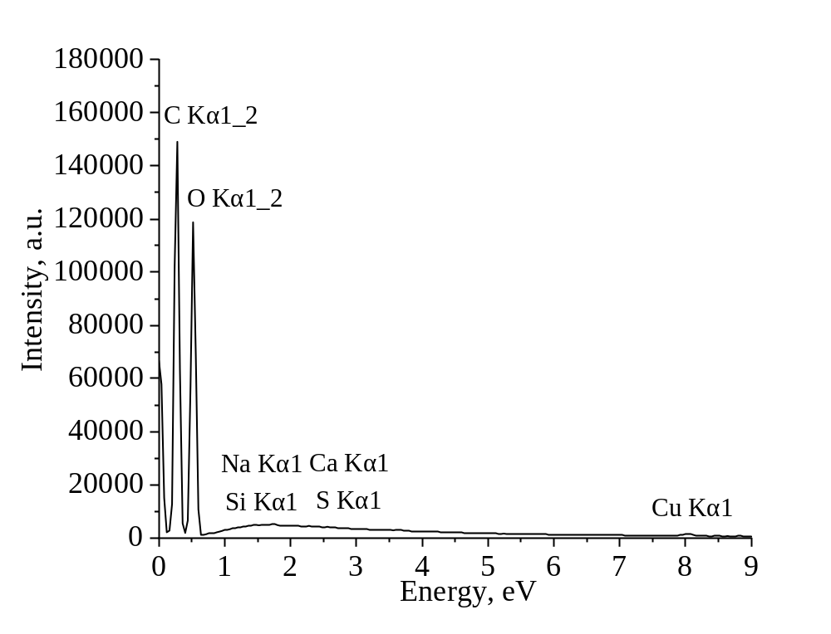
Fig. S71. Energy-dispersive spectrum of methylcellulose film modified with 0.4% CuO nanoparticles

