Tagging summary (using ExifPro and PowerPoint):
1. Tag image sequence as ‘non-identifiable’ if there are no clear images of the quolls lateral sides, otherwise proceed to step 2.
2. Determine if image sequence includes clear images of one lateral side, or both lateral sides.
3. Tag images with either a pre-existing quoll label (if images match) or with a new label.
4. Add example images of lateral spot patterns to corresponding PowerPoint slide for profiled quoll.
5. Repeat process until all images are tagged.

BOTH
ONE
4(a).
This individual quoll profile is now complete. Additional lateral images can be added as identification progresses
COMPLETE
NO
3(a).
Create a new individual quoll label (e.g. Q001)
YES
NO
YES
2.
Does the image sequence include images of one lateral side, or both lateral sides?

3(b).
Create a new individual quoll label (e.g. Q003). Replace the old tag with the new tag
2(a).
Do lateral spot patterns match with a pre-existing quoll profile (complete or semi-complete)?

SEMI-COMPLETE

1.
Does the image sequence show clear spot patterns of either/both of the quolls lateral side(s)?
3(c).
Tag image sequence to match pre-existing quoll label (e.g. Q002)

3(d).
Create a new individual quoll label, indicating that only one-side of the quoll has been profiled (e.g. L001 for left-hand side).
3(e).
Tag image sequence to match pre-existing quoll label (e.g. L001)

4(b).
This individual quoll profile is semi-complete. (e.g. left or right side only). Check images with new complete profiles as identification progresses
1(a).
Tag image sequence as ‘non-identifiable’
(e.g. NONID)
2(b).
Do lateral spot patterns match with a semi-complete quoll profile?
NO
YES

Figure S1. Flow-chart for tagging individual quolls using ExifPro and PowerPoint.

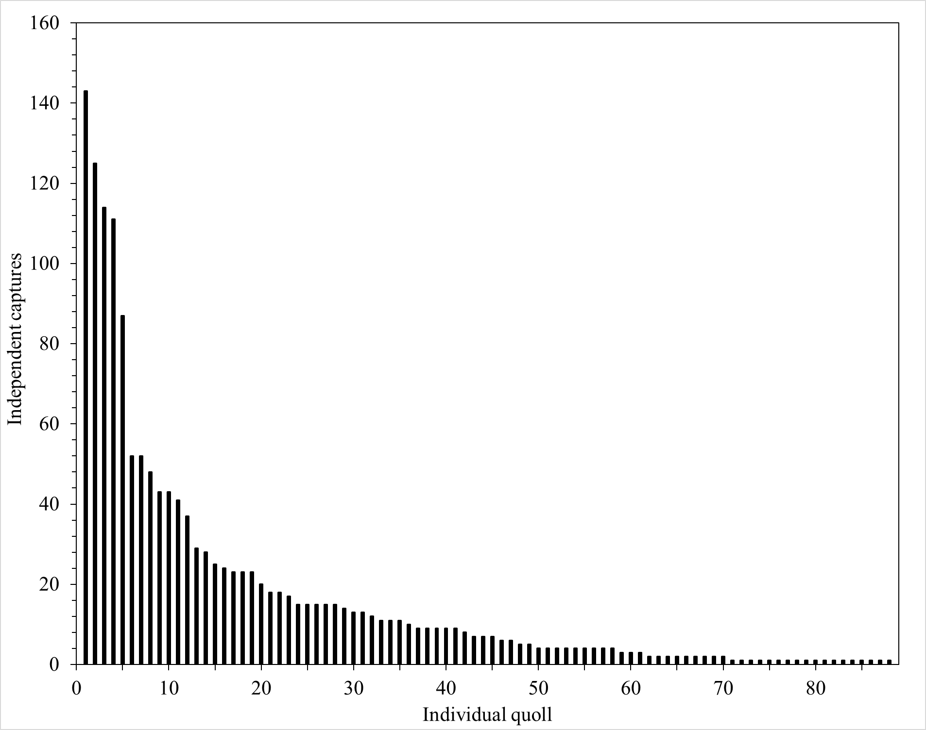
Figure S2. The number of times each individual quoll was detected at the Fragmented site. Each detection is an ‘independent event’ (≥10 mins between subsequent image sequences).
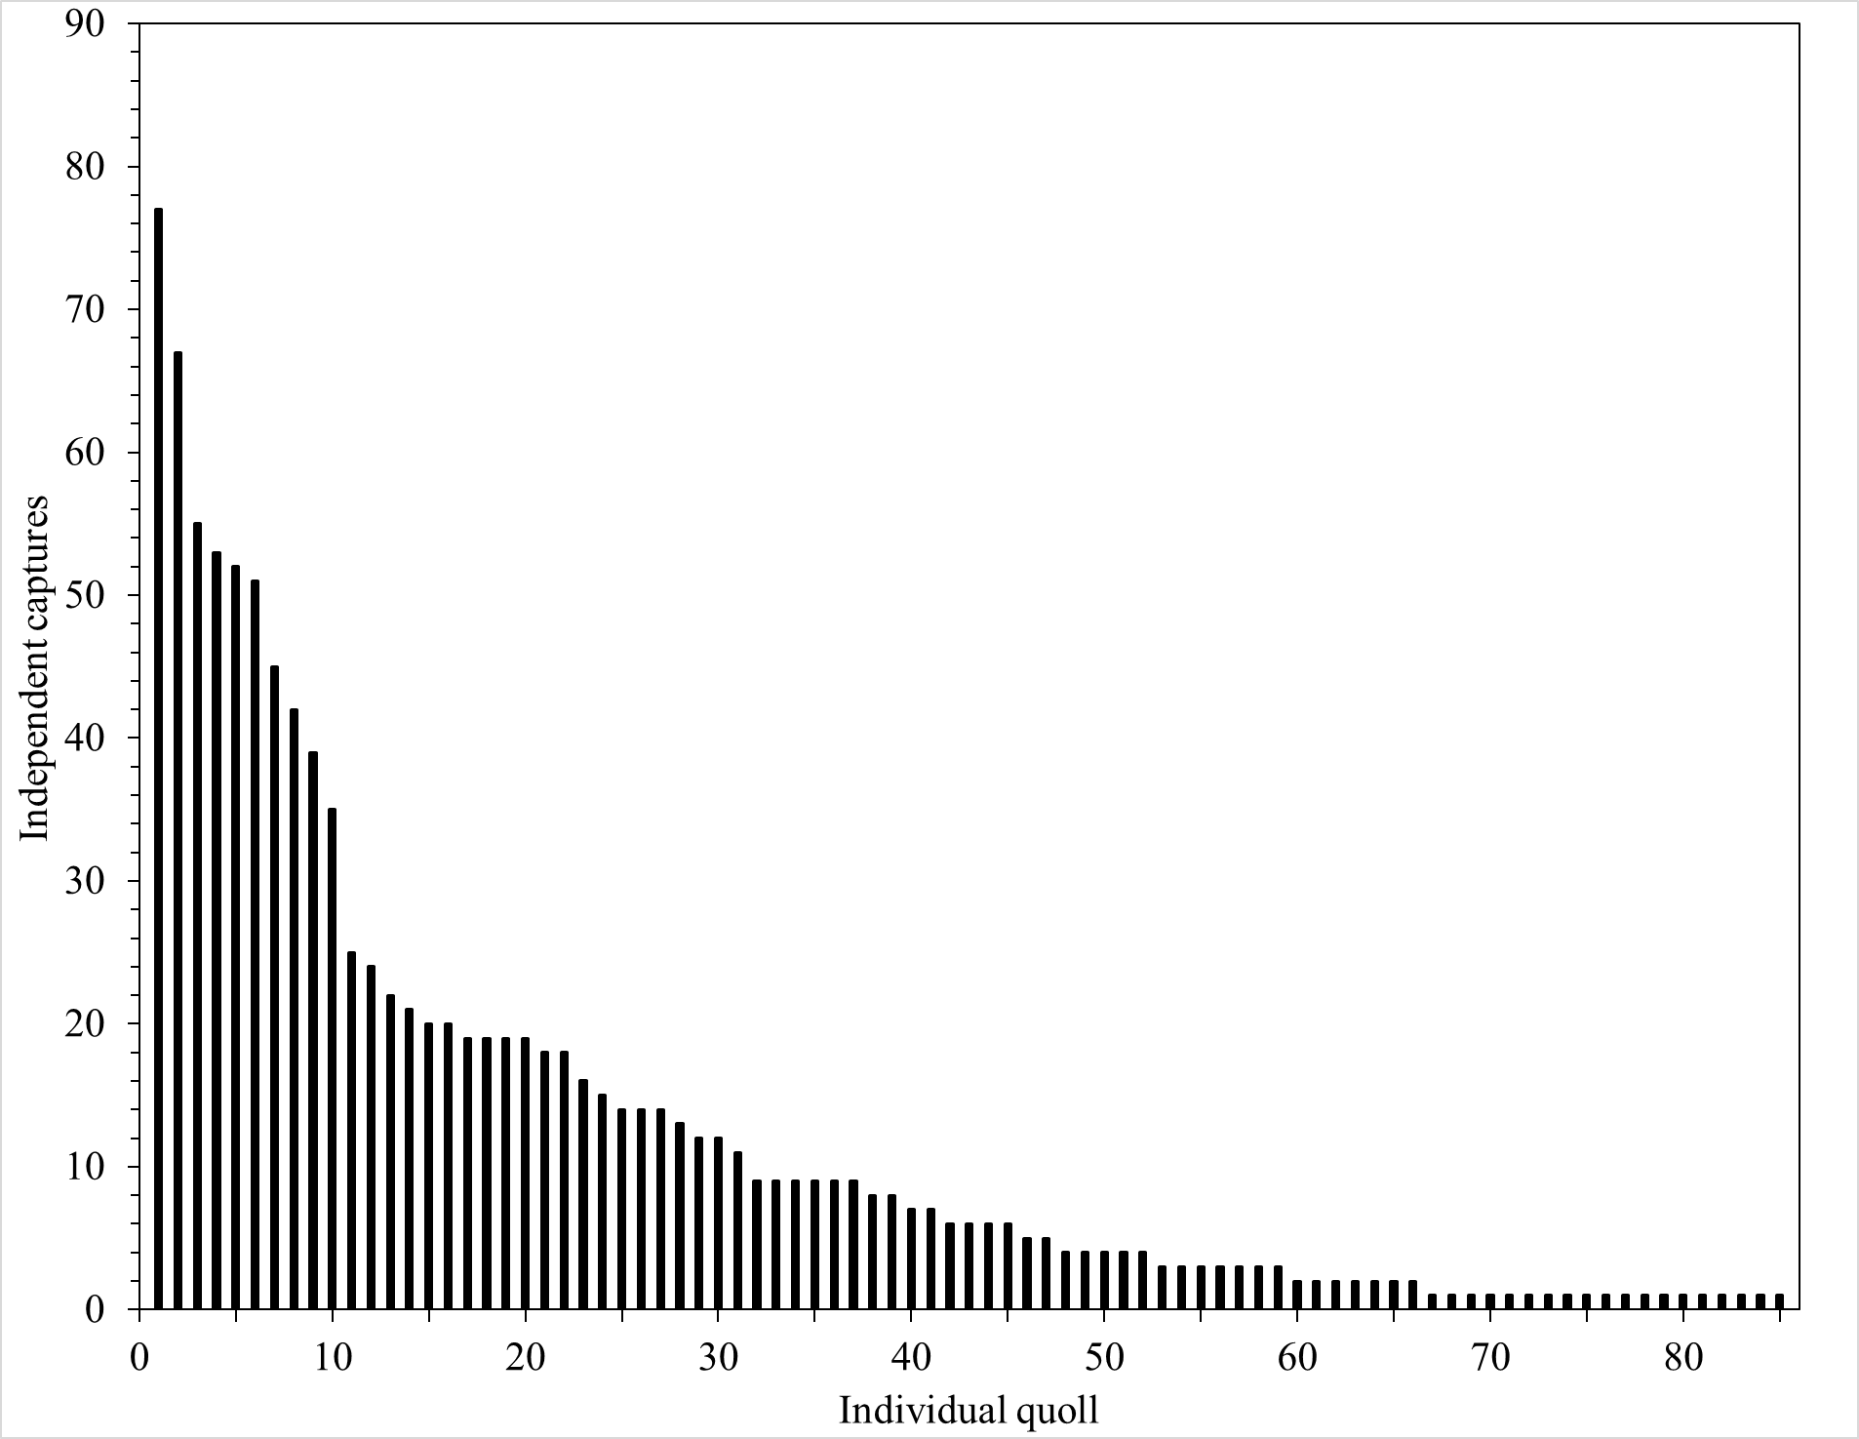
Figure S3. The number of times each individual quoll was detected at the Intact site. Each detection is an ‘independent event’ (≥10 mins between subsequent image sequences).
Table S1. Summary of spatial capture-recapture model outputs for each survey for the Fragmented site. K = total number of parameters; LL = log-likelihood; AICc = Akaike Information Criterion corrected for small sample size; ΔAICc = delta AICc; AIC wt = AICc weight.
Jul-Aug 2018
Model | K | LL | AICc | ΔAICc | AICc wt
bk | 4 | -355.89 | 722.85 | 0.00 | 1.00
0 | 3 | -364.00 | 735.72 | 12.87 | 0.00
T | 4 | -362.67 | 736.42 | 13.57 | 0.00
Bk | 4 | -363.21 | 737.50 | 14.65 | 0.00
b | 4 | -363.53 | 738.14 | 15.29 | 0.00
B | 4 | -363.94 | 738.97 | 16.12 | 0.00
Oct-Nov 2018
Model | K | LL | AICc | ΔAICc | AICc wt
T | 4 | -203.74 | 419.93 | 0.00 | 0.98
B | 4 | -208.14 | 428.73 | 8.80 | 0.01
0 | 3 | -210.68 | 429.76 | 9.83 | 0.01
bk | 4 | -209.37 | 431.18 | 11.25 | 0.00
Bk | 4 | -209.63 | 431.71 | 11.78 | 0.00
b | 4 | -210.68 | 433.80 | 13.87 | 0.00
Nov-Dec 2018
Model | K | LL | AICc | ΔAICc | AICc wt
T | 4 | -207.99 | 427.97 | 0.00 | 0.95
bk | 4 | -211.20 | 434.41 | 6.44 | 0.04
b | 4 | -212.84 | 437.69 | 9.72 | 0.01
0 | 3 | -215.19 | 438.56 | 10.59 | 0.00
B | 4 | -214.39 | 440.78 | 12.81 | 0.00
Bk | 4 | -214.76 | 441.51 | 13.54 | 0.00
Feb-Mar 2019
Model | K | LL | AICc | ΔAICc | AICc wt
0 | 3 | -215.34 | 439.08 | 0.00 | 0.45
T | 4 | -214.45 | 441.35 | 2.28 | 0.14
b | 4 | -214.61 | 441.66 | 2.58 | 0.12
bk | 4 | -214.63 | 441.70 | 2.62 | 0.12
B | 4 | -214.86 | 442.17 | 3.10 | 0.10
Bk | 4 | -215.31 | 443.06 | 3.98 | 0.06
Apr-May 2019
Model | K | LL | AICc | ΔAICc | AICc wt
bk | 4 | -429.19 | 868.12 | 0.00 | 0.97
T | 4 | -432.67 | 875.07 | 6.96 | 0.03
0 | 3 | -436.03 | 879.06 | 10.95 | 0.00
Bk | 4 | -435.81 | 881.36 | 13.24 | 0.00
B | 4 | -435.92 | 881.58 | 13.47 | 0.00
b | 4 | -435.99 | 881.73 | 13.61 | 0.00
Jun-Jul 2019
Model | K | LL | AICc | ΔAICc | AICc wt
bk | 4 | -853.70 | 1717.00 | 0.00 | 1.00
Bk | 4 | -868.44 | 1746.48 | 29.48 | 0.00
B | 4 | -875.21 | 1760.02 | 43.02 | 0.00
b | 4 | -881.22 | 1772.04 | 55.03 | 0.00
0 | 3 | -883.66 | 1774.25 | 57.25 | 0.00
T | 4 | -883.11 | 1775.81 | 58.81 | 0.00
Aug-Sep 2019
Model | K | LL | AICc | ΔAICc | AICc wt
bk | 4 | -559.23 | 1129.31 | 0.00 | 0.56
Bk | 4 | -560.42 | 1131.70 | 2.39 | 0.17
T | 4 | -560.59 | 1132.03 | 2.72 | 0.14
0 | 3 | -562.82 | 1133.24 | 3.93 | 0.08
b | 4 | -562.15 | 1135.15 | 5.84 | 0.03
B | 4 | -562.32 | 1135.49 | 6.18 | 0.03
Table S1 continued.

Oct-Dec 2019
Model | K | LL | AICc | ΔAICc | AICc wt
T | 4 | -361.98 | 738.62 | 0.00 | 1.00
B | 4 | -378.74 | 772.14 | 33.52 | 0.00
0 | 3 | -382.24 | 773.91 | 35.29 | 0.00
b | 4 | -380.09 | 774.84 | 36.22 | 0.00
Bk | 4 | -380.97 | 776.60 | 37.98 | 0.00
bk | 4 | -382.04 | 778.75 | 40.13 | 0.00
Mar-Apr 2020
Model | K | LL | AICc | ΔAICc | AICc wt
T | 4 | -314.6 | 641.5 | 0.0 | 1.0
B | 4 | -321.5 | 655.4 | 13.9 | 0.0
b | 4 | -324.9 | 662.2 | 20.7 | 0.0
0 | 3 | -327.8 | 664.0 | 22.4 | 0.0
bk | 4 | -326.2 | 664.9 | 23.4 | 0.0
Bk | 4 | -327.4 | 667.2 | 25.6 | 0.0
May-Jun 2020
Model | K | LL | AICc | ΔAICc | AICc wt
bk | 4 | -792.21 | 1594.33 | 0.00 | 1.00
Bk | 4 | -817.27 | 1644.44 | 50.11 | 0.00
T | 4 | -820.04 | 1649.99 | 55.66 | 0.00
B | 4 | -822.46 | 1654.82 | 60.49 | 0.00
0 | 3 | -824.81 | 1656.70 | 62.37 | 0.00
b | 4 | -824.20 | 1658.30 | 63.97 | 0.00
Aug-Sep 2020
Model | K | LL | AICc | ΔAICc | AICc wt
bk | 4 | -657.78 | 1327.56 | 0.00 | 1.00
T | 4 | -670.66 | 1353.31 | 25.75 | 0.00
0 | 3 | -673.98 | 1356.15 | 28.59 | 0.00
Bk | 4 | -672.95 | 1357.90 | 30.34 | 0.00
b | 4 | -673.31 | 1358.63 | 31.07 | 0.00
B | 4 | -673.39 | 1358.78 | 31.22 | 0.00
Nov-Dec 2020
Model | K | LL | AICc | ΔAICc | AICc wt
bk | 4 | -243.09 | 497.27 | 0.00 | 1.00
b | 4 | -269.07 | 549.21 | 51.95 | 0.00
Bk | 4 | -271.56 | 554.19 | 56.93 | 0.00
T | 4 | -272.88 | 556.84 | 59.58 | 0.00
0 | 3 | -276.12 | 559.95 | 62.68 | 0.00
B | 4 | -275.49 | 562.06 | 64.79 | 0.00

Table S2. Summary of spatial capture-recapture model outputs for each survey for the Intact site. K = total number of parameters; LL = log-likelihood; AICc = Akaike Information Criterion corrected for small sample size; ΔAICc = delta AICc; AIC wt = AICc weight.
Aug-Sep 2019
Model | K | LL | AICc | ΔAICc | AICc wt
b | 4 | -340.44 | 691.95 | 0.00 | 0.60
bk | 4 | -341.46 | 694.00 | 2.05 | 0.22
0 | 3 | -344.07 | 695.85 | 3.90 | 0.09
B | 4 | -342.79 | 696.67 | 4.72 | 0.06
Bk | 4 | -343.59 | 698.26 | 6.31 | 0.03
T | 4 | -344.06 | 699.20 | 7.25 | 0.02
Jan-Feb 2020
Model | K | LL | AICc | ΔAICc | AICc wt
T | 4 | -260.13 | 530.37 | 0.00 | 0.84
b | 4 | -262.55 | 535.21 | 4.85 | 0.07
bk | 4 | -262.61 | 535.33 | 4.96 | 0.07
0 | 3 | -266.16 | 539.52 | 9.15 | 0.01
Bk | 4 | -264.95 | 540.01 | 9.64 | 0.01
B | 4 | -265.88 | 541.87 | 11.50 | 0.00
Apr-May 2020
Model | K | LL | AICc | ΔAICc | AICc wt
bk | 4 | -480.60 | 971.11 | 0.00 | 0.97
b | 4 | -484.10 | 978.11 | 7.01 | 0.03
B | 4 | -487.18 | 984.26 | 13.16 | 0.00
Bk | 4 | -487.48 | 984.86 | 13.76 | 0.00
T | 4 | -487.52 | 984.94 | 13.84 | 0.00
0 | 3 | -490.79 | 988.67 | 17.56 | 0.00
Jul-Aug 2020
Model | K | LL | AICc | ΔAICc | AICc wt
bk | 4 | -834.72 | 1678.98 | 0.00 | 1.00
Bk | 4 | -854.16 | 1717.85 | 38.87 | 0.00
b | 4 | -854.74 | 1719.03 | 40.05 | 0.00
B | 4 | -855.52 | 1720.57 | 41.59 | 0.00
0 | 3 | -857.93 | 1722.75 | 43.77 | 0.00
T | 4 | -857.10 | 1723.73 | 44.75 | 0.00
Oct-Nov 2020
Model | K | LL | AICc | ΔAICc | AICc wt
T | 4 | -357.28 | 725.63 | 0.00 | 1.00
0 | 3 | -365.57 | 738.85 | 13.22 | 0.00
b | 4 | -365.19 | 741.45 | 15.83 | 0.00
Bk | 4 | -365.38 | 741.84 | 16.21 | 0.00
bk | 4 | -365.44 | 741.95 | 16.32 | 0.00
B | 4 | -365.57 | 742.21 | 16.58 | 0.00
Jan-Mar 2021
Model | K | LL | AICc | ΔAICc | AICc wt
bk | 4 | -297.46 | 605.27 | 0.00 | 0.91
T | 4 | -299.81 | 609.96 | 4.70 | 0.09
b | 4 | -303.47 | 617.29 | 12.02 | 0.00
0 | 3 | -306.92 | 621.17 | 15.90 | 0.00
Bk | 4 | -306.69 | 623.73 | 18.46 | 0.00
B | 4 | -306.90 | 624.14 | 18.88 | 0.00
May-Jun 2021
Model | K | LL | AICc | ΔAICc | AICc wt
bk | 4 | -720.71 | 1451.01 | 0.00 | 1.00
B | 4 | -730.44 | 1470.48 | 19.47 | 0.00
Bk | 4 | -734.64 | 1478.87 | 27.86 | 0.00
b | 4 | -734.87 | 1479.34 | 28.33 | 0.00
0 | 3 | -737.01 | 1480.94 | 29.93 | 0.00
T | 4 | -736.21 | 1482.03 | 31.01 | 0.00

