Supplementary Materials
Supplementary Tables

Supplementary Table 1: complete clustering results. For each solution we report the respective clustering algorithm, whether the data were normalized or used in the original CIELAB values, the number of clusters, as well as the silhouette and adjusted Rand index value.
Algorithm | Data Preprocessing | Number of Clusters | Silhouette Value | Adjusted Rand Index
Mean Shift | normalized data | 2 | 0.52770001 | 0.5633894
Mean Shift | original data | 2 | 0.48910001 | 0.48546671
K-means | original data | 4 | 0.4066 | 0.33154957
BIRCH | original data | 4 | 0.389 | 0.31465603
K-means | normalized data | 4 | 0.37239999 | 0.3811878
Hierarchical Clustering | original data | 4 | 0.3511 | 0.23090465
Hierarchical Clustering | normalized data | 4 | 0.3493 | 0.33875248
K-medoids | normalized data | 4 | 0.34195504 | 0.3811878
K-medoids | original data | 4 | 0.30958319 | 0.33154957
AP | original data | 17 | 0.30899999 | 0.09132933
SC | normalized data | 4 | 0.3089 | 0.39571553
SC | original data | 4 | 0.3044 | 0.05672896
AP | normalized data | 15 | 0.29519999 | 0.12487027
DBSCAN | original data | 1 | 0 | 0
DBSCAN | normalized data | 1 | 0 | 0
BIRTCH | normalized data | 1 | 0 | 0
OPTICS | original data | 12 | -0.2278 | -0.0009027
OPTICS | normalized data | 10 | -0.256 | 0.00462037
K-modes | original data | 4 | -0.3124 | -0.0021754
K-modes | normalized data | 4 | -0.3688 | -0.0021754

Supplementary Figures
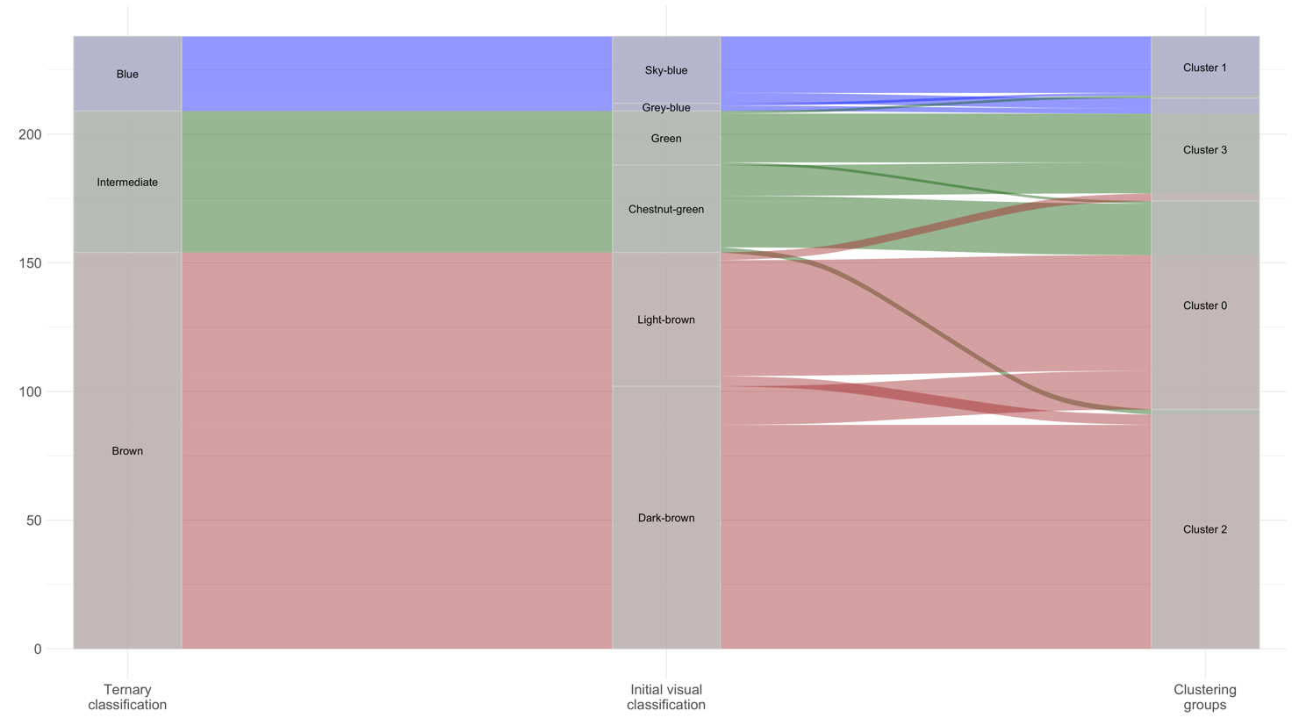
Supplementary Figure 1: alluvial plot showing sample distributions across different classifications. From left to right: ternary classification as used in the IrisPlex system, initial visual classification, and clustering groups as defined by k-means applied on the normalized CIELAB values.

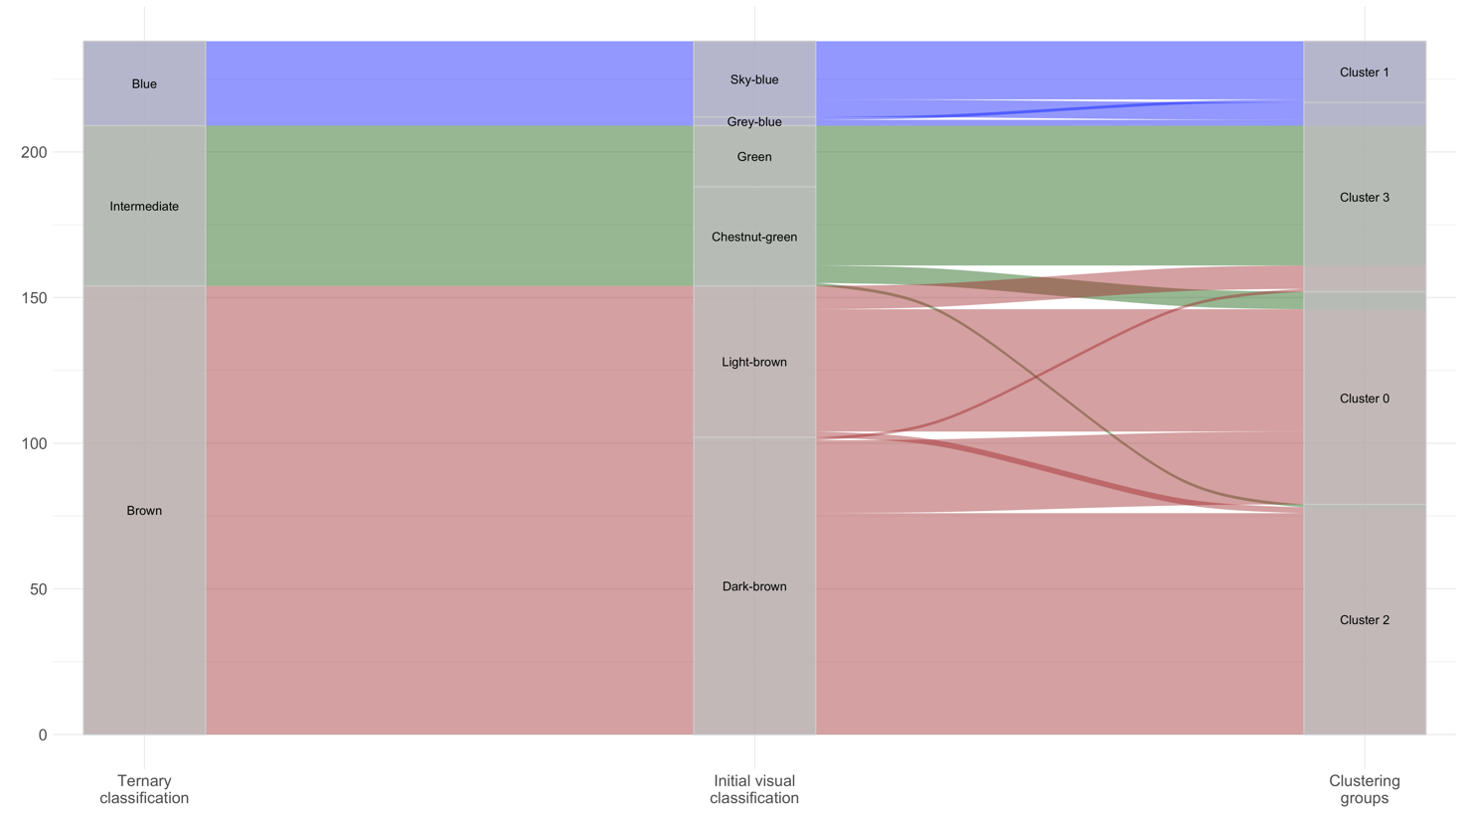
Supplementary Figure 2: alluvial plot showing sample distributions across different classifications. From left to right: ternary classification as used in the IrisPlex system, initial visual classification, and clustering groups as defined by SC applied on the normalized CIELAB values.

