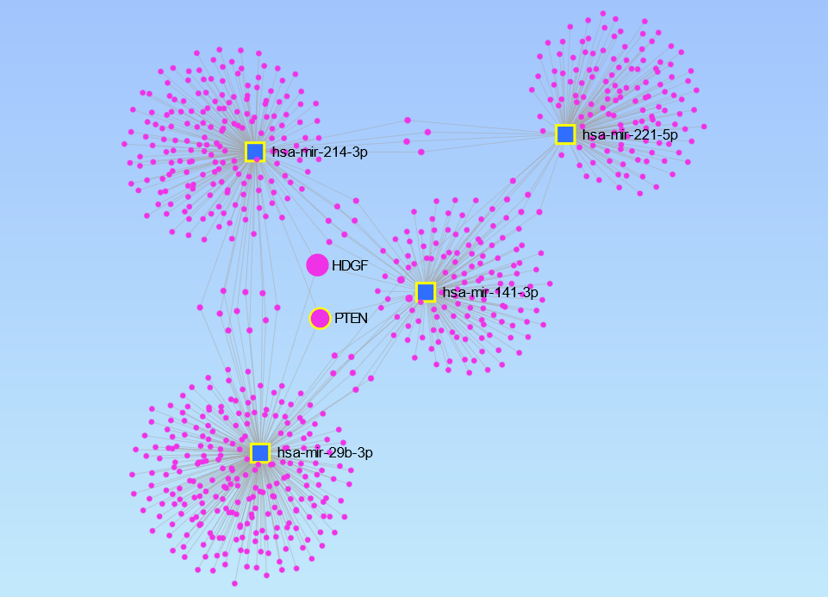
Figure S1. The relationship between four miRNAs: hsa-miR-29b-3p hsa-miR-214-3p, hsa-miR-221-5p, has-mir-141-3p, expressed in milk somatic cells, and their target genes identified using miRNet software

