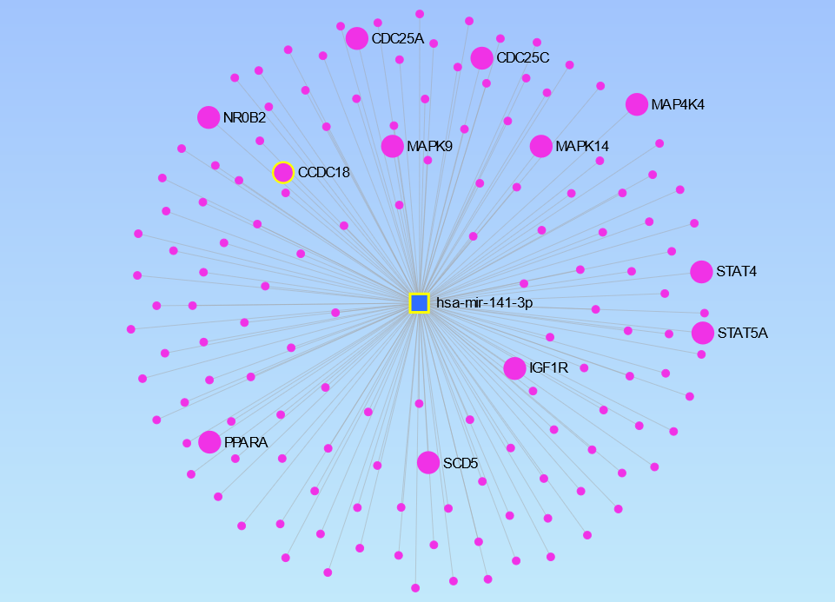
Figure S4. The target genes of has-mir-141-3p, expressed in milk somatic cells, identified using miRNet software

