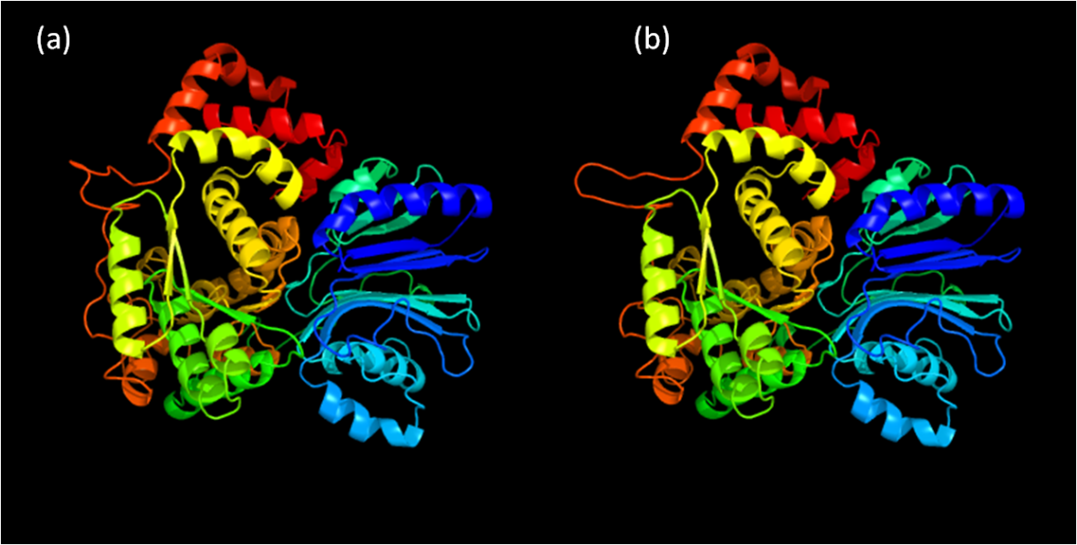
Supplementary Figure S3. Comparison of 3D structure of asparagines synthetase enzyme coded by LOC_Os03g18130 gene obtained from (a) low grain weight and (b) high grain weight genotypes. Low grain weight accession names: ARC 11571, KEYA NUNIA, JC157 and HIRA KHI. High grain weight accession names: ARC 12757, T 757, ARC 12493 and PISINI (details of the accessions are provided in supplementary file 6).

