Supplemental Information for:

Spatial and temporal variation in New Hampshire bat diets

Devon O’Rourke, Nicholas P. Rouillard, Katy L. Parise, Jeffrey T. Foster

Table of Contents:
Figure S1 | Page 2
Figure S2 | Page 3
Figure S3 | Page 4
Table S1 | Page 5
Table S2 | Page 6
Table S3 | Page 7-8
Table S4 | Page 9
Table S5 | Page 9
Table S6 | Page 11

Figure S1. Dietary richness for a single site (Fox State Forest in Hillsboro, NH, USA) in 2016 among samples collected in six time periods: sampling windows span 37 day periods, beginning in Window 3 (March 16 to April 22) and ending in Window 8 (September 17 through October 24). Richness shown for three metrics: observed OTUs (SR), Shannon’s entropy (H), and Faith’s phylogenetic diversity (PD).
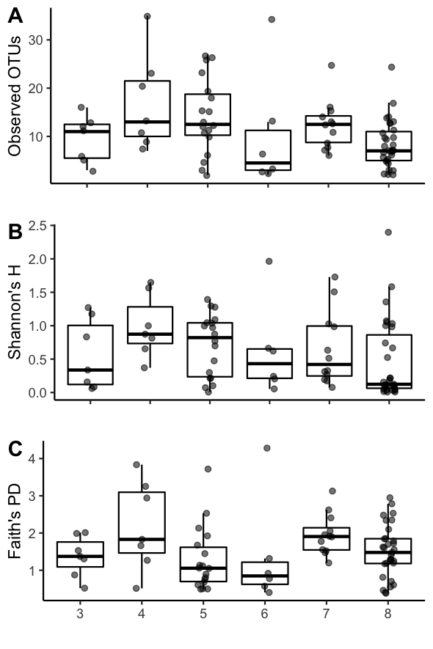

Figure S2. Dietary richness among samples collected at one of six sites in 2016 during three sampling windows beginning on Window 4 (April 23 to May 29) and ending on Window 6 (July 5 to August 11). Richness shown for three metrics: observed OTUs (SR), Shannon’s entropy (H), and Faith’s phylogenetic diversity (PD). Pairwise significant differences between each site+date group indicated by distinct letters above each group.

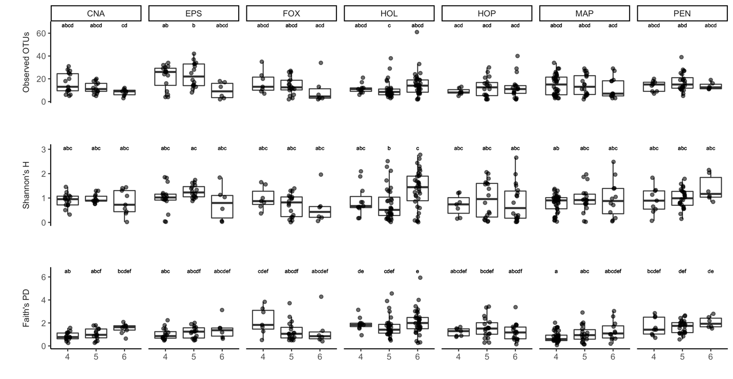

Figure S3. Indicator species analysis among samples collected at one of six sites in 2016 during three sampling windows beginning on Window 4 (April 23 to May 29) and ending on Window 6 (July 5 to August 11). Analysis to identify particular diet items distinguishing a group conducted separately for sites only, sampling windows only, and for site+window groups.

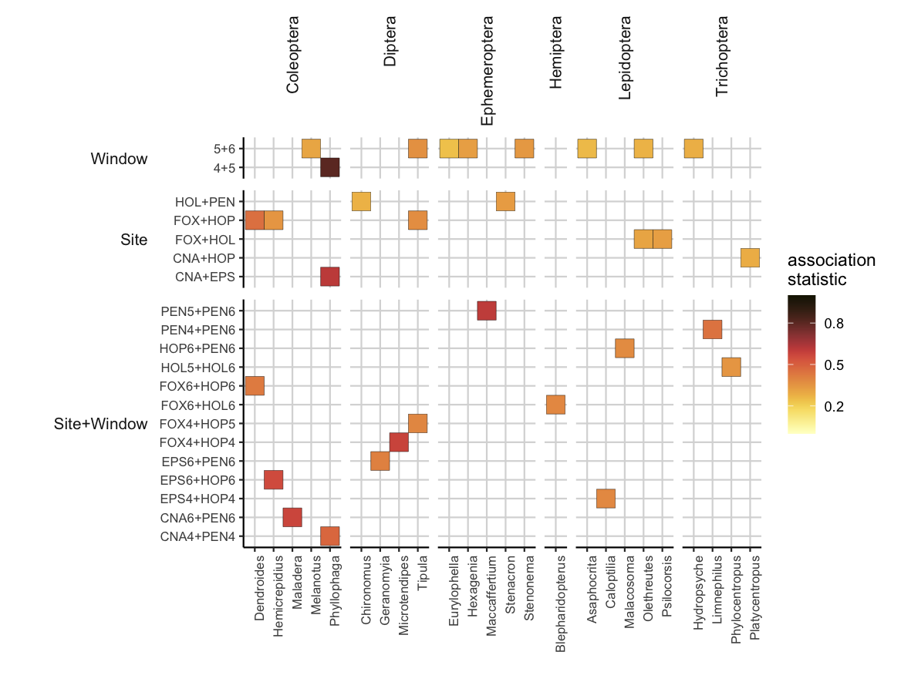

Table S1. Comparison the number of samples collected relative to number of samples that passed quality controls for analyses in study, per site, per year species.

Site | collected2015 | evaluated2015 | collected2016 | evaluated2016
ALS | .. | .. | 150 | 43
BRN | 144 | 11 | 264 | 49
CHI | .. | .. | 240 | 46
CNA | .. | .. | 122 | 38
CNB | .. | .. | 194 | 38
COR | 71 | 20 | 73 | 24
EPS | .. | .. | 240 | 42
FOX | 94 | 16 | 337 | 82
GIL | 23 | 5 | 48 | 16
GRN | 48 | 2 | .. | ..
HOL | .. | .. | 264 | 80
HOP | 191 | 28 | 335 | 58
MAP | 140 | 16 | 252 | 73
MAS | 82 | 12 | 188 | 4
MTV | .. | .. | 203 | 68
PEN | .. | .. | 118 | 39
ROL | .. | .. | 24 | ..
SWZ | 139 | 45 | .. | ..
WLD | 131 | 23 | .. | ..
WLT | 105 | 21 | .. | ..

Table S2. Comparison of number of samples available for analysis per site per year per sampling window. Top row represents sampling year (2015 and 2016), second row represents sampling window (5-8, and 3-9). Sampling windows span 37 day periods, beginning in Window 3 (March 16 to April 22) and ending in Window 8 (September 17 through October 24).

 | 2015 |  |  |  | 2016
Site | 5 | 6 | 7 | 8 | 3 | 4 | 5 | 6 | 7 | 8 | 9
ALS | 0 | 0 | 0 | 0 | 0 | 0 | 0 | 18 | 22 | 3 | 0
BRN | 0 | 5 | 6 | 0 | 0 | 30 | 14 | 4 | 1 | 0 | 0
CHI | 0 | 0 | 0 | 0 | 0 | 0 | 12 | 15 | 19 | 0 | 0
CNA | 0 | 0 | 0 | 0 | 0 | 15 | 13 | 10 | 0 | 0 | 0
CNB | 0 | 0 | 0 | 0 | 0 | 4 | 17 | 8 | 9 | 0 | 0
COR | 2 | 12 | 6 | 0 | 0 | 0 | 0 | 20 | 4 | 0 | 0
EPS | 0 | 0 | 0 | 0 | 0 | 16 | 16 | 6 | 4 | 0 | 0
FOX | 3 | 8 | 5 | 0 | 7 | 7 | 18 | 6 | 12 | 31 | 1
GIL | 0 | 3 | 0 | 2 | 0 | 10 | 6 | 0 | 0 | 0 | 0
GRN | 2 | 0 | 0 | 0 | 0 | 0 | 0 | 0 | 0 | 0 | 0
HOL | 0 | 0 | 0 | 0 | 0 | 11 | 32 | 34 | 2 | 1 | 0
HOP | 5 | 13 | 6 | 4 | 5 | 7 | 18 | 18 | 0 | 10 | 0
MAP | 3 | 9 | 4 | 0 | 0 | 36 | 18 | 12 | 0 | 7 | 0
MAS | 1 | 10 | 1 | 0 | 0 | 1 | 1 | 2 | 0 | 0 | 0
MTV | 0 | 0 | 0 | 0 | 0 | 0 | 22 | 13 | 16 | 17 | 0
PEN | 0 | 0 | 0 | 0 | 0 | 9 | 24 | 6 | 0 | 0 | 0
SWZ | 5 | 24 | 16 | 0 | 0 | 0 | 0 | 0 | 0 | 0 | 0
WLD | 6 | 15 | 2 | 0 | 0 | 0 | 0 | 0 | 0 | 0 | 0
WLT | 5 | 4 | 12 | 0 | 0 | 0 | 0 | 0 | 0 | 0 | 0

Table S3. Table of most frequently detected OTUs (exact sequence variants clustered at 98.5% identity). Showing the number and fraction of OTUs detected across all samples in the study along with taxonomic information (taxonomic Order, Genus, and Species, when applicable), as well as the OTU alias used as the identifier through the manuscript. OTUid represents the QIIME-specific alphanumeric key assigned to a unique OTU, which can be used when accessing raw data records available in the Zenodo archive.

Order | Genus | Species | # Samples with OTU | % Samples with OTU | OTUalias | OTUid
Blattodea | Parcoblatta | Parcoblatta uhleriana | 53 | 0.05895439 | OTU-49 | 7cee309d88263cb90811fe24f627aeae
Coleoptera | Dendroides | Dendroides canadensis | 181 | 0.20133482 | OTU-10 | 92e807f319442dd87ddae1a3f7725e65
Coleoptera | Dendroides | Dendroides canadensis | 47 | 0.05228031 | OTU-153 | 15026701e67c14acc6da34251e1b8ec4
Coleoptera | Dendroides | Dendroides canadensis | 45 | 0.05005562 | OTU-168 | 0bb64283957e498be2b9cd8fa3d18c95
Coleoptera | Dendroides | Dendroides concolor | 60 | 0.06674082 | OTU-50 | 04f0c5769fcb09d7d91f7e73a349518c
Coleoptera | Diplotaxis | NA | 183 | 0.20355951 | OTU-9 | dacf098cf73e7cf3e16a1d89287188f6
Coleoptera | Diplotaxis | NA | 59 | 0.06562848 | OTU-57 | 873a3d186ca2bfa1fc2c503b59c0d0e9
Coleoptera | Diplotaxis | NA | 58 | 0.06451613 | OTU-103 | a7b90c8d4da7f7087ba278f514194ca6
Coleoptera | Hemicrepidius | Hemicrepidius brevicollis | 50 | 0.05561735 | OTU-54 | 44ff1f1258c5ae73633dd2536fc3a50b
Coleoptera | Hemicrepidius | Hemicrepidius memnonius | 250 | 0.27808676 | OTU-4 | 80c4d80457fcc8395bbccc4f364533a8
Coleoptera | Labarrus | Labarrus cincticulus | 59 | 0.06562848 | OTU-62 | c4afba60302c265bd32b9ef5846b7377
Coleoptera | Maladera | Maladera castanea | 330 | 0.36707453 | OTU-1 | c5098366c5ba2170bb0bdbb4ebb969cf
Coleoptera | Melanotus | Melanotus hyslopi | 75 | 0.08342603 | OTU-132 | ddfa0472353451578d9575aab094716a
Coleoptera | Phyllophaga | Phyllophaga anxia | 203 | 0.22580645 | OTU-7 | dd8ead02d602f21e3650a1dfafdbf815
Coleoptera | Phyllophaga | Phyllophaga anxia | 52 | 0.05784205 | OTU-73 | 6eaae078420e552cc363c5f4780aa6fc
Coleoptera | Phyllophaga | Phyllophaga hirsuta | 378 | 0.42046719 | OTU-2 | 8aa059190885cb9440084a9821d998bd
Coleoptera | Phyllophaga | Phyllophaga hirsuta | 244 | 0.27141268 | OTU-6 | 9b325409d4145b3b0e225a2898c95d4e
Coleoptera | Phyllophaga | Phyllophaga hirsuta | 146 | 0.16240267 | OTU-45 | dfca7860c63a33d7c089f71282707255
Coleoptera | Phyllophaga | Phyllophaga hirsuta | 116 | 0.12903226 | OTU-110 | ec9f8a7eb5d4108a2dbf70de19089914
Coleoptera | Phyllophaga | Phyllophaga hirsuta | 112 | 0.12458287 | OTU-98 | 581908a907d4a43569ff7ab27e81d92f
Coleoptera | Phyllophaga | Phyllophaga hirsuta | 80 | 0.08898776 | OTU-141 | 4520bec9094a2cd39253c1583cd34316
Coleoptera | Phyllophaga | Phyllophaga hirsuta | 79 | 0.08787542 | OTU-56 | 164c6d1dc6dc62f3a5a9ab952da44f11
Coleoptera | Phyllophaga | Phyllophaga hirsuta | 69 | 0.07675195 | OTU-155 | cfca0b93157741b1761a48c2ef432007
Coleoptera | Phyllophaga | Phyllophaga hirsuta | 56 | 0.06229143 | OTU-147 | 4995a74b93fbcbd4863b8c90d9a203e3
Coleoptera | Phyllophaga | Phyllophaga hirsuta | 49 | 0.05450501 | OTU-247 | ee3a6834c427e1b13790f3cffa05b7e5
Coleoptera | Phyllophaga | Phyllophaga hirsuta | 47 | 0.05228031 | OTU-184 | 69b5f37bc81d188104e8bb4752dcf91a
Coleoptera | Phyllophaga | Phyllophaga longispina | 111 | 0.12347052 | OTU-84 | 3449f6fcaac748b5a36c5669bd41c07c
Coleoptera | Phyllophaga | Phyllophaga longispina | 95 | 0.10567297 | OTU-89 | aafdb90962b5cf3f0dec2723b4a51d1e
Coleoptera | Phyllophaga | NA | 121 | 0.13459399 | OTU-93 | 7a7a22fee1f403b540ef56bdd72730a3
Coleoptera | Phyllophaga | NA | 121 | 0.13459399 | OTU-95 | c805d4e616ccda7232cf489692e7448f
Coleoptera | Phyllophaga | NA | 98 | 0.10901001 | OTU-129 | 31a28ac06c612e1cffa640ba7458a875
Coleoptera | Phyllophaga | NA | 92 | 0.10233593 | OTU-122 | 129778c8e844bed04c1422b5a25ad7a5
Coleoptera | Phyllophaga | NA | 46 | 0.05116796 | OTU-257 | 726042bb37839f5b9b9337e9ba2d2606
Diptera | Chaoborus | Chaoborus punctipennis | 52 | 0.05784205 | OTU-53 | af2ab83b85a6265e8a1e56410e308ebf
Diptera | Chironomus | NA | 72 | 0.08008899 | OTU-15 | d60fd5104a3b25d195a9f6b2f97879b8
Diptera | Erioptera | Erioptera caliptera | 53 | 0.05895439 | OTU-12 | d18b9b0d9c0501fc4310fd74dbfc5a16
Diptera | Pseudolimnophila | NA | 62 | 0.06896552 | OTU-17 | ac6327a1ae9883cd711b1540091ab15e
Diptera | Tipula | NA | 78 | 0.08676307 | OTU-36 | 2fcdfe59f27b507c180020747d4c77da
Diptera | Tipula | NA | 74 | 0.08231368 | OTU-68 | 61d776536df85afa044e4b7b6f7ea839
Diptera | NA | NA | 75 | 0.08342603 | OTU-19 | 1b18a4671325538a4ab7b6f3f4315195
Ephemeroptera | Hexagenia | Hexagenia limbata | 105 | 0.11679644 | OTU-16 | 3bccc7419ed71054e8d594ffa35fe0c6
Ephemeroptera | Stenacron | Stenacron interpunctatum | 52 | 0.05784205 | OTU-61 | 2050295dd1918980f7eb677368198625
Ephemeroptera | Stenonema | Stenonema femoratum | 75 | 0.08342603 | OTU-14 | d52aa99985f4de1593549d5f2e0b7cbd
Lepidoptera | Agonopterix | NA | 57 | 0.06340378 | OTU-3 | 73d24c9b0eca55bcce443e60c5639b37
Lepidoptera | Amphipyra | Amphipyra pyramidoides | 54 | 0.06006674 | OTU-29 | eb3a4a579b410351b538a2510c37a56c
Lepidoptera | Caloptilia | Caloptilia alnivorella | 77 | 0.08565072 | OTU-18 | 2224f202213b63a097f0a8b32859850f
Lepidoptera | Eucopina | Eucopina tocullionana | 86 | 0.09566185 | OTU-13 | bb7a70bd300d349afb79afa8797e76e7
Lepidoptera | Olethreutes | Olethreutes fasciatana | 54 | 0.06006674 | OTU-38 | 1599b1cb541938729b721f96e6118499
Megaloptera | Chauliodes | Chauliodes pectinicornis | 64 | 0.07119021 | OTU-127 | df673a0b19267b9b666b868a983f14fa
Trichoptera | Hydropsyche | Hydropsyche sparna | 68 | 0.0756396 | OTU-71 | e1220ee8629ff7ecaff92f6010a848d9
Trichoptera | Platycentropus | Platycentropus radiatus | 70 | 0.07786429 | OTU-25 | 65c16f3bd80e055bfeff00f11a6fade1

Table S4. PERMANOVA analysis investigating main effects of sampling period (Window) at a single site: Fox State Forest in Hillsboro, NH, USA; the site with the most complete collection data, for 2016 only. Showing PERMANOVA results for Adonis test using a distance metric without phylogenetic information (Dice-Sorensen) and with phylogenetic signal (UniFrac Unweighted).
Class | Df | Sum.Sq | F.value | R2 | Pr..F. | Metric
Window | 5 | 7.709 | 4.311 | 0.223 | 0.001 | Dice-Sorensen
Residual | 75 | 26.823 | NA | 0.777 | NA | Dice-Sorensen
Total | 80 | 34.532 | NA | 1 | NA | Dice-Sorensen
Window | 5 | 4.686 | 3.429 | 0.186 | 0.001 | UniFrac Unweighted
Residual | 75 | 20.503 | NA | 0.814 | NA | UniFrac Unweighted
Total | 80 | 25.189 | NA | 1 | NA | UniFrac Unweighted

Table S5. PERMANOVA analysis investigating main effects of diet composition across multiple sampling sites (Site) and sampling periods (Window) for 2016 only. Showing PERMANOVA results for Adonis test using a distance metric without phylogenetic information (Dice-Sorensen) and with phylogenetic signal (UniFrac Unweighted).

Class | Df | Sum.Sq | R2 | F.value | Pr..F. | Metric | WindowGroup
Site | 6 | 17.231 | 0.126 | 8.626 | 0.001 | Dice-Sorensen | windows456
Window | 2 | 6.533 | 0.048 | 9.81 | 0.001 | Dice-Sorensen | windows456
Site:Window | 12 | 10.031 | 0.073 | 2.511 | 0.001 | Dice-Sorensen | windows456
Residual | 310 | 103.214 | 0.753 | NA | NA | Dice-Sorensen | windows456
Total | 330 | 137.009 | 1 | NA | NA | Dice-Sorensen | windows456
Site | 6 | 13.7 | 0.139 | 9.689 | 0.001 | UniFrac-Unweighted | windows456
Window | 2 | 4.946 | 0.05 | 10.495 | 0.001 | UniFrac-Unweighted | windows456
Site:Window | 12 | 7.064 | 0.072 | 2.498 | 0.001 | UniFrac-Unweighted | windows456
Residual | 310 | 73.056 | 0.74 | NA | NA | UniFrac-Unweighted | windows456
Total | 330 | 98.766 | 1 | NA | NA | UniFrac-Unweighted | windows456

Table S6. Indicator species analysis showing the number of genus-level taxa significantly associated to a particular Site and/or Sampling Window. For example, the site at Holderness, NH (HOL) contained the largest number of genera associated to that location (18) at any sampling date, whereas sampling window 6 contained the largest number of genera associated at a particular time interval across any sampling location.

Group | Index | # Significant Taxa
Site | HOL | 18
Site | FOX | 5
Site | HOP | 5
Site | FOX+HOP | 3
Site | PEN | 3
Site | FOX+HOL | 2
Site | HOL+PEN | 2
Site | MAP | 2
Site | CNA | 1
Site | CNA+EPS | 1
Site | CNA+HOP | 1
Site | EPS | 1
Site+Window | HOL4 | 6
Site+Window | HOL6 | 5
Site+Window | HOL5 | 2
Site+Window | PEN6 | 2
Site+Window | CNA4+PEN4 | 1
Site+Window | CNA6 | 1
Site+Window | CNA6+PEN6 | 1
Site+Window | EPS4+HOP4 | 1
Site+Window | EPS5 | 1
Site+Window | EPS6 | 1
Site+Window | EPS6+HOP6 | 1
Site+Window | EPS6+PEN6 | 1
Site+Window | FOX4 | 1
Site+Window | FOX4+HOP4 | 1
Site+Window | FOX4+HOP5 | 1
Site+Window | FOX6 | 1
Site+Window | FOX6+HOL6 | 1
Site+Window | FOX6+HOP6 | 1
Site+Window | HOL5+HOL6 | 1
Site+Window | HOP4 | 1
Site+Window | HOP6+PEN6 | 1
Site+Window | MAP4 | 1
Site+Window | MAP6 | 1
Site+Window | PEN4+PEN6 | 1
Site+Window | PEN5+PEN6 | 1
Window | 6 | 26
Window | 5+6 | 8
Window | 4 | 7
Window | 4+5 | 1
Window | 5 | 1

