Supplementary figures
Supplementary Fig. 1.
a, SDS-PAGE of Japanese basket clam boiled soup. Coomassie Brilliant Blue staining, gel purification, trypsin treatment, and analysis using MALDI-TOF-MS. The protein was identified as tropomyosin (P43689) in Biomphalaria glabrata. b, c, Re-analysis of MALDI-TOF-MS/MS data using the amino acid sequence of tropomyosin from Japanese basket clams (Corbicula japonica). b and c are the results obtained using proteins purified from different bands. SDS-PAGE of d, Japanese oyster (upper band) and e, Japanese oyster (lower band) boiled soup. Coomassie Brilliant Blue staining, gel purification, trypsin treatment, and analysis using MALDI-TOF-MS. The proteins were identified as tropomyosin in Chlamys nipponensis and Perna viridis, respectively.
Supplementary Fig. 2.
a, Change in cloudiness after the addition of SDS to Japanese basket clam boiled soup. 1. White boiled soup 2. SDS (1% final concentration) was added to the boiled soup. 3. SDS (1% final concentration) was added to the boiled soup and boiled for 5 min. b, Change in cloudiness after the addition of SDS to 10% skim milk solution. 1. 10% skim milk solution SDS. 2. SDS (1% final concentration) was added to the skim milk solution. 3. SDS (1% final concentration) was added to the skim milk solution boiled for 5 min. c, Change in cloudiness when a denaturant was added to boiled soup. 1. Boiled soup, 2. β-Mercaptoethanol was added at a final concentration of 1% to the boiled soup. 3. Boiled soup treated with 3 M urea. 4. Boiled soup treated with 100 mM guanidine hydrochloride. d, Change in cloudiness when a denaturant was added to the boiled soup. 1. Boiled soup. 2. Acetone was added to the boiled soup. 3. Methanol was added at a final concentration of 50% to the boiled soup. 4. Chloroform was added at a final concentration of 50% to the boiled soup. e, Change in cloudiness of boiled soup due to variations in pH.
Supplementary Fig, 3.
a, Amino acid sequence alignments of brown shrimp and Japanese water calm tropomyosin. The epitope region is shown in a blue and red square, respectively. The part surrounded by the red square represents residues that are the same as those of Brown shrimp. b, Results of western blotting using Japanese basket clam boiled soup and protein extracted from mouse myocardium. SDS-PAGE and Coomassie Brilliant Blue staining. 1. Size marker; 2. Japanese basket clam soup; 3. Proteins extracted from mouse myocardium. Western blot. 4. Japanese basket clam boiled soup; 5. Mouse myocardium. c, Coiled-coil helical wheel and heptad repeats. d, Sequence of tropomyosin from Homo sapiens, Japanese water clams, and white leg shrimp, emphasising the outer surface (b, c, and f) residues from the α zones (shaded). Such acidic residues (red) are found in the C-terminal half of each of the seven β zones; a positively charged residue (blue) followed by apolar residues (green) are found in the N-terminal half of most tropomyosin α-zones. The core alanine residues are highlighted in yellow, and the D-position aspartate-137 is highlighted in purple. This figure was adapted and modified from Brown et al.²² and Lehman et al.²³.
- Brown, J. H., Zhou, Z., Reshetnikova, L., Robinson, H., Yammani, R. D., Tobacman, L. S. & Cohen, C. Structure of the mid-region of tropomyosin: Bending and binding sites for actin. Proc. Natl. Acad. Sci. USA 102, 18878−18883 (2005). DOI: 10.1073/pnas.0509269102.
- Lehman, W., Rynkiewicz, M. J. & Moore, J. R. A new twist on tropomyosin binding to actin filaments: perspectives on thin filament function, assembly and biomechanics. J. Muscle Res. Cell Motil. 41, 23−38 (2020). DOI: 10.1007/s10974-019-09501-5.

Supplementary table 1.
Elemental analysis. The Japanese basket clam boiled soup was ultrafiltered using a membrane with a 100-kDa cut-off. The supernatant was collected, TCA (final concentration, 10%) was added, the mixture was centrifuged, and the supernatant was discarded. The pellets were rinsed with water and treated with nitric acid. They were decomposed by heating at 100 °C for 12 hours. Ten millilitres of 0.1 N HNO3 was added and well mixed. These samples were used for ICP-MS analysis.
Supplementary table 2.
List of human proteins with less than 17 constituent amino acids. In total, 14,508 human proteins with 280 or more amino acid residues were analysed.
Supplementary Data 1.
Amino acid composition of all human proteins. These data were created using Perl script (https://www.nntp.perl.org/group/perl.beginners/2010/12/msg114941.html).

Supplementary Fig. 1
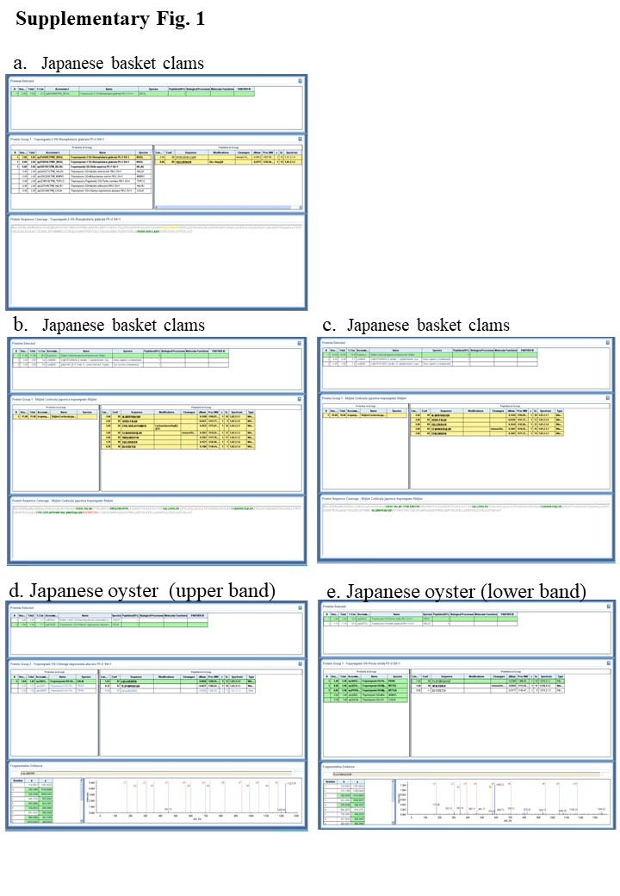

Supplementary Fig. 2.
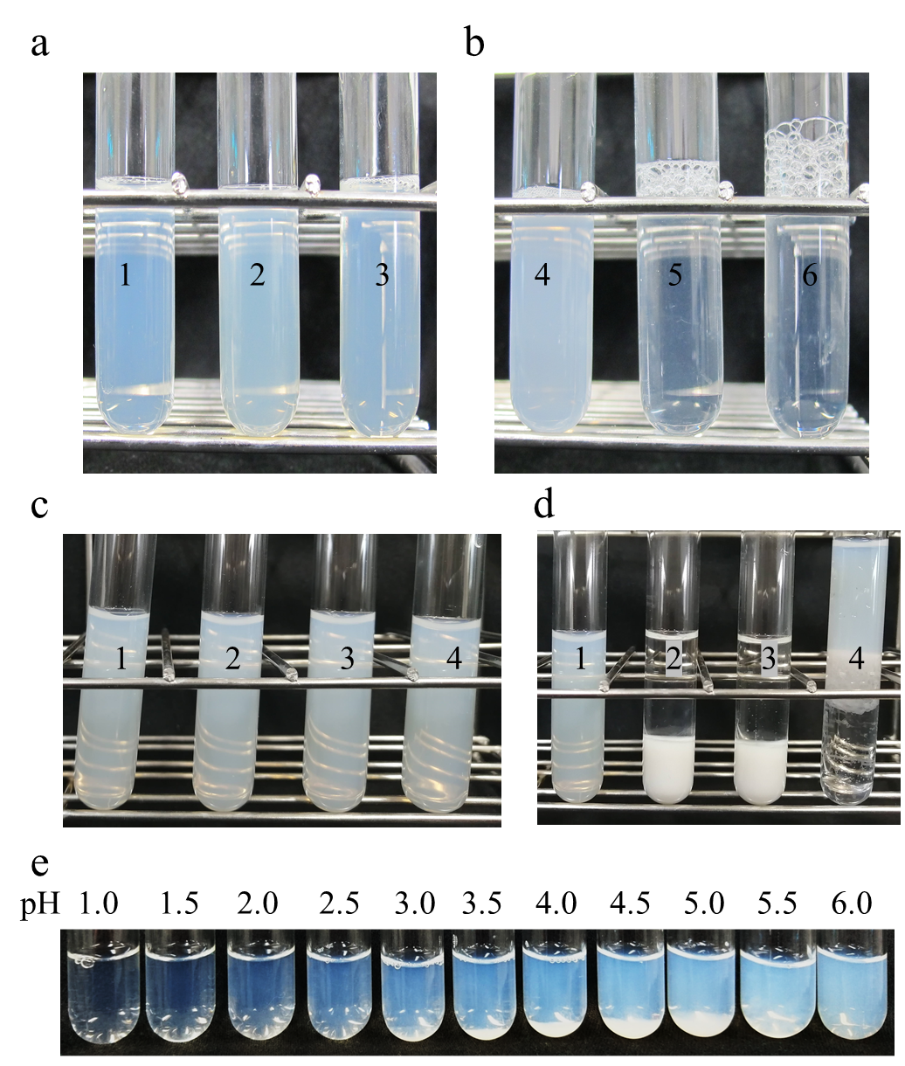

Supplementary Fig. 3.
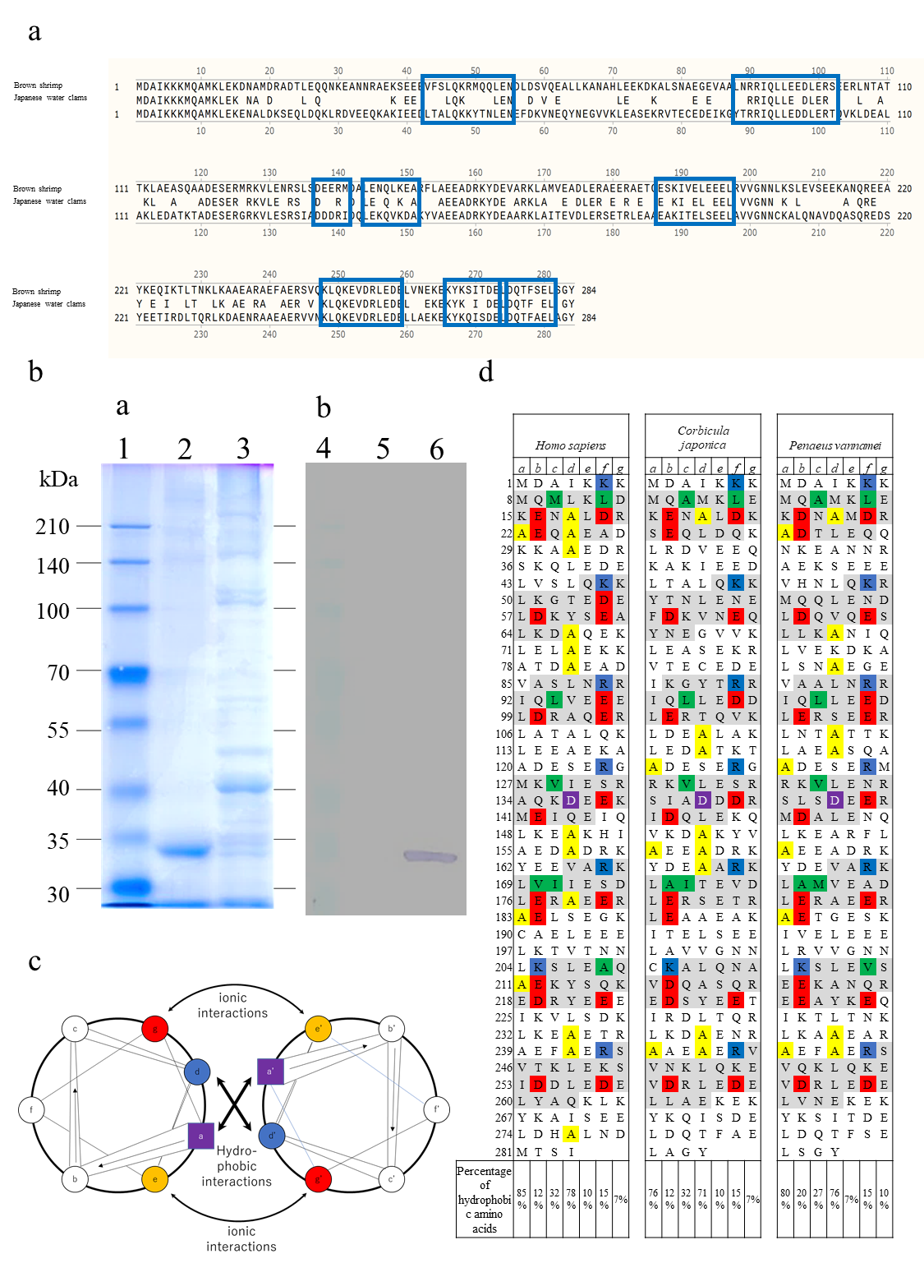

Supplementary Table 1
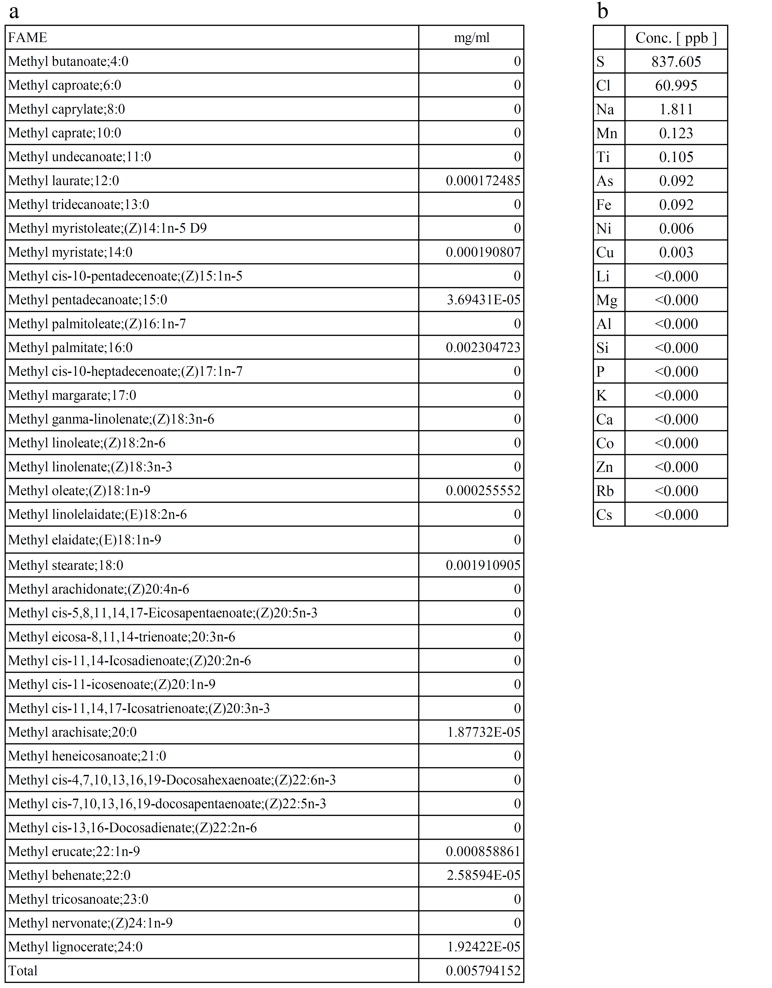

Supplementary Table 2.

