Biological evaluation, molecular modeling and dynamics simulation of Phenanthrenes isolated from Bletilla striata as butyrylcholinesterase inhibitors

Yi Liu ¹, Yanbei Tu ², Yunyao Kang ¹, Chao Zhu ¹, Chuanhai Wu ¹, Gang Chen ^{3,4}, Zerong Liu ^{3,4},
Yanfang Li ^{1,}*
¹ School of Chemical Engineering, Sichuan University, Chengdu, 610065, China
² School of pharmacy, Jiangsu University, Zhenjiang, 212012, China
³ Central Nervous System Drug Key Laboratory of Sichuan Province, Luzhou, 646106, China
⁴ Sichuan Credit Pharmaceutical CO., Ltd. Luzhou, 646106, China
* Corresponding author：E-mail address: lyf471@vip.163.com.

Figure S1. Isolation scheme of anticholinesterases bio-guide fractionation of B. striata tubers.
Figure S2. The three times parallel RMSD of 10(A) and 12(B) with BChE.
Figure S3. Percentage inhibition of BChE induced by compounds 6(A), 8(B), 10(C), 12(D), 14(E) in comparison to Galantamine(F).

Table S1 Inhibition activity of extract/fractions of B. striata against two cholinesterases.
Table S2. HPLC method.

The representative ¹H NMR, ¹³C NMR, 2D-NMR, HR ESI-MS spectrum and HPLC chromatogram of compounds 1-22.

Figure S1. Isolation scheme of anticholinesterases bio-guide fractionation of B. striata tubers.
Figure S2. The three times parallel RMSD of 10(A) and 12(B) with BChE.

Figure S3. Percentage inhibition of BChE induced by compounds 6(A), 8(B), 10(C), 12(D), 14(E) in comparison to galantamine (F).

Table S1 Inhibition activity of extract/fractions of B. striata against two cholinesterases.
extracts/fractions | IC₅₀ (μg/mL) |  | Inhibition against BChE(%)
extracts/fractions | BChE | AChE | 50 μg/mL | 25 μg/mL
95% EtOH | 8.6 ± 0.2 | 296.4 ± 22.5
PE | 187.9 ±11.5 | 355.6 ± 15.2
EtOAc | 2.3 ± 0.1 | 224.0 ± 18.9
n-BuOH | 213.2 ±12.4 | 479.8 ± 25.7
Water | >600 | >600
galantamine ª | 13.2 ± 0.8 | 4.3 ± 0.3
Fr.A |  |  | 20.5 ± 5.1 | 8.9 ± 4.0
Fr.B |  |  | 23.5 ± 9.9 | 10.4 ± 2.2
Fr.C |  |  | 37.2 ± 1.5 | 30.6 ± 4.6
Fr.D |  |  | 53.1 ± 16.1 | 43.4 ± 11.3
Fr.E |  |  | 27.4 ± 10.1 | 20.4 ± 5.7
Fr.F |  |  | 32.0 ± 3.4 | 17.6 ± 1.8
Fr.G |  |  | 39.8 ± 8.2 | 25.6 ± 6.9
Fr.H |  |  | 60.1 ± 2.5 | 43.3 ± 4.8
Fr.I |  |  | 67.2 ± 2.4 | 47.2 ± 5.3
Fr.J |  |  | 87.1 ± 3.6 | 76.8 ± 3.9
Fr.K |  |  | 96.5 ± 2.2 | 94.4 ± 2.7
Fr.J1 |  |  |  | 3.0 ± 1.1
Fr.J2 |  |  |  | 3.3 ± 2.7
Fr.J3 |  |  |  | 2.0 ± 0.3
Fr.J4 |  |  |  | 2.5 ± 1.5
Fr.J5 |  |  |  | 2.0 ± 0.6
Fr.J6 |  |  |  | 17.6 ± 3.1
Fr.J7 |  |  |  | 55.7 ± 2.8
Fr.J8 |  |  |  | 58.5 ± 0.7
Fr.J9 |  |  |  | 80.7 ± 1.8
Fr.J10 |  |  |  | 84.5 ± 0.7
Fr.J11 |  |  |  | 85.0 ± 3.2
Fr.K1 |  |  |  | 1.0 ± 0.8
Fr.K2 |  |  |  | 4.5 ± 3.9
Fr.K3 |  |  |  | 16.5 ± 6.5
Fr.K4 |  |  |  | 91.0 ± 2.6
Fr.K5 |  |  |  | 90.3 ± 0.2
Fr.K6 |  |  |  | 95.1 ± 2.9
Fr.K7 |  |  |  | 81.2 ± 5.5
Fr.K8 |  |  |  | 29.5 ± 6.0
Fr.K9 |  |  |  | 14.6 ± 4.6
ª positive control

Table S2. HPLC method.
The purities of compounds were determined by the HPLC methods shown in following table.
The peak aera was determined according UV (280 nm) or ELSD detector.
Equipment | Alltech Modells 201 with a ELSD 6000 detector
Column | Nacalai tesque COSMOSIL Packed column AR-Ⅱ (4.6 ID × 250 mm)
Method | CH₃OH/ 0.1% formic acid, from 40% (v/v) of CH₃OH gradient in the beginning to 100%(v/v) of CH₃OH gradient in 40 minutes
Method | flow rate: 1.0 mL /min
Results | Compounds | Retention time (min) | Relative purity (%)
Results | 1 | 14.04 | 96.03
Results | 2 | 16.93 | 97.98
Results | 3 | 18.25 | 96.84
Results | 4 | 15.15 | 97.99
Results | 5 | 18.09 | 98.92
Results | 6 | 20.00 | 98.84
Results | 7 | 15.92 | 99.14
Results | 8 | 8.90 | 99.22
Results | 9 | 10.60 | 99.12
Results | 10 | 10.18 | 99.43
Results | 11 | 11.63 | 98.87
Results | 12 | 11.64 | 97.55
Results | 13 | 11.90 | 98.91
Results | 14 | 9.45 | 98.18
Results | 15 | 24.07 | 96.30
Results | 16 | 26.45 | 97.79
Results | 17 | 13.32 | 95.69
Results | 18 | 17.86 | 92.32
Results | 19 | 13.17 | 99.11
Results | 20 | 26.82 | 97.93
Results | 21 | 13.17 | 99.11
Results | 22 | 15.68 | 99.16

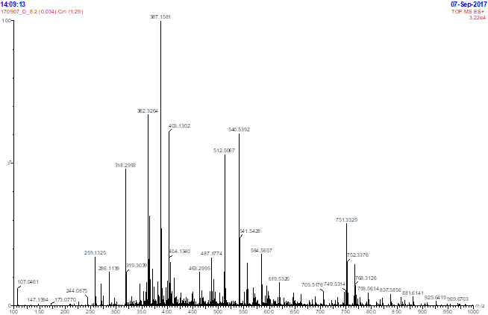
HR-ESI-MS spectrum of compound 1
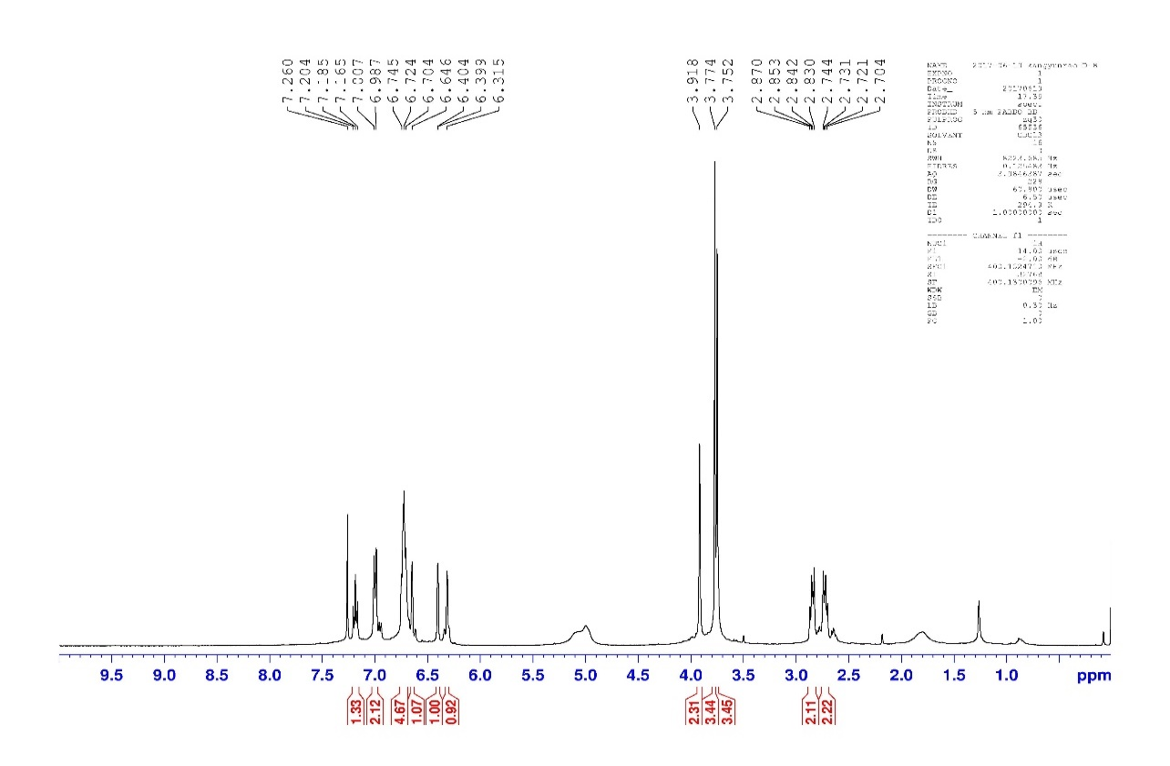
¹H NMR (400 MHz, CDCl₃) spectrum of compound 1
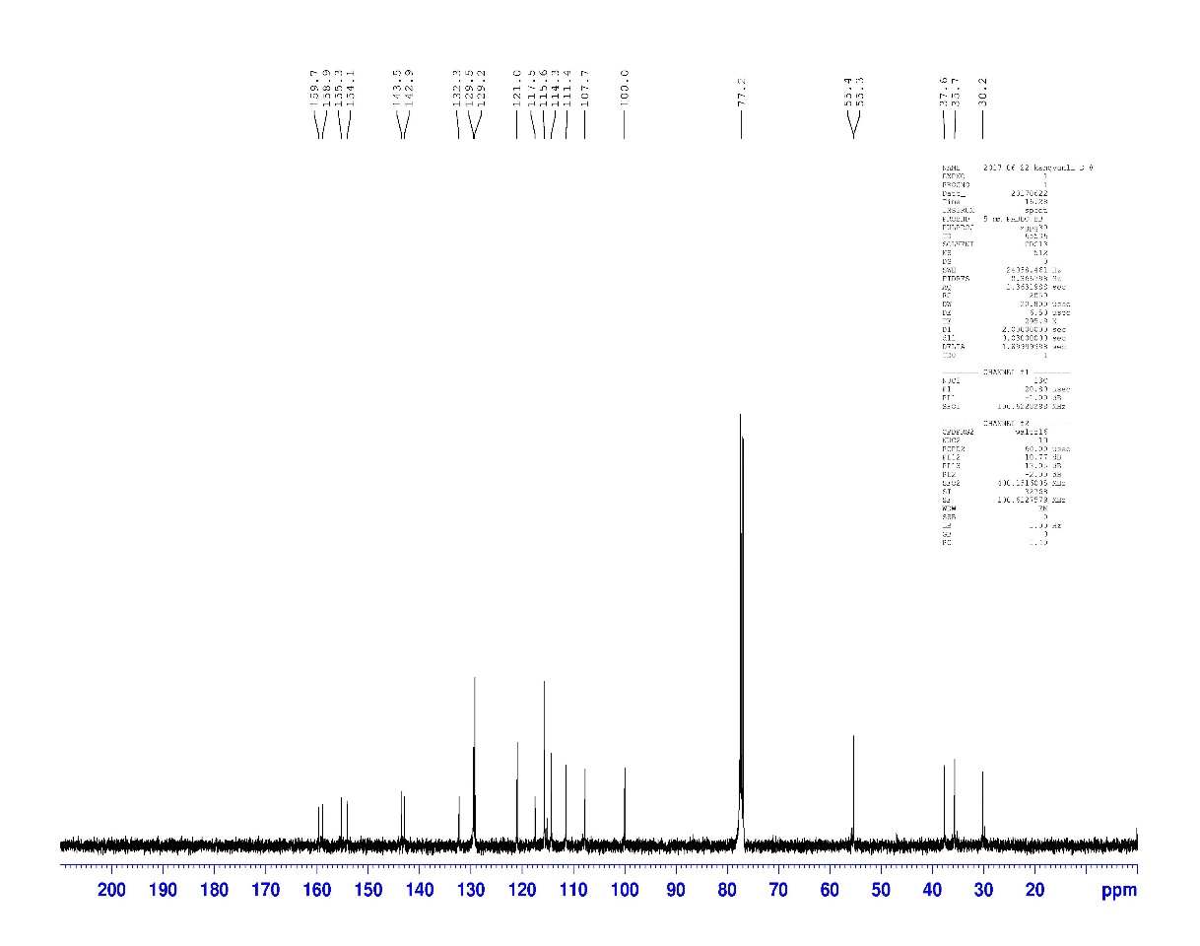
¹³C NMR (100 MHz, CDCl₃) spectrum of compound 1

HPLC chromatogram of compound 1

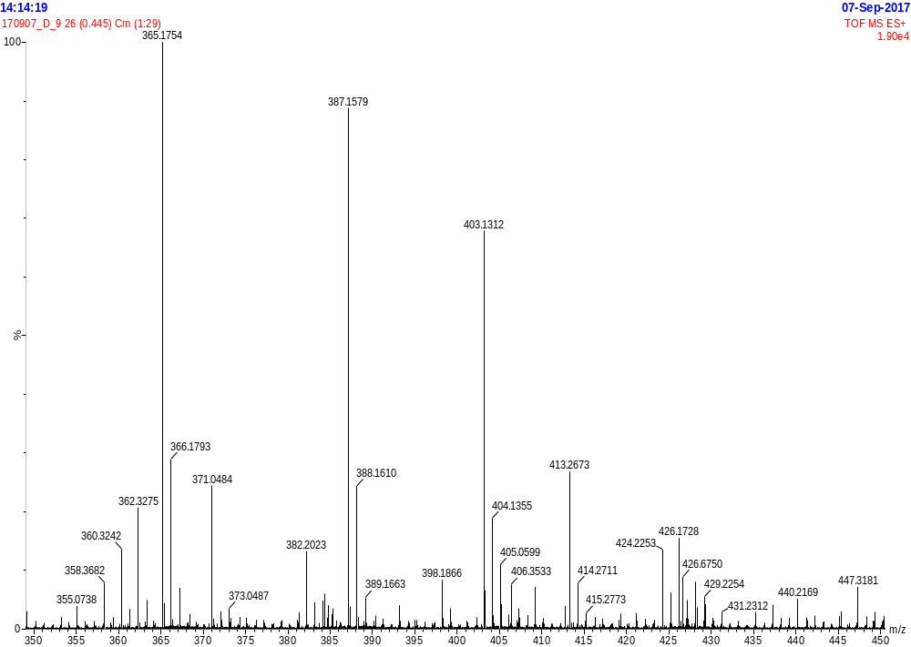
HR-ESI-MS spectrum of compound 2
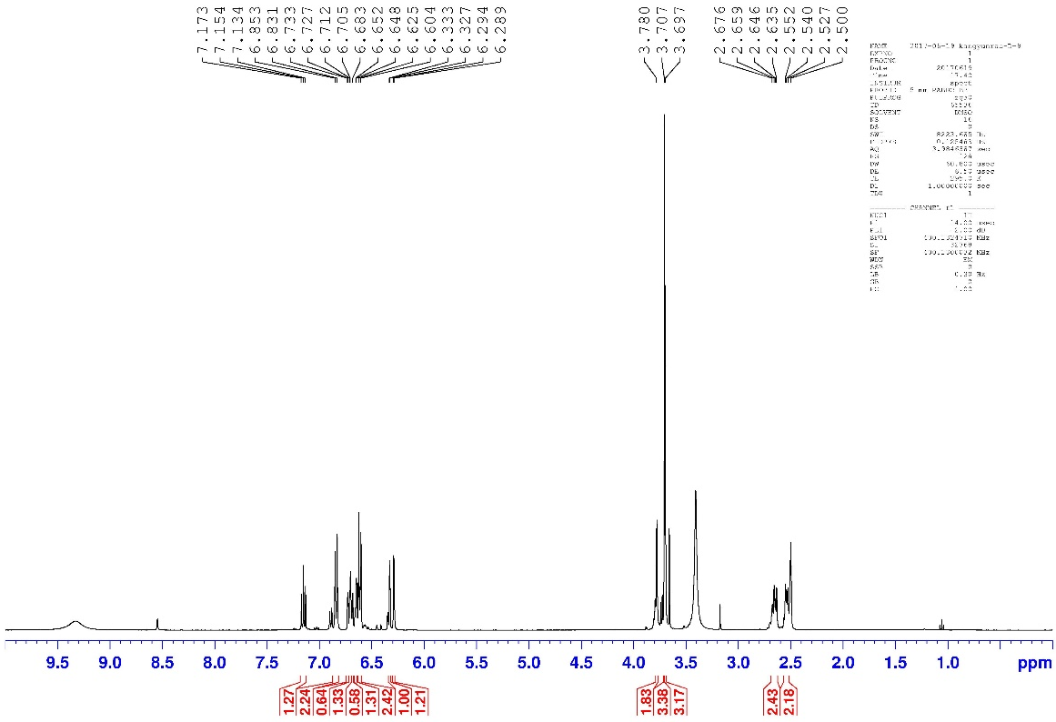
¹H NMR (400 MHz, DMSO-d₆) spectrum of compound 2
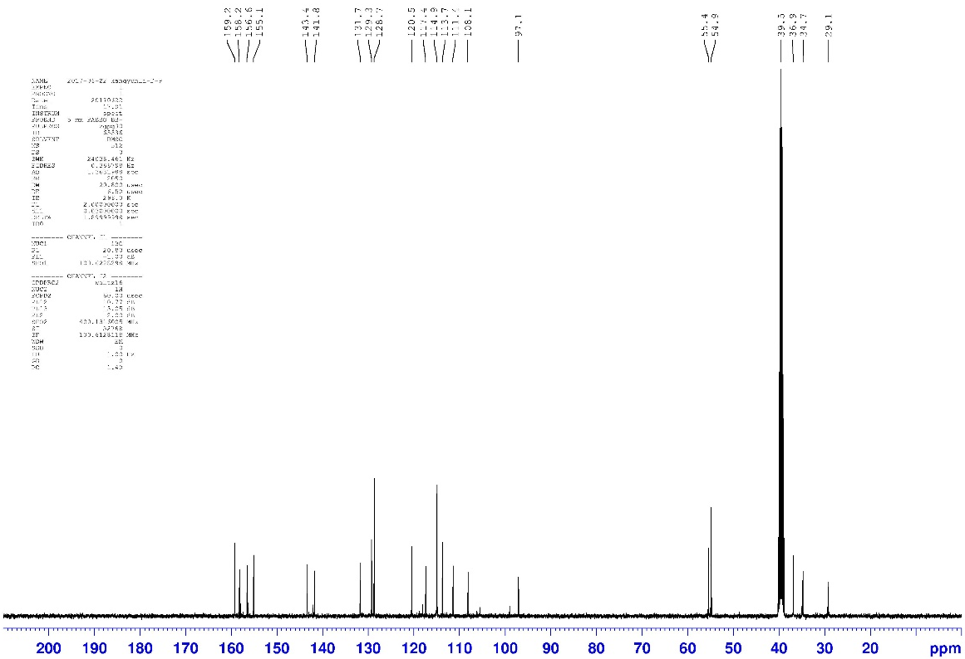
¹³C NMR (100 MHz, DMSO-d₆) spectrum of compound 2
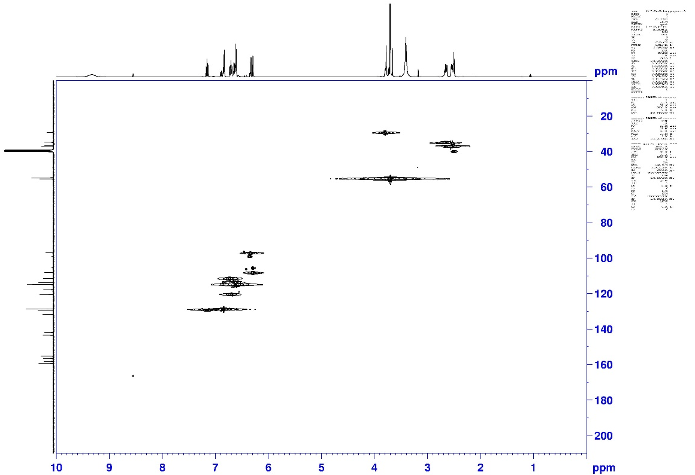
HSQC spectrum of compound 2
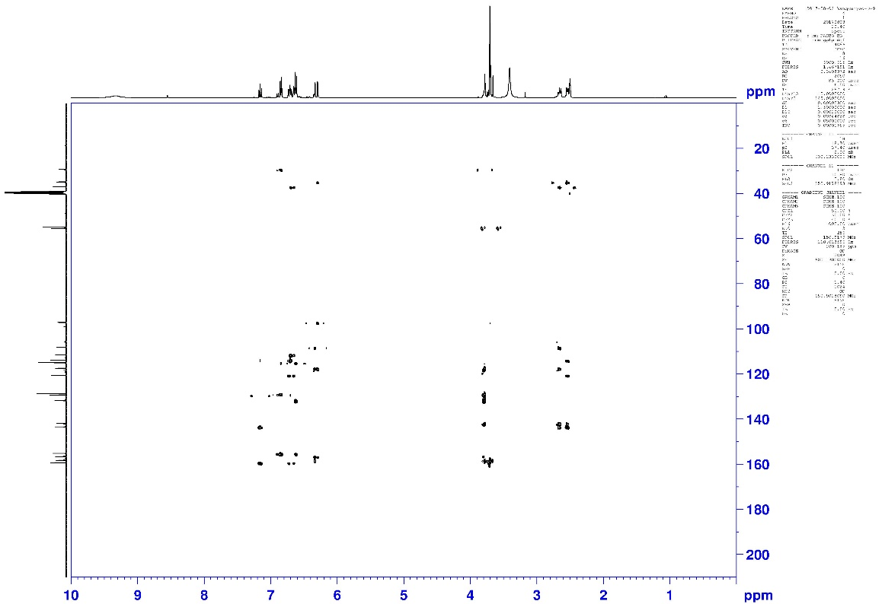
HMBC spectrum of compound 2

HPLC chromatogram of compound 2

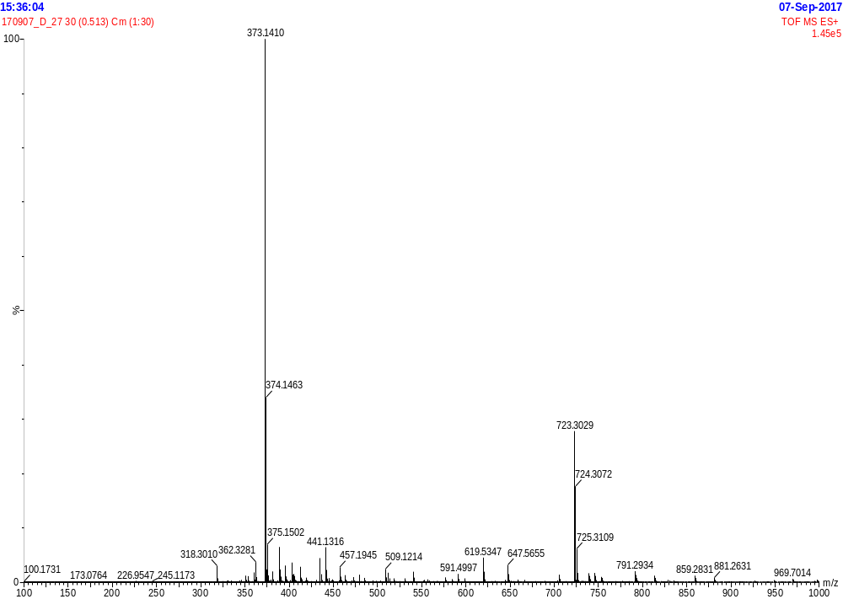
HR-ESI-MS spectrum of compound 3
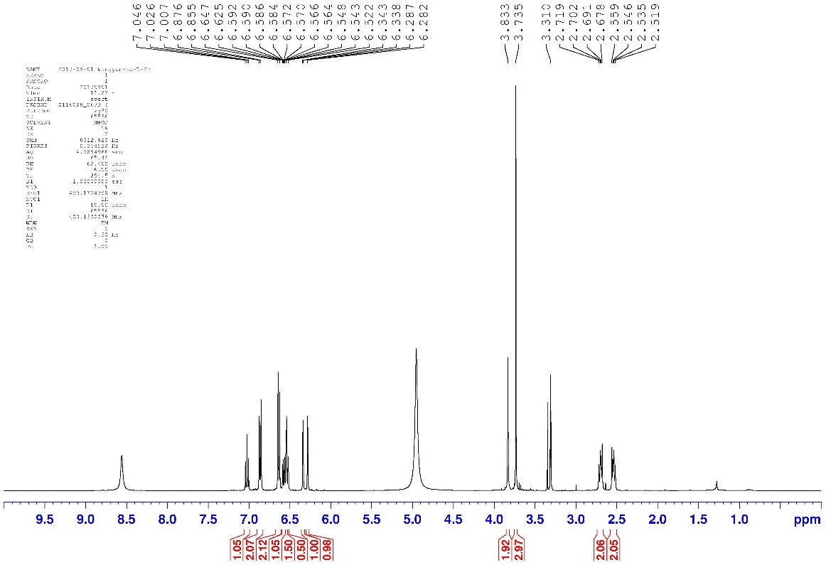
¹H NMR (400 MHz, CD₃OD) spectrum of compound 3
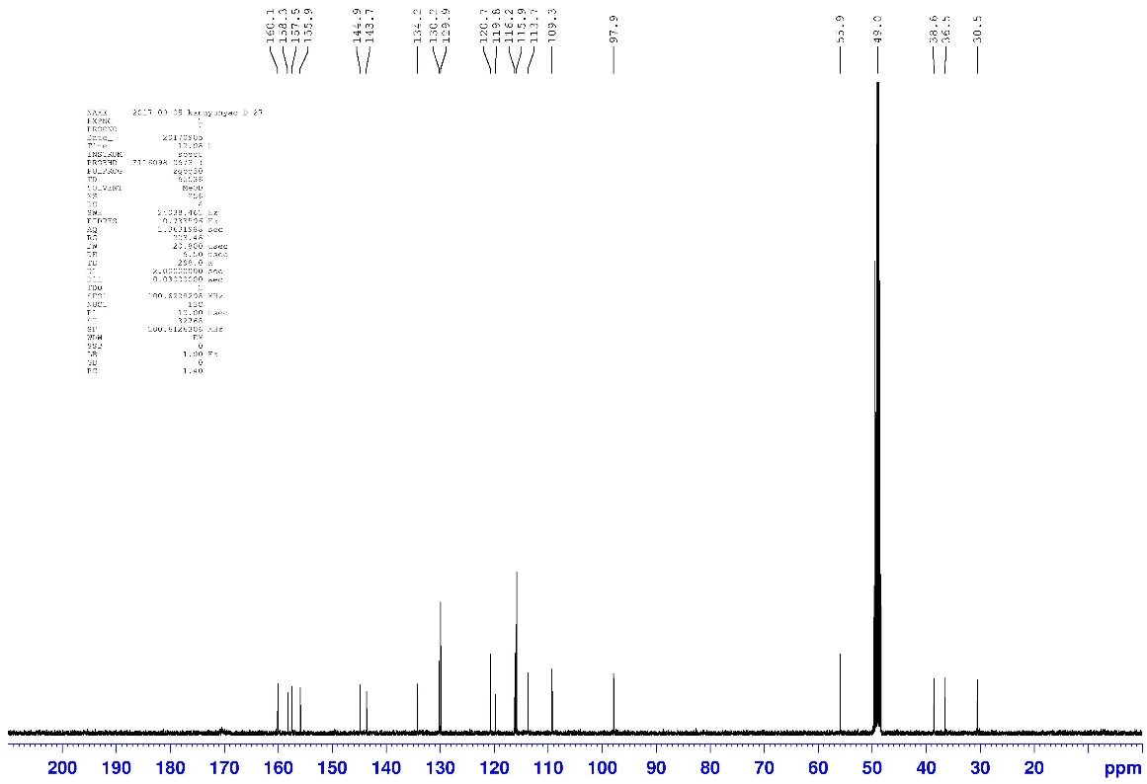
¹³C NMR (100 MHz, CD₃OD) spectrum of compound 3

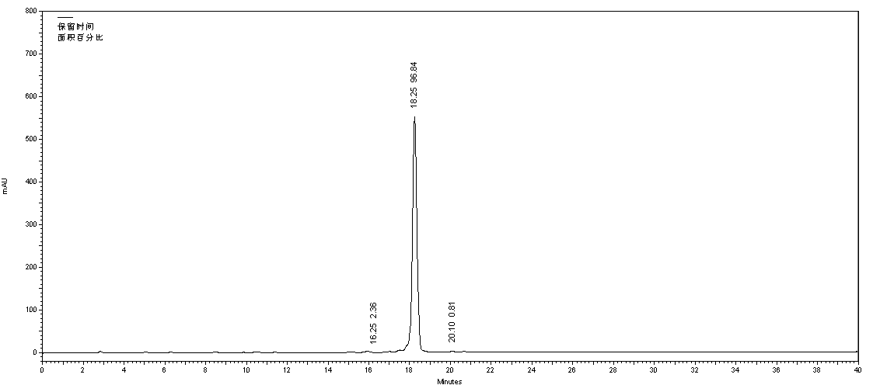
HPLC chromatogram of compound 3

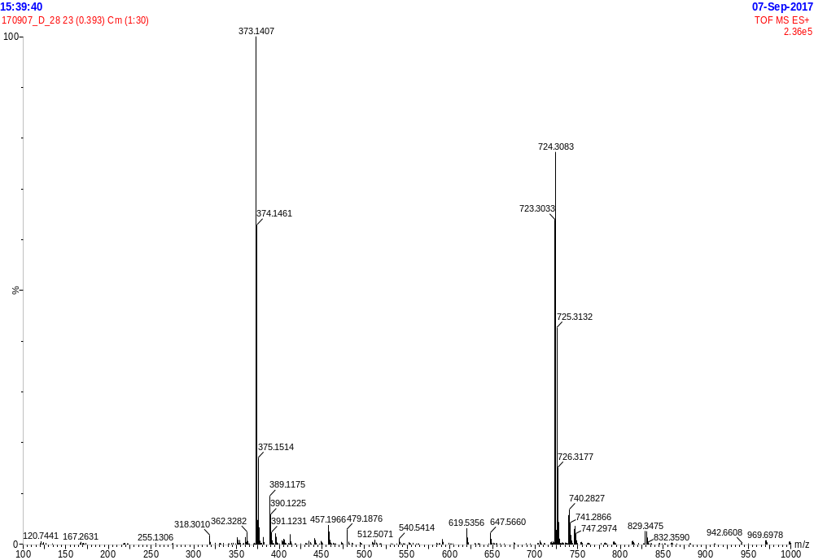
HR-ESI-MS spectrum of compound 4
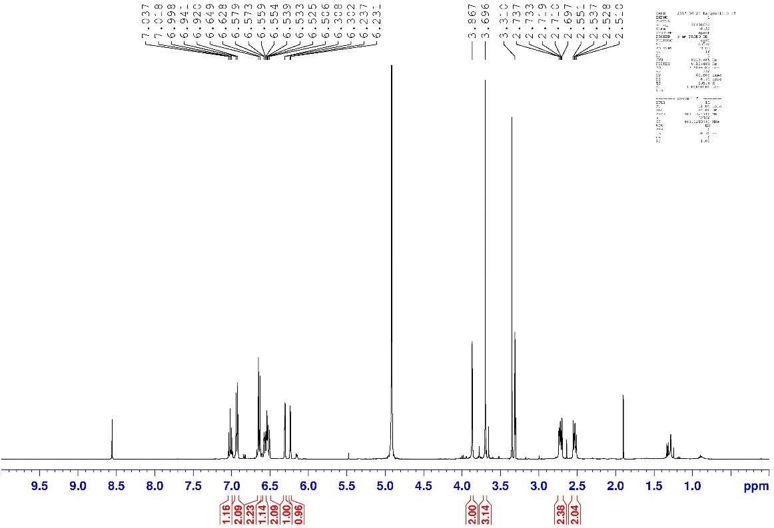
¹H NMR (400 MHz, CD₃OD) spectrum of compound 4
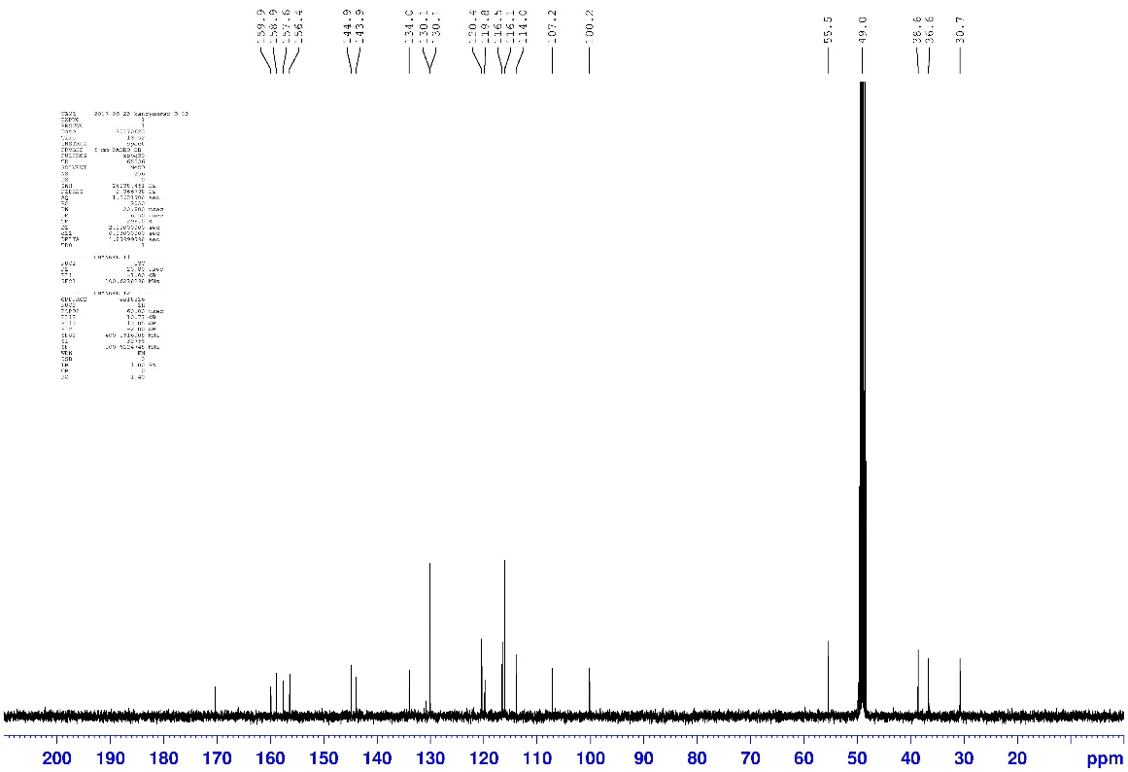
¹³C NMR (100 MHz, CD₃OD) spectrum of compound 4

HPLC chromatogram of compound 4

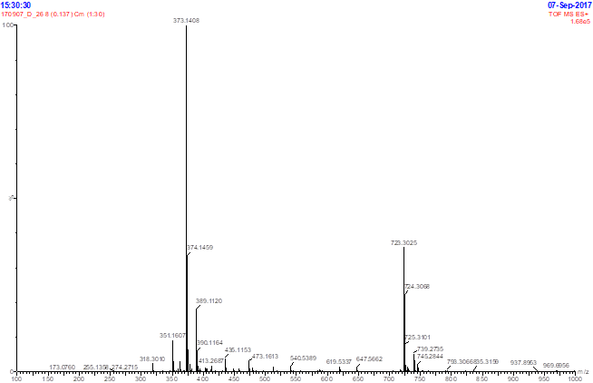
HR-ESI-MS spectrum of compound 5
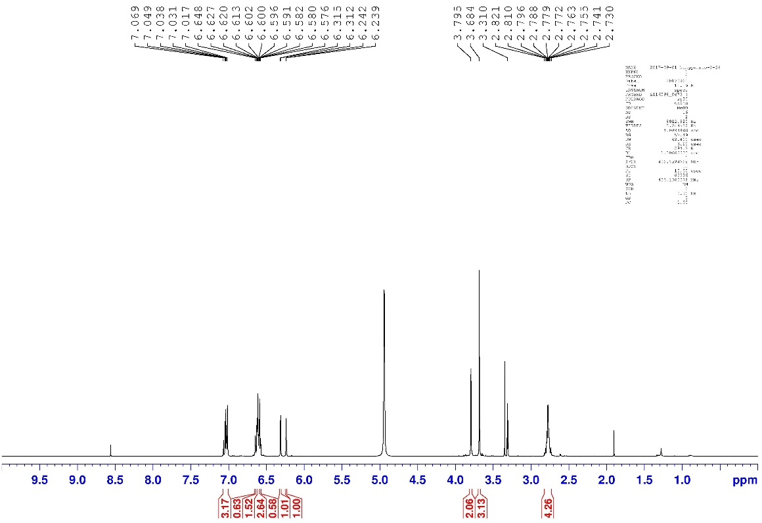
¹H NMR (400 MHz, CD₃OD) spectrum of compound 5
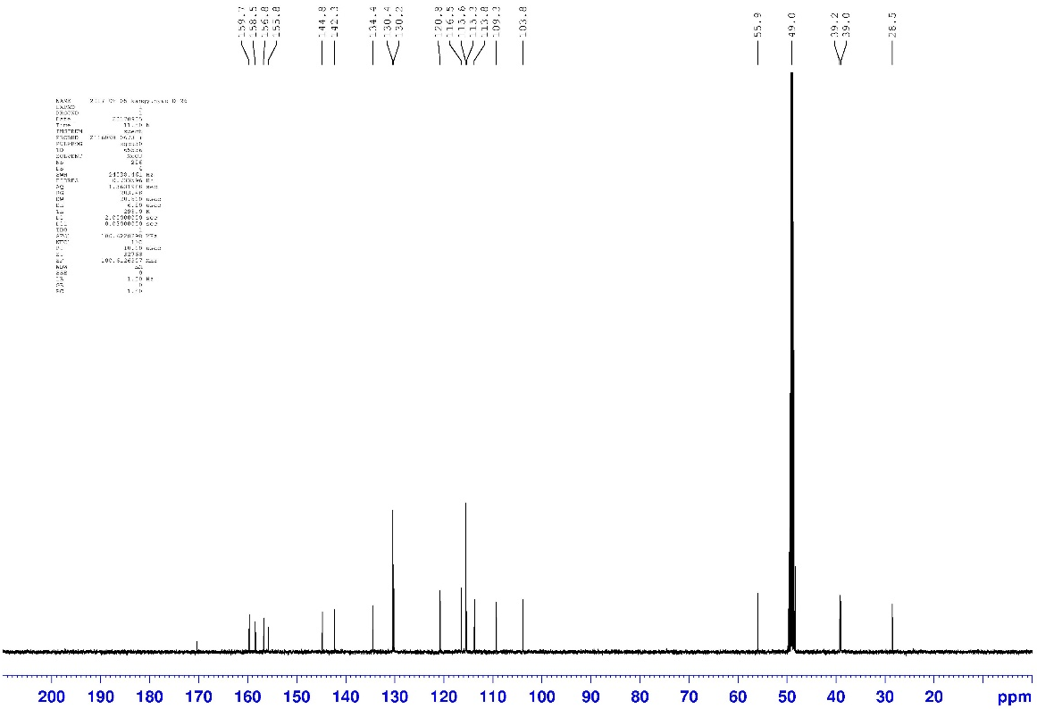
¹³C NMR (100 MHz, CD₃OD) spectrum of compound 5
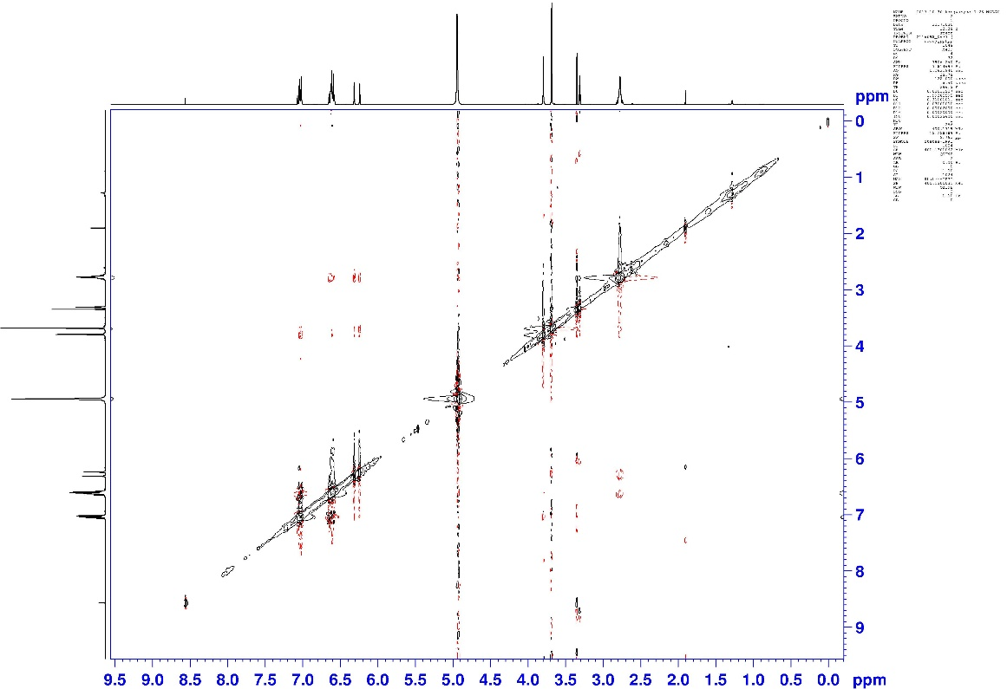
NOESY spectrum of compound 5

HPLC chromatogram of compound 5

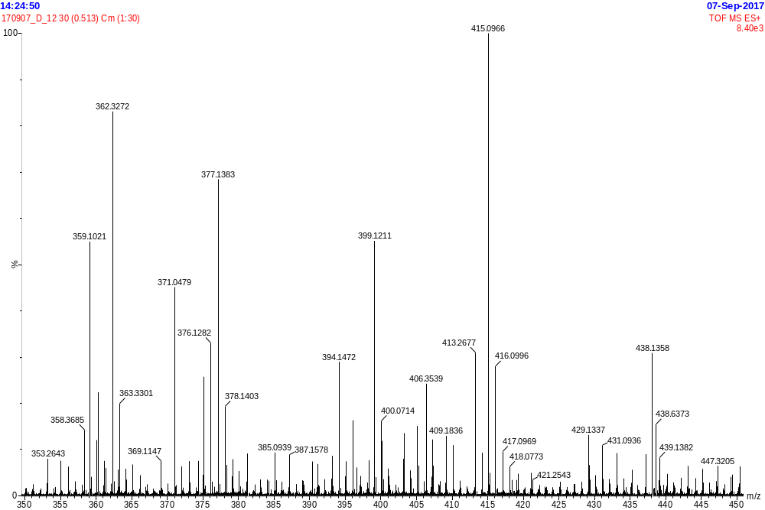
HR-ESI-MS spectrum of compound 6
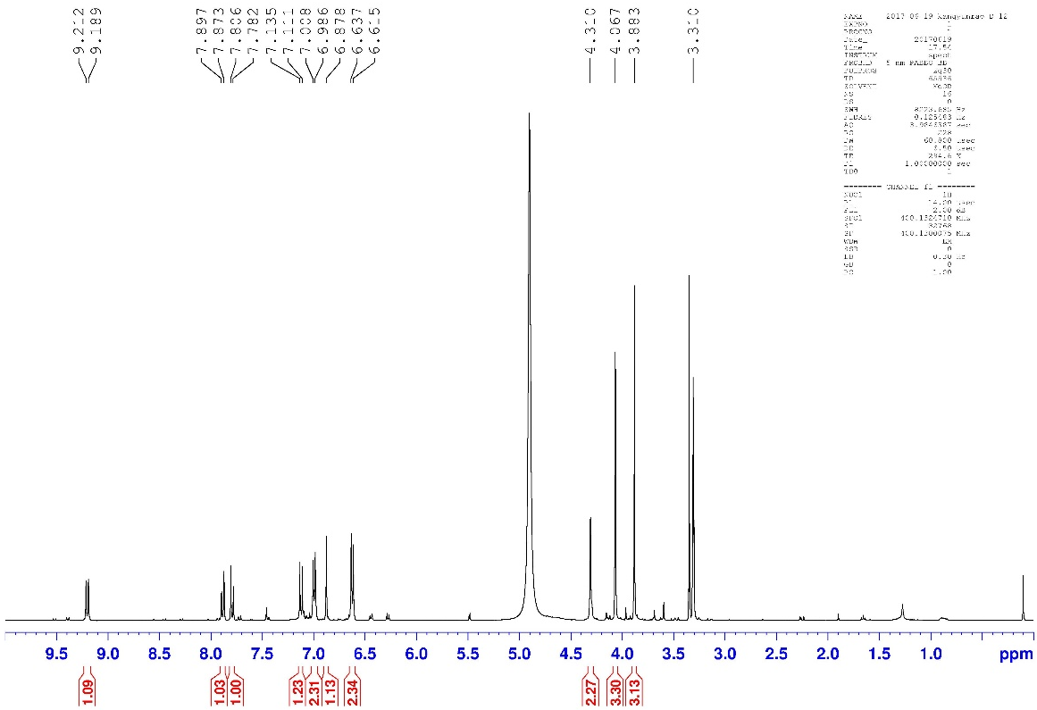
¹H NMR (400 MHz, CD₃OD) spectrum of compound 6
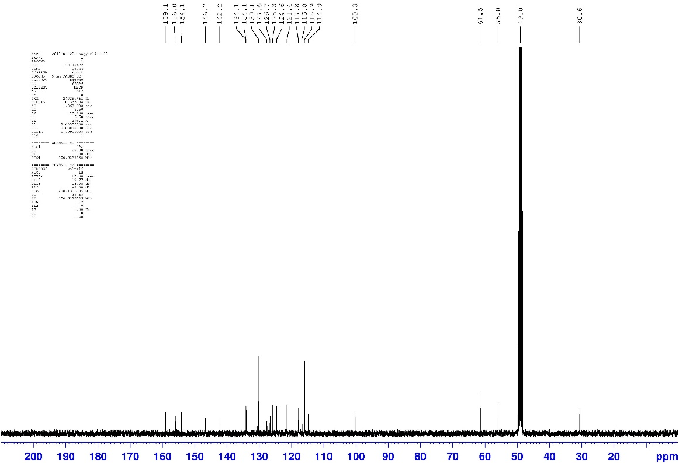
¹³C NMR (100 MHz, CD₃OD) spectrum of compound 6
HPLC chromatogram of compound 6

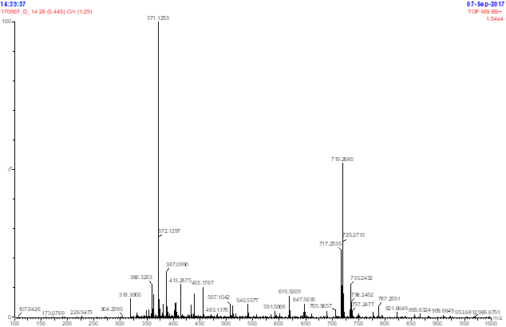
HR-ESI-MS spectrum of compound 7
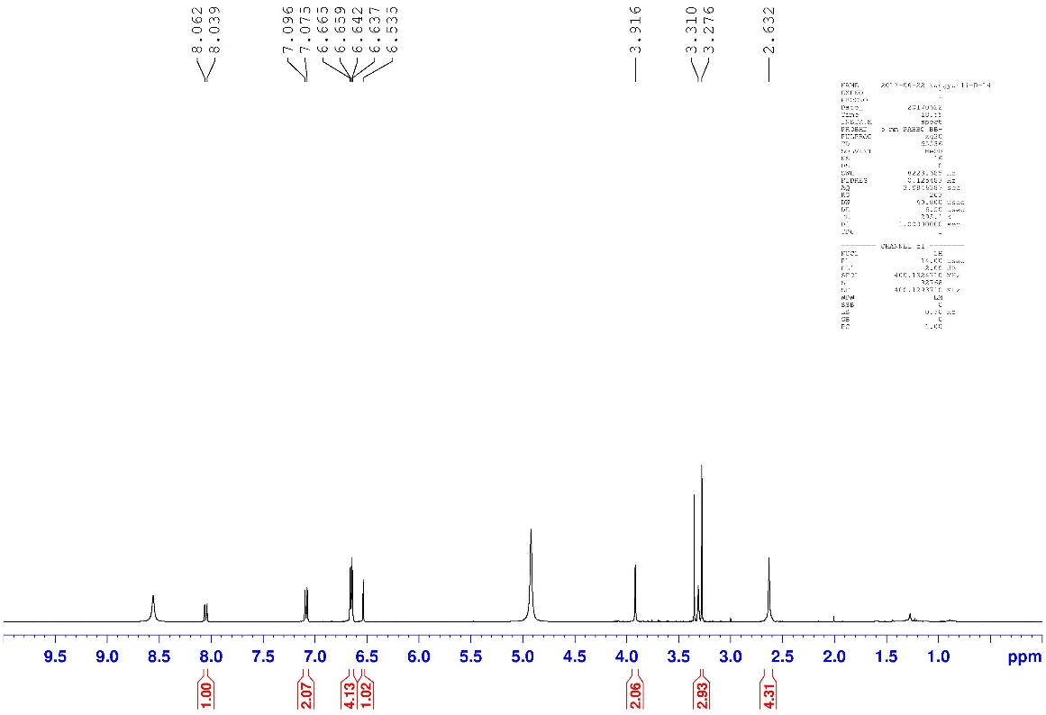
¹H NMR (400 MHz, CD₃OD) spectrum of compound 7
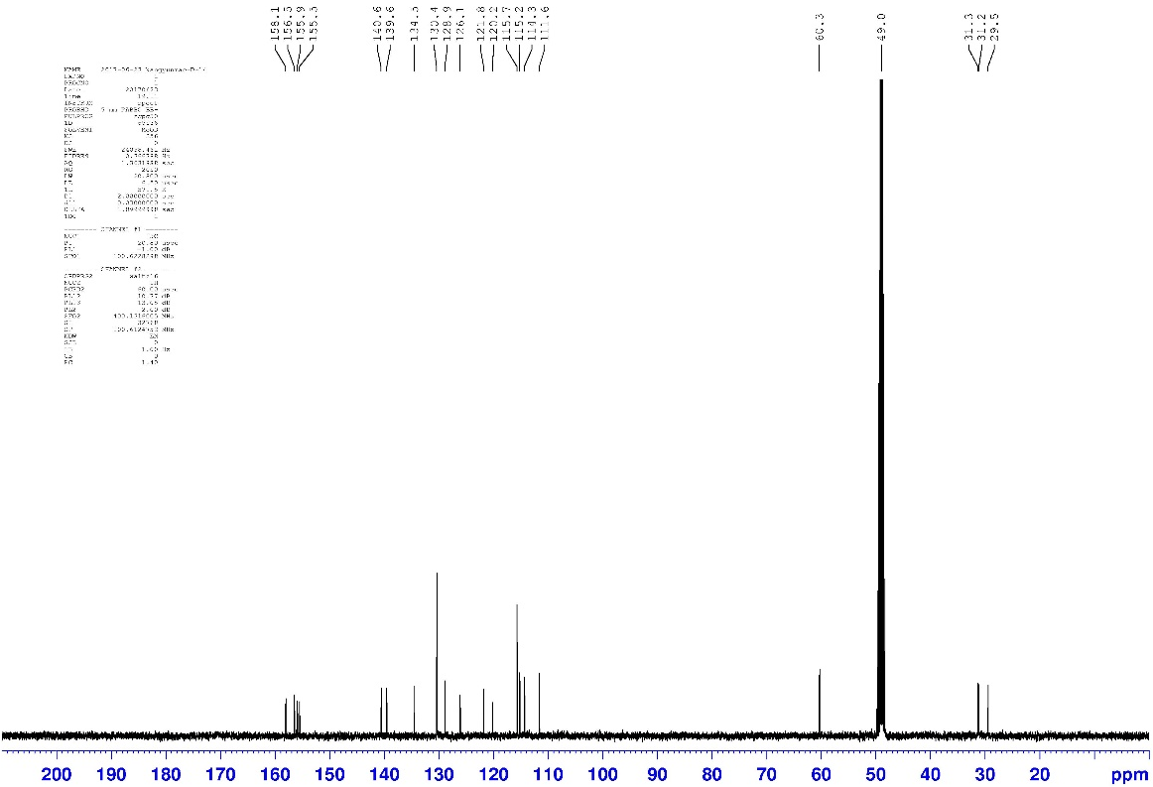
¹³C NMR (100 MHz, CD₃OD) spectrum of compound 7
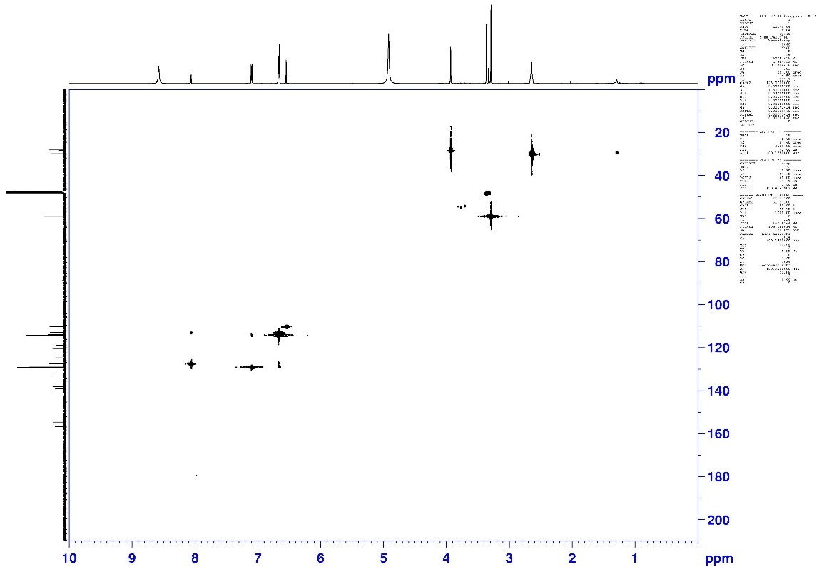
HSQC spectrum of compound 7
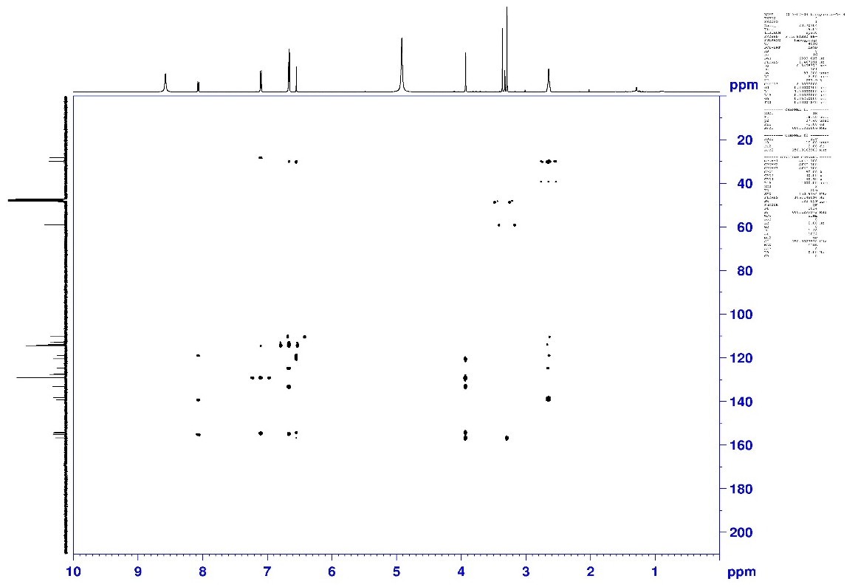
HMBC spectrum of compound 7
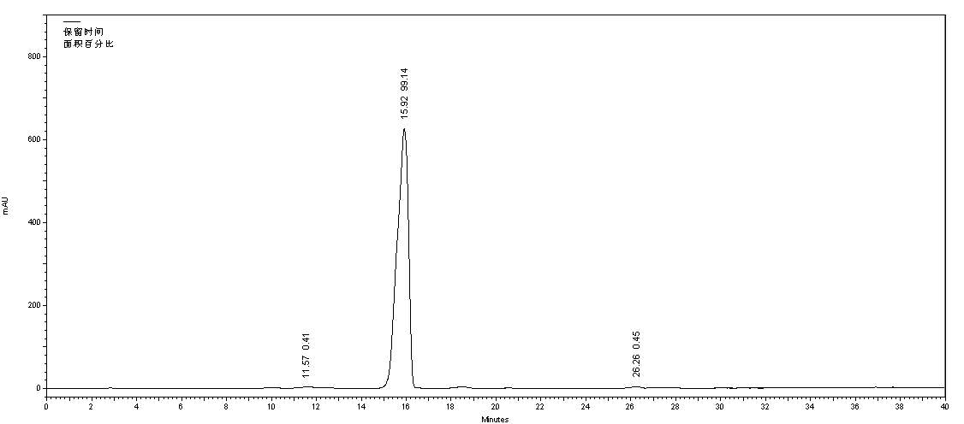
HPLC chromatogram of compound 7

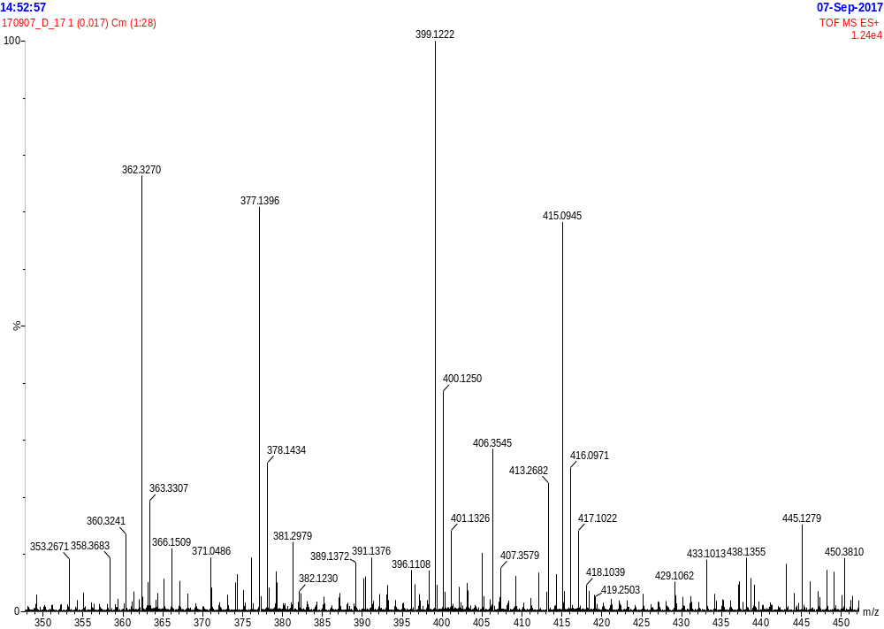
HR-ESI-MS spectrum of compound 8
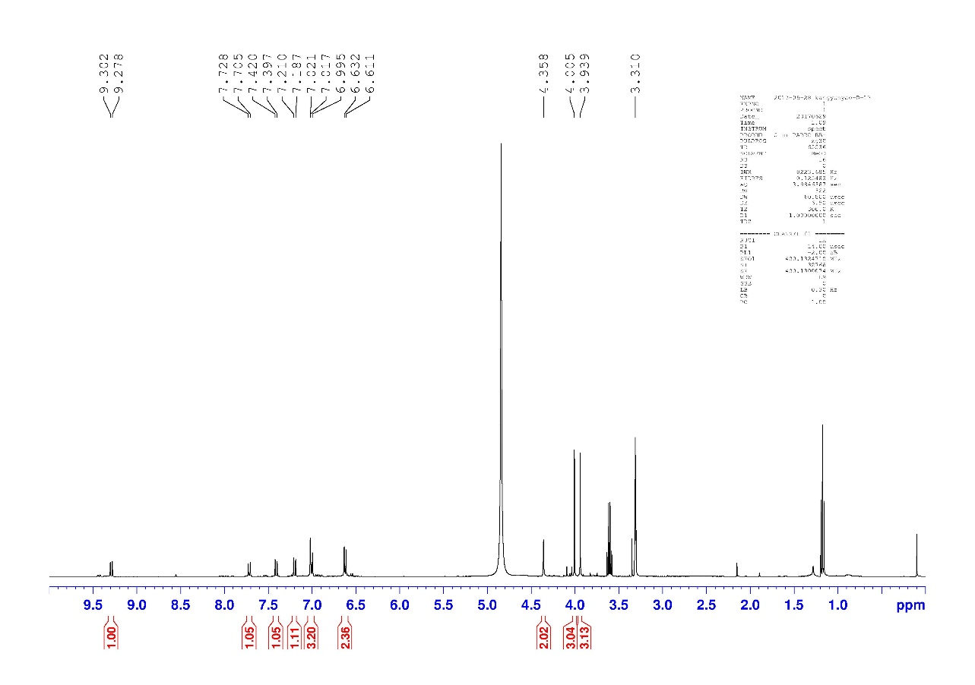
¹H NMR (400 MHz, CD₃OD) spectrum of compound 8
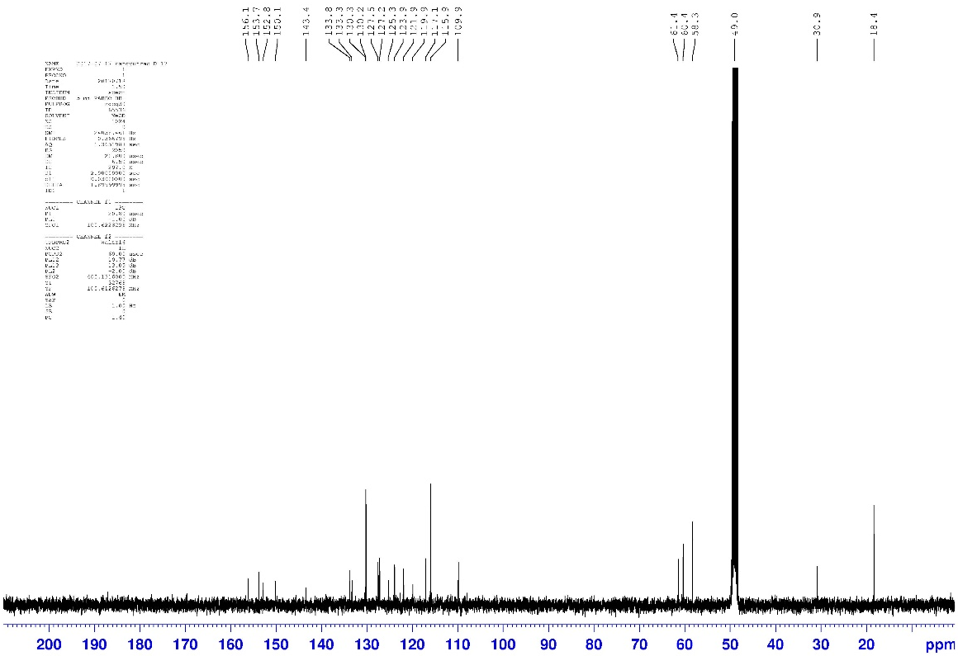
¹³C NMR (100 MHz, CD₃OD) spectrum of compound 8

HPLC chromatogram of compound 8

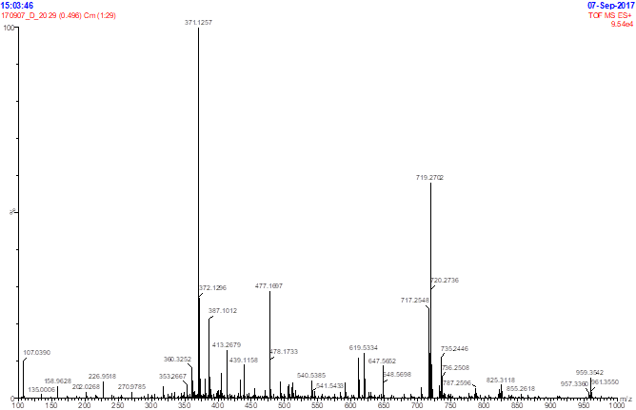
HR-ESI-MS spectrum of compound 9
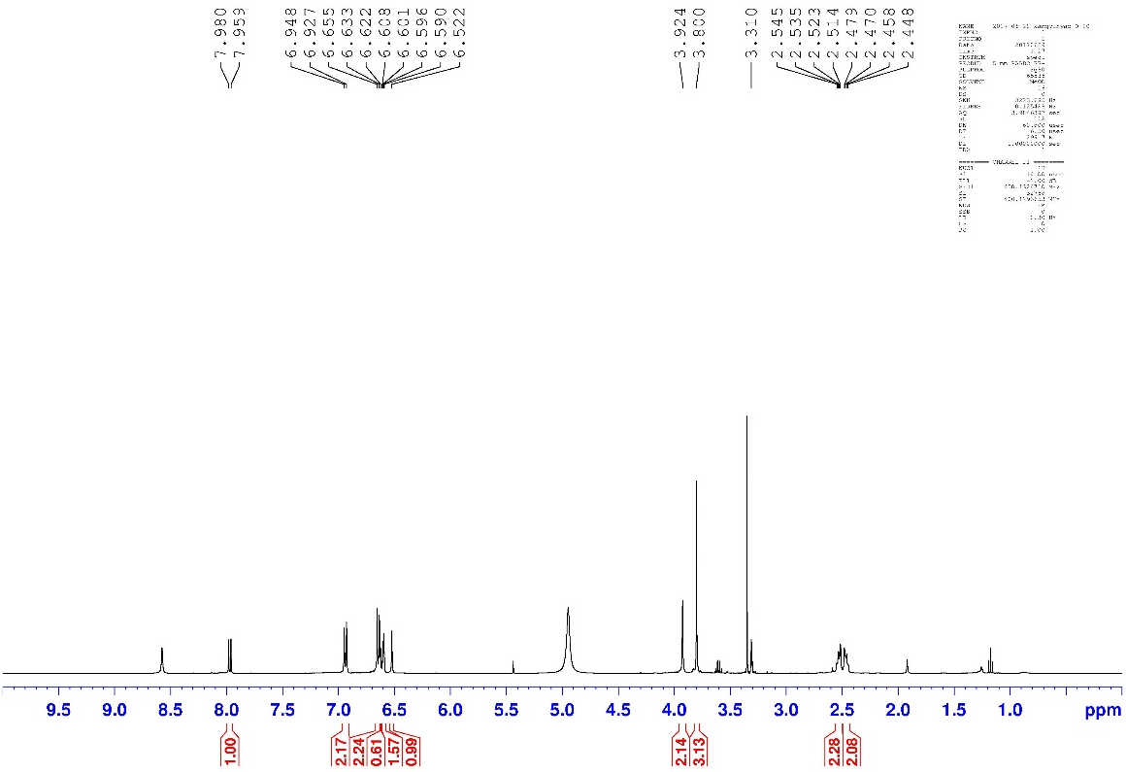
¹H NMR (400 MHz, CD₃OD) spectrum of compound 9
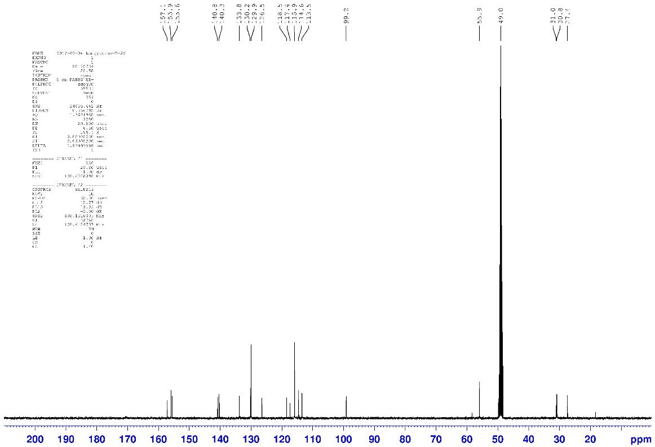
¹³C NMR (100 MHz, CD₃OD) spectrum of compound 9

HPLC chromatogram of compound 9

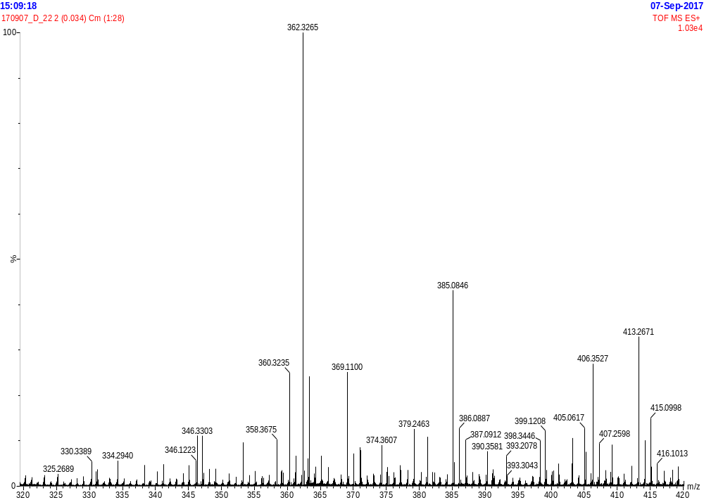
HR-ESI-MS spectrum of compound 10
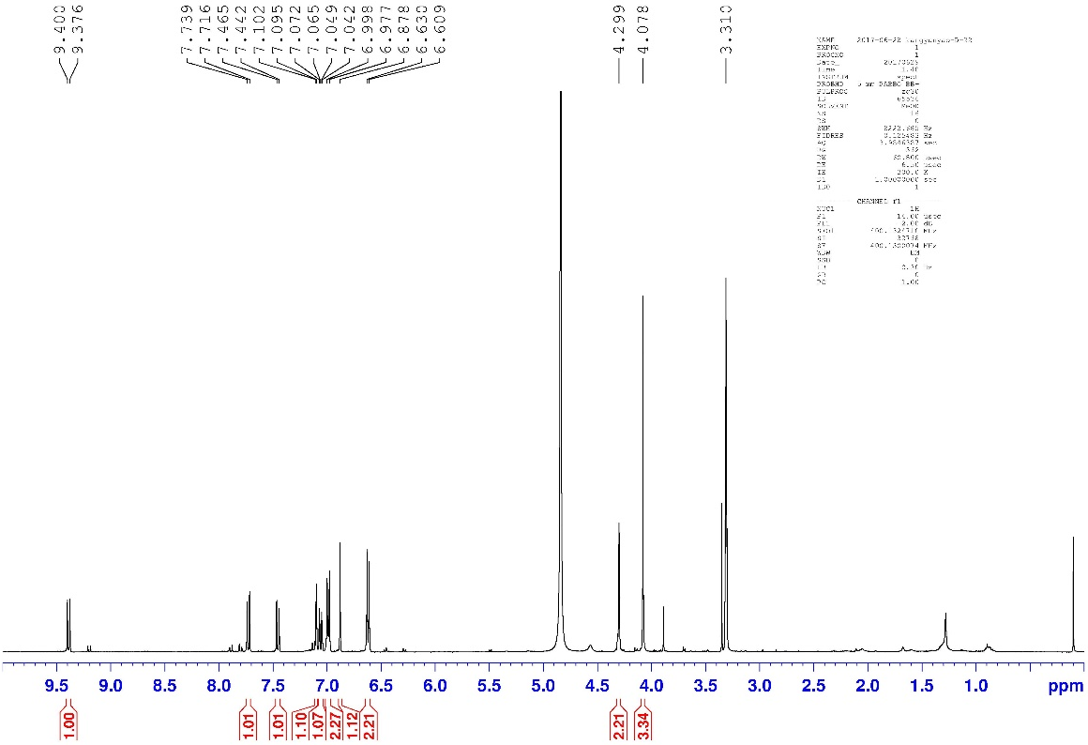
¹H NMR (400 MHz, CD₃OD) spectrum of compound 10
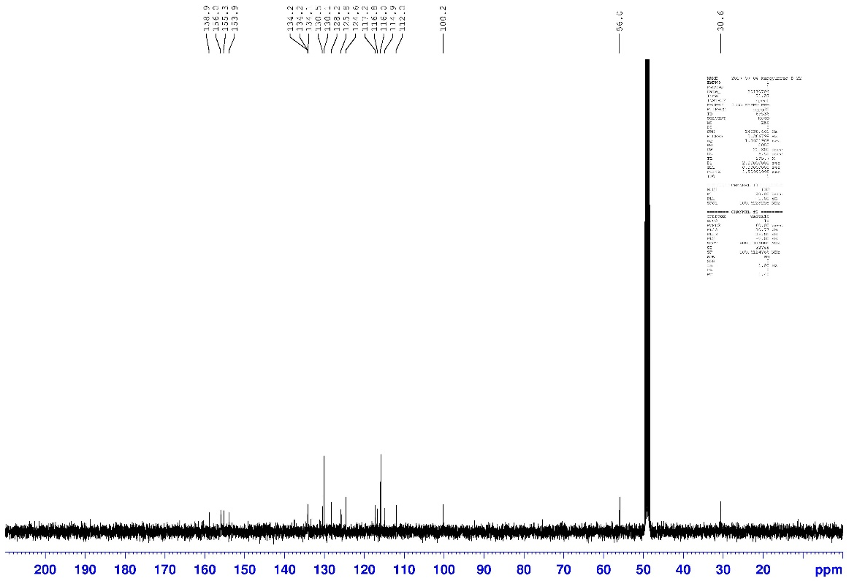
¹³C NMR (100 MHz, CD₃OD) spectrum of compound 10
HPLC chromatogram of compound 10

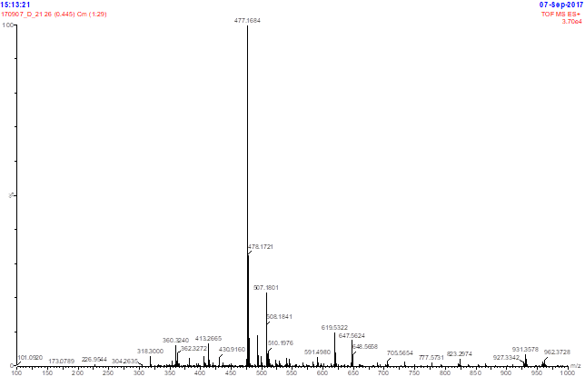
HR-ESI-MS spectrum of compound 11
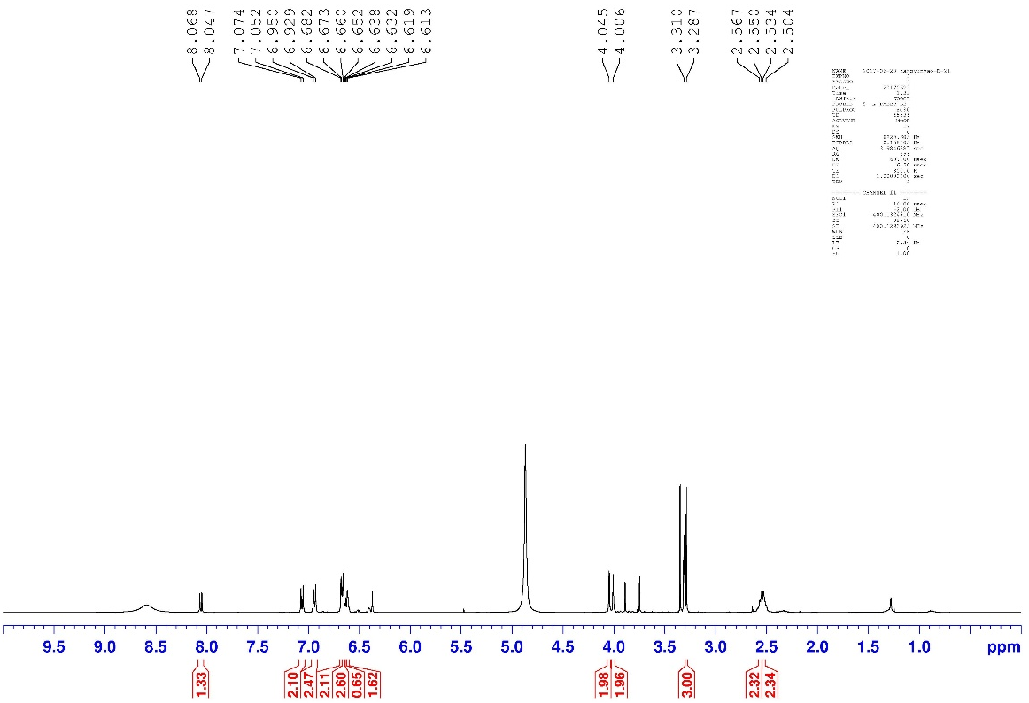
¹H NMR (400 MHz, CD₃OD) spectrum of compound 11
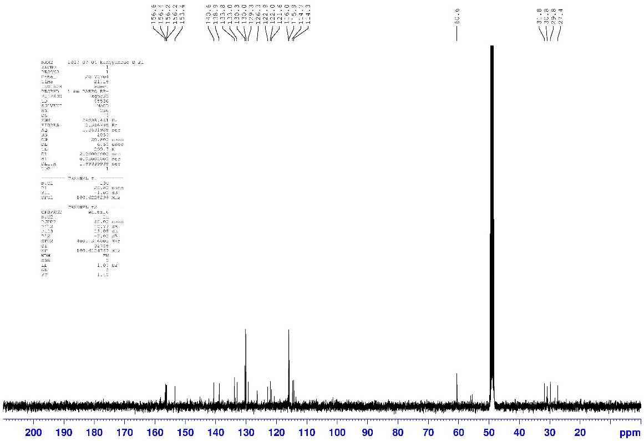
¹³C NMR (100 MHz, CD₃OD) spectrum of compound 11
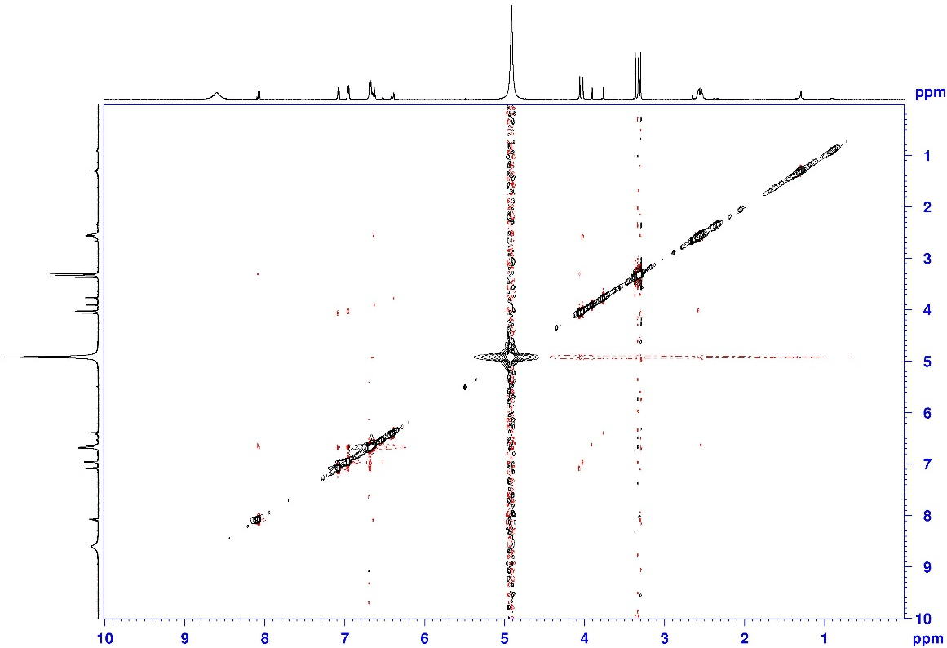
NOESY spectrum of compound 11

HPLC chromatogram of compound 11

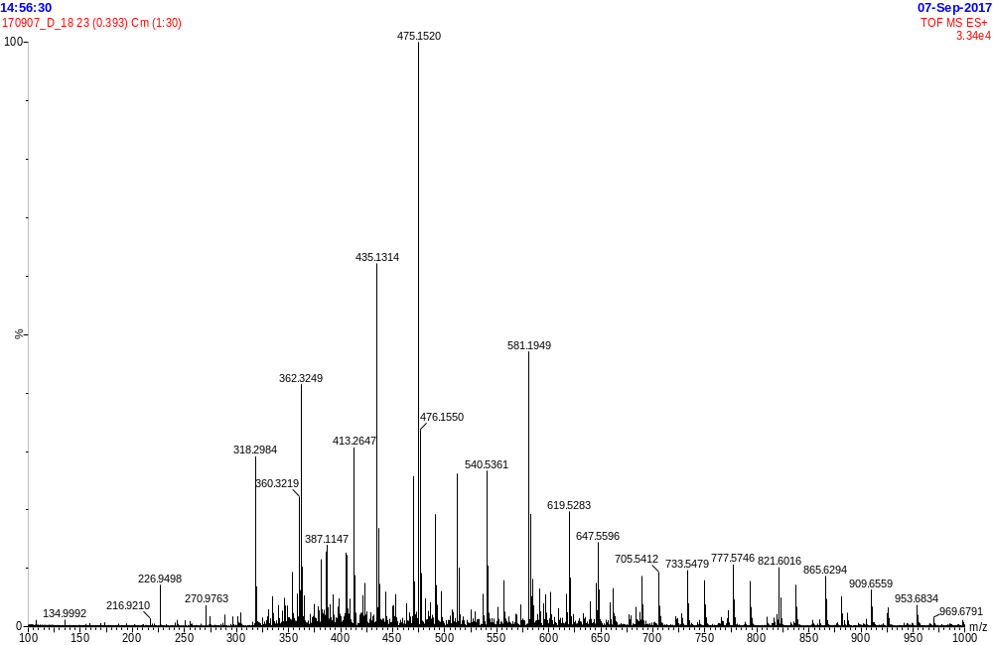
HR-ESI-MS spectrum of compound 12
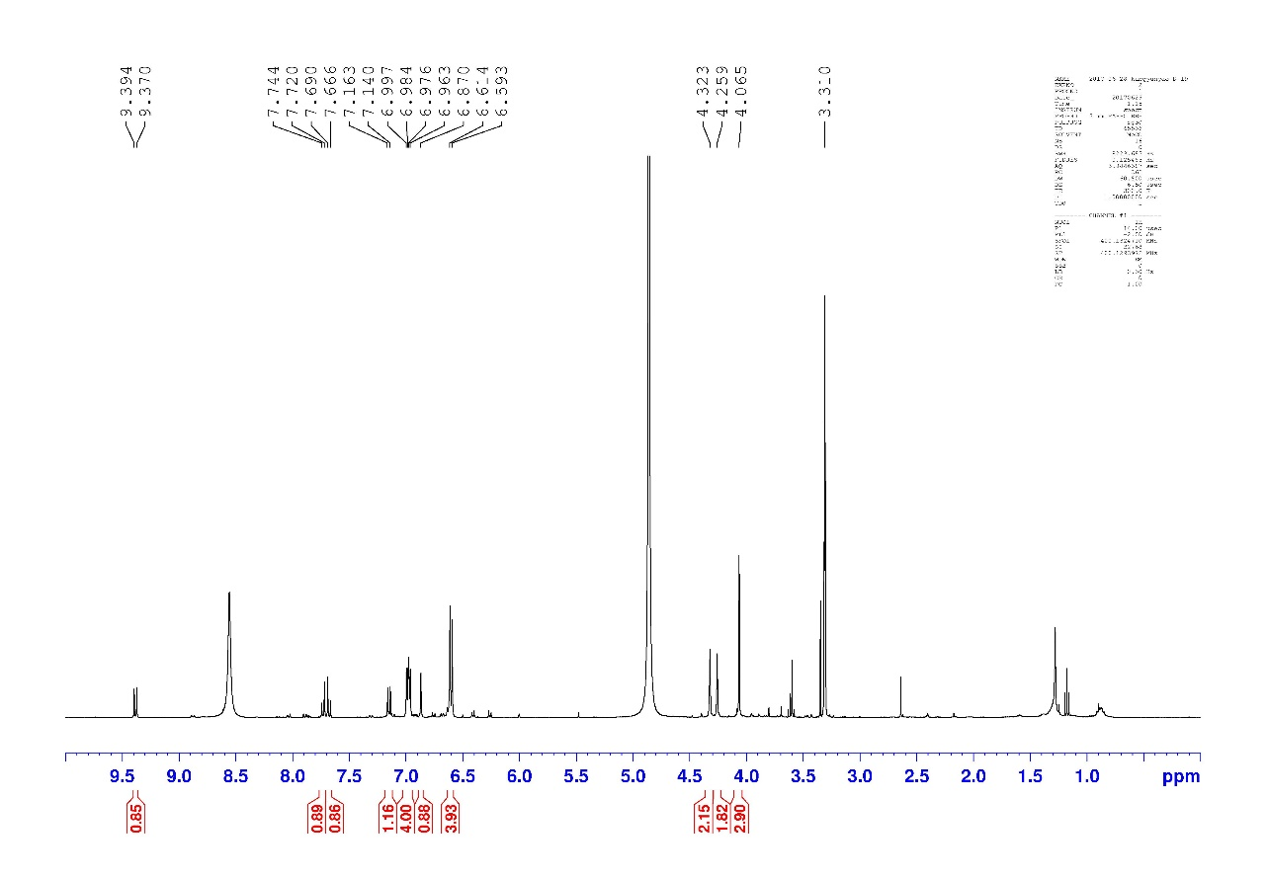
¹H NMR (400 MHz, CD₃OD) spectrum of compound 12

HPLC chromatogram of compound 12

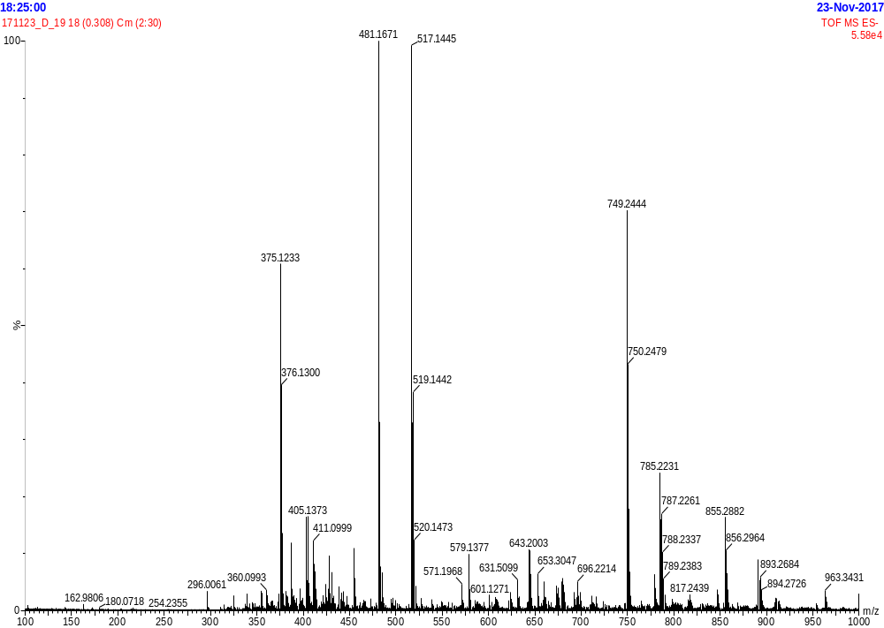
HR-ESI-MS spectrum of compound 13
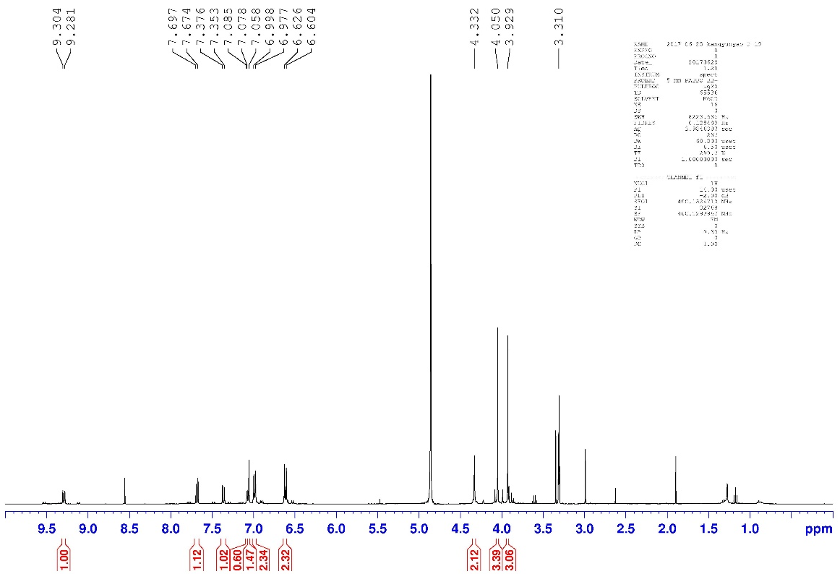
¹H NMR (400 MHz, CD₃OD) spectrum of compound 13
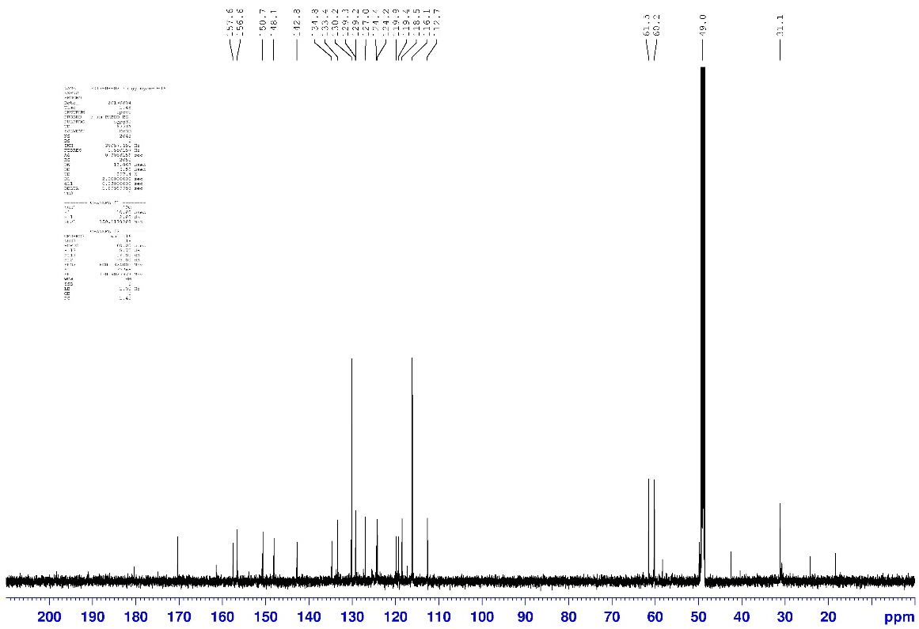
¹³C NMR (100 MHz, CD₃OD) spectrum of compound 13
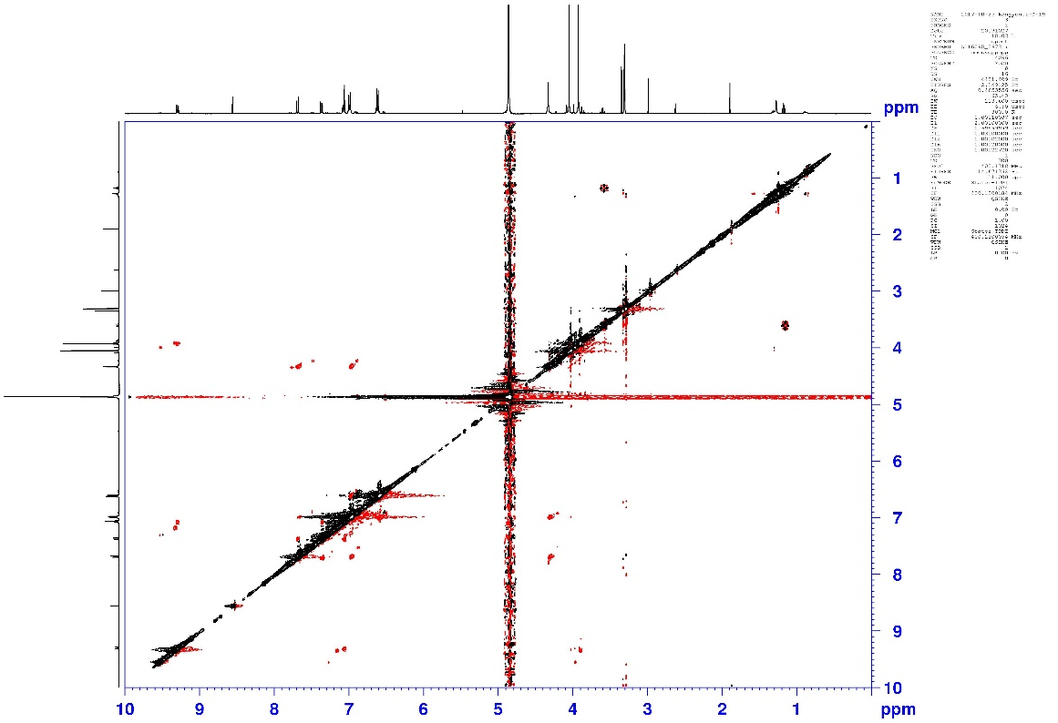
NOESY spectrum of compound 13

HPLC chromatogram of compound 13

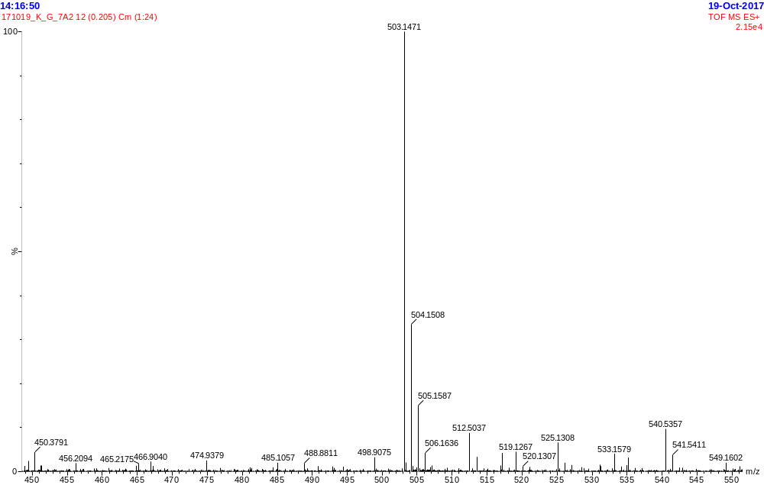
HR-ESI-MS spectrum of compound 14
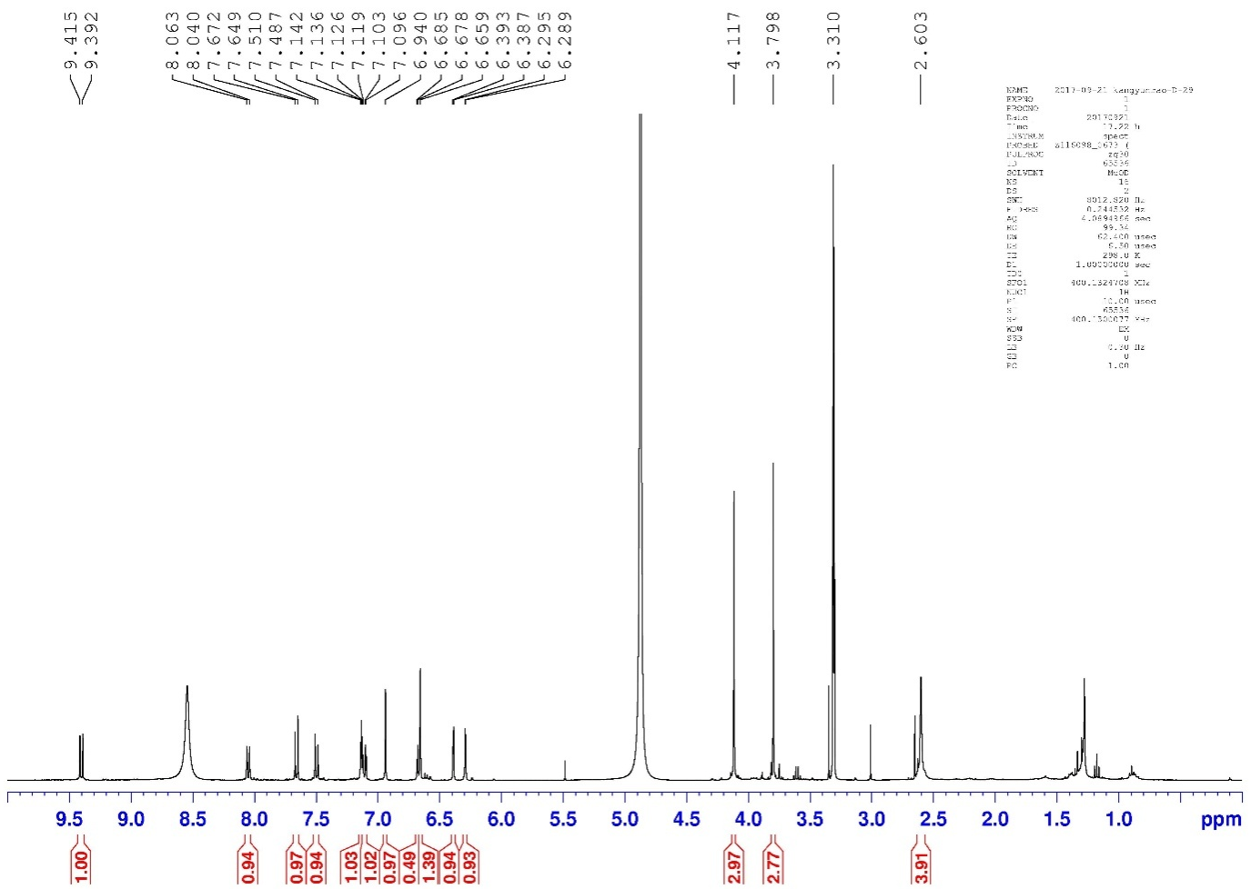
¹H NMR (400 MHz, CD₃OD) spectrum of compound 14
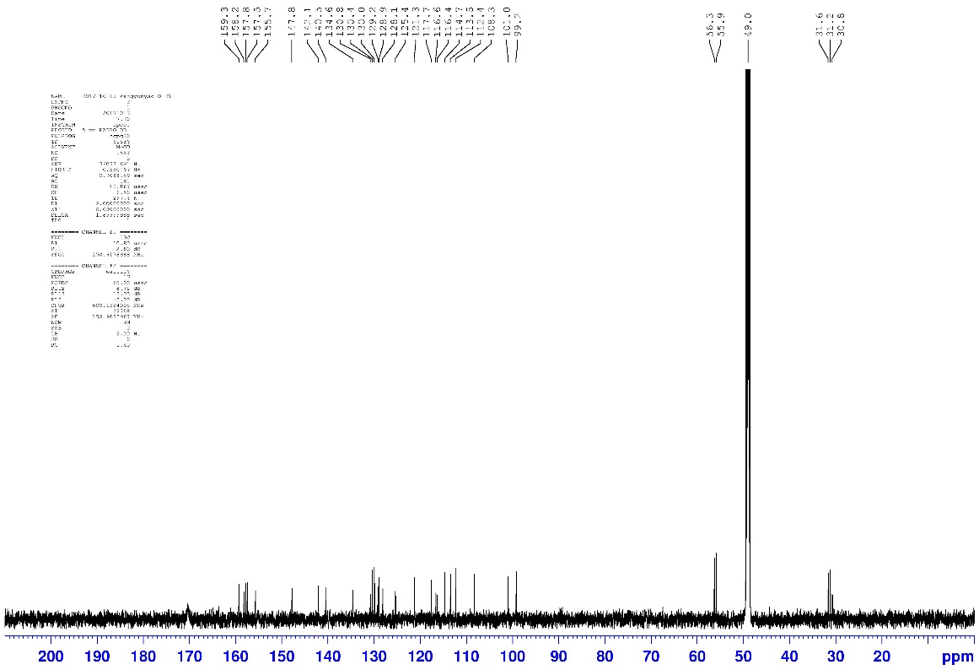
¹³C NMR (100 MHz, CD₃OD)spectrum of compound 14

HPLC chromatogram of compound 14

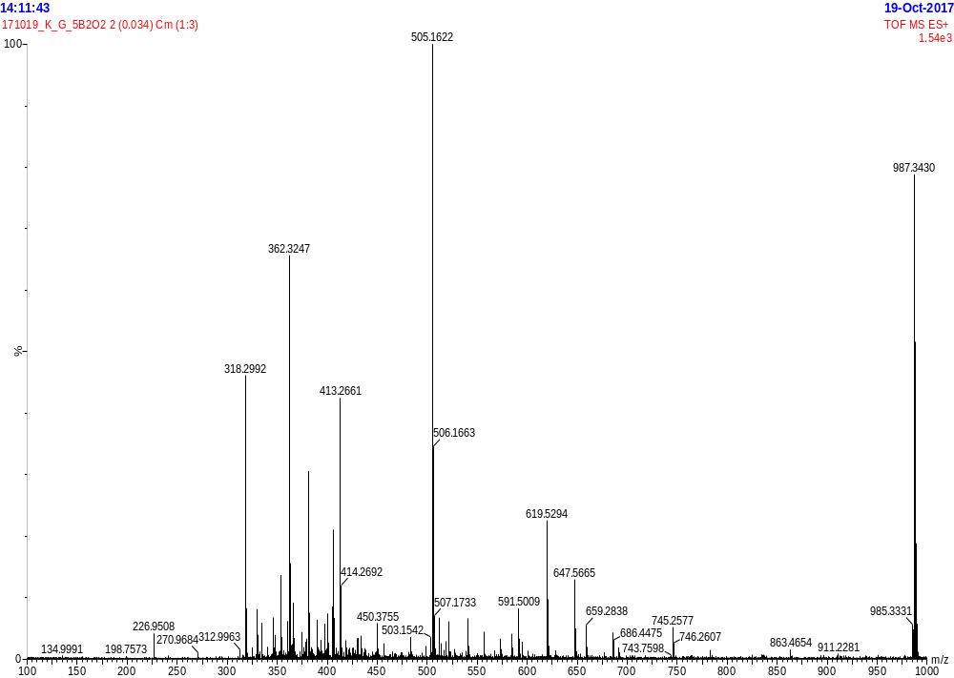
HR-ESI-MS spectrum of compound 15
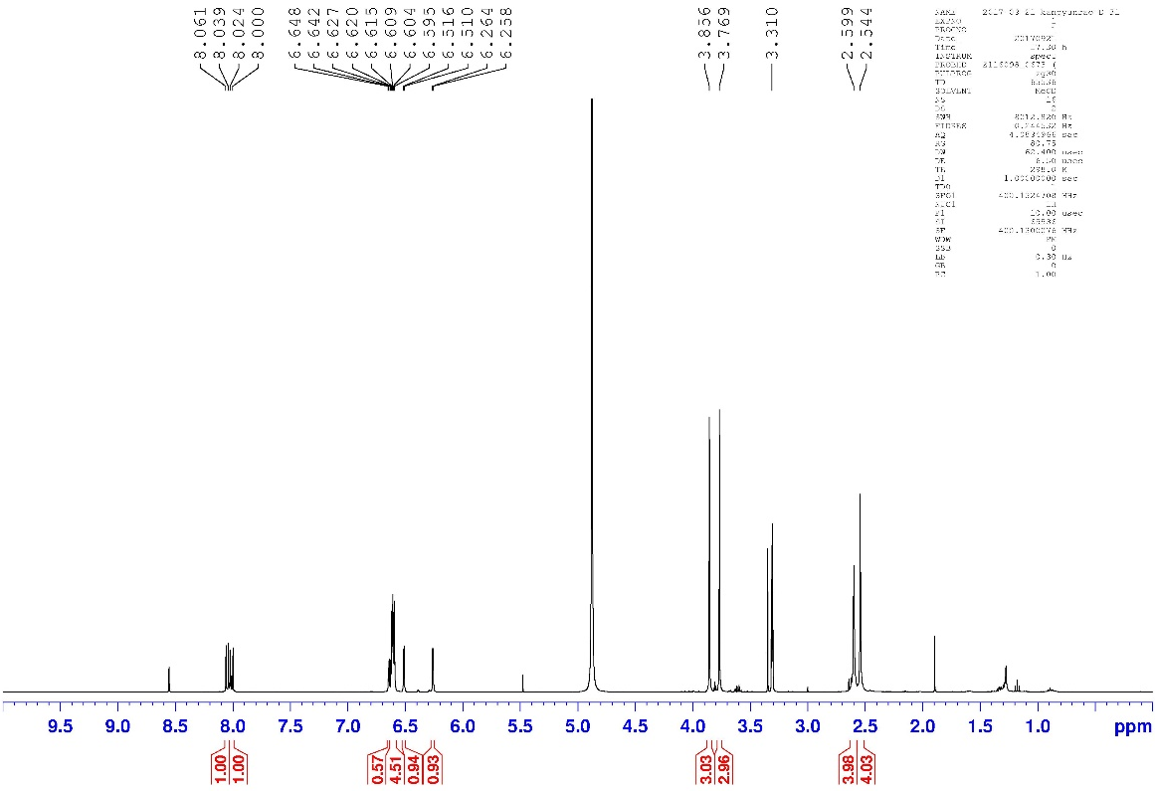
¹H NMR (400 MHz, CD₃OD) spectrum of compound 15
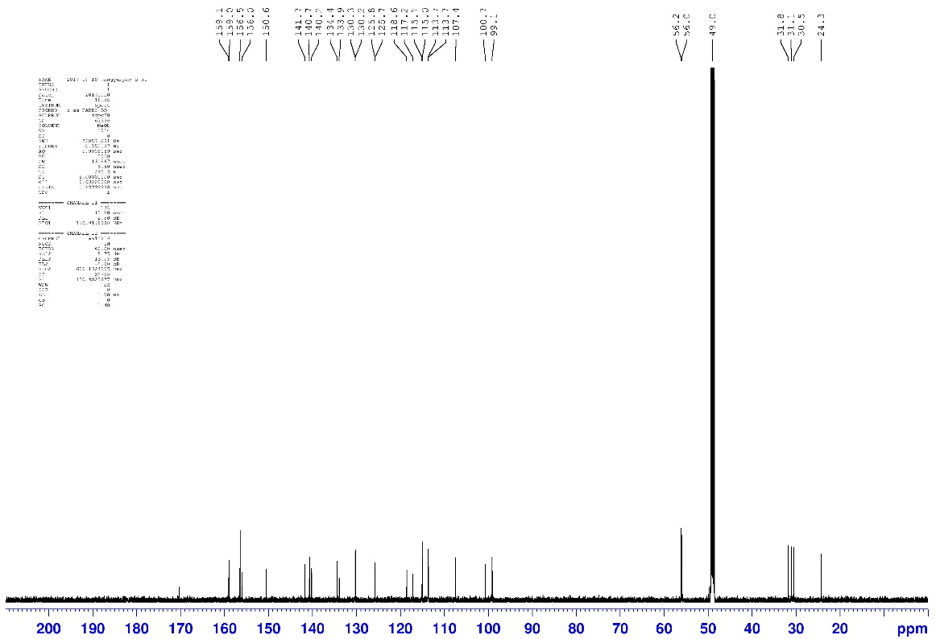
¹³C NMR (100 MHz, CD₃OD) spectrum of compound 15
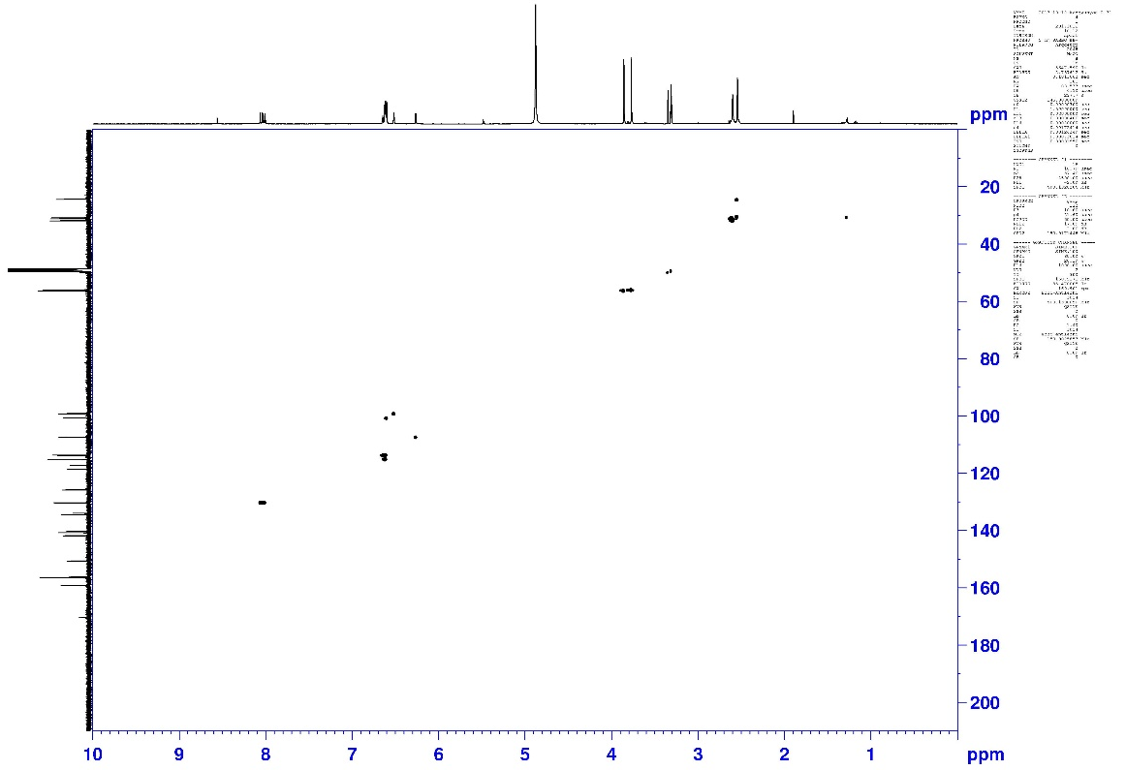
HSQC spectrum of compound 15
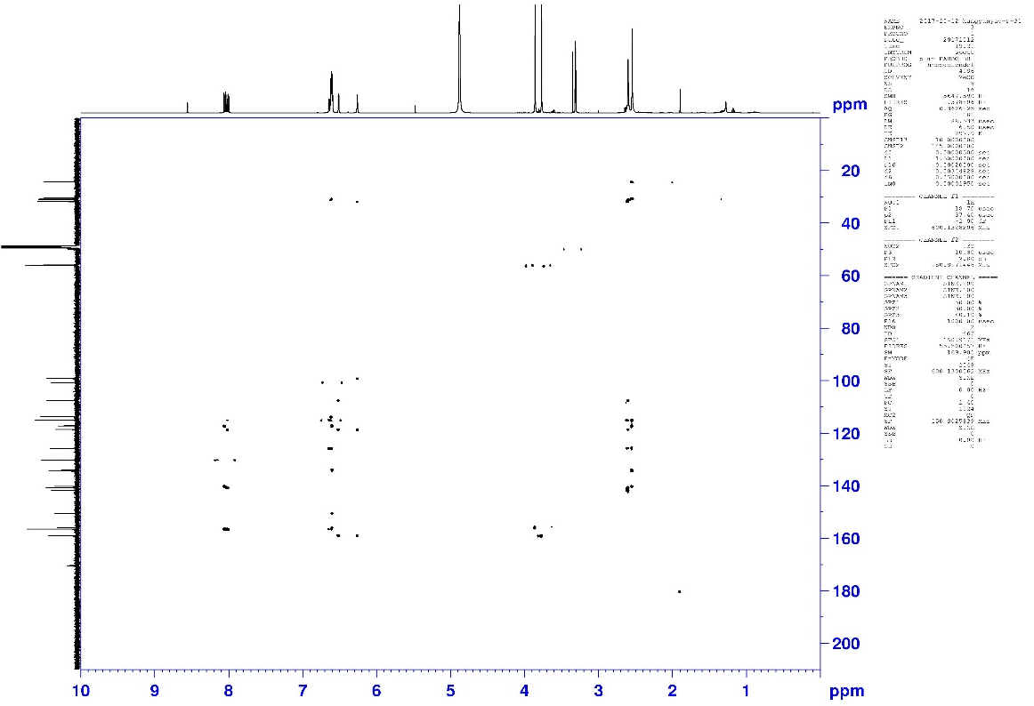
HMBC spectrum of compound 15
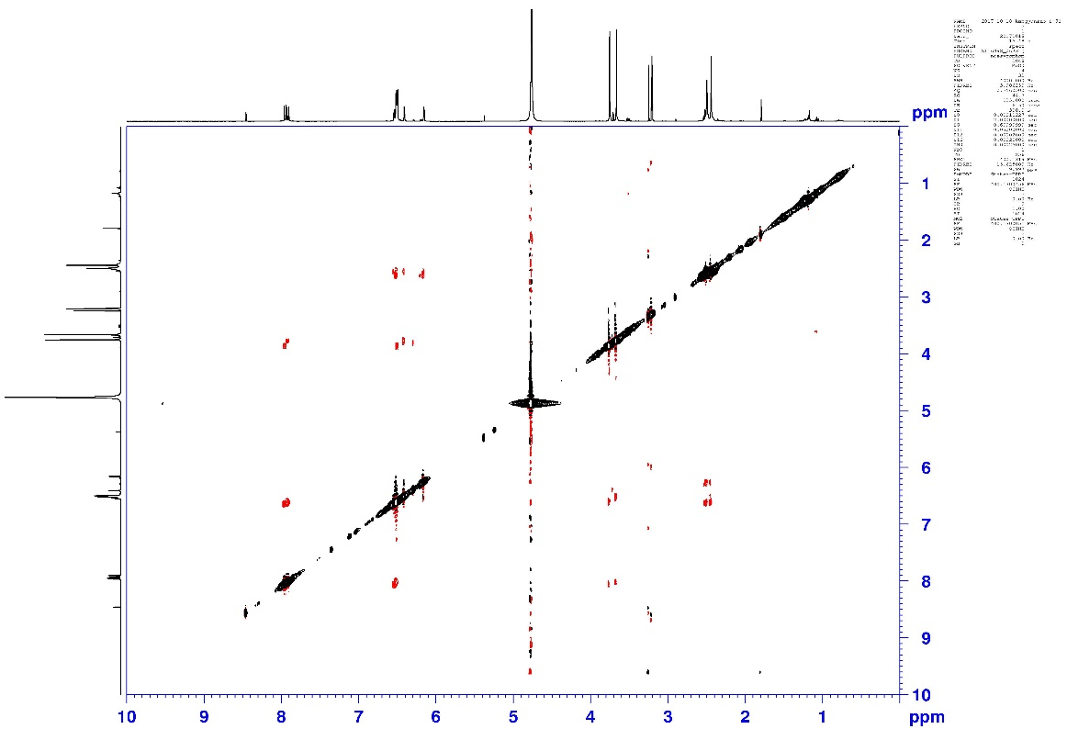
NOESY spectrum of compound 15
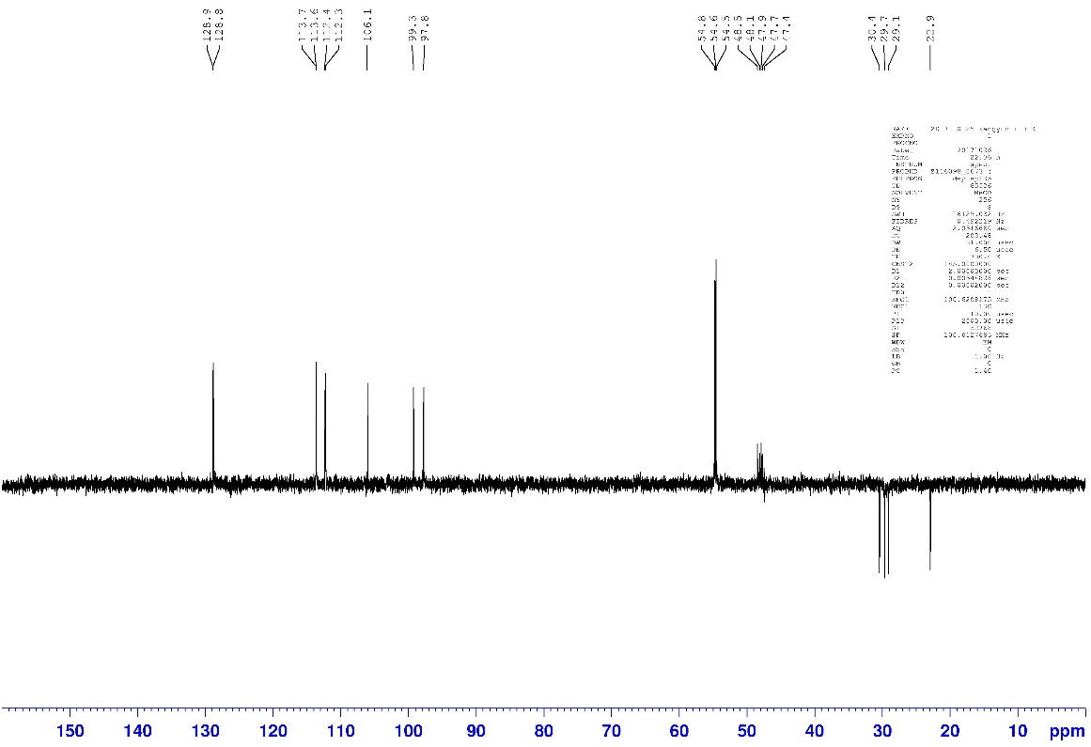
Dept 135 spectrum of compound 15

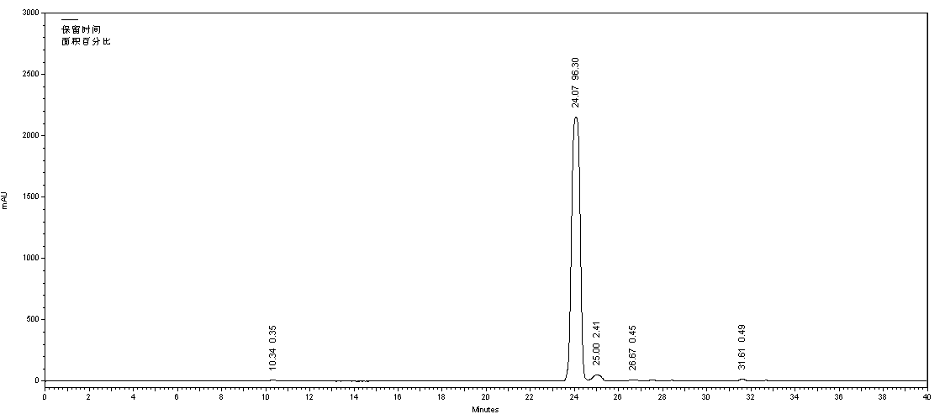
HPLC chromatogram of compound 15

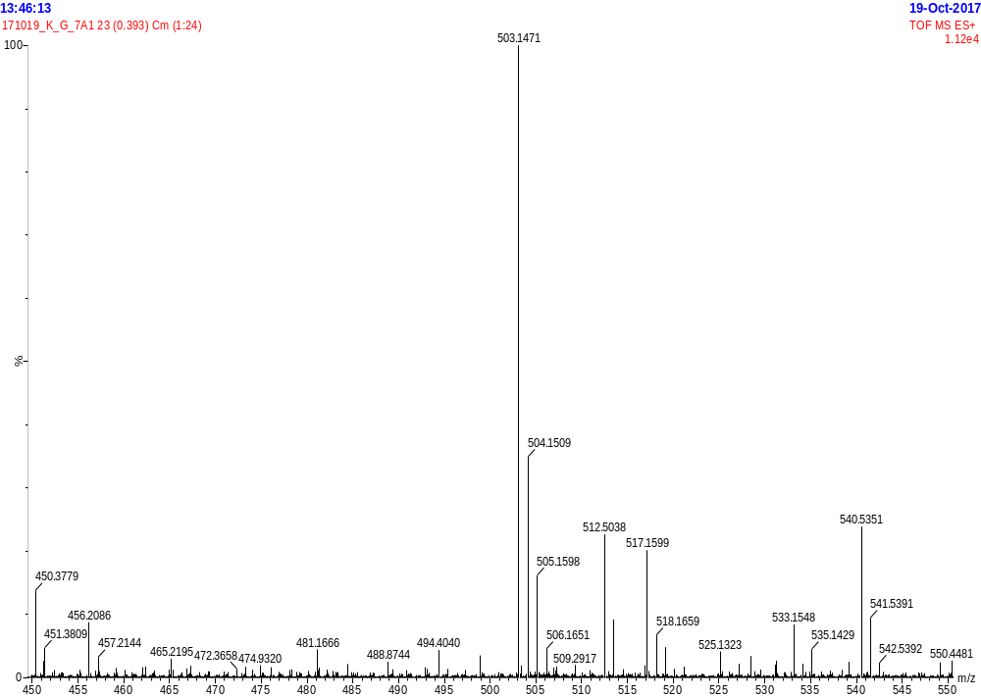
HR-ESI-MS spectrum of compound 16
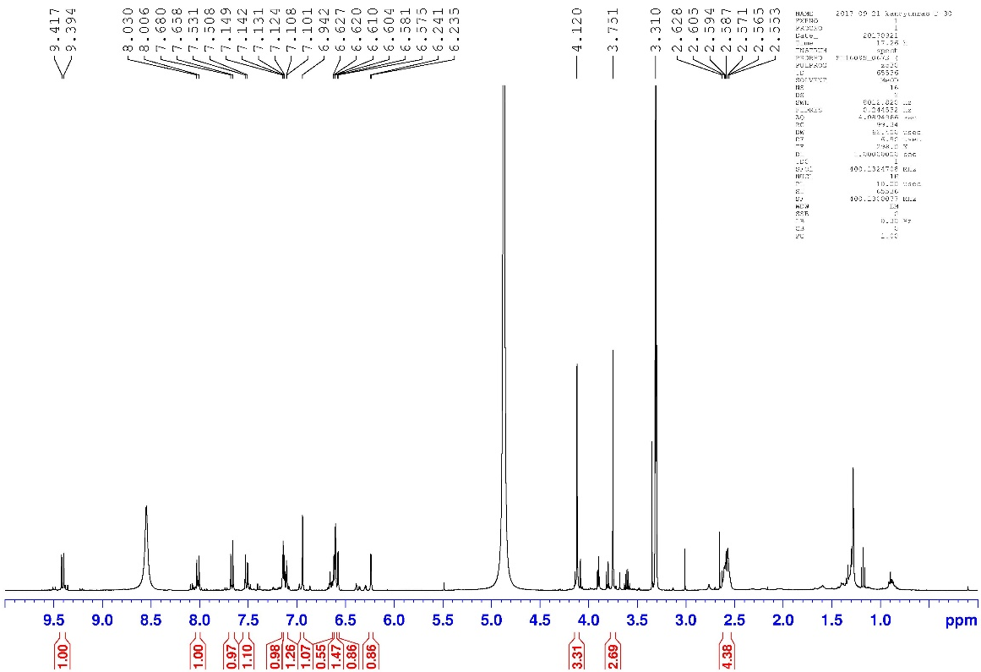
¹H NMR (400 MHz, CD₃OD) spectrum of compound 16

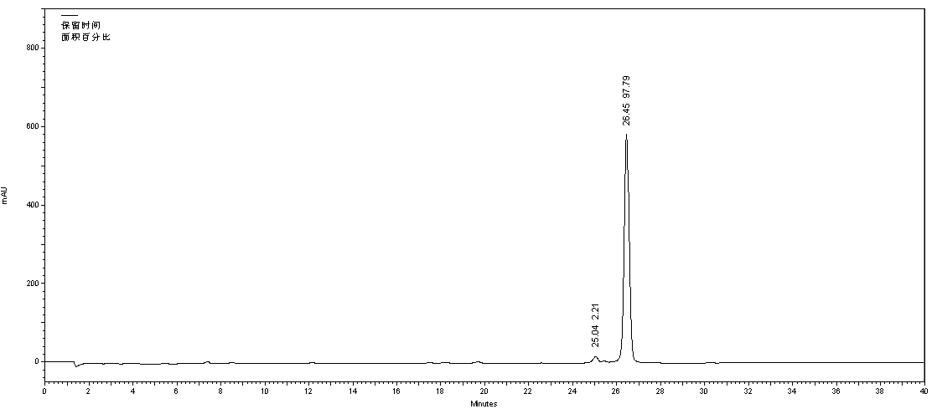
HPLC chromatogram of compound 16

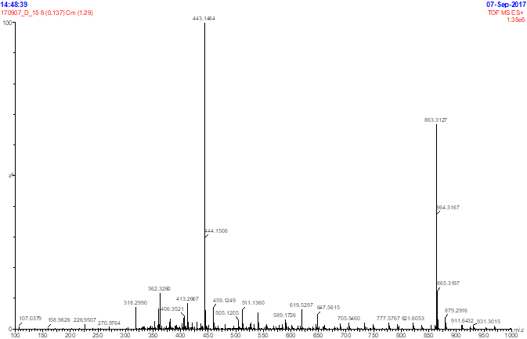
HR-ESI-MS spectrum of compound 17
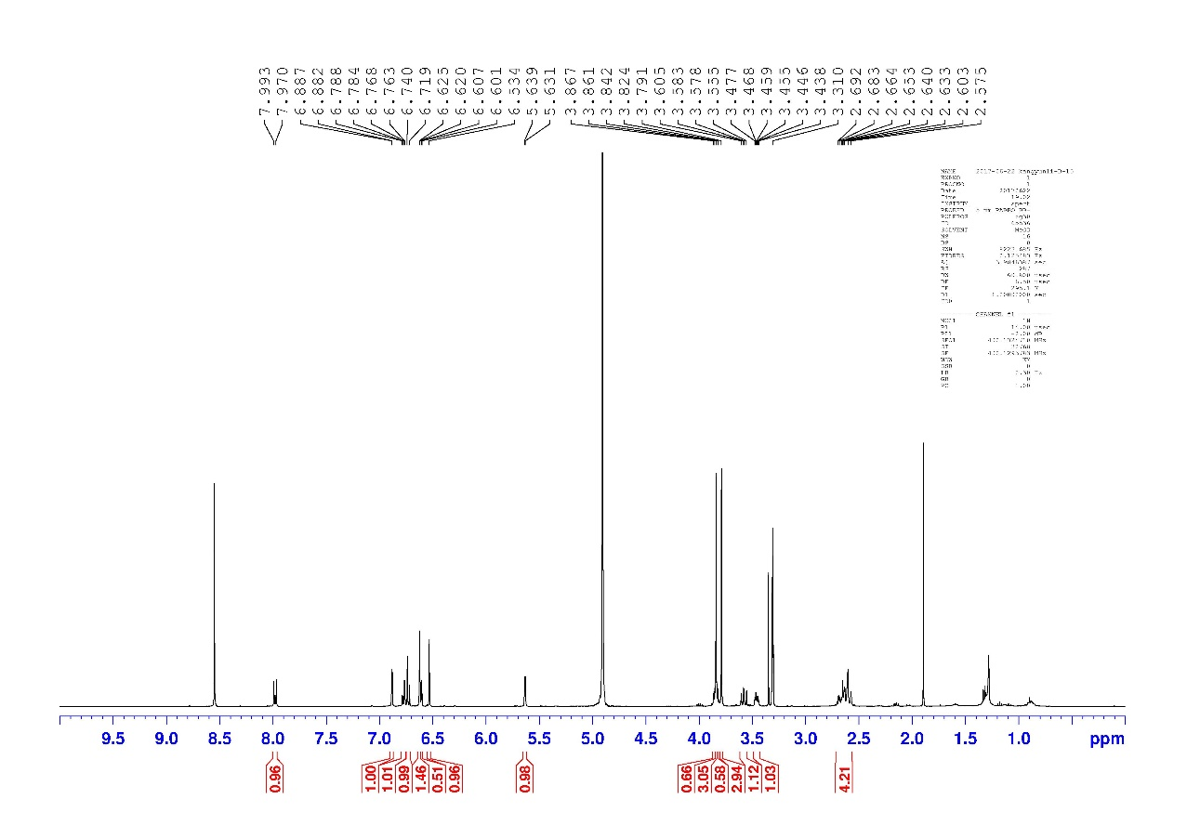
¹H NMR (400 MHz, CD₃OD) spectrum of compound 17
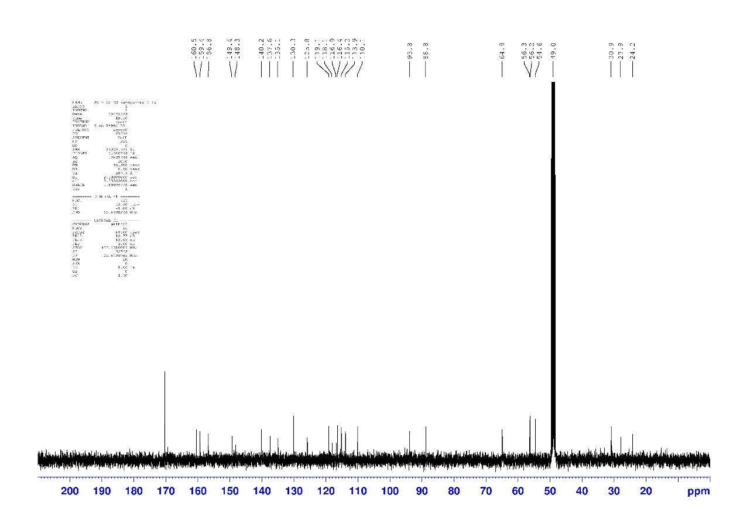
¹³C NMR (100 MHz, CD₃OD) spectrum of compound 17

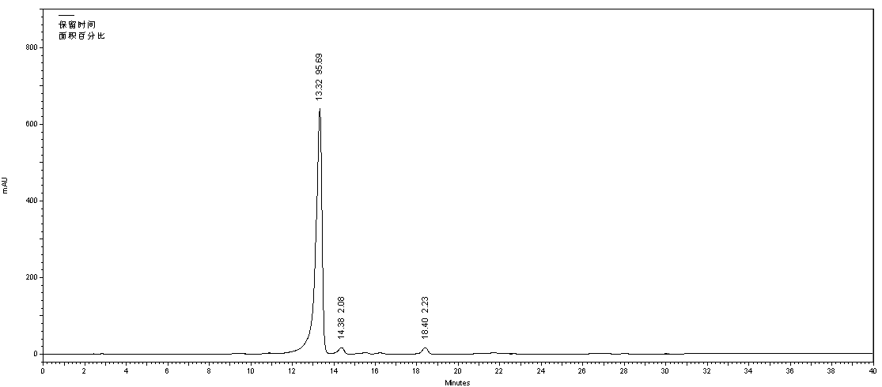
HPLC chromatogram of compound 17

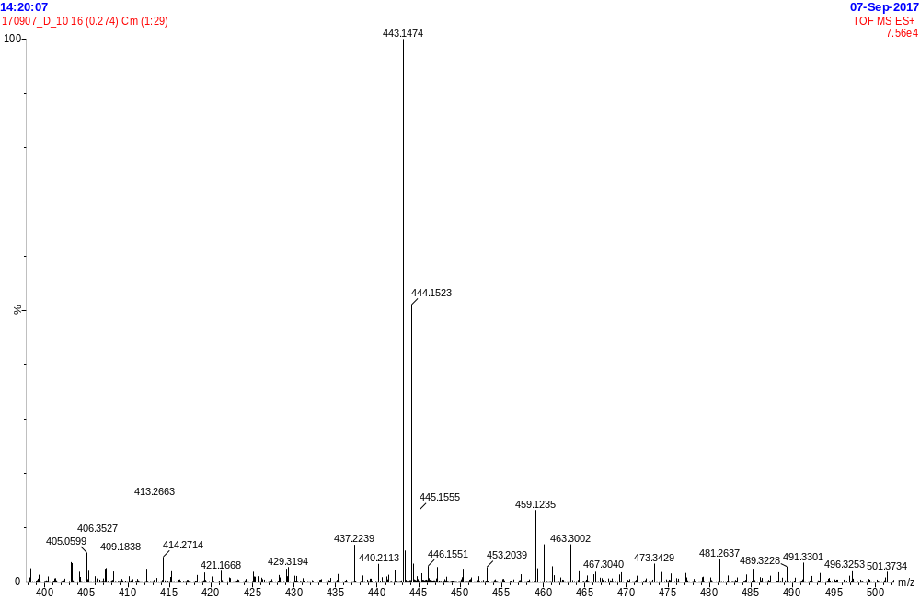
HR-ESI-MS spectrum of 18
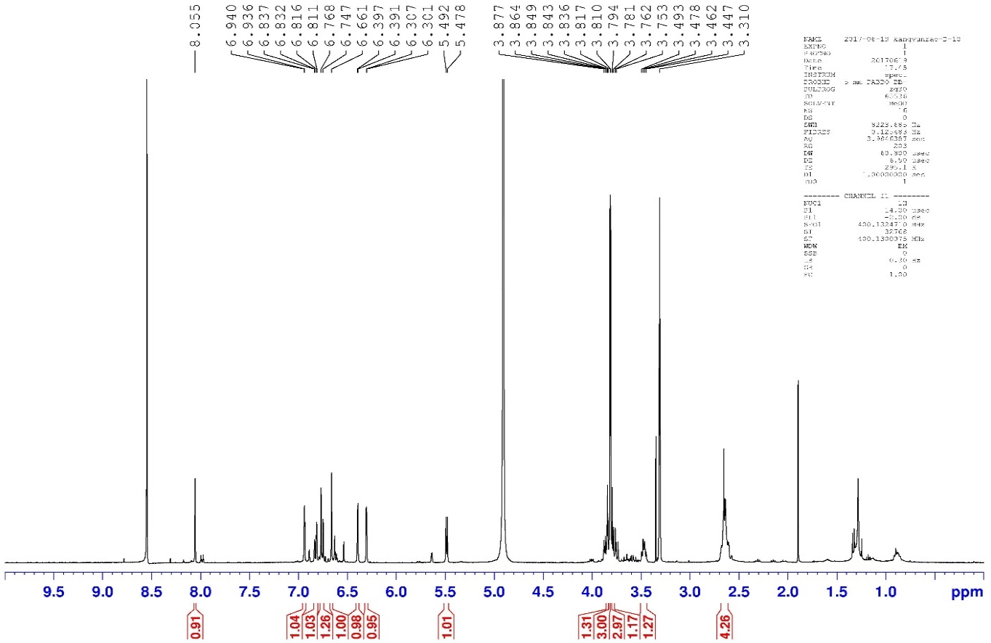
¹H NMR (400 MHz, CD₃OD) spectrum of 18
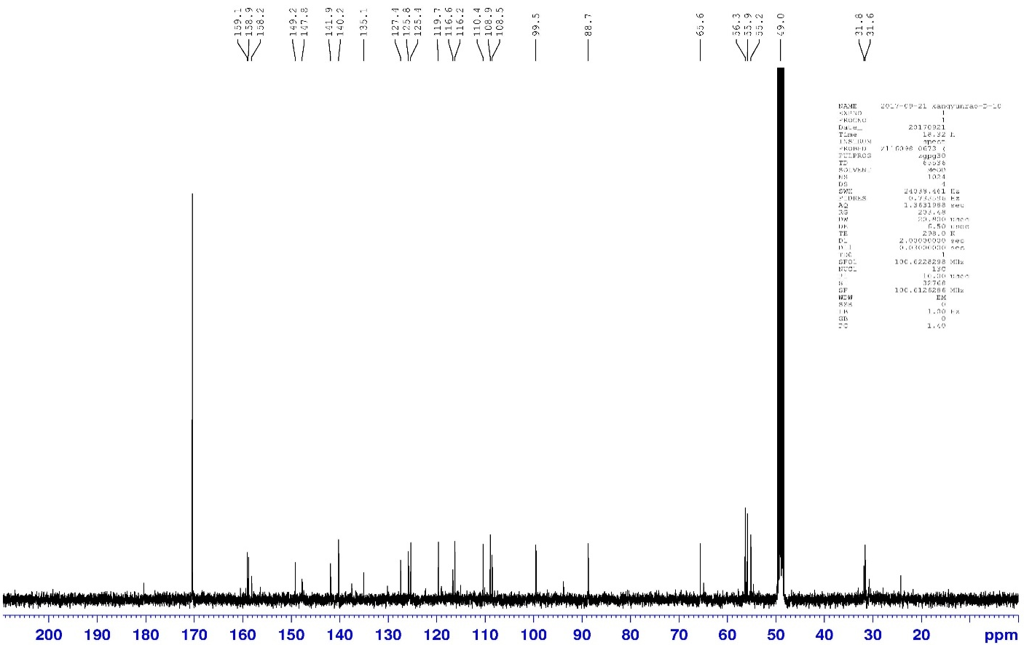
¹³C NMR (100 MHz, CD₃OD) spectrum of 18
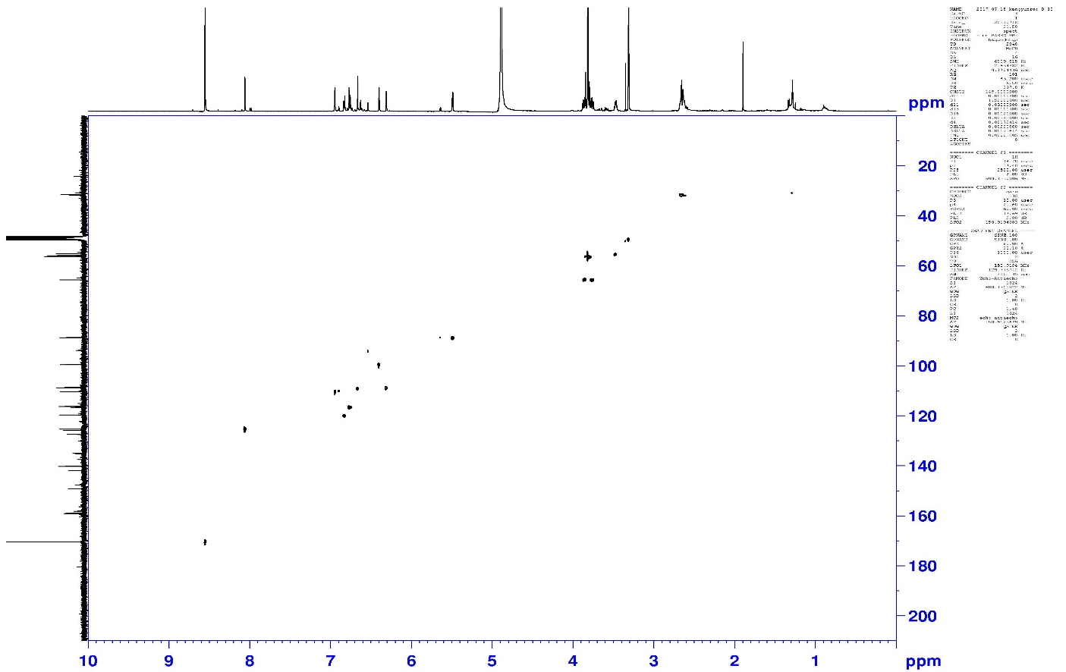
HSQC spectrum of 18.
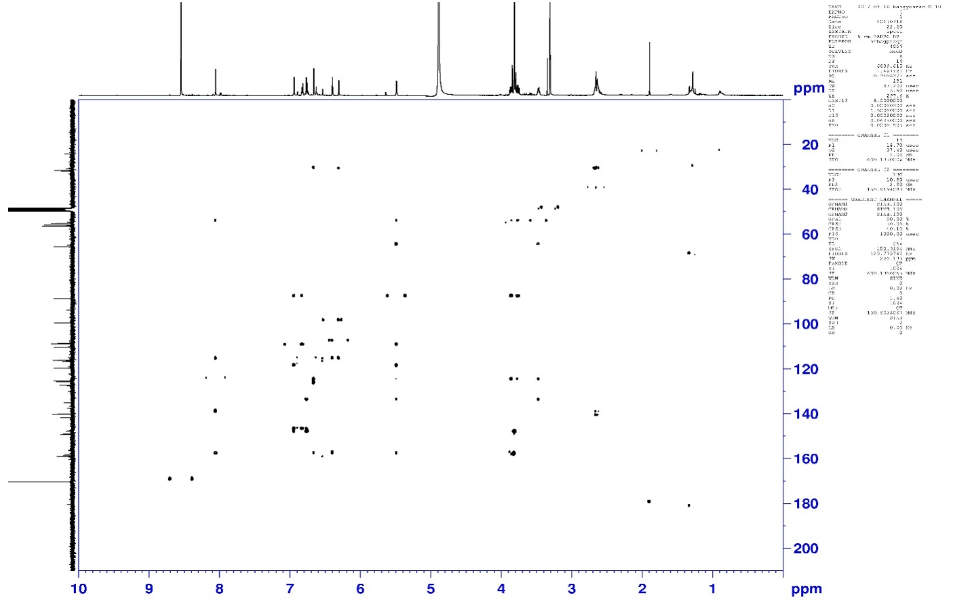
HMBC spectrum of 18
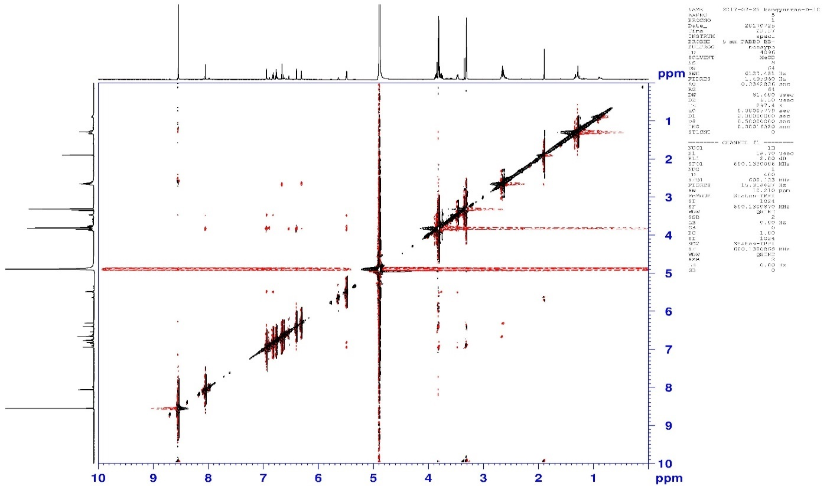
NOESY spectrum of 18

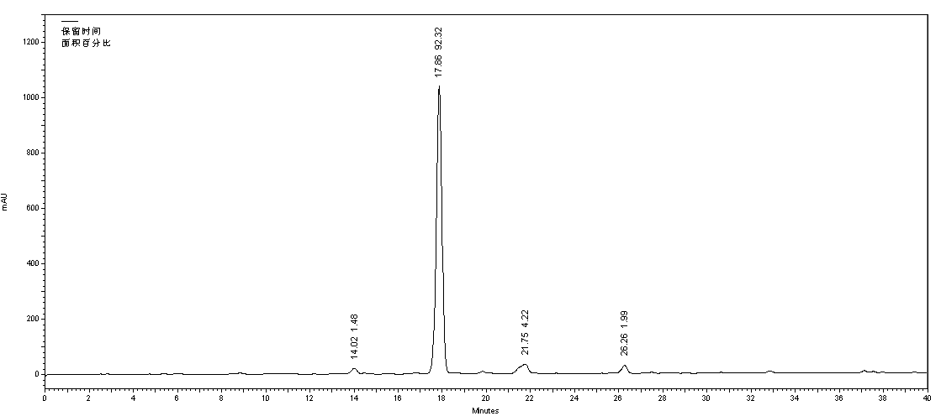
HPLC chromatogram of compound 18

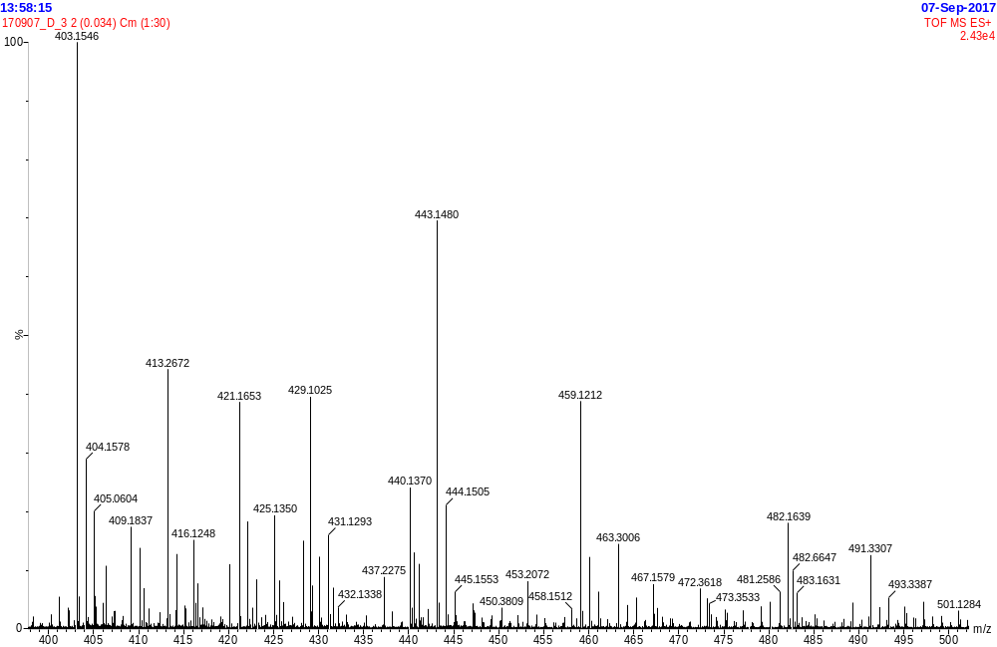
HR-ESI-MS spectrum of compound 19
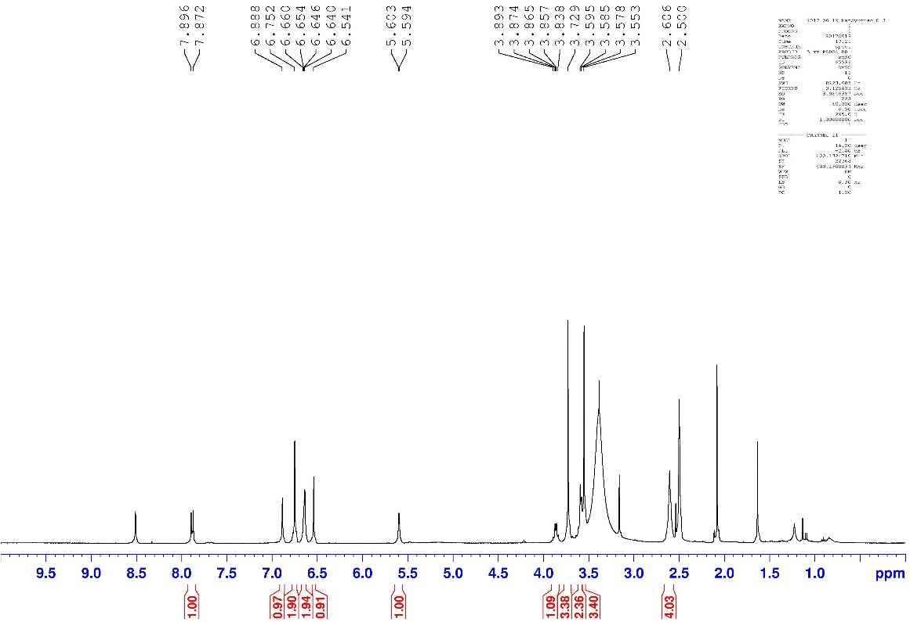
¹H NMR (400 MHz, DMSO-d₆) spectrum of compound 19
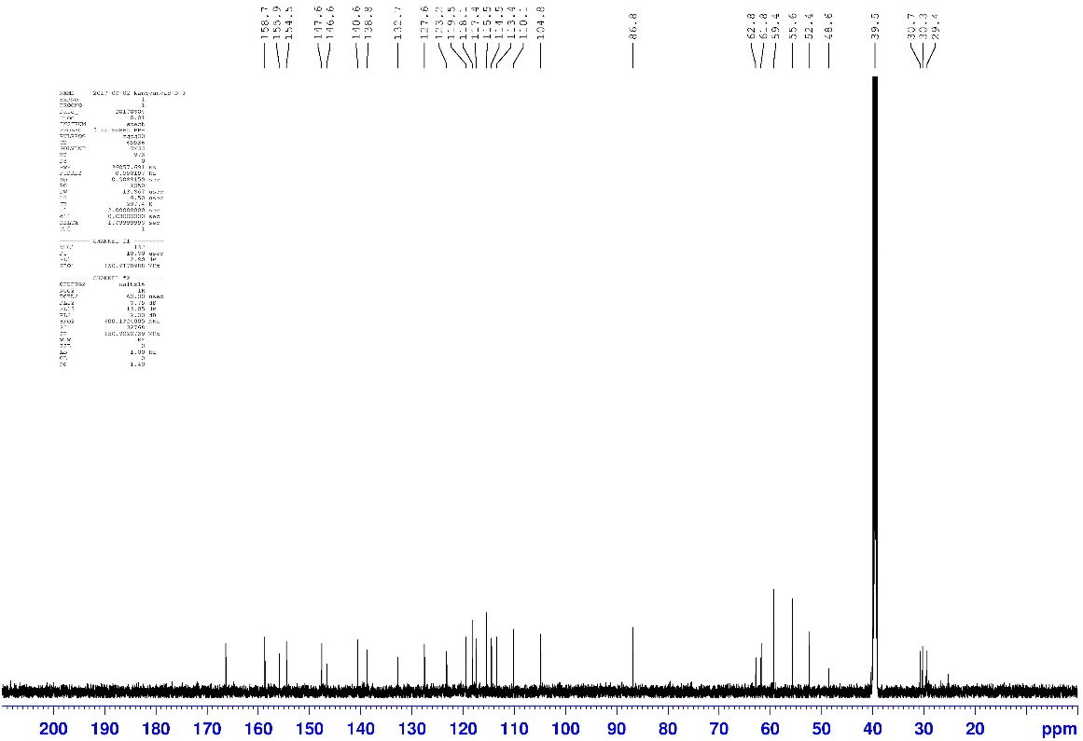
¹³C NMR (100 MHz, DMSO-d₆) spectrum of compound 19
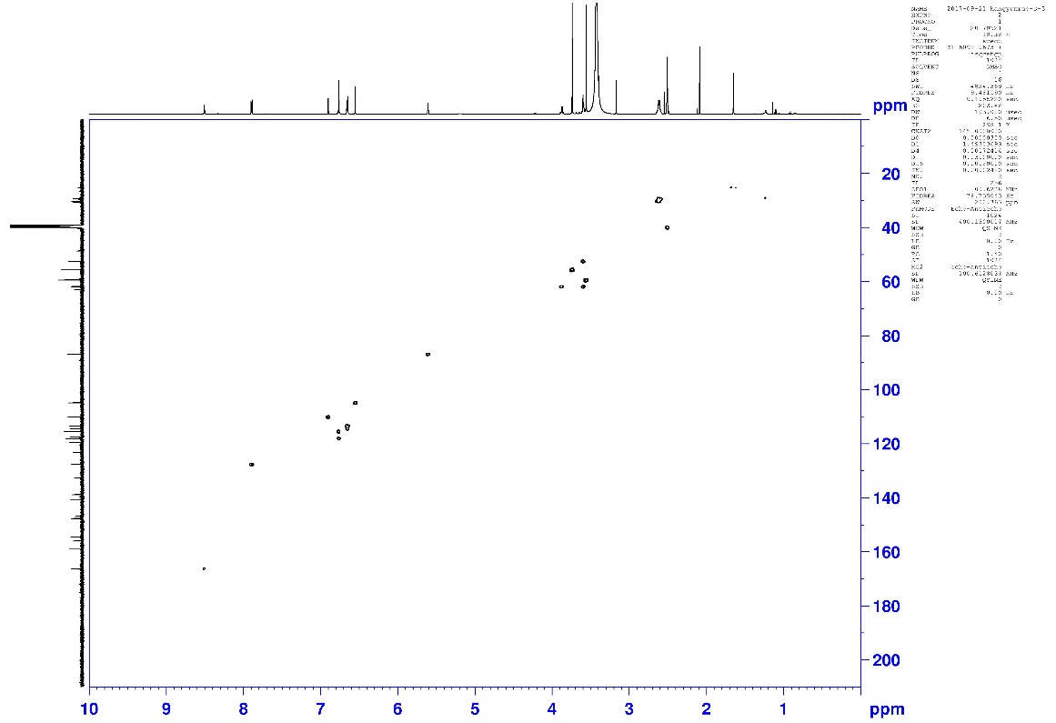
HSQC spectrum of compound 19
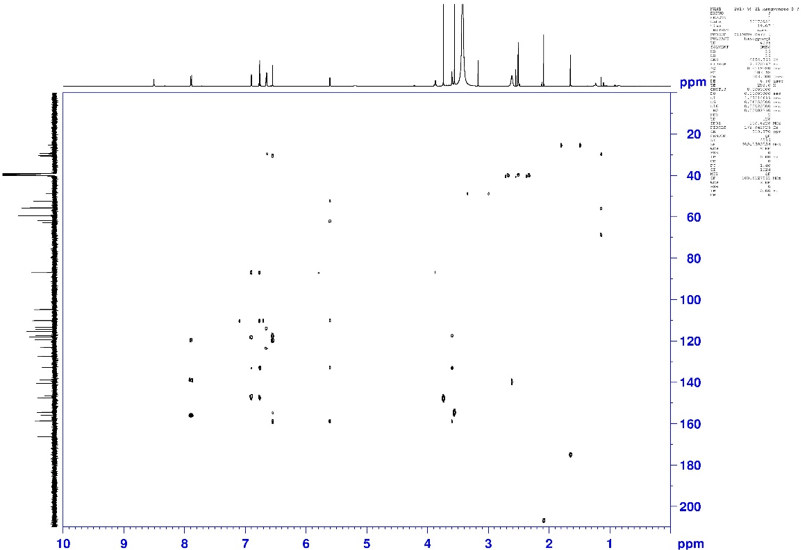
HMBC spectrum of compound 19
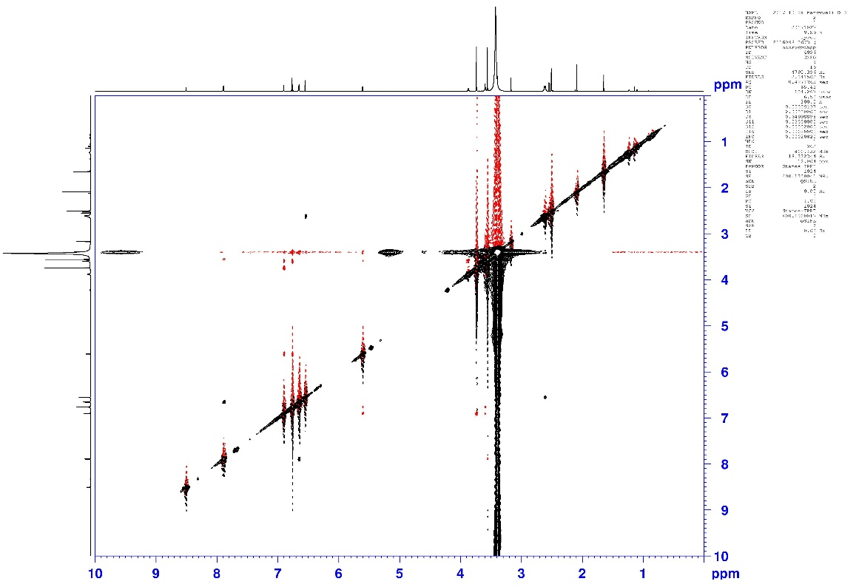
NOESY spectrum of compound 19
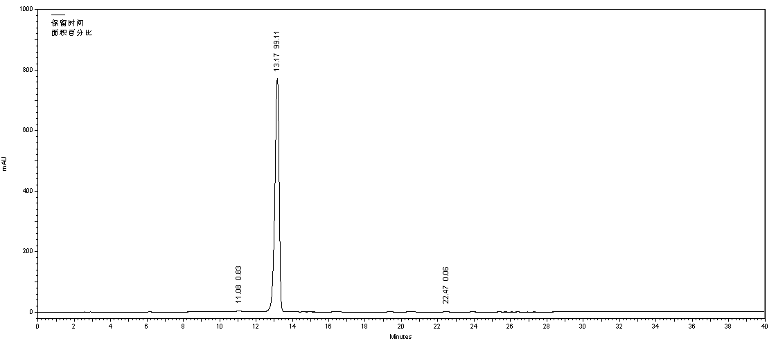
HPLC chromatogram of compound 19

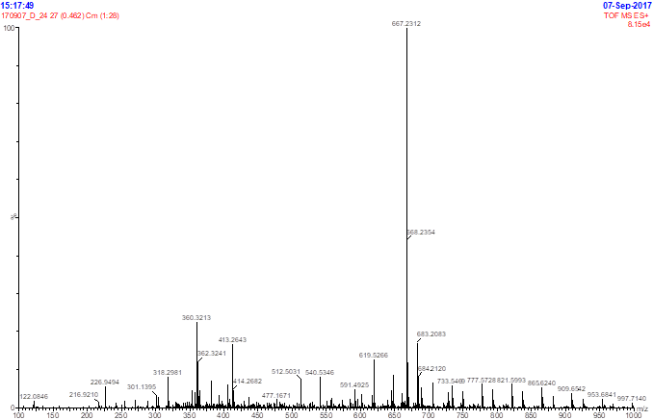
HR-ESI-MS spectrum of compound 20.
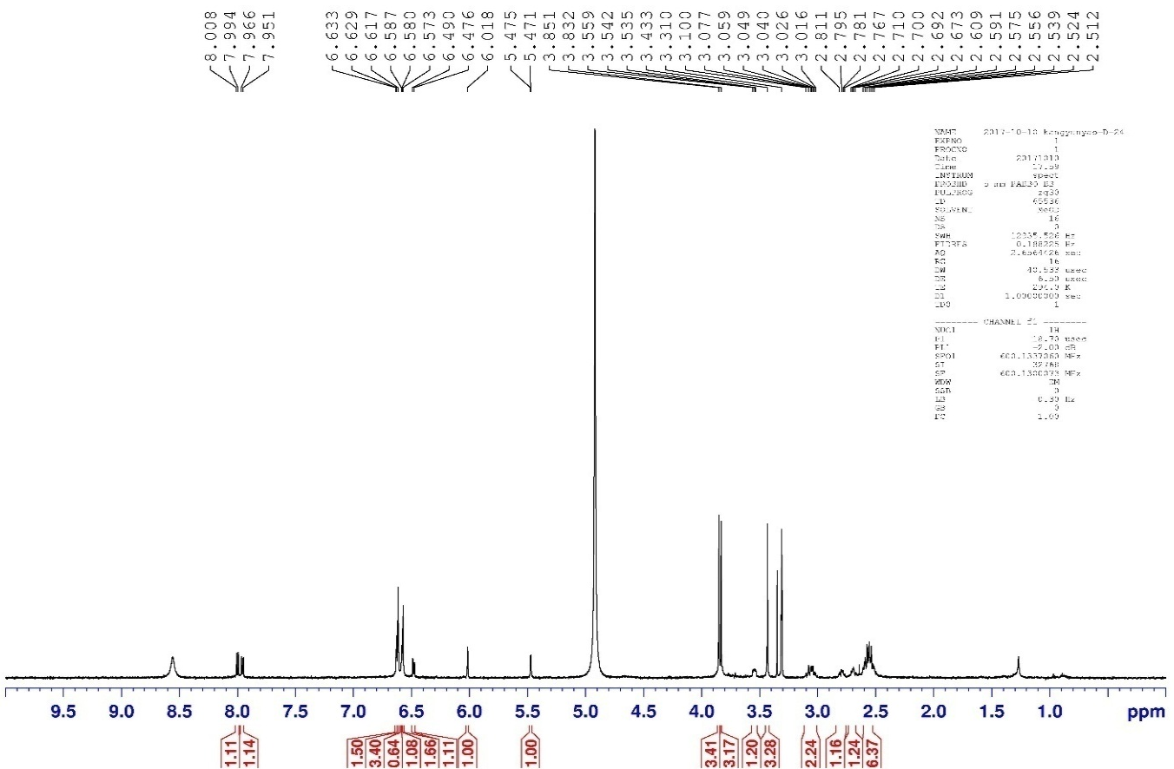
¹H NMR (400 MHz, CD₃OD) spectrum of compound 20
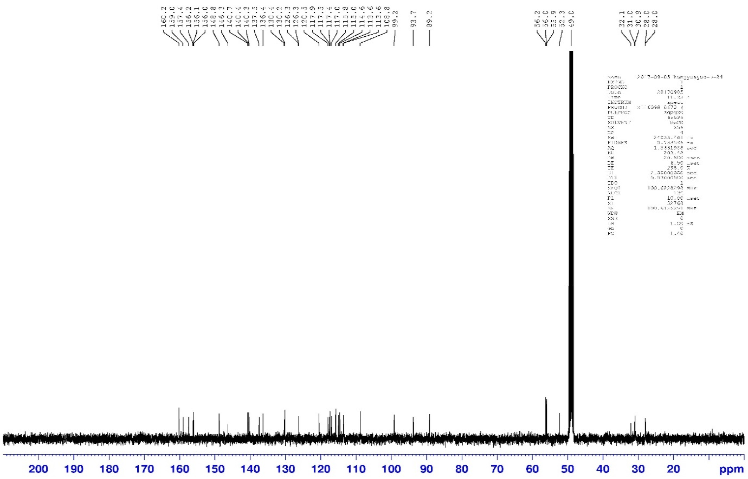
¹³C NMR (100 MHz, CD₃OD) spectrum of compound 20.
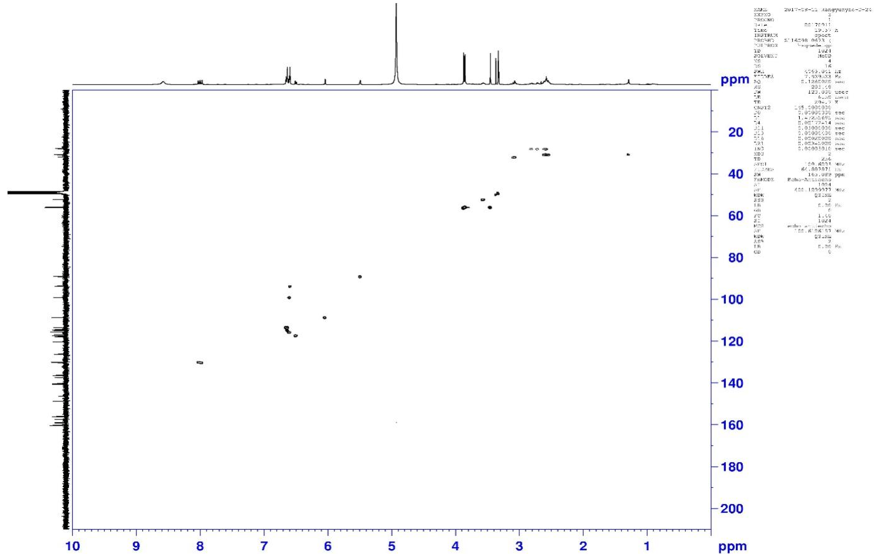
HSQC spectrum of compound 20.
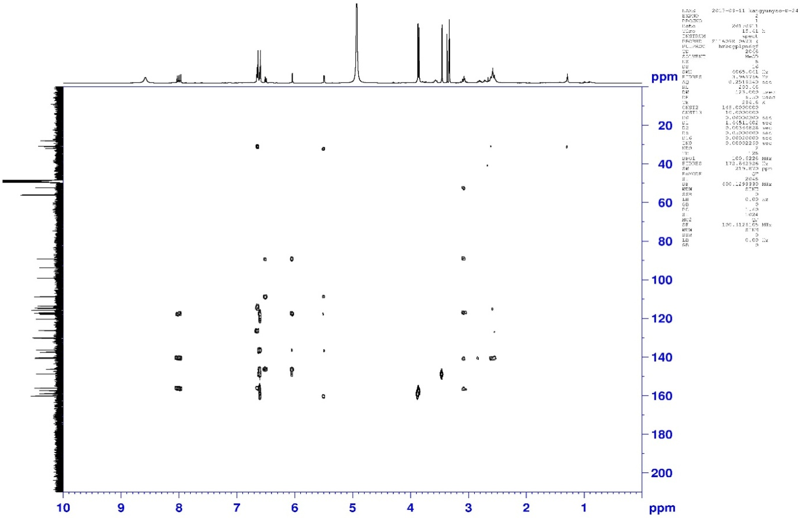
HMBC spectrum of compound 20
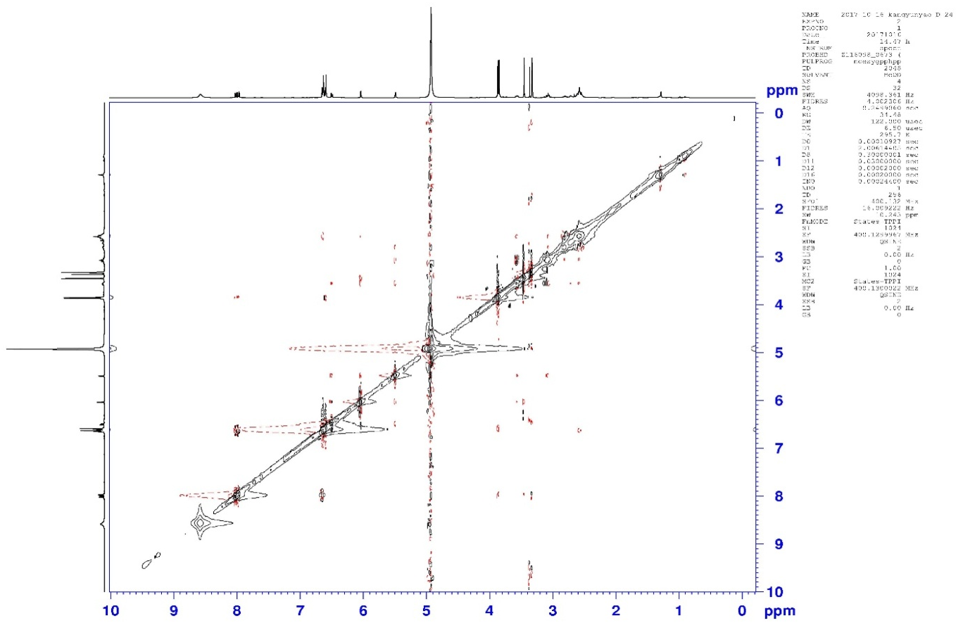
NOESY spectrum of compound 20.

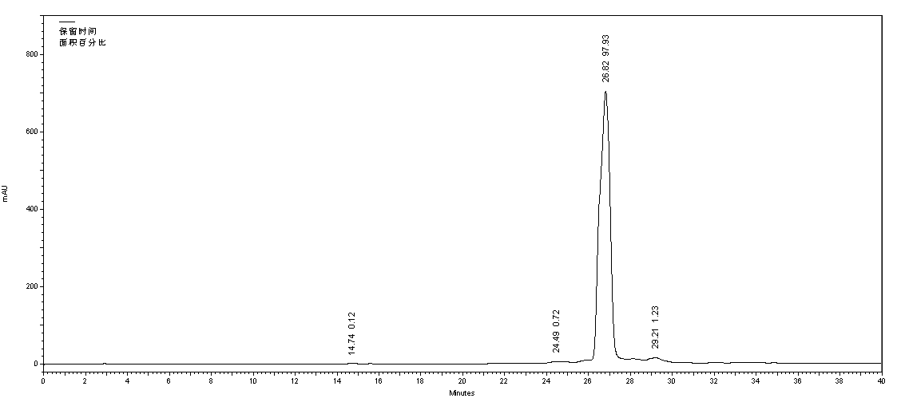
HPLC chromatogram of compound 20

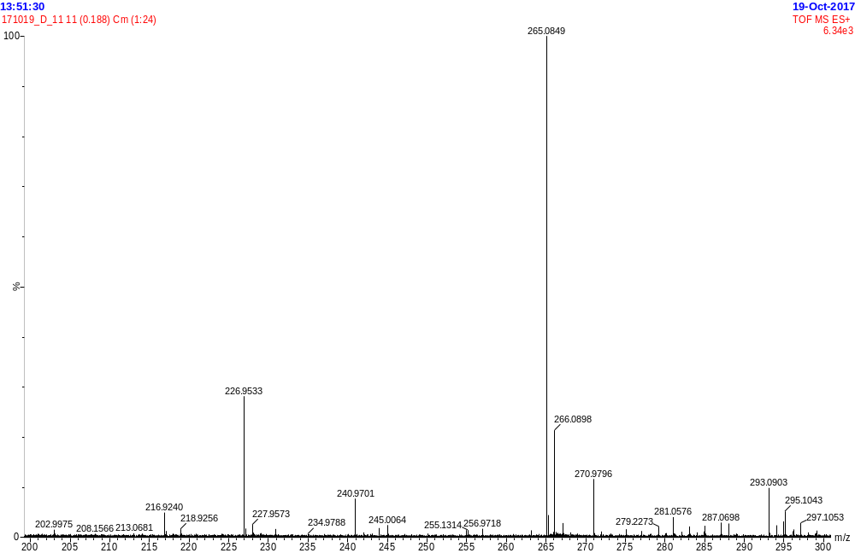
HR-ESI-MS spectrum of compound 21
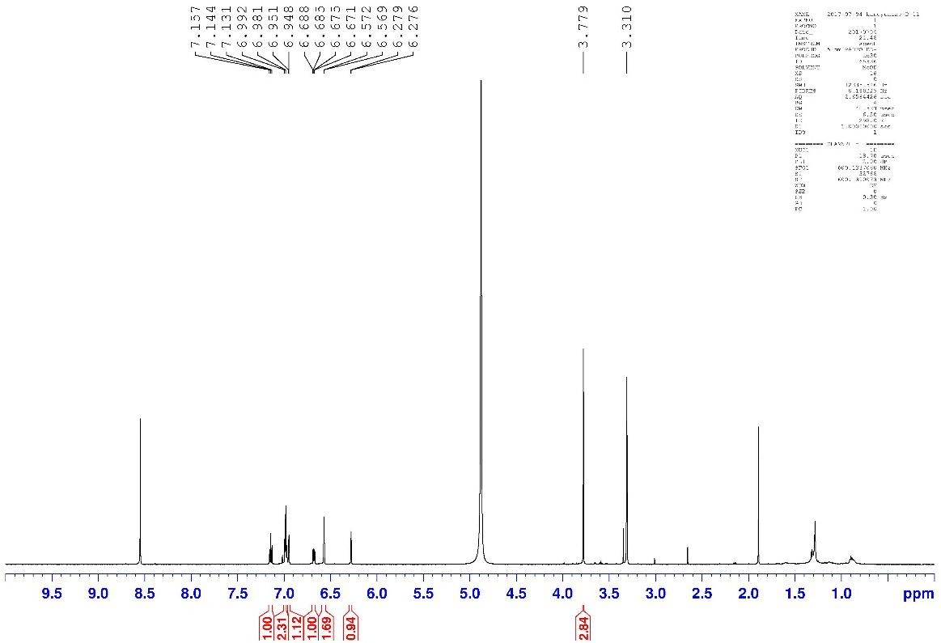
¹H NMR (400 MHz, CD₃OD) spectrum of compound 21
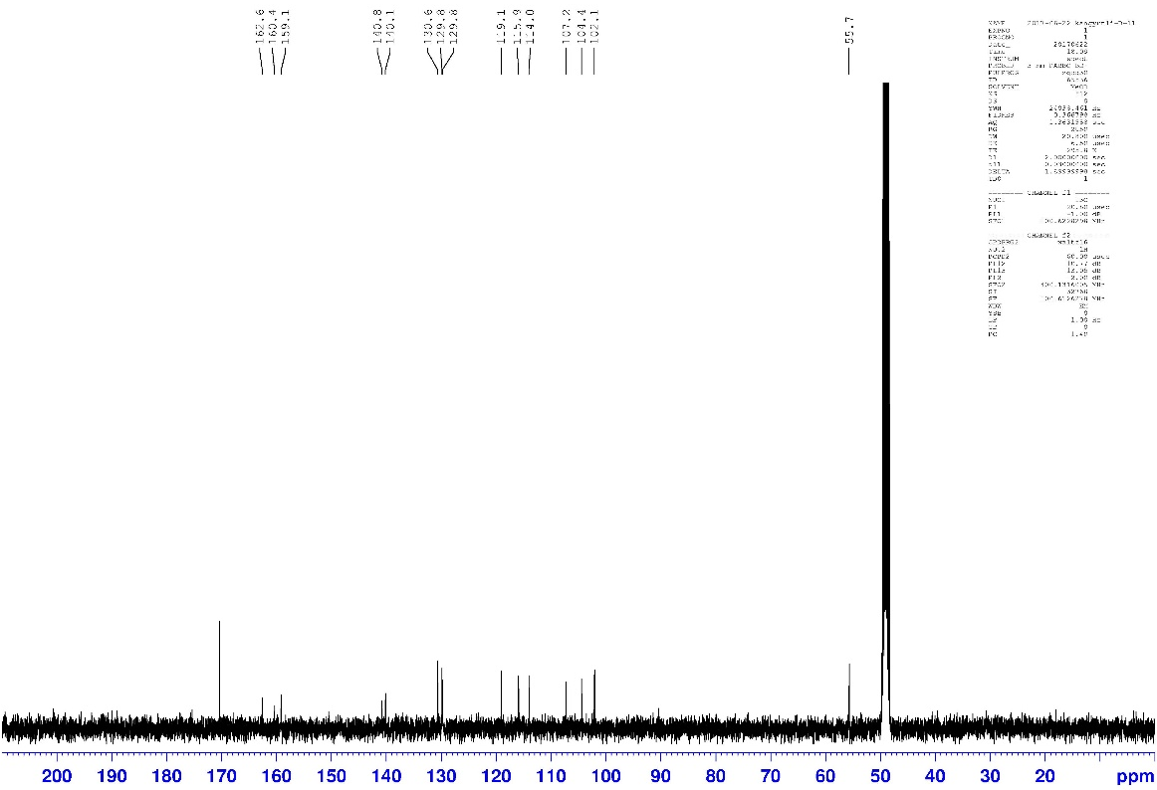
¹³C NMR (100 MHz, CD₃OD) spectrum of compound 21

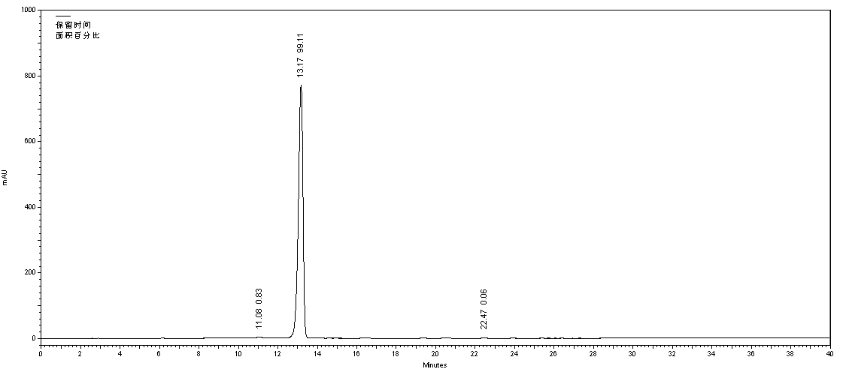
HPLC chromatogram of compound 21

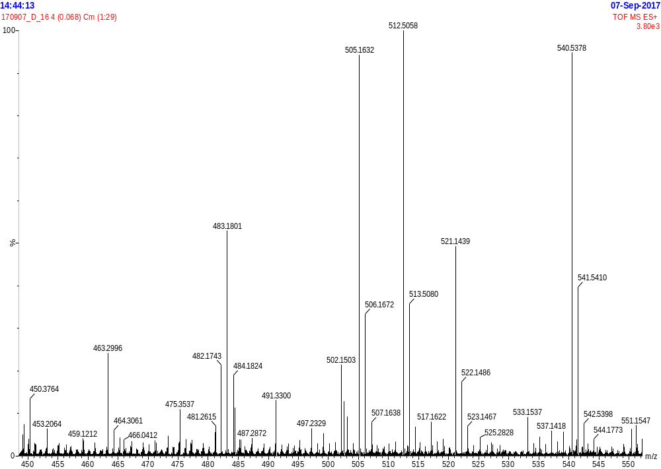
HR-ESI-MS spectrum of compound 22
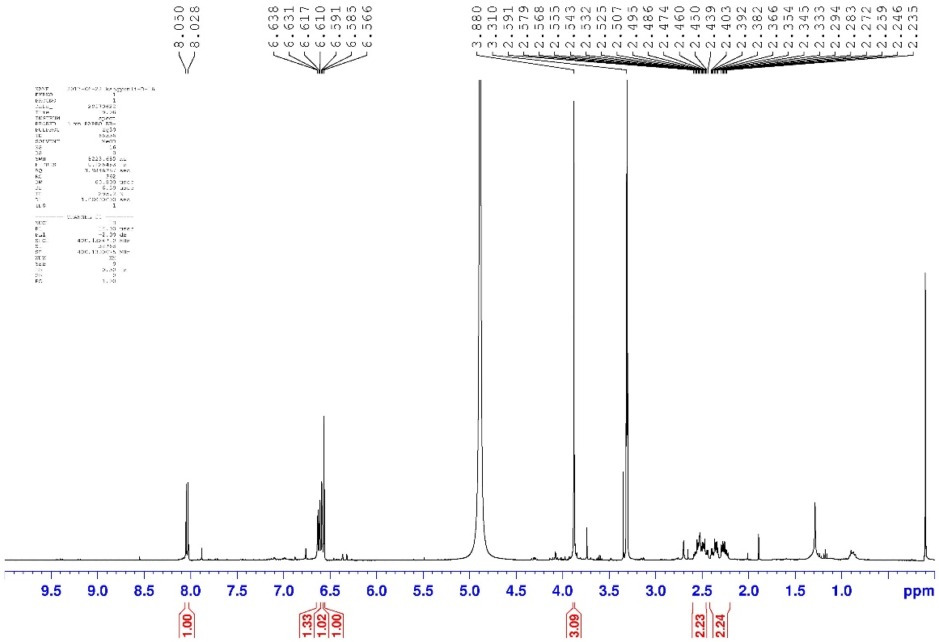
¹H NMR (400 MHz, CD₃OD)spectrum of compound 22
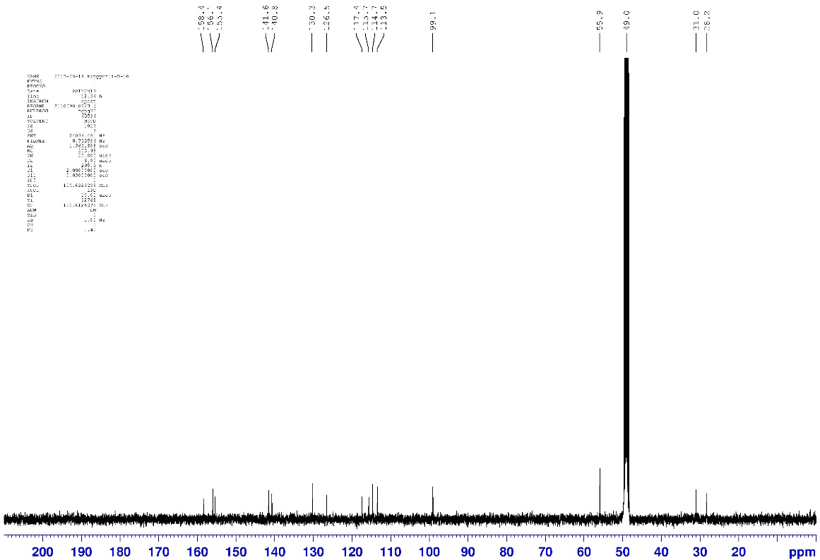
¹³C NMR (100 MHz, CD₃OD) spectrum of compound 22

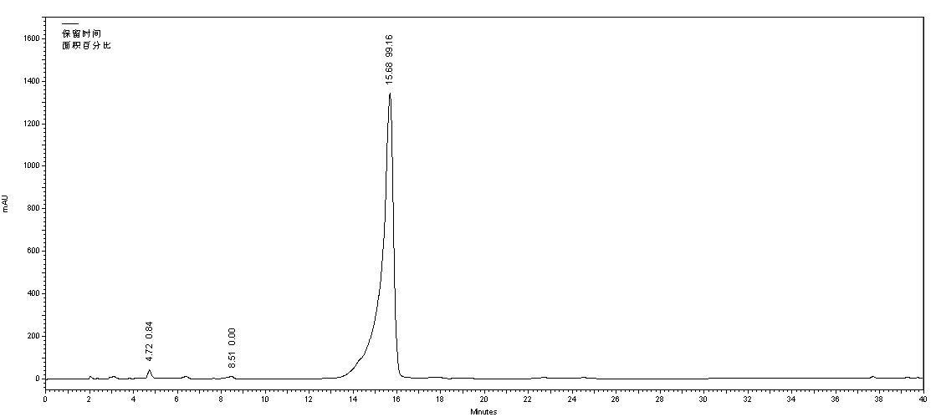
HPLC chromatogram of compound 22

