Lane 3
Lane 2
Lane 1

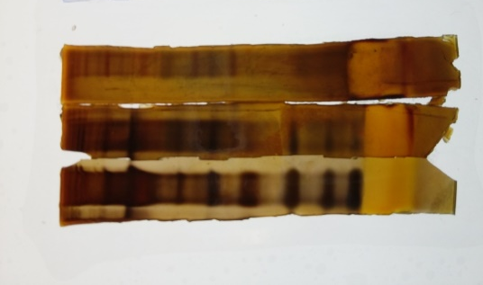

Figure 4 (Un-edited): E. vermicularis egg antigen bands in silver-stained gel after SDS-PAGE.
Lanes 1 and 2 - BenchMark® unstained protein marker (10 KDa to 220 KDa);
Lane 3 - bands of E. vermicularis egg proteins (ranging from 18 – 151 KDa).
Only Lanes 1 and 3 are shown in the manuscript.
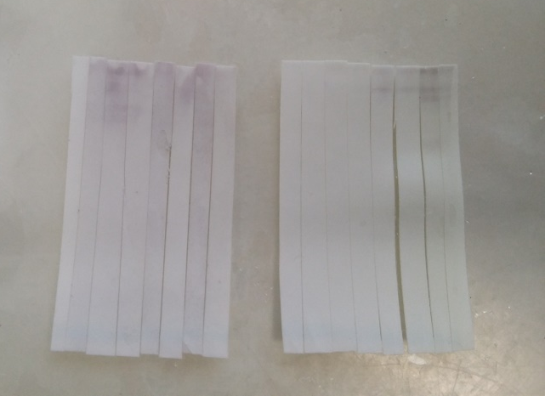
2
8
7
6
5
4
3
1
8
7
6
3
5
4
2
1
IgG
IgM
Figure 5 (Un-edited): Western blots for IgM and IgG secondary antibodies with, (1) positive human serum, (2) day 0 or negative rat serum, (3) day 7 rat serum, (4) day 14 rat serum, (5) day 21 rat serum, (6) day 28 rat serum, (7) day 35 rat serum, (8) day 42 rat serum (nitrocellulose membrane was cut into 16 strips prior to hybridisation with primary and secondary antibodies).

