Supplementary Figure S2. Contour-enhanced funnel plots for detecting publication bias of pooled association between early pulmonary hypertension and (A) oligohydramnios and (B) small-for-gestational- age. Filled circle indicates included study, while open circle suggests imputed study identified from the trim and fill method.
(A) 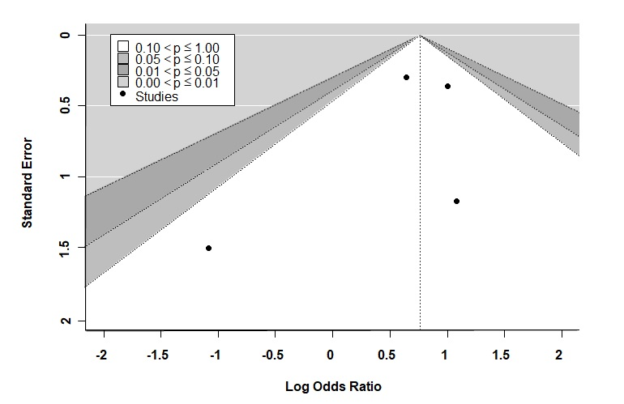

(B)
