Supplementary material 2.- Color patterns used for the identification of each peptide in the 3D structure.
Epitope | Protein | Domain | Epitope sequence* | Epitope length | Position
1 | S | S1 | SQCVNLTT | 8 | 13-20
2 | S | S1 | RTQLPPAYTNS (1) | 11 | 21-31
3 | S | S1 | GVYYPDKVF | 9 | 35-43
4 | S | S1 | SNVTWFHAIHVSGTNGTKRF | 20 | 60-79
5 | S | S1 | FLGVYYHKNNKSWME | 15 | 140-154
6 | S | S1 | MESEFRVYSSANN (2) | 13 | 153-165
7 | S | S1 | INLVRDLPQGFSA | 13 | 210-222
8 | S | S1 | LTPGDSSSGWTAG | 13 | 249-261
9 | S | S1 | VRQIAPGQTGKIAD | 14 | 407-420
10 | S | S1 | SNNLDSKVGGNYNYLY (3) | 15 | 438-453
11 | S | S1 | RLFRKSNLKPFERD (4) | 14 | 454-467
12 | S | S1 | ISTEIYQAGSTPCNGVEGF (5) | 19 | 468-486
13 | S | S1 | YGFQPTNGVGYQ (6) | 12 | 495-506
14 | S | S1 | GPKKSTNLVKNK (7) | 12 | 526-537
15 | S | S1 | RDIADTTDAVRDPQ | 14 | 567-580
16 | S | S2 | QTQTNSPRRARSV | 13 | 675-687
17 | S | S2 | ILPDPSKPSKRS | 12 | 805-816
18 | S | S2 | VPAQEKNFTT | 10 | 1068-1077
19 | S | S2 | FDEDDSEPVL | 10 | 1256-1265
20 | N |  | MSDNGPQNQRNAPRIT | 16 | 1-16
21 | N |  | AALALLLLDRL | 11 | 217-227
22 | N |  | KHWPQIAQFAPSASAFF | 17 | 299-315
23 | N |  | RIRGGDGKMKDL | 12 | 93-104
24 | N |  | SPRWYFYYLG | 10 | 105-114
25 | N |  | ILLNKHIDAYKT | 12 | 351-362
*In red: selected peptides in protein S. Numbers indicate the position of each peptide in figure 2.

Supplementary material 4.- Conservancy analysis of the selected peptides and other Coronavirus-related virus.
 | Access number | Epitope Conservancy Analysis Result
Name | Human | NT-1 | NT-2 | RBD1 | RBD2 | RBD3 | RBD4 | RBD5
Severe acute respiratory syndrome coronavirus 2 | YP_009724390.1 | 100% | 100% | 100% | 100% | 100% | 100% | 100%
SARS coronavirus Tor2 | YP_009825051.1 | 0% | 0% | 0% | 0% | 0% | 0% | 0%
Middle East respiratory syndrome-related coronavirus | YP_009047204.1 | 0% | 0% | 0% | 0% | 0% | 0% | 0%
Middle East respiratory syndrome-related coronavirus | AHX00731.1 | 0% | 0% | 0% | 0% | 0% | 0% | 0%
Human betacoronavirus 2c England-Qatar/2012 | AGG22542.1 | 0% | 0% | 0% | 0% | 0% | 0% | 0%
Human coronavirus NL63 | YP_003767.1 | 0% | 0% | 0% | 0% | 0% | 0% | 0%
Human coronavirus 229E | NP_073551.1 | 0% | 0% | 0% | 0% | 0% | 0% | 0%
Human coronavirus 229E | ABB90529.1 | 0% | 0% | 0% | 0% | 0% | 0% | 0%
Human coronavirus HKU1 | YP_173238.1 | 0% | 0% | 0% | 0% | 0% | 0% | 0%
Human coronavirus HKU1 | ADN03339.1 | 0% | 0% | 0% | 0% | 0% | 0% | 0%
Human coronavirus OC43 | YP_009555241.1 | 0% | 0% | 0% | 0% | 0% | 0% | 0%
Host | Animals
Miniopterus bat coronavirus HKU8 | YP_001718612.1 | 0% | 0% | 0% | 0% | 0% | 0% | 0%
Rousettus bat coronavirus HKU9 | YP_001039971.1 | 0% | 0% | 0% | 0% | 0% | 0% | 0%
Beluga whale coronavirus SW1 | YP_001876437.1 | 0% | 0% | 0% | 0% | 0% | 0% | 0%
Bottlenose dolphin coronavirus HKU22 | AHB63508.1 | 0% | 0% | 0% | 0% | 0% | 0% | 0%
Night heron coronavirus HKU19 | AFD29226.1 | 0% | 0% | 0% | 0% | 0% | 0% | 0%
Porcine coronavirus HKU15 | AFD29187.1 | 0% | 0% | 0% | 0% | 0% | 0% | 0%
Munia coronavirus HKU13-3514 | YP_002308506.1 | 0% | 0% | 0% | 0% | 0% | 0% | 0%
Bat coronavirus RaTG13 | QHR63300.2 | 0% | 0% | 0% | 0% | 0% | 0% | 0%
Bat coronavirus | QPD89843.1 | 0% | 0% | 0% | 0% | 0% | 0% | 0%
Bovine coronavirus | CCE89341.1 | 0% | 0% | 0% | 0% | 0% | 0% | 0%
Avian coronavirus | QIM61640.1 | 0% | 0% | 0% | 0% | 0% | 0% | 0%

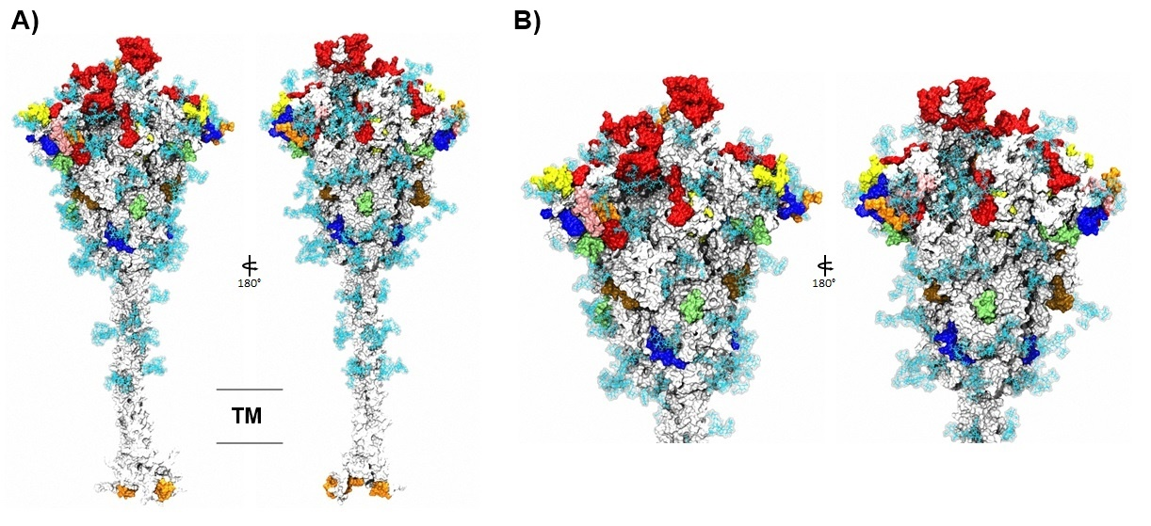
Supplementary Material 6.- Localization of all selected peptides in the trimeric structure of the spike protein. (A) The structure of the glycosylated trimeric S protein is shown in the side view and 180-degree view. (B) A zoom of the head of the S protein. In both images, peptides are indicated with color patterns (see Supplementary Material 2), glycans are represented as cyan line surf structures, and the transmembrane viral region is represented by two lines in gray.

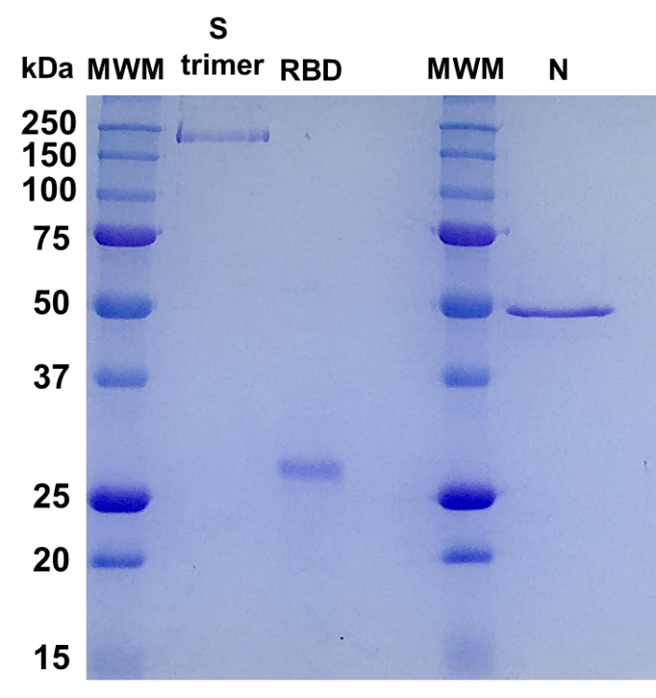
Supplementary material 7.- Original image of the SDS-PAGE of the used recombinant proteins. Lane 1: Molecular weight marker (Precision Plus Protein™ Unstained Protein Standards, Biorad Cat #1610363). Lane 2: S trimer (spike glycoprotein). Lane 3: RBD (Receptor binding Domain). Lane 4: space. Lane 5: Molecular weight marker. Lane 6: N (nucleocapsid protein).

Supplementary Material 8.- Amino acid changes and deletions in SARS-CoV-2 variants of concern.
Variants* | Protein S | Protein N
Alpha (B.1.1.7) | H69, V70, Y144, N501Y, A570D, D614G, P681H, T716I, S982A, D1118H | D3L, R203K, G204R, S235F
Beta (B.1.351) | D80A, D215G, L241-243, K417N, E484, N501Y, D614G, A701V | T205I
Gamma (P.1) | L18F, T20N, P26S, D138Y, R190S, K417T, E484K, N501Y, D614G, H655Y, T1027I, V1176F | P80R, R203K, G204R
Delta (B.1.617.2) | T19R, E156, F157, R158G, L452R, T478K, D614G, P681R, D950N | D63G, R203M, D377Y
Omicron (BA.1) | A67V, H69, V70, T95I, G142-Y144, Y145D, N211, L212I, G339D, S371L, S373P, S375F, K417N, N440K, G446S, S477N, T478K, E484A, Q493R, G496S, Q498R, N501Y, Y505H, T547K, D614G, H655Y, N679K, P681H, N764K, D796Y, N856K, Q954H, N969K, L981F | P13L, E31-S33, R203K, G204R
*Source: CoVariants (https://covariants.org/variants). : Deletion.

