Supplementary material 5.- Conservancy analysis of the peptides and other coronavirus-related virus.
SARS coronavirus Tor2 (Access number: YP_009825051.1)
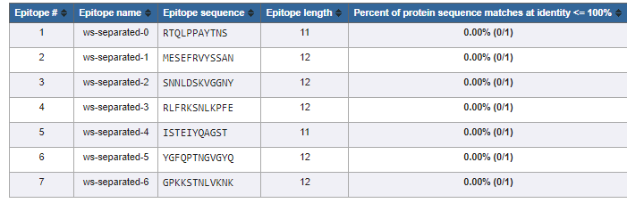
Severe acute respiratory syndrome coronavirus 2 (Access number: YP_009724390.1)
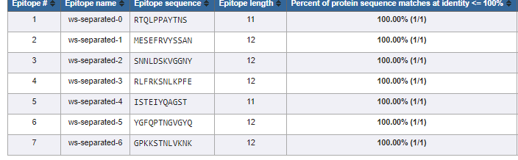
Middle East respiratory syndrome-related coronavirus (Access number: YP_009047204.1)
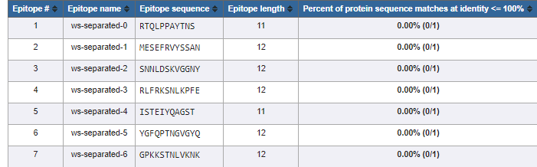
Middle East respiratory syndrome-related coronavirus (Access number: AHX00731.1)
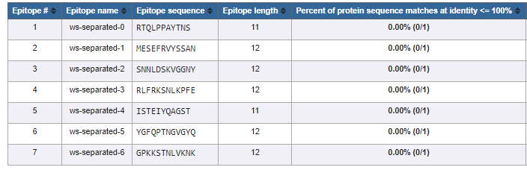

Human betacoronavirus 2c England-Qatar/2012 (Access number: AGG22542.1)
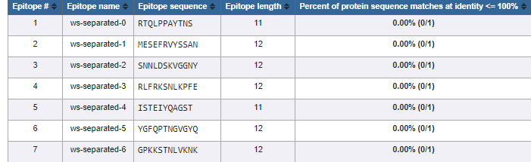
Human coronavirus NL63 (Access number: YP_003767.1)
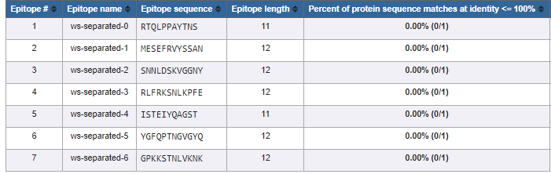
Human coronavirus 229E (Access number: NP_073551.1)
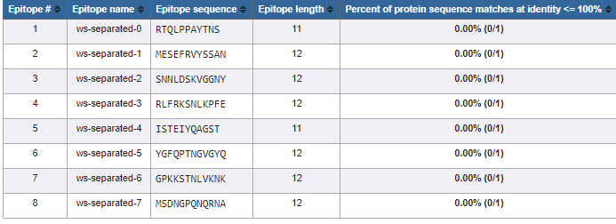

Human coronavirus 229E (Access number: ABB90529.1)
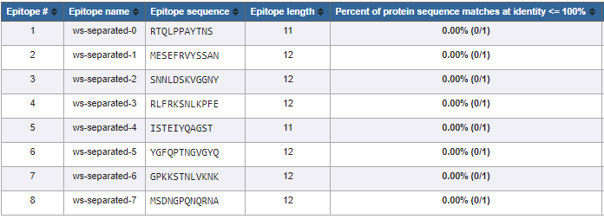
Human coronavirus HKU1 (Access number: YP_173238.1)
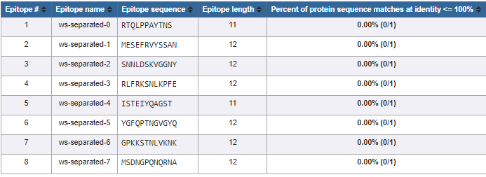
Human coronavirus HKU1 (Access number: ADN03339.1)
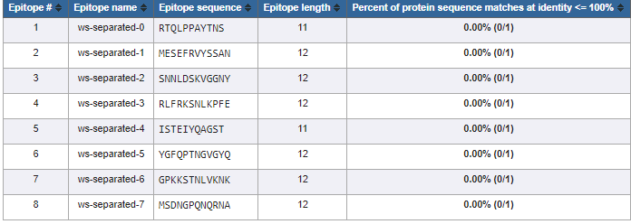

Human coronavirus OC43 (Access number: YP_009555241.1)
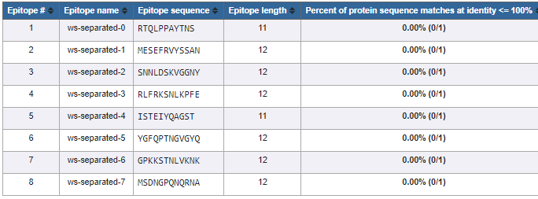

Animals
Miniopterus bat coronavirus HKU8 (Access number: YP_001718612.1)
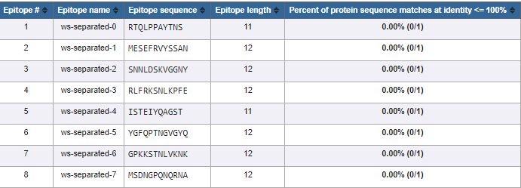
Rousettus bat coronavirus HKU9 (Access number: YP_001039971.1)
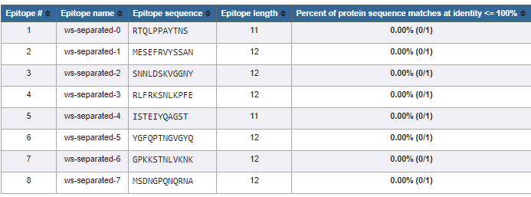

Beluga whale coronavirus SW1 (Access number: YP_001876437.1)
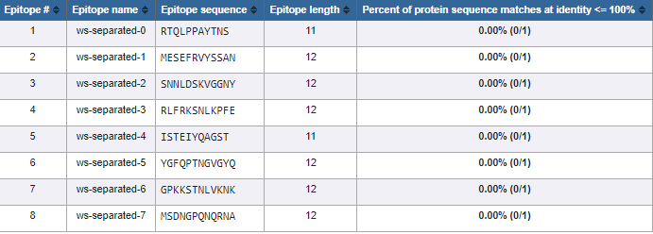
Bottlenose dolphin coronavirus HKU22 (Access number: AHB63508.1)
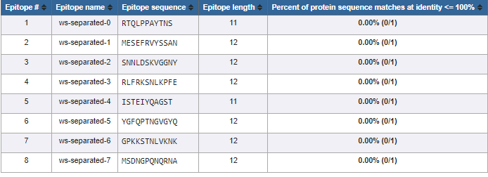
Night heron coronavirus HKU19 (Access number: AFD29226.1)
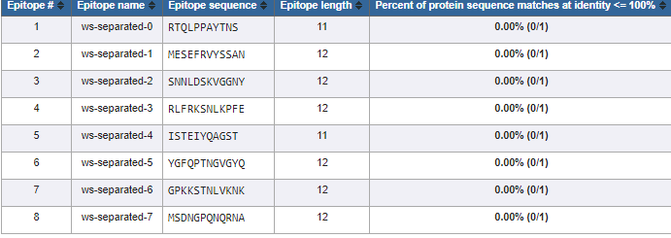

Porcine coronavirus HKU15 (Access number: AFD29187.1)
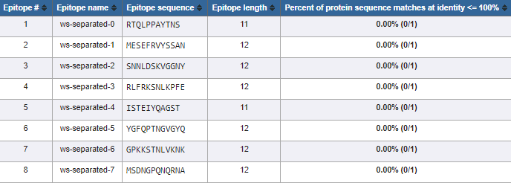
Munia coronavirus HKU13-3514 (Access number: YP_002308506.1)
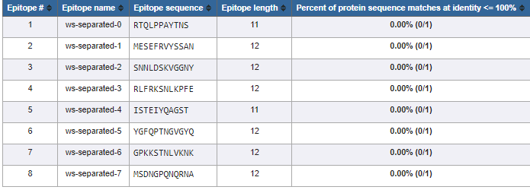
Bat coronavirus RaTG13 (Access number: QHR63300.2)
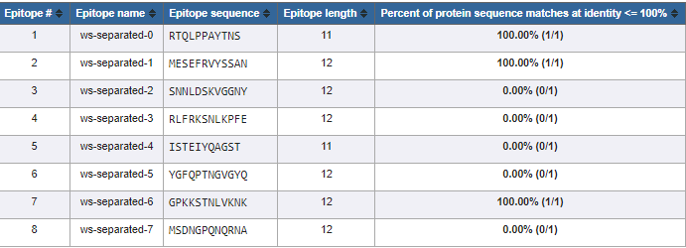

Bat coronavirus (Access number: QPD89843.1)
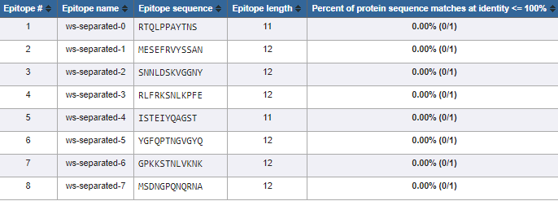
Bovine coronavirus (Access number: CCE89341.1)
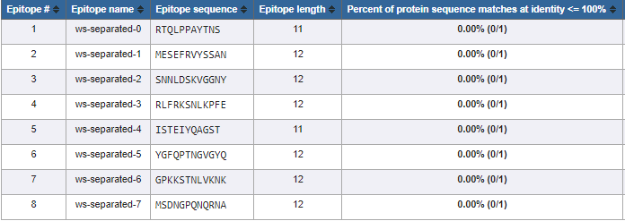
Avian coronavirus (Access number: QIM61640.1)
