Effect of amide protoporphyrin derivatives on immune response in Apis mellifera

Mariusz Trytek¹*, Katarzyna Buczek¹, Agnieszka Zdybicka-Barabas², Iwona Wojda², Grzegorz Borsuk³, Małgorzata Cytryńska², Agnieszka Lipke⁴, Dorota Gryko⁵

¹Department of Industrial and Environmental Microbiology, Institute of Biological Sciences, Faculty of Biology and Biotechnology, Maria Curie-Skłodowska University, Akademicka 19, 20-033 Lublin, Poland
²Department of Immunobiology, Institute of Biological Sciences, Faculty of Biology and Biotechnology, Maria Curie-Skłodowska University, Akademicka 19, 20-033 Lublin, Poland
³Institute of Biological Basis of Animal Production; Faculty of Biology, Animal Sciences and Bioeconomy; University of Life Sciences in Lublin, Akademicka 13, 20-950 Lublin, Poland
⁴Department of Inorganic Chemistry, Institute of Chemical Sciences, Faculty of Chemistry, Maria Curie-Skłodowska University, M. Curie Skłodowska Sq. 2, 20-031 Lublin, Poland
⁵Institute of Organic Chemistry, Polish Academy of Sciences, Kasprzaka 44/52, 01-224 Warsaw, Poland;

*Corresponding author
E-mail 1: mariusz.trytek@mail.umcs.pl; e-mail 2: mtrytek1@o2.pl (MT)
Department of Industrial and Environmental Microbiology, Institute of Biological Sciences, Maria Curie-Skłodowska University, 20-033 Lublin, Akademicka 19
Fax: +48-815375959; tel. +48-81-537-5933

Supplementary Figure S1

Experimental procedures. 2% agarose gels showing PCR products amplified from Nosema DNA extracted from spores isolated from intestines of Nosema-infected honeybees of selected colonies (C1-C6). M: Molecular weight markers (Gene ruler, 1-kb ladder, Thermo Scientific). Lanes C1-C5 correspond to selected colonies with Nosema ceranae infection. C6 represents a honeybee colony with N. ceranae and N. apis coinfection.

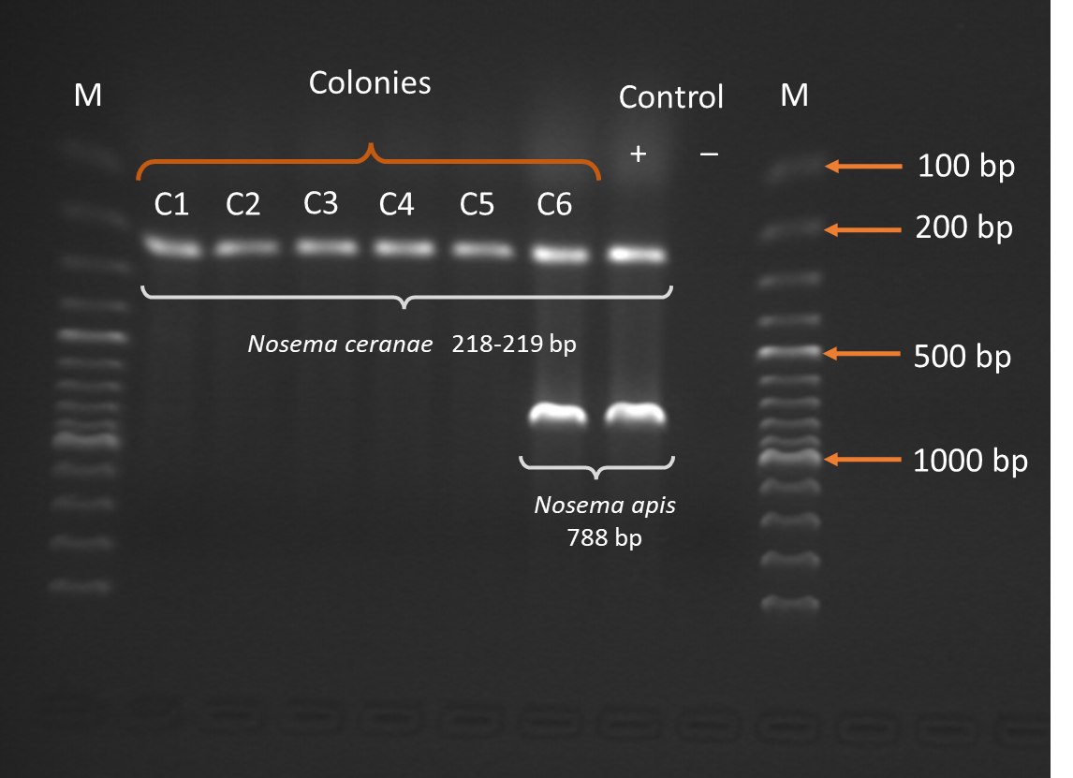

Supplementary Figure S2

Fluorescence spectra of the protoporphyrin IX amide derivatives, PP(Asp)2, and PP(Lys)2 in water.

Supplementary Table S3
P values of contrasts between the immune-related AMP gene expression in non-infected and infected honeybees treated with protoporphyrin IX derivatives on day 3 post N. ceranae-infection (data refers to Figure 7a).
 |  |  | Non- infected bees |  |  |  |  |  | Infected bees
 |  |  | PP(Asp)₂ |  |  | PP(Lys)₂ |  |  | Control |  |  | PP(Asp)₂ |  |  | PP(Lys)₂
 |  |  | Aba | Def | Hym | Aba | Def | Hym | Aba | Def | Hym | Aba | Def | Hym | Aba | Def | Hym
Infected bees | PP(Lys)₂ | Hym |  |  | p>0.05 |  |  | p>0.05 |  |  | p>0.05 |  |  | p>0.05 |  |  | -
Infected bees | PP(Lys)₂ | Def |  | p<0.05 |  |  | p>0.05 |  |  | p>0.05 |  |  | p>0.05 |  |  | -
Infected bees | PP(Lys)₂ | Aba | p<0.001 |  |  | p>0.05 |  |  | p<0.01 |  |  | p<0.05 |  |  | -
Infected bees | PP(Asp)₂ | Hym |  |  | p>0.05 |  |  | p>0.05 |  |  | p>0.05 |  |  | - |  |  | p>0.05
Infected bees | PP(Asp)₂ | Def |  | p<0.05 |  |  | p>0.05 |  |  | p>0.05 |  |  | - |  |  | p>0.05
Infected bees | PP(Asp)₂ | Aba | p>0.05 |  |  | p>0.05 |  |  | p<0.001 |  |  | - |  |  | p<0.05
Infected bees | Control | Hym |  |  | p<0.01 |  |  | p>0.05 |  |  | - |  |  | p>0.05 |  |  | p>0.05
Infected bees | Control | Def |  | p>0.05 |  |  | p>0.05 |  |  | - |  |  | p>0.05 |  |  | p>0.05
Infected bees | Control | Aba | p<0.0001 |  |  | p<0.0001 |  |  | - |  |  | p<0.001 |  |  | p<0.01
Non-infected bees | PP(Lys)₂ | Hym |  |  | p<0.01 |  |  | - |  |  | p>0.05 |  |  | p>0.05 |  |  | p>0.05
Non-infected bees | PP(Lys)₂ | Def |  | p<0.05 |  |  | - |  |  | p>0.05 |  |  | p<0.05 |  |  | p>0.05
Non-infected bees | PP(Lys)₂ | Aba | p<0.01 |  |  | - |  |  | p<0.0001 |  |  | p>0.05 |  |  | p>0.05
Non-infected bees | PP(Asp)₂ | Hym |  |  | - |  |  | p<0.01 |  |  | p<0.01 |  |  | p>0.05 |  |  | p>0.05
Non-infected bees | PP(Asp)₂ | Def |  | - |  |  | p<0.05 |  |  | p<0.05 |  |  | p<0.05 |  |  | p<0.05
Non-infected bees | PP(Asp)₂ | Aba | - |  |  | p<0.01 |  |  | p<0.0001 |  |  | p>0.05 |  |  | p<0.001

Supplementary Table S4
P values of contrasts between the immune-related AMP gene expression in non-infected and infected honeybees treated with protoporphyrin IX derivatives on day 4 post N. ceranae-infection (data refers to Figure 7b).
 |  |  | Non- infected bees |  |  |  |  |  | Infected bees
 |  |  | PP(Asp)₂ |  |  | PP(Lys)₂ |  |  | Control |  |  | PP(Asp)₂ |  |  | PP(Lys)₂
 |  |  | Aba | Def | Hym | Aba | Def | Hym | Aba | Def | Hym | Aba | Def | Hym | Aba | Def | Hym
Infected bees | PP(Lys)₂ | Hym |  |  | p<0.01 |  |  | p<0.01 |  |  | p>0.05 |  |  | p>0.05 |  |  | -
Infected bees | PP(Lys)₂ | Def |  | p<0.01 |  |  | p<0.01 |  |  | p<0.05 |  |  | p>0.05 |  |  | -
Infected bees | PP(Lys)₂ | Aba | p>0.05 |  |  | p>0.05 |  |  | p>0.05 |  |  | p>0.05 |  |  | -
Infected bees | PP(Asp)₂ | Hym |  |  | p>0.05 |  |  | p>0.05 |  |  | p<0.001 |  |  | - |  |  | p>0.05
Infected bees | PP(Asp)₂ | Def |  | p>0.05 |  |  | p>0.05 |  |  | p<0.01 |  |  | - |  |  | p>0.05
Infected bees | PP(Asp)₂ | Aba | p>0.05 |  |  | p>0.05 |  |  | p<0.05 |  |  | - |  |  | p>0.05
Infected bees | Control | Hym |  |  | p<0.001 |  |  | p<0.001 |  |  | - |  |  | p<0.001 |  |  | p>0.05
Infected bees | Control | Def |  | p<0.001 |  |  | p<0.001 |  |  | - |  |  | p<0.01 |  |  | p>0.05
Infected bees | Control | Aba | p<0.01 |  |  | p<0.01 |  |  | - |  |  | p<0.05 |  |  | p>0.05
Non-infected bees | PP(Lys)₂ | Hym |  |  | p>0.05 |  |  | - |  |  | p<0.001 |  |  | p>0.05 |  |  | p<0.01
Non-infected bees | PP(Lys)₂ | Def |  | p>0.05 |  |  | - |  |  | p<0.001 |  |  | p>0.05 |  |  | p<0.01
Non-infected bees | PP(Lys)₂ | Aba | p>0.05 |  |  | - |  |  | p<0.01 |  |  | p>0.05 |  |  | p>0.05
Non-infected bees | PP(Asp)₂ | Hym |  |  | - |  |  | p>0.05 |  |  | p<0.001 |  |  | p>0.05 |  |  | p<0.01
Non-infected bees | PP(Asp)₂ | Def |  | - |  |  | p>0.05 |  |  | p<0.001 |  |  | p>0.05 |  |  | p<0.01
Non-infected bees | PP(Asp)₂ | Aba | - |  |  | p>0.05 |  |  | p<0.01 |  |  | p>0.05 |  |  | p>0.05

