African wild dogs (Lycaon pictus) from the Kruger National Park, South Africa, are not inbred but have low genomic diversity

Supplementary material

Supplementary Figure 1: Distribution of heterozygosity across the original SNP dataset of 527,726 variants. (a) Density of H_{O} and H_{E} across 527,726 SNPs. (b) Scatter plot representing the correlation of H_{O} and H_{E} for each variant (c) Distribution of delta heterozygosity (Δ=H_{O}−H_{E}) across SNPs.
Supplementary Table 1: African wild dog samples included in this study, including age, sex and sampling location.
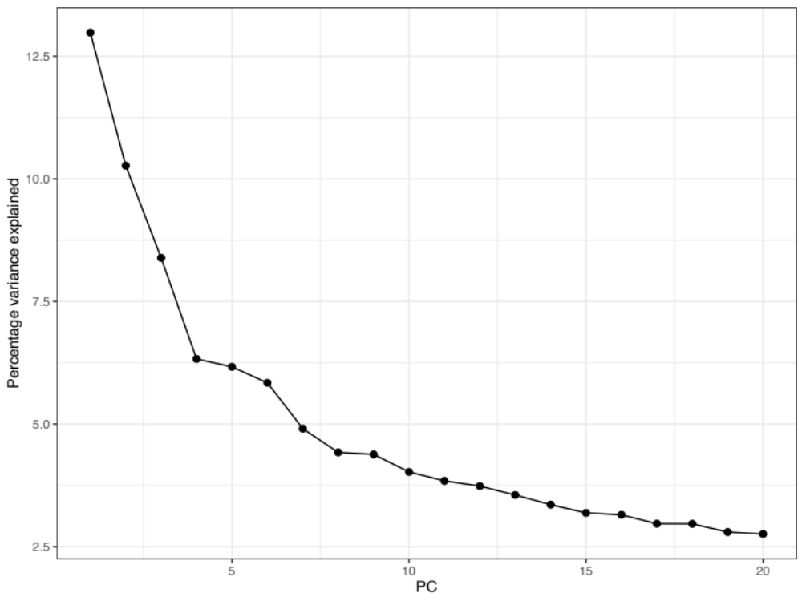
Supplementary Figure 2: Scree plot showing the percentage variance (eigenvalues) explained by 20 principal components (PC).

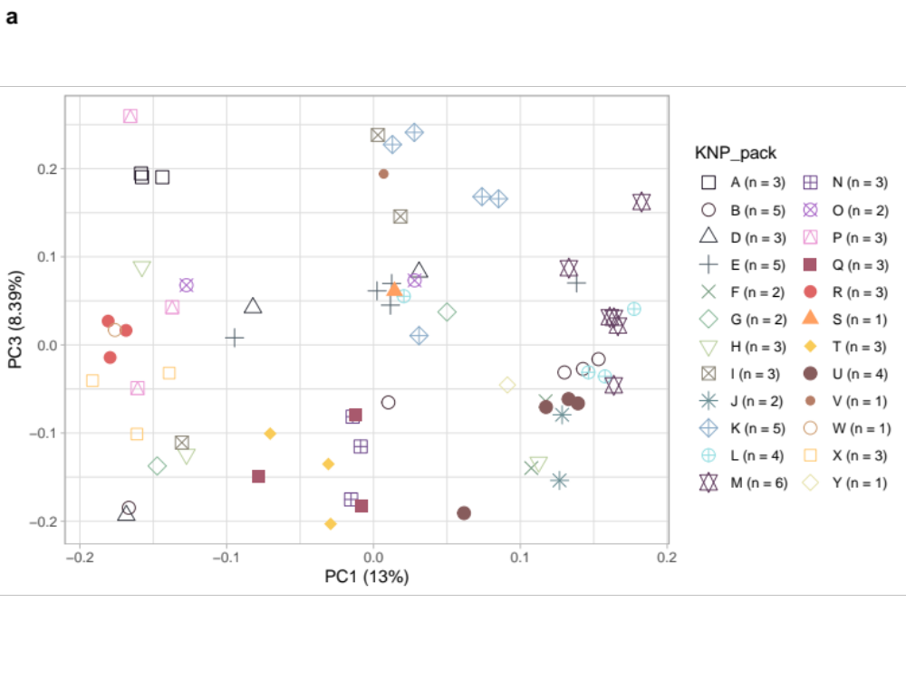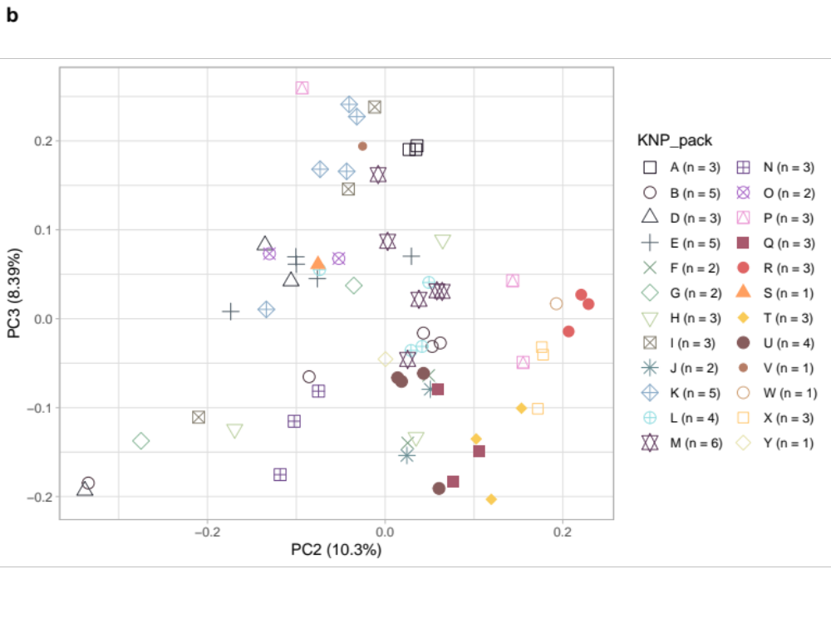
Supplementary Figure 3: Principal component analysis of 71 African wild dog samples (24 packs). Principal components 1 and 3; 2 and 3 are shown, with the proportion of variance accounted for by each indicated in parentheses. Each data point in the plot represents an individual, where each coloured shape corresponds to a pack (KNP_pack).

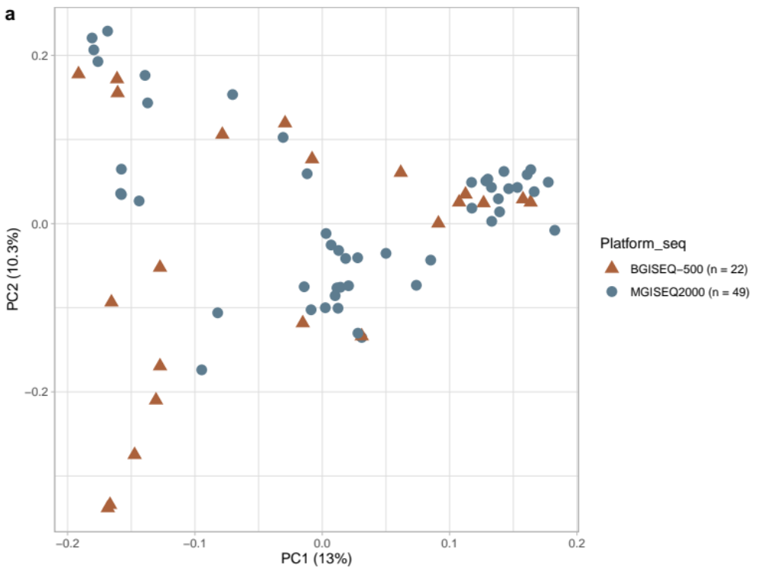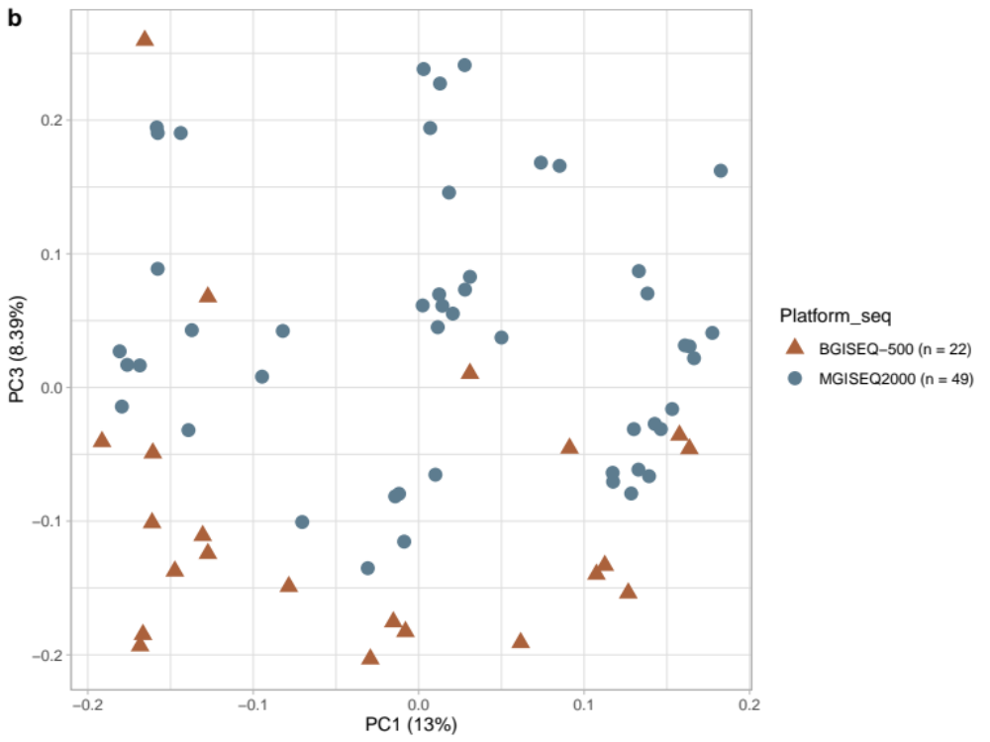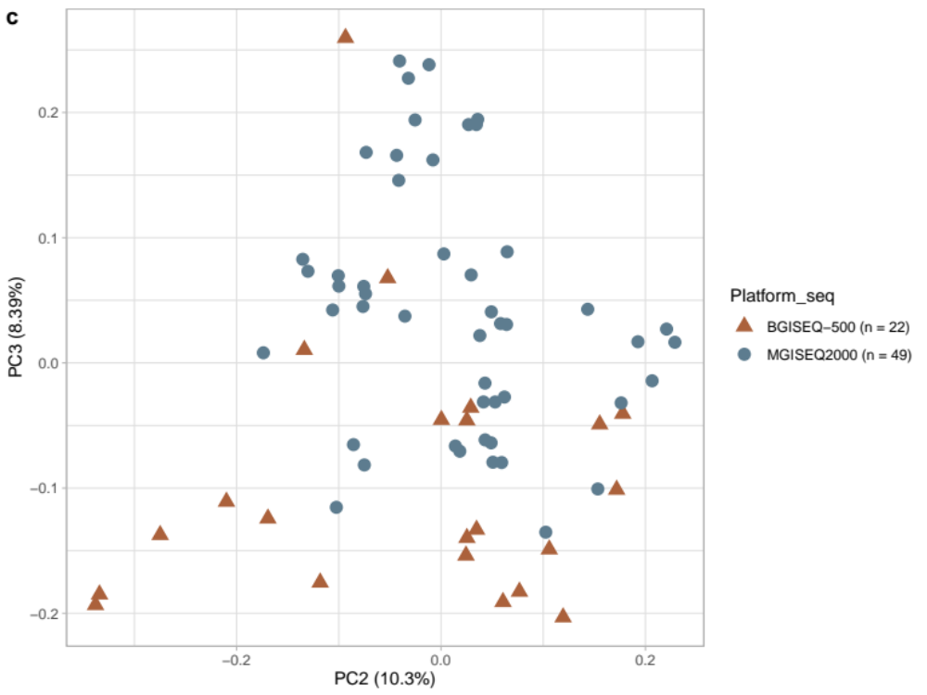
Supplementary Figure 4: Principal component analysis of 71 African wild dog samples. The first three principal components (PC 1, PC 2 and PC 3) are shown (a-c), with the proportion of variance accounted for by each indicated in parentheses. Each data point represents an individual, with the coloured shapes corresponding to the sequencing platform (Platform_seq).

Supplementary Table 1: Summary table of the runs of homozygosity (ROH) per African wild dog, including the number of ROH segments (NSEG), total length of ROH segments (KB) and average ROH length (KBAVG).

ID | NSEG | KB | KBAVG

LVS201605-011 | 102 | 70433.1 | 690.521
LP-J-02 | 115 | 81815.2 | 711.437
LP-K-02 | 110 | 86511.4 | 786.467
LP-M-04 | 135 | 95503.1 | 707.43
LP-N-01 | 134 | 102763 | 766.887
LP-M-03 | 107 | 82978 | 775.496
LP-M-05 | 92 | 67708.7 | 735.965
LP-M-06 | 85 | 63225.2 | 743.825
LP-E-04 | 143 | 107530 | 751.956
LP-L-04 | 74 | 57379.1 | 775.393
LP-N-03 | 99 | 74066 | 748.142
LVS201607-004 | 98 | 77258.7 | 788.354
LP-I-03 | 199 | 157871 | 793.324
LP-L-01c | 128 | 91571.7 | 715.404
LP-T-02 | 121 | 94654.8 | 782.271
LP-O-03 | 69 | 52846.8 | 765.896
LP-U-01 | 105 | 75468.2 | 718.744
LP-P-01 | 70 | 51578.6 | 736.837
LP-P-02 | 244 | 190793 | 781.939
LP-Q-02 | 131 | 101441 | 774.356
LP-Q-03 | 145 | 111715 | 770.451
LP-K-04 | 122 | 86818.2 | 711.624
LP-D-01 | 196 | 155611 | 793.933
LP-K-05 | 96 | 70313.1 | 732.429
LP-W-01 | 46 | 33534.1 | 729.001
LP-E-05 | 88 | 62921.4 | 715.016
LP-X-01 | 119 | 92791.9 | 779.764
LP-X-03 | 63 | 52177.8 | 828.218
LP-X-04 | 49 | 40754.4 | 831.723
LP-R-01 | 165 | 142244 | 862.085
LP-R-02 | 155 | 117504 | 758.089
LP-R-03 | 97 | 67025.8 | 690.988
LP-S-03 | 54 | 39109.7 | 724.254
LP-B-04 | 155 | 121111 | 781.358
LP-T-01 | 93 | 69304.6 | 745.211
LP-T-03 | 136 | 106218 | 781.013
LP-O-01 | 97 | 71591 | 738.051
LP-U-02 | 132 | 103033 | 780.556
LP-U-03 | 95 | 74566.8 | 784.914
LP-U-04 | 114 | 91669.2 | 804.116
LP-P-03 | 73 | 52918.3 | 724.908
LP-Q-04 | 74 | 58679.6 | 792.967
LP-V-01 | 133 | 103378 | 777.28
LP-N-02b | 131 | 99939.5 | 762.897
LP-D-02 | 125 | 94439.8 | 755.518
LP-T-03 | 58 | 46942.5 | 809.354
LP-A-01 | 98 | 71007.9 | 724.571
LP-A-02 | 90 | 71260.7 | 791.786
LP-A-03 | 114 | 86335.9 | 757.333
LP-B-01 | 123 | 92387.2 | 751.116
LP-B-02 | 63 | 49460.4 | 785.086
LP-B-03 | 85 | 62080.1 | 730.354
LP-I-01 | 102 | 75807.7 | 743.213
LP-J-01 | 88 | 67021 | 761.602
LP-D-03 | 66 | 50453.7 | 764.45
LP-E-01b | 86 | 65260.8 | 758.846
LP-K-01 | 79 | 62820.2 | 795.192
LP-K-03 | 107 | 73991.5 | 691.51
LP-L-02 | 84 | 64281.6 | 765.257
LP-L-03 | 89 | 63673.3 | 715.431
LP-M-01 | 64 | 49806.6 | 778.228
LP-M-02 | 106 | 78711.1 | 742.558
LP-E-02 | 96 | 69389.5 | 722.807
LP-E-03 | 72 | 52949.6 | 735.411
LP-F-03 | 48 | 40731 | 848.562
LP-F-02 | 171 | 134767 | 788.109
LP-G-02 | 82 | 61868.4 | 754.493
LP-H-02 | 65 | 47895.9 | 736.86
LP-I-02 | 81 | 56118.4 | 692.82
LP-G-01 | 148 | 115026 | 777.203
LP-H-01 | 84 | 70066.6 | 834.126

Supplementary Table 2: African wild dog samples included in this study, including pack, age, sex, sampling location, and the KNP section of the sampling locations.

ID | Pack | Age Class | Sex | Sampling Location | KNP Section
LP-A-01 | A | Y.Adult | Male | Skukuza | South
LP-A-02 | A | Y.Adult | Male | Skukuza | South
LP-A-03 | A | Y.Adult | Female | Skukuza | South
LP-B-01 | B | Y.Adult | Female | Spanplekspruit | South
LP-B-02 | B | Adult | Female | Skukuza | South
LP-B-03 | B | Adult | Female | Skukuza | South
LP-B-04 | B | Adult | Female | Doispane Skukuza | South
LP-B-05 | B | Adult | Female | Kruger Gate | South
LP-D-01 | D | Adult | Male | Pretoriuskop | South
LP-D-02 | D | - | Female | Mestel Dam | South
LP-D-03 | D | Adult | Male | Mestel Dam | South
LP-E-01b | E | Adult | Female | Stolsnek | South
LP-E-02 | E | - | Female | Timfenene | South
LP-E-03 | E | - | Male | Timfenene | South
LP-E-04 | E | Adult | Female | Malelane | South
LP-E-05 | E | Adult | Male | Matjulu Windmill | South
LP-F-02 | F | Y.Adult | Female | Kingfisherspruit | Central
LP-F-03 | F | Y.Adult | Female | Kingfisherspruit | Central
LP-G-01 | G | Adult | Female | Pretoriuskop | South
LP-G-02 | G | Adult | Male | Pretoriuskop | South
LVS201607-004 | H | Adult | Female | Talamati | Central
LP-H-01 | H | Adult | Female | Lower Sabie | South
LP-H-02 | H | Adult | Male | Lower Sabie | South
LP-I-01 | I | Adult | Female | Skukuza | South
LP-I-02 | I | Adult | Female | Skukuza | South
LP-I-03 | I | Adult | Male | Western Boundry | Central
LP-J-01 | J | Adult | Male | Kwaggaspan | South
LP-J-02 | J | Adult | Male | Kwaggaspan | South
LP-K-01 | K | Y.Adult | Male | Crocodile bridge | South
LP-K-02 | K | Adult | Female | Crocodile bridge | South
LP-K-03 | K | Adult | Male | Crocodile bridge | South
LP-K-04 | K | Adult | Male | Malelane | South
LP-K-05 | K | Adult | Female | Malelane | South
LP-L-01c | L | Adult | Male | Mlambane River | South
LP-L-02 | L | Adult | Female | Malelane | South
LP-L-03 | L | Adult | Male | Malelane | South
LP-L-04 | L | Adult | Male | Bergendal | South
LP-M-01 | M | Adult | Male | Mudzanzeni | Central
LP-M-02 | M | Y.Adult | Female | Mudzanzeni | Central
LP-M-03 | M | Y.Adult | Female | Mudzanzeni | Central
LP-M-04 | M | Adult | Male | Mudzanzeni | Central
LP-M-05 | M | Adult | Male | Mudzanzeni | Central
LP-M-06 | M | O.Adult | Male | Mudzanzeni | Central
LP-N-01 | N | Adult | Female | Imbali | Central
LP-N-02b | N | Adult | Male | Imbali | Central
LP-N-03 | N | Adult | Male | Imbali | Central
LP-O-01 | O | Adult | Male | Tshokwane | Central
LP-O-03 | O | Adult | Female | Tshokwane | Central
LP-P-01 | P | Adult | Male | Skukuza | South
LP-P-02 | P | Adult | Female | Skukuza | South
LP-P-03 | P | Adult | Male | Skukuza | South
LP-Q-02 | Q | O. Adult | Female | Letaba-Phalaborwa Road | North
LP-Q-03 | Q | Adult | Male | Letaba-Phalaborwa Road | North
LP-Q-04 | Q | O. Adult | Female | Letaba-Phalaborwa Road | North
LP-R-01 | R | Juvenile | Female | Phalaborwa Gate | North
LP-R-02 | R | Adult | Male | Phalaborwa Gate | North
LP-R-03 | R | Adult | Male | Phalaborwa Gate | North
LP-S-03 | S | Y.Adult | Female | Skukuza | South
LP-T-01 | T | Y.Adult | Female | Phalaborwa | North
LP-T-02 | T | O.Adult | Male | Phalaborwa | North
LP-T-03 | T | Juvenile | Female | Phalaborwa | North
LP-U-01 | U | O.Adult | Male | Tamboti | Central
LP-U-02 | U | Adult | Male | Tamboti | Central
LP-U-03 | U | Adult | Female | Tamboti | Central
LP-U-04 | U | Y.Adult | Female | Tamboti | Central
LP-V-01 | V | Y.Adult | Female | Sabi Sands | Central
LP-W-01 | W | Adult | Female | Shingwedzi | North
LP-X-01 | X | Y.Adult | Male | Shingwedzi | North
LP-X-03 | X | Y.Adult | Female | Shingwedzi | North
LP-X-04 | X | Y.Adult | Female | Shingwedzi | North
LVS201605-011 | Y | Adult | Male | Tshokwane | Central

O. Adult: old adult; Y. Adult: young adult
Wild dog age ranges:
• Juvenile: 0-1 year
• Young Adult: 1-2 years
• Adult: 3-5 years
• Old Adult: 6 years and above

Supplementary Table 3: Comparative analysis between BGISEQ-500 (BGI, China) and MGISEQ-2000 (SAMRC/BGI Genomics Centre, South Africa).

Sample A China Sample A South Africa

Instrument BGISEQ-500 MGISEQ2000
Number of reads produced 1,228,381,660 424,219,801
Mean read depth 50.99× 26.05×
Breadth of coverage 97.44% 97.41%
Mapping rate 98.52% 98.45%
Number of variants called 1,986,828 2,040,368
Number of indels called 666,097 679,948

BGI: Beijing Genomics Institute
SAMRC: South African Medical Research Council
Sample A: African wild dog LP-D-01

