Supporting information

Supplementary Table S1. Spectrum analysis report of Bm-ponericin-L1.
Spectrum Analysis Report
Date: 01/16/2022 Time: 18:01
FileName: D:\Data\Ahmet Kati\09.08.2021_Maldi_1\09.08.2021\LOW25 MIN\0_C5\1\1SRef\pdata\1\1r

Sequence data:
Unmatched
Intensity Coverage: 0.6 % (420 cnts) Sequence Coverage MS: 100.0%
Sequence Coverage MS/MS: 0.0% pI (isoelectric point): 10.8

Display Parameter:
Sequence Name: Ponericin-L1 OS=Pachycondyla goeldii PE=1 SV=1 PCL1_PACGO MH+ (mono): 1.008
MH+ (avg): 1.008 Threshold (a.i.): 0.000 Tolerance (Da): 0.500
Number of Peaks: 86
Peaklist:
Peak | Mass | Intensity | Peak | Mass | Intensity | Peak | Mass | Intensity
1 | 598.453 | 184.234 | 2 | 602.298 | 184.007 | 3 | 604.377 | 176.654
4 | 617.476 | 1998.807 | 5 | 619.483 | 266.369 | 6 | 628.363 | 195.320
7 | 633.437 | 1113.855 | 8 | 644.128 | 236.982 | 9 | 650.145 | 1018.529
10 | 655.376 | 225.486 | 11 | 656.134 | 373.600 | 12 | 657.399 | 226.937
13 | 666.128 | 1038.660 | 14 | 672.124 | 581.174 | 15 | 673.511 | 168.561
16 | 679.626 | 686.786 | 17 | 682.065 | 343.107 | 18 | 688.112 | 168.160
19 | 694.273 | 189.167 | 20 | 700.528 | 186.217 | 21 | 761.543 | 687.373
22 | 762.556 | 276.169 | 23 | 775.468 | 186.379 | 24 | 777.489 | 530.611
25 | 778.495 | 238.370 | 26 | 781.509 | 172.379 | 27 | 788.676 | 197.136
28 | 839.133 | 222.851 | 29 | 841.508 | 157.194 | 30 | 855.116 | 243.248
31 | 861.130 | 549.178 | 32 | 874.620 | 152.781 | 33 | 877.113 | 836.263
34 | 893.066 | 303.524 | 35 | 905.616 | 230.902 | 36 | 916.631 | 682.168
37 | 921.620 | 161.355 | 38 | 938.629 | 194.912 | 39 | 1030.689 | 3026.357
40 | 1037.632 | 136.636 | 41 | 1042.670 | 240.412 | 42 | 1052.670 | 790.199
43 | 1056.694 | 144.520 | 44 | 1060.672 | 141.457 | 45 | 1064.671 | 330.398
46 | 1068.654 | 353.645 | 47 | 1090.690 | 145.186 | 48 | 1096.705 | 6004.227
49 | 1118.689 | 1275.695 | 50 | 1134.661 | 530.373 | 51 | 1359.771 | 109.977
52 | 1462.901 | 1266.907 | 53 | 1463.396 | 1313.894 | 54 | 1463.840 | 264.288
55 | 1465.377 | 130.660 | 56 | 1784.069 | 771.114 | 57 | 1806.052 | 187.126
58 | 1942.118 | 106.962 | 59 | 2072.345 | 455.945 | 60 | 2086.365 | 735.087
61 | 2094.327 | 182.780 | 62 | 2108.341 | 385.794 | 63 | 2124.279 | 191.217
64 | 2470.375 | 109.909 | 65 | 2481.458 | 113.244 | 66 | 2502.491 | 154.772
67 | 2577.543 | 303.048 | 68 | 2595.553 | 545.337 | 69 | 2597.530 | 203.852
70 | 2682.594 | 474.576 | 71 | 2739.547 | 188.183 | 72 | 2744.728 | 193.882
73 | 2766.750 | 186.064 | 74 | 2768.541 | 140.984 | 75 | 2888.641 | 415.007
76 | 2891.686 | 622.266 | 77 | 2896.657 | 324.609 | 78 | 2900.361 | 472.982
79 | 2907.839 | 654.826 | 80 | 2910.958 | 2996.215 | 81 | 2916.626 | 326.597
82 | 2920.730 | 399.996 | 83 | 2924.769 | 21695.772 | 84 | 2939.852 | 449.620
85 | 2946.768 | 492.606 | 86 | 2980.816 | 445.634

Supplementary Table S2 – Physicochemical properties for all 16 ponericin-like peptides deposited in APD.
Peptide name | Sequence | Charge (z) | Hydrophobicity (%) | Hydrophobic moment (<μH>)
Ponericin-G1 | ₁GWKDWAKKAGGWLKKKGPGMAKAALKAAMQ₃₀ | +7 | 22.0 | 0.228
Ponericin-G2 | ₁GWKDWLKKGKEWLKAKGPGIVKAALQAATQ₃₀ | +5 | 28.7 | 0.331
Ponericin-G3 | ₁GWKDWLNKGKEWLKKKGPGIMKAALKAATQ₃₀ | +6 | 23.2 | 0.366
Ponericin-G4 | ₁DFKDWMKTAGEWLKKKGPGILKAAMAAAT₂₉ | +3 | 30.8 | 0.347
Ponericin-G5 | ₁GLKDWVKIAGGWLKKKGPGILKAAMAAATQ₃₀ | +5 | 38.5 | 0.290
Ponericin-G6 | ₁GLVDVLGKVGGLIKKLLP₁₈ | +2 | 60.8 | 0.587
Ponericin-G7 | ₁GLVDVLGKVGGLIKKLLPG₁₉ | +2 | 57.6 | 0.556
Ponericin-L1* | ₁LLKELWTKMKGAGKAVLGKIKGLL₂₄ | +5 | 45.8 | 0.542
Ponericin-L2 | ₁LLKELWTKIKGAGKAVLGKIKGLL₂₄ | +5 | 48.2 | 0.566
Ponericin-W1 | ₁WLGSALKIGAKLLPSVVGLFKKKKQ₂₅ | +6 | 47.5 | 0.403
Ponericin-W2 | ₁WLGSALKIGAKLLPSVVGLFQKKKK₂₅ | +6 | 47.5 | 0.413
Ponericin-W3 | ₁GIWGTLAKIGIKAVPRVISMLKKKKQ₂₆ | +7 | 42.0 | 0.365
Ponericin-W4 | ₁GIWGTALKWGVKLLPKLVGMAQTKKQ₂₆ | +5 | 50.9 | 0.305
Ponericin-W5 | ₁FWGALIKGAAKLIPSVVGLFKKKQ₂₄ | +5 | 55.9 | 0.497
Ponericin-W6 | ₁FIGTALGIASAIPAIVKLFK₂₀ | +2 | 78.0 | 0.403
Ponericin-Q42 | ₁FWGAVWKILSKVLPHIPGTVKWLQEKV₂₇ | +3 | 71.9 | 0.531
APD: Antimicrobial Peptide Database. Hydrophobic moment<μH> calculated according to the Eisenberg scale. The physicochemical properties were calculated on HeliQuest server (https://heliquest.ipmc.cnrs.fr).*Corresponds to ponericin-L1, the same peptide sequence identified in our work, named Bm-ponericin-L1.

Supplementary Table S3 – Antimicrobial predictions for all 16 ponericin-like peptides deposited in APD.
Peptide name | SVM | RF | ANN | DA | DBAASP | STM
Ponericin-G1 | 0.996 | 0.962 | AMP | 0.999 | AMP | 0.648
Ponericin-G2 | 0.994 | 0.998 | AMP | 0.999 | AMP | 0.685
Ponericin-G3 | 0.993 | 0.996 | AMP | 0.998 | AMP | 0.798
Ponericin-G4 | 0.752 | 0.817 | NAMP | 0.970 | AMP | 0.822
Ponericin-G5 | 0.992 | 0.995 | AMP | 0.999 | AMP | 0.647
Ponericin-G6 | 0.945 | 0.874 | AMP | 0.997 | AMP | 1.116
Ponericin-G7 | 0.958 | 0.968 | AMP | 0.998 | AMP | 1.052
Ponericin-L1* | 0.991 | 0.998 | AMP | 0.993 | AMP | 0.881
Ponericin-L2 | 0.993 | 0.999 | AMP | 0.999 | AMP | 0.942
Ponericin-W1 | 0.989 | 1 | AMP | 1 | AMP | 0.788
Ponericin-W2 | 0.986 | 1 | AMP | 1 | AMP | 0.796
Ponericin-W3 | 0.995 | 1 | AMP | 0.999 | AMP | 0.821
Ponericin-W4 | 0.992 | 0.996 | AMP | 0.999 | AMP | 0.629
Ponericin-W5 | 0.998 | 1 | AMP | 1 | AMP | 0.726
Ponericin-W6 | 0.991 | 0.962 | AMP | 0.999 | NAMP | 0.645
Ponericin-Q42 | 0.881 | 0.917 | AMP | 0.939 | AMP | 0.944
APD: Antimicrobial Peptide Database; SVM: Support Vector Machine; RF: Random Forest; ANN: Artificial Neural Network; DA: Discriminant Analysis; DBAASP: Database of Antimicrobial Activity and Structure of Peptides; STM: Sense The Moment. Probabilities and scores higher than 0.5 indicate positive prediction for antimicrobial activity (AMP). *Corresponds to ponericin-L1, the same peptide sequence identified in our work, named Bm-ponericin-L1.

Supplementary Table S4 – Structural statistics for three-dimensional theoretical models for all 16 ponericin-like peptides deposited in APD.
Peptide name | APD ID | Ramachandran (most favored) (%) | G-factors | Z-score | Bad bonds (%) | Bad angles (%)
Ponericin-G1 | AP00376 | 95.7 | -0.25 | -2.33 | 3.46 | 0.33
Ponericin-G2 | AP00377 | 95.8 | -0.12 | -1.94 | 2.92 | 0.93
Ponericin-G3 | AP00378 | 95.8 | -0.12 | -2.0 | 3.28 | 1.23
Ponericin-G4 | AP00379 | 95.8 | -0.15 | -2.0 | 3.28 | 1.23
Ponericin-G5 | AP00380 | 95.7 | -0.23 | -1.3 | 4.05 | 1.69
Ponericin-G6 | AP00381 | 84.6 | -0.14 | 0.33 | 1.57 | 2.37
Ponericin-G7 | AP00382 | 84.6 | -0.5 | 0.4 | 2.29 | 1.72
Ponericin-L1* | AP00383 | 100 | 0.26 | -1.71 | 0.55 | 0.89
Ponericin-L2 | AP00384 | 100 | 0.36 | -1.44 | 0.55 | 1.67
Ponericin-W1 | AP00386 | 100 | -0.23 | -1.2 | 4.12 | 1.56
Ponericin-W2 | AP00387 | 100 | -0.27 | -1.24 | 5.15 | 1.17
Ponericin-W3 | AP00388 | 95.2 | -0.10 | -0.58 | 1.98 | 0.75
Ponericin-W4 | AP00389 | 95 | -0.19 | -0.88 | 3.43 | 1.10
Ponericin-W5 | AP00390 | 100 | -0.16 | -1.27 | 4.79 | 1.20
Ponericin-W6 | AP00391 | 100 | 0.05 | -1.6 | 1.38 | 2.05
Ponericin-Q42 | AP02435 | 95.2 | -0.01 | -0.44 | 2.14 | 0.94
The z-scores obtained for all structures here reported are in agreement with those with similar size, structurally determined by X-ray crystallography and deposited in the Protein Data Bank (PDB). The G-factors indicate that the overall average for the dihedral angles, along with the main-chain covalent forces for each structure are within the expected values for reliable structures (G-factors > −0.5). The structural validations were performed on PROCHECK, ProSa-web, PROCHECK and MolProbity. *Corresponds to ponericin-L1, the same peptide sequence identified in our work, named Bm-ponericin-L1.

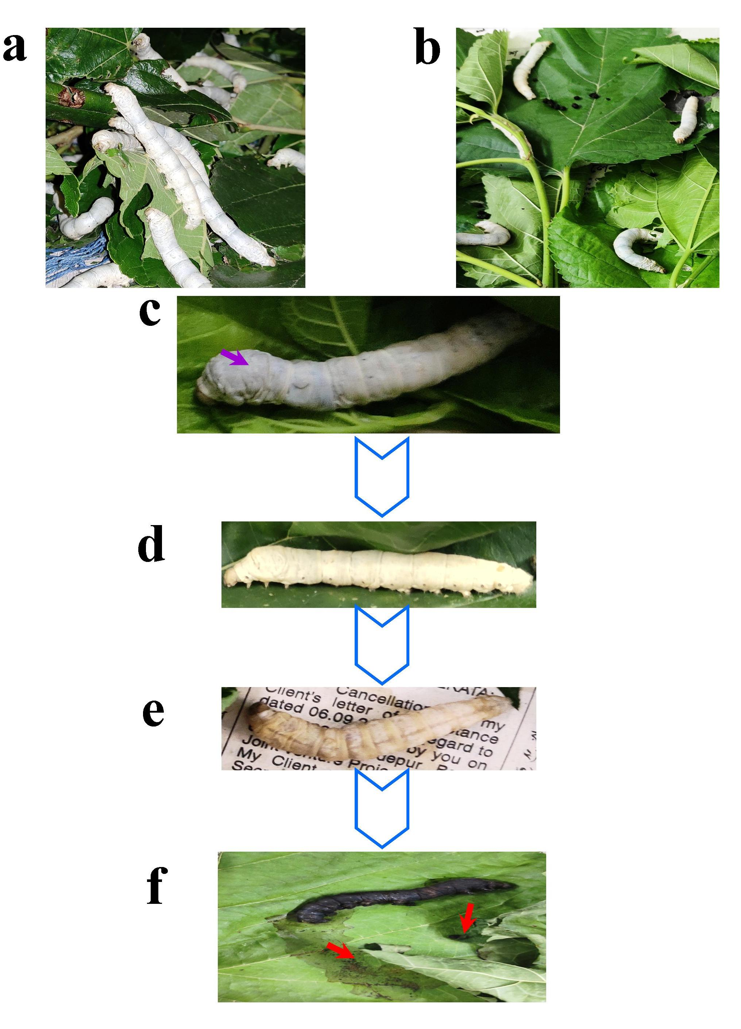

Supplementary Figure S1.Modulation in foraging behavior and integument in non-immunized and immunized B. mori larvae. (a) Continued feeding of untreated larvae. (b) Discontinued feeding in immunized larvae. (c) Purple color arrow showing the swelling in head and thorax. (d-f) Changes in larval color from white to pale yellow, coffee brown and, ultimately, black due to onset of infection. Hemolymph discharged from ruptured integument indicated by red color arrow.

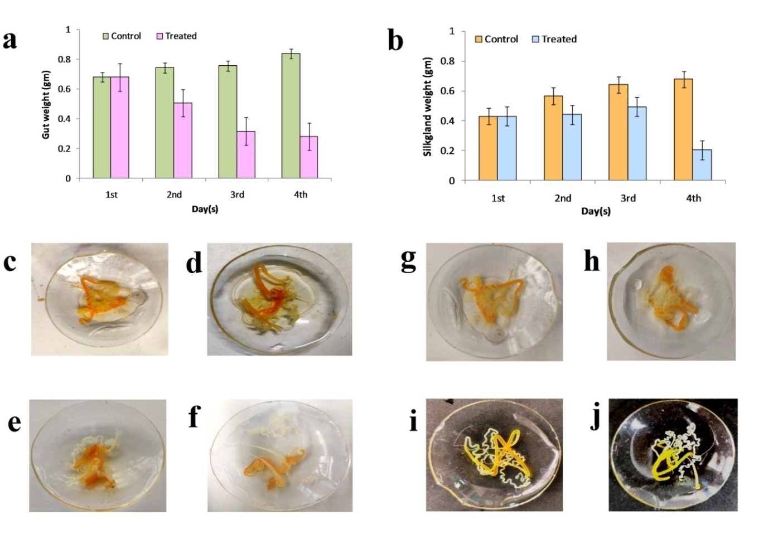
Supplementary Figure S2.Changes in gut weight and silk gland weight in immunized and non-immunized B. mori larvae. Changes in silk gland color in immunized and non-immunized silkworms. The loss of craving activity triggered immunized silkworm causes significant decrease in both wet weight of gut and wet weight of the silk gland compared to the control group (a & b). Decrease in silk production resulting in white color silk gland (c-f). The silk gland of the dissected non-immunized group showed a gradual increase in the intensity of yellow color, which is probably due to normal feeding behavior accompanied by increased silk production (g-j).

