Bacillus velezensis strain Ag75 as a new multifunctional agent for biocontrol, phosphate solubilization and growth promotion in maize and soybean crops

Mirela Mosela¹, Galdino Andrade¹, Luana Rainieri Massucato², Suelen Regina de Araújo Almeida², Alison Fernando Nogueira², Renato Barros de Lima Filho³, Douglas Mariani Zeffa³, Silas Mian², Allan Yukio Higashi², Gabriel Danilo Shimizu², Gustavo Manoel Teixeira¹, kelvin Shinohata Branco², Marcos Ventura Faria⁴, Renata Mussoi Giacomin⁵, Carlos Alberto Scapim³ and Leandro Simões Azeredo Gonçalves^{2,3*}

¹Universidade Estadual de Londrina (UEL), Microbiology Department, Londrina, 86051-900, Brazil.
²Universidade Estadual de Londrina (UEL), Agronomy Department, Londrina, 86051-900, Brazil.
³Universidade Estadual de Maringá (UEM), Agronomy Department, Maringá, 87020-900, Brazil.
⁴Universidade Estadual do Centro Oeste (Unicentro), Agronomy Department, Guarapuava, 85040-167, Brazil.
⁵Universidade Estadual do Centro Oeste (Unicentro), Biology Department, Guarapuava, 85040-167, Brazil.

*leandrosag@uel.br

Supporting information
Additional supporting information may be found in the online version of this article.

Supplementary Table S1. Characterization of the soil used in the greenhouse experiment.
Characteristics^{1/} | Londrina – Greenhouse
Soil | Dystroferric Red Latosol
pH (H₂0) | 5.50
H+Al (cmolc dm³) | 3.24
K (cmolc dm³) | 0.83
Ca (cmolc dm³) | 5.81
Mg (cmolc dm³) | 2.50
Al (cmolc dm³) | 0.00
P (mg dm³) | 13.30
Organic matter (%) | 9.51

Supplementary Table S2. Characterization of environments used in maize and soybean experiments.

Characteristics^{1/} | Londrina  (2020/2021) | Maringá  (2020/2021) | Guarapuava (2020/2021) | Londrina  (2021/2021) | Londrina (2021/2022) | Guarapuava  (2021/2022)
Geographical coordinates | 23° 17’ S; 51° 10’ W | 23° 11' S; 52° 03'  W | 25° 23' S; 51º 29' W | 23° 17’ S; 51° 10’ W | 23° 17’ S; 51° 10’ W | 25° 23' S; 51º 29' W
Altitude (m) | 550 | 555 | 1026 | 550 | 550 | 1026
Climate^{2/} | Cfa | Cfa | Cfb | Cfa | Cfa | Cfb
Soil | Dystroferric Red Latosol | Dystroferric Red Latosol | Dystroferric Bruno Latosol | Dystroferric Red Latosol | Dystroferric Red Latosol | Dystroferric Bruno Latosol
pH (CaCl₂) | 5,2 | 5,2 | 4,5 | 5,3 | 5,4 | 5,1
H+Al (cmolc dm³) | 3,3 | 3,2 | 5,5 | 3.5 | 3,2 | 3,9
K (cmolc dm³) | 0,8 | 0,5 | 0,3 | 1,2 | 0,9 | 0,9
Ca (cmolc dm³) | 5,4 | 2,9 | 2,1 | 5,8 | 5,4 | 2,7
Mg (cmolc dm³) | 1,6 | 1,3 | 0,6 | 1,2 | 1,5 | 1,2
Al (cmolc dm³) | 0,1 | 0,0 | 0,9 | 0,1 | 0,0 | 0,5
P (mg dm³) | 22,6 | 10,7 | 7,0 | 12,3 | 13,4 | 9,0
Organic Matter (%) | 2,8 | 1,8 | 4,2 | 2,5 | 2,6 | 4,4
^{1/} Physical-chemical analyses were performed using soil layer samples from 0 to 20 cm.
^{2/} Köppen climate classification = Cfa, Humid subtropical climate; Cfb: Temperate oceanic climate.

Supplementary Table S3. Analysis of variance for five agronomical traits evaluated in maize in greenhouse with seeds inoculated with different phosphate-solubilizing bacteria.

Source of  Variation | DF | Mean Square^{1/}
Source of  Variation | DF | SD | PH | RDM | SDM | SPC
Treatments | 14 | 6.72** | 354.98** | 1.34** | 6.41** | 1.95**
Error | 75 | 2.16 | 82.08 | 0.32 | 1.63 | 0.26
Mean |  | 11.90 | 74.2 | 1.85 | 6.58 | 4.43
CV (%) |  | 12.37 | 12.21 | 30.49 | 19.39 | 11.63
¹SD: stem diameter, PH: plant height, RDM: root dry mass, SDM: shoot dry mass, and SPC: shoot phosphorus content.
ns, ** e * indicates non-significance, significance at levels 1 and 5% of probability by the F test, respectively

Supplementary Table S4. Mean clustering test (Scott-Knott) for stem diameter (SD), plant height (PH), root dry mass (RDM), shoot dry mass (SDM) and shoot phosphorus content (SPC) in maize seeds inoculated with phosphorus solubilizing bacteria in a greenhouse experiment.

Treatments | Traits
Treatments | SD | PH | RDM | SDM | SPC
Control | 12.18 a | 72.83 b | 1.85 c | 6.16 b | 3.99 b
Biomaphos | 13.15 a | 71.17 b | 2.11 b | 6.83 a | 4.43 b
Strain01 | 11.27 b | 70.83 b | 1.65 c | 6.25 b | 3.79 b
Strain02 | 13.13 a | 76.67 a | 2.04 b | 7.53 a | 4.40 b
Strain03 | 13.67 a | 84.67 a | 2.68 a | 8.78 a | 5.39 a
Strain04 | 12.95 a | 80.33 a | 2.79 a | 7.72 a | 4.66 a
Strain05 | 11.62 b | 67.33 b | 1.25 c | 6.03 b | 5.06 a
Strain06 | 10.88 b | 74.17 b | 1.47 c | 6.33 b | 4.28 b
Strain07 | 9.60 b | 58.33 c | 1.14 c | 4.74 b | 5.12 a
Strain08 | 11.56 b | 61.83 c | 1.54 c | 5.43 b | 4.70 a
Strain09 | 11.37 b | 71.50 b | 1.98 b | 6.67 b | 4.40 b
Strain10 | 11.80 b | 79.50 a | 2.03 b | 6.37 b | 4.20 b
Strain11 | 12.15 a | 80.50 a | 2.10 b | 7.29 a | 3.85 b
Strain12 | 10.95 b | 79.00 a | 1.67 c | 5.90 b | 4.17 b
Strain13 | 12.24 a | 84.33 a | 1.83 c | 7.34 a | 4.78 a
^{1/} Means followed by the same letter in the column do not differ statistically at 5% probability by the Scott-Knott test.

Supplementary Table S5. Effects of phosphorus solubilizing bacteria on grain yield in maize in six experiments.
Treatments | Experiments^{1/}
Treatments | Env.1 | Env.2 | Env.3 | Env.4 | Env.5 | Env.6
Control 25 Kg P₂O₅ | 8291 b | 6475 b | 4679 b | 4486 a | 8317 b | 6778 b
Control 42 Kg P₂O₅ | 9108 ab | 6555 b | 5481 ab | 5176 a | 9978 a | 7264 ab
Control 84 Kg P₂O₅ | 9477 a | 7822 a | 6088 a | 5322 a | 10856 a | 7539 a
25 Kg P₂O₅ + Biomaphos | 8608 ab | 6842 ab | 5407 ab | 4953 a | 10147 a | 7294 ab
25 Kg P₂O₅ + Ag75 | 9210 ab | 7369 ab | 5829 ab | 5043 a | 11206 a | 7306 ab
^{1/}Env1.: Londrina (2020/2021), Env2.: Maringá (2020/2021), Env3.: Guarapuava (2020/2021), Env4.: Londrina (2021/2021), Env5.: Londrina (2021/2022) and Env6.: Guarapuava (2021/2022).

Supplementary Table S6. Effects of phosphorus solubilizing bacteria on grain yield in soybean in five experiments.
Treatments | Experiments^{1/}
Treatments | Env.1 | Env.2 | Env.3 | Env.4 | Env.5
Control 25 Kg P₂O₅ | 2058 b | 2052 b | 3580 b | 3195 b | 2936 b
Control 42 Kg P₂O₅ | 2512 ab | 2708 ab | 3899 ab | 3374 ab | 3523 ab
Control 84 Kg P₂O₅ | 2945 a | 2780 a | 4313 a | 4002 a | 3449 ab
25 Kg P₂O₅ + Biomaphos | 2240 ab | 2344 ab | 4494 a | 3389 ab | 3754 a
25 Kg P₂O₅ + Ag75 | 2843 a | 2694 ab | 4013 ab | 3808 ab | 3334 ab
^{1/}Env1.: Londrina (2020/2021), Env2.: Maringá (2020/2021), Env3.: Guarapuava (2020/2021), Env4.: Londrina (2021/2022) and Env5.: Guarapuava (2021/2022).

Supplementary Table S7. Biosynthetic Gene Clusters (BGCs) found within Bacillus velezensis Ag109 genome using the webserver antiSMASH 5.1.0.

Cluster | Type | From (pb) | To (pb) | Most similar known cluster |  | Similarity (%)
1 | thiopeptide | 281.447 | 311.183 | - | - | -
2 | NRPS | 322.005 | 387.087 | Surfactin | NRP:Lipopeptide | 82
3 | PKS-like | 918.587 | 959.831 | Butirosin A and B | Saccharide | 7
4 | Terpene | 1045.457 | 1062.628
5 | TransAT-PKS | 1392.865 | 1479.251 | Macrolactin | Polyketide | 100
6 | TransAT-PKS, T3PKS, NRPS | 1705.384 | 1805.935 | Bacilaene | Polyketide + NRP | 100
7 | NRPS, TransAT-PKS, Betalactone | 1874.238 | 2011.614 | fengycin | NRP | 100
8 | Terpene | 2034.651 | 2056.534 | - | - | -
9 | T3PKS | 2140.205 | 2181.305 | - | - | -
10 | TransAT-PKS | 2313.205 | 2406.997 | Difficidin | Polyketide + NRP | 100
11 | NRPS, RiPP-like | 3039.587 | 3091.378 | Bacillibactin | NRP | 100
12 | Other | 3619.927 | 3661.345 | Bacilysin | Other | 100
NRPS, non-ribosomal peptide synthetase; NRP, non-ribosomal peptide. PKS, polyketide synthetase. AT, acetyltransferase; T3PKS, type 3 Pks.

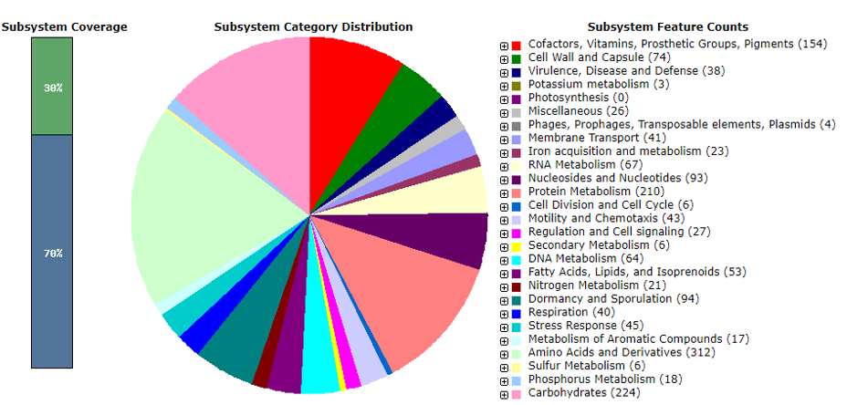

Supplementary Figure S1. SEED classification of Ag75 genome. Pie chart depicting functional categories in Ag75 genome. The SEED annotated genome was compared to hundreds of genomes maintained within the SEED integration. RAST annotation (server possessed identified protein encoding genes (PEGs), RNA genes and repeat regions) was used to create the pie chart.

