Genomic Epidemiology of Mycobacterium abscessus in a Canadian Cystic Fibrosis Centre
Authors and Affiliations
Nicholas Waglechner¹, Elizabeth Tullis^{2,3}, Anne L. Stephenson^{2,3,4}, Valerie Waters⁵, Fiona McIntosh^{6,7}, Jennifer Ma⁸, Frances B. Jamieson⁸, Marcel A. Behr^{6,7,9}, Jane Batt*^{10,11}, Robyn S. Lee*^{1,12}

¹Dalla Lana School of Public Health, University of Toronto, 155 College St., Toronto, Ontario, Canada M5T 3M7. ²Adult Cystic Fibrosis Program, Division of Respirology, St. Michael’s Hospital, Unity Health Toronto, Toronto, Ontario, Canada. ³Li Ka Shing Knowledge Institute, St. Michael’s Hospital, Toronto, Ontario, Canada.
⁴Institute of Health Policy, Management and Evaluation, University of Toronto, Toronto, Ontario, Canada. ⁵Hospital for Sick Children, Department of Pediatrics, Division of Infectious Diseases, 555 University Avenue, Toronto, Ontario, Canada M5G 1X8. ⁶Infectious Diseases and Immunity in Global Health Program, Research Institute of the McGill University Health Centre, Montreal, Quebec, Canada. ⁷McGill International TB Centre, McGill University, Montreal, Quebec, Canada. ⁸Public Health Ontario, Public Health Ontario Laboratories, 661 University Avenue, Suite 1701, Toronto, ON, Canada M5G 1V2. ⁹Department of Epidemiology, Biostatistics and Occupational Health, McGill University, Montreal, Quebec. ¹⁰Keenan Research Center for Biomedical Science, St. Michael’s Hospital, Toronto, Ontario, Canada. ¹¹Tuberculosis Program, St. Michael’s Hospital Unity Health Toronto, Toronto, Ontario, Canada M5B 1WB. ¹²Center for Communicable Disease Dynamics, Harvard School of Public Health, Boston, MA, USA.

*These authors contributed equally

Supplementary Material

Supplementary Tables

Supplementary Table 1: Isolate Sequencing statistics and quality control.
See attached file.

Supplementary Table 2: Ontario isolate SNV statistics
See attached file.

Supplementary Table 3: Public SRA sequences used for global comparison.
See attached file.

Supplementary Table 4: Possible transmission pairs
See attached file.

Supplementary Table 5: SRA sample statistics and quality control.
See attached file.

Supplementary Table 6: Global M. abscessus isolate SNV statistics.
See attached file

Supplementary Figure Legends

Supplementary Figure 1 - Assembly contiguity vs length. Four isolates are outliers with respect to both length and number of contigs (orange) compared to the other isolates (blue).

Supplementary Figure 2 – Pairwise distance matrix of M. abscessus Isolates. Number of SNVs between each pair of isolates from the recombination masked SNV alignment used to generate the maximum-likelihood phylogeny in Figure 2.

Supplementary Figure 3 – Pairwise distance matrix of M. massiliense isolates. Number of SNVs between each pair of isolates from the recombination masked SNV alignment used to generate the maximum-likelihood phylogeny in Figure 2.

Supplementary Figure 4 – Timeline of interactions between patients. a Patients 1 and 4. b Patients 1 and 22. c Patients 4 and 22. For each patient, available visit data, microbiology results, and isolate data are indicated. Hospital visits are shown on the timeline as bars for clinic (gold), pulmonary function testing (PFT, purple), hospitalization (blue) events. Spirometry during CF clinic visits occurs in the patient clinic room, post-2014, rather than a central location. Contact recorded as a grey vertical bar for overlapping visits when they occur on the same day for both patients. Mycobacterium-specific microbiology results are indicated by circles for no growth (open grey), growth of other Mycobacterium spp. (filled grey) and growth of Mycobacterium abscessus complex organisms (filled green). Sequencing of collected isolates is indicated for unsequenced (open dark red) and sequenced (filled red) isolates and labelled with the isolate identifier.

Supplementary Figure 5 – Maximum-likelihood unadjusted SNV phylogeny of global M. abscessus isolates. This phylogeny includes a total 2669 M. abscessus isolates. The country of sampling, where available is indicated by the colour used for leaf branches and on the outer ring. The positions of Ontario patients are indicated.

Supplementary Figure 6 – Maximum-likelihood unadjusted SNV phylogeny of global M. massiliense isolates. This phylogeny includes a total 983 M. massiliense isolates. The country of sampling, where available is indicated by the colour used for leaf branches and on the outer ring. The positions of Ontario patients are indicated. Country colours follow Supplementary Figure 5.

Supplementary Figure 7 – Maximum-likelihood unadjusted SNV phylogeny of M. bolletii isolates. This phylogeny includes a total 219 M. bolletii isolates. The country of sampling, where available, is indicated by the colour used for leaf branches and on the outer ring. The position of the Ontario patient is indicated. Country colours follow Supplementary Figure 5.

Supplementary Figures

Supplementary Figure 1
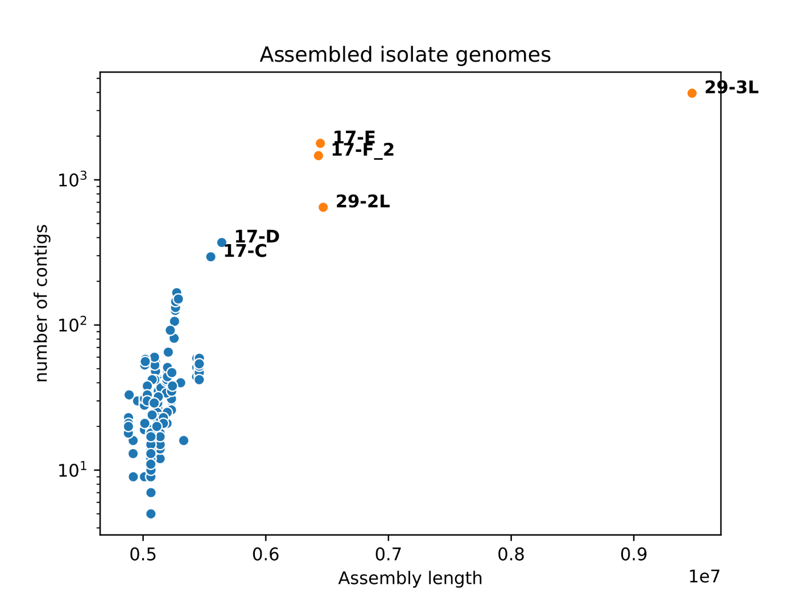

Supplementary Figure 2
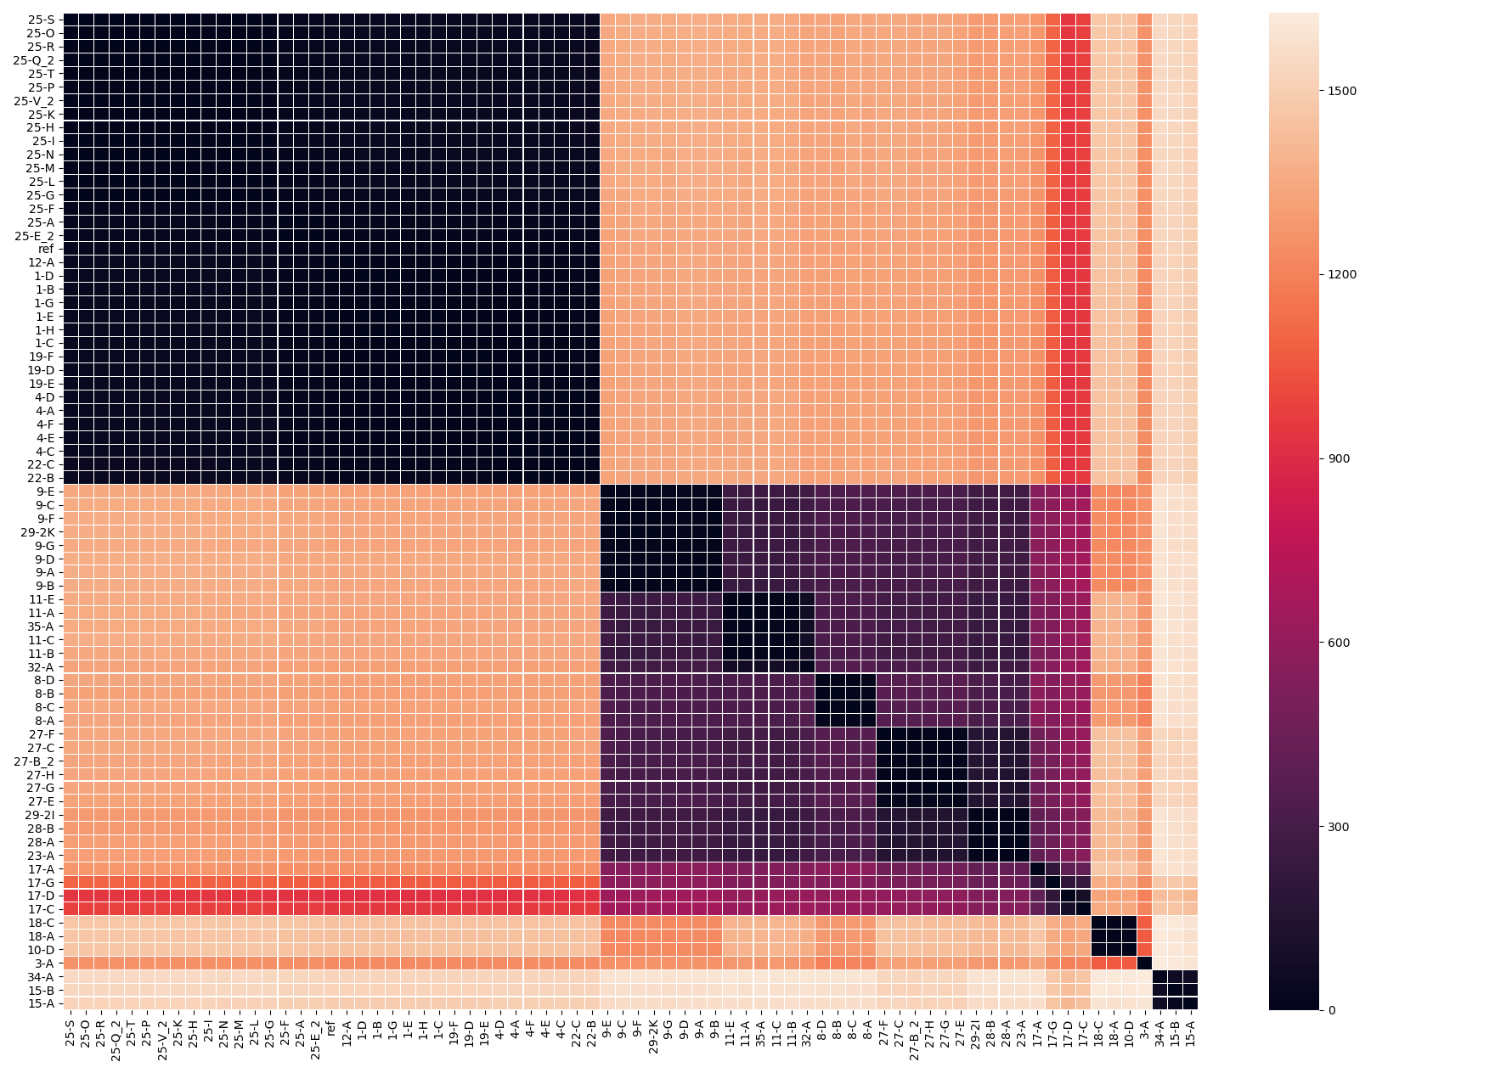

Supplementary Figure 3
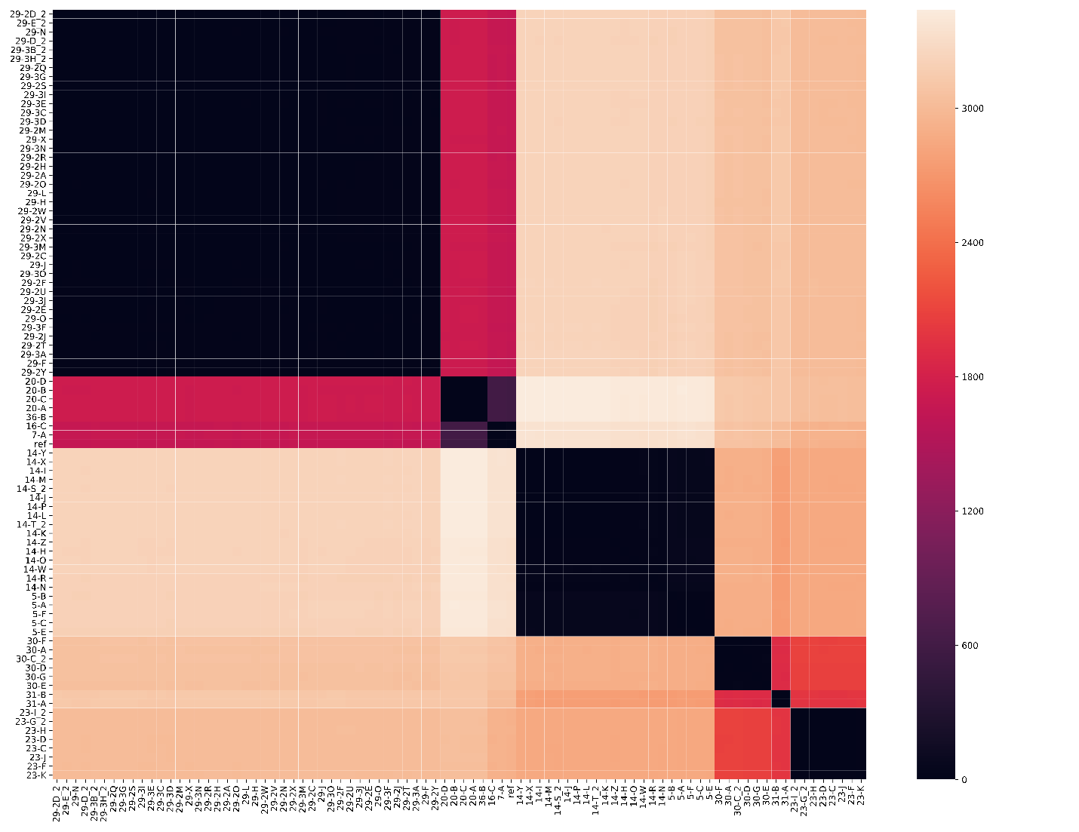

Supplementary Figure 4
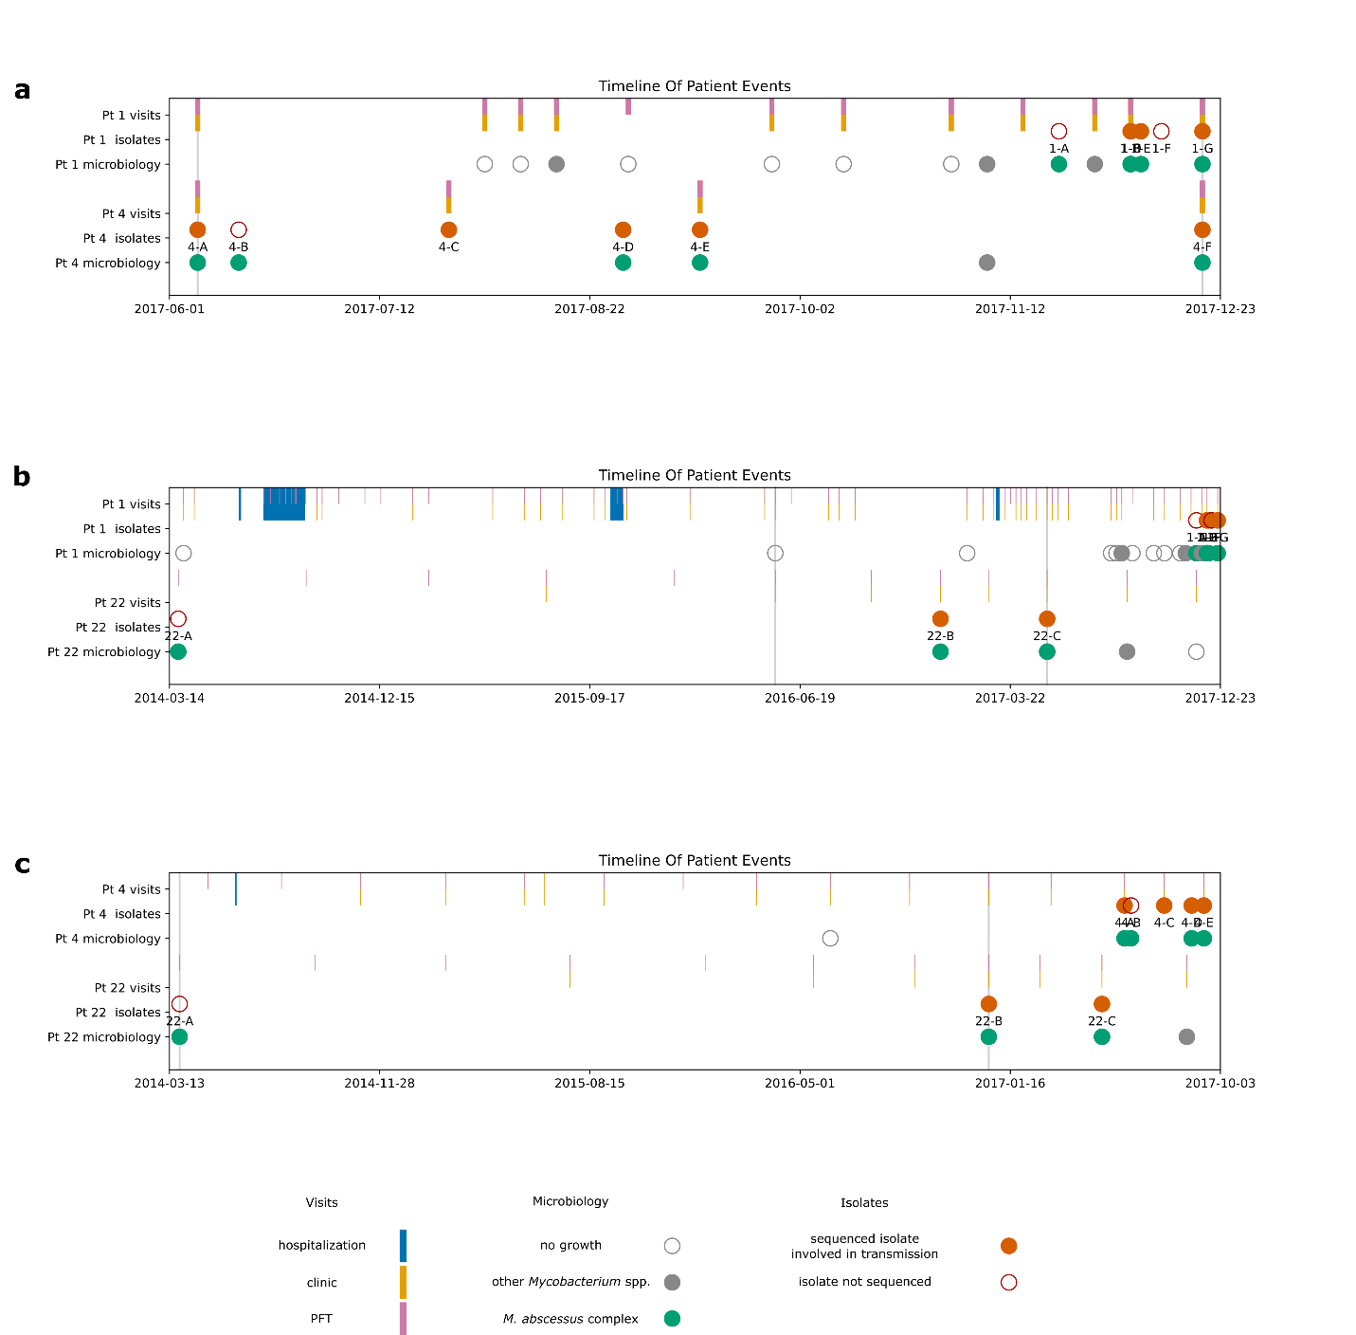

Supplementary Figure 5
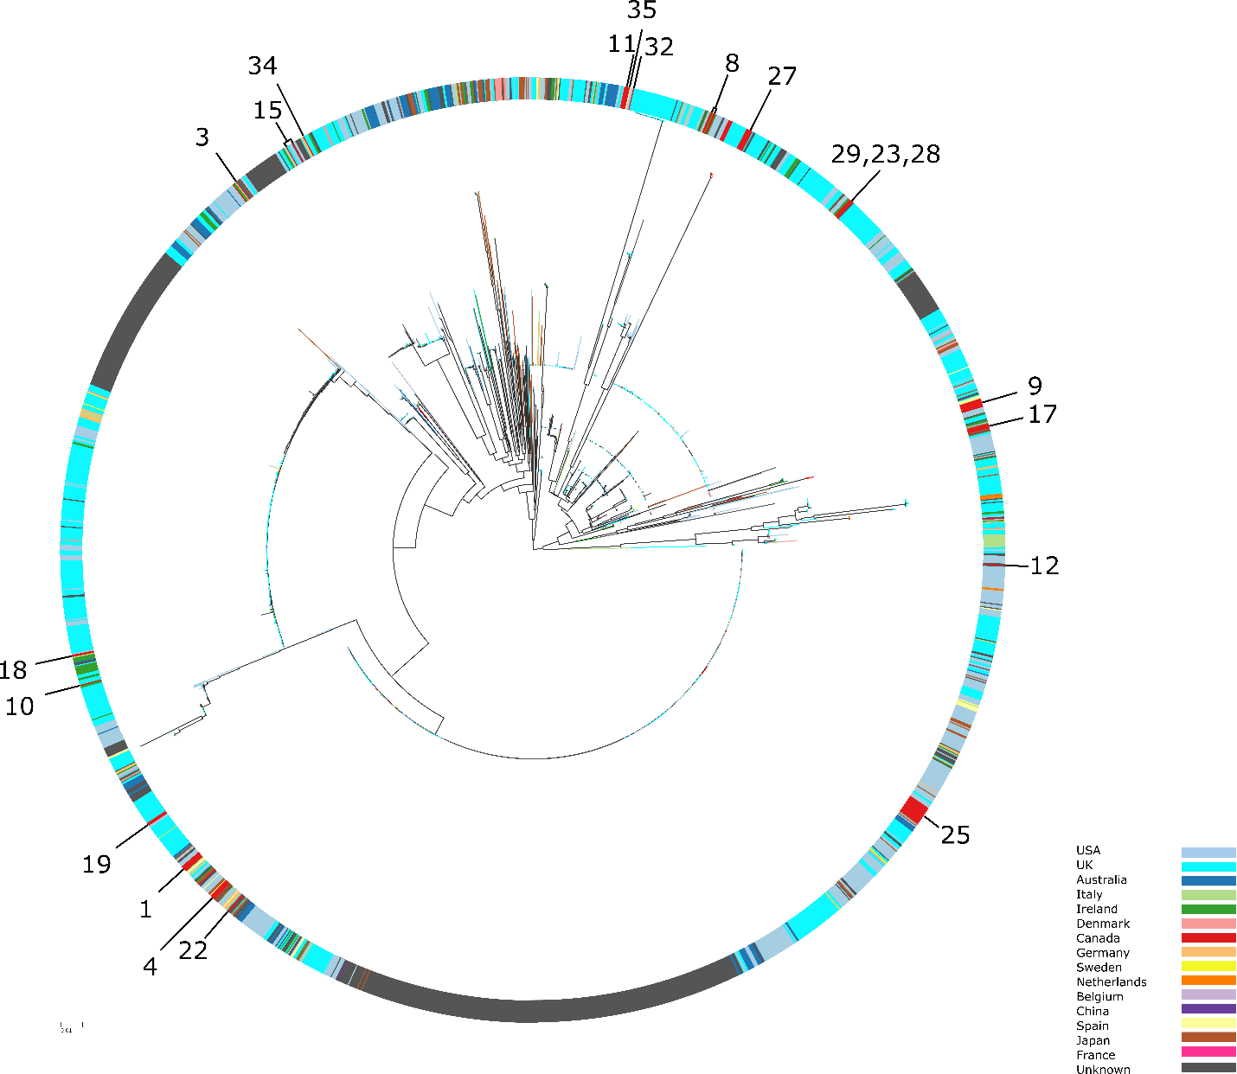
Supplementary Figure 6
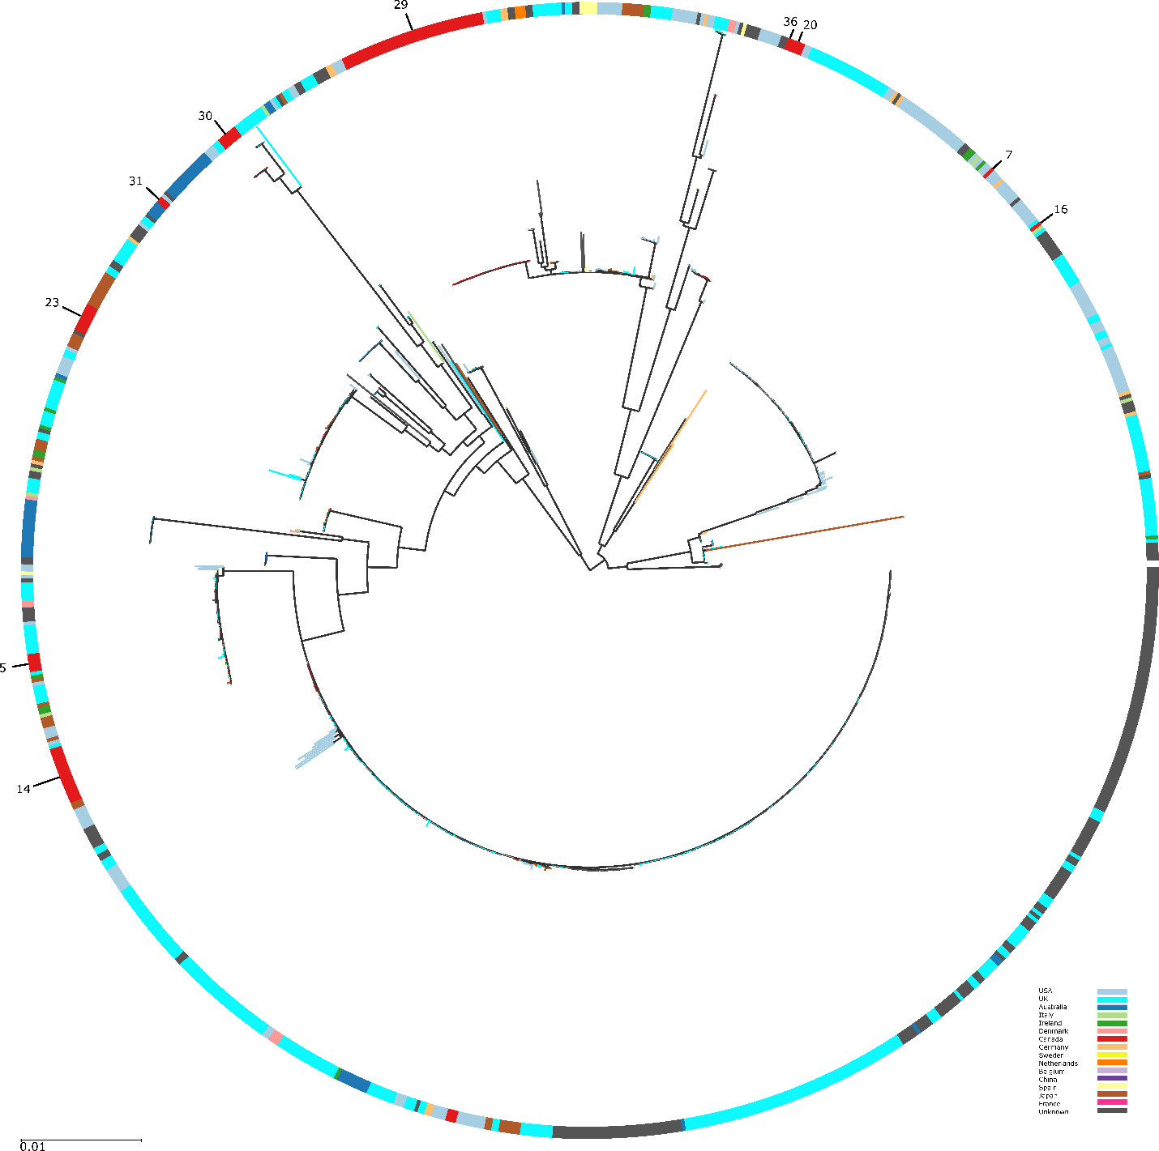

Supplementary Figure 7
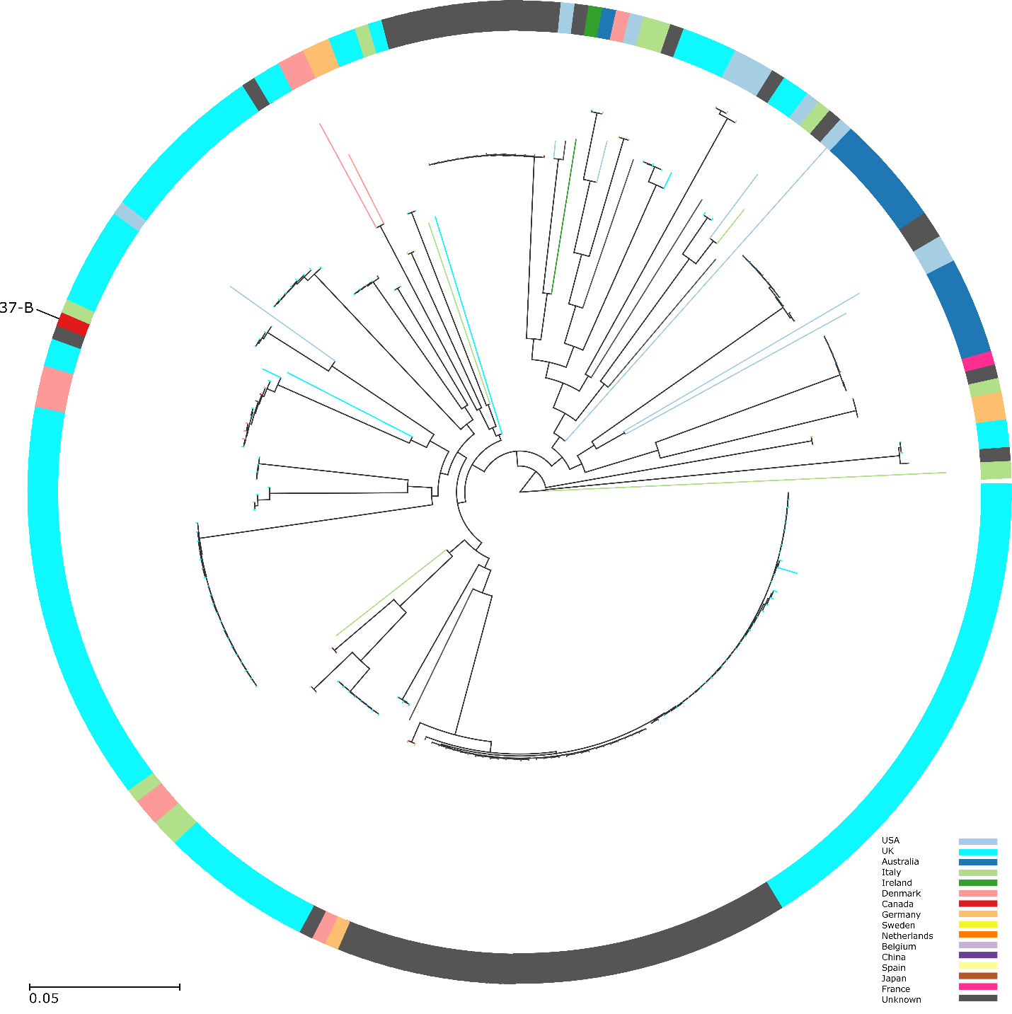

Supplementary Figure 8
