Supplementary Information

Development of a new toolbox for mouse PET-CT brain image analysis fully based on CT images and validation in a PD mouse model
Presotto L^{1,2}, Bettinardi V¹, Mercatelli D³, Picchio M^{1,4}, Morari M³, Moresco RM^{1,2,5,6}and Belloli S^{1,2,6}
¹Nuclear Medicine Department, IRCCS San Raffaele Scientific Institute, Milan, Italy;
²Milan Centre for Neuroscience, University of Milano - Bicocca, Milan, Italy;
³Department of Neuroscience and Rehabilitation, University of Ferrara, Ferrara, Italy;
⁴Vita-Salute San Raffaele University, Milan, Italy;
⁵Medicine and Surgery Department, University of Milano - Bicocca, Monza (MB), Italy;
⁶Institute of Molecular Bioimaging and Physiology (IBFM) of CNR, Segrate (MI), Italy.

Corresponding author: Belloli Sara, Institute of Molecular Bioimaging and Physiology (IBFM) of National Research Council (CNR), Segrate (MI), Italy. e-mail address: sara.belloli@ibfm.cnr.it; belloli.sara@hsr.it; phone: +39 02 26433640.

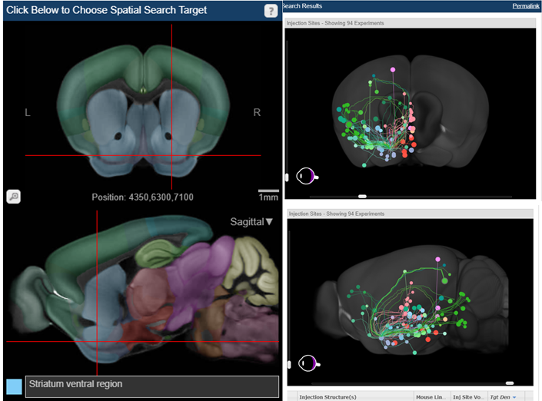

Supplementary Figure 1.
High-resolution map of neural connections of striatum ventral region in the mouse brain, built on an array of mice genetically engineered to target specific cell types. The coloured dots indicate the position of the regions connected to the selected one: light blue and light green for amygdalar nuclei, green for entorhinal areas, dark green for orbital areas and orange for mammillary nucleus.
Image credit: Allen Institute (www.alleninstitute.org).

