Supplementary Figure 1.
A.

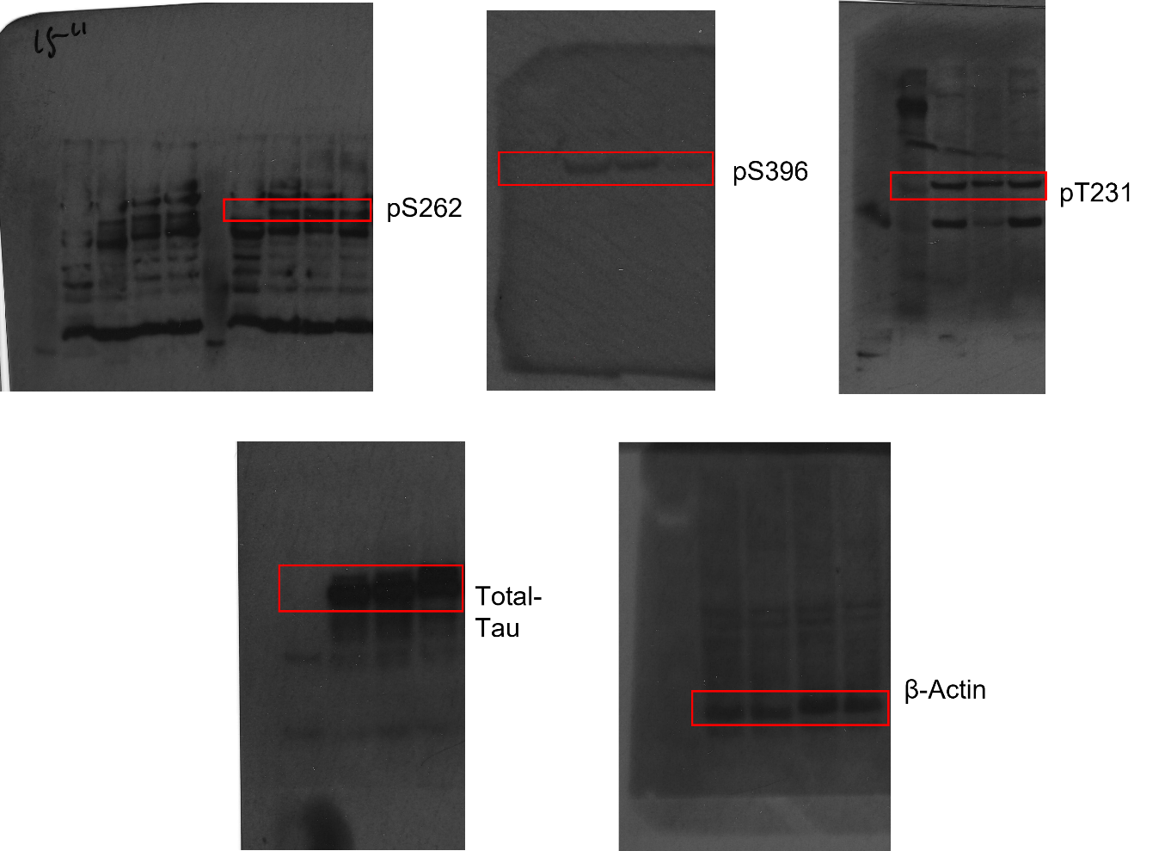
C.
B.
E.
D.

Supplementary Figure 1. DYRK1A inhibitors reduced phosphorylation of human Tau expressed pan-neuronally in Drosophila
Whole Westerns for images (red boxes) used in Figure 1. Western blots show effects of treatment with DYRK1A inhibitors (DYR219 and DYR533) on phosphorylation of human Tau 0N4R overexpressed pan-neuronally using the elav-Gal4 driver: 1st lane is elav-Gal4/+ control, 2nd lane is elav>human Tau 0N4R with normal food, 3rd lane is elav>human Tau treated with 304 μM DYR219 and 4th lane is elav>human Tau with 248 μM DYR533 treatment throughout development and adulthood (treatments were the same for all figures). Three antibodies against phosphorylated Tau (pS262, pS396 and pT231) were tested compared to the level of total unphosphorylated Tau (~55kDa) using a fourth antibody.

Supplementary Figure 2.
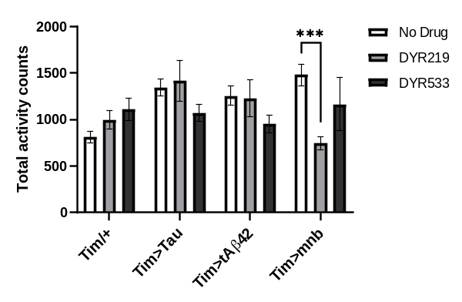
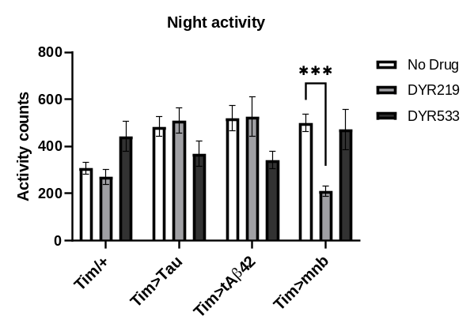
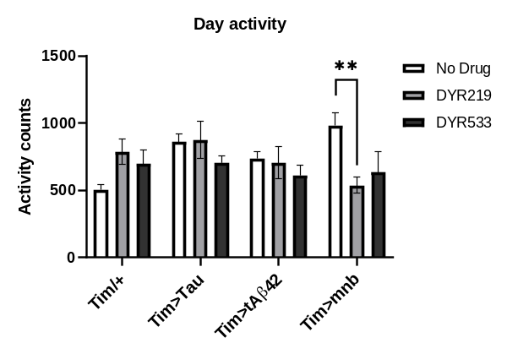
A.
B.
C.

Supplementary Figure 2. Quantification of activity of Drosophila with clock expression of human Tau, tAβ42 and mnb
Flies with clock-wide (timeless (tim)-Gal4) expression of human Tau, tAβ42 or mnb were placed in Drosophila Activity Monitors (DAM) under LD conditions allowing total activity counts to made throughout a 24hr day (A) and then plotted as activity during the day (B) and night (C). This showed and DYR219 significantly decreased total activity counts of mnb overexpressing flies under all three conditions, this was consistent with the increased sleep seen in mnb flies treated with DYR219. One-way ANOVA with Bonferroni's multiple comparisons test (** P < 0.01 and *** P < 0.001).

