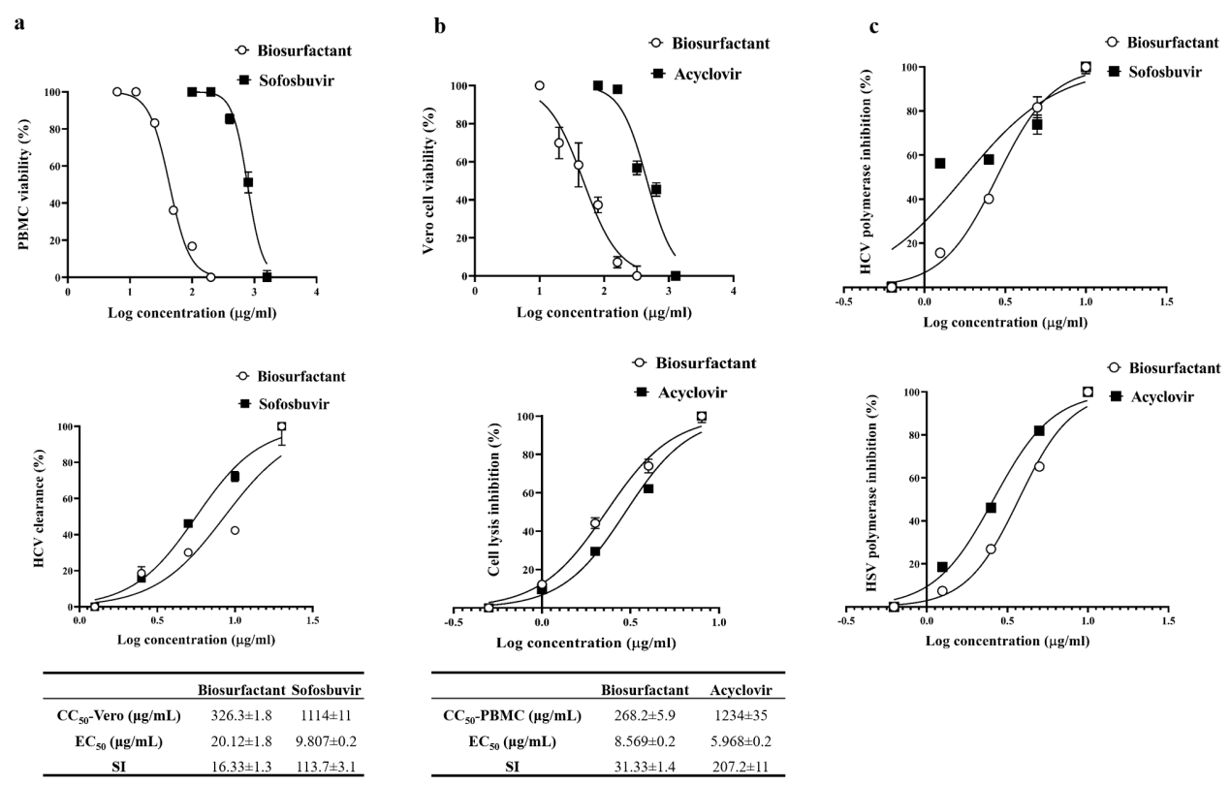

Supplementary Figure 1. Dose response curves of cell viability, antiviral and polymerase inhibition. (a) Peripheral blood mononuclear cell (PBMC) viability (%) and qPCR results of HCV clearance (%) after treatment with serial concentrations of biosurfactant and sofosbuvir with the summarized table of cytotoxic concentration (CC₅₀) at 50% viral host cell viability, effective concentration (EC₅₀) at 50% viral clearance and the calculated selectivity index of antiviral effect (SI). (b) Vero cell viability (%) and HSV1 clearance, in the term of cell lysis inhibition, upon the treatment with serial concentrations of biosurfactant and acyclovir with summarized table of CC₅₀, EC₅₀, and SI. (c) The percentage inhibition of HCV polymerase and HSV polymerase at serial dilutions of biosurfactant and standard antiviral drugs (sofosbuvir and acyclovir, respectively). All data from triple-repeated experiments (n=3) are expressed as mean±SEM.

