Supplementary information
Tables and Figures A (Sample description)
Table A1. Descriptive statistics
 | Average |  | April |  | May |  | June |  | July |  | August |  | September |  | October
 | Mean | SD | Mean | SD | Mean | SD | Mean | SD | Mean | SD | Mean | SD | Mean | SD | Mean | SD
Dependent variable
Weekly COVID-19 deaths | 51 | 185 | 64 | 269 | 62 | 199 | 39 | 112 | 39 | 112 | 51 | 164 | 44 | 144 | 43 | 141
International mobility
Passengers (lag 1 month) | 113323 | 259198 | 185294 | 387729 | 55113 | 122884 | 68949 | 156910 | 82709 | 195028 | 133716 | 276556 | 126904 | 266989 | 139919 | 292615
Importation risk (lag 1 month) | 1922 | 2260 | 601 | 701 | 1545 | 1365 | 1900 | 2596 | 2044 | 2747 | 2104 | 2496 | 2571 | 2321 | 2501 | 2072
Airport centrality (lag 1 month) | 679 | 5068 | 4165 | 13446 | 202 | 1077 | 128 | 577 | 71 | 302 | 271 | 1272 | 121 | 644 | 162 | 649
Travel bans (%)
Total ban | 34 | 47 | 7 | 25 | 55 | 50 | 54 | 50 | 31 | 46 | 34 | 48 | 21 | 41 | 23 | 42
No or minimal restrictions | 8 | 28 | 38 | 49 | 3 | 16 | 7 | 26 | 10 | 30 | 8 | 27 | 8 | 27 | 8 | 27
Partial ban | 58 | 49 | 55 | 50 | 42 | 49 | 39 | 49 | 59 | 49 | 58 | 49 | 71 | 45 | 69 | 46
Local factors
Population (thousands) | 5510 | 14872 | 5510 | 14872 | 5510 | 14872 | 5510 | 14872 | 5510 | 14872 | 5510 | 14872 | 5510 | 14872 | 5510 | 14872
Oxford stringency index (lag 3 weeks) | 63 | 20 | 23 | 19 | 83 | 11 | 76 | 11 | 63 | 16 | 59 | 16 | 59 | 16 | 54 | 17
Real GDP pc PPP | 31946 | 21690 | 31946 | 21713 | 31946 | 21713 | 31946 | 21713 | 31946 | 21713 | 31946 | 21713 | 31946 | 21713 | 31946 | 21713
Population density (pop/km2) | 336 | 1234 | 336 | 1236 | 336 | 1236 | 336 | 1236 | 336 | 1236 | 336 | 1236 | 336 | 1236 | 336 | 1236
Hospital beds per 1000 | 4 | 3 | 4 | 3 | 4 | 3 | 4 | 3 | 4 | 3 | 4 | 3 | 4 | 3 | 4 | 3
Share of 65+ (%) | 16 | 6 | 16 | 6 | 16 | 6 | 16 | 6 | 16 | 6 | 16 | 6 | 16 | 6 | 16 | 6
Cardiovascular deaths (x 100k) | 207 | 123 | 207 | 123 | 207 | 123 | 207 | 123 | 207 | 123 | 207 | 123 | 207 | 123 | 207 | 123
Cancer deaths (x 100k) | 121 | 20 | 121 | 20 | 121 | 20 | 121 | 20 | 121 | 20 | 121 | 20 | 121 | 20 | 121 | 20
Prevalence of adult obesity (%) | 23 | 8 | 23 | 8 | 23 | 8 | 23 | 8 | 23 | 8 | 23 | 8 | 23 | 8 | 23 | 8
Week of first COVID death | 13 | 3 | 13 | 3 | 13 | 3 | 13 | 3 | 13 | 3 | 13 | 3 | 13 | 3 | 13 | 3
Observations | 14570 |  | 470 |  | 470 |  | 470 |  | 470 |  | 470 |  | 470 |  | 470
Source: Sub-National COVID-19 Incidence and Determinants Dataset.
Tables and Figures B (Precocity)
Table B1. The impact of late 2019 air passenger traffic on the precocity of COVID-19 outbreaks (occurrence of 1st and 10th death) including outlier regions (India, Japan regions and US regions). OLS regressions without and with continent fixed effects
B1A. Airline passengers from Chinese airports
DV: Calendar week | (1) | (2) | (3) | (4) | (5) | (6) | (7) | (8)
of 1st/10th COVID-19 death | Wk 1st | Wk 1st | Wk 1st | Wk 1st | Wk 10th | Wk 10th | Wk 10th | Wk 10th
No airport in region | .239 | .0616 | .548 | .162 | 1.810* | 1.191 | 1.931** | 1.350*
 | (.400) | (.398) | (.351) | (.332) | (.808) | (.770) | (.691) | (.668)
Inbound passengers (end 2019) | -.803*** | -.551*** | -.582*** | -.445*** | -1.569*** | -.667* | -.702** | -.479
 | (.137) | (.151) | (.136) | (.129) | (.272) | (.292) | (.267) | (.258)
Airport centrality (end 2019) | -.196 | -.190 | -.190 | -.076 | -.031 | -.061 | -.172 | -.334
 | (.135) | (.146) | (.129) | (.123) | (.267) | (.275) | (.247) | (.242)
Population |  | -.273* | -.509*** | -.716*** |  | -.544* | -.925*** | -1.439***
 |  | (.138) | (.124) | (.131) |  | (.263) | (.238) | (.258)
Population density (pop/km2) |  | -.0120 | -.0512 | -.249* |  | .0542 | -.094 | -.388
 |  | (.143) | (.125) | (.121) |  | (.270) | (.240) | (.237)
Real GDP pc PPP |  | -.558*** | .0229 | .257 |  | -2.307*** | -.623* | -.337
 |  | (.142) | (.137) | (.136) |  | (.305) | (.313) | (.323)
Hospital beds per 1000 residents |  |  |  | -.277 |  |  |  | .808*
 |  |  |  | (.184) |  |  |  | (.366)
Share of 65+ |  |  |  | -.815*** |  |  |  | -1.706***
 |  |  |  | (.192) |  |  |  | (.394)
Cardiovascular death rate |  |  |  | 1.025*** |  |  |  | .308
 |  |  |  | (.247) |  |  |  | (.512)
Cancer death rate |  |  |  | .441* |  |  |  | 1.418***
 |  |  |  | (.181) |  |  |  | (.364)
Prevalence of adult obesity |  |  |  | -.754** |  |  |  | -2.906***
 |  |  |  | (.271) |  |  |  | (.543)
Observations | 489 | 489 | 489 | 489 | 465 | 465 | 465 | 465
R-squared | .091 | .121 | .341 | .438 | .095 | .196 | .376 | .445
Continent Fixed Effects | No | No | Yes | Yes | No | No | Yes | Yes

B1B. Airline passengers from non-Chinese airports
DV: Calendar week | (1) | (2) | (3) | (4) | (5) | (6) | (7) | (8)
of 1st/10th COVID-19 death | Wk 1st | Wk 1st | Wk 1st | Wk 1st | Wk 10th | Wk 10th | Wk 10th | Wk 10th
No airport in region | .567 | .200 | .677 | .243 | 2.506** | 1.345 | 2.076** | 1.483*
 | (.405) | (.399) | (.349) | (.334) | (.823) | (.771) | (.691) | (.664)
Inbound passengers (end 2019) | -.540*** | -.409* | -.664*** | -.340* | -.635* | -.207 | -.685* | -.827**
 | (.162) | (.162) | (.142) | (.145) | (.322) | (.306) | (.277) | (.285)
Airport centrality (end 2019) | -.115 | -.0540 | .0829 | -.001 | -.114 | -.069 | .089 | -.004
 | (.162) | (.175) | (.152) | (.143) | (.323) | (.329) | (.294) | (.278)
Population |  | -.385** | -.609*** | -.828*** |  | -.720** | -1.058*** | -1.490***
 |  | (.133) | (.117) | (.125) |  | (.252) | (.227) | (.243)
Population density (pop/km2) |  | -.095 | -.178 | -.320** |  | .001 | -.227 | -.499*
 |  | (.145) | (.126) | (.121) |  | (.274) | (.243) | (.237)
Real GDP pc PPP |  | -.700*** | -.045 | .186 |  | -2.563*** | -.749* | -.413
 |  | (.135) | (.132) | (.135) |  | (.283) | (.302) | (.314)
Hospital beds per 1000 residents |  |  |  | -.168 |  |  |  | 1.085**
 |  |  |  | (.192) |  |  |  | (.376)
Share of 65+ |  |  |  | -.805*** |  |  |  | -1.668***
 |  |  |  | (.193) |  |  |  | (.392)
Cardiovascular death rate |  |  |  | 1.007*** |  |  |  | .120
 |  |  |  | (.252) |  |  |  | (.516)
Cancer death rate |  |  |  | .433* |  |  |  | 1.446***
 |  |  |  | (.182) |  |  |  | (.363)
Prevalence of adult obesity |  |  |  | -.930*** |  |  |  | -3.155***
 |  |  |  | (.270) |  |  |  | (.537)
Observations | 489 | 489 | 489 | 489 | 465 | 465 | 465 | 465
R-squared | .048 | .108 | .345 | .430 | .037 | .187 | .375 | .451
Continent Fixed Effects | No | No | Yes | Yes | No | No | Yes | Yes
Standard errors in parentheses. * p < .05, ** p < .01, *** p < .001.
Source: Sub-National COVID-19 Incidence and Determinants Dataset.

Figure B1. Scatterplot of the precocity of COVID-19 outbreak (occurrence of 1st death) and incoming passengers from China or from other airports
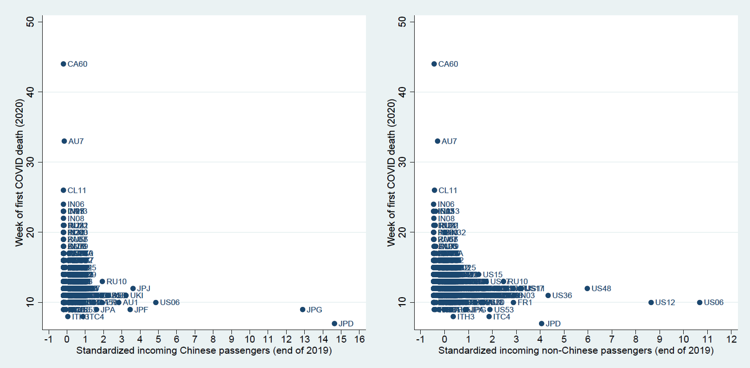
Source: Sub-National COVID-19 Incidence and Determinants Dataset.

Figure B2. The impact of air travel on the precocity of first COVID-19 death: measuring robustness to the exclusion of countries
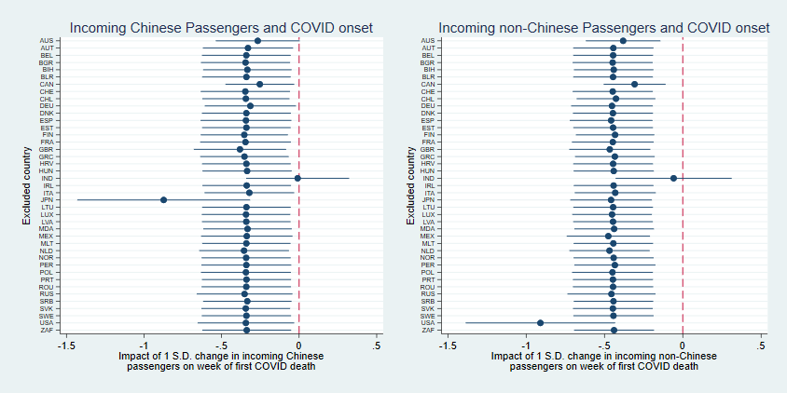
Note: outcomes control for the covariates of models 4 in Tables B1A and B1B.
Source: Sub-National COVID-19 Incidence and Determinants Dataset.

Table B2. The impact of late 2019 air passenger traffic on the precocity of COVID-19 outbreaks (occurrence of 1st and 10th case) excluding outlier regions (India, Japan regions and US regions). OLS regressions with and without continent fixed effects
B2A. Airline passengers from Chinese airports
DV: Calendar week | (1) | (2) | (3) | (4) | (5) | (6) | (7) | (8)
of 1st/10th COVID-19 case | Wk 1st | Wk 1st | Wk 1st | Wk 1st | Wk 10th | Wk 10th | Wk 10th | Wk 10th
No airport in region | .851* | .533 | .776* | .349 | .419 | -.00146 | .474 | .114
 | (.338) | (.330) | (.321) | (.300) | (.335) | (.321) | (.291) | (.277)
Inbound passengers (end 2019) | -1.982*** | -1.040*** | -1.029*** | -.766** | -1.098*** | .0393 | -.160 | .0580
 | (.231) | (.282) | (.286) | (.268) | (.227) | (.273) | (.258) | (.247)
Airport centrality (end 2019) | .0570 | .0842 | .214 | .142 | -.452* | -.426* | -.132 | -.206
 | (.213) | (.222) | (.215) | (.199) | (.209) | (.214) | (.194) | (.182)
Population |  | -2.356*** | -2.481*** | -2.297*** |  | -2.830*** | -2.884*** | -2.783***
 |  | (.512) | (.532) | (.494) |  | (.499) | (.485) | (.459)
Population density (pop/km2) |  | -.0881 | -.0855 | -.214 |  | -.0782 | -.0317 | -.145
 |  | (.176) | (.169) | (.157) |  | (.170) | (.152) | (.144)
Real GDP pc PPP |  | -.429*** | -.182 | -.0390 |  | -.540*** | -.225* | -.093
 |  | (.115) | (.121) | (.118) |  | (.111) | (.109) | (.109)
Hospital beds per 1000 residents |  |  |  | .0349 |  |  |  | .088
 |  |  |  | (.226) |  |  |  | (.207)
Share of 65+ |  |  |  | -.895*** |  |  |  | -.757***
 |  |  |  | (.168) |  |  |  | (.156)
Cardiovascular death rate |  |  |  | .964*** |  |  |  | .776***
 |  |  |  | (.225) |  |  |  | (.207)
Cancer death rate |  |  |  | .446** |  |  |  | .303*
 |  |  |  | (.166) |  |  |  | (.153)
Prevalence of adult obesity |  |  |  | -.826** |  |  |  | -.709*
 |  |  |  | (.318) |  |  |  | (.293)
Observations | 457 | 457 | 457 | 457 | 455 | 455 | 455 | 455
R-squared | .164 | .228 | .308 | .425 | .0792 | .186 | .365 | .452
Continent Fixed Effects | No | No | Yes | Yes | No | No | Yes | Yes

B2B. Airline passengers from non-Chinese airports
DV: Calendar week | (1) | (2) | (3) | (4) | (5) | (6) | (7) | (8)
of 1st/10th COVID-19 case | Wk 1st | Wk 1st | Wk 1st | Wk 1st | Wk 10th | Wk 10th | Wk 10th | Wk 10th
No airport in region | .481 | .394 | .629 | .269 | .121 | -.0287 | .409 | .106
 | (.338) | (.331) | (.320) | (.298) | (.330) | (.320) | (.287) | (.274)
Inbound passengers (end 2019) | -1.483*** | -.663** | -.571* | -.578** | -1.175*** | -.270 | -.278 | -.209
 | (.166) | (.228) | (.221) | (.212) | (.161) | (.220) | (.198) | (.195)
Airport centrality (end 2019) | -.005 | .128 | .156 | .175 | -.093 | .043 | .102 | .093
 | (.128) | (.133) | (.130) | (.121) | (.124) | (.128) | (.116) | (.110)
Population |  | -3.002*** | -3.508*** | -2.551*** |  | -2.932*** | -3.427*** | -2.955***
 |  | (.623) | (.614) | (.606) |  | (.606) | (.555) | (.565)
Population density (pop/ km2) |  | -.060 | -.044 | -.180 |  | -.122 | -.028 | -.151
 |  | (.174) | (.167) | (.155) |  | (.167) | (.149) | (.142)
Real GDP pc PPP |  | -.355** | -.155 | .003 |  | -.517*** | -.208 | -.085
 |  | (.124) | (.127) | (.122) |  | (.119) | (.113) | (.112)
Hospital beds per 1000 residents |  |  |  | .0366 |  |  |  | .102
 |  |  |  | (.225) |  |  |  | (.206)
Share of 65+ |  |  |  | -.907*** |  |  |  | -.740***
 |  |  |  | (.168) |  |  |  | (.155)
Cardiovascular death rate |  |  |  | .926*** |  |  |  | .719***
 |  |  |  | (.225) |  |  |  | (.206)
Cancer death rate |  |  |  | .410* |  |  |  | .316*
 |  |  |  | (.165) |  |  |  | (.152)
Prevalence of adult obesity |  |  |  | -.580 |  |  |  | -.695*
 |  |  |  | (.322) |  |  |  | (.296)
Observations | 456 | 456 | 456 | 456 | 454 | 454 | 454 | 454
R-squared | .191 | .237 | .316 | .435 | .140 | .203 | .385 | .466
Continent Fixed Effects | No | No | Yes | Yes | No | No | Yes | Yes
Standard errors in parentheses. * p < .05, ** p < .01, *** p < .001.
Source: Sub-National COVID-19 Incidence and Determinants Dataset.

Tables and Figures C (severity)
Table C1. The impact of air passenger traffic on the severity of COVID-19 deaths in April-October 2020, controlling for population mixing (NPI), structural predispositions and recursive effects. Generalized linear mixed-effects models with sequential addition of covariates
DV: Weekly COVID-19 deaths | Model 0 | Model 1 | Model 2 | Model 3 | Model 4 | Model 5 | Model 6
Partial travel ban (lag 3 weeks)° | 1.014*  [1.002;1.025] | 1.013*  [1.002;1.025] | 1.013*  [1.002;1.024] | 1.013*  [1.001;1.024] | 1.013*  [1.001;1.024] | 1.001  [.989;1.012] | .957***  [.946;.969]
None/Minimal travel restrictions (lag 3 weeks)° | 1.058***  [1.049;1.067] | 1.058***  [1.049;1.067] | 1.058***  [1.049;1.067] | 1.057***  [1.049;1.066] | 1.057***  [1.048;1.066] | 1.021***  [1.012;1.03] | .992  [.983;1.001]
Calendar week° | .984  [.885;1.093] | .980  [.931;1.031] | .979  [.932;1.029] | .968  [.926;1.012] | .971  [.927;1.016] | .988  [.96;1.016] | 1.018  [.991;1.046]
Population size |  | 2.084***  [1.804;2.408] | 2.123***  [1.839;2.45] | 1.471***  [1.277;1.694] | 1.457***  [1.267;1.675] | 1.479***  [1.284;1.704] | 1.477***  [1.283;1.702]
Population density (pop/km2) |  |  | 1.180**  [1.043;1.335] | 1.026  [.918;1.147] | 1.028  [.921;1.148] | 1.041  [.93;1.164] | 1.042  [.932;1.165]
Share of 65+ |  |  | 1.539**  [1.162;2.038] | 1.245  [.969;1.6] | 1.271  [.991;1.63] | 1.172  [.909;1.511] | 1.169  [.908;1.505]
Real GDP pc PPP |  |  | 1.066  [.908;1.251] | 1.149  [.997;1.323] | 1.123  [.975;1.293] | 1.099  [.952;1.269] | 1.092  [.947;1.26]
Hospital beds per 1000 residents |  |  | .786  [.399;1.547] | .703  [.393;1.26] | .697  [.387;1.253] | .656  [.347;1.241] | .614  [.335;1.124]
Cardiovascular death rate |  |  | .853  [.46;1.583] | 1.189  [.694;2.037] | 1.251  [.727;2.152] | 1.494  [.832;2.682] | 1.503  [.859;2.629]
Cancer death rate |  |  | .839  [.459;1.534] | .791  [.473;1.322] | .81  [.482;1.36] | .782  [.447;1.37] | .799  [.469;1.362]
Prevalence of adult obesity |  |  | 1.668  [.769;3.621] | 1.62  [.842;3.117] | 1.574  [.813;3.049] | 1.453  [.708;2.983] | 1.527  [.774;3.011]
Week of first COVID death |  |  |  | .679***  [.636;.726] | .686***  [.642;.733] | .693***  [.648;.742] | .693***  [.648;.740]
No airport in region |  |  |  |  | .612**  [.443;.845] | .772  [.555;1.074] | .773  [.557;1.074]
Centrality (lag 1 mnt)° |  |  |  |  |  | .980***  [.975;.986] | .974***  [.969;.980]
Inbound passengers (lag 1 mnt)° |  |  |  |  |  | 1.016***  [1.011;1.021] | 1.009***  [1.004;1.014]
Importation risk (lag 1 mnt)° |  |  |  |  |  | .981***  [.978;.984] | .981***  [.977;.984]
Importation risk x inbound passengers (lag 1 mnt)° |  |  |  |  |  | 1.067*  [1.012;1.125] | 1.054*  [1.000;1.111]
Oxford stringency index (lag 3 wks)° |  |  |  |  |  |  | .974***  [.970;.979]
NUTS in (Country in Continent)-Intercept | 1.4e+00 | 1.4e+00 | 1.3e+00 | 1.3e+00 | 1.5e+00 | 1.5e+00 | 1.6e+00
NUTS in (Country in Continent)-Slope | 5.4e-02 | 5.5e-02 | 5.2e-02 | 5.2e-02 | 5.2e-02 | 5.2e-02 | 5.2e-02
NUTS in (Country in Continent)-Corr | -6.5e-01 | -6.5e-01 | -6.2e-01 | -6.2e-01 | -6.1e-01 | -6.2e-01 | -5.7e-01
Country in Continent -Intercept | 1.3e+00 | 1.4e+00 | 1.3e+00 | 1.3e+00 | 1.5e+00 | 1.7e+00 | 1.7e+00
Country in Continent -Slope | 7.9e-02 | 8.5e-02 | 1.1e-01 | 1.1e-01 | 1.1e-01 | 1.1e-01 | 1.1e-01
Country in Continent -Corr | 4.0e-02 | -1.0e-01 | -1.1e-01 | -1.3e-01 | -2.0e-01 | -3.3e-01 | -3.9e-01
Continent -Intercept | .0e+00 | 2.1e-04 | 1.2e-01 | 9.4e-02 | 3.6e-01 | 5.8e-01 | 2.8e-04
Continent -Slope | 4.2e-07 | 1.1e-06 | 2.2e-02 | 2.0e-02 | 2.9e-02 | 3.3e-02 | 1.1e-01
Continent -Corr | NaN | -1.0e+00 | -1.0e+00 | -1.0e+00 | -1.0e+00 | -1.0e+00 | -1.5e-01
* p < .05, ** p < .01, *** p < .001. ° by week.
Source: Sub-National COVID-19 Incidence and Determinants Dataset.

Figure C1. Conditional modes of the random effects (intercept and slope) from the negative binomial generalized linear mixed model of Table C1 (model 6)

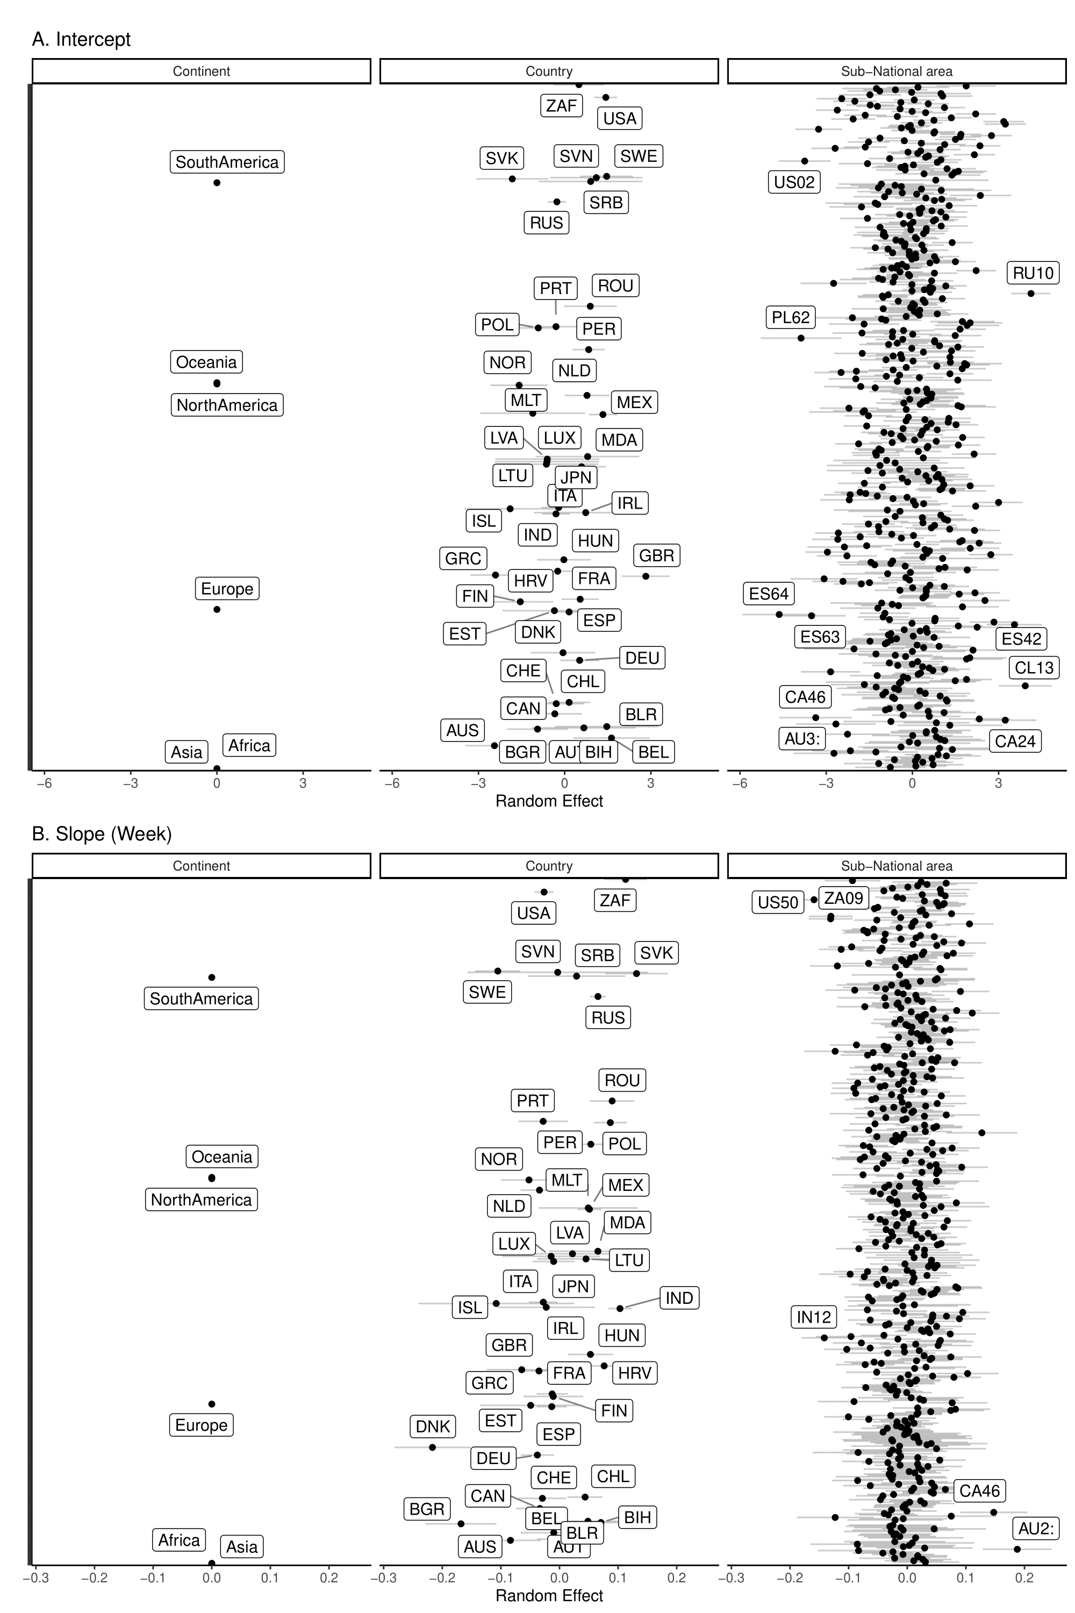
Source: Sub-National COVID-19 Incidence and Determinants Dataset.

Table C2. The impact of air passenger traffic on the severity of COVID-19 deaths in April-October 2020, controlling for population mixing (NPI), structural predispositions and recursive effects. Negative binomial regressions with continent fixed effects
DV: Weekly COVID-19 deaths | (1) | (2) | (3) | (4) | (5) | (6) | (7)
 | April | May | June | July | Aug | Sep | Oct
International mobility
No airport in region | .607* | .491*** | .275*** | .582* | .793 | .897 | .654*
 | [.385,.956] | [.325,.741] | [.166,.454] | [.365,.926] | [.508,1.240] | [.574,1.404] | [.437,.980]
Inbound passengers (lag 1 mnt) | 1.387*** | 1.669*** | 2.006** | 1.495*** | 1.588*** | 1.425*** | 1.315***
 | [1.149,1.675] | [1.372,2.030] | [1.267,3.177] | [1.193,1.875] | [1.282,1.967] | [1.197,1.697] | [1.118,1.546]
Importation risk (lag 1 mnt) | 1.180 | 1.147 | .978 | .731* | 1.153 | 1.339** | 1.163
 | [.995,1.399] | [.972,1.353] | [.651,1.468] | [.576,.928] | [.940,1.414] | [1.120,1.600] | [.995,1.358]
Importation risk x inbound passengers | 1.303* | 1.413** | 1.801 | .833 | .935 | 1.021 | 1.131
 | [1.034,1.643] | [1.141,1.751] | [.797,4.070] | [.582,1.192] | [.815,1.072] | [.880,1.185] | [.910,1.405]
Airport centrality (lag 1 mnt) | .881 | .895 | .954 | 1.018 | .955 | 1.159 | 1.142
 | [.767,1.011] | [.786,1.018] | [.796,1.145] | [.863,1.199] | [.792,1.153] | [.942,1.427] | [.982,1.328]
Travel restrictions (ref: total travel ban)
None/minimal (lag 3 wks) | 4.611*** | 4.746*** | 3.108*** | 2.953*** | 4.495*** | 2.543 | .900
 | [2.725,7.804] | [2.284,9.859] | [1.607,6.012] | [1.560,5.591] | [1.921,1.52] | [.598,1.81] | [.401,2.020]
Partial ban (lag 3 wks) | 4.716*** | .599** | 2.029*** | 2.024** | 1.329 | 1.285 | .569
 | [2.616,8.502] | [.429,.838] | [1.376,2.992] | [1.258,3.255] | [.623,2.835] | [.364,4.537] | [.291,1.111]
Containment policies
Oxford stringency index (lag 3 wks) | .821* | 1.021 | 1.279* | 2.152*** | 1.297 | 1.565** | 1.565**
 | [.681,.991] | [.877,1.188] | [1.037,1.578] | [1.669,2.773] | [.970,1.734] | [1.155,2.120] | [1.160,2.113]
Structural variables
Population size | 1.311* | 1.442*** | 1.190 | 1.623*** | 1.383** | 1.408** | 1.366**
 | [1.053,1.632] | [1.169,1.779] | [.893,1.586] | [1.236,2.131] | [1.083,1.767] | [1.101,1.801] | [1.089,1.714]
Real GDP pc PPP | 1.127 | 1.103 | .940 | .880 | .781* | .697*** | .678***
 | [.913,1.391] | [.919,1.325] | [.720,1.227] | [.732,1.058] | [.633,.964] | [.575,.844] | [.570,.807]
Population density (pop/km2) | .987 | .923 | 1.072 | 1.098 | 1.003 | 1.183 | 1.083
 | [.848,1.149] | [.802,1.062] | [.891,1.288] | [.924,1.304] | [.847,1.186] | [.958,1.460] | [.934,1.256]
Hospital beds per 1000 | .547*** | .851 | .779 | .641** | .784 | .796 | .956
 | [.432,.691] | [.681,1.064] | [.599,1.014] | [.480,.854] | [.574,1.072] | [.553,1.147] | [.707,1.292]
Share of 65+ | 1.099 | 1.201 | .900 | .874 | .655** | .861 | .729*
 | [.801,1.509] | [.951,1.518] | [.670,1.210] | [.664,1.148] | [.492,.870] | [.657,1.129] | [.566,.939]
Cardiovascular death rate | 1.645** | 1.551** | 3.302*** | 5.365*** | 3.179*** | 2.435*** | 1.622**
 | [1.127,2.403] | [1.155,2.083] | [2.184,4.991] | [3.771,7.631] | [2.235,4.521] | [1.685,3.517] | [1.126,2.337]
Cancer death rate | 1.146 | .878 | .729* | .642*** | .863 | 1.094 | 1.056
 | [.908,1.448] | [.722,1.067] | [.565,.940] | [.508,.812] | [.667,1.116] | [.852,1.405] | [.845,1.321]
Prevalence of adult obesity | 1.952*** | 1.742** | 1.236 | 2.541*** | .811 | .502** | 1.259
 | [1.344,2.834] | [1.189,2.551] | [.761,2.007] | [1.660,3.890] | [.535,1.228] | [.314,.802] | [.867,1.827]
Recursive effects
Week of first COVID death | .063*** | .155*** | .338*** | .456*** | .406*** | .471*** | .473***
 | [.0419,.0962] | [.114,.210] | [.254,.448] | [.354,.588] | [.315,.523] | [.367,.603] | [.386,.579]
Lnalpha | 1.055 | 1.185* | 1.840*** | 1.556*** | 1.471*** | 1.518*** | 1.204**
 | [.902,1.233] | [1.035,1.357] | [1.600,2.115] | [1.339,1.809] | [1.267,1.707] | [1.313,1.754] | [1.047,1.383]
Avg. deaths per week | 63.84 | 62.19 | 38.56 | 38.85 | 5.81 | 44.45 | 43.03
Observations | 470 | 470 | 470 | 470 | 470 | 470 | 470
Pseudo R-squared | .210 | .145 | .108 | .129 | .134 | .118 | .110
Continent Fixed Effects | Yes | Yes | Yes | Yes | Yes | Yes | Yes
Standard errors in parentheses. * p < .05, ** p < .01, *** p < .001.
Source: Sub-National COVID-19 Incidence and Determinants Dataset.

Table C3. The impact of air passenger traffic on the severity of COVID-19 deaths in April-October 2020, controlling for population mixing (NPI), structural predispositions and recursive effects, including air pollution. Negative binomial regressions with continent fixed effects
DV: Weekly COVID-19 deaths | (1) | (2) | (3) | (4) | (5) | (6) | (7)
 | April | May | June | July | Aug | Sep | Oct
International mobility
No airport in region | .726 | .482** | .248*** | .448** | .616 | 1.176 | .611*
 | [.454,1.161] | [.306,.759] | [.139,.441] | [.269,.747] | [.370,1.026] | [.696,1.988] | [.386,.968]
Inbound passengers (lag 1 mnt) | 1.329** | 1.792*** | 2.214** | 1.579*** | 1.638*** | 1.513*** | 1.478***
 | [1.098,1.608] | [1.450,2.215] | [1.335,3.671] | [1.233,2.024] | [1.267,2.117] | [1.217,1.881] | [1.222,1.788]
Importation risk (lag 1 mnt) | 1.166 | 1.160 | 1.005 | .682** | 1.073 | 1.589*** | 1.142
 | [.984,1.382] | [.964,1.395] | [.632,1.599] | [.514,.905] | [.848,1.356] | [1.271,1.987] | [.946,1.380]
Importation risk x inbound passengers | 1.356* | 1.509*** | 1.629 | .699 | .896 | .975 | .987
 | [1.064,1.729] | [1.199,1.899] | [.674,3.941] | [.456,1.072] | [.756,1.062] | [.829,1.147] | [.766,1.271]
Airport centrality (lag 1 mnt) | .929 | .865* | .897 | 1.004 | .932 | 1.102 | 1.108
 | [.800,1.078] | [.757,.989] | [.741,1.085] | [.837,1.204] | [.764,1.137] | [.884,1.373] | [.940,1.305]
Travel restrictions (ref: total travel ban)
None/minimal (lag 3 wks) | 4.025*** | 4.862*** | 3.334** | 2.378* | 17.17*** | 2.113 | .269**
 | [2.236,7.245] | [1.974,11.98] | [1.348,8.245] | [1.122,5.043] | [5.257,56.09] | [.495,9.020] | [.110,.655]
Partial ban (lag 3 wks) | 2.763** | .961 | 2.137** | 2.404** | 6.533*** | 2.946 | .579
 | [1.474,5.179] | [.664,1.390] | [1.292,3.534] | [1.374,4.206] | [2.528,16.88] | [.915,9.486] | [.289,1.158]
Containment policies
Oxford stringency index (lag 3 wks) | .814* | .822* | 1.317 | 2.064*** | 1.256 | 1.570** | 1.256
 | [.673,.985] | [.681,.991] | [.959,1.809] | [1.494,2.851] | [.917,1.720] | [1.151,2.143] | [.918,1.717]
Structural variables
Population size | 1.364** | 1.760*** | 1.157 | 1.599** | 1.578** | 1.349* | 1.369**
 | [1.095,1.701] | [1.382,2.241] | [.856,1.564] | [1.207,2.119] | [1.190,2.092] | [1.053,1.729] | [1.081,1.735]
Real GDP pc PPP | 1.265* | 1.038 | .924 | .881 | .790 | .632*** | .638***
 | [1.001,1.598] | [.859,1.255] | [.683,1.251] | [.717,1.082] | [.605,1.031] | [.507,.788] | [.525,.774]
Population density (pop/km2) | .824* | .926 | 1.102 | 1.142 | 1.060 | 1.103 | 1.108
 | [.688,.987] | [.780,1.098] | [.882,1.377] | [.933,1.399] | [.864,1.301] | [.887,1.372] | [.931,1.317]
Hospital beds per 1000 residents | .525*** | .763* | .701* | .511*** | .594** | .651* | .755
 | [.406,.679] | [.590,.986] | [.514,.956] | [.347,.754] | [.416,.851] | [.437,.970] | [.538,1.061]
Share of 65+ | 1.125 | 1.166 | 1.045 | .920 | .775 | .772 | .645**
 | [.791,1.600] | [.901,1.511] | [.731,1.492] | [.667,1.268] | [.534,1.123] | [.540,1.105] | [.478,.870]
Cardiovascular death rate | .745 | 1.269 | 5.783*** | 3.346** | 3.939*** | 1.046 | .958
 | [.400,1.389] | [.690,2.334] | [2.587,12.93] | [1.547,7.237] | [1.895,8.191] | [.528,2.073] | [.555,1.654]
Cancer death rate | 1.064 | .924 | .821 | .606*** | .845 | 1.277 | 1.084
 | [.840,1.347] | [.759,1.124] | [.608,1.110] | [.471,.781] | [.630,1.134] | [.919,1.775] | [.832,1.413]
Prevalence of adult obesity | 5.443*** | 3.228*** | .791 | 4.963*** | 1.049 | .706 | 2.154**
 | [3.144,9.422] | [1.734,6.009] | [.363,1.723] | [2.757,8.934] | [.536,2.052] | [.317,1.570] | [1.256,3.692]
Air pollution (PM 2.5) | 1.376* | 1.163 | .927 | 1.006 | 1.019 | 1.286 | 1.159
 | [1.031,1.837] | [.852,1.588] | [.670,1.283] | [.771,1.313] | [.773,1.343] | [.960,1.723] | [.912,1.473]
Recursive effects
Week of first COVID death | .058*** | .172*** | .360*** | .493*** | .487*** | .537*** | .547***
 | [.0363,.0954] | [.116,.255] | [.257,.504] | [.368,.661] | [.361,.656] | [.402,.717] | [.429,.698]
Lnalpha | .904 | 1.053 | 1.908*** | 1.418*** | 1.435*** | 1.391*** | 1.133
 | [.759,1.078] | [.908,1.221] | [1.636,2.225] | [1.198,1.679] | [1.215,1.694] | [1.180,1.638] | [.969,1.326]
Avg. deaths per week | 67.48 | 68.55 | 42.49 | 42.01 | 55.97 | 49.10 | 47.92
Observations | 389 | 389 | 389 | 389 | 389 | 389 | 389
Pseudo R-squared | .227 | .160 | .108 | .144 | .141 | .133 | .123
Continent Fixed Effects | Yes | Yes | Yes | Yes | Yes | Yes | Yes
Standard errors in parentheses. * p < .05, ** p < .01, *** p < .001.
Source: Sub-National COVID-19 Incidence and Determinants Dataset.

Table C4. The impact of air passenger traffic on the severity of COVID-19 deaths in the first 24 epidemiological weeks controlling for population mixing (NPI), structural predispositions and recursive effects. Negative binomial regressions with continent fixed effects
DV: Weekly COVID-19 deaths | (1) | (2) | (3) | (4) | (5) | (6) | (7)
 | Epi wk 6 | Epi wk 10 | Epi wk 14 | Epi wk 18 | Epi wk 22 | Epi wk 26 | Epi wk 30
International mobility
No airport in region | .406*** | .561* | .782 | .791 | .400*** | .713 | .538**
 | [.258,.640] | [.350,.900] | [.477,1.284] | [.483,1.297] | [.256,.624] | [.470,1.083] | [.353,.821]
Inbound passengers (lag 1 mnt) | 3.052*** | 2.682*** | 1.962*** | 1.530** | 1.416*** | 1.401*** | 1.343*
 | [2.267,4.110] | [1.900,3.786] | [1.417,2.717] | [1.174,1.993] | [1.165,1.721] | [1.168,1.679] | [1.066,1.691]
Importation risk (lag 1 mnt) | 1.171 | 1.237 | 1.222 | 1.111 | .962 | 1.060 | 1.043
 | [.914,1.499] | [.923,1.657] | [.937,1.594] | [.893,1.384] | [.792,1.169] | [.897,1.251] | [.877,1.240]
Importation risk x inbound passengers | 1.701* | 2.972*** | 2.058** | .983 | 1.021 | .976 | .929
 | [1.071,2.700] | [1.592,5.549] | [1.207,3.510] | [.709,1.363] | [.892,1.168] | [.849,1.122] | [.766,1.126]
Airport centrality (lag 1 mnt) | .679*** | .862 | 1.037 | 1.003 | 1.010 | 1.121 | 1.060
 | [.556,.830] | [.708,1.050] | [.877,1.225] | [.832,1.209] | [.844,1.207] | [.901,1.395] | [.843,1.333]
Travel restrictions (ref: total travel ban)
None/minimal (lag 3 wks) | 2.750** | 3.580** | 3.535*** | 1.280 | 16.30*** | 2.931** | 1.598
 | [1.345,5.623] | [1.633,7.850] | [1.753,7.129] | [.663,2.471] | [5.107,52.03] | [1.401,6.133] | [.841,3.034]
Partial ban (lag 3 wks) | .996 | 1.408* | 1.580* | .971 | 3.706* | 1.128 | .609
 | [.691,1.436] | [1.003,1.975] | [1.008,2.477] | [.619,1.524] | [1.348,1.19] | [.582,2.186] | [.361,1.027]
Containment policies
Oxford stringency index (lag 3 wks) | 1.022 | 1.381*** | 2.181*** | 1.487*** | 1.384* | 1.617*** | 1.174
 | [.857,1.219] | [1.186,1.608] | [1.729,2.752] | [1.179,1.876] | [1.069,1.791] | [1.235,2.117] | [.855,1.612]
Structural variables
Population size | 1.018 | 1.257 | 1.203 | 1.307* | 1.685*** | 1.581*** | 1.703***
 | [.828,1.252] | [.984,1.607] | [.893,1.621] | [1.005,1.701] | [1.288,2.204] | [1.237,2.021] | [1.277,2.270]
Real GDP pc PPP | 1.076 | 1.031 | 1.026 | .742** | .831 | .709*** | .684***
 | [.867,1.335] | [.834,1.275] | [.808,1.301] | [.599,.920] | [.687,1.005] | [.607,.828] | [.583,.803]
Population density (pop/km2) | .961 | 1.027 | 1.087 | 1.134 | 1.025 | .996 | 1.238*
 | [.811,1.138] | [.862,1.224] | [.894,1.323] | [.936,1.374] | [.877,1.198] | [.873,1.137] | [1.027,1.492]
Hospital beds per 1000 residents | .588*** | .958 | .985 | .506*** | .715* | .906 | .801
 | [.462,.747] | [.760,1.209] | [.764,1.270] | [.379,.675] | [.514,.994] | [.687,1.194] | [.591,1.086]
Share of 65+ | 1.058 | .945 | 1.141 | .974 | .652** | .771* | .605***
 | [.795,1.408] | [.727,1.228] | [.860,1.515] | [.732,1.297] | [.493,.861] | [.599,.992] | [.465,.789]
Cardiovascular death rate | 1.121 | 1.342 | 4.854*** | 4.083*** | 2.499*** | 1.927*** | 1.313
 | [.807,1.556] | [.981,1.835] | [3.142,7.498] | [2.909,5.730] | [1.786,3.497] | [1.392,2.668] | [.933,1.849]
Cancer death rate | .853 | .611*** | .774 | .849 | 1.422** | 1.192 | 1.457**
 | [.671,1.083] | [.492,.760] | [.598,1.000] | [.655,1.101] | [1.106,1.827] | [.948,1.499] | [1.122,1.892]
Prevalence of adult obesity | 1.294 | 1.991*** | .488** | .847 | .401*** | .938 | 2.117***
 | [.861,1.946] | [1.383,2.867] | [.308,.775] | [.566,1.268] | [.264,.609] | [.681,1.293] | [1.488,3.013]
Recursive effects
Week of first COVID death | .384*** | .392*** | .508*** | .509*** | .641*** | .601*** | .577***
 | [.292,.504] | [.301,.512] | [.391,.660] | [.394,.657] | [.512,.804] | [.483,.747] | [.458,.728]
Lnalpha | 1.655*** | 1.576*** | 1.845*** | 1.736*** | 1.438*** | 1.352*** | 1.319***
 | [1.454,1.884] | [1.378,1.802] | [1.599,2.128] | [1.495,2.015] | [1.243,1.664] | [1.169,1.565] | [1.150,1.513]
Avg. deaths per week | 91.65 | 51.27 | 42.74 | 47.56 | 5.57 | 44.48 | 55.98
Observations | 478 | 478 | 476 | 470 | 469 | 460 | 434
Pseudo R-squared | .112 | .0996 | .109 | .114 | .134 | .120 | .0870
Continent Fixed Effects | Yes | Yes | Yes | Yes | Yes | Yes | Yes
Standard errors in parentheses. * p < .05, ** p < .01, *** p < .001.
Source: Sub-National COVID-19 Incidence and Determinants Dataset.

