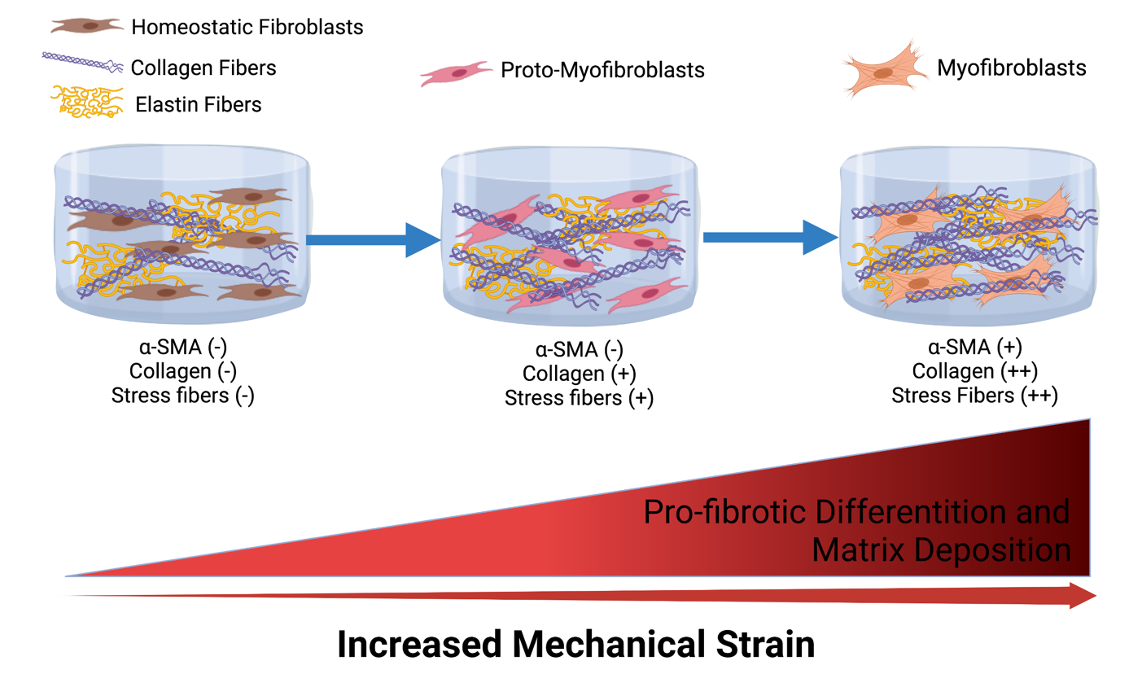
Supplementary Figure 1. Relationship between the degree of mechanical strain applied on the tissue and fibroblast-to-myofibroblast transition. Increased mechanical strain leads to the formation of proto-myofibroblast and subsequent differentiation to myofibroblasts. “Created with Biorender.com”

Table 1. Forward and reverse primers for real-time PCR
Gene | Forward Primer | Reverse Primer | Ref.
MMP-1 | 5’-CAACTTACATCGTGTTGCGG-3’ | 5’-ACCGGACTTCATCTCTGTCG-3’ | (34)
MMP-2 | 5’-CCAAGAACTTCCGTCTGTCC-3’ | 5’-TGAACCGGTCCTTGAAGAAG-3’ | (34)
MMP-3 | 5’-CAGCCAACTGTGATCCTGCT-3’ | 5’-CTTCATATGCGGCATCCACG-3’ | (34)
ELN | 5’-GGTGTAGGTGGAGCTTTTGC-3’ | 5’-CTGTTGGGTAACCAGCCTTG-3’ | (35)
FBN | 5’-GTTATGCTGGTTGTACAGGG-3’ | 5’-CATCATCGTAACACGTTGCC-3’ | (35)
COL I | 5’-GTTGGTGCTAAGGGTGAAGC-3’ | 5’-GTTGGTGCTAAGGGTGAAGC-3’ | (35)
COL IV | 5’-TTCGACTTGCGGCTCAAAG-3’ | 5’-CCACGCTCTCCTTTCAATCC-3’ | (35)
CJUN | 5’-TTCTCTCCGTCGCAACTTGT-3’ | 5’-GCCAACTCATGCTAACGCAG-3’ | (36)
TRPV4 | 5’-ACCATCCTGGACATTGSGGG-3’ | 5’-CACCTCATCCACCCTGAAGC-3’ | (37)
CD206 | 5’-CTACAAGGGATCGGGTTTATGGA-3’ | 5’-TTGGCATTGCCTAGTAGCGTA-3’ | (38)
CCL18 | 5’-AAGAGCTCTGCTGCCTCGTCTA-3’ | 5’-CCCTCAGGCATTCAGCTTAC-3’ | (38)
α-SMA | 5’-GTCAGCACTTCGCATCAAGG-3’ | 5’-TTCACAGGATTCTGGGAGCGG-3’ | (35)
TGF-β1 | 5’-GGTTATCTTTTGATGTCACCG-3’ | 5’-GTTATGCTGGTTGTACAGGG-3’ | (35)
TGFR-β1 | 5’-GTGACAGATGGGCTCTGCTT-3’ | 5’-AGCAATGGTAAACCAGTAGTTGG-3’ | (35)
GAPDH | 5’-AGAAGGCTGGGGCTCATTTG-3’ | 5’-AGGGGCCATCCACAGTCTTC-3’ | (38)

