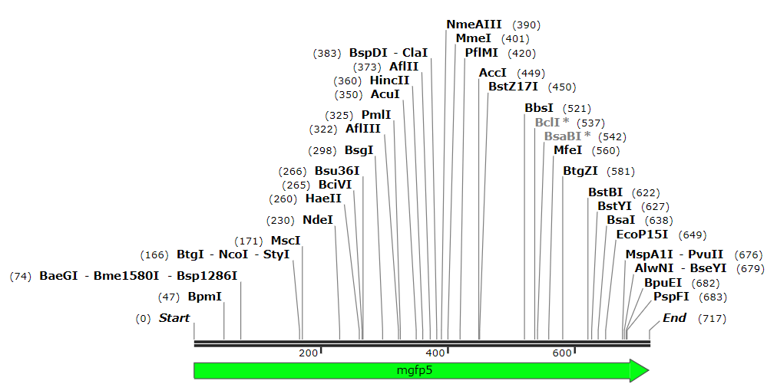
Fig. S1
DNA Map (717bp) of mgfp5

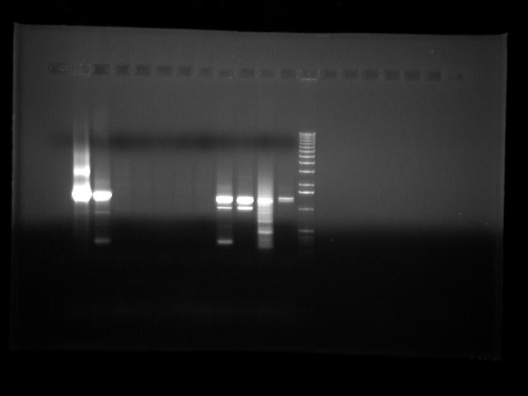
Fig. S2
Complete uncropped picture of Fig. 8c, showing PCR amplicons

