Probing Patterning in Microbial Consortia with a Cellular Automaton for Spatial Organisation
Sankalpa Venkatraghavan^{1,2,†}, Sathvik Anantakrishnan^{1,2,†} and Karthik Raman^{1,2,3,*}

Supplementary Information

Parameter | Value | Reference
Diffusion coefficient (D) - Quorum Sensing Molecules | 8×10 ⁻¹⁰ m²/s | (1)
Diffusion coefficient (D) - Metabolites | 5×10⁻¹⁰ m²/s | (2)
Base fitness | User-defined (10/T_{d} in mins)  Default: 0.082 | Methods
Threshold | User-defined  Default: 1 nM | (3)
Fitness changes due to quorum sensing | User-Defined  Default: 0.082 | Methods
Rates of secretion of quorum sensing molecules (QS_AMT_1, QS_AMT_2, and QS_AMT_3) | 0.16 nmol/cellblock.iter | (4)
Rate of degradation of quorum sensing molecules (dgAHL) | 0.0046 per iteration | (5)
Distance between neighbouring cells (dl) | 3×10⁻³ m | Methods
Time elapsed per iteration (dt) | 600s | Methods
Grid size (gridlenx × gridleny) | Default: 100x100 | Methods
niter | Default: 100 | Methods

S1 Table: Default values of parameters used in simulations.

# | Gene ID | Gene Name | grRatio
66 | 'b3733' | 'atpG' | 0.3220276
67 | 'b3735' | 'atpH' | 0.3220276
71 | 'b3731' | 'atpC' | 0.3220276
72 | 'b3734' | 'atpA' | 0.3220276
73 | 'b3738' | 'atpB' | 0.3220276
74 | 'b3732' | 'atpD' | 0.3220276
75 | 'b3736' | 'atpF' | 0.3220276
76 | 'b3737' | 'atpE' | 0.3220276
273 | 'b0429' | 'cyoD' | 0.860351
275 | 'b0432' | 'cyoA' | 0.860351
280 | 'b0431' | 'cyoB' | 0.860351
281 | 'b0430' | 'cyoC' | 0.860351
386 | 'b1779' | 'gapA' | 0.7880651
857 | 'b2926' | 'pgk' | 0.7880651
1024 | 'b2279' | 'nuoK' | 0.8158387
1026 | 'b2283' | 'nuoG' | 0.8158387
1028 | 'b2278' | 'nuoL' | 0.8158387
1032 | 'b2288' | 'nuoA' | 0.8158387
1034 | 'b2284' | 'nuoF' | 0.8158387
1036 | 'b2285' | 'nuoE' | 0.8158387
1040 | 'b2281' | 'nuoI' | 0.8158387
1042 | 'b2280' | 'nuoJ' | 0.8158387
1045 | 'b2277' | 'nuoM' | 0.8158387
1047 | 'b2282' | 'nuoH' | 0.8158387
1050 | 'b2286' | 'nuoC' | 0.8158387
1052 | 'b2276' | 'nuoN' | 0.8158387
1056 | 'b2287' | 'nuoB' | 0.8158387

S2 Table: Gene list for E. coli iAF1260 obtained from FBA studies. grRatio is the normalised growth rate of the cell with respect to the wildtype, obtained from single gene deletions filtered to select for those in the range 30-90%.

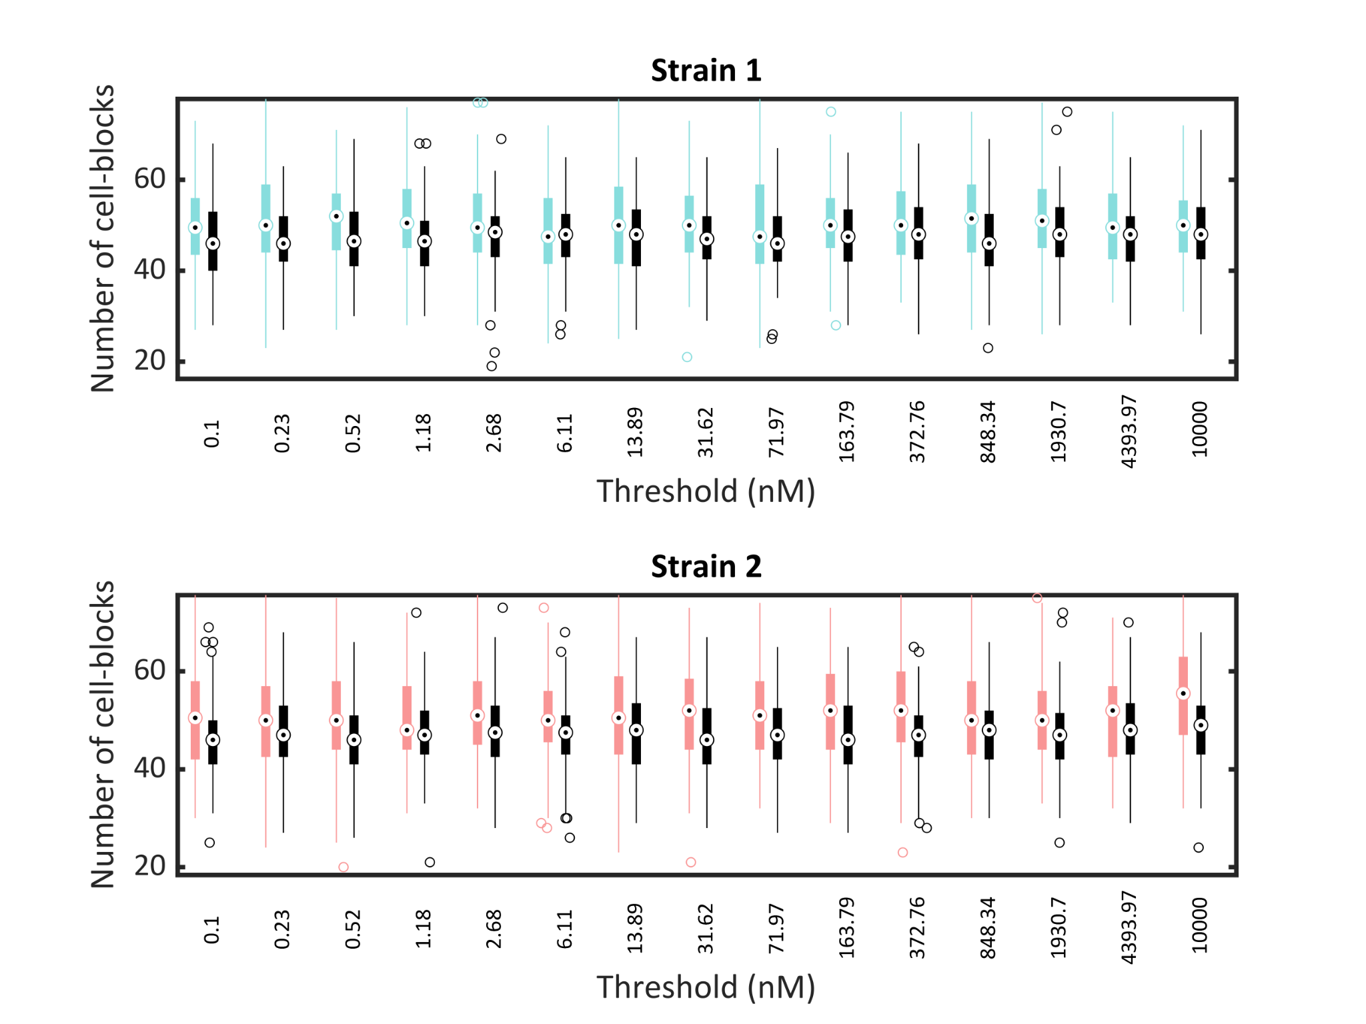
Supp. Fig. 1: Results of a preferential growth assay quantifying the number of cell-blocks of Strain 1 (above) and Strain 2 (below) dividing towards (shown in color) and away from (shown in black) cell-blocks of the other strain with the threshold AHL amount to induce gene expression in Strain 1 being varied and the threshold for Strain 2 kept constant at 5 nM.

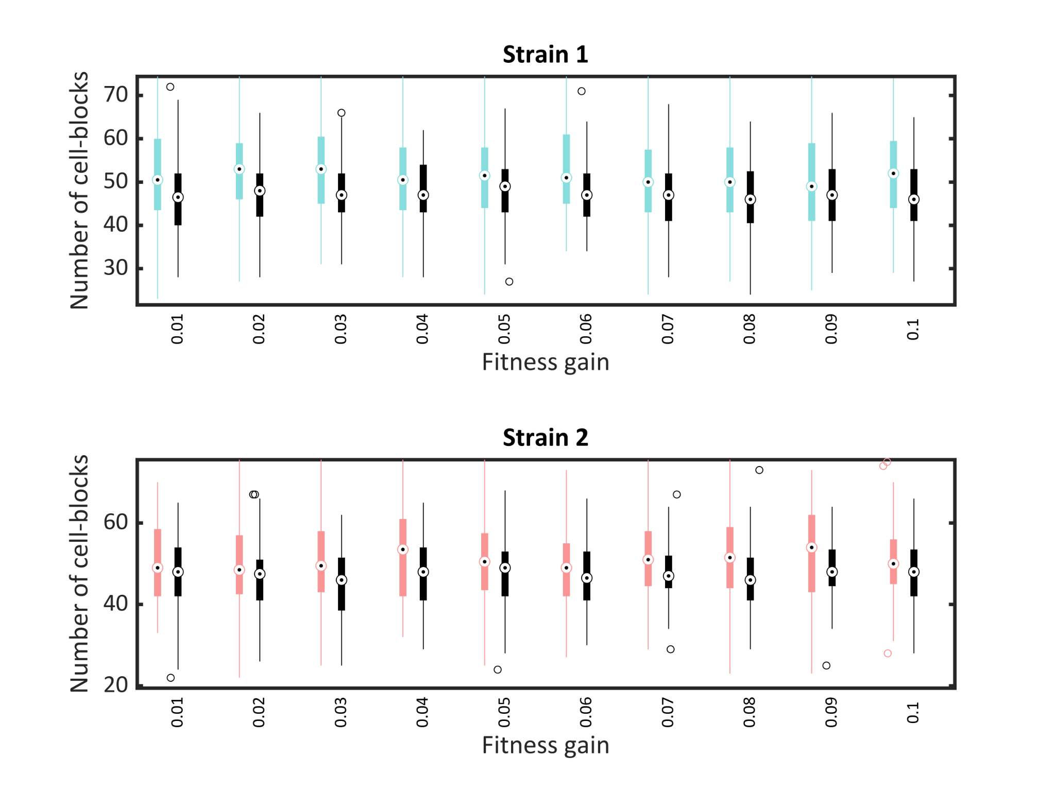
Supp. Fig. 2: Results of a preferential growth assay quantifying the number of cell-blocks of Strain 1 (above) and Strain 2 (below) dividing towards (shown in color) and away from (shown in black) cell-blocks of the other strain with the fitness gain due to QS-mediated gene expression in Strain 1 being varied and the fitness gain for Strain 2 kept constant at 0.05.

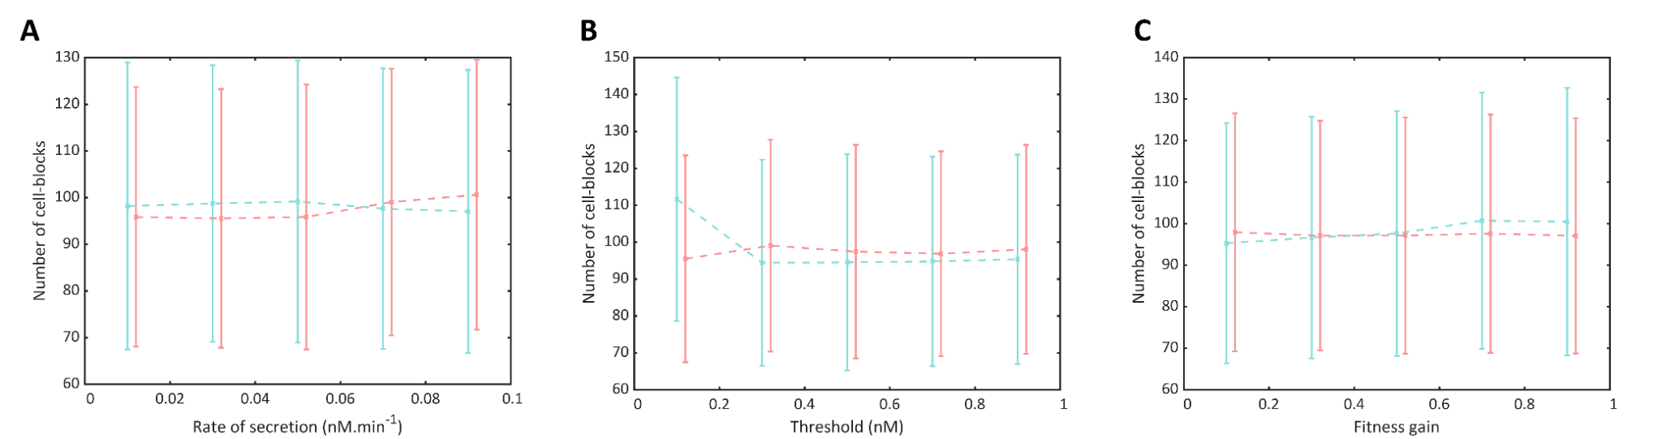
Supp. Fig. 3: Results of the parameter grid search. (A) The populations of each strain in the two-strain QSMM with the rate of secretion of AHL molecules from Strain 1 being varied and the rate of secretion from Strain 2 kept constant at 1.6×10⁻² nM cell-block⁻¹ min⁻¹. (B) The populations of each strain in the two-strain QSMM with the threshold AHL amount to induce gene expression in Strain 1 being varied and the threshold for Strain 2 kept constant at 5 nM. (C) The populations of each strain in the two-strain QSMM with the fitness gain due to QS-mediated gene expression in Strain 1 being varied and the fitness gain for Strain 2 kept constant at 0.05.

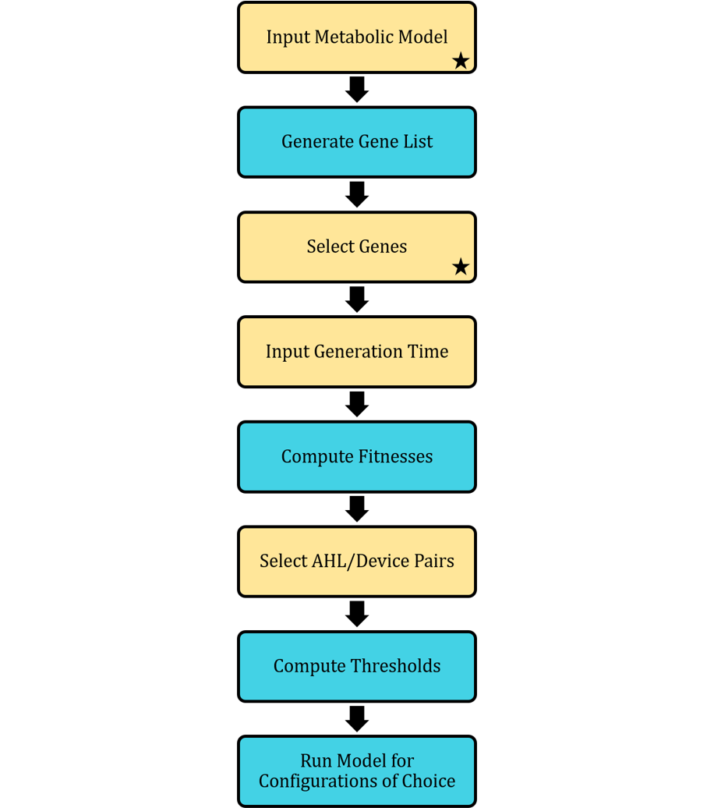
Supp. Fig. 4: Flowchart depicting the workflow of our models in the package. Steps in yellow indicate that user input is required while steps in blue indicate the background computations. The starred steps indicate the points from which the workflow can be initiated.

References

1. Trovato A, Seno F, Zanardo M, Alberghini S, Tondello A, Squartini A. Quorum vs. diffusion sensing: a quantitative analysis of the relevance of absorbing or reflecting boundaries. FEMS Microbiol Lett. 2014 Mar;352(2):198–203.
2. Nakanishi K, Adachi S, Yamamoto S, Matsuno R, Tanaka A, Kamikubo T. Diffusion of Saccharides and Amino Acids in Cross-linked Polymers. Agric Biol Chem. 1977 Dec 1;41(12):2455–62.
3. Kylilis N, Tuza ZA, Stan GB, Polizzi KM. Tools for engineering coordinated system behaviour in synthetic microbial consortia. Nat Commun. 2018 Dec;9(1):1–9.
4. Marenda M, Zanardo M, Trovato A, Seno F, Squartini A. Modeling quorum sensing trade-offs between bacterial cell density and system extension from open boundaries. Sci Rep [Internet]. 2016 Dec;6.
5. Kaufmann GF, Sartorio R, Lee SH, Rogers CJ, Meijler MM, Moss JA, et al. Revisiting quorum sensing: Discovery of additional chemical and biological functions for 3-oxo-N-acylhomoserine lactones. Proc Natl Acad Sci U S A. 2005 Jan;102(2):309–14.

