Table S1: List of primers used in qRT-PCR analysis of chickpea CIPK genes.

Purpose | Primer | Sequence
 | CaEF1α F | 5' TCCACCACTTGGTCGTTTTG 3'
  qRT-PCR
qRT-PCR | CaEF1α R | 5' CTTAATGACACCGACAGCAACAG 3'
qRT-PCR | CaCIPK2 F | 5' CCGGTTGTGCCTGTGAGTAT 3'
qRT-PCR | CaCIPK2 R | 5' AGCAATCTCTTCCAGCCTCG 3'
qRT-PCR | CaCIPK11 F | 5' TGTCTCCACGAAGTTCTCGC 3'
qRT-PCR | CaCIPK11 R | 5' AACCGACCCTTTGCGATCTT 3'
qRT-PCR | CaCIPK12 F | 5' GATGATTGACGCCGCCTTT 3'
qRT-PCR | CaCIPK12 R | 5' AATCGTGAGGGCCAAGAAGA 3'
qRT-PCR | CaCIPK16 F | 5' TCACACAACCAACATTCCTTCAC 3'
qRT-PCR | CaCIPK16 R | 5' GGAATTTTGGAAGGTTGTTGAGA 3'
qRT-PCR | CaCIPK17 F | 5' CCAGGATAACGATGACGGGG 3'
qRT-PCR | CaCIPK17 R | 5' ATACGGATTGGCGATCCTGG 3'
qRT-PCR | CaCIPK21 F | 5' AGAAAACTTGCTCCTTGACAGC 3'
qRT-PCR | CaCIPK21 R | 5' GGAGCCACATAGCACGGGGAAC 3'

Table S2: Sequence logo of different motifs identified through MEME.

Logo | E-value | Sites | Width
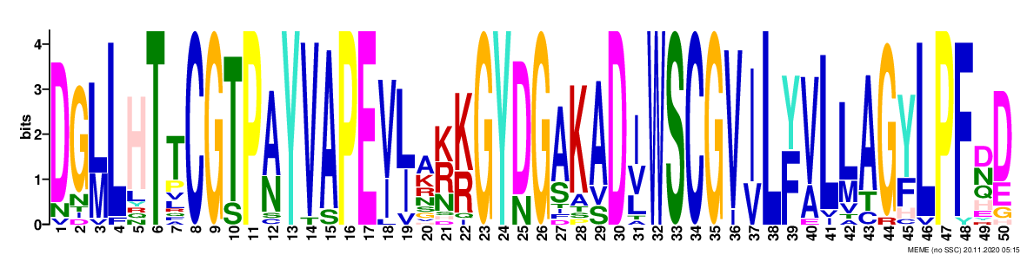 | 1.1e-797 | 22 | 50
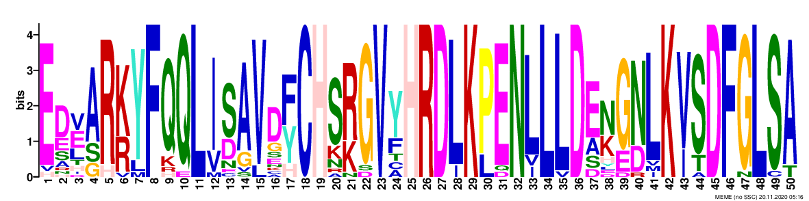 | 5.1e-768 | 22 | 50
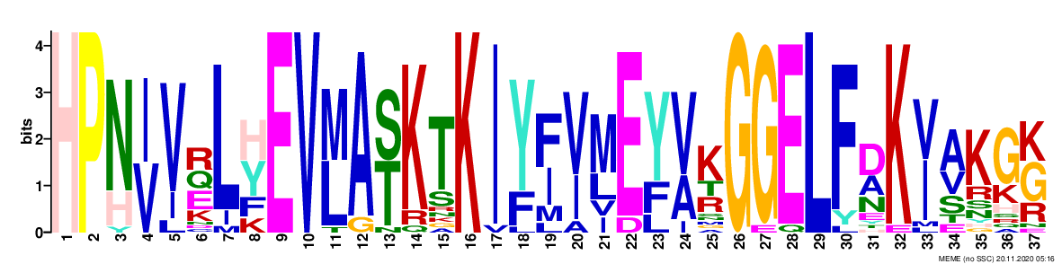 | 2.0e-441 | 22 | 37
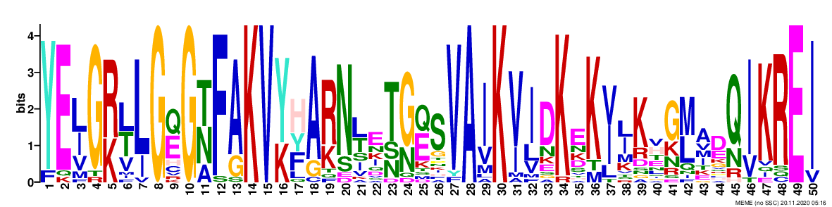 | 3.1e-502 | 22 | 50
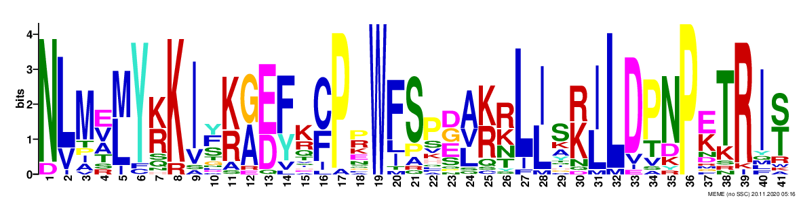 | 5.7e-409 | 22 | 41
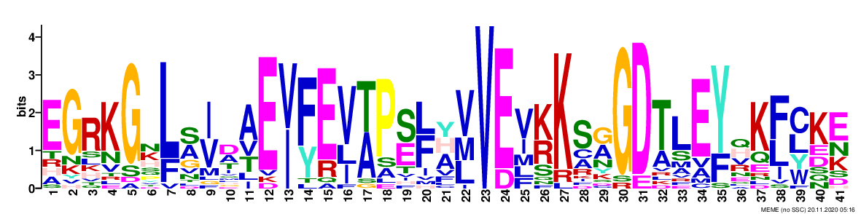 | 2.7e-254 | 21 | 41
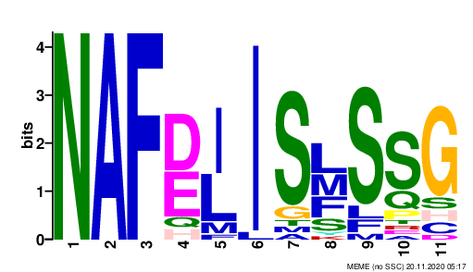 | 4.4e-097 | 22 | 11
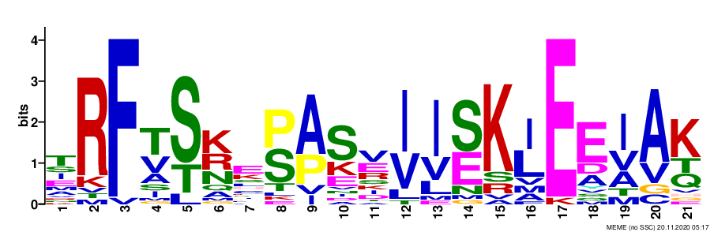 | 2.7e-092 | 22 | 21
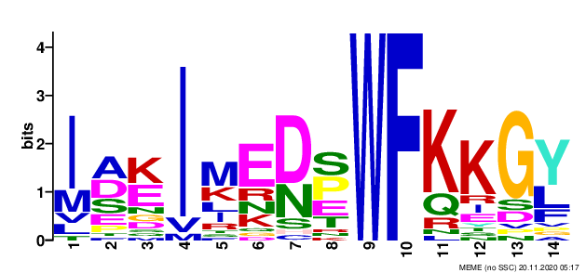 | 7.1e-084 | 22 | 14
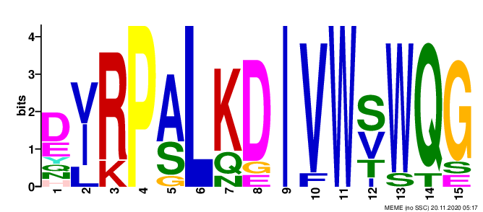 | 3.1e-065 | 10 | 15

Table S3: List of segmentally duplicated gene pairs.

Collinear gene pair
Gene name | Gene name | Ka | Ks | Ka/Ks
CaCIPK7 | CaCIPK5 | 0.1373 | 1.7532 | 0.0783
CaCIPK1 | CaCIPK17 | 0.1356 | 0.8096 | 0.1675
CaCIPK2 | CaCIPK18 | 0.2566 | 5.4846 | 0.0468
CaCIPK14 | CaCIPK22 | 0.3502 | 2.2212 | 0.1577
CaCIPK2 | CaCIPK10 | 0.1562 | 1.1211 | 0.1394
CaCIPK14 | CaCIPK11 | 0.1903 | 2.101 | 0.0906
CaCIPK18 | CaCIPK10 | 0.2768 | 2.8293 | 0.0978
CaCIPK22 | CaCIPK11 | 0.3208 | 47.4983 | 0.0068
CaCIPK18 | CaCIPK15 | 0.1194 | 0.9769 | 0.1222

Table S4: List of cis-regulatory elements identified in the promoter regions of CaCIPK genes.

 | CaCIPK1 | CaCIPK2 | CaCIPK3 | CaCIPK4 | CaCIPK5 | CaCIPK6 | CaCIPK7 | CaCIPK8 | CaCIPK9 | CaCIPK10 | CaCIPK11 | CaCIPK12 | CaCIPK13 | CaCIPK14 | CaCIPK15 | CaCIPK16 | CaCIPK17 | CaCIPK18 | CaCIPK19 | CaCIPK20 | CaCIPK21 | CaCIPK22
LTR |  | 1 |  |  |  |  |  |  |  | 1 |  |  |  |  |  |  |  |  | 1 |  | 1
ABRE | 1 | 10 | 1 | 3 | 2 | 2 | 1 | 3 |  | 3 | 1 |  |  | 2 |  |  | 1 | 1 | 1 |  |  | 1
ERE | 5 | 3 | 4 | 2 | 2 | 2 | 3 | 1 | 2 | 1 | 3 | 4 | 6 | 3 | 1 | 4 | 3 | 3 | 1 | 2 | 3 | 6
W box | 1 | 1 | 1 |  | 1 | 1 |  |  |  | 1 |  | 1 |  |  |  |  |  |  |  | 1 | 1 | 1
WUN-motif | 2 | 1 |  |  | 1 | 3 | 5 |  |  |  | 2 | 1 |  | 2 |  |  | 1 |  | 2 | 1 | 1 | 3
ARE | 2 | 4 | 1 | 2 |  | 2 | 1 | 2 |  | 3 | 3 | 3 | 2 | 4 | 1 | 2 | 2 | 2 | 1 | 1 | 1 | 2
LAMP-element | 1 |  |  |  |  |  |  |  |  |  |  |  |  |  | 1 |  |  |  |  |  | 1
Box 4 | 8 | 1 | 9 | 7 | 4 |  | 8 | 2 | 1 | 12 | 1 | 3 | 3 | 4 | 5 | 5 | 9 | 5 | 6 |  | 8 | 5
MYB | 2 | 3 | 6 | 3 | 1 | 5 | 6 |  | 2 | 6 | 3 | 6 | 3 | 5 | 1 | 3 | 1 | 4 | 2 | 5 | 6 | 1
GT1-motif | 4 | 5 | 1 |  | 1 | 1 | 2 |  |  | 1 |  | 1 |  | 1 |  |  |  | 2 | 2 |  | 2
AE-box | 1 |  |  | 1 |  |  |  |  |  | 1 | 1 | 1 |  |  | 1 | 1
MYB recognition site |  | 1 |  |  |  |  |  |  |  |  |  | 1 | 1 |  |  |  |  |  |  |  | 1
O2-site |  | 1 |  |  | 3 |  |  |  |  |  |  |  | 1 |  |  | 1 |  |  | 1 | 1
AuxRR-core |  |  | 1 |  |  |  |  |  |  |  |  | 1 |  |  |  | 1 |  | 1
TCA-element |  | 1 |  | 1 |  |  | 1 |  |  | 1 |  |  | 1 | 1 |  | 1 | 2 | 1 | 1 |  | 1
TC-rich repeats |  | 1 | 1 |  | 1 |  | 2 |  |  |  | 2 |  |  | 1 | 1 |  | 1 | 1 | 1 | 1 |  | 1

Table S5: The confidence, coverage and sequence identities of the homologous relationship of the CaCIPKs.

 |  |  | Model based on the template
Protein | Percentage confidence | Percentage coverage | Template id | Percentage identity with template | Percentage identity with c4czuC_
CaCIPK1 | 100 | 92 | c6c9dB_ | 30 | 61
CaCIPK2 | 100 | 91 | c6c9dB_ | 29 | 59
CaCIPK3 | 100 | 93 | c6c9dB_ | 33 | 75
CaCIPK4 | 100 | 59 | c5ebzF_ | 25 | 54
CaCIPK5 | 100 | 93 | c6c9dB_ | 31 | 56
CaCIPK6 | 100 | 57 | c5ebzF_ | 27 | 65
CaCIPK7 | 100 | 92 | c6c9dB_ | 29 | 57
CaCIPK8 | 100 | 54 | c5ebzF_ | 29 | 66
CaCIPK9 | 100 | 90 | c6c9dB_ | 29 | 85
CaCIPK10 | 100 | 54 | c5ebzF_ | 29 | 60
CaCIPK11 | 100 | 57 | c5ebzF_ | 28 | 58
CaCIPK12 | 100 | 50 | c5ebzF_ | 31 | 66
CaCIPK13 | 100 | 91 | c6c9dB_ | 31 | 59
CaCIPK14 | 100 | 58 | c5ebzF_ | 26 | 59
CaCIPK15 | 100 | 54 | c5ebzF_ | 27 | 65
CaCIPK16 | 100 | 95 | c6c9dB_ | 30 | 61
CaCIPK17 | 100 | 93 | c6c9dB_ | 29 | 59
CaCIPK18 | 100 | 54 | c5ebzF_ | 28 | 63
CaCIPK19 | 100 | 93 | c6c9dB_ | 31 | 63
CaCIPK20 | 100 | 56 | c5ebzF_ | 27 | 62
CaCIPK21 | 100 | 57 | c5ebzF_ | 28 | 61
CaCIPK22 | 100 | 58 | c5ebzF_ | 23 | 52

Table S6: Type and strength of interactions between CBL and CIPK proteins in chickpea

Node1 | Node2 | Node1_string_id | Node2_string_id | coexpression | experimentally_determined_interaction | database_annotated | automated_textmining | combined_score
CaCBL1 | CaCIPK7 | XP_004508968.1 | XP_004486613.1 | 0.044 | 0.2 | 0.047 | 0.282 | 0.406
CaCBL1 | CaCIPK1 | XP_004508968.1 | XP_004488187.1 | 0.044 | 0.847 | 0.047 | 0.602 | 0.937
CaCBL1 | CaCIPK9 | XP_004508968.1 | XP_004488520.1 | 0.044 | 0.843 | 0.047 | 0.696 | 0.95
CaCBL1 | CaCIPK2 | XP_004508968.1 | XP_004490705.1 | 0.044 | 0.395 | 0.047 | 0.289 | 0.555
CaCBL1 | CaCIPK14 | XP_004508968.1 | XP_004490706.1 | 0.044 | 0.777 | 0.047 | 0.576 | 0.902
CaCBL1 | CaCIPK3 | XP_004508968.1 | XP_004491202.1 | 0.044 | 0.282 | 0.047 | 0.623 | 0.72
CaCBL1 | CaCIPK18 | XP_004508968.1 | XP_004492544.1 | 0.044 | 0.395 | 0.047 | 0.289 | 0.555
CaCBL1 | CaCIPK22 | XP_004508968.1 | XP_004492546.1 | 0.044 | 0.777 | 0.047 | 0.564 | 0.899
CaCBL1 | CaCIPK4 | XP_004508968.1 | XP_004498005.1 | 0.044 | 0.445 | 0.047 | 0.474 | 0.698
CaCBL1 | CaCIPK16 | XP_004508968.1 | XP_004498818.1 | 0.044 | 0.2 | 0.047 | 0.282 | 0.406
CaCBL1 | CaCIPK10 | XP_004508968.1 | XP_004500345.1 | 0.044 | 0.395 | 0.047 | 0.289 | 0.555
CaCBL1 | CaCIPK13 | XP_004508968.1 | XP_004500544.1 | 0.044 | 0.395 | 0.047 | 0.289 | 0.555
CaCBL1 | CaCIPK15 | XP_004508968.1 | XP_004506437.1 | 0.044 | 0.395 | 0.047 | 0.289 | 0.555
CaCBL1 | CaCIPK5 | XP_004508968.1 | XP_004507079.1 | 0.044 | 0.2 | 0.047 | 0.282 | 0.406
CaCBL1 | CaCIPK6 | XP_004508968.1 | XP_004507724.1 | 0.044 | 0.485 | 0.047 | 0.681 | 0.83
CaCBL1 | CaCIPK21 | XP_004508968.1 | XP_004507818.1 | 0.044 | 0.355 | 0.047 | 0.543 | 0.695
CaCBL2 | CaCIPK1 | XP_004499340.1 | XP_004488187.1 | 0.044 | 0.678 | 0.047 | 0.521 | 0.84
CaCBL2 | CaCIPK9 | XP_004499340.1 | XP_004488520.1 | 0.044 | 0.838 | 0.047 | 0.696 | 0.949
CaCBL2 | CaCIPK2 | XP_004499340.1 | XP_004490705.1 | 0.044 | 0.197 | 0.047 | 0.29 | 0.411
CaCBL2 | CaCIPK14 | XP_004499340.1 | XP_004490706.1 | 0.044 | 0.291 | 0.047 | 0.326 | 0.506
CaCBL2 | CaCIPK3 | XP_004499340.1 | XP_004491202.1 | 0.044 | 0.449 | 0.047 | 0.519 | 0.726
CaCBL2 | CaCIPK18 | XP_004499340.1 | XP_004492544.1 | 0.044 | 0.197 | 0.047 | 0.29 | 0.411
CaCBL2 | CaCIPK22 | XP_004499340.1 | XP_004492546.1 | 0.044 | 0.64 | 0.047 | 0.478 | 0.805
CaCBL2 | CaCIPK13 | XP_004499340.1 | XP_004500544.1 | 0.044 | 0.197 | 0.047 | 0.29 | 0.411
CaCBL2 | CaCIPK15 | XP_004499340.1 | XP_004506437.1 | 0.044 | 0.197 | 0.047 | 0.29 | 0.411
CaCBL2 | CaCIPK10 | XP_004499340.1 | XP_004500345.1 | 0.044 | 0.197 | 0.047 | 0.29 | 0.411
CaCBL2 | CaCIPK21 | XP_004499340.1 | XP_004507818.1 | 0.044 | 0.199 | 0.047 | 0.488 | 0.576
CaCBL2 | CaCIPK6 | XP_004499340.1 | XP_004507724.1 | 0.044 | 0.756 | 0.047 | 0.621 | 0.904
CaCBL3 | CaCIPK7 | XP_004500149.1 | XP_004486613.1 | 0.044 | 0.168 | 0.047 | 0.404 | 0.487
CaCBL3 | CaCIPK1 | XP_004500149.1 | XP_004488187.1 | 0.044 | 0.678 | 0.047 | 0.521 | 0.84
CaCBL3 | CaCIPK9 | XP_004500149.1 | XP_004488520.1 | 0.044 | 0.838 | 0.047 | 0.696 | 0.949
CaCBL3 | CaCIPK2 | XP_004500149.1 | XP_004490705.1 | 0.044 | 0.197 | 0.047 | 0.623 | 0.687
CaCBL3 | CaCIPK14 | XP_004500149.1 | XP_004490706.1 | 0.044 | 0.291 | 0.047 | 0.62 | 0.721
CaCBL3 | CaCIPK3 | XP_004500149.1 | XP_004491202.1 | 0.044 | 0.449 | 0.047 | 0.521 | 0.727
CaCBL3 | CaCIPK18 | XP_004500149.1 | XP_004492544.1 | 0.044 | 0.197 | 0.047 | 0.29 | 0.411
CaCBL3 | CaCIPK22 | XP_004500149.1 | XP_004492546.1 | 0.044 | 0.64 | 0.047 | 0.478 | 0.805
CaCBL3 | CaCIPK16 | XP_004500149.1 | XP_004498818.1 | 0.044 | 0.168 | 0.047 | 0.404 | 0.487
CaCBL3 | CaCIPK15 | XP_004500149.1 | XP_004506437.1 | 0.044 | 0.197 | 0.047 | 0.29 | 0.411
CaCBL3 | CaCIPK13 | XP_004500149.1 | XP_004500544.1 | 0.044 | 0.197 | 0.047 | 0.29 | 0.411
CaCBL3 | CaCIPK21 | XP_004500149.1 | XP_004507818.1 | 0.044 | 0.199 | 0.047 | 0.521 | 0.603
CaCBL3 | CaCIPK10 | XP_004500149.1 | XP_004500345.1 | 0.044 | 0.197 | 0.047 | 0.623 | 0.687
CaCBL3 | CaCIPK6 | XP_004500149.1 | XP_004507724.1 | 0.044 | 0.756 | 0.047 | 0.621 | 0.904
CaCBL4 | CaCIPK7 | XP_004502645.1 | XP_004486613.1 | 0.044 | 0.2 | 0.047 | 0.294 | 0.416
CaCBL4 | CaCIPK1 | XP_004502645.1 | XP_004488187.1 | 0.044 | 0.847 | 0.047 | 0.602 | 0.937
CaCBL4 | CaCIPK9 | XP_004502645.1 | XP_004488520.1 | 0.044 | 0.843 | 0.047 | 0.696 | 0.95
CaCBL4 | CaCIPK2 | XP_004502645.1 | XP_004490705.1 | 0.044 | 0.395 | 0.047 | 0.546 | 0.716
CaCBL4 | CaCIPK14 | XP_004502645.1 | XP_004490706.1 | 0.044 | 0.777 | 0.047 | 0.559 | 0.898
CaCBL4 | CaCIPK3 | XP_004502645.1 | XP_004491202.1 | 0.044 | 0.282 | 0.047 | 0.587 | 0.693
CaCBL4 | CaCIPK18 | XP_004502645.1 | XP_004492544.1 | 0.044 | 0.395 | 0.047 | 0.289 | 0.555
CaCBL4 | CaCIPK22 | XP_004502645.1 | XP_004492546.1 | 0.044 | 0.777 | 0.047 | 0.564 | 0.899
CaCBL4 | CaCIPK4 | XP_004502645.1 | XP_004498005.1 | 0.044 | 0.445 | 0.047 | 0.474 | 0.698
CaCBL4 | CaCIPK16 | XP_004502645.1 | XP_004498818.1 | 0.044 | 0.2 | 0.047 | 0.294 | 0.416
CaCBL4 | CaCIPK10 | XP_004502645.1 | XP_004500345.1 | 0.044 | 0.395 | 0.047 | 0.546 | 0.716
CaCBL4 | CaCIPK13 | XP_004502645.1 | XP_004500544.1 | 0.044 | 0.395 | 0.047 | 0.289 | 0.555
CaCBL4 | CaCIPK5 | XP_004502645.1 | XP_004507079.1 | 0.044 | 0.2 | 0.047 | 0.282 | 0.406
CaCBL4 | CaCIPK15 | XP_004502645.1 | XP_004506437.1 | 0.044 | 0.395 | 0.047 | 0.289 | 0.555
CaCBL4 | CaCIPK21 | XP_004502645.1 | XP_004507818.1 | 0.044 | 0.355 | 0.047 | 0.543 | 0.695
CaCBL4 | CaCIPK6 | XP_004502645.1 | XP_004507724.1 | 0.044 | 0.485 | 0.047 | 0.681 | 0.83
CaCBL5 | CaCIPK7 | XP_004503610.1 | XP_004486613.1 | 0.044 | 0.168 | 0.047 | 0.503 | 0.572
CaCBL5 | CaCIPK1 | XP_004503610.1 | XP_004488187.1 | 0.044 | 0.198 | 0.047 | 0.327 | 0.442
CaCBL5 | CaCIPK9 | XP_004503610.1 | XP_004488520.1 | 0.044 | 0.201 | 0.047 | 0.644 | 0.706
CaCBL5 | CaCIPK2 | XP_004503610.1 | XP_004490705.1 | 0.044 | 0.168 | 0.047 | 0.62 | 0.673
CaCBL5 | CaCIPK14 | XP_004503610.1 | XP_004490706.1 | 0.044 | 0.198 | 0.047 | 0.698 | 0.749
CaCBL5 | CaCIPK3 | XP_004503610.1 | XP_004491202.1 | 0.044 | 0.168 | 0.047 | 0.335 | 0.428
CaCBL5 | CaCIPK18 | XP_004503610.1 | XP_004492544.1 | 0.044 | 0.168 | 0.047 | 0.478 | 0.551
CaCBL5 | CaCIPK22 | XP_004503610.1 | XP_004492546.1 | 0.044 | 0.198 | 0.047 | 0.519 | 0.601
CaCBL5 | CaCIPK16 | XP_004503610.1 | XP_004498818.1 | 0.044 | 0.168 | 0.047 | 0.503 | 0.572
CaCBL5 | CaCIPK10 | XP_004503610.1 | XP_004500345.1 | 0.044 | 0.168 | 0.047 | 0.62 | 0.673
CaCBL5 | CaCIPK13 | XP_004503610.1 | XP_004500544.1 | 0.044 | 0.168 | 0.047 | 0.478 | 0.551
CaCBL5 | CaCIPK15 | XP_004503610.1 | XP_004506437.1 | 0.044 | 0.168 | 0.047 | 0.478 | 0.551
CaCBL5 | CaCIPK5 | XP_004503610.1 | XP_004507079.1 | 0.044 | 0.168 | 0.047 | 0.503 | 0.572
CaCBL5 | CaCIPK21 | XP_004503610.1 | XP_004507818.1 | 0.044 | 0.168 | 0.047 | 0.581 | 0.639
CaCBL5 | CaCIPK6 | XP_004503610.1 | XP_004507724.1 | 0.044 | 0.168 | 0.047 | 0.622 | 0.675
CaCBL6 | CaCIPK10 | XP_004486376.1 | XP_004500345.1 | 0.044 | 0.197 | 0.047 | 0.29 | 0.411
CaCBL6 | CaCIPK18 | XP_004486376.1 | XP_004492544.1 | 0.044 | 0.197 | 0.047 | 0.29 | 0.411
CaCBL6 | CaCIPK15 | XP_004486376.1 | XP_004506437.1 | 0.044 | 0.197 | 0.047 | 0.29 | 0.411
CaCBL6 | CaCIPK2 | XP_004486376.1 | XP_004490705.1 | 0.044 | 0.197 | 0.047 | 0.29 | 0.411
CaCBL6 | CaCIPK13 | XP_004486376.1 | XP_004500544.1 | 0.044 | 0.197 | 0.047 | 0.29 | 0.411
CaCBL6 | CaCIPK14 | XP_004486376.1 | XP_004490706.1 | 0.044 | 0.291 | 0.047 | 0.326 | 0.506
CaCBL6 | CaCIPK21 | XP_004486376.1 | XP_004507818.1 | 0.044 | 0.199 | 0.047 | 0.488 | 0.576
CaCBL6 | CaCIPK3 | XP_004486376.1 | XP_004491202.1 | 0.044 | 0.449 | 0.047 | 0.519 | 0.726
CaCBL6 | CaCIPK22 | XP_004486376.1 | XP_004492546.1 | 0.044 | 0.64 | 0.047 | 0.478 | 0.805
CaCBL6 | CaCIPK1 | XP_004486376.1 | XP_004488187.1 | 0.044 | 0.678 | 0.047 | 0.521 | 0.84
CaCBL6 | CaCIPK6 | XP_004486376.1 | XP_004507724.1 | 0.044 | 0.756 | 0.047 | 0.621 | 0.904
CaCBL6 | CaCIPK9 | XP_004486376.1 | XP_004488520.1 | 0.044 | 0.838 | 0.047 | 0.696 | 0.949
CaCBL8 | CaCIPK7 | XP_004503608.1 | XP_004486613.1 | 0.044 | 0.168 | 0.047 | 0.541 | 0.605
CaCBL8 | CaCIPK9 | XP_004503608.1 | XP_004488520.1 | 0.044 | 0.201 | 0.047 | 0.645 | 0.706
CaCBL8 | CaCIPK14 | XP_004503608.1 | XP_004490706.1 | 0.044 | 0.168 | 0.047 | 0.482 | 0.554
CaCBL8 | CaCIPK3 | XP_004503608.1 | XP_004491202.1 | 0.044 | 0.168 | 0.047 | 0.327 | 0.421
CaCBL8 | CaCIPK22 | XP_004503608.1 | XP_004492546.1 | 0.044 | 0.197 | 0.047 | 0.7 | 0.751
CaCBL8 | CaCIPK16 | XP_004503608.1 | XP_004498818.1 | 0.044 | 0.168 | 0.047 | 0.541 | 0.605
CaCBL8 | CaCIPK6 | XP_004503608.1 | XP_004507724.1 | 0.044 | 0.168 | 0.047 | 0.48 | 0.553
CaCBL8 | CaCIPK5 | XP_004503608.1 | XP_004507079.1 | 0.044 | 0.168 | 0.047 | 0.541 | 0.605
CaCBL8 | CaCIPK21 | XP_004503608.1 | XP_004507818.1 | 0.044 | 0.168 | 0.047 | 0.581 | 0.639
CaCBL9 | CaCIPK7 | XP_004510366.1 | XP_004486613.1 | 0.044 | 0.168 | 0.047 | 0.351 | 0.442
CaCBL9 | CaCIPK1 | XP_004510366.1 | XP_004488187.1 | 0.044 | 0.168 | 0.047 | 0.578 | 0.637
CaCBL9 | CaCIPK9 | XP_004510366.1 | XP_004488520.1 | 0.044 | 0.168 | 0.047 | 0.797 | 0.825
CaCBL9 | CaCIPK2 | XP_004510366.1 | XP_004490705.1 | 0.044 | 0.168 | 0.047 | 0.313 | 0.409
CaCBL9 | CaCIPK14 | XP_004510366.1 | XP_004490706.1 | 0.044 | 0.198 | 0.047 | 0.591 | 0.661
CaCBL9 | CaCIPK3 | XP_004510366.1 | XP_004491202.1 | 0.044 | 0.168 | 0.047 | 0.62 | 0.673
CaCBL9 | CaCIPK18 | XP_004510366.1 | XP_004492544.1 | 0.044 | 0.168 | 0.047 | 0.313 | 0.409
CaCBL9 | CaCIPK22 | XP_004510366.1 | XP_004492546.1 | 0.044 | 0.173 | 0.047 | 0.552 | 0.617
CaCBL9 | CaCIPK4 | XP_004510366.1 | XP_004498005.1 | 0.044 | 0.168 | 0.047 | 0.35 | 0.441
CaCBL9 | CaCIPK16 | XP_004510366.1 | XP_004498818.1 | 0.044 | 0.168 | 0.047 | 0.351 | 0.442
CaCBL9 | CaCIPK10 | XP_004510366.1 | XP_004500345.1 | 0.044 | 0.168 | 0.047 | 0.313 | 0.409
CaCBL9 | CaCIPK13 | XP_004510366.1 | XP_004500544.1 | 0.044 | 0.168 | 0.047 | 0.313 | 0.409
CaCBL9 | CaCIPK15 | XP_004510366.1 | XP_004506437.1 | 0.044 | 0.168 | 0.047 | 0.313 | 0.409
CaCBL9 | CaCIPK5 | XP_004510366.1 | XP_004507079.1 | 0.044 | 0.168 | 0.047 | 0.351 | 0.442
CaCBL9 | CaCIPK6 | XP_004510366.1 | XP_004507724.1 | 0.044 | 0.168 | 0.047 | 0.862 | 0.881
CaCBL9 | CaCIPK21 | XP_004510366.1 | XP_004507818.1 | 0.044 | 0.168 | 0.047 | 0.576 | 0.635
CaCBL10 | CaCIPK7 | XP_004498906.1 | XP_004486613.1 | 0.044 | 0.168 | 0.047 | 0.446 | 0.523
CaCBL10 | CaCIPK1 | XP_004498906.1 | XP_004488187.1 | 0.044 | 0.168 | 0.047 | 0.578 | 0.637
CaCBL10 | CaCIPK9 | XP_004498906.1 | XP_004488520.1 | 0.044 | 0.168 | 0.047 | 0.797 | 0.825
CaCBL10 | CaCIPK2 | XP_004498906.1 | XP_004490705.1 | 0.044 | 0.168 | 0.047 | 0.446 | 0.523
CaCBL10 | CaCIPK14 | XP_004498906.1 | XP_004490706.1 | 0.044 | 0.198 | 0.047 | 0.573 | 0.646
CaCBL10 | CaCIPK3 | XP_004498906.1 | XP_004491202.1 | 0.044 | 0.168 | 0.047 | 0.621 | 0.674
CaCBL10 | CaCIPK18 | XP_004498906.1 | XP_004492544.1 | 0.044 | 0.168 | 0.047 | 0.313 | 0.409
CaCBL10 | CaCIPK22 | XP_004498906.1 | XP_004492546.1 | 0.044 | 0.173 | 0.047 | 0.552 | 0.617
CaCBL10 | CaCIPK4 | XP_004498906.1 | XP_004498005.1 | 0.044 | 0.168 | 0.047 | 0.35 | 0.441
CaCBL10 | CaCIPK16 | XP_004498906.1 | XP_004498818.1 | 0.044 | 0.168 | 0.047 | 0.446 | 0.523
CaCBL10 | CaCIPK15 | XP_004498906.1 | XP_004506437.1 | 0.044 | 0.168 | 0.047 | 0.313 | 0.409
CaCBL10 | CaCIPK13 | XP_004498906.1 | XP_004500544.1 | 0.044 | 0.168 | 0.047 | 0.313 | 0.409
CaCBL10 | CaCIPK5 | XP_004498906.1 | XP_004507079.1 | 0.044 | 0.168 | 0.047 | 0.351 | 0.442
CaCBL10 | CaCIPK10 | XP_004498906.1 | XP_004500345.1 | 0.044 | 0.168 | 0.047 | 0.446 | 0.523
CaCBL10 | CaCIPK21 | XP_004498906.1 | XP_004507818.1 | 0.044 | 0.168 | 0.047 | 0.576 | 0.635
CaCBL10 | CaCIPK6 | XP_004498906.1 | XP_004507724.1 | 0.044 | 0.168 | 0.047 | 0.862 | 0.881

Table S7: Log2FPKM values of different tissues belonging to different developmental stages.

 | Germination |  |  | Seedling |  | Vegetative |  |  |  | Reproductive |  |  |  |  |  |  |  |  | Senescence
Gene | Radicle | Plumule | Embryo | Epicotyl | Primary Root | Root | Petiole | Stem | Leaf | Petiole | Stem | Nodules | Root | Flowers | Buds | Pods | Immature Seeds | Leaf |  | Leaf | Leaf Yellow | Immature Seeds | Mature Seeds | Seed Coat | Stem | Petiole | Root | Nodules
CaCIPK1 | 1.774 | -1.490 | 0.852 | 1.826 | 2.665 | 2.642 | 0.458 | 1.110 | 0.090 | 1.444 | 1.674 | 2.572 | 4.090 | 2.789 | 2.340 | 0.853 | 1.103 | 0.338 |  | 1.022 | -0.157 | 0.425 | 0.014 | 0.589 | 2.106 | 0.139 | 2.882 | 1.927
CaCIPK2 | -2.335 | -1.788 | -1.297 | 1.637 | -3.686 | -0.624 | -3.235 | -2.493 | -2.310 | -1.002 | -1.040 | -4.632 | 0.096 | 0.929 | -0.319 | -0.205 | -0.017 | 1.240 |  | -0.835 | -1.627 | -0.685 | 2.475 | -0.104 | -0.733 | -2.896 | -1.232 | -2.833
CaCIPK3 | 5.066 | 4.230 | 4.853 | 4.678 | 4.042 | 5.303 | 4.862 | 4.639 | 5.373 | 4.149 | 2.681 | 3.724 | 4.355 | 4.392 | 4.841 | 3.804 | 3.546 | 5.432 |  | 4.359 | 4.343 | 2.738 | 3.179 | 2.693 | 3.258 | 3.561 | 3.667 | 3.621
CaCIPK4 | 3.878 | 3.817 | 3.366 | 5.266 | 5.292 | 7.585 | 5.762 | 5.757 | 3.698 | 5.065 | 6.681 | 5.816 | 6.526 | 3.988 | 3.839 | 4.355 | 4.065 | 3.022 |  | 5.198 | 5.201 | 2.021 | 2.061 | 2.156 | 6.164 | 5.549 | 5.946 | 5.839
CaCIPK5 | 3.947 | 2.683 | 3.606 | 2.036 | 4.170 | 2.892 | 4.007 | 1.972 | 2.677 | 1.950 | 2.105 | 3.274 | 3.830 | 2.404 | 1.382 | 1.216 | 2.131 | -0.202 |  | 2.239 | 2.351 | 0.733 | -0.597 | 1.271 | 3.206 | 1.870 | 1.806 | 3.732
CaCIPK6 | 6.992 | 7.575 | 7.778 | 7.239 | 6.096 | 5.563 | 6.453 | 5.318 | 6.826 | 5.864 | 5.730 | 5.475 | 5.982 | 7.195 | 7.204 | 7.056 | 7.044 | 7.828 |  | 5.808 | 5.787 | 4.633 | 3.447 | 4.923 | 6.176 | 6.625 | 6.308 | 5.919
CaCIPK7 | 7.897 | 7.191 | 8.194 | 6.904 | 7.135 | 7.136 | 7.270 | 7.992 | 6.297 | 8.493 | 8.565 | 7.882 | 8.223 | 6.821 | 6.805 | 6.428 | 6.081 | 6.044 |  | 6.608 | 6.630 | 2.815 | 4.524 | 3.266 | 6.721 | 7.380 | 7.280 | 7.242
CaCIPK8 | 0.000 | 0.000 | 0.000 | 0.000 | -7.760 | 0.000 | 0.000 | 0.000 | -5.032 | 0.000 | 0.000 | -1.516 | -5.053 | -5.963 | 0.000 | 0.000 | -4.978 | 0.000 |  | 0.000 | 0.000 | 0.000 | 0.000 | -5.855 | -9.172 | -5.371 | -5.668 | -2.107
CaCIPK9 | 3.695 | 2.336 | 3.123 | 2.115 | 2.890 | 2.337 | 0.972 | 1.869 | 1.050 | 2.189 | 2.120 | 1.399 | 3.522 | 0.618 | 1.949 | 2.579 | 0.754 | 2.418 |  | 1.675 | 1.844 | -0.383 | 0.049 | 0.895 | 3.618 | 1.219 | 3.336 | 2.669
CaCIPK10 | 3.074 | 2.092 | 1.367 | 2.590 | 2.212 | 1.805 | 1.641 | 1.644 | 1.347 | 1.578 | 2.287 | 1.485 | 0.000 | 2.724 | 1.925 | 0.881 | 0.243 | 1.784 |  | 2.210 | 1.808 | 0.690 | 1.479 | 0.422 | 2.664 | 2.421 | 2.011 | 1.838
CaCIPK11 | 2.616 | 2.863 | 1.614 | 1.846 | -0.604 | 0.212 | 1.076 | 2.492 | 0.952 | 2.829 | 2.002 | 0.388 | -0.280 | 6.064 | 4.213 | 3.750 | 4.218 | 0.489 |  | 0.985 | 0.923 | 0.786 | 1.800 | 0.366 | 1.471 | 2.277 | 0.451 | 0.353
CaCIPK12 | 4.745 | 3.602 | 3.287 | 3.506 | 2.476 | 3.304 | 3.456 | 3.393 | 2.619 | 3.215 | 4.568 | 2.867 | 3.969 | 3.556 | 3.287 | 1.981 | 0.794 | 2.891 |  | 3.381 | 3.281 | -0.179 | -2.243 | -0.855 | 4.654 | 3.597 | 4.968 | 3.051
CaCIPK13 | -0.416 | -0.716 | 0.996 | 0.320 | -0.739 | -1.337 | -0.445 | -0.251 | -2.449 | -2.659 | -1.244 | -1.698 | -0.167 | -3.610 | -0.054 | -0.704 | 1.391 | -1.517 |  | -1.425 | -1.232 | -1.325 | 0.000 | -1.814 | -1.056 | -1.167 | 3.210 | -2.099
CaCIPK14 | 5.413 | 5.324 | 4.661 | 5.514 | 5.938 | 6.673 | 4.796 | 5.683 | 4.133 | 5.803 | 6.506 | 4.154 | 5.783 | 5.244 | 5.374 | 6.350 | 5.396 | 4.589 |  | 5.093 | 5.206 | 3.457 | 3.172 | 3.627 | 5.603 | 5.906 | 5.449 | 4.166
CaCIPK15 | 7.382 | 6.870 | 5.273 | 5.529 | 4.491 | 4.562 | 4.436 | 5.931 | 3.869 | 6.520 | 5.885 | 4.737 | 5.327 | 5.967 | 3.613 | 4.501 | 2.938 | 4.007 |  | 6.307 | 6.306 | 1.031 | 2.172 | 1.437 | 4.752 | 6.273 | 4.608 | 3.958
CaCIPK16 | 5.289 | 4.346 | 4.780 | 5.416 | 5.144 | 4.500 | 5.139 | 3.562 | 4.569 | 5.182 | 4.287 | 3.795 | 5.407 | 5.836 | 4.084 | 5.719 | 6.278 | 5.257 |  | 5.803 | 5.845 | 3.336 | -0.243 | 3.519 | 6.175 | 5.487 | 6.619 | 4.760
CaCIPK17 | 0.832 | 0.864 | -1.258 | 1.670 | 0.458 | 2.579 | 2.053 | 1.149 | 1.411 | 1.758 | 3.129 | 0.000 | 2.207 | 0.753 | 0.955 | 0.425 | -1.657 | 1.751 |  | 2.593 | 2.859 | -3.925 | -2.926 | -3.351 | 1.842 | 1.506 | 2.342 | -1.153
CaCIPK18 | 4.530 | 4.333 | 4.410 | 5.983 | 4.135 | 5.339 | 4.101 | 5.169 | 4.734 | 5.991 | 5.375 | 4.704 | 5.418 | 5.887 | 5.219 | 6.185 | 5.403 | 6.119 |  | 4.643 | 4.706 | 2.470 | 1.072 | 2.721 | 5.149 | 5.234 | 4.311 | 4.649
CaCIPK19 | 0.000 | -0.465 | 0.000 | 0.000 | 0.000 | 0.000 | 0.000 | 0.000 | 0.000 | 0.000 | 0.000 | 0.000 | 0.000 | -1.733 | 0.000 | -0.490 | 0.000 | 0.000 |  | 0.000 | 0.000 | -2.036 | 0.992 | 0.000 | 0.000 | 0.000 | 0.000 | 0.000
CaCIPK20 | -3.837 | 0.000 | 0.000 | 0.000 | 0.000 | 0.000 | -5.020 | -5.280 | 0.000 | 0.000 | 0.000 | 0.000 | -4.056 | 8.005 | 1.921 | -3.367 | -2.552 | -1.044 |  | -5.223 | -4.399 | 0.000 | 0.000 | -4.313 | 0.000 | 0.000 | -1.773 | 0.000
CaCIPK21 | 0.000 | -1.251 | 0.000 | -9.715 | 0.000 | 0.000 | -3.111 | -1.751 | -1.289 | -1.537 | -2.977 | 0.000 | 0.000 | -0.274 | -5.108 | 0.000 | -0.852 | -3.550 |  | -2.263 | 0.000 | -1.476 | 0.000 | -2.271 | -7.441 | 0.000 | -2.465 | -5.051
CaCIPK22 | 2.839 | 2.961 | 3.032 | 5.030 | 3.207 | 4.748 | 5.426 | 4.591 | 4.765 | 5.717 | 5.567 | 3.912 | 4.373 | 5.461 | 4.919 | 4.950 | 4.802 | 5.179 |  | 5.659 | 5.549 | 0.159 | 1.438 | 0.130 | 5.140 | 5.325 | 3.857 | 4.665

Table S8: Log2 Fold Change values of CaCIPKs in various stages of seed development.

 | SEED STAGE 1 |  | SEED STAGE 2 |  | SEED STAGE 3 |  | SEED STAGE 4 |  | SEED STAGE 5 |  | SEED STAGE 6 |  | SEED STAGE 7
GENE | JGK3 | HIMCHANA1 | JGK3 | HIMCHANA1 | JGK3 | HIMCHANA1 | JGK3 | HIMCHANA1 | JGK3 | HIMCHANA1 | JGK3 | HIMCHANA1 | JGK3 | HIMCHANA1
CaCIPK1 | -2.648 | -1.964 | -0.522 | -0.097 | -0.817 | 0.398 | -0.086 | 0.464 | -0.213 | -1.114 | -3.006 | -2.411 | -2.977 | -2.135
CaCIPK2 | 2.360 | 2.453 | 1.789 | 1.847 | 1.637 | 1.372 | 2.677 | 3.548 | 3.234 | 1.404 | 5.204 | 3.481 | 5.040 | 1.961
CaCIPK3 | -0.625 | -0.196 | -0.051 | 0.329 | -0.289 | -1.064 | -1.041 | -0.555 | -0.163 | -0.496 | -0.924 | -0.660 | -0.225 | -0.257
CaCIPK4 | 0.101 | 0.961 | 0.743 | 1.292 | -0.785 | 1.087 | 0.085 | 1.810 | -1.383 | -0.479 | -2.655 | -0.403 | -2.410 | -0.036
CaCIPK5 | -1.347 | -1.082 | -0.855 | -0.633 | -1.069 | -0.397 | -0.271 | -0.786 | -2.796 | -3.618 | -0.502 | 0.094 | -0.542 | 1.113
CaCIPK6 | -0.515 | -0.297 | 0.768 | 0.809 | -0.732 | -0.208 | -0.605 | -0.246 | -2.152 | -3.680 | -3.514 | -3.354 | -3.779 | -3.545
CaCIPK7 | -0.281 | -0.860 | 0.467 | -0.265 | -1.211 | -1.376 | -0.475 | -0.716 | -1.827 | -0.864 | -1.171 | -0.778 | -2.002 | -0.297
CaCIPK9 | -0.274 | -0.433 | -0.127 | -0.698 | -0.546 | -2.460 | -0.794 | -0.550 | -0.502 | -4.233 | -4.151 | -2.852 | -2.044 | -2.064
CaCIPK10 | -2.533 | -2.511 | -1.263 | -1.931 | -2.458 | -2.577 | -0.035 | -0.033 | 0.516 | 0.154 | -0.610 | -2.098 | -1.306 | -2.892
CaCIPK11 | 6.421 | 5.647 | 7.195 | 6.910 | 5.883 | 6.104 | 6.508 | 6.238 | 4.177 | 4.020 | 4.010 | 2.766 | 5.752 | 2.005
CaCIPK12 | -3.112 | -3.016 | -2.559 | -2.069 | -2.309 | -2.183 | -2.347 | -2.564 | -2.915 | -4.507 | -3.905 | -4.191 | -3.134 | -4.191
CaCIPK13 | 5.183 | 4.290 | 5.909 | 4.723 | 5.497 | 4.100 | 4.719 | 3.202 | 4.819 | 3.722 | 0.131 | -0.446 | 0.000 | -1.257
CaCIPK14 | 0.671 | 0.601 | 1.410 | 1.169 | 0.543 | 0.853 | 0.720 | 0.696 | -0.702 | -0.963 | -1.623 | -0.202 | -0.947 | 0.421
CaCIPK15 | -0.962 | -1.278 | -0.466 | -0.094 | -1.383 | -2.016 | -0.839 | -1.005 | -2.734 | -1.112 | -1.081 | -1.078 | -1.682 | 0.124
CaCIPK16 | -1.114 | -0.284 | 0.340 | 0.804 | -0.677 | -0.127 | -0.888 | -0.099 | -2.347 | -3.791 | -4.804 | -4.249 | -5.235 | -4.463
CaCIPK17 | -6.550 | -5.754 | -4.590 | -3.573 | -7.096 | -5.911 | -5.892 | -6.034 | -5.460 | -6.153 | -6.638 | -7.327 | -6.587 | -8.327
CaCIPK18 | 1.553 | 1.106 | 2.255 | 1.330 | 1.223 | 1.353 | 2.119 | 2.093 | 1.086 | -0.174 | -1.920 | -2.629 | -1.749 | -2.466
CaCIPK21 | 0.000 | 3.769 | 0.000 | 3.007 | 0.000 | 3.470 | 0.000 | 1.018 | 0.000 | 2.108 | 0.000 | 0.000 | 0.000 | -1.327
CaCIPK22 | -1.973 | -1.904 | -1.989 | -1.329 | -3.666 | -2.125 | -2.863 | -2.272 | -6.082 | -5.465 | -6.213 | -5.952 | -6.288 | -6.648

Table S9: qPCR expression data of CaCIPKs under drought, salt and ABA treatments in chickpea.

Root
Drought
 |  | 1hr |  |  | 3hr |  |  | 6hr
Gene | Gene ID | Fold Change | Regulation | P value | Fold Change | Regulation | P value | Fold Change | Regulation | P value
CaCIPK2 | LOC101488582 | 3.3 | UP | 0.04 | 2.05 | UP | 0.23 | 6.59 | UP | 0.0002
CaCIPK11 | LOC101499591 | 4.3 | UP | 0.03 | 7.87 | UP | 0.02 | 1.48 | UP | 0.3
CaCIPK12 | LOC101506657 | 20.6 | UP | 0.003 | 2.9 | UP | 0.04 | 71 | UP | 0.01
CaCIPK16 | LOC101510050 | 0.2 | DOWN | 0.03 | 5.18 | UP | 0.02 | 0.07 | DOWN | 0.01
CaCIPK17 | LOC101510187 | 7.64 | UP | 0.14 | 5.18 | UP | 0.018 | 7.64 | UP | 0.0009
CaCIPK21 | LOC101512343 | 6.9 | UP | 0.007 | 1.53 | UP | 0.025 | 2.2 | UP | 0.24
Shoot
Drought
 |  | 1hr |  |  | 3hr |  |  | 6hr
Gene | Gene ID | Fold Change | Regulation | P value | Fold Change | Regulation | P value | Fold Change | Regulation | P value
CaCIPK2 | LOC101488582 | 4.17 | UP | 0.03 | 18 | UP | 0.001 | 9.33 | UP | 0.003
CaCIPK11 | LOC101499591 | 2.3 | UP | 0.0009 | 6 | UP | 0.002 | 5.3 | UP | 0.02
CaCIPK12 | LOC101506657 | 0.2 | DOWN | 0.03 | 15 | UP | 0.004 | 3.07 | UP | 0.1
CaCIPK16 | LOC101510050 | 0.84 | DOWN | 0.59 | 3.2 | UP | 0.04 | 5.4 | UP | 0.04
CaCIPK17 | LOC101510187 | 0.56 | DOWN | 0.31 | 1.3 | UP | 0.03 | 1.5 | UP | 0.23
CaCIPK21 | LOC101512343 | 1.5 | UP | 0.21 | 1.13 | UP | 0.23 | 0.92 | DOWN | 0.11

Figure S1: Percentage of identity and similarity between CaCIPKs.
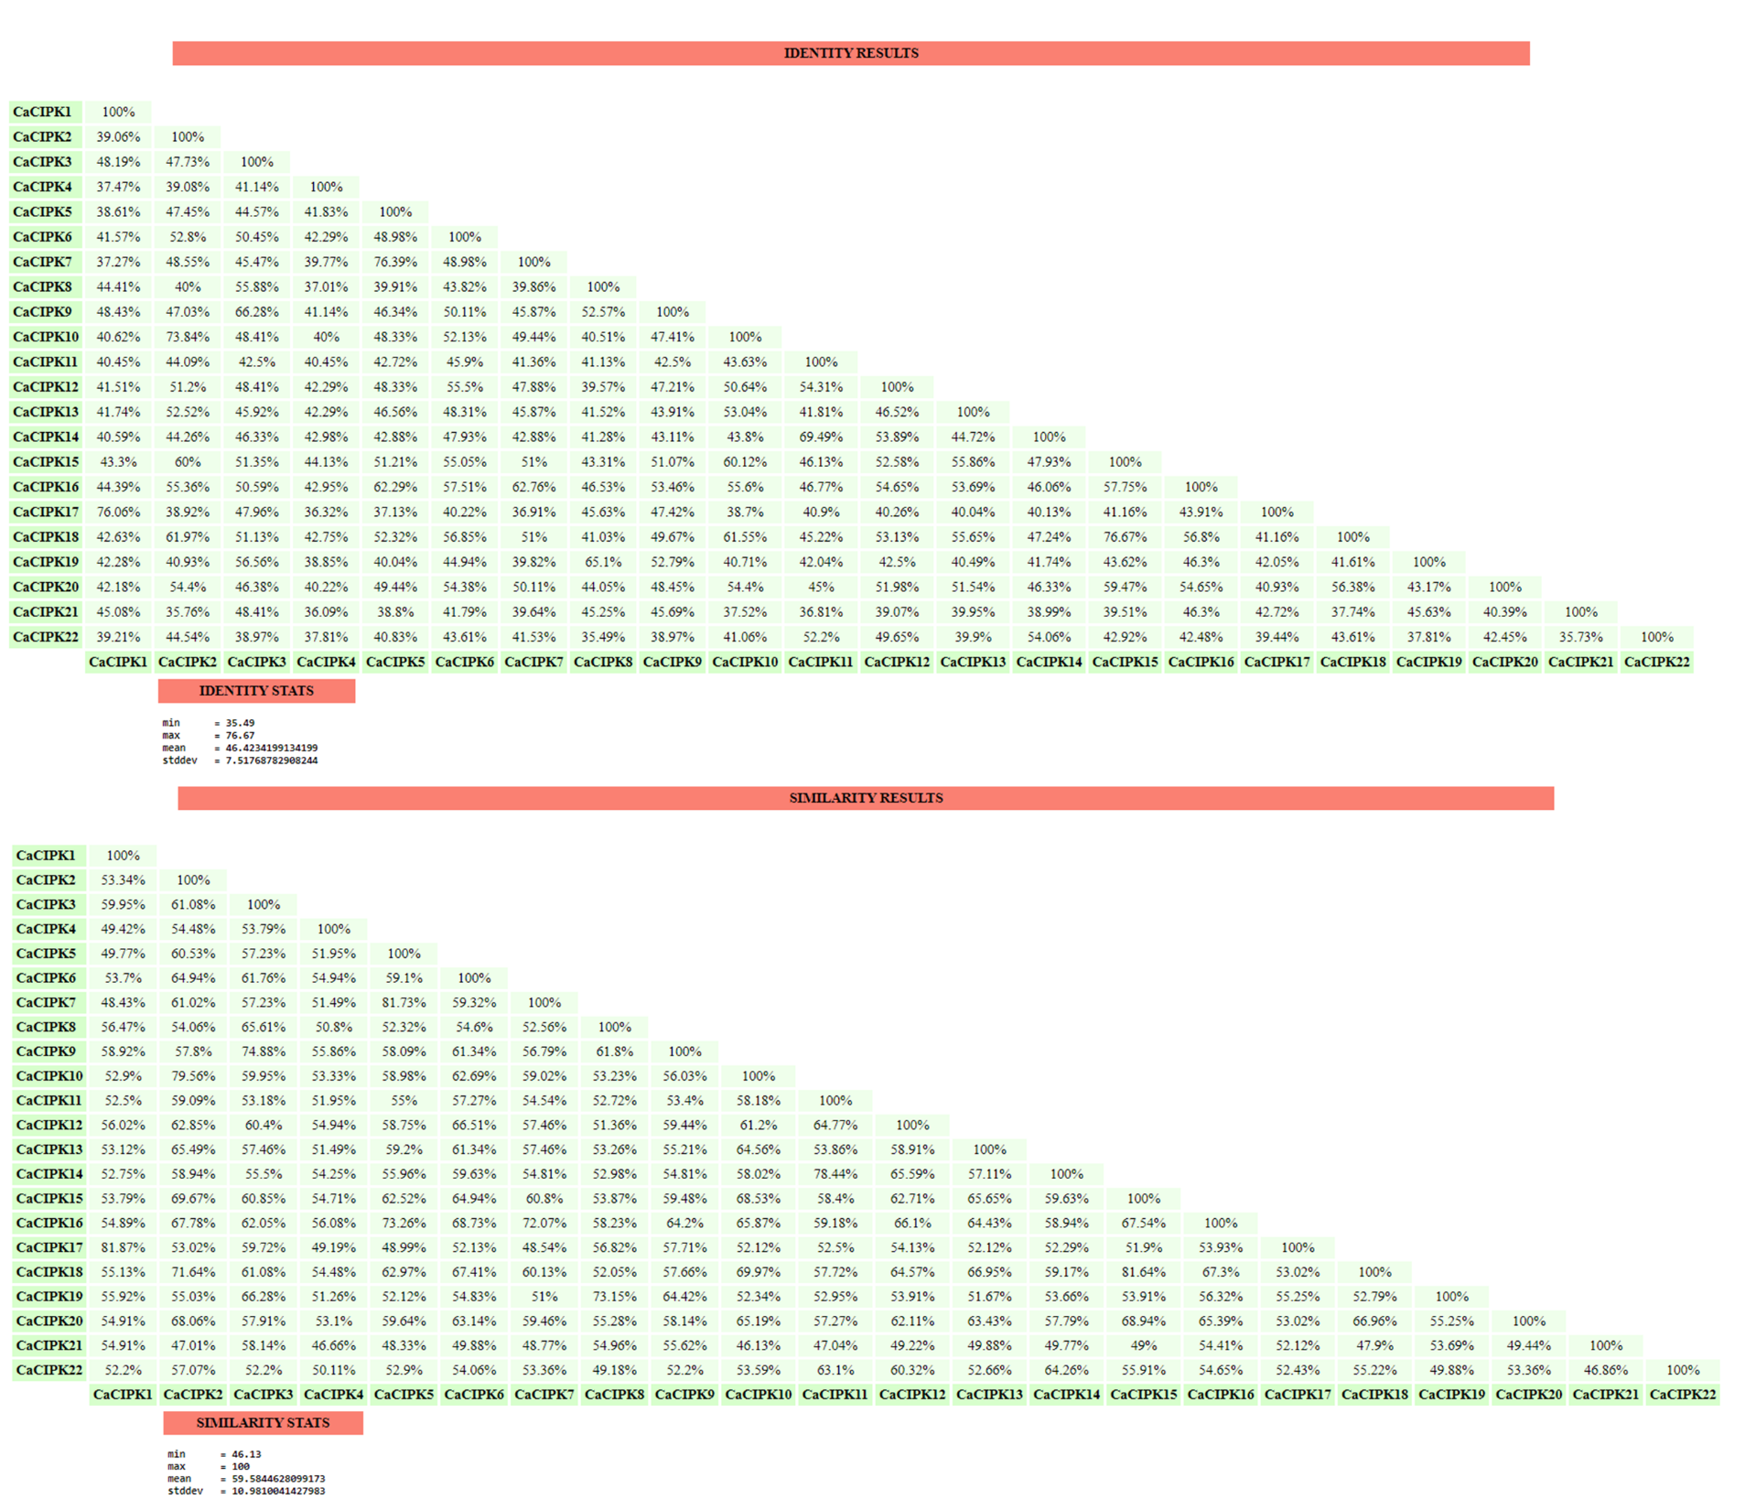
Figure S2: Alignment of 22 CaCIPKs for domain identification.
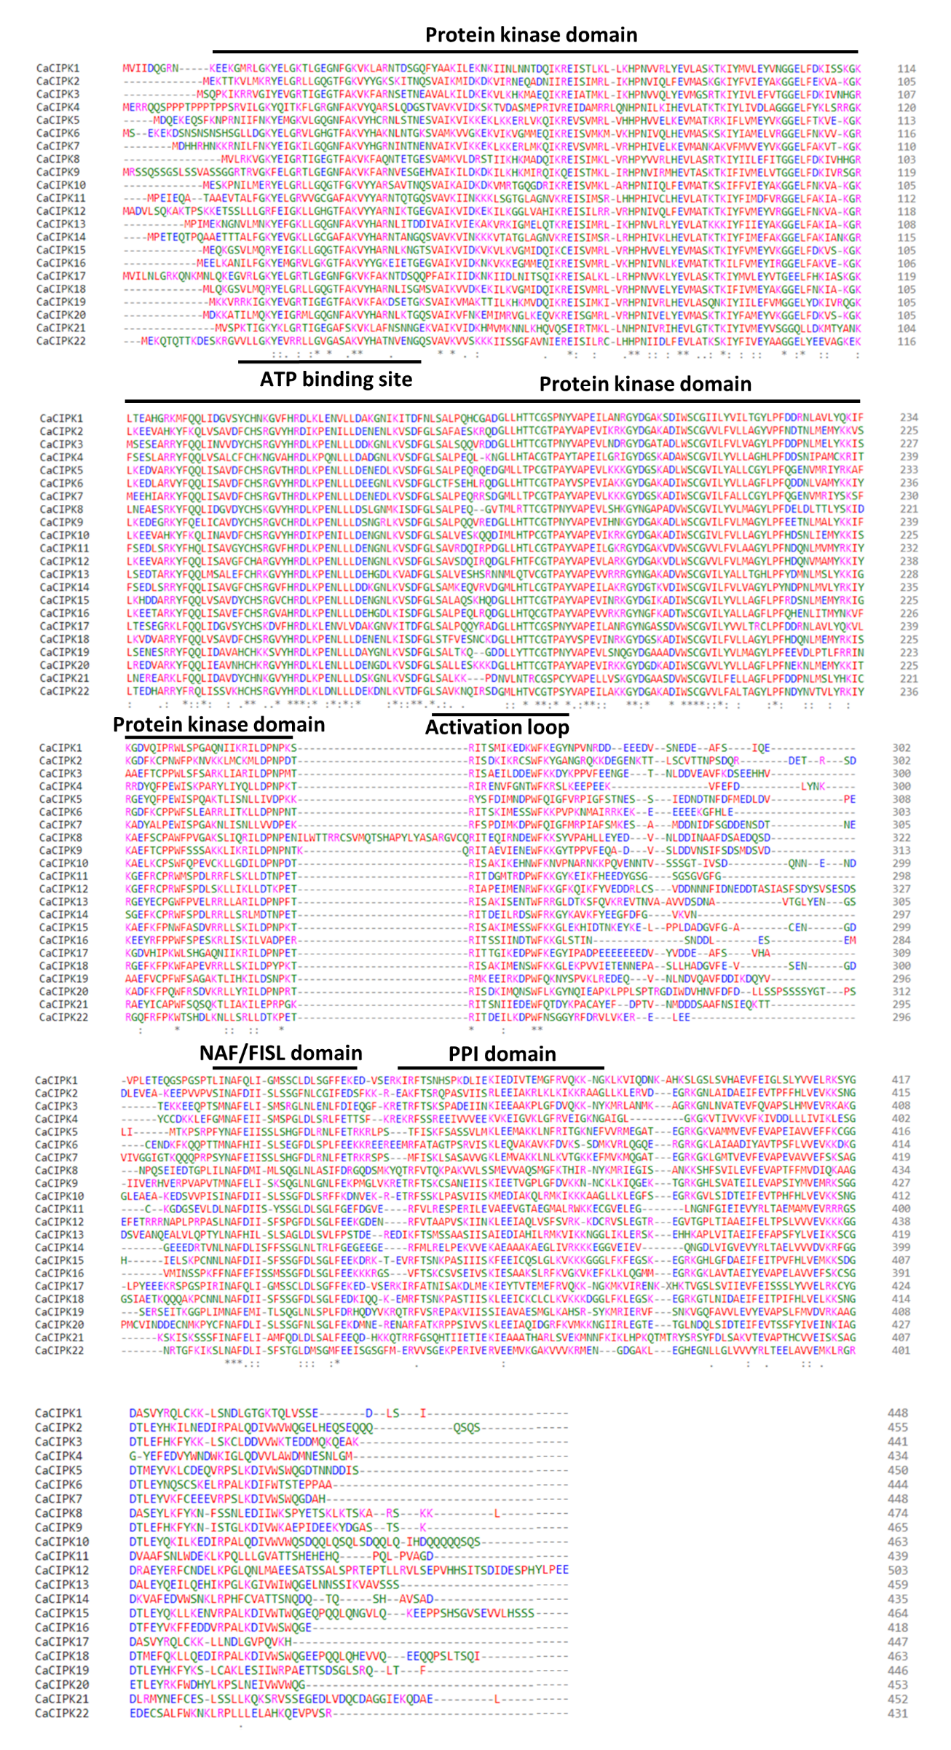

Figure S3: Identification of motifs through MEME.
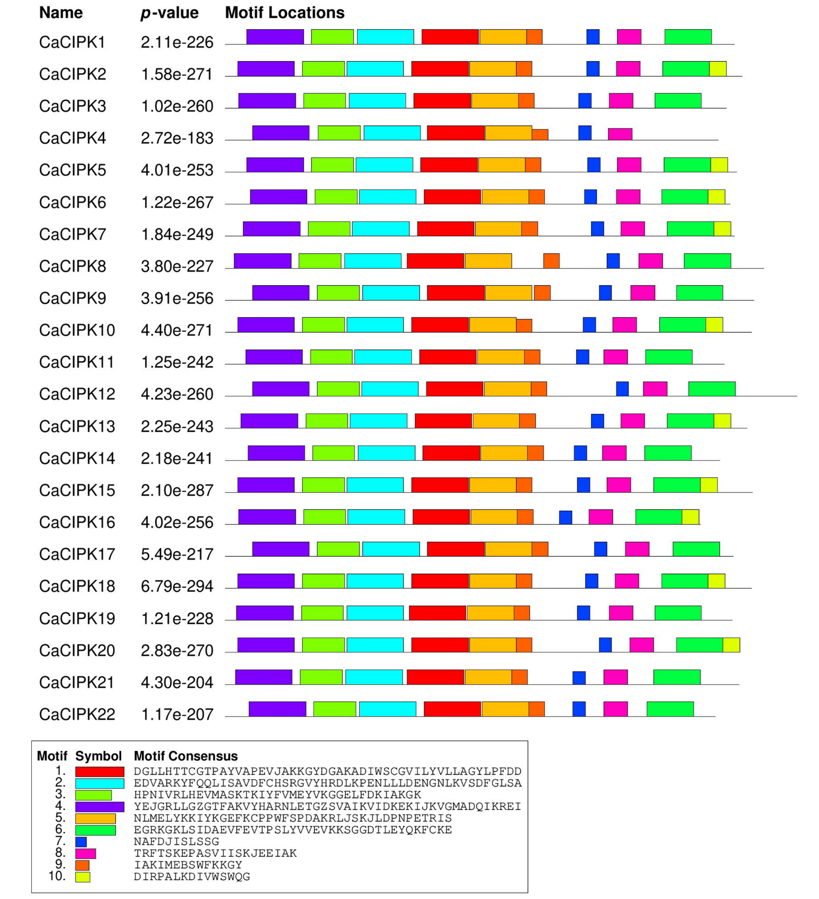

Figure S4: Duplication of chickpea CIPK genes performed by MCScanX is shown via Circos plot.
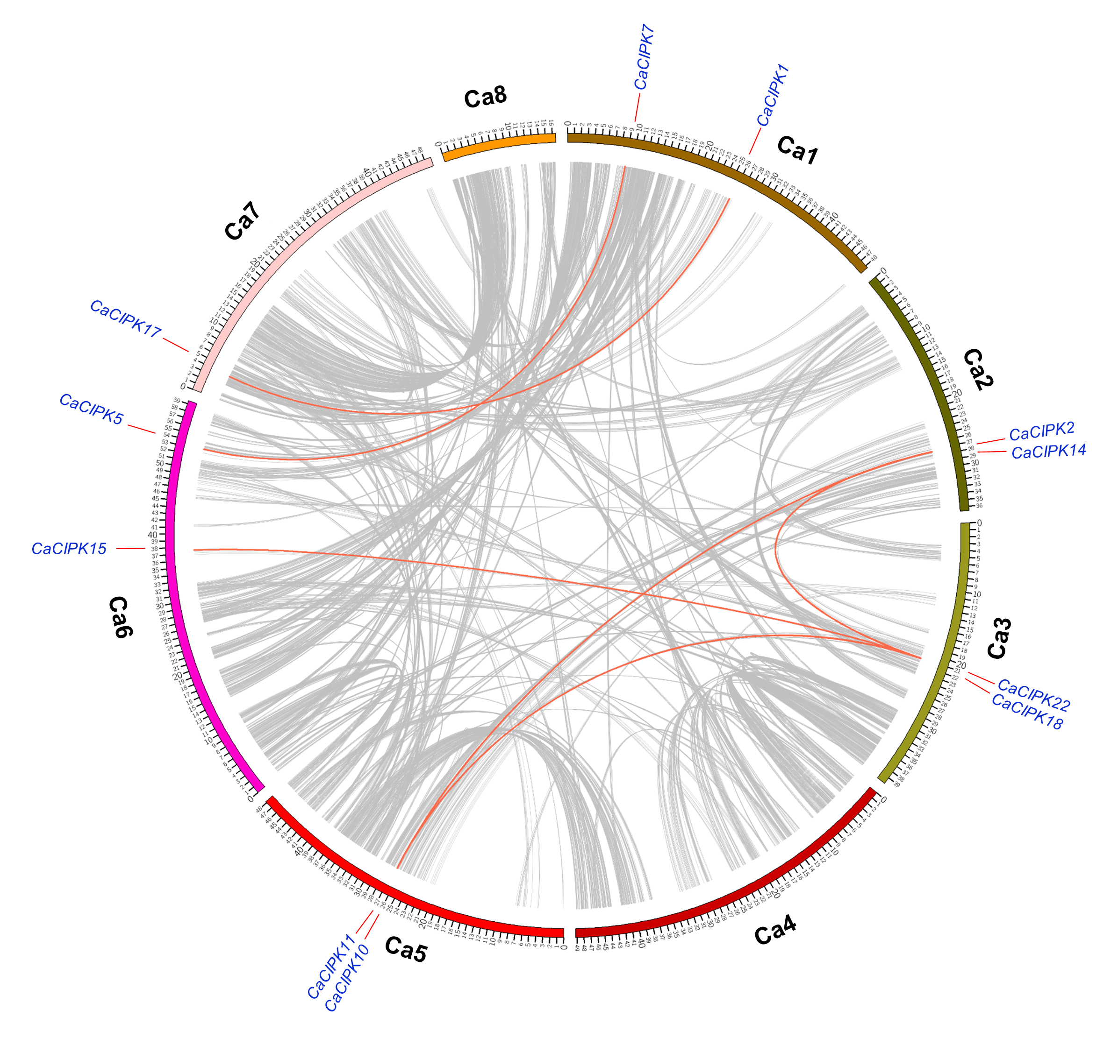

Figure S5. Expression profiles of different CIPK genes in different developmental stages of pigeonpea.

Figure S6. Expression profiles of CIPK genes under heat and salt stress in pigeonpea. The terms SS and ST in the figure correspond to “Salt Susceptible” and “Salt Tolerant” respectively.

