Supporting Information For
Effect of Diffusion Kinetics on the Ice Nucleation Temperature Distribution
Lorenzo Stratta, Andrea Arsiccio & Roberto Pisano*.
Molecular Engineering Laboratory (molE), Department of Applied Science and Technology, Politecnico di Torino, 24 corso Duca degli Abruzzi, IT-10129 Torino, Italy
Corresponding Author
* Correspondence to: roberto.pisano@polito.it.

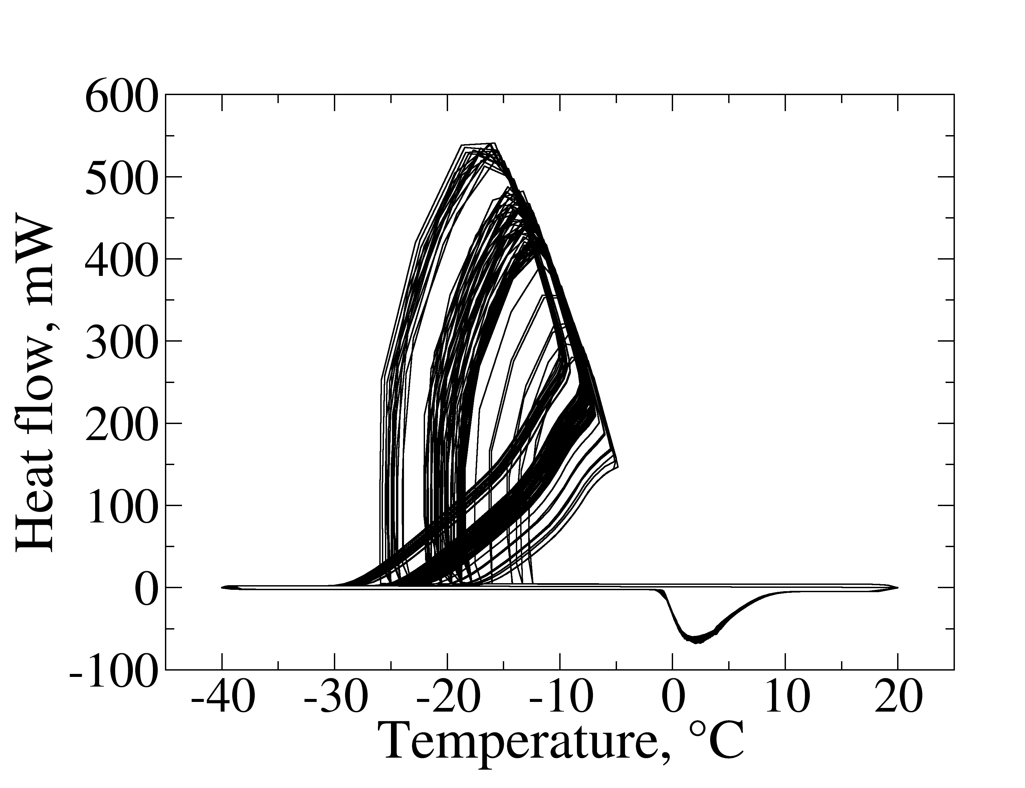
Figure S1. Thermogram produced during experiment X, plotted against the temperature of the sample. While the nucleation temperatures are highly scattered, the melting peaks are superimposed.

Figure S2. Median nucleation temperature T₅₀ versus the residence time above 0°C (τ, in logarithmic scale, experiments I-V, X-XXIV in Table 1). The error bars show the width of the distributions, with the upper and lower values corresponding to T₁₀ and T₉₀, respectively. There is no clear correlation between τ and T₅₀ (the omnibus test fails with a p-value of 0.43, F-value 1.16, degrees of freedom 12).

Figure S3. Width of the nucleation temperature distribution (T₁₀-T₉₀, in °C) versus the average nucleation temperature T₅₀ (Experiments I-V, X-XXIV in Table 1). There is no clear correlation between T₅₀ and T₁₀-T₉₀ (the omnibus test fails with a p-value of 0.78, F-value 0.62, degrees of freedom 16).

Figure S4. a: Average nucleation temperature T₅₀ versus cooling/heating rate R. The error bars show the width of the distribution, with the upper and lower values corresponding to T₁₀ and T₉₀, respectively. b: Width of the nucleation temperature distribution (T₁₀-T₉₀, in °C) versus cooling/heating rate R. Experiments I, and XVI-XXI in Table 1 were used for this analysis.

Figure S5. a: Average nucleation temperature T₅₀ and b: its distribution T₁₀-T₉₀ versus sample mass m_{w.} The error bars show the width of the distribution, with the upper and lower values corresponding to T₁₀ and T₉₀, respectively (Experiments I-V, X-XXIV in Table 1). The omnibus test indicates absence of any significant correlation between m_{w} and either T₅₀ (F-value 1.04, degrees of freedom 14, p-value 0.51) or T₁₀-T₉₀ (F-value 0.92, degrees of freedom 14, p-value 0.58).

