Supplementary material: A prospective cross over study on the effects of medium cut-off membranes on T cellular and serologic immune phenotypes in hemodialysis.

Georg Lorenz¹ *#, Yuli Shen¹ ⁶*, Renate Hausinger¹, Caroline Scheid¹, Marie Eckermann¹, Sophia Hornung¹, Joana Cardoso¹, Maciej Lech^{1,2}, Andrea Ribeiro^{1,2}, Bernhard Haller³, Christopher Holzmann-Littig¹, Dominik Steubl¹, Matthias C. Braunisch¹, Roman Günthner¹, Andreas Poschenrieder⁴, Britt Freitag⁵, Mario Weber⁵, Peter Luppa⁴, Uwe Heeman¹, Christoph Schmaderer¹
¹ Technical University of Munich, School of Medicine, Klinikum rechts der Isar, Department of Nephrology, Germany
² LMU Klinikum Department of nephrology Ludwig-Maximilian University, Munich, Germany
³ Institute for AI and Informatics in Medicine, Klinikum rechts der Isar, Technical University Munich, Germany
⁴ Department of clinical chemistry, Klinikum rechts der Isar, Technical University Munich, Germany
⁵ MVZ KfH-Gesundheitszentrum Emmering / Dachau, Dachau Germany
⁶ Nephrology & Rheumatology Department, Longgang District People’s Hospital of Shenzhen
& The Third Affiliated Hospital (Provisional) of The Chinese University of Hong Kong, Shenzhen, 518172, China
* these authors contributed equally to this work
# corresponding author

Supplementary Table 1. Monoclonal antibodies and conjugates
Application | Target antigen/ fluorescence | Catalog nr. | Clone | Company
Viability dye | Propidium Iodide | P3566 | 1820546 | Thermo Fisher Scientific, Waltham, USA
Viability dye | Fixable Viability Dye eFluor 780 | 65.0865.14 | 2039434 | Thermo Fisher Scientific, Waltham, USA
T cells surface antigens | Anti- Human CD25 PE-Dazzle | 356126 | M-A251 | Biolegend, San Diego, USA
 | Anti- Human CD3 BV605 | 317322 | OKT3 | Biolegend, San Diego, USA
 | Anti- Human CD4 BV785 | 300554 | RPA-T4 | Biolegend, San Diego, USA
 | Anti- Human CD8 BV510 | 301048 | RPA-T8 | Biolegend, San Diego, USA
 | Anti- Human CD69 AlexaFluor700 | 310922 | FN30 | Biolegend, San Diego, USA
 | Anti- Human CD28 APC | 302912 | CD28.2 | Biolegend, San Diego, USA
 | Anti- Human PD-1 PE | 329906 | EH12.2H7 | Biolegend, San Diego, USA
 | Anti- Human CTLA4 PE/Cy7 | 349914 | L3D10 | Biolegend, San Diego, USA
T cells were stained using antibodies for CD25, CD45RO, CD3, CD4, CD8, CD28, CD69, PD1, and CTLA4+. FMOs were used to define the gating of CD69 and CTLA4, respectively.All surface markers were stained for 30mins at 4°C.

Supplementary table 2: Baseline patients’ characteristics for the per-protocol population
Parameter | Missing data | Overall | MCO Fx60/80 | Fx60/80 MCO | P -value
Number of patients | - | 34 | 17 | 17 | -
Age (years) | - | 71 [62, 79] | 77 [61, 79] | 67 [52, 78] | 0.36
Sex, male (n%) | - | 24 (71%) | 13 (77%) | 11 (65%) | 0.71
BMI (kg/m²) | - | 26 ± 5 | 28 ± 5 | 24 ± 5 | 0.64
Upper arm circumference (cm) | 2 | 29 ± 5 | 30 ± 5 | 29 ± 5 | 0.46
Cause of CKD | - |  |  |  | 0.4
- Diabetes / hypertension | - | 15 (44%) | 9 (53%) | 6 (35%) | -
- Glomerulonephritis |  | 5 (15%) | 4 (24%) | 1 (6%) | -
- Systemic disease |  | 1 (3%) | 0 (0%) | 1 (6%) | -
- hereditary cause |  | 6 (18%) | 2 (12%) | 4 (24%) | -
- other |  | 7 (20%) | 2 (12%) | 5 (29%) | -
CCI | - | 9 [6, 10] | 9 [5, 12] | 9 [6, 10] | 0.79
Diabetes mellitus (n%) | - | 11 (32%) | 6 (35%) | 5 (29%) | 1
History MI (n%) | - | 8 (24%) | 2 (12%) | 6 (35%) | 0.26
Coronary heart disease (n%) | - | 15 (44%) | 9 (53%) | 6 (35%) | 0.49
Atria Fibrillation (n%) | - | 13 (38%) | 8 (47%) | 5 (29%) | 0.48
COPD(n%) | - | 8 (24%) | 4 (24%) | 4 (24%) | 1
HD vintage [months] | - | 36 [29,86] | 46 [32, 88] | 33 [10, 78] | 0.27
Residual renal function [ml], n=15 | - | 720 [400, 1090] | 720 [375, 1075] | 563 [363, 1155] | 1
Access (catheter) | - | 7 (21%) | 0 (0%) | 7 (41%) | 0.007
Anticoagulation (citrate / agatra n=1) | - | 5 (15%) | 3 (18%) | 2 (12%) | 0.60
Effective session duration [h] | - | 4.2 ± 0.3 | 4.4 ± 0.3 | 4.1 ± 0.2 | 0.59
Ultrafiltration rate [ml/h] |  | 525 ± 189 | 535 ± 162 | 514 ± 217 | 0.24
Blood flow rate [ml/min] | - | 238 ± 47 | 243 ± 49 | 232 ± 46 | 0.73
Dialysate flow [ml/min] | - | 378 ± 133 | 382 ± 145 | 374 ± 125 | 0.99
Dialysate Na+ [mmol] | - | 138 [138, 138] | 138 [138, 138] | 138 [138, 138] | 0.79
Dialysate K+ [mmol] | - | 3 [2,3] | 2 [2,3] | 3 [2,3] | 0.13
Dialysate Mg2+[mmol] | - | 1 [0.75, 1] | 0,75 [0.75, 1] | 1 [0.88, 1] | 0.11
Dialysate Ca2+ [mmol] | - | 1,25 [1.25, 1.25] | 1,25 [1.25, 1.25] | 1.25 [1.25, 1.25] | 0.79
Dialysate HCO3- [mmol] | - | 32 [32, 32] | 32 [32, 32] | 32 [32, 32] | 0.63
Dialysis unit 1 (n%) | - | 11 (32%) | 4 (24%) | 7 (41%) | 0.47
Immunosup. (n%) | - | 2 (6%) | 1 (6%) | 1 (6%) | 0.60
Statin(n%) | - | 11 (32%) | 6 (35%) | 5 (29%) | 1
Anti-hypertensives (n%) | - | 25 (74%) | 10 (59%) | 15 (88%) | 0.12
Anticoagulation(n%) | - | 6 (18%) | 3 (18%) | 3 (18%) | 1
Abbreviations: BMI = body mass index; COPD = chronic obstructive pulmonary disease; Immunosup. = Immunisuppression; MI = myocardial infarction.

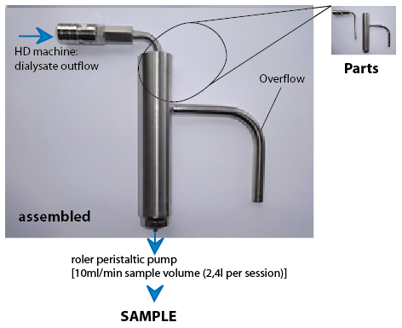
Supplementary figure 1: The device used to sample an “average dialysate” specimen consists of a collection siphons (see pictures) attached to a continuously working peristaltic roler pump (set at 10ml/min). This way fractions of the dialysates with high (beginning of HD session) or low (end of HD session) mediator levels were collected in equal shares during an average dialysis session.

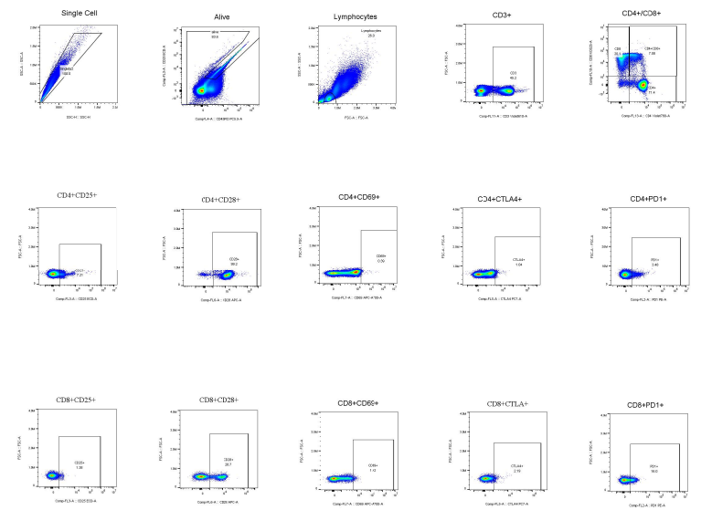
Supplementary figure 2: T cell gating strategy for cryopreserved PBMCs.

