SUPPLEMENTAL FIGURES

Longitudinal Bioluminescence Imaging to Monitor Breast Tumor Growth and Axitinib Treatment Response using the Chick Chorioallantoic Membrane Model
Sumreen Javed,¹ Sepideh Soukhtehzari,¹ Nazarine Fernandes,¹ and Karla C. Williams^{1*}
¹Faculty of Pharmaceutical Sciences, The University of British Columbia, Vancouver, Canada
*Corresponding author: karla.williams@ubc.ca
Keywords: breast cancer, chick embryo, chorioallantoic membrane, tumor growth, therapeutic response, axitinib

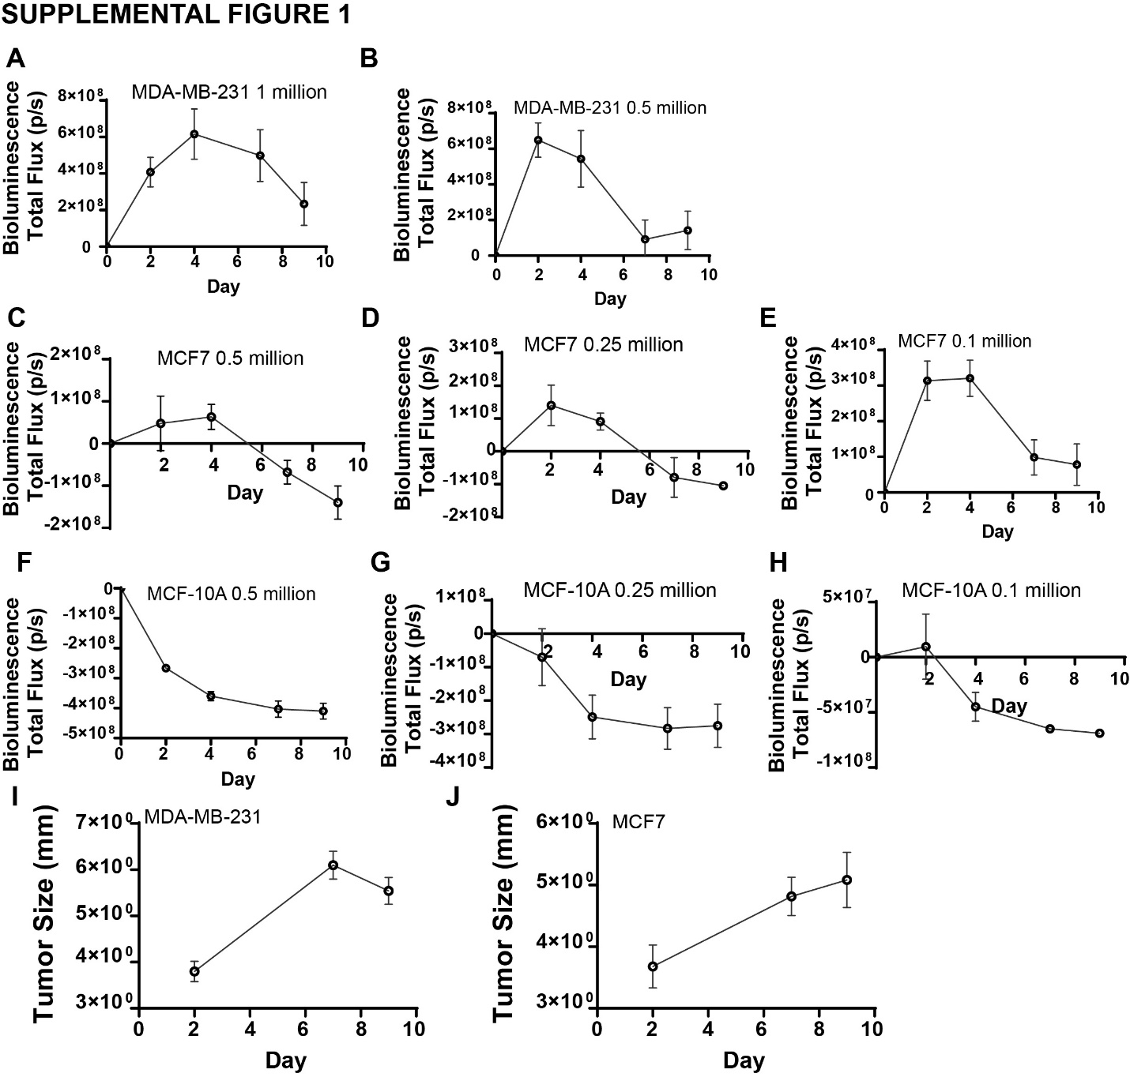
Supplemental Figure 1. (A-H) Growth curves of cell spheroids, as assessed by BLI, based on cell number for: MDA-MB-231 at (A) 10⁶ and (B) 5x10⁵cells/sphere, MCF7 at (C) 5x10⁵ (D) 2.5x10⁵ and (E) 1x10⁵ cells/sphere, and MCF-10A at (F) 5x10⁵ (G) 2.5x10⁵ (H) 1x10⁵cells/sphere. (I) Tumor spheroid growth curve of engineered MDA-MB-231luc spheroid (2.5x10⁵ cells/spheroid) on CAM post engrafting measured through light microscope. (J). Tumor spheroid growth curve of engineered MCF7luc spheroid (5x10⁴ cells/spheroid) on CAM post engrafting measured through light microscope.

