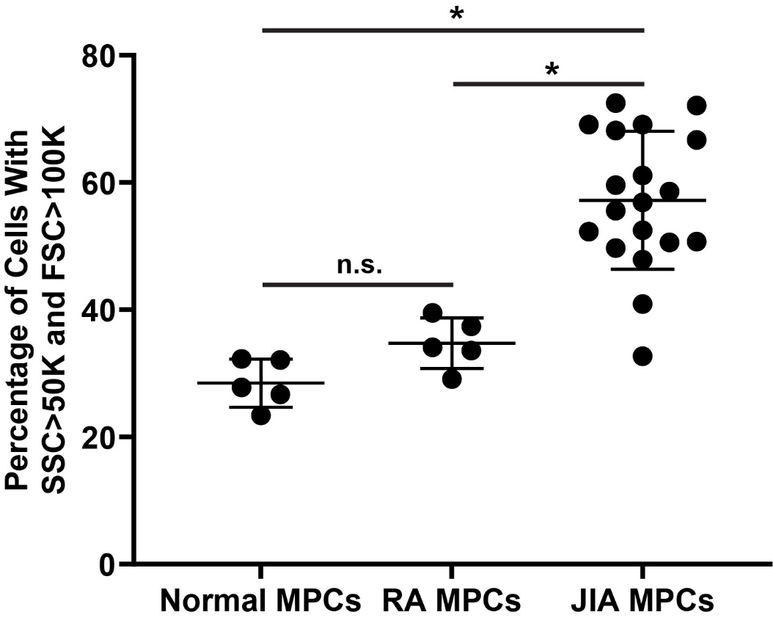

Figure S1. Quantification of side scatter (SSC) and forward scatter (FSC) in MPCs. Synovial MPCs from normal (n=5), JIA (n=19) and RA (n=5) joints were assayed for SSC and FSC using flow cytometry. A significant increase in SSC and FSC was observed in JIA MPCs vs. normal and RA MPCs. Error bars represent mean +/- SD. n.s. = not significant. * = p<0.05.

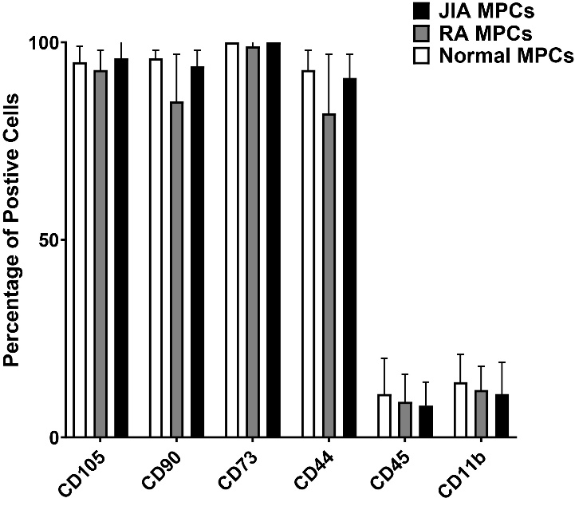

Figure S2. Quantification of cell surfaces markers in MPCs. Synovial MPCs from normal, JIA and RA joints were assayed for cell surfaces marker expression. No significant difference in any marker was observed. Error bars represent mean +/- SD.

