Appendix 2

Figure 1: Relationships between the number of BINs and OTUs. Green data points: biological farming, red: recent conversion from traditional to biological farming, orange: conventional farming. The black line in divides data mainly from 1919 (below) and those obtained in 2020 (above).

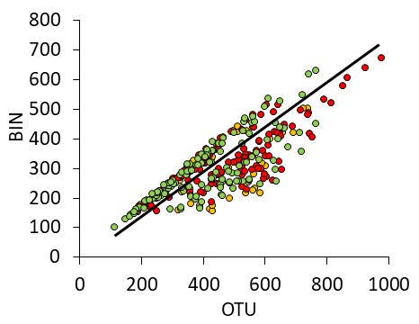
Figure 2: Dependencies of BINs, OTUs, and the OTU / BIN ratio on sampling day and distances to the nearest woody plants. Green data points: biological farming, red: recent conversion from traditional to biological farming, orange: conventional farming. Parametric significances of linear (a-c) and 2nd order polynomic (d-f) ordinary least squares regressions: ***: P < 0.001.

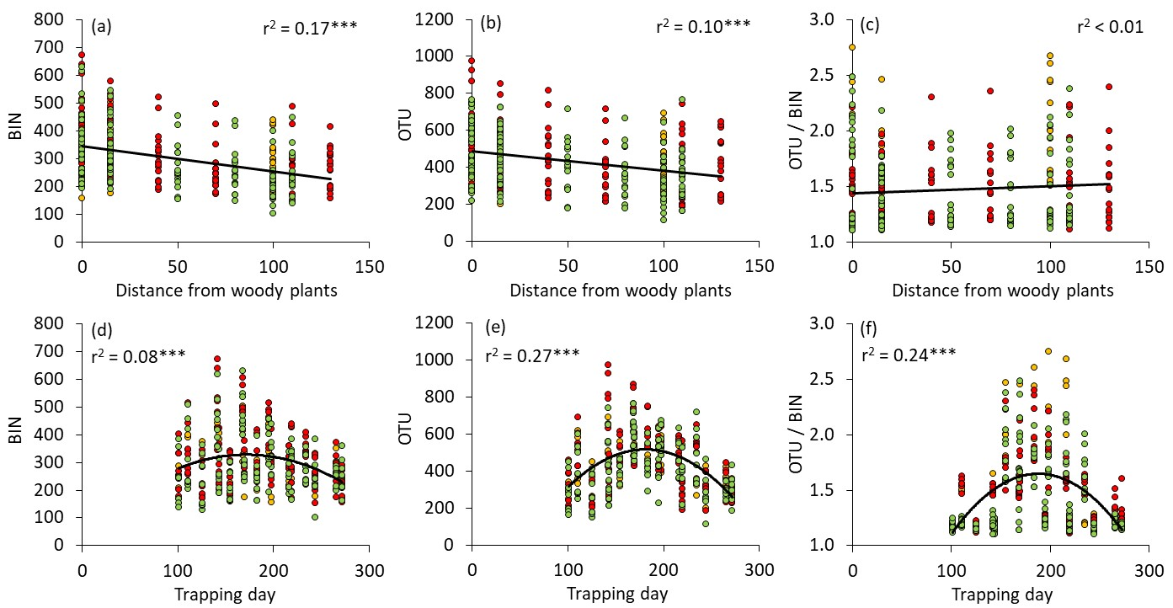

Figure 3: Phenology of the OTU / biomass relationship in 2019 (continuous lines) and 2020 (broken lines).

