Synthesis and anticancer activity of new benzensulfonamides incorporating s-triazines as cyclic linkers for inhibition of carbonic anhydrase IX

Supplementary Material

Spectral data section …………………………. Figures 1-84
Biological section ……………………………. Figures 85-124

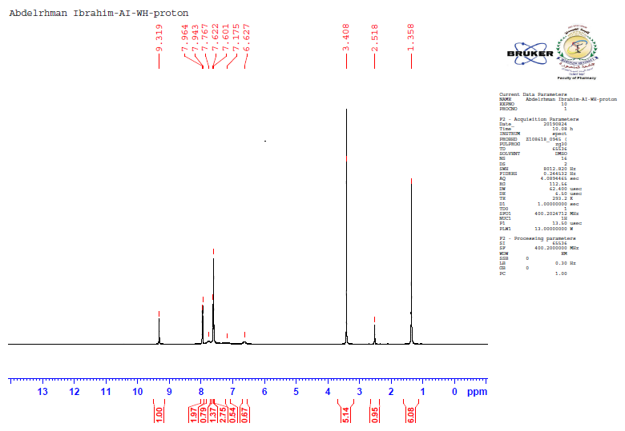
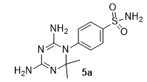

Figure 1. ¹H NMR (400 MHz, DMSO-d₆) spectrum of compound 5a
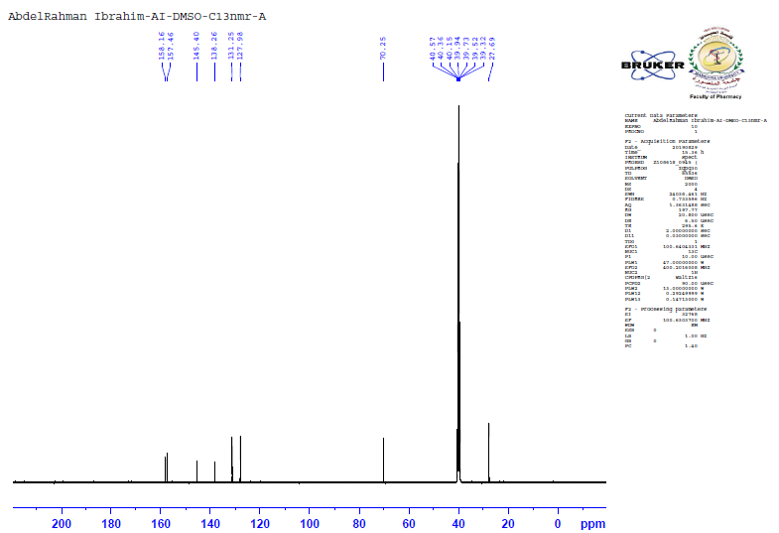

Figure 2. ¹³C NMR (100 MHz, DMSO) spectrum of compound 5a

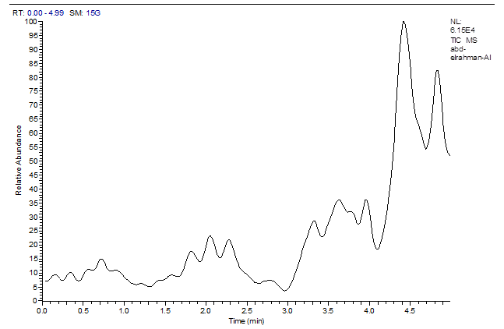

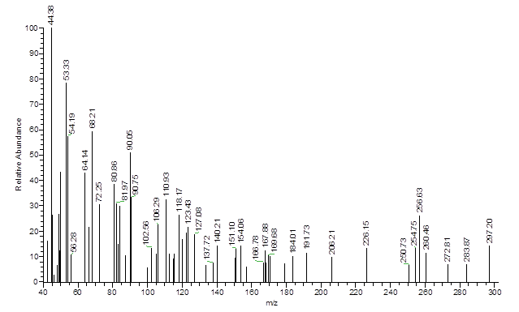
Figure 3. Mass spectrum of compound 5a

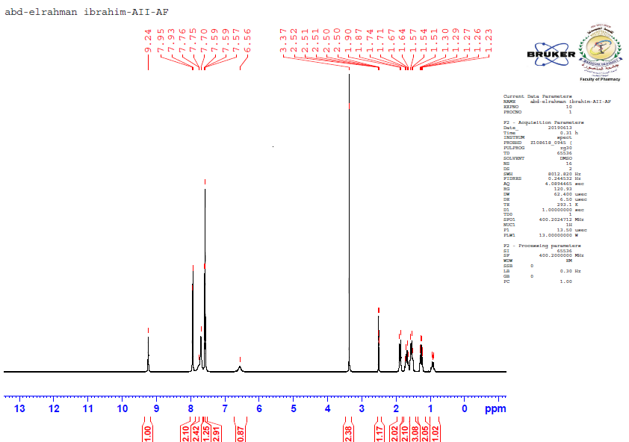
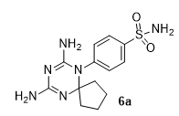

Figure 4. ¹H NMR (400 MHz, DMSO-d₆) spectrum of compound 6a
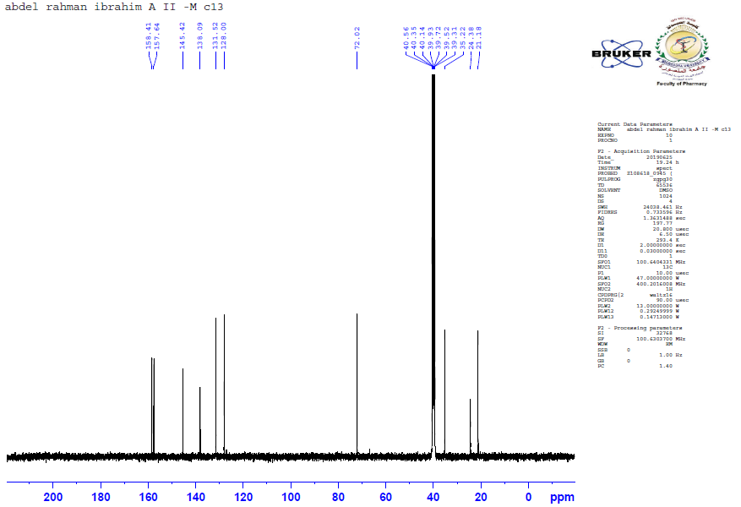

Figure 5. ¹³C NMR (100 MHz, DMSO) spectrum of compound 6a

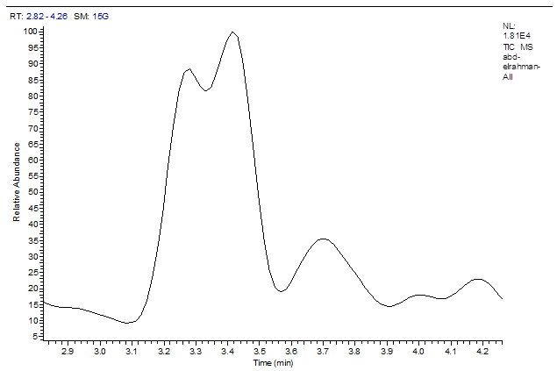

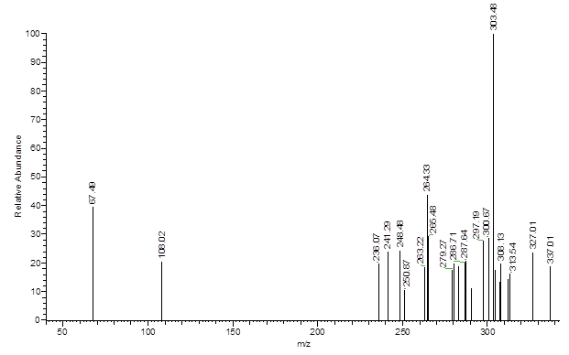

Figure 6. Mass spectrum of compound 6a

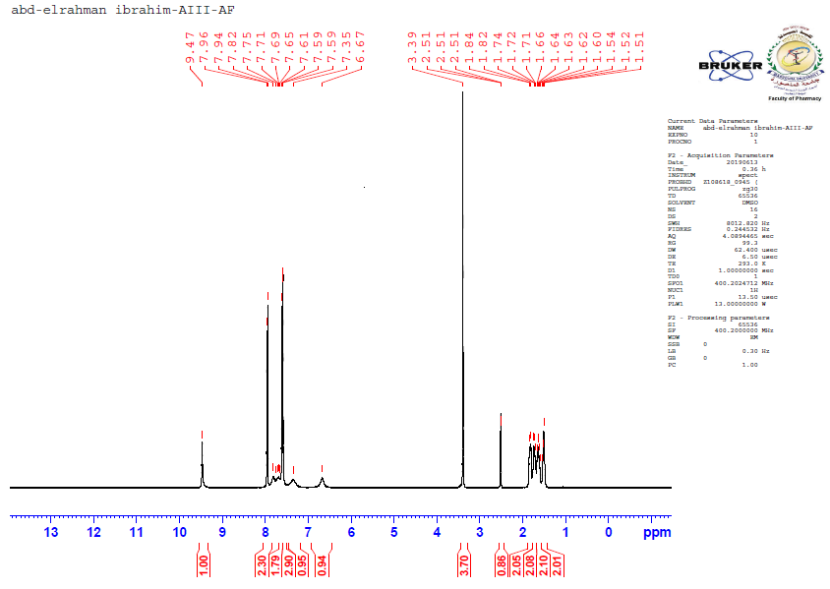

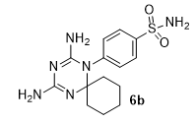

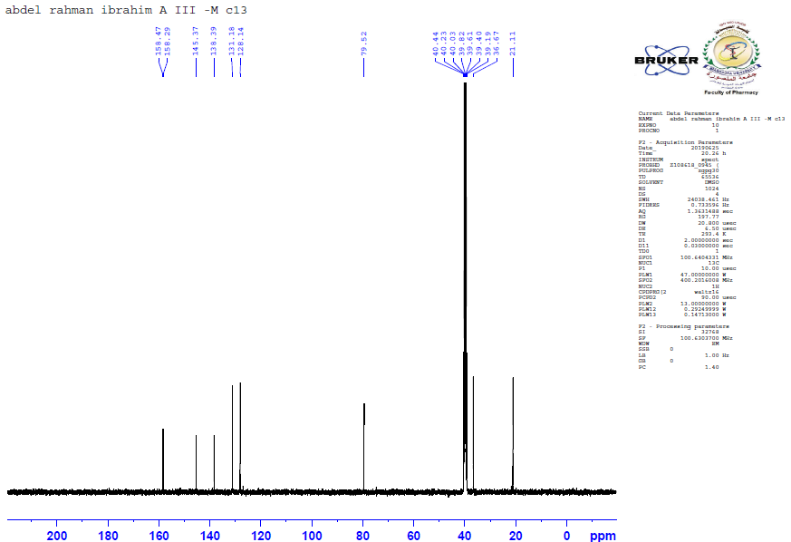
Figure 7. ¹H NMR (400 MHz, DMSO-d₆) spectrum of compound 6b

Figure 8. ¹³C NMR (100 MHz, DMSO) spectrum of compound 6b

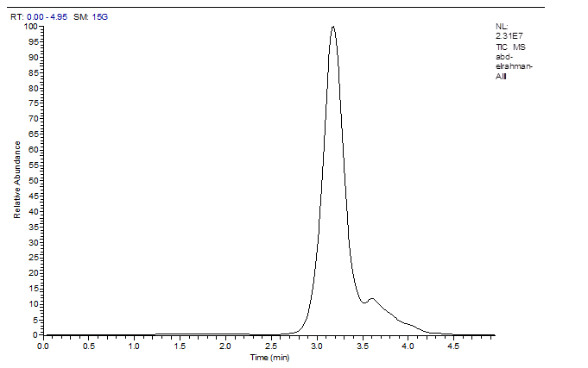

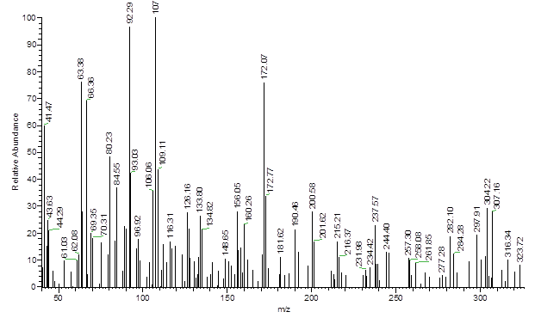

Figure 9. Mass spectrum of compound 6b

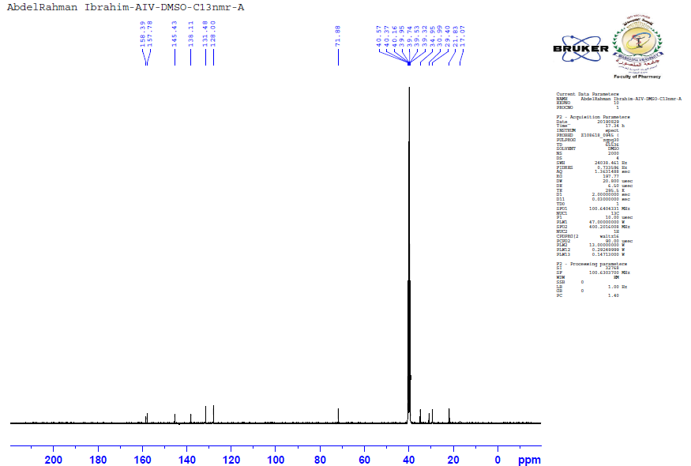
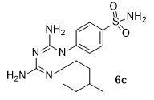
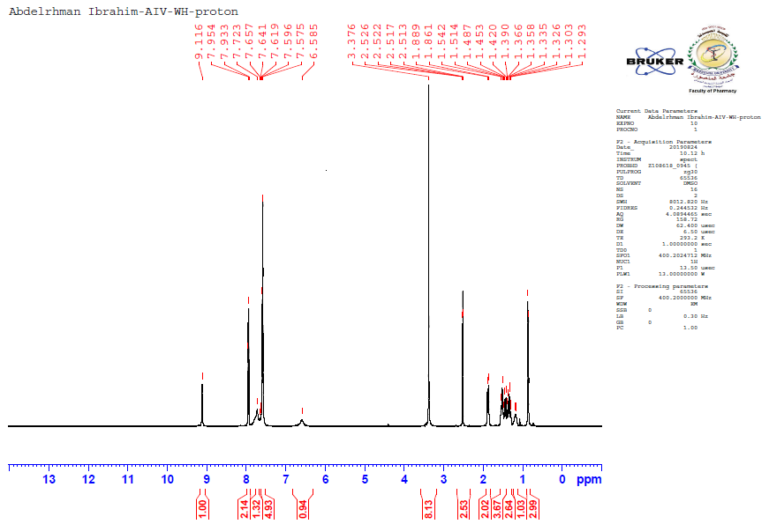

Figure 10. ¹H NMR (400 MHz, DMSO-d₆) spectrum of compound 6c

Figure 11. ¹³C NMR (100 MHz, DMSO) spectrum of compound 6c

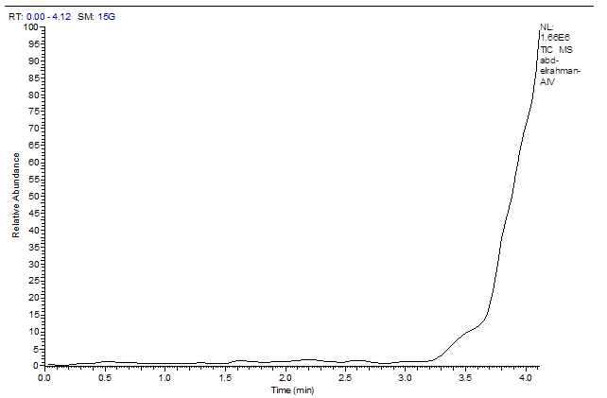

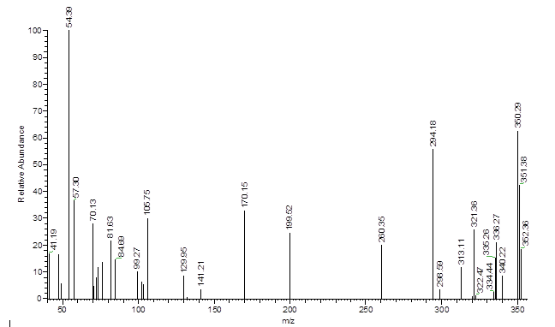

Figure 12. Mass spectrum of compound 6c

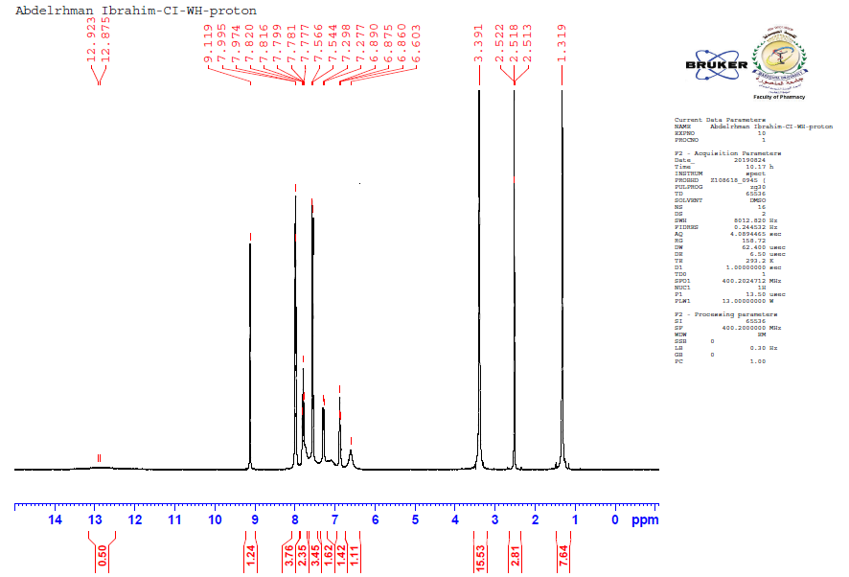

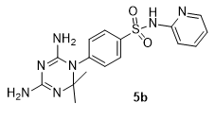

Figure 13. ¹H NMR (400 MHz, DMSO-d₆) spectrum of compound 5b
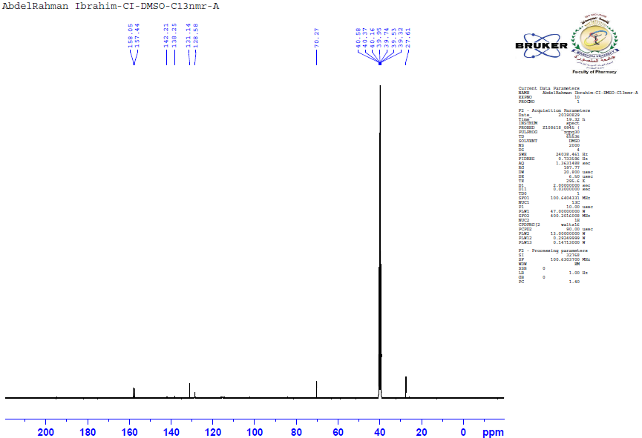

Figure 14. ¹³C NMR (100 MHz, DMSO) spectrum of compound 5b

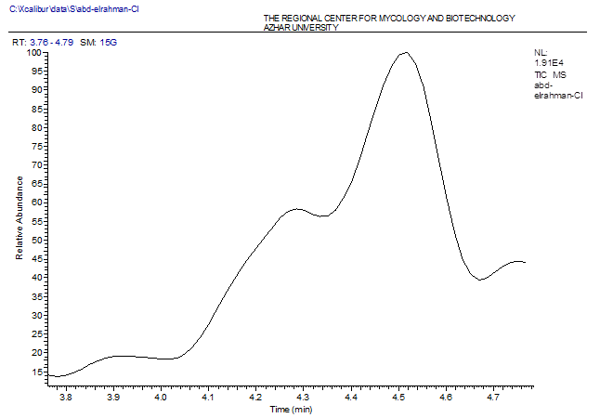

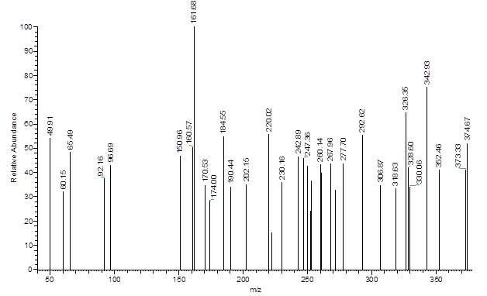

Figure 15. Mass spectrum of compound 5b

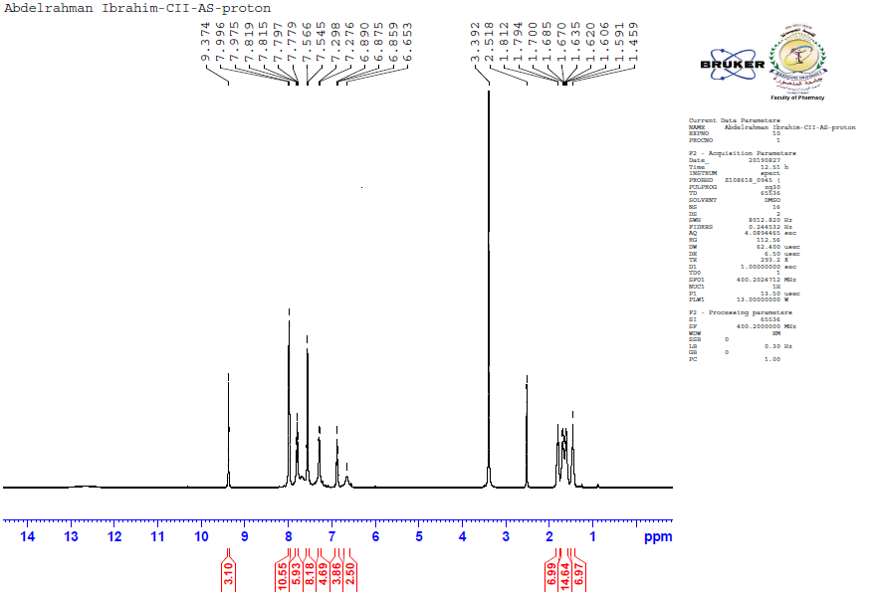

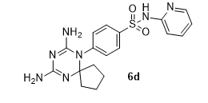

Figure 16. ¹H NMR (400 MHz, DMSO-d₆) spectrum of compound 6d
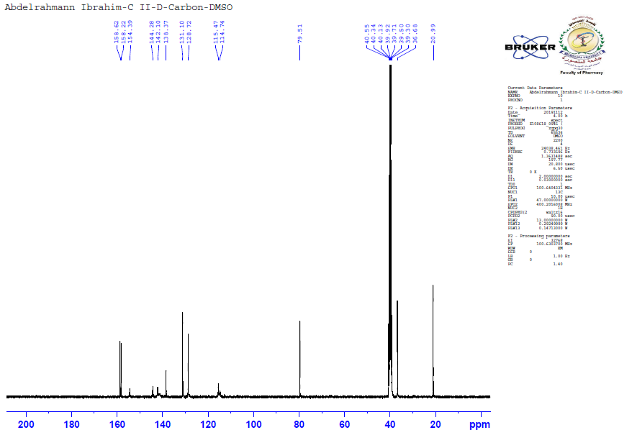

Figure 17. ¹³C NMR (100 MHz, DMSO) spectrum of compound 6d

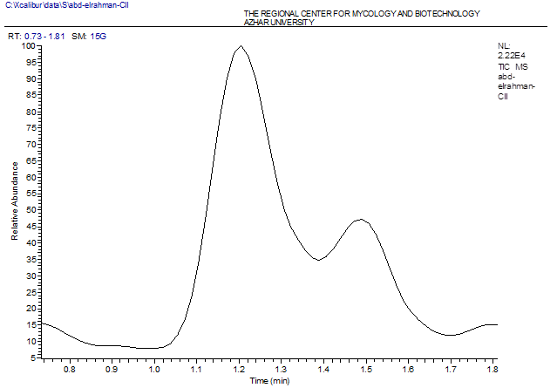
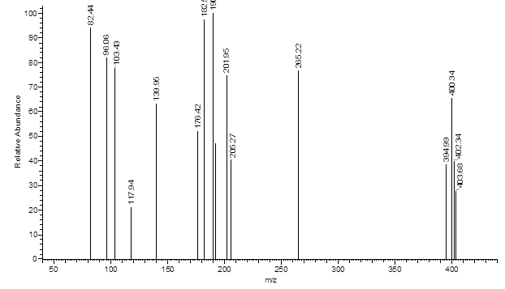

Figure 18. Mass spectrum of compound 6d

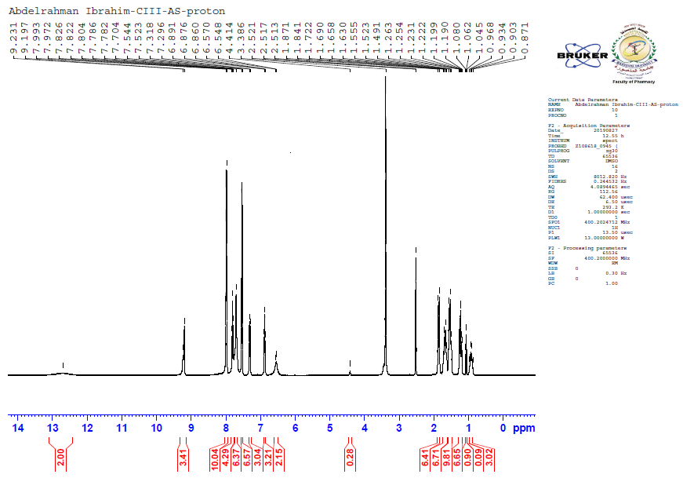

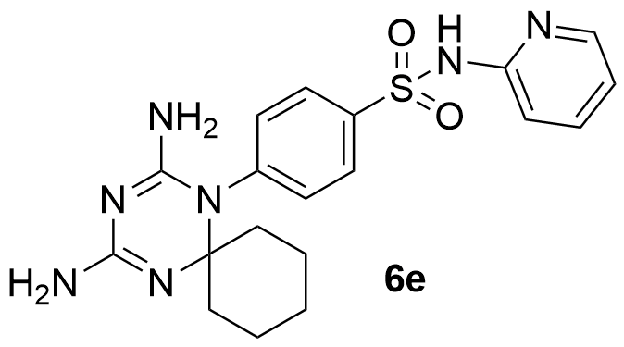

Figure 19. ¹H NMR (400 MHz, DMSO-d₆) spectrum of compound 6e
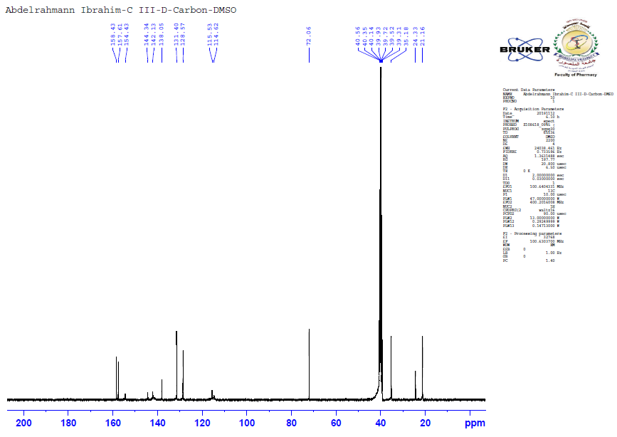

Figure 20. ¹³C NMR (100 MHz, DMSO) spectrum of compound 6e

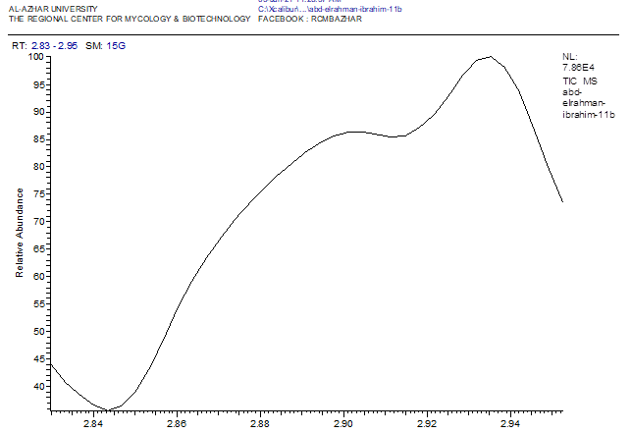

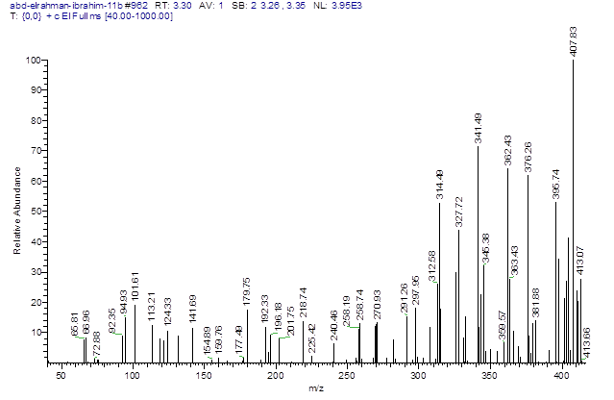

Figure 21. Mass spectrum of compound 6e

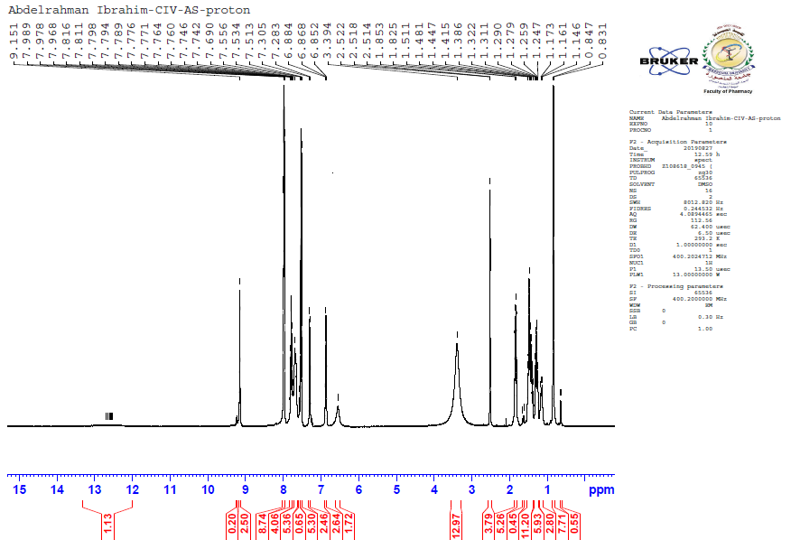
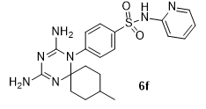
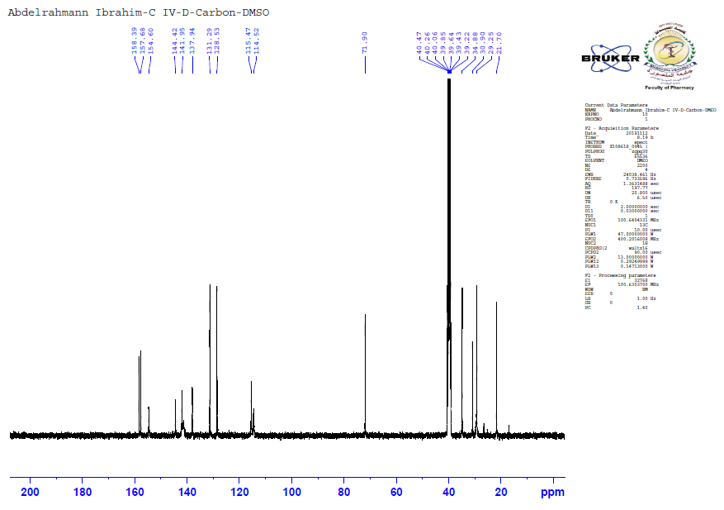

Figure 22. ¹H NMR (400 MHz, DMSO-d₆) spectrum of compound 6f

Figure 23. ¹³C NMR (100 MHz, DMSO) spectrum of compound 6f

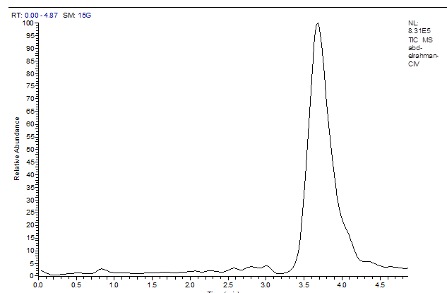

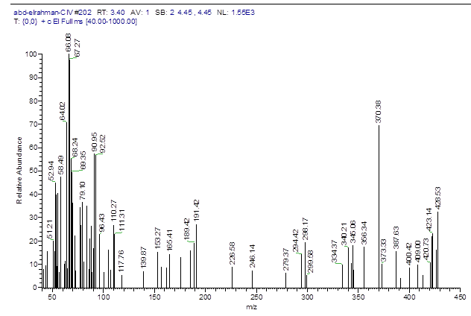

Figure 24. Mass spectrum of compound 6f

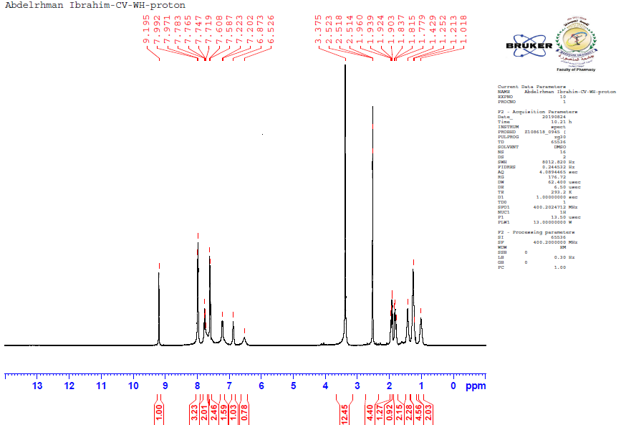
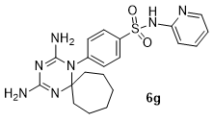

Figure 25. ¹H NMR (400 MHz, DMSO-d₆) spectrum of compound 6g
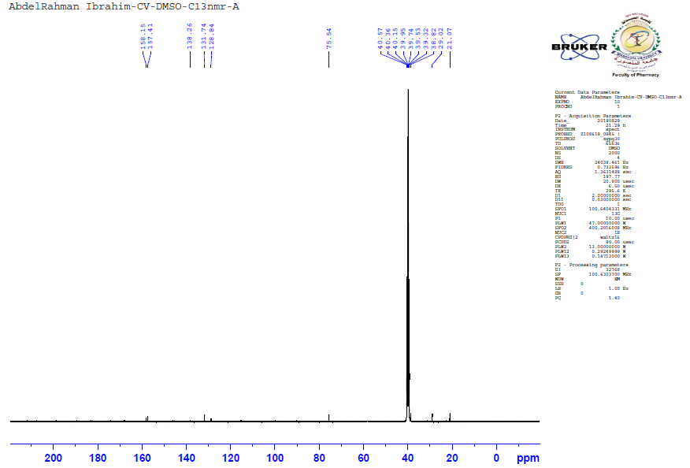

Figure 26. ¹³C NMR (100 MHz, DMSO) spectrum of compound 6g

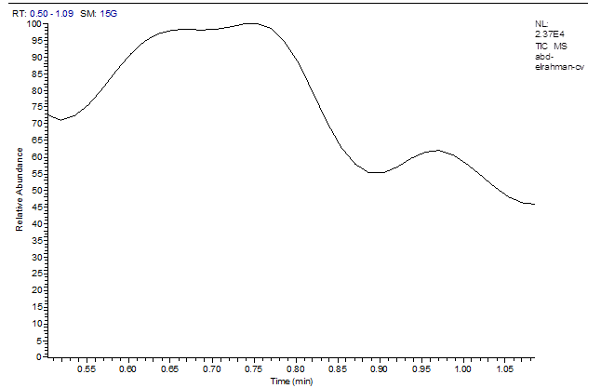
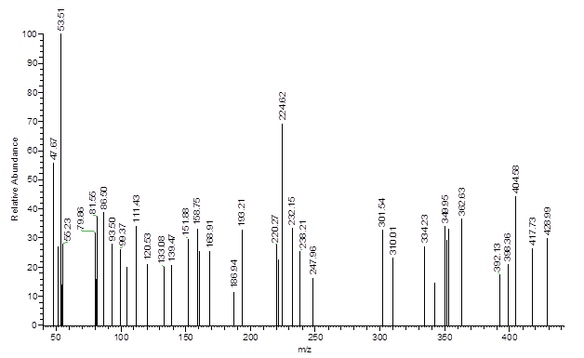

Figure 27. Mass spectrum of compound 6g

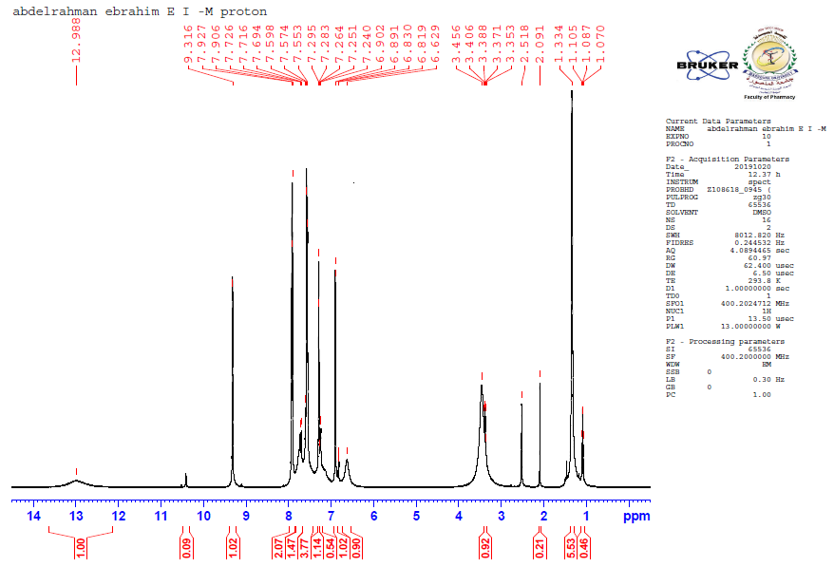
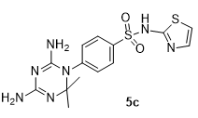

Figure 28. ¹H NMR (400 MHz, DMSO-d₆) spectrum of compound 5c
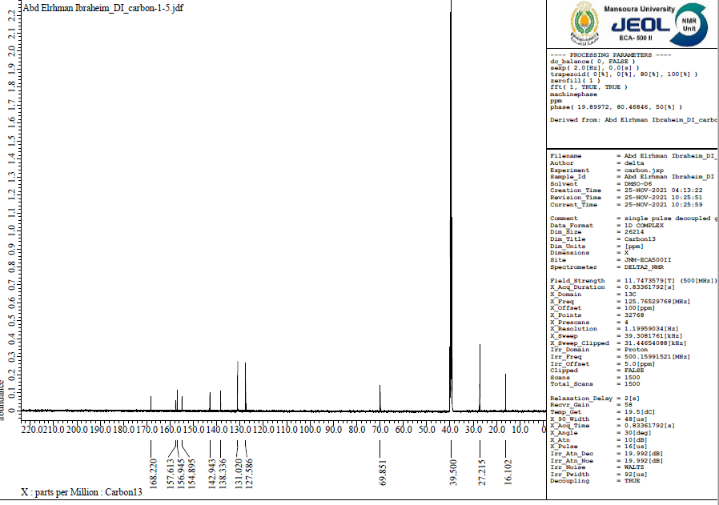

Figure 29. ¹³C NMR (100 MHz, DMSO) spectrum of compound 5c

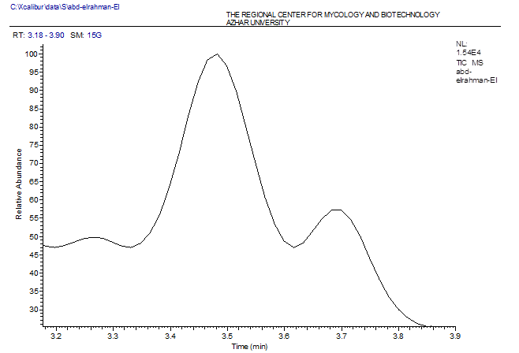

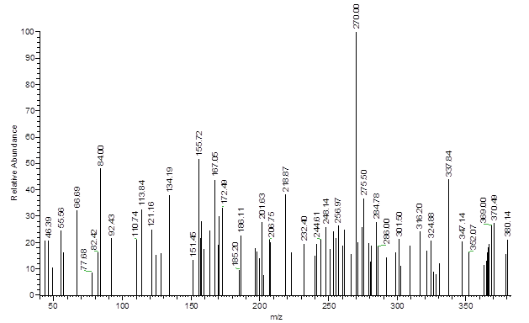

Figure 30. Mass spectrum of compound 5c

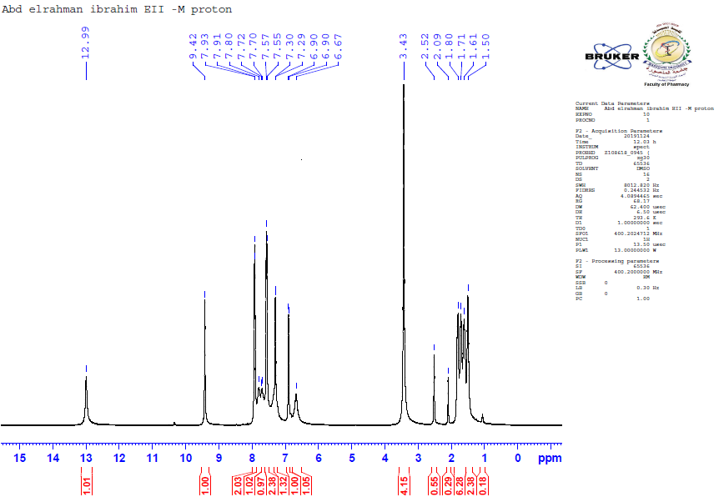
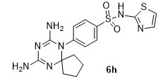

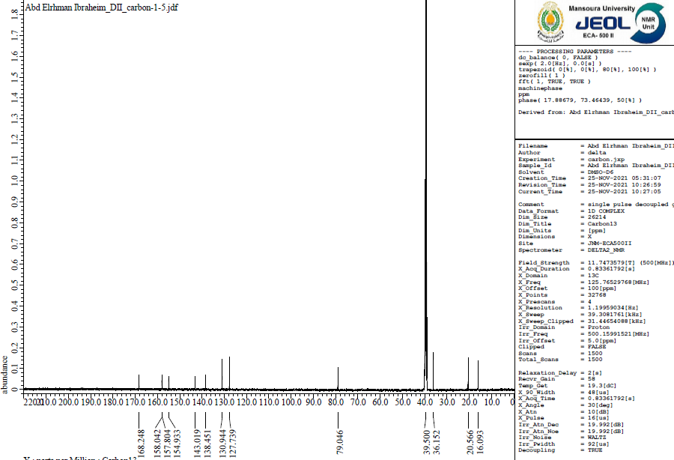
Figure 31. ¹H NMR (400 MHz, DMSO-d₆) spectrum of compound 6h

Figure 32. ¹³C NMR (100 MHz, DMSO) spectrum of compound 6h

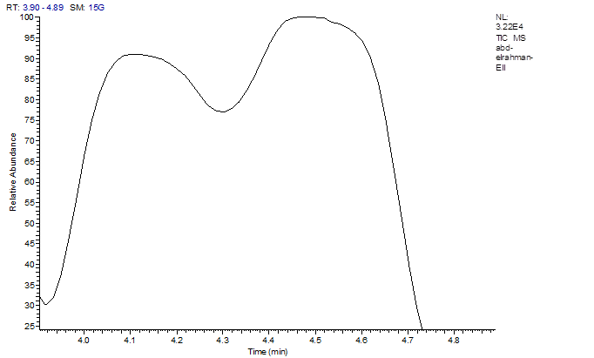
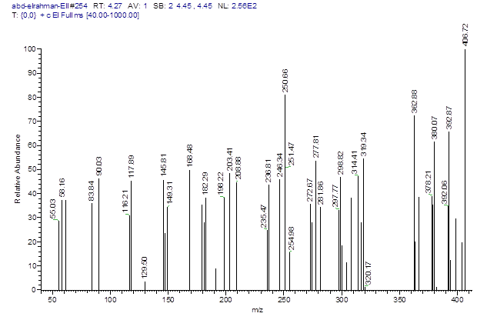

Figure 33. Mass spectrum of compound 6h

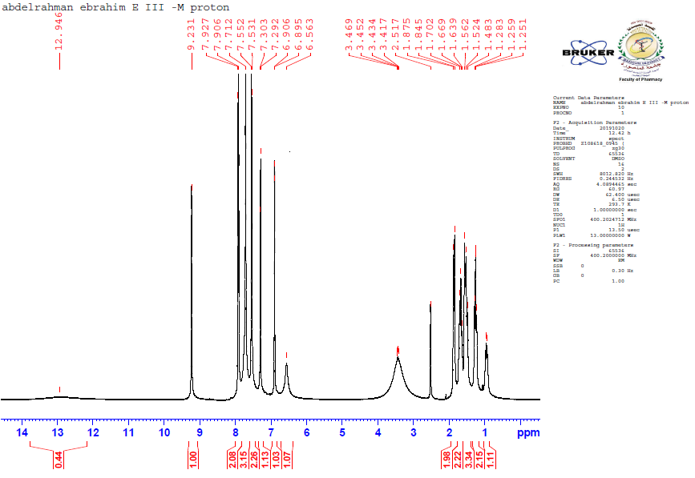
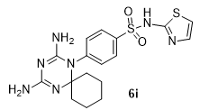

Figure 34. ¹H NMR (400 MHz, DMSO-d₆) spectrum of compound 6i
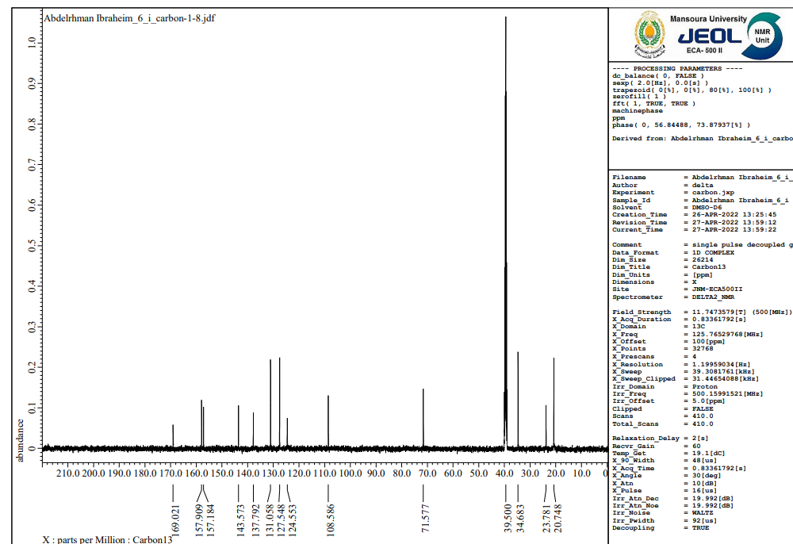

Figure 35. ¹³C NMR (100 MHz, DMSO) spectrum of compound 6i

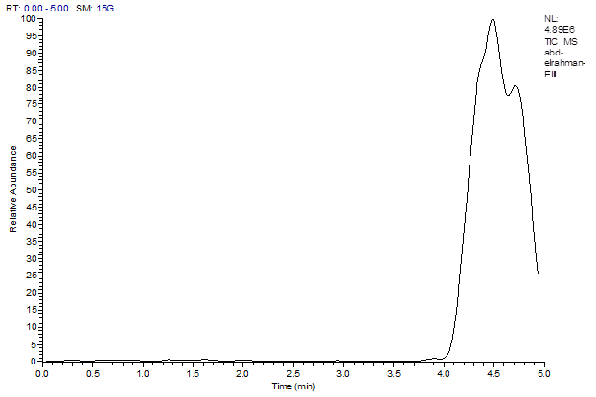

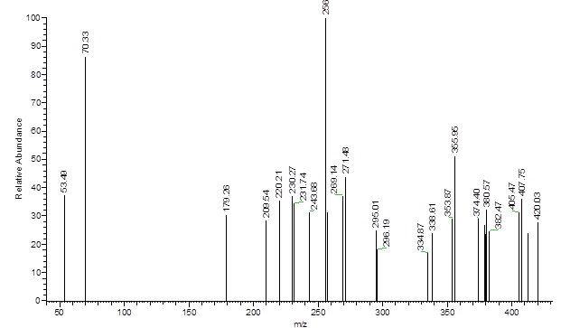

Figure 36. Mass spectrum of compound 6i

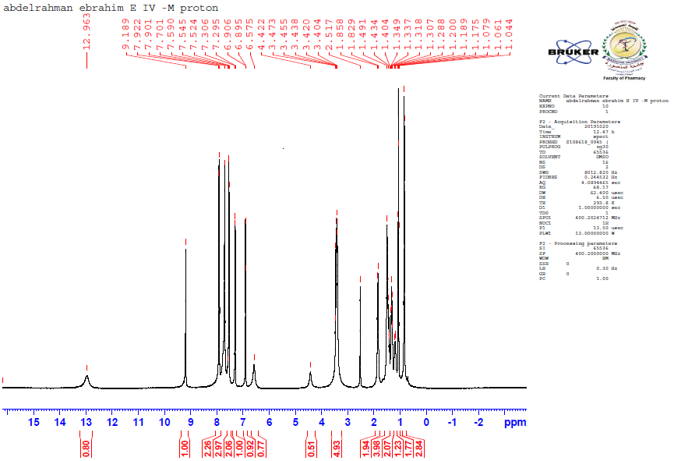
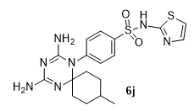

Figure 37. ¹H NMR (400 MHz, DMSO-d₆) spectrum of compound 6j
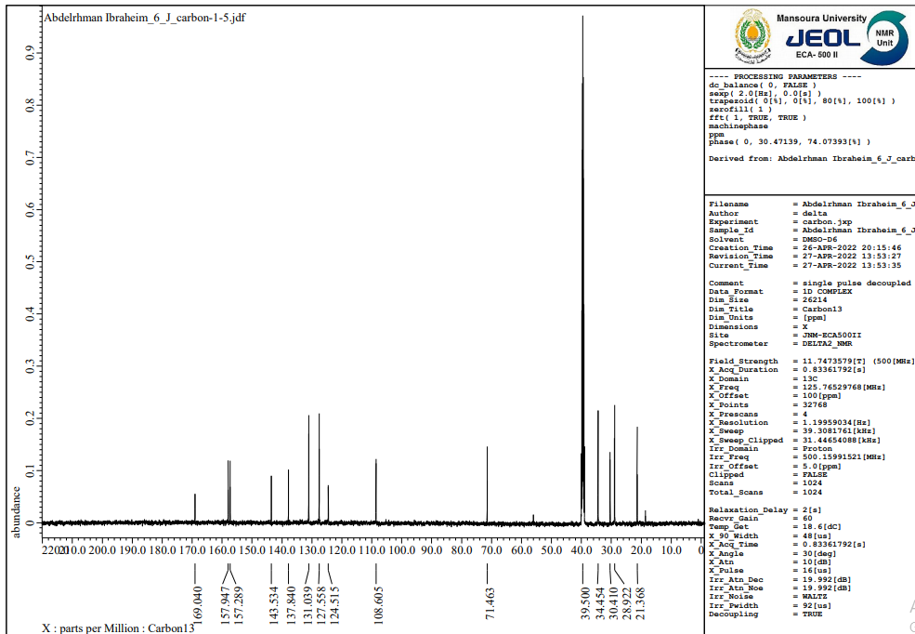

Figure 38. ¹³C NMR (100 MHz, DMSO) spectrum of compound 6j

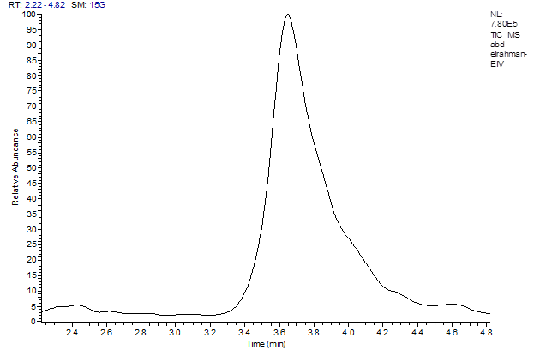

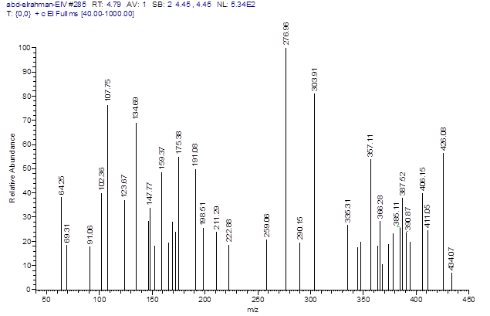

Figure 39. Mass spectrum of compound 6j

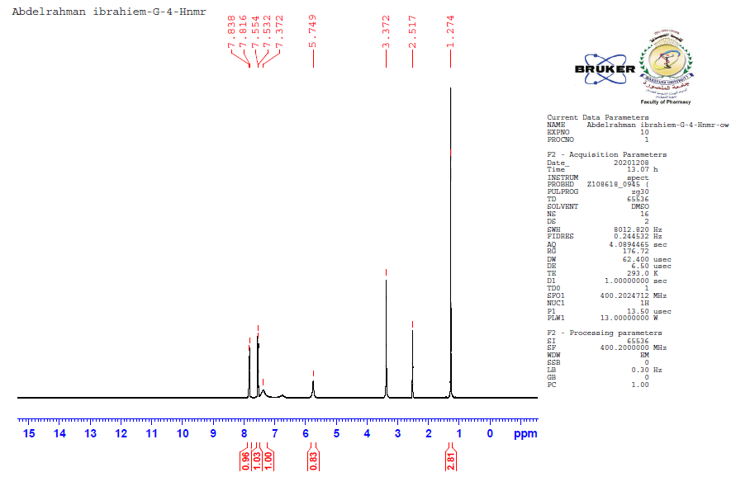
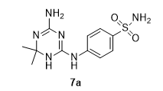

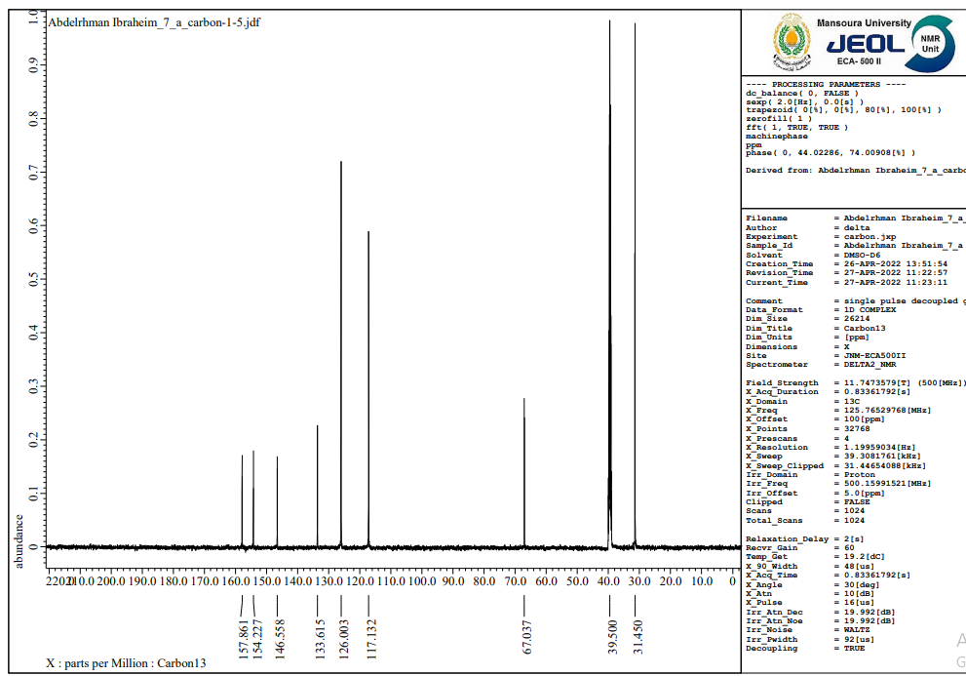
Figure 40. ¹H NMR (400 MHz, DMSO-d₆) spectrum of compound 7a

Figure 41. ¹³C NMR (100 MHz, DMSO) spectrum of compound 7a

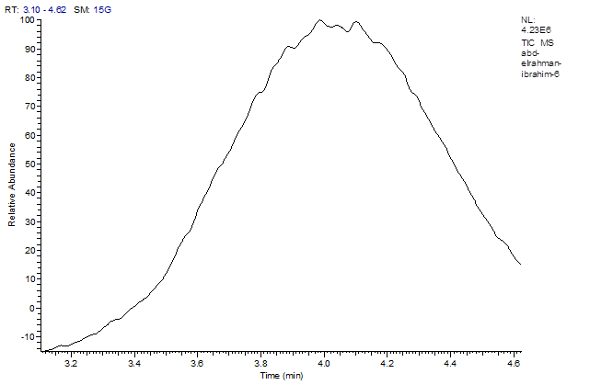

Figure 42. Mass spectrum of compound 7a

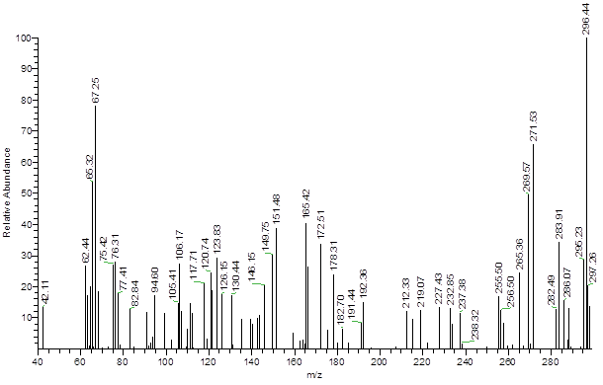

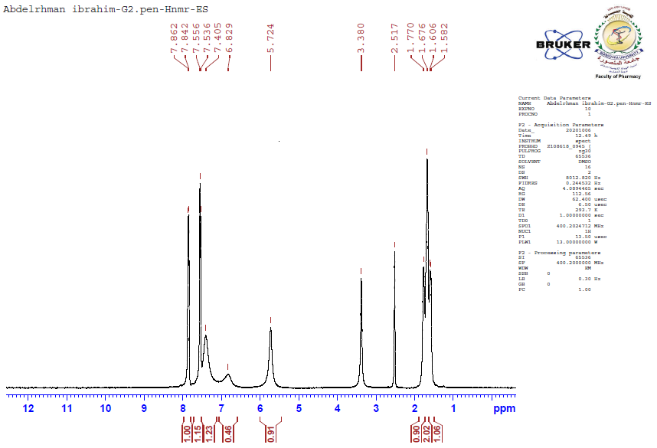

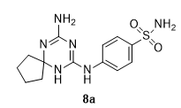

Figure 43. 1H NMR (400 MHz, DMSO-d6) spectrum of compound 8a

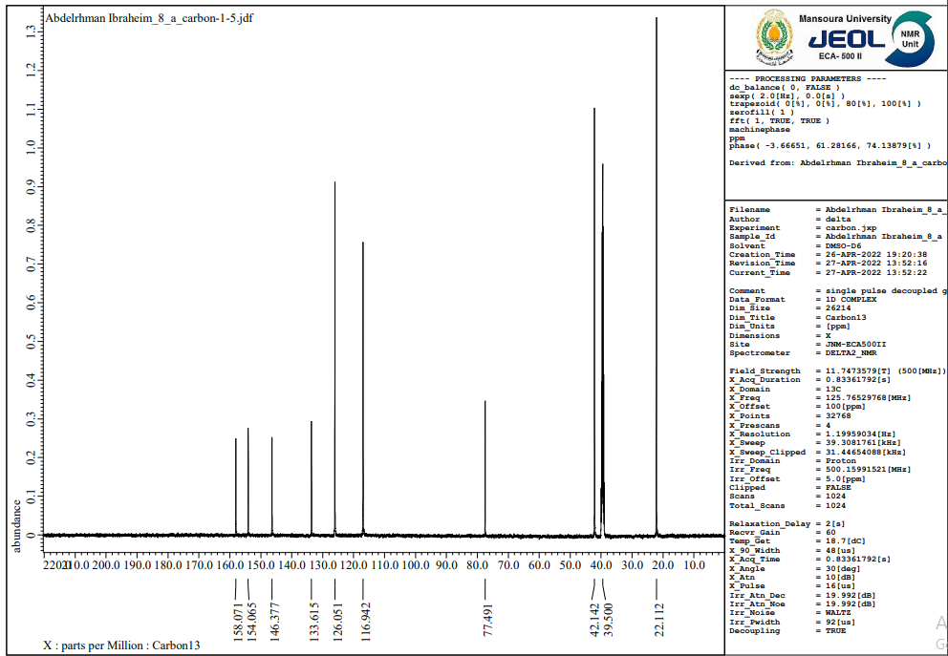

Figure 44. ¹³C NMR (100 MHz, DMSO) spectrum of compound 8a

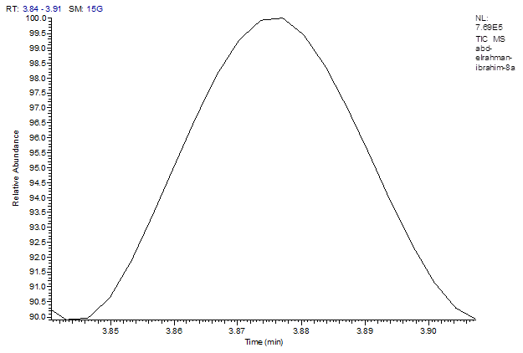

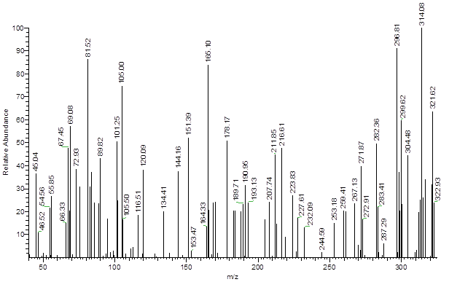

Figure 45. Mass spectrum of compound 8a

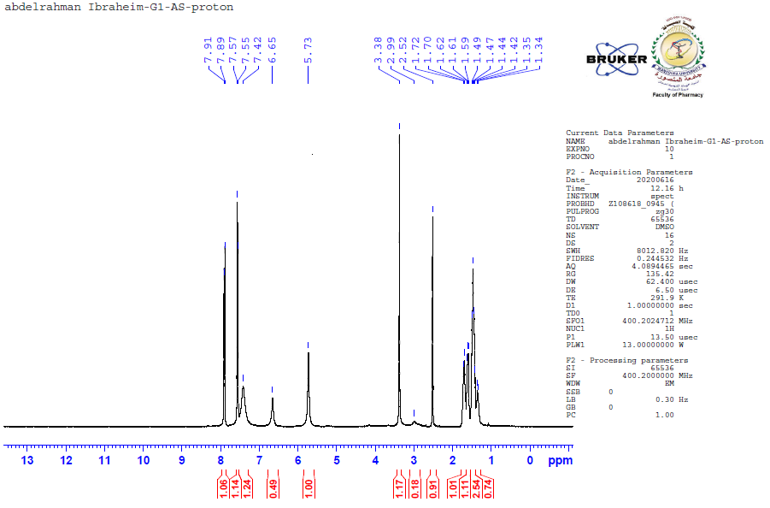
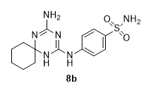

Figure 46. 1H NMR (400 MHz, DMSO-d6) spectrum of compound 8b
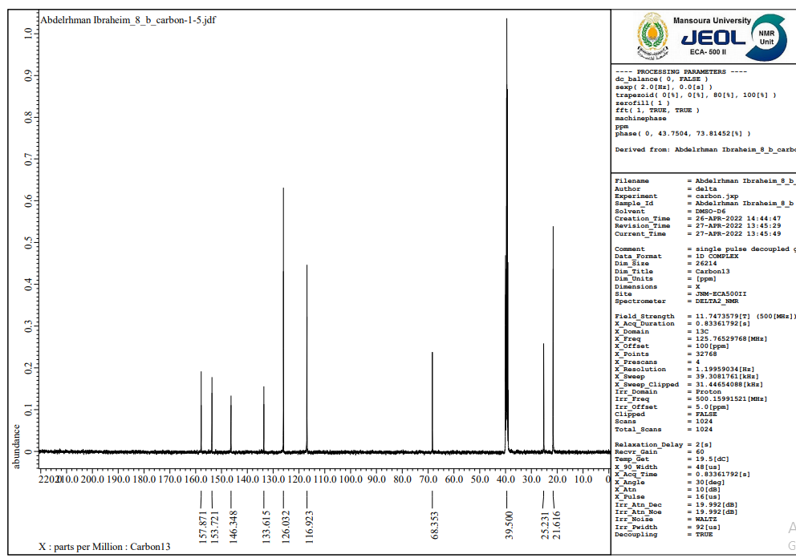

Figure 47. ¹³C NMR (100 MHz, DMSO) spectrum of compound 8b

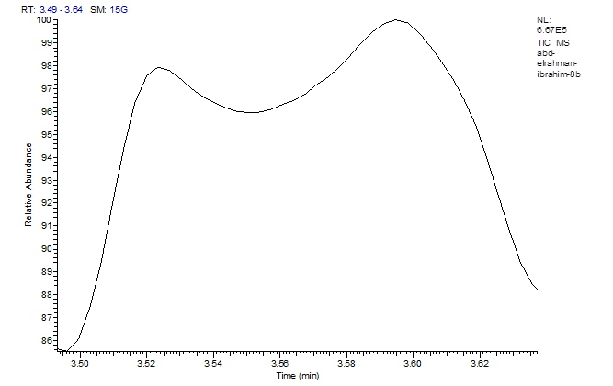
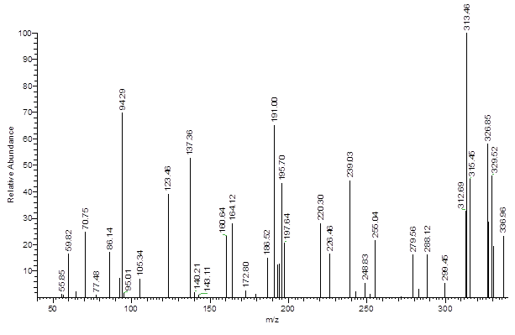

Figure 48. Mass spectrum of compound 8b

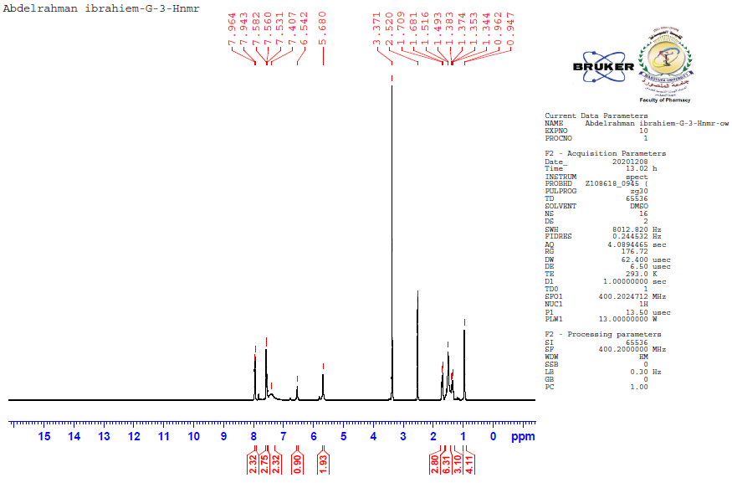
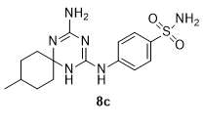

Figure 49. 1H NMR (400 MHz, DMSO-d6) spectrum of compound 8c
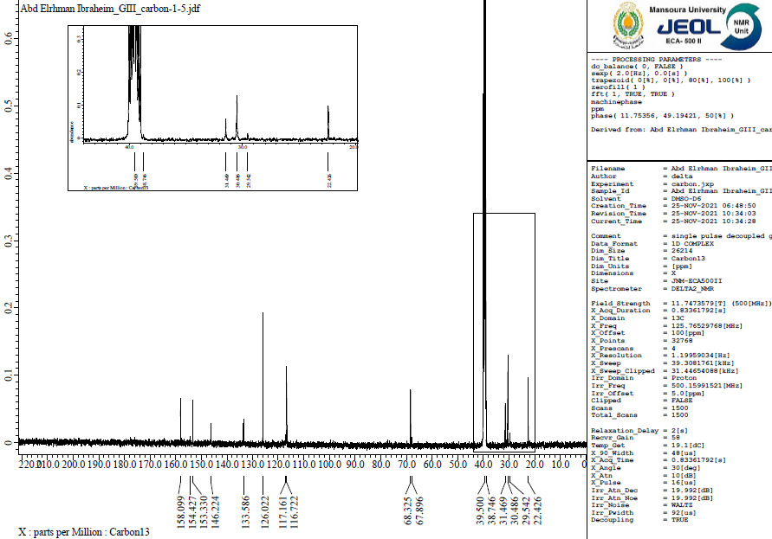

Figure 50. ¹³C NMR (100 MHz, DMSO) spectrum of compound 8c

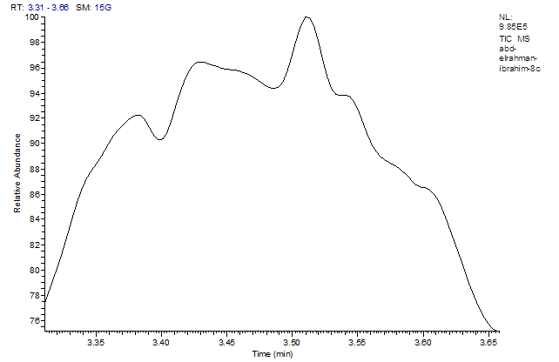
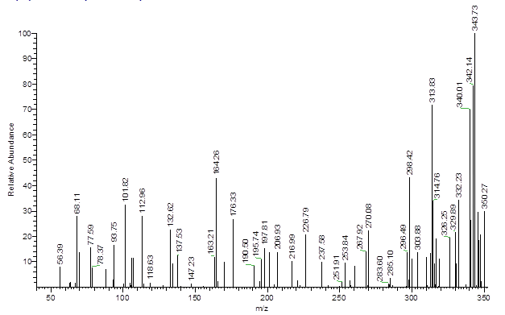

Figure 51. Mass spectrum of compound 8c

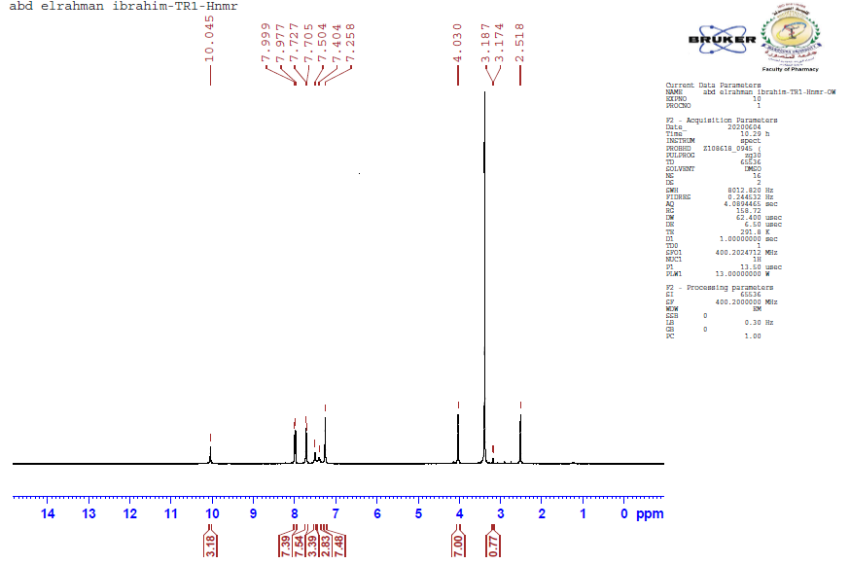
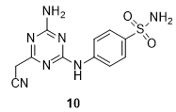

Figure 52. 1H NMR (400 MHz, DMSO-d6) spectrum of compound 10
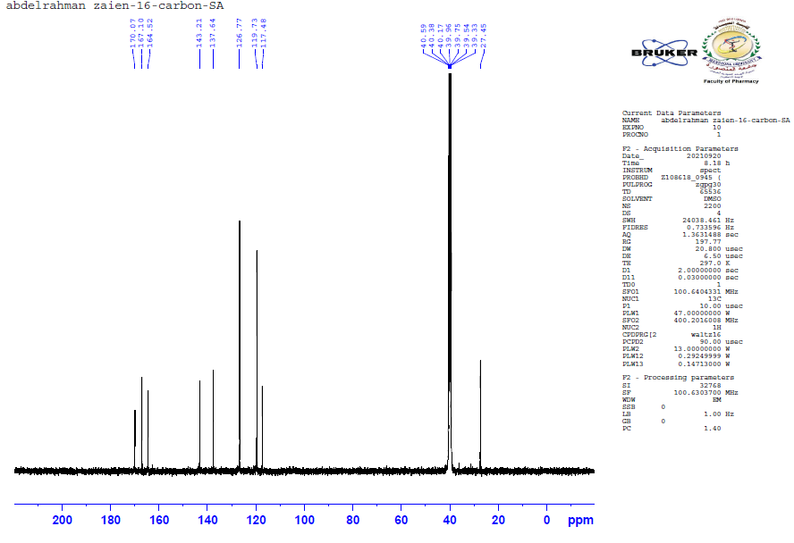

Figure 53. ¹³C NMR (100 MHz, DMSO) spectrum of compound 10

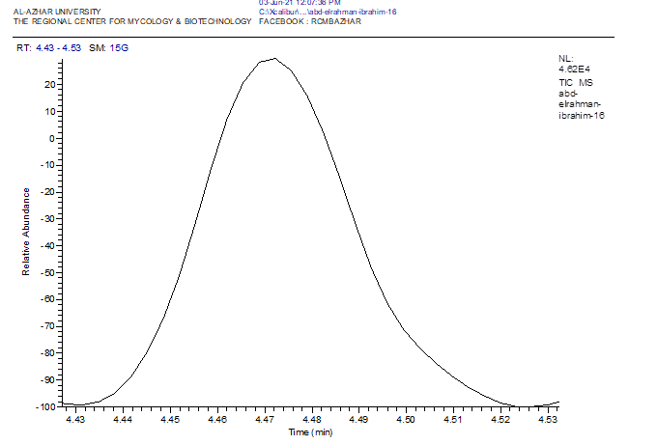
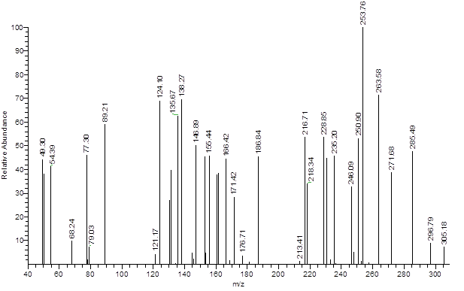

Figure 54. Mass spectrum of compound 10

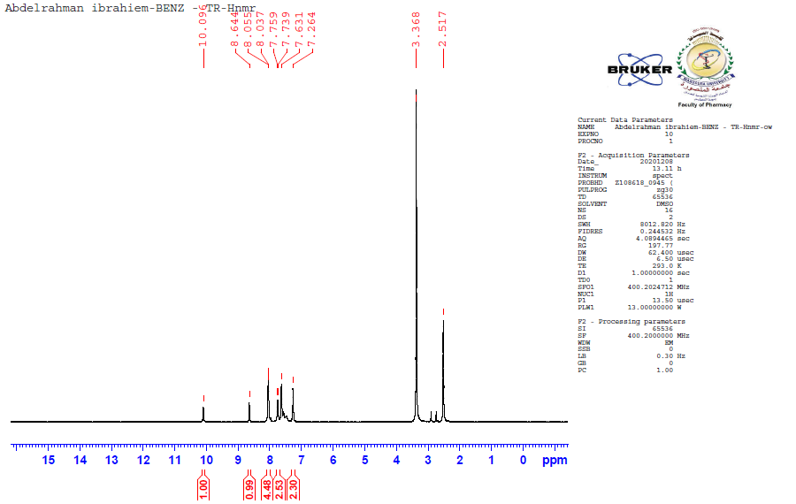
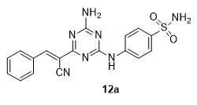

Figure 55. 1H NMR (400 MHz, DMSO-d6) spectrum of compound 12a
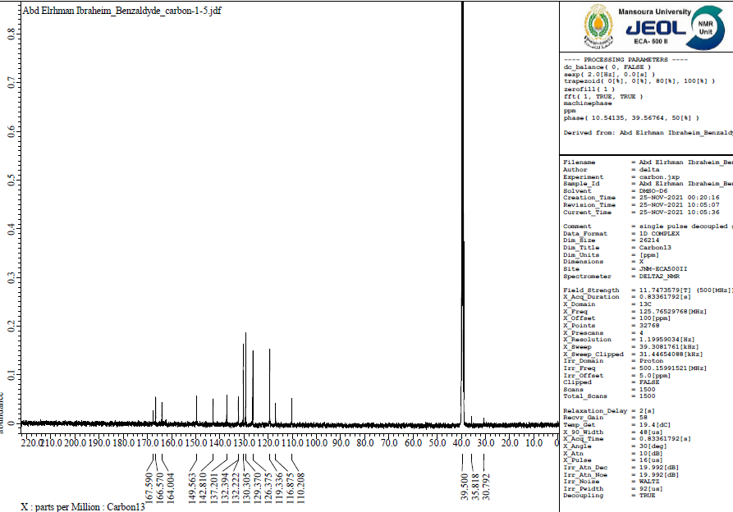

Figure 56. ¹³C NMR (100 MHz, DMSO) spectrum of compound 12a

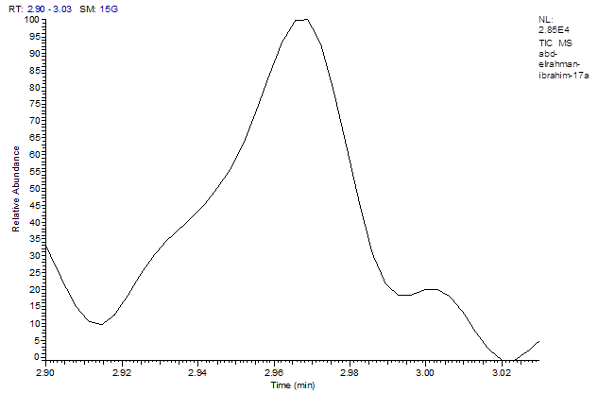

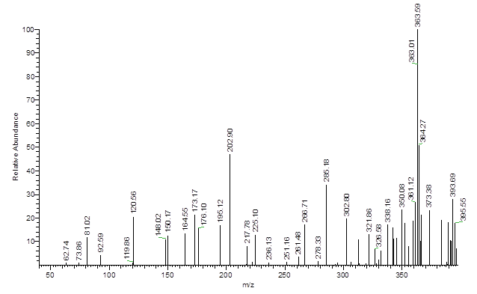

Figure 57. Mass spectrum of compound 12a

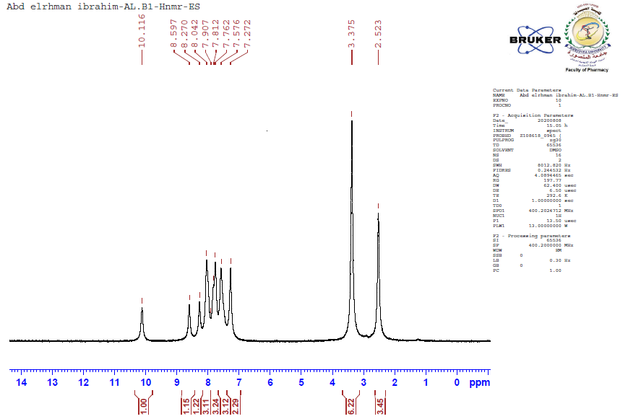
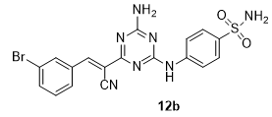

Figure 58. 1H NMR (400 MHz, DMSO-d6) spectrum of compound 12b
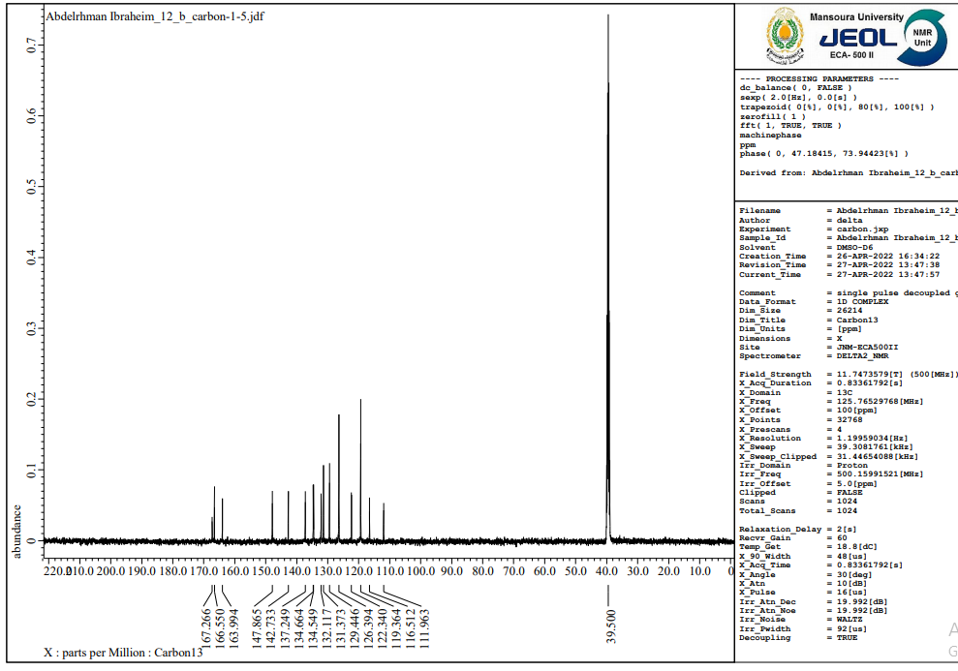

Figure 59. ¹³C NMR (100 MHz, DMSO) spectrum of compound 12b

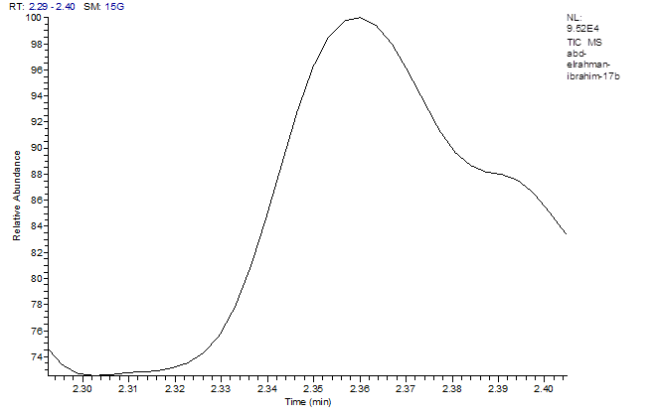

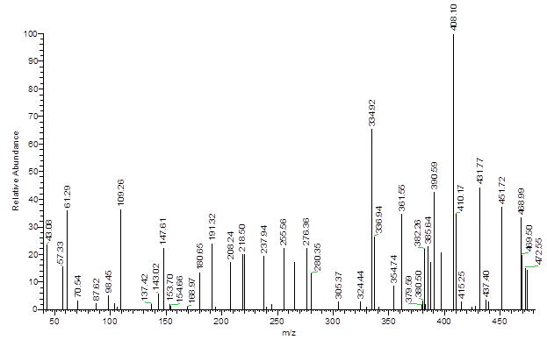

Figure 60. Mass spectrum of compound 12b

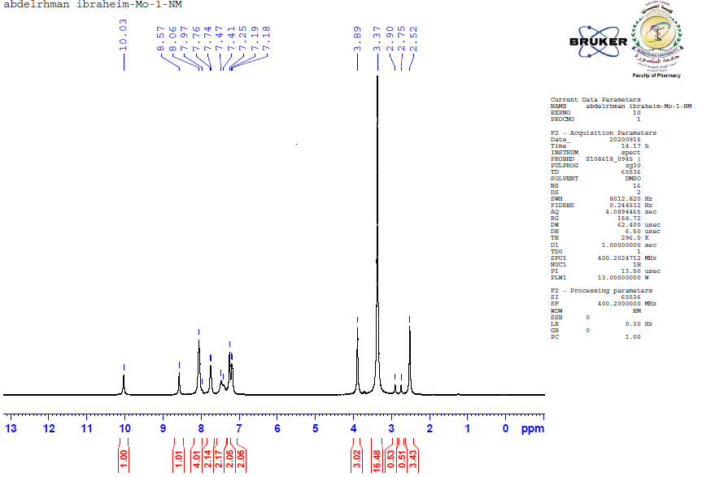

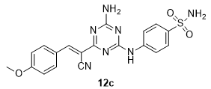

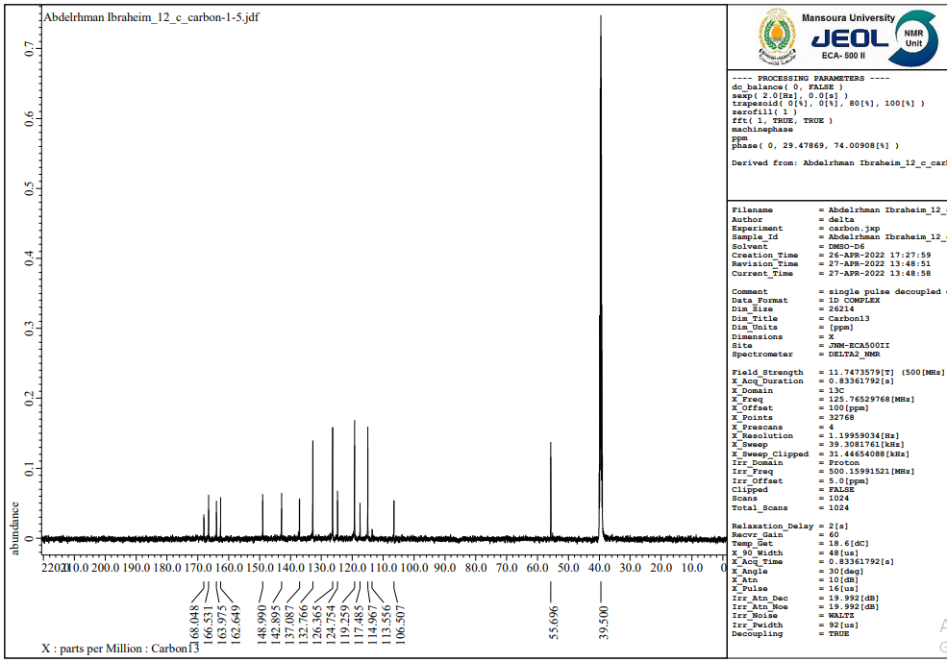
Figure 61. 1H NMR (400 MHz, DMSO-d6) spectrum of compound 12c

Figure 62. ¹³C NMR (100 MHz, DMSO) spectrum of compound 12c

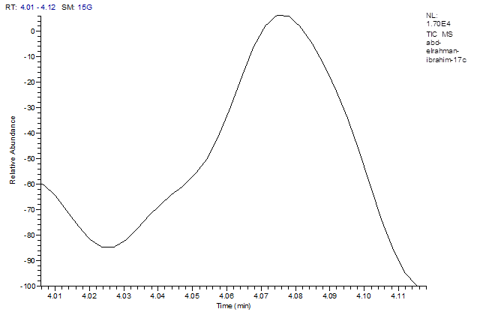

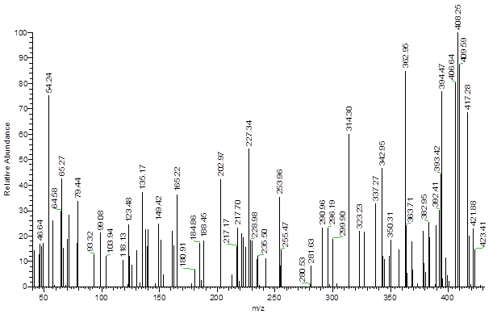

Figure 63. Mass spectrum of compound 12c

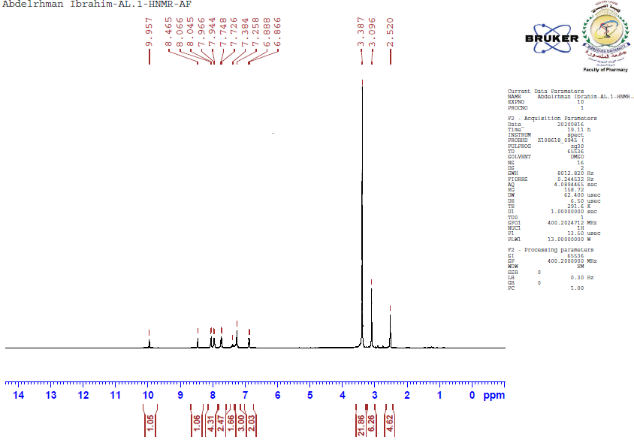
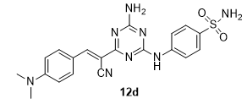

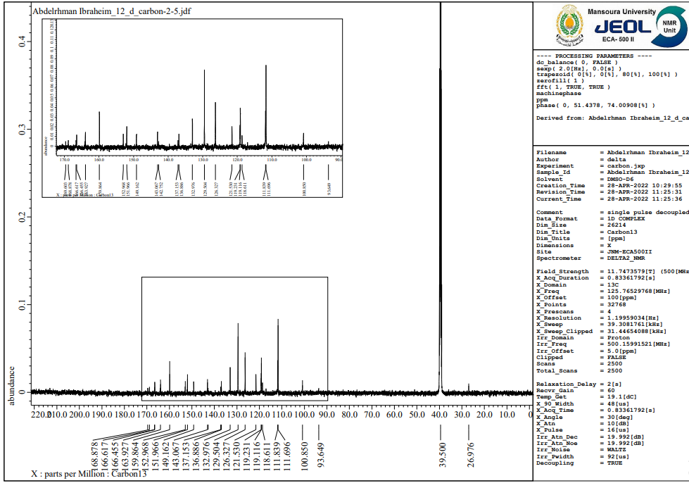
Figure 64. 1H NMR (400 MHz, DMSO-d6) spectrum of compound 12d

Figure 65. ¹³C NMR (100 MHz, DMSO) spectrum of compound 12d
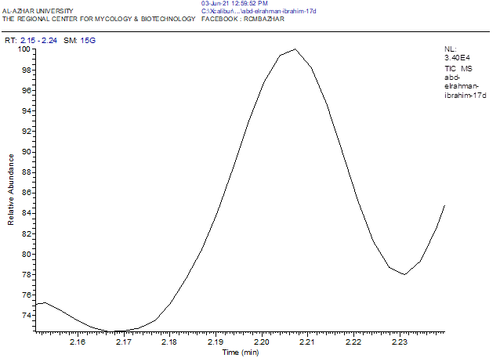

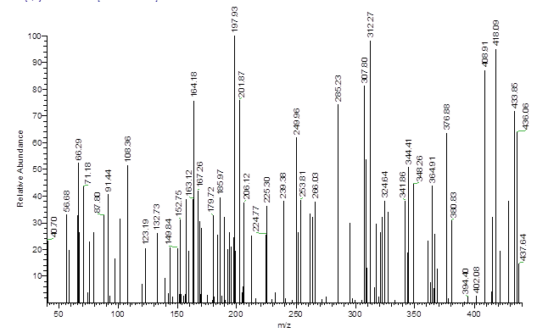

Figure 66. Mass spectrum of compound 12d

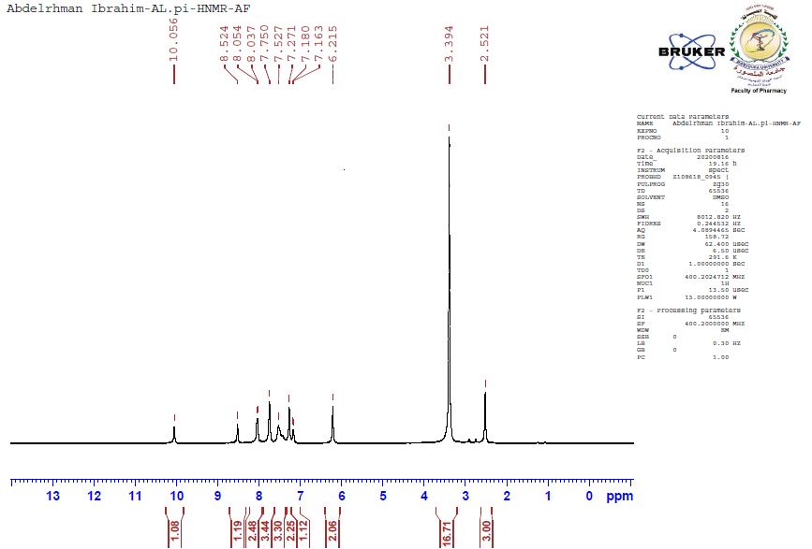

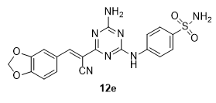

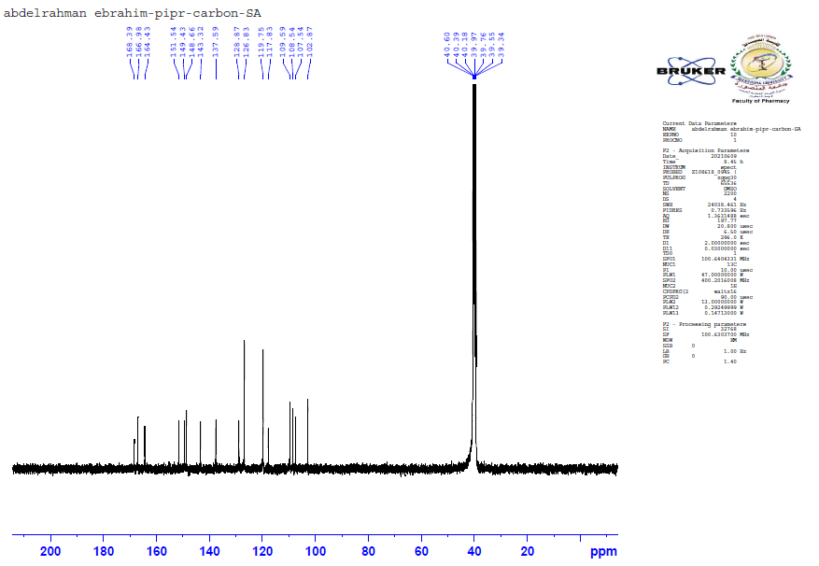
Figure 67. 1H NMR (400 MHz, DMSO-d6) spectrum of compound 12e

Figure 68. ¹³C NMR (100 MHz, DMSO) spectrum of compound 12e

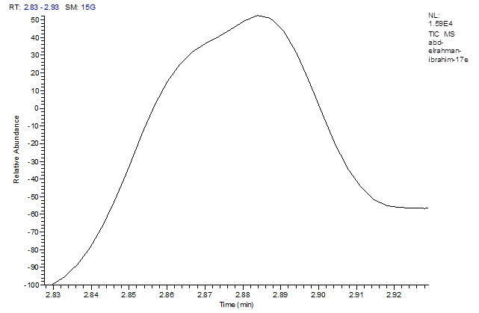

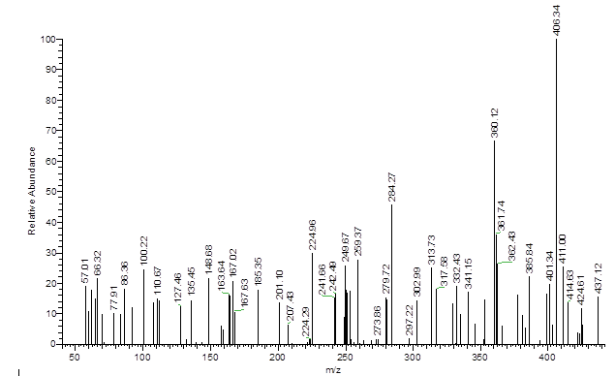

Figure 69. Mass spectrum of compound 12e

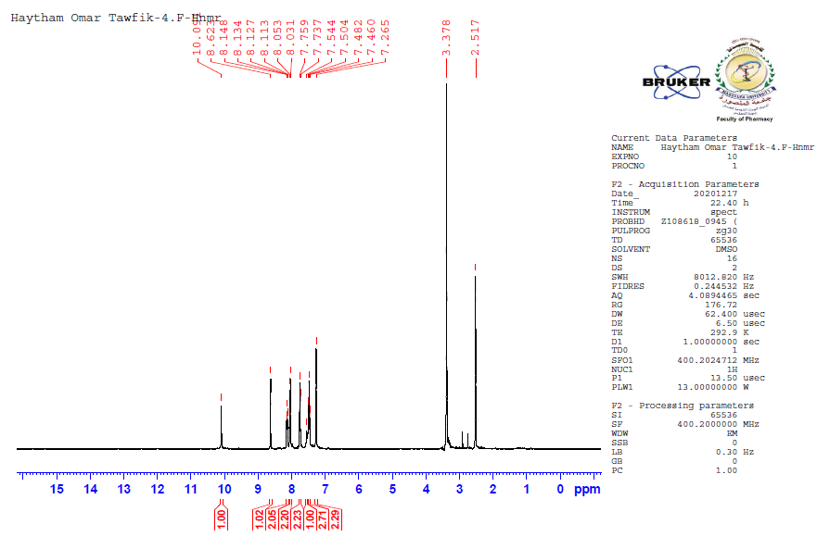
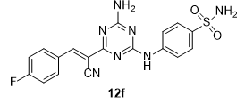

Figure 70. 1H NMR (400 MHz, DMSO-d6) spectrum of compound 12f
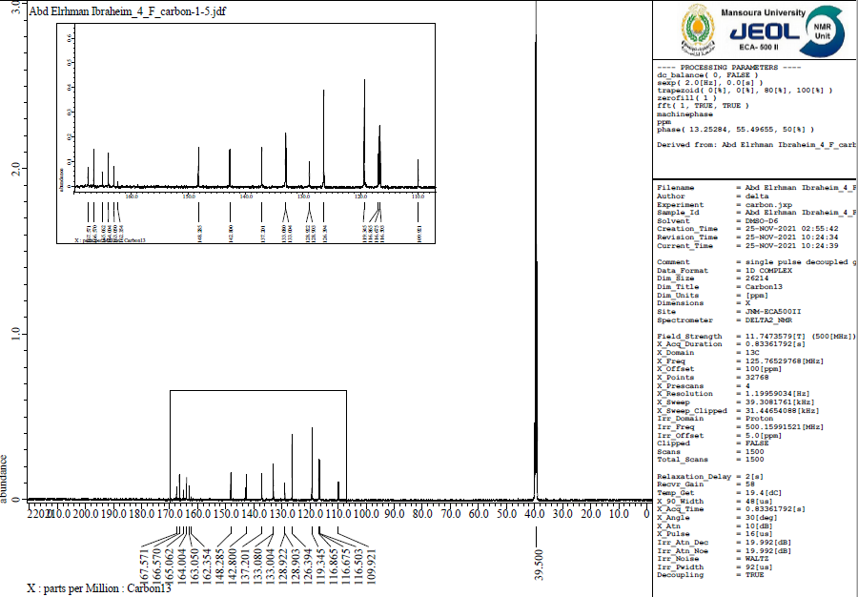

Figure 71. ¹³C NMR (100 MHz, DMSO) spectrum of compound 12f

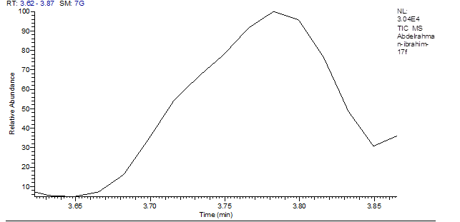

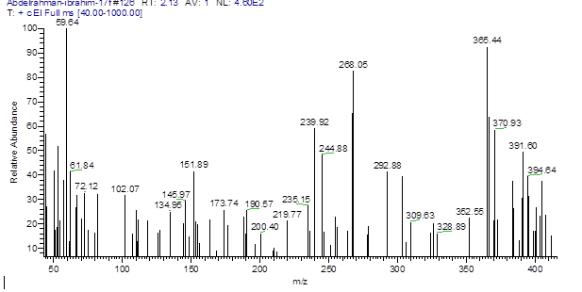

Figure 72. Mass spectrum of compound 12f

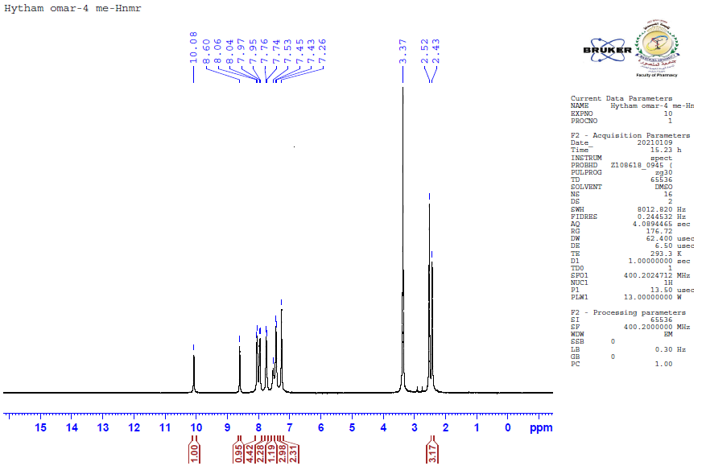
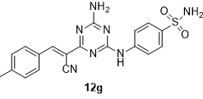

Figure 73. 1H NMR (400 MHz, DMSO-d6) spectrum of compound 12g
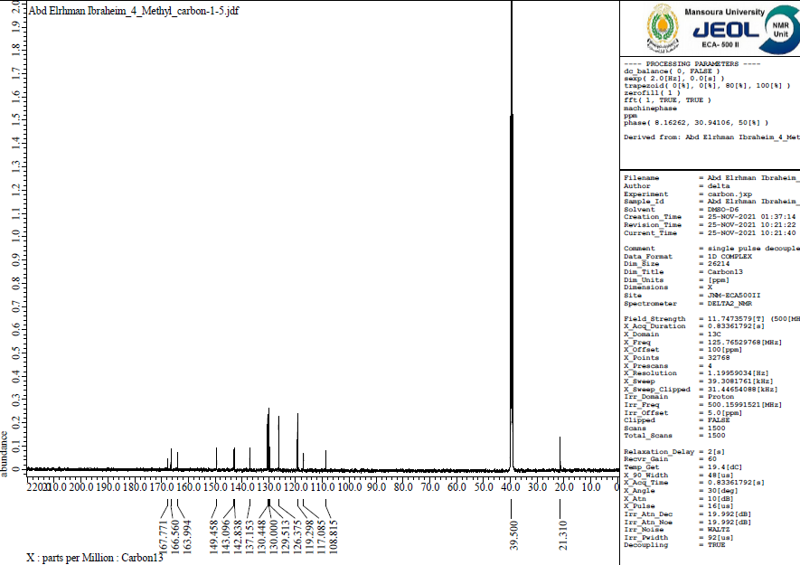

Figure 74. ¹³C NMR (100 MHz, DMSO) spectrum of compound 12g

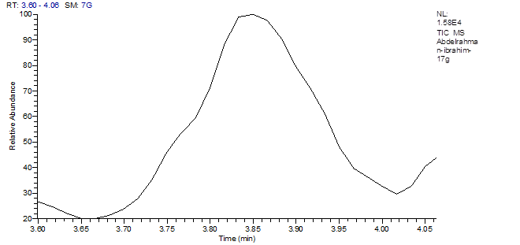

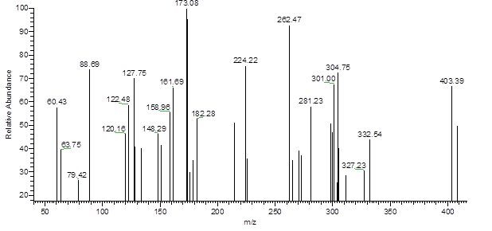

Figure 75. Mass spectrum of compound 12g

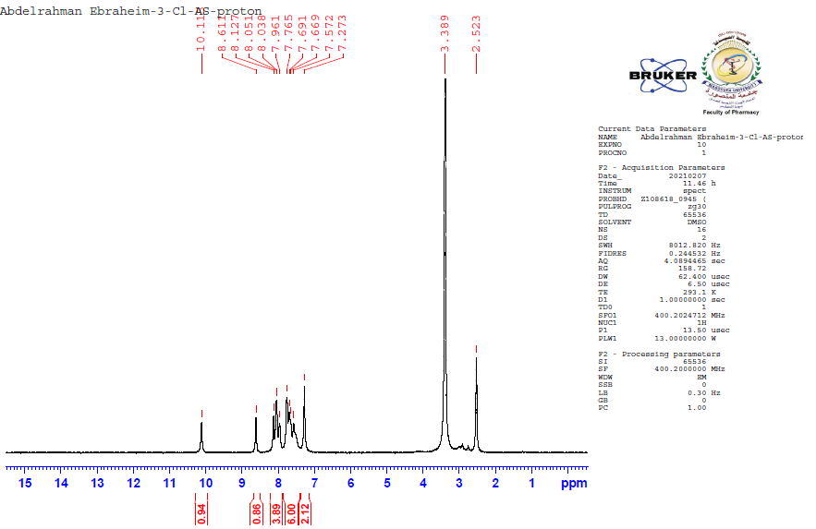
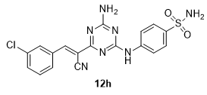

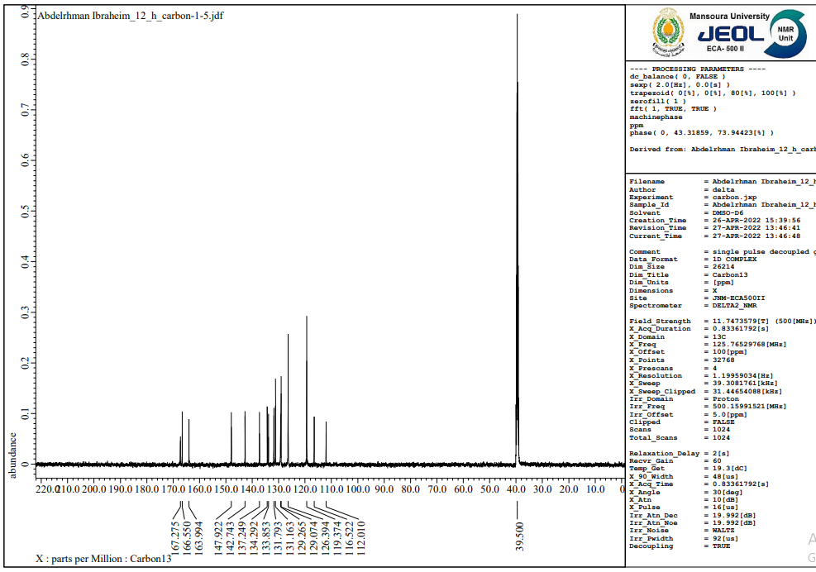
Figure 76. 1H NMR (400 MHz, DMSO-d6) spectrum of compound 12h

Figure 77. ¹³C NMR (100 MHz, DMSO) spectrum of compound 12h

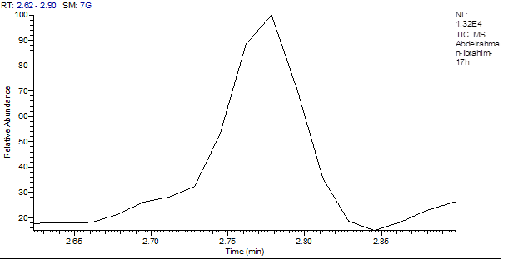

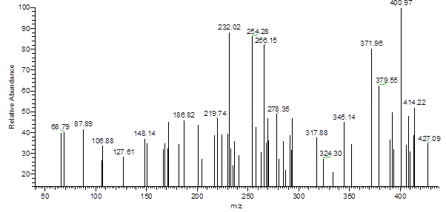

Figure 78. Mass spectrum of compound 12h

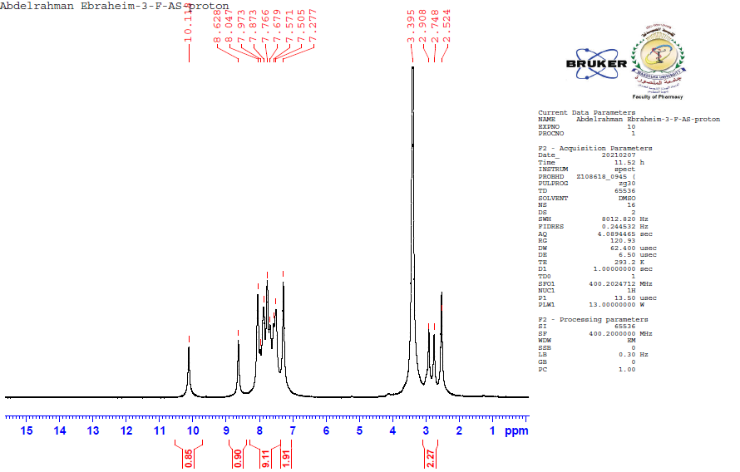

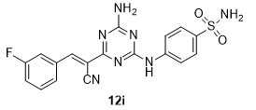

Figure 79. 1H NMR (400 MHz, DMSO-d6) spectrum of compound 12i
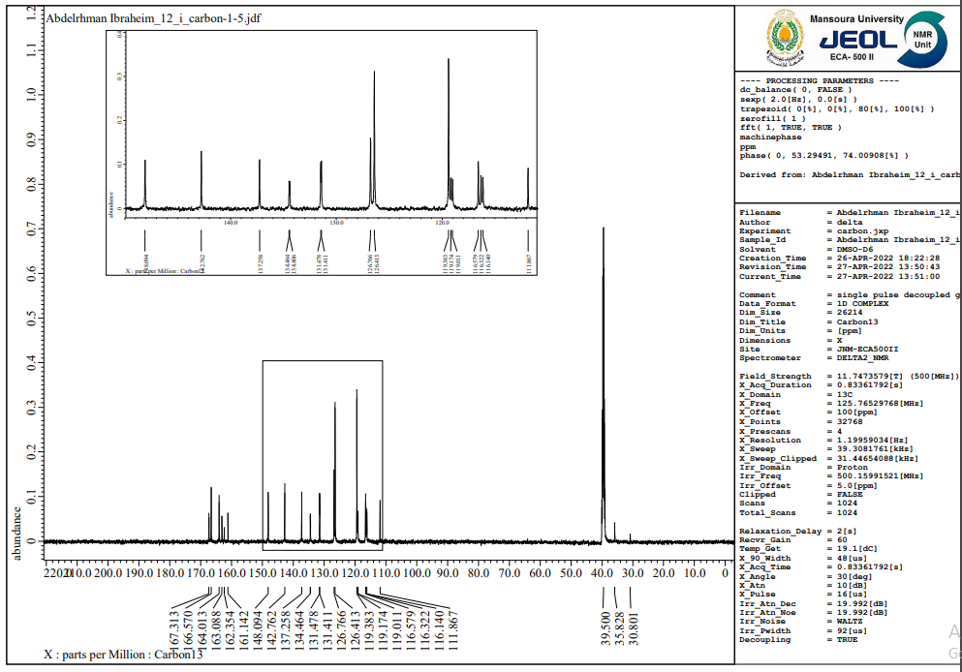

Figure 80. ¹³C NMR (100 MHz, DMSO) spectrum of compound 12i

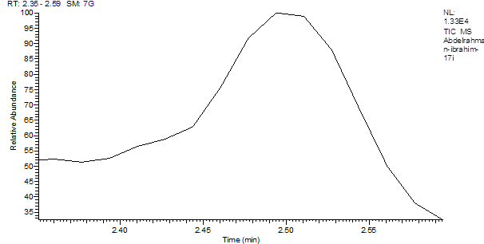

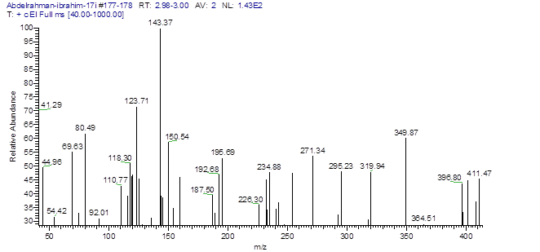
Figure 81. Mass spectrum of compound 12i

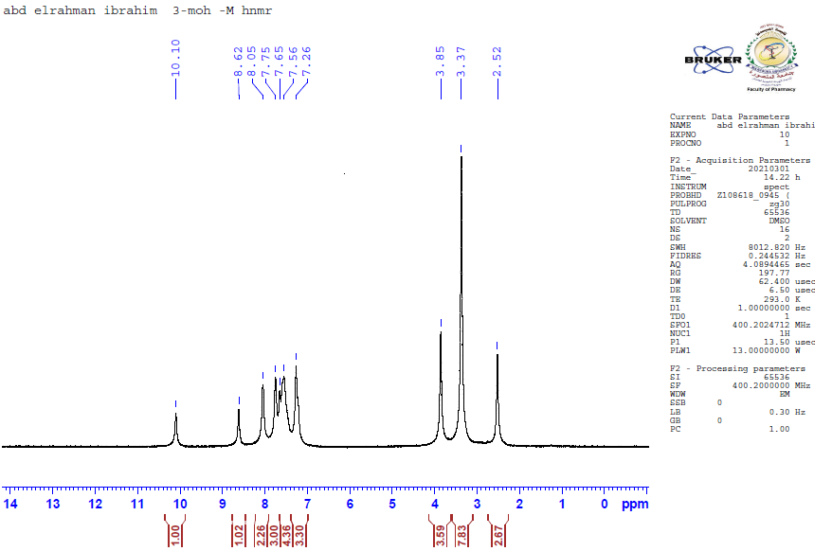

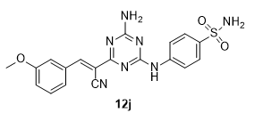

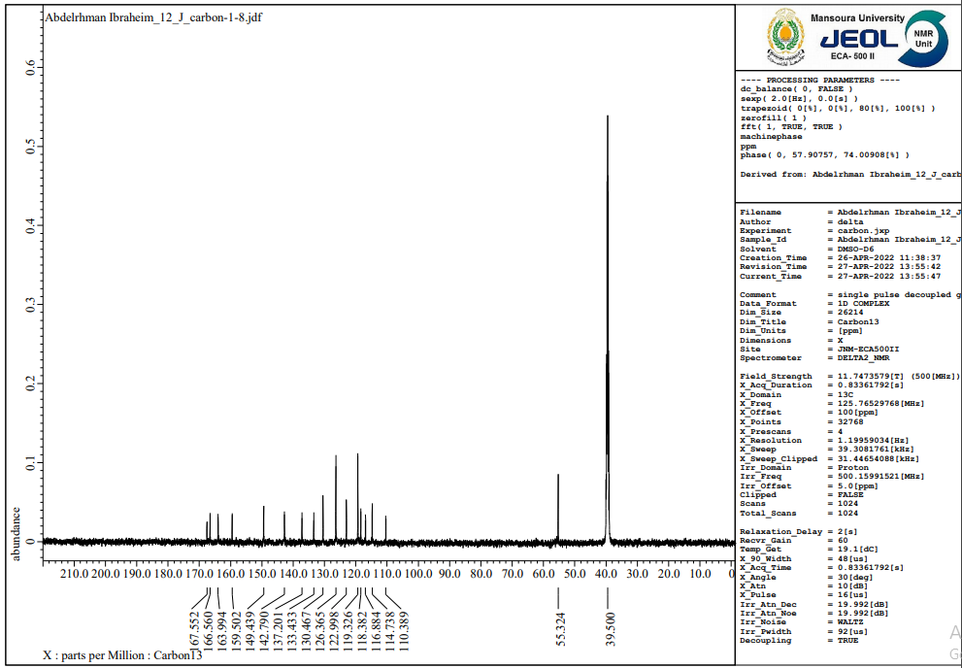
Figure 82. 1H NMR (400 MHz, DMSO-d6) spectrum of compound 12j

Figure 83. ¹³C NMR (100 MHz, DMSO) spectrum of compound 12j

Figure 84. Mass spectrum of compound 12j

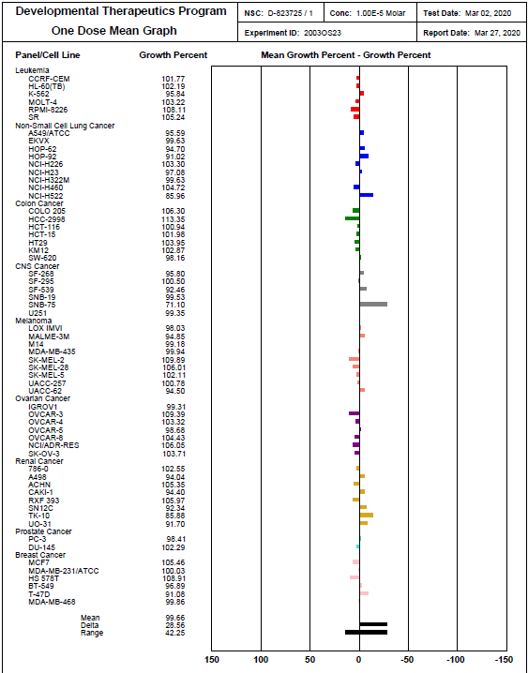

Figure 85. One dose mean graph for compound 5a at 10 μM

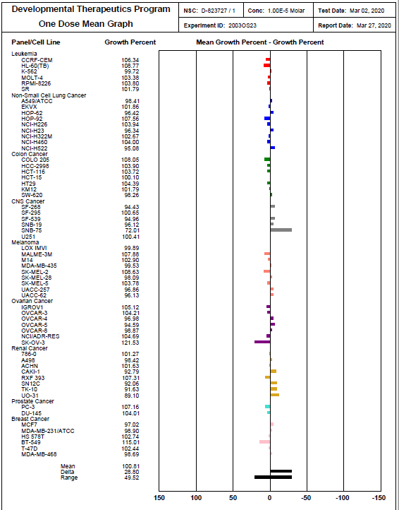

Figure 86. One dose mean graph for compound 5b at 10 μM

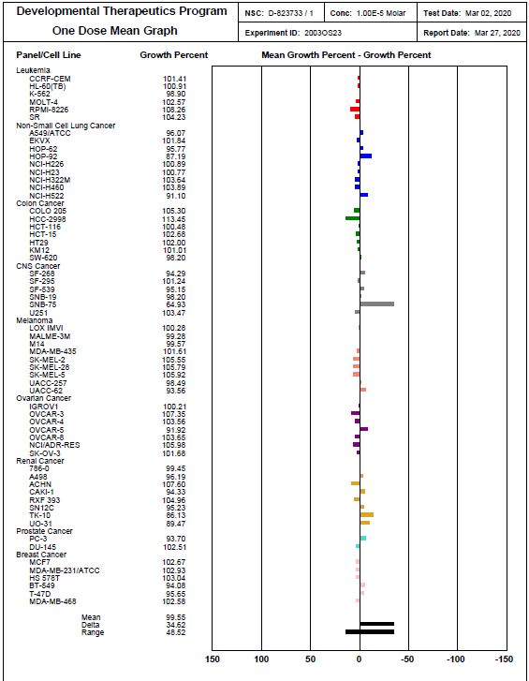

Figure 87. One dose mean graph for compound 5c at 10 μM

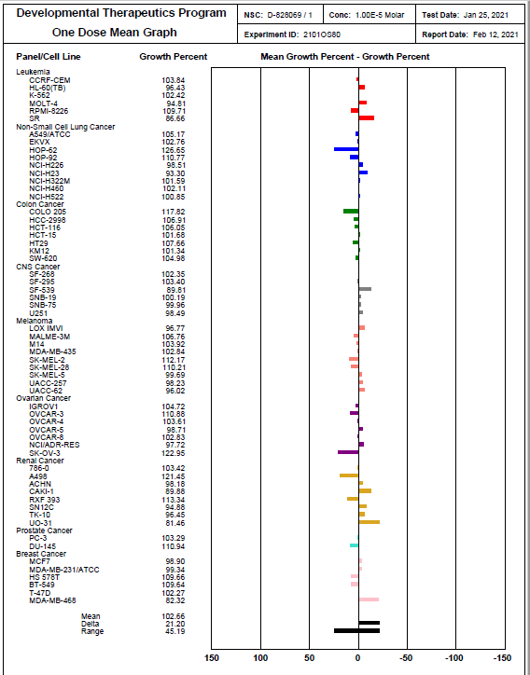
Figure 88. One dose mean graph for compound 6a at 10 μM

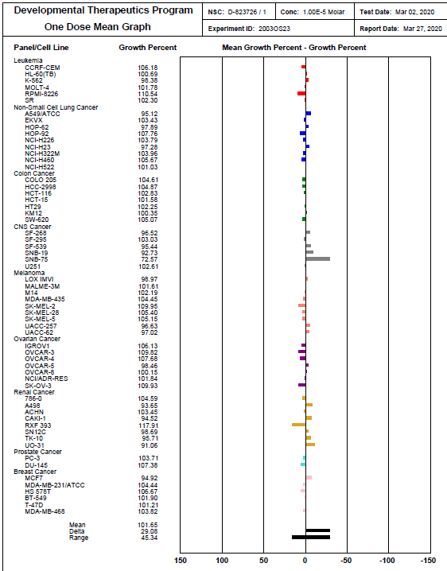
Figure 89. One dose mean graph for compound 6b at 10 μM

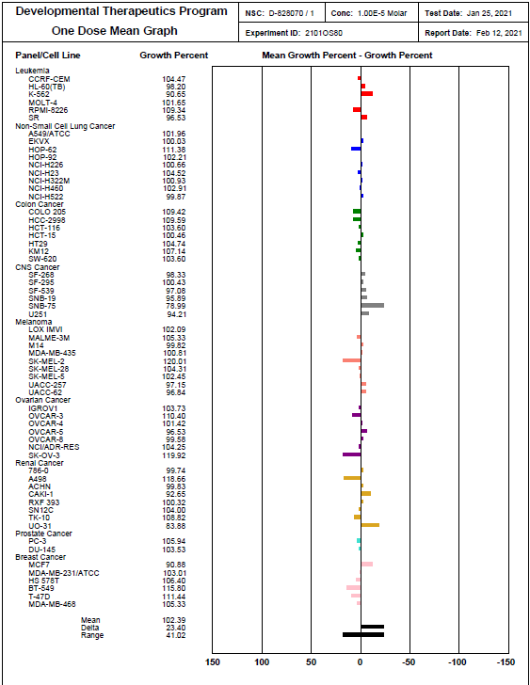
Figure 90. One dose mean graph for compound 6c at 10 μM

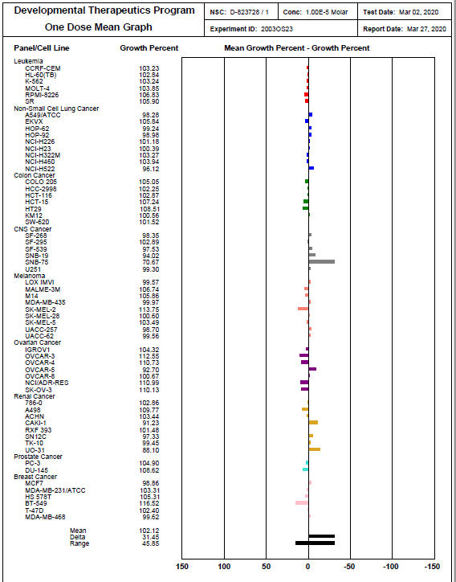
Figure 91. One dose mean graph for compound 6d at 10 μM

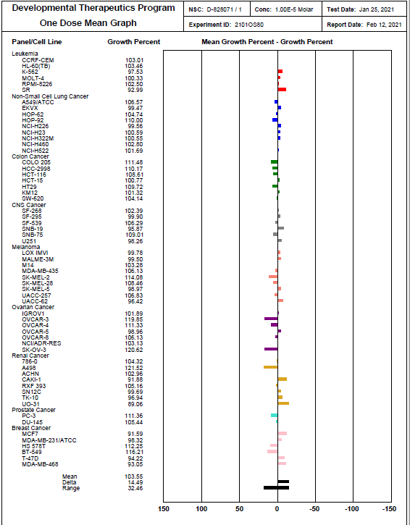
Figure 92. One dose mean graph for compound 6e at 10 μM

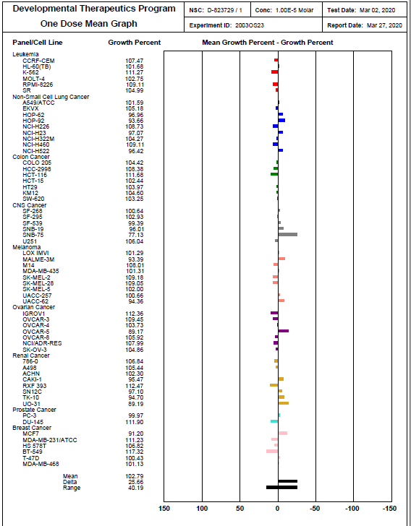
Figure 93. One dose mean graph for compound 6f at 10 μM

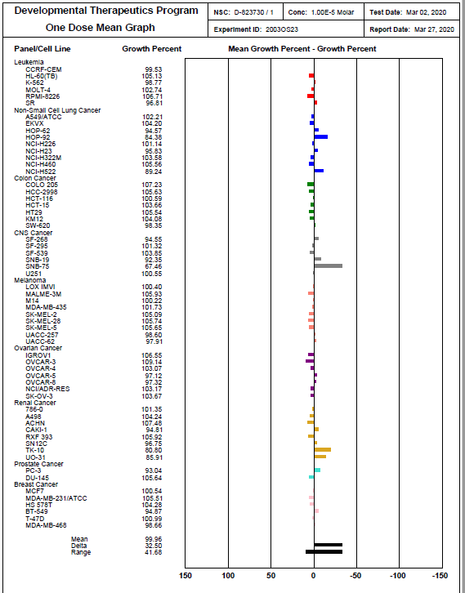
Figure 94. One dose mean graph for compound 6g at 10 μM

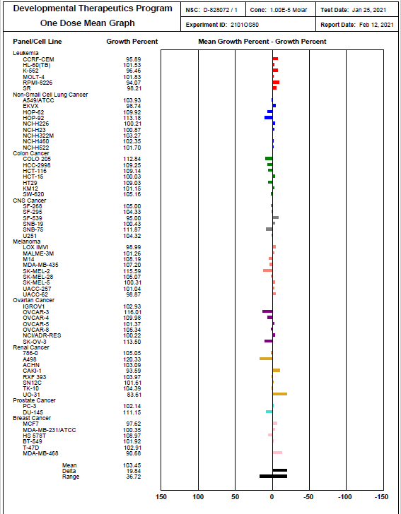
Figure 95. One dose mean graph for compound 6h at 10 μM

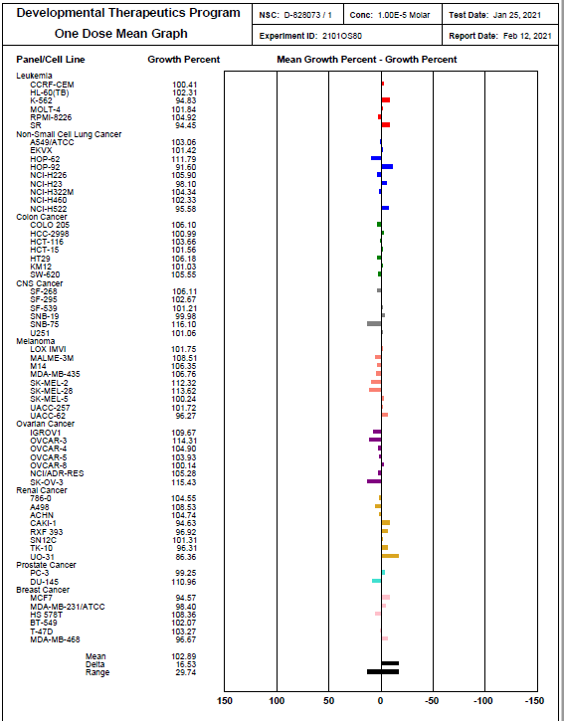
Figure 96. One dose mean graph for compound 6i at 10 μM

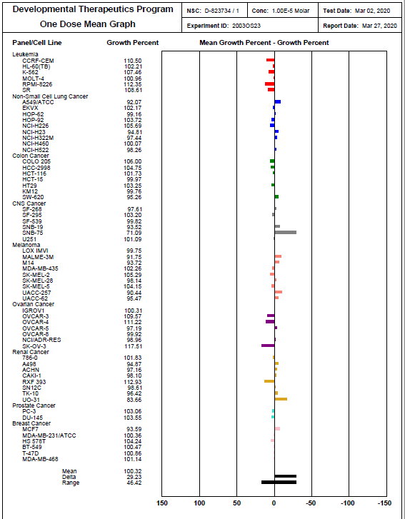
Figure 97. One dose mean graph for compound 6j at 10 μM

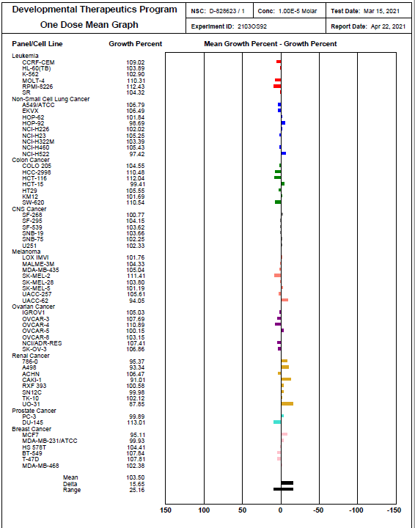
Figure 98. One dose mean graph for compound 7a at 10 μM

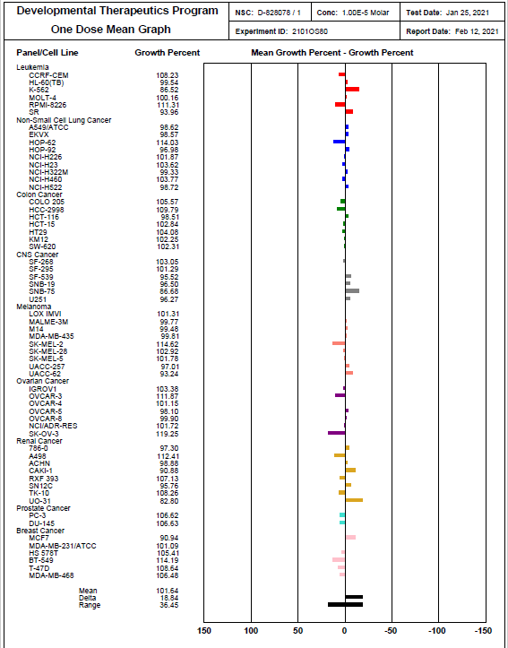
Figure 99. One dose mean graph for compound 8a at 10 μM

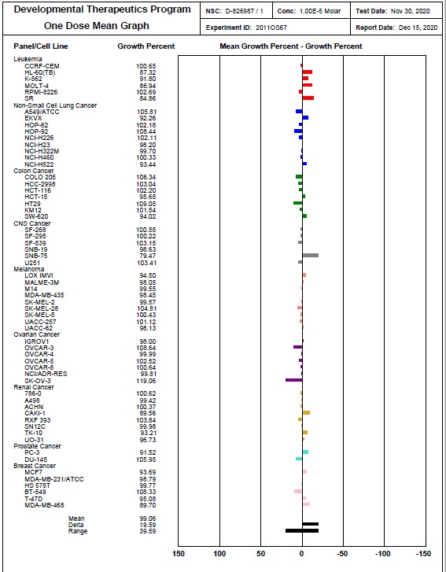
Figure 100. One dose mean graph for compound 8b at 10 μM

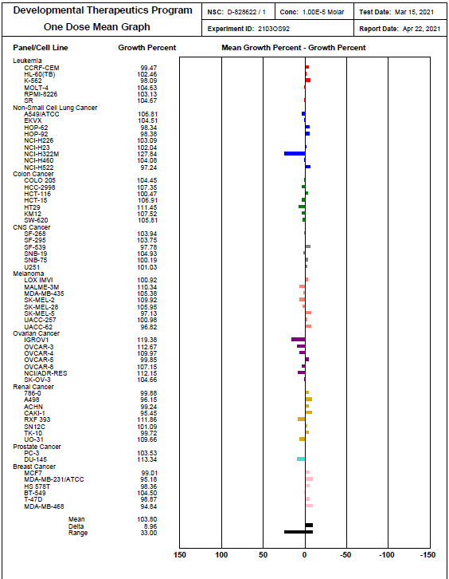
Figure 101. One dose mean graph for compound 8c at 10 μM

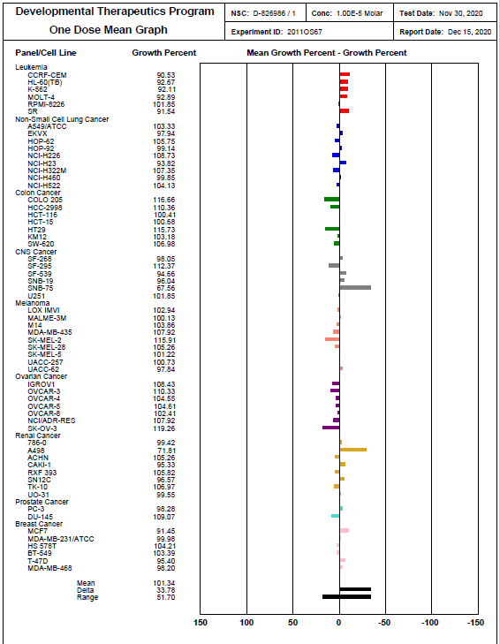
Figure 102. One dose mean graph for compound 10 at 10 μM

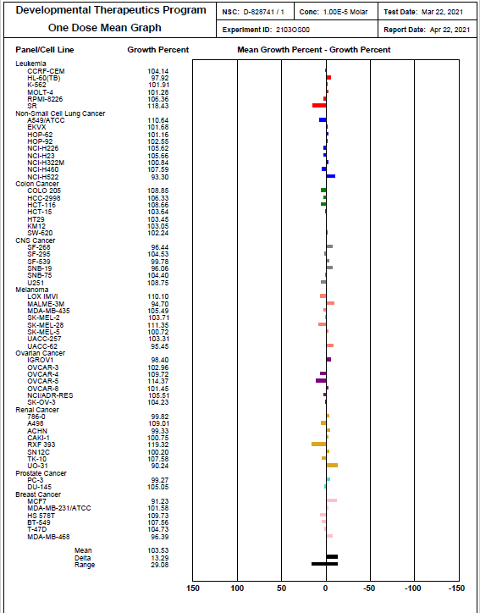
Figure 103. One dose mean graph for compound 12a at 10 μM

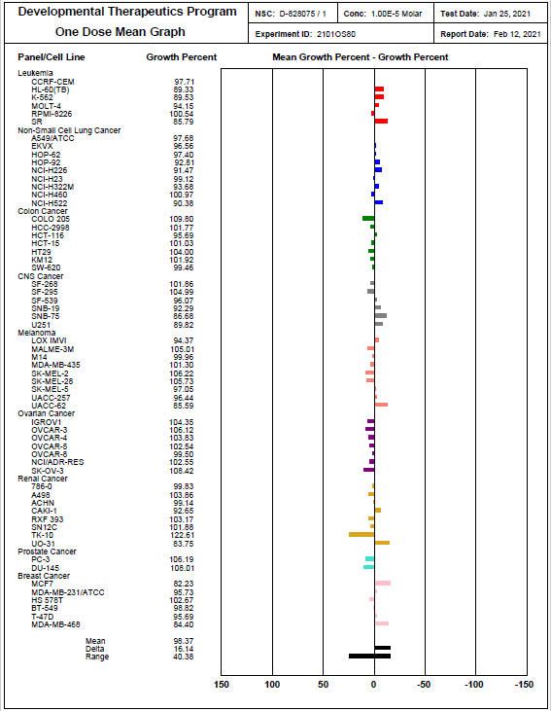
Figure 104. One dose mean graph for compound 12b at 10 μM

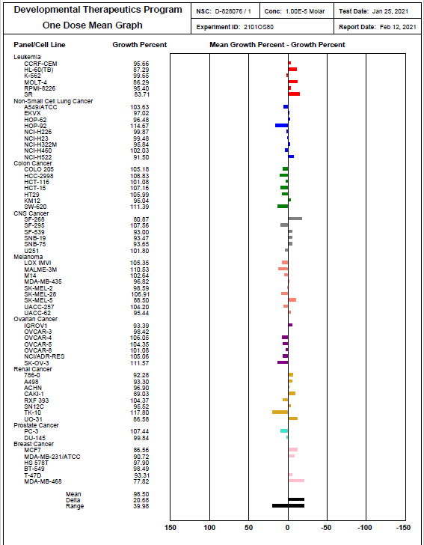

Figure 105. One dose mean graph for compound 12c at 10 μM

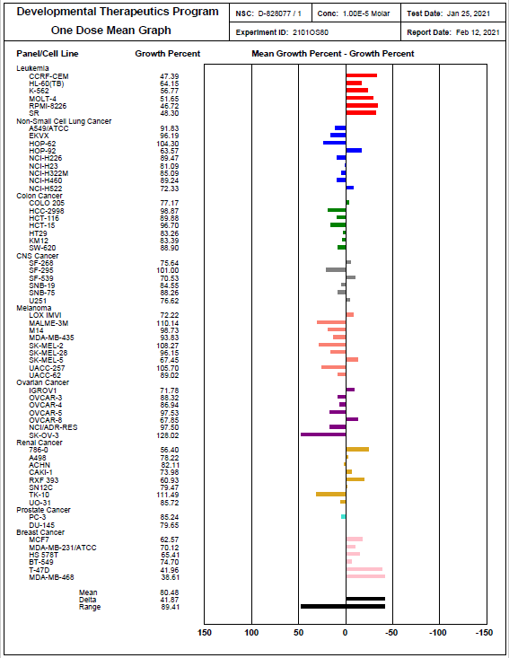
Figure 106. One dose mean graph for compound 12d at 10 μM

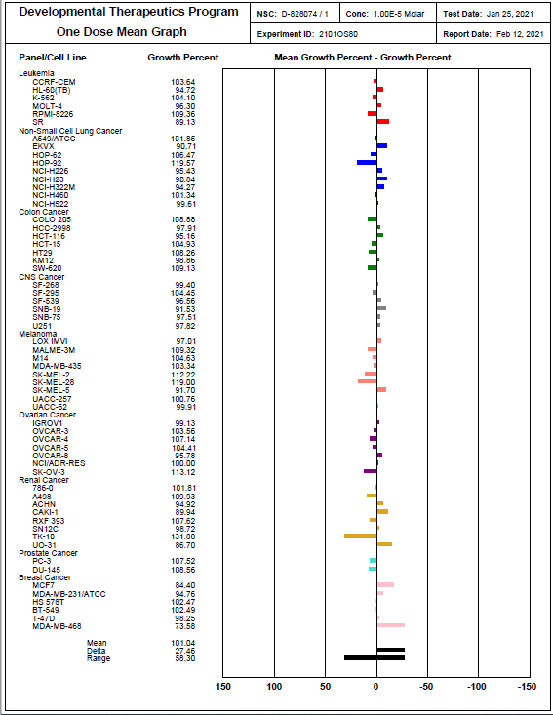

Figure 107. One dose mean graph for compound 12e at 10 μM

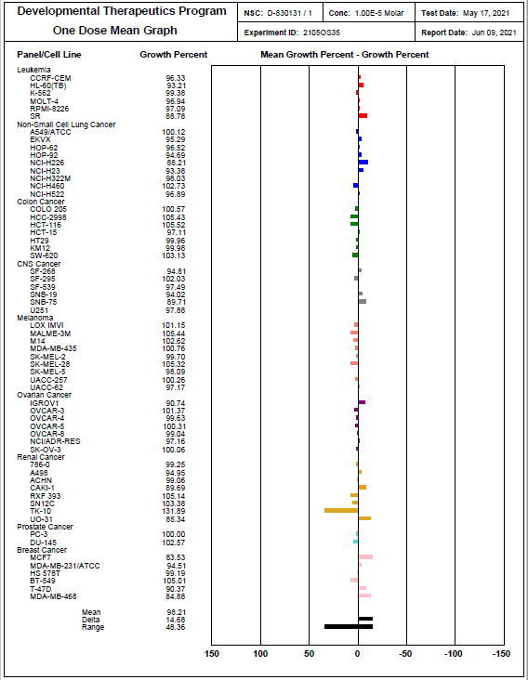
Figure 108. One dose mean graph for compound 12f at 10 μM

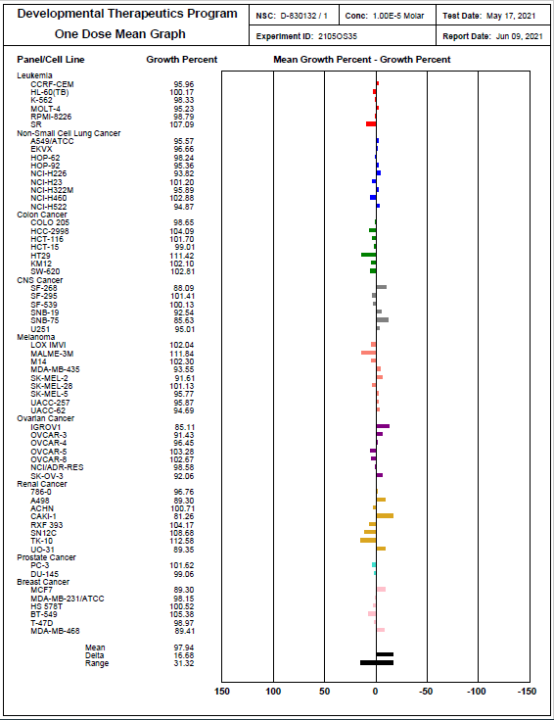
Figure 109. One dose mean graph for compound 12g at 10 μM

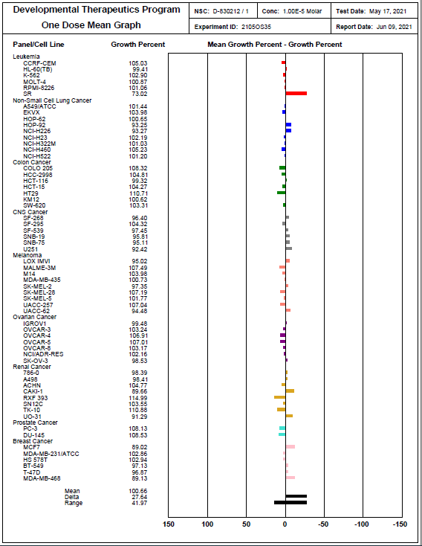
Figure 110. One dose mean graph for compound 12h at 10 μM

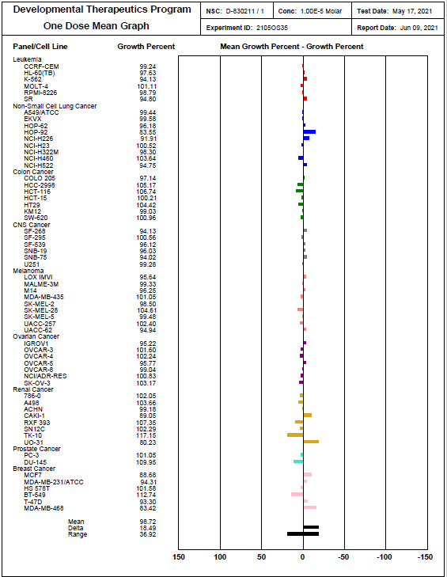
Figure 111. One dose mean graph for compound 12i at 10 μM

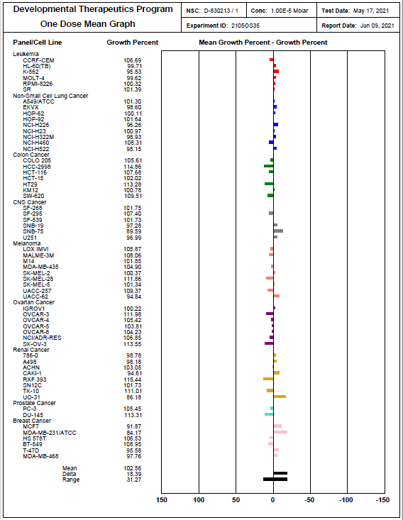
Figure 112. One dose mean graph for compound 12j at 10 μM

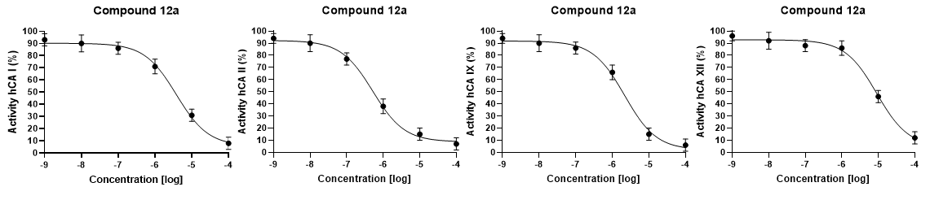
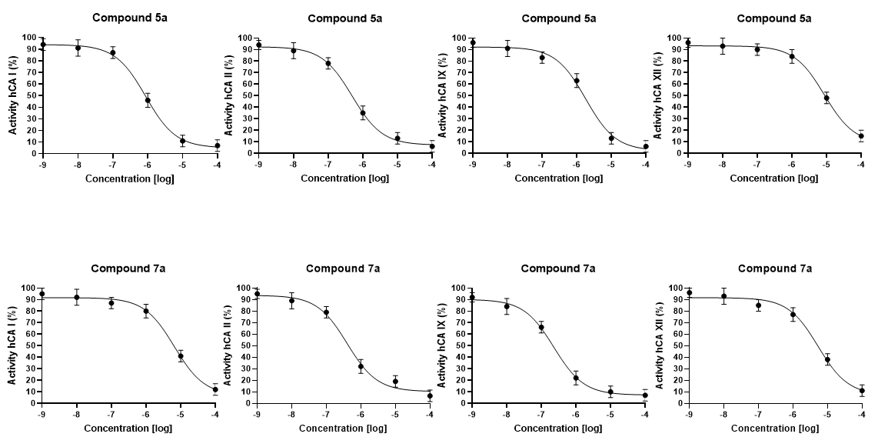
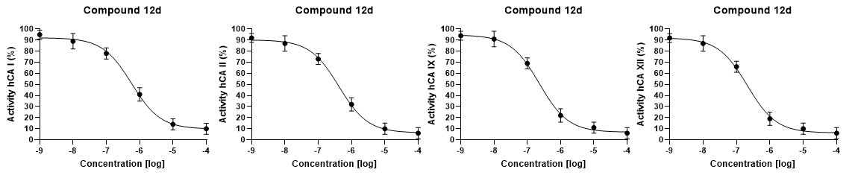

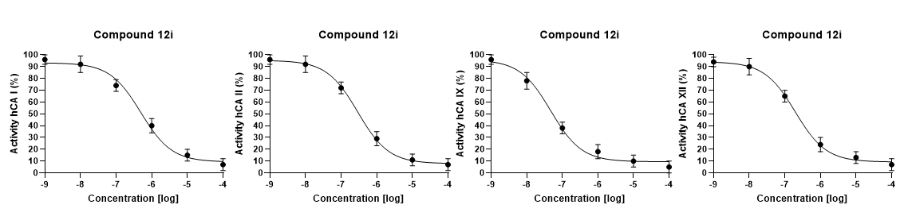
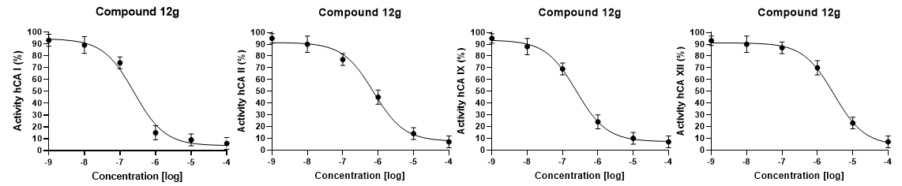

Figure 113. Dose response curves of highly active and selective compounds 5a, 7a, 12a, 12d, 12i, and 12g on four human CA isoforms.

- Western blot analysis procedure

Preparation of slab gel:
12 % Slab gel was prepared by mixing acrylamide- bisacrylamide, (10 ml); resolving gel buffer stock, (9.7 ml); 10 % SDS, (0.9 ml); freshly prepared; 1.5 % ammonium per sulphate , (1.5 ml) ; distilled water, (14.45ml) and TEMED, (0.015). 4 % stacking gel was prepared using acrylamide- bisacrylamide (2.5 ml) ; stacking gel buffer stock , (5.0 ml); SDS 10 % (0.2 ml); freshly prepared 1.5 % ammonium per sulphate , (1.0 ml) ; distilled water (11.9 ml) and TEMED, (0.015 ml).
Loading of samples and electrophoresis:
For each sample, after gel polymerization, 90 µg proteins was loaded and electrophoresis was performed at 75 volt through stacking gel followed by 125 v during approximately 2 h.
Protein staining:
Gel were stained 0.1 % comassie blue R- 250 for 2 h. Then distained with a solution (1:9:6) of glacial acetic acid; methanol; and water, respectively.
Data analysis:
Gel documentation system (Geldoc-it, UVP, England), was applied for data analysis using Totallab analysis software, ww.totallab.com, (Ver.1.0.1).
Blotting technique:
- Blotting Solutions:
1-a- Blotting buffers:
25 mM Tris, pH 7.4, 0.15 M NaCl and 0.1% Tween 20.
1-b- Blocking solution:
2-5% Nonfat dry milk in blotting buffer adjust pH to 7.4.
1- c- Antibody solution:
1-5% Nonfat dry milk in blotting buffer adjust pH to 7.4
2. Blotting protocol:

Eelectrophoresed proteins on SDS-PAGE were transferred to a Hybond™ nylon membrane (GE Healthcare) via TE62 Standard transfer tank with Cooling Chamber (Hoefer Inc. and incubate for 1 hour at room temperature in Blocking Solution. Additionally, β-actin (abcam, ab8227) was applied as housekeeping protein.
- Membrane was incubated the overnight at 4°C in antibody solution containing caspase isoform (Cell Signalling) separately for each antibody.
- Membrane was washed at room temperature for 90-60 minutes with 5 or more changes of blotting buffer.
- Membrane was incubated for 1 hour at room temperature in antibody solution containing appropriate dilution of HRP-conjugated secondary antibody (antibody concentration. 0.1-0.5 microgram/mL. adjust antibody concentration from 0.05 to 2.0 microgram/mL to obtain desired signal strength and low background.
- Membrane was washed for 90-60 minutes with 5 or more changes of blotting buffer.
- Colorimetric technique was used to visualize immune reactive bands using Geldoc-it, UVP, England. Each experiment was run in triplicate.
Western Blot Protocol References:
- Antibody Techniques, Vedpal S. Malik and Erik P. Lillehoj, 1994 Academic Press, pg 273-289.
- Immunochemical Protocols, Second Edition, John D. Pound, 1998 Humana Press, pg 207-216.
- Using Antibodies, A Laboratory Manual, Ed Harlow and David Lane, 1999 A Cold Spring Harbor Laboratory Press, pg.267-309.

- Western blot analysis results
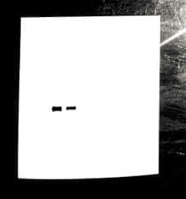
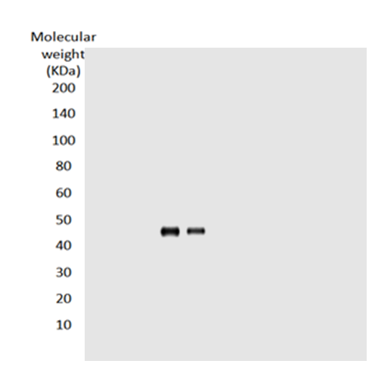

Treated
Control
Treated
Control
Procaspase-9

Procaspase-9 (46 KDa)

- (b)
Figure 114. Western blotting analysis of procaspase 9 expression level in MDA-MB-468 breast cancer cell line (control) and when treated with compound 12d (treated); (a) Original blotting membrane with visible edges, (b) Computerized version of the membrane used to calculate the molecular weight (KDa)

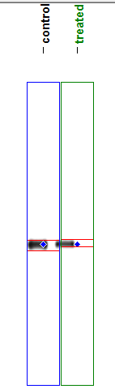
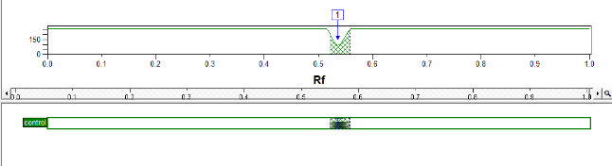
Control

Treated
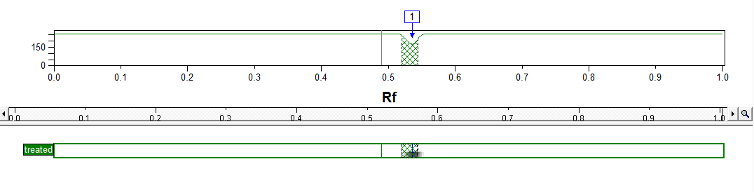

Figure 115. Computerized analysis of procaspase 9 expression level in MDA-MB-468 breast cancer cell line (control) and when treated with compound 12d (treated)
 |  | Replicate 1 | Replicate 2 | Replicate 3 | Mean ± SD
Control (1) | Lane % | 40.50 | 40.50 | 40.52 | 40.53 ± 0.008
Treated (2) | Lane % | 25.30 | 25.31 | 25.30 | 25.30 ± 0.004
Table 1. Expression level of procaspase 9 in control and treated samples in three replicates

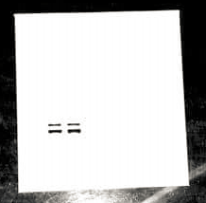
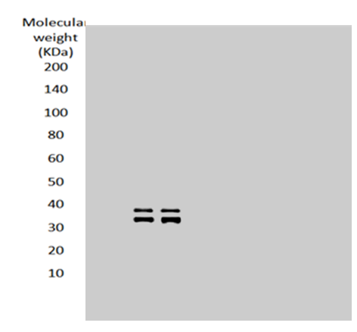
Control
Treated
Treated
Control

Cleaved caspase-9 (35/37 KDa)
Cleaved caspase-9
(a)
(b)

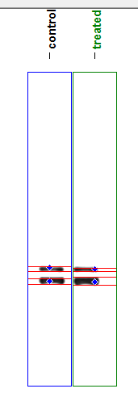
Figure 116. Western blotting analysis of cleaved caspase 9 expression level in MDA-MB-468 breast cancer cell line (control) and when treated with compound 12d (treated); (a) Original blotting membrane with visible edges, (b) Computerized version of the membrane used to calculate the molecular weight (KDa)

Control
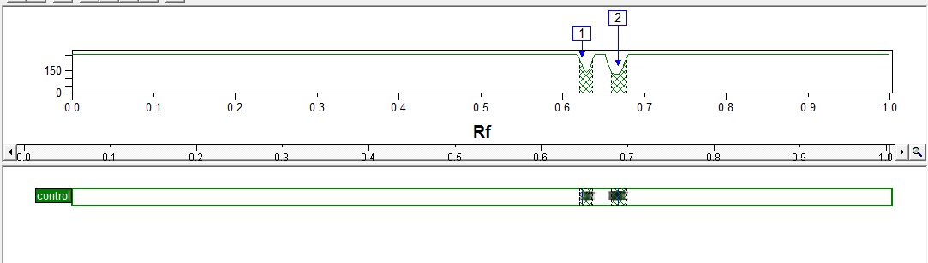

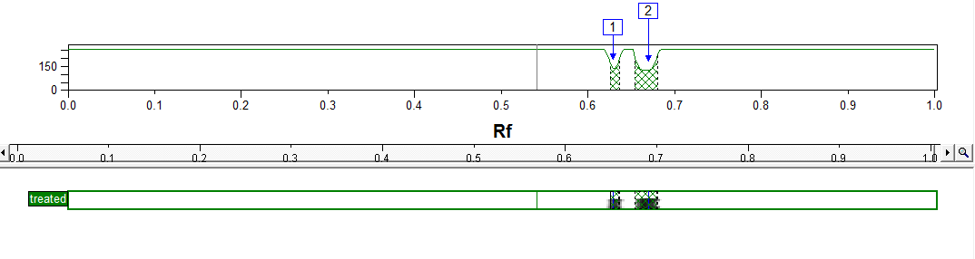
Treated

Figure 117. Computerized analysis of cleaved caspase 9 expression level in MDA-MB-468 breast cancer cell line (control) and when treated with compound 12d (treated)
Table 2. Expression level of cleaved caspase 9 in control and treated samples in three replicates
 |  | Replicate 1 | Replicate 2 | Replicate 3 | Mean ± SD
Control (1) | Lane % | 6.75 | 6.75 | 6.77 | 6.75 ± 0.008
Control (1) | Lane % | 14.32 | 14.31 | 14.32 | 14.32 ± 0.004
Treated (2) | Lane % | 6.01 | 6.04 | 6.04 | 6.04 ± 0.012
Treated (2) | Lane % | 21.59 | 21.60 | 21.60 | 21.59 ± 0.004

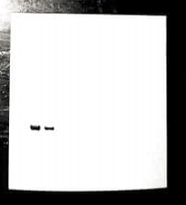
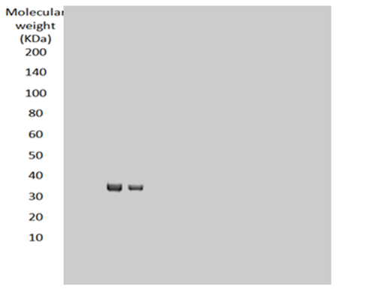

Control
Treated
Control
Treated

Procaspase-3 (35 KDa)
Procaspase-3
(a)
(b)

Figure 118. Western blotting analysis of procaspase 3 expression level in MDA-MB-468 breast cancer cell line (control) and when treated with compound 12d (treated); (a) Original blotting membrane with visible edges, (b) Computerized version of the membrane used to calculate the molecular weight (KDa)

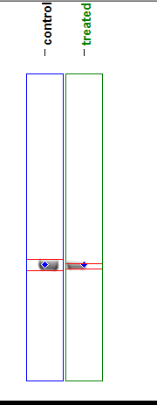
Control
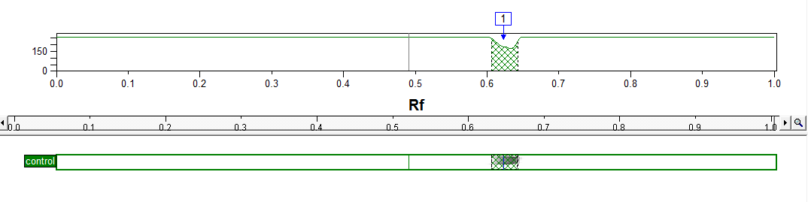

Treated
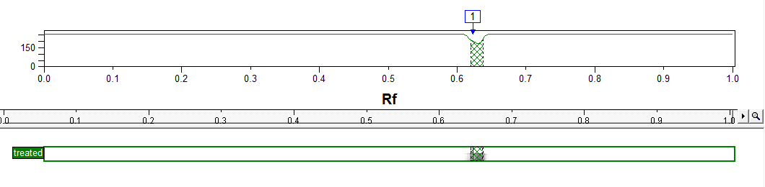

Figure 119. Computerized analysis of procaspase 3 expression level in MDA-MB-468 breast cancer cell line (control) and when treated with compound 12d (treated)

Table 3. Expression level of procaspase 3 in control and treated samples in three replicates
 |  | Replicate 1 | Replicate 2 | Replicate 3 | Mean ± SD
Control (1) | Lane % | 42.54 | 42.51 | 42.51 | 42.52 ± 0.013
Treated (2) | Lane % | 27.80 | 27.80 | 27.82 | 27.81 ± 0.008
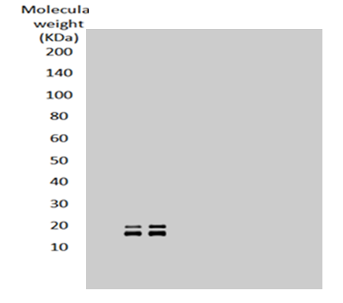
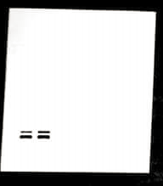

Control
Treated
Treated
Control

Cleaved caspase-3
Cleaved caspase-3 (17/19 KDa)

(b)
(a)

Figure 120. Western blotting analysis of cleaved caspase 3 expression level in MDA-MB-468 breast cancer cell line (control) and when treated with compound 12d (treated); (a) Original blotting membrane with visible edges, (b) Computerized version of the membrane used to calculate the molecular weight (KDa)
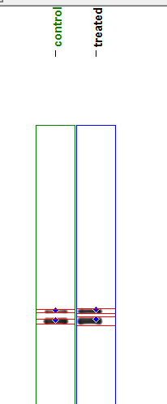
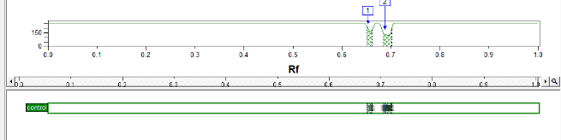
Control

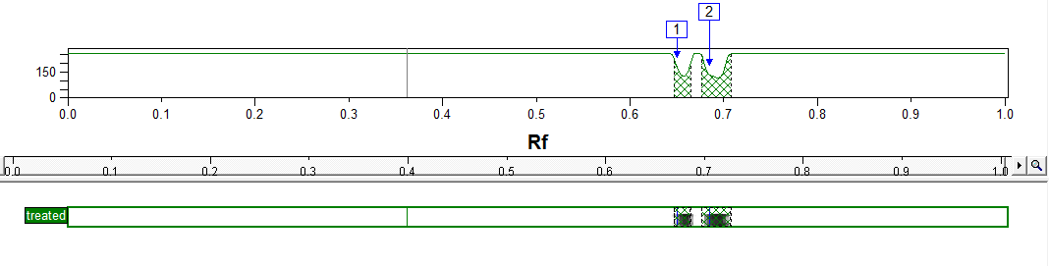
Treated

Figure 121. Computerized analysis of cleaved caspase 3 expression level in MDA-MB-468 breast cancer cell line (control) and when treated with compound 12d (treated)
Table 4. Expression level of cleaved caspase 3 in control and treated samples in three replicates
 |  | Replicate 1 | Replicate 2 | Replicate 3 | Mean ± SD
Control (1) | Lane % | 4.90 | 4.90 | 4.94 | 4.91 ± 0.017
Control (1) | Lane % | 13.59 | 13.59 | 13.59 | 13.59 ± 0.0
Treated (2) | Lane % | 6.88 | 6.90 | 6.88 | 6.88 ± 0.008
Treated (2) | Lane % | 22.42 | 22.42 | 22.42 | 22.42 ± 0.0

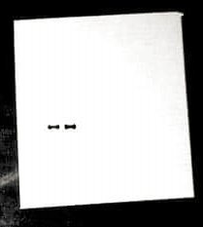

Treated
Control

β-actin

Figure 122. Western blotting analysis of β-actin expression level in MDA-MB-468 breast cancer cell line (control) and when treated with compound 12d (treated)

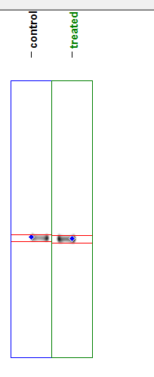

Figure 123. Computerized analysis of β-actin expression level in MDA-MB-468 breast cancer cell line (control) and when treated with compound 12d (treated)

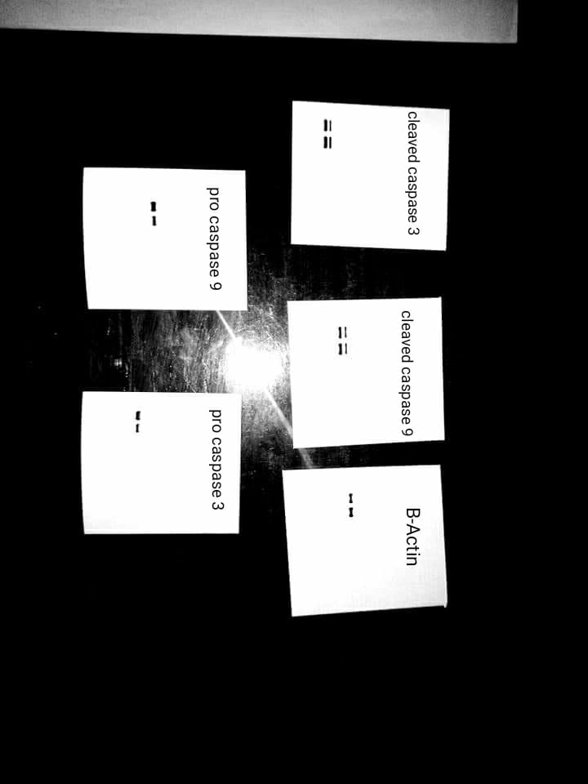

Figure 124. Complete membranes with visible edges of western blot analysis of proteins markers, bands on the left on each plate are for control while bands on the right are corresponding to 12d.

