Supplementary Material
Comparative hydrodynamic characterisation of two hydroxylated polymers based on α-pinene- or oleic acid-derived monomers for potential use as archaeological consolidants
Michelle Cutajar^{1,2*}, Fabricio Machado^{2,3}, Valentina Cuzzucoli Crucitti⁴, Susan Braovac⁵, Robert A. Stockman², Steven M. Howdle² and Stephen E. Harding^{1,5*}
- National Centre for Macromolecular Hydrodynamics (NCMH), University of Nottingham, School of Biosciences, Sutton Bonington, LE12 5RD, UK
- School of Chemistry, University of Nottingham, University Park Nottingham, NG7 2RD UK
- Instituto de Química, Universidade de Brasília, Campus Universitário Darcy Ribeiro, 70910-900 Brasília, DF, Brazil
- Centre for Additive Manufacturing, Department of Chemical and Environmental Engineering, Faculty of Engineering, University of Nottingham, Nottingham, NG7 2RD UK
- Museum of Cultural History, University of Oslo, Kabelgata 34, 0580 Oslo, Norway

α-Pinene oxide (1)

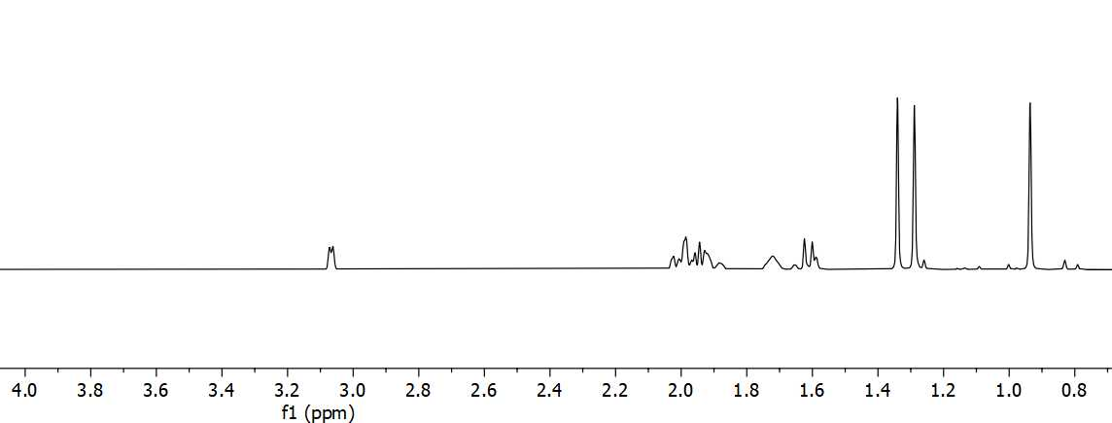
Figure S1. ¹H NMR spectra for 1
Synthesis of α-pinene oxide, 1¹. 1S-(-)-α-pinene (5.82 mL, 36.7 mmol) was added to a suspension of NaHCO₃ (3.92 g, 46.6 mmol) in CH₂Cl₂ (7.5 mL) and then cooled to 0 °C. Meta-chloroperbenzoic acid (mCPBA) (~70%, 9.22 g, 37.4 mmol) was gradually added to the solution. The reaction was stirred for 1 hour, after which saturated aqueous solution of Na₂SO₃ (27 mL) was added to the reaction mixture. The reaction was allowed to settle to room temperature and stirred for a further 30 minutes. The reaction mixture was diluted with saturated aqueous solution of NaHCO₃ (30 mL) and CH₂Cl₂ (60 mL). The aqueous washings were extracted with CH₂Cl₂ (75 mL). The organic phase was washed with saturated aqueous solution of NaHCO₃ (100 mL x 3). The organic extracts were then combined, washed with brine (100 mL x 3), dried over MgSO₄, filtered and concentrated under reduced pressure to yield the title compound (1) (4.78 g, 31.4 mmol, 86% yield).
FTIR (ATR) ν_{max} /cm⁻¹: 2977, 2914, 2834, 1229, 1084, 943, 818; ¹H NMR (400 MHz, CDCl₃) δ_{H} 3.07 (d, J = 4.1 Hz, 1H), 2.01 – 1.83 (m, 4H), 1.72 (s, 1H), 1.61 (d, J = 9.4, 1H), 1.34 (s, 3H), 1.29 (s, 3H), 0.94 (s, 3H); ¹³C NMR (100 MHz, CDCl₃) δ_{C} 60.3, 56.9, 45.1, 40.5, 39.7, 27.6, 26.7, 25.9, 22.4, 20.2.

Trans-sobrerol (2)
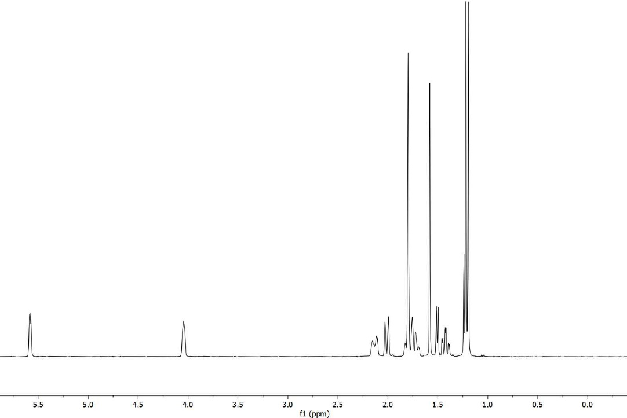
Figure S2. ¹H NMR spectra for 2
Synthesis of trans-sobrerol, 2.¹ CO₂ was continuously passed through H₂O (52 mL) until the pH was approximately 4.5 – 5. 1 (4 g, 26.3 mmol) was then added and the mixture stirred at room temperature for 24 hours. The solution was concentrated under reduced pressure and a white solid precipitated. The crude solid was washed with cold ethyl acetate (5 mL x 2) to give the title compound as a white, crystalline solid (2) (2.4 g, 14.4 mmol, 55% yield).
FTIR (ATR) ν_{max} /cm⁻¹: 3321, 2973, 2887, 1376, 1052, 919; ¹H NMR (400 MHz, CDCl₃) δ_{H} 5.58 (d, J = 5.4 Hz, 1H), 4.04 (s, 1H), 2.17 – 2.08 (m, 1H), 2.05 – 1.97 (m, 1H), 1.84 – 1.67 (m, 5H), 1.42 (td, J = 13.1, 3.9 Hz, 1H), 1.22 (s, 3H), 1.19 (s, 3H); ¹³C NMR (100 MHz, CDCl₃) δ_{C} 133.2, 126.6, 71.3, 68.8, 38.9, 33.8, 27.8, 27.3, 26.5, 21.0; HRMS (ESI) m/z calculated for [C₁₀H₁₈NaO₂]⁺ 193.1204 found 193.1210 (M⁺ Na⁺).
(1S,5R)-5-(2-hydroxypropan-2-yl)-2-methylcyclohex-2-en-1-yl acrylate (3)
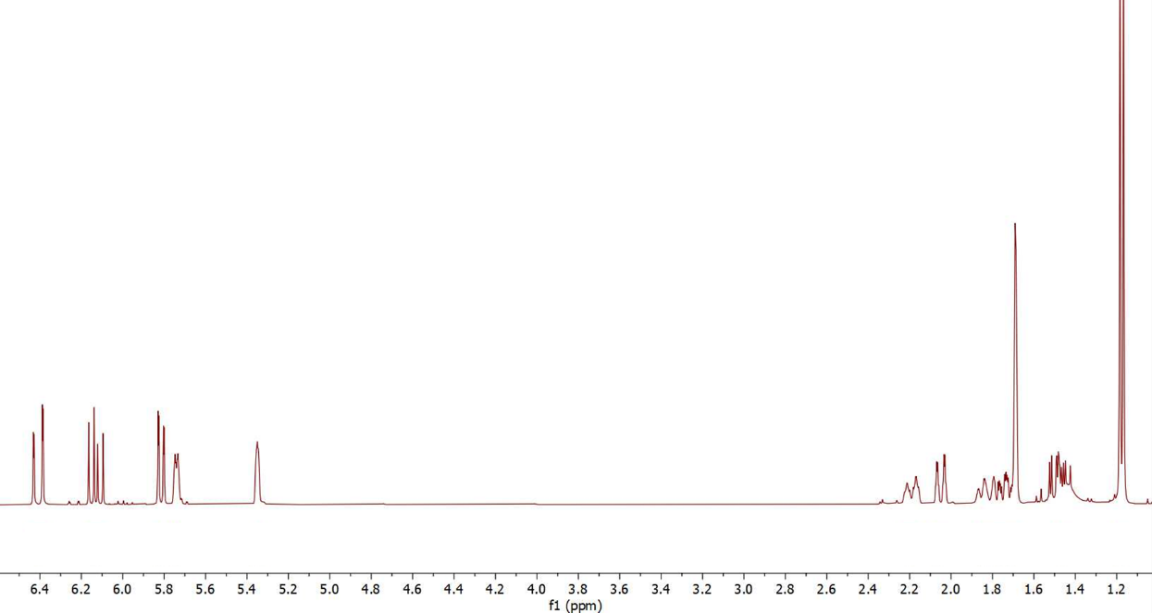
Figure S3. ¹H NMR spectra for 3

FTIR (ATR) ν_{max} /cm⁻¹: 3421, 2969, 2935, 1717, 1704, 1404, 1294, 1267, 1192, 1162, 1038. ¹H NMR (400 MHz, CD₃OD) δ_{H} 6.42 (dd, J = 17.3, 1.5, 1H), 6.14 (dd, J = 17.3, 10.4, 1H, H-12), 5.82 (dd, J = 10.4, 1.5, 1H), 5.75 (dt, J = 5.6, 1.8, 1H), 5.36 (dt, J = 3.5, 1H), 2.19 (dddt, J = 17.0, 5.7, 4.3, 1.6, 1H), 2.05 (dq, J = 14.0, 2.2, 1H), 1.90–1.82 (m, 1H), 1.74 (tdd, J = 2.4, 4.0, 12.5, 1H), 1.71 (dt, J = 2.8, 1.5, 3H), 1.49 (ddd, J = 14.1, 12.9, 4.0, 2H, H-6), 1.18 (J = 6.9, 6H); ¹³C NMR (101 MHz, CD₃OD) δ_{C} 166.1, 131.0, 130.6, 128.1, 125.3, 72.2, 71.0, 39.5, 30.0, 27.6, 27.4, 26.8, 20.9; HRMS (ESI): Calculated for [C₁₃H₂₀NaO₃]⁺ 247.3000 obtained 247.1309 (M⁺ Na⁺).

8-(3-octyloxiran-2-yl)octanoic acid (4)
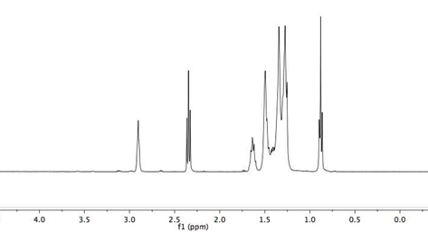
Figure S4. ¹H NMR spectra for 4
Synthesis of epoxidized oleic acid, 4². To oleic acid (33.8 mL, 106.4 mmol) in toluene (180 mL) was added formic acid (12.3 mL, 326.0 mmol). The solution was stirred under reflux at 30 °C. H₂O₂ (72.1 mL, 2352.8 mmol) was added dropwise (over 1 hour) and the mixture left to stir for 24 hours. This was then transferred to a separation funnel and the organic phase was purified using NaHCO₃ (sat. aq., 50 mL x 3), DI water (50 mL x 3) and dried with MgSO₄ and filtered. The solution was then concentrated under reduced pressure to yield the product (4) as a white solid (26.5 g, 88.8 mmol, 84% yield).
FTIR (ATR) ν_{max} /cm⁻¹: 2958, 2849, 1696, 1473, 1431, 1276, 1031, 1012, 846. ¹H NMR (400 MHz, CD₃OD) δ_{H} 2.92 (m, 2H), 2.35 (t, J = 7.5, 2H), 1.65 (d, J = 6.9, 2H), 1.49 (dt, J = 6.9, 3.9, 4H), 1.35 (m, 10H), 1.29 – 1.27 (10H, m, 10H), 0.92 – 0.84 (m, 3H); ¹³C NMR (101 MHz, CD₃OD) δ_{C} 57.44, 57.39, 34.01, 32.00, 29,70, 29.68, 29.46, 29.32, 29.31, 29.09, 27.96, 27.92, 26.74, 26.70, 24.79, 22.81, 14.25; HRMS (ESI): Calculated for [C₁₃H₂₀NaO₃]⁺ 320.47 obtained 321.24 (M⁺ Na⁺).

10-(acryloyloxy)-9-hydroxyoctadecanoic acid (5)
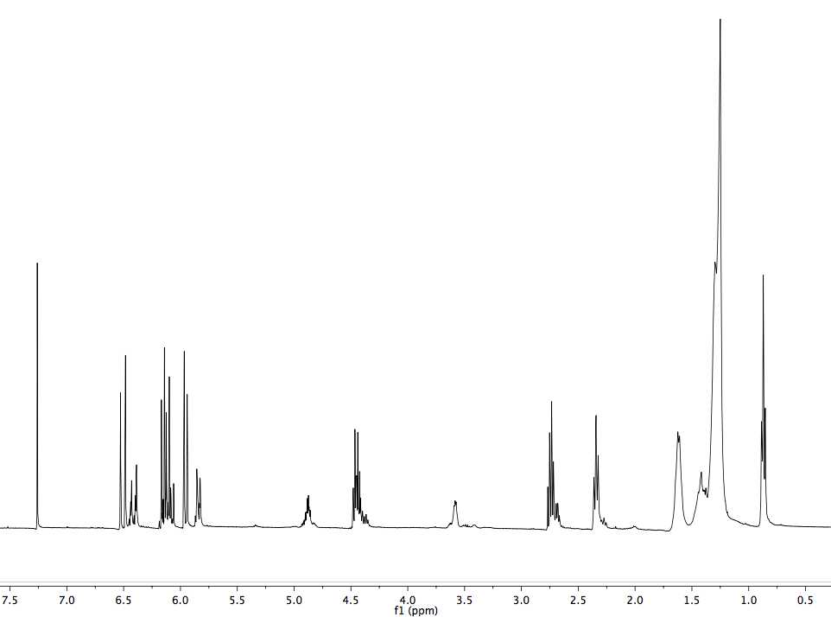
Figure S5. ¹H NMR spectra for 5

Synthesis of acrylated oleic acid, 5². To a solution of 4 (40 g, 0.1 mmol) were added acrylic acid (acid with low H₂O content, 99.5% stab. with ca. 200 ppm methoxyphenol, 76.12 mL, 1109.2 mmol) and hydroquinone (24 mg, 0.2 mmol). The reaction mixture was maintained at a mass ratio 2 : 1 acrylic acid : epoxidized oleic acid and left to stir for 6 hours at 100 °C. The aqueous layer was separated with diethyl ether (100 mL x 3) and the organic layer was washed with NaHCO₃ (sat. aq., 50 mL x 3). The reaction mixture was then dried with MgSO₄, filtered and concentrated to yield the title compound (5) as a whitish viscous liquid (48.2 g, 130.1 mmol, 97% yield).
FTIR (ATR) ν_{max} /cm⁻¹: 3461, 2959, 2873, 1697, 1431, 1261, 1193, 771. ¹H NMR (400 MHz, CD₃OD) δ_{H} 6.56 – 6.36 (m, 1H, H-20), 6.11 (ddd, J = 17.3, 15.2, 10.4, 1H, H-19), 5.96 (dd, J = 10.4, 1,4, 1H), 4.87 (m, 1H), 4.44 (tt, J 10.1, 6.3, 1H), 3.58 (m, 1H), 2.39 – 2.23 (m, 1H), 1.61 (m, 4H,), 1.43 (m, 2H), 1.30 (m, 10H), 1.26 (m, 10H), 0.91 – 0.80 (m, 3H); ¹³C NMR (101 MHz, CD₃OD) δ_{C} 171.10, 133.14, 131.53, 128.12, 128.07, 60.19, 34.08, 33.71, 31.99, 29.64, 29.39, 29.05, 25.50, 24.74, 22.80, 14.24; HRMS (ESI): Calculated for [C₁₃H₂₀NaO₃]⁺ 392.57 obtained 393.26 (M⁺ Na⁺).

Polymer TPA6

FTIR (ATR) ν_{max} /cm⁻¹: 3434 (-OH), 2931 (C-H), 1725 (C=O), 1448 (C-H), 1378 (-OH), 1245 (-OH), 1154 (C-O), 1025 (C-O), 943 (C=C), 914 (C=C), 840 (C=C), 814 (C=C); ¹H NMR (400 MHz, (CD₃OD) δ_{H} 5.69 (br), 5.24 (br), 2.09 (br), 1.73 – 1.67 (br), 1.21 – 1.07 (br).

Copolymer TPA7

FTIR (ATR) ν_{max} /cm⁻¹: 3434 (-OH), 2931 (C-H), 2856 (C-H), 1725 (C=O), 1448 (C-H), 1378 (-OH), 1245 (-OH), 1154 (C-O), 1025 (C-O), 943 (C=C), 914 (C=C), 840 (C=C), 814 (C=C); ¹H NMR (400 MHz, (CD₃OD) δ_{H} 5.69 (br), 5.24 (br), 4.85 (br), 3.56 (br), 2.09 (br), 1.87 (br), 1.73 – 1.67 (br), 1.34 – 1.25 (br), 1.21 – 1.07 (br).

a)

b)

Figure S6. The polymer peaks from the GPC analyses of a) TPA6 and b) TPA7

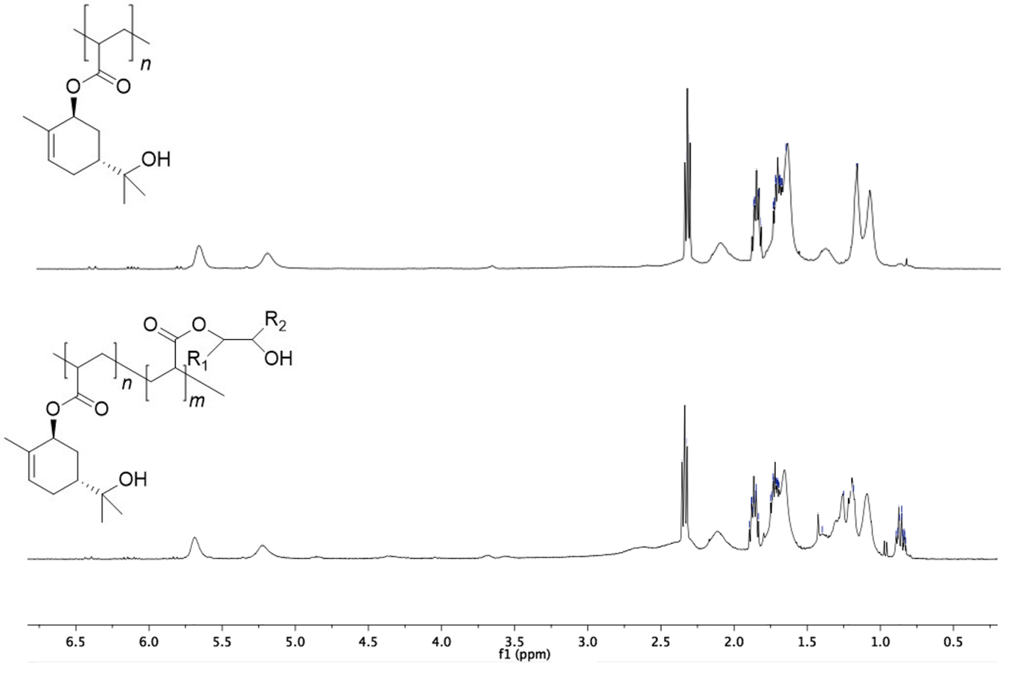

Figure S7. A comparison of the ¹H NMR analyses of TPA6 and TPA7 after purification with hexane. The peaks at δ = 6.42 and 5.75 ppm representing the acrylate peaks no longer appeared, indicating that there were no residual monomer molecules left in the products.

Table S1. The M_{w,app} obtained from the sedimentation equilibrium experiment for all concentrations for TPA6.
Concentration (mg/mL) | M_{w,app} (M*) (kDa) | M_{w,app} (hinge point) (kDa)
0.5 | 3.3 | -
0.75 | 3.8 | -
1.0 | 4.1 | 3.6
1.5 | 3.0 | 3.2

Table S2. The M_{w,app} values obtained from the sedimentation equilibrium experiment for all concentrations for TPA7.
Concentration (mg/mL) |  | M_{w,app} (M*) (kDa) |  | M_{w,app} (hinge point) (kDa)
 | 0.5 | 4.4 | 3.8
 | 0.75 | 4.0 | 3.9
 | 1.0 | 4.2 | 3.8
 | 1.5 | 4.7 | 4.3
 | 2.0 | 4.7 | 4.2
 | 3.0 | 4.6 | 4.1
 | 4.0 | 4.6 | 4.1

References
1. Cutajar, M. et al. Terpene polyacrylate TPA5 shows favorable molecular hydrodynamic properties as a potential bioinspired archaeological wood consolidant. Sci. Rep. 11, 7343 (2021).
2. Neto, W. S. et al. Superparamagnetic nanoparticles stabilized with free-radical polymerizable oleic acid-based coating. J. Alloys Compd. 739, 1025–1036 (2017).

