Figure 1 circRNA_00907 gene standard curve and product dissolution curve
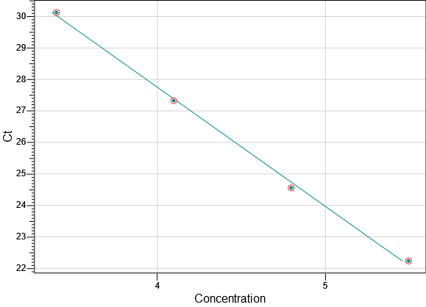 | 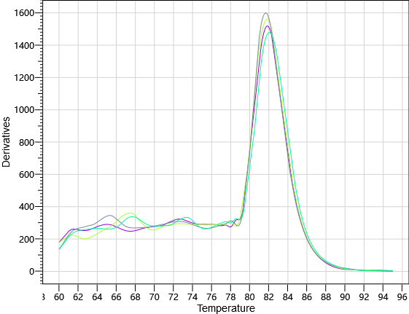

Figure 2 circRNA_01106 gene standard curve and product dissolution curve
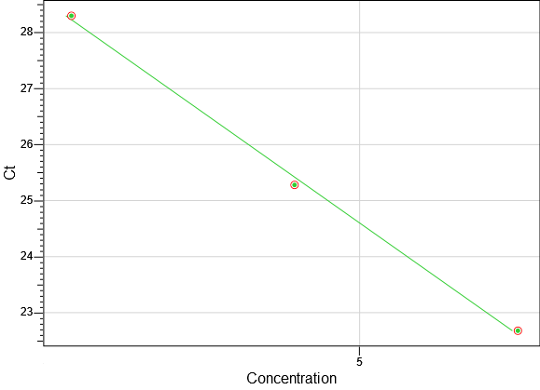 | 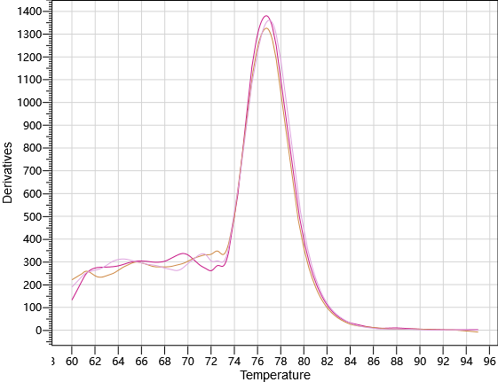

Figure 3 circRNA_06424 gene standard curve and product dissolution curve
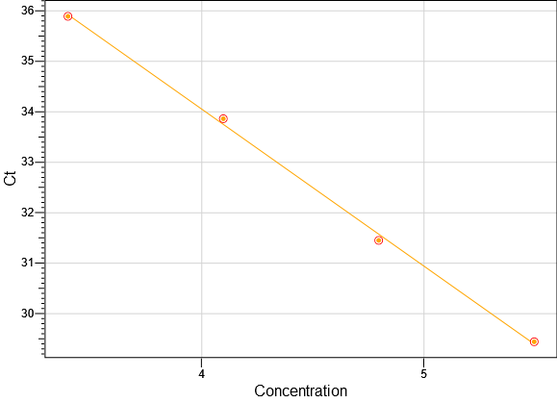 | 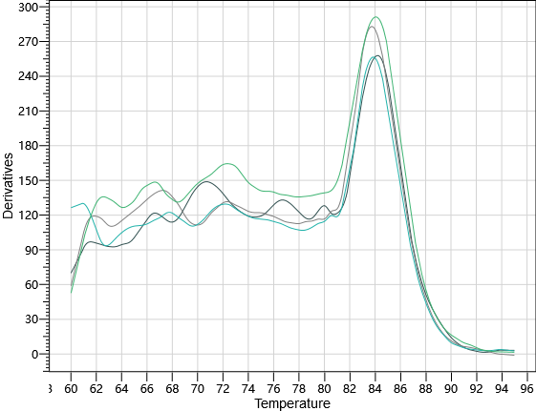

Figure 4 CircRNA_08840 gene standard curve and product dissolution curve
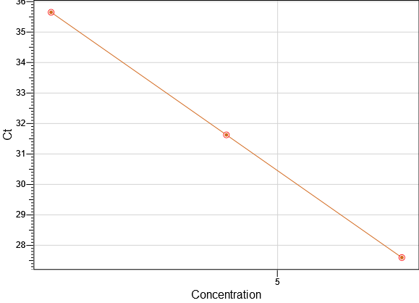 | 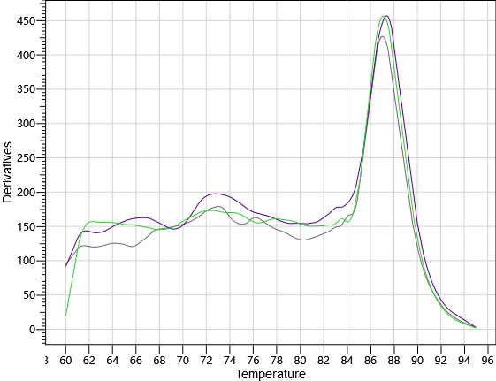

Figure 5 CircRNA_15332 gene standard curve and product dissolution curve
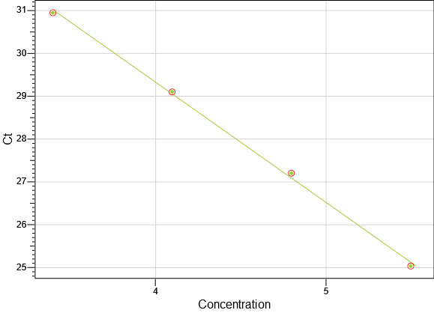 | 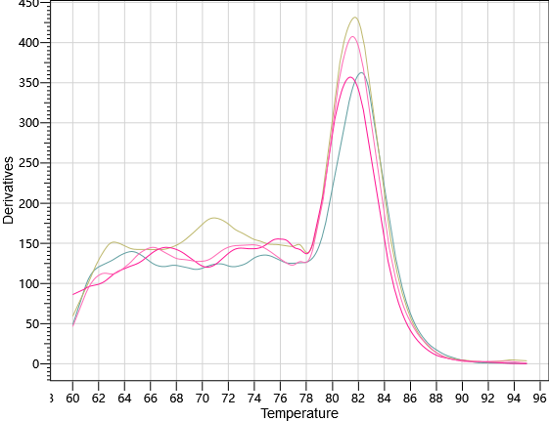

Figure 6 CircRNA_22410 gene standard curve and product dissolution curve
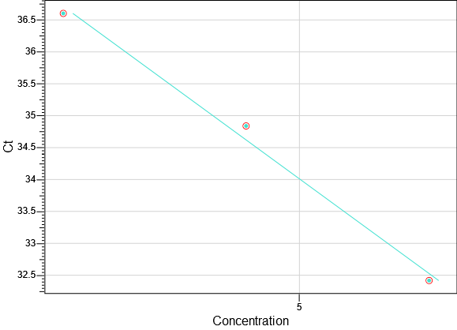 | 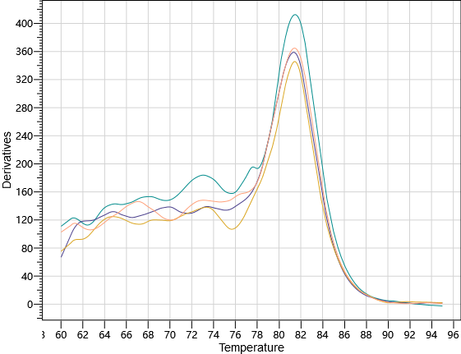

Figure 7 miR-361-3p gene standard curve and product dissolution curve
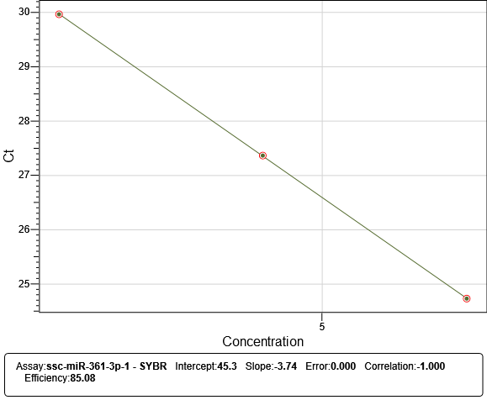 | 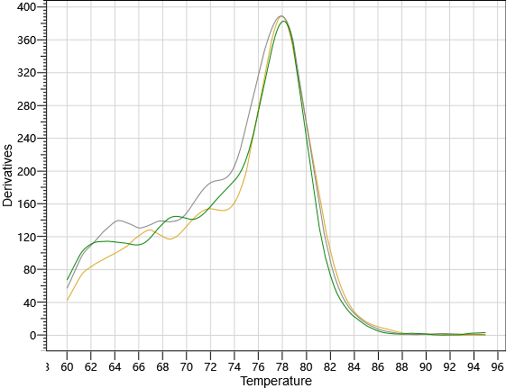

Figure 8 miR-331-3p gene standard curve and product dissolution curve
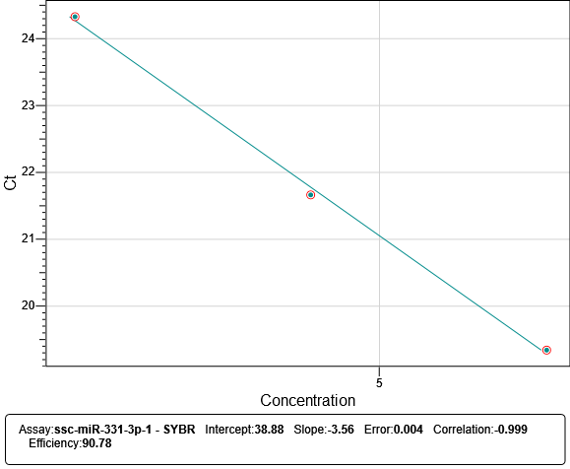 | 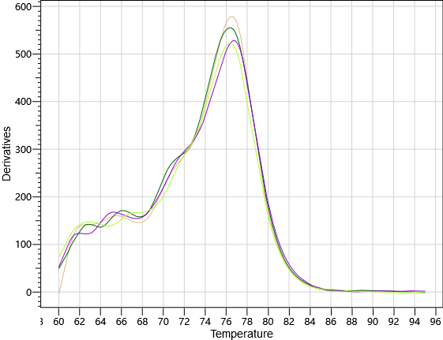

Figure 9 miR-328 gene standard curve and product dissolution curve
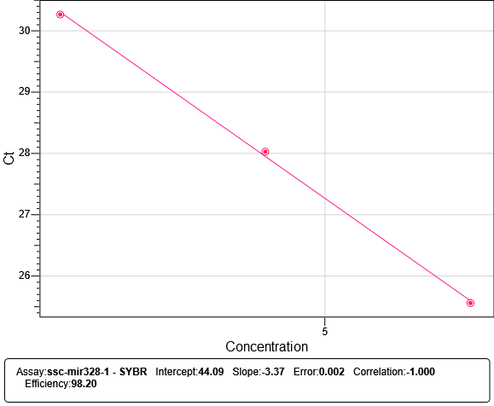 | 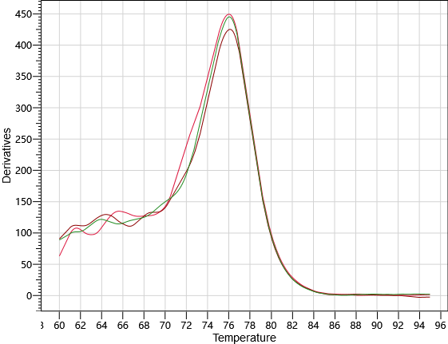

Figure 10 PPARD gene standard curve and product dissolution curve
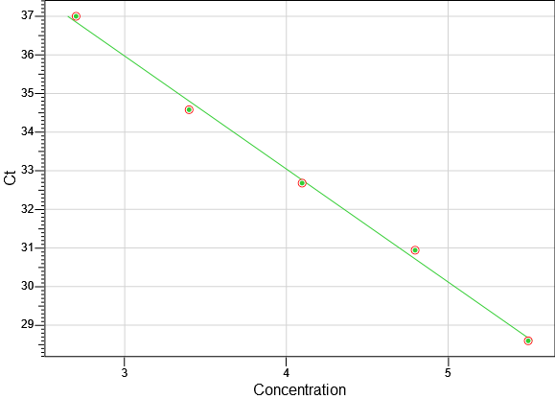 | 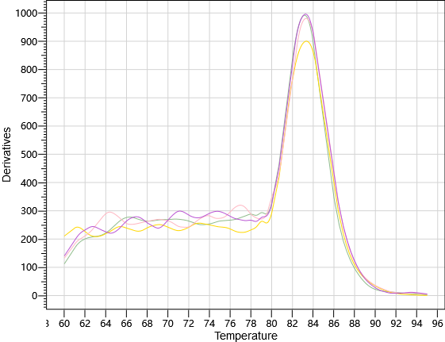

Figure 11 MMP9 gene standard curve and product dissolution curve
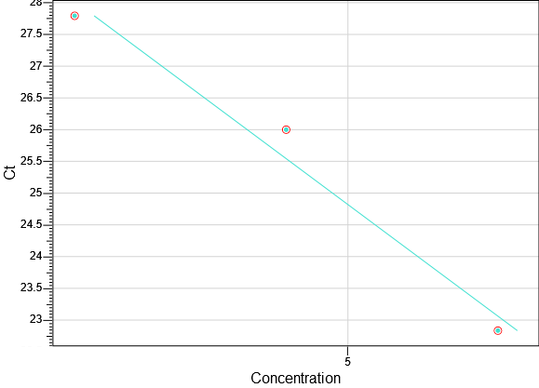 | 