Supplementary Materials for
Towards Routine 3D Characterization of Intact Mesoscale Samples by Multi-scale and Multimodal Scanning X-ray Tomography

Authors
Ruiqiao Guo, Andrea Somogyi, Dominique Bazin, Elise Bouderlique, Emmanuel Letavernier, Catherine Curie, Marie-Pierre Isaure, Kadda Medjoubi

This file includes:
Fig. S1
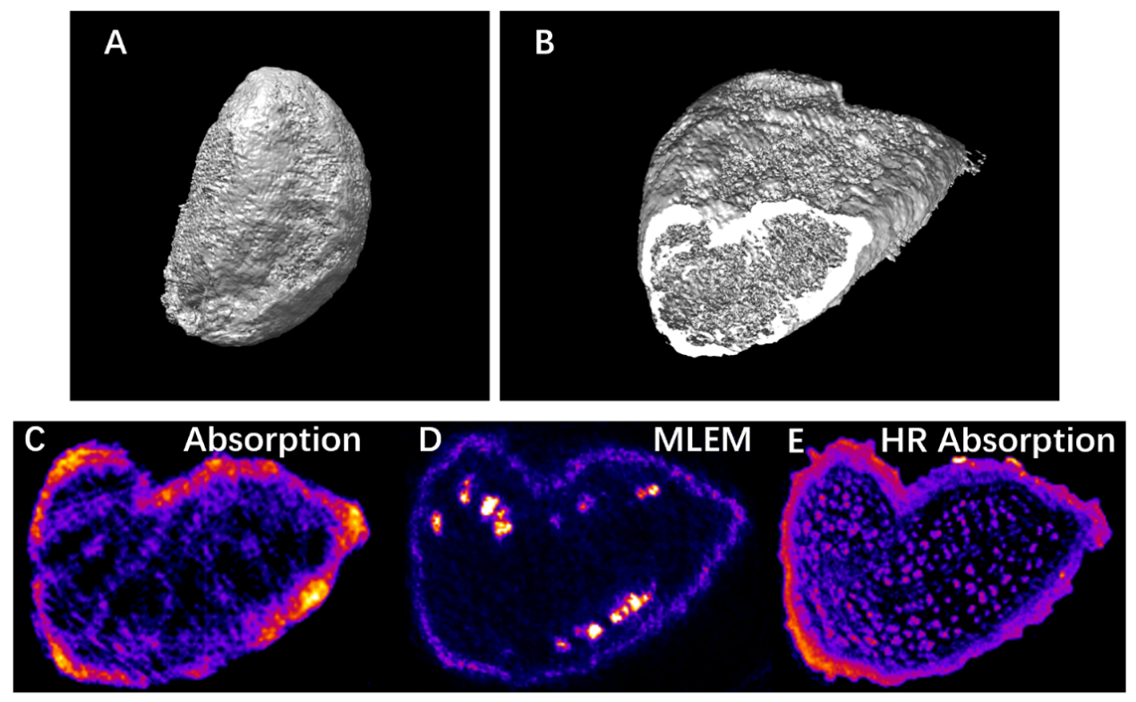
Fig. S1. Reconstruction of the scanning X-ray absorption tomography of the Arabidopsis thaliana seed, collected simultaneously with XRF tomography.
(A) 3D volume rendering of X-ray absorption reconstructed from the 20-projection dataset with MLEM algorithm. Cut-off view (B) and the reconstructed virtual slice (C) of the absorption tomogram at the altitude marked by the red line in Fig. 2. (D) Mn distribution within the same virtual slice as B and C obtained with MLEM algorithm from the XRF tomography dataset (already shown in Fig. 3D). (E) Reconstruction result of the high-resolution X-ray absorption sinogram.

