Supporting Information

Arsenic removal performance and mechanism from water on iron hydroxide nanopetalines
Yulong Wang^{1,2,3,†}, Lin Zhang^{1,3,†}, Chen Guo^{1,3}, Yali Gao^{1,3}, Shanshan Pan^{1,3}, Yanhong Liu^{4,}*, Xuhui Li^{1,2,3,}*, Yangyang Wang^{1,2,3,}*
¹ National Demonstration Center for Environmental and Planning, College of Geography and Environmental Science, Henan University, Kaifeng, 475004, China
² Key Laboratory of Geospatial Technology for the Middle and Lower Yellow River Regions (Henan University), Ministry of Education, Kaifeng, 475004, China
³ Henan Engineering Research Center for Control and Remediation of Soil Heavy Metal Pollution, Henan University, Kaifeng, 475004, China
⁴ College of Software, Henan University, Kaifeng, 475004, China
† These two authors contribute equally to this work and should be regarded as co-first authors.

*Corresponding authors: liuyanhongxmu@163.com (Y Liu); lixuhui@henu.edu.cn (X Li); wangyangyangxyz@163.com (YY Wang).

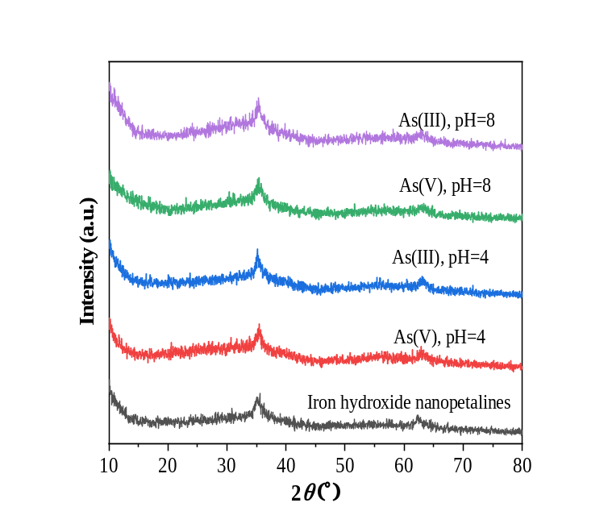
Figure S1. XRD patterns of iron hydroxide nanopetalines before and after As(III) and As(V) adsorption at pH 4.0 and 8.0.

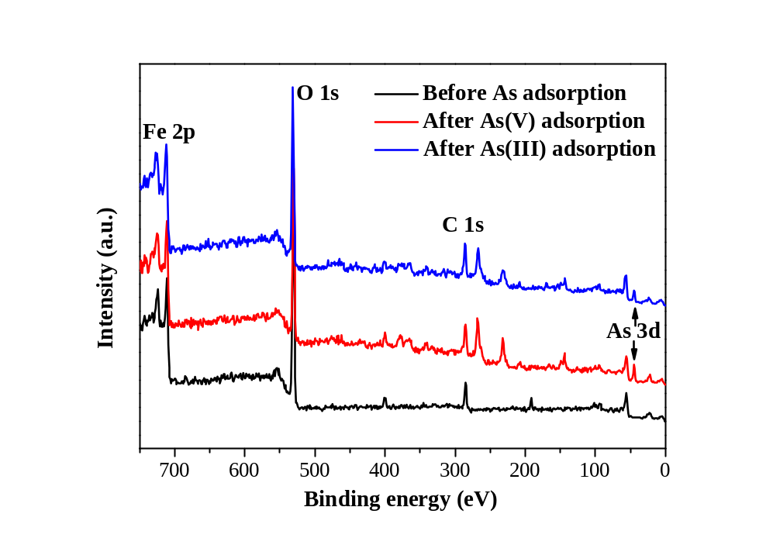
Figure S2. Full spectra of iron hydroxide nanopetalines before and after As(III) and As(V) adsorption at pH 4.0.

