Supplemental Table S1. Univariate analysis result for each parameter of COPD patients. The statistical tests used for the univariate analysis and corresponding P values are listed in the last two columns. ANOVA: ANOVA test; t-test: Student's t-test; Fisher test: Fisher’s exact test.

Variable | Readmit |  | p value
Variable | yes | no | p value
Age in years  Mean (± sd) | 69.0(11.9) | 68.4(12.2) | 0.315 | ANOVA
Age in years  Mean (± sd) | 69.0(11.9) | 68.4(12.2) | 0.306 | t-test
Sex (%) |  |  | 0.0891 | ANOVA
Sex (%) |  |  | 0.0927 | Fisher test
Female | 57.0 | 61.0
Male | 43.0 | 39.0
Race (%) |  |  | 0.0148 * | ANOVA
Race (%) |  |  | 0.01479 * | Chi-square
Asian | 1.9 | 1.8
Black | 26.7 | 22.0
Caucasian | 66.1 | 68.5
Hispanic | 0.4 | 0.4
Indian, America | 0.2 | 0.08
Other | 4.7 | 7.3
Admission Source (%) |  |  | 0.325 | ANOVA
Admission Source (%) |  |  | 0.325 | Chi-square
Clinic or Phys Office | 7.0 | 5.7
Emergency Room Dis | 69.0 | 70.0
Non-Healthcare Facility | 19.6 | 21.0
Other | 4.5 | 3.3
Discharge Disposition (%) |  |  | 0.0408 * | ANOVA
Discharge Disposition (%) |  |  | 0.04625 * | Fisher test
Routine Discharge Home | 65.5 | 70.1
Other | 34.5 | 29.9
Risk of Mortality  Mean (± sd) | 2.45 (0.87) | 2.26 (0.94) | 2.11e-05 *** | ANOVA
Risk of Mortality  Mean (± sd) | 2.45 (0.87) | 2.26 (0.94) | 8.99e-06 *** | t-test
Severity of Illness  Mean (± sd) | 2.72 (0.79) | 2.50(0.83) | 3.49E-08 *** | ANOVA
Severity of Illness  Mean (± sd) | 2.72 (0.79) | 2.50(0.83) | 1.826e-08 *** | t-test
Length of Stay (LOS)  Mean (± sd) | 5.93(4.79) | 4.99(4.57) | 2.87E-05 *** | ANOVA
Length of Stay (LOS)  Mean (± sd) | 5.93(4.79) | 4.99(4.57) | 2.87E-05 *** | t-test
Number of diagnosis POA Mean (± sd) | 11.79 (4.97) | 10.29 (4.67) | 6.13E-11 *** | ANOVA
Number of diagnosis POA Mean (± sd) | 11.79 (4.97) | 10.29 (4.67) | 5.173e-10 *** | t-test
Payor (%) |  |  | 0.00656 ** | ANOVA
Payor (%) |  |  | 0.006611 ** | Chi-square
Medicare | 77.7 | 71.4
Managed Care | 8.5 | 13.4
Other | 2.7 | 1.9
Self-pay | 2.9 | 3.6
Unknown | 8.1 | 9.6
Last 6 months Inpatient visits  Mean (± sd) | 1.37 (1.70) | 0.71(1.20) | <2e-16 *** | ANOVA
Last 6 months Inpatient visits  Mean (± sd) | 1.37 (1.70) | 0.71(1.20) | <2e-16 *** | t-test
# unique medications administered on the day of admission  Mean (± sd) | 11.03 (5.95) | 10.55(5.68) | 0.0825 | ANOVA
 | 11.03 (5.95) | 10.55(5.68) | 0.09222 | t-test
Marital Status |  |  | 0.000118 *** | ANOVA
Marital Status |  |  | 0.000118 *** | Fisher test
Last 6 months # of unique medications  mean (± sd) | 25.58721(21.60668) | 17.12824(17.10666) | <2e-16 *** | ANOVA
Last 6 months # of unique diagnosis | 31.47868 (18.88611) | 23.10356 (15.28231) | <2e-16 *** | ANOVA

Supplemental Table S2. Characteristics of COPD patients.

Total number | 3005
Age  Mean (± sd) | 68.53(± 12.18)
Sex (%)
Female | 60.31%
Male | 39.69%
Race (%)

Asian | 1.84%
Black | 22.79%
Caucasian | 68.07%
Hispanic | 0.37%
Indian, America | 0.10%
Other | 6.83%
Admission Source (%)
Clinic or Phys Office | 5.9%
Emergency Room Dis | 70.0%
Non-Healthcare Facility | 20.6%
Other | 3.5%
Discharge Disposition (%)
Routine Discharge Home | 69.7%
Other | 30.3%
Length of Stay (LOS)  Mean (± sd) | 5.15(± 4.62)
Number of diagnosis POA  Mean (± sd) | 10.61(± 4.72)

Supplemental Table S3. Relative importance of the input variables evaluated by Garson’s algorithm.

Variables sort by relative importance in the neural network model.
1) Insurance status: Self Pay,
2) Number of in-patient visits within prior 6 months,
3) Rothman Index at the day of admission,
4) number of unique medications at admission day,
5) Insurance status: Medicare,
6) Insurance status: MGD Care,
7) Insurance status: Unknown,
8) Insurance status: Other

Supplemental Figure S1. Calibration Plots for Validation data for LG and ANN Models. Left: calibration curve for LG model; right: calibration curve for ANN Model.
Supplemental Figure S2: The entry screen and history screen of the HM Re-Admit App.

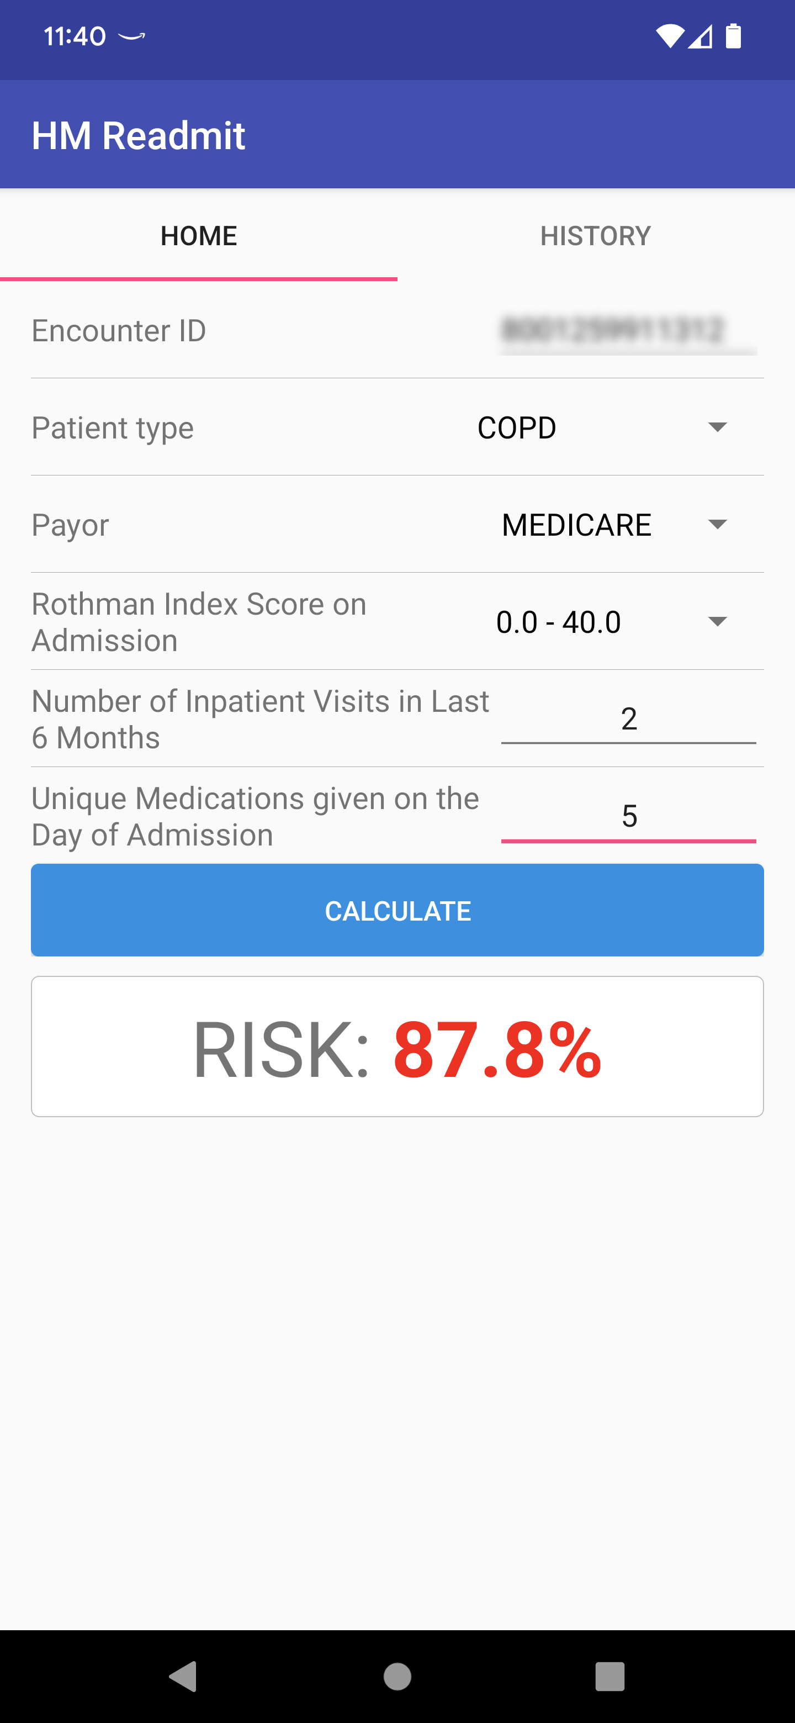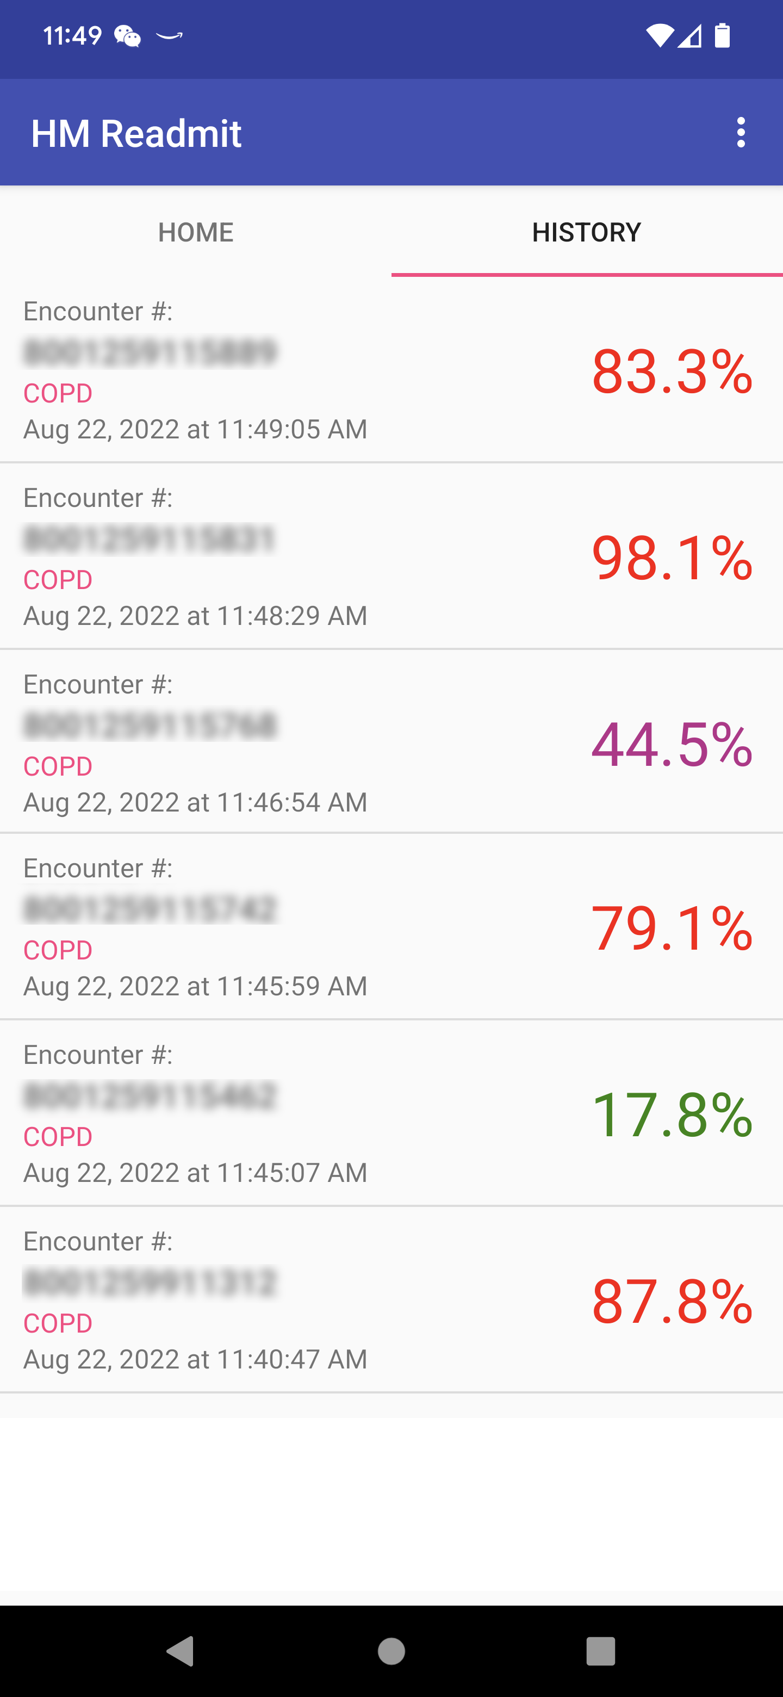

Supplemental Figure S3: The Rothman Index Score may use 26 variables, for example, vital signs, including temperature, systolic blood pressure, diastolic blood pressure, heart rate, blood oxygen saturation and respiratory rate; nursing assessments, including cardiac, food/nutrition, gastrointestinal, genitourinary, musculoskeletal, neurological, peripheral vascular, psycho-social, respiratory, skin/tissue and safety/fall risk standards; scores, including Braden Scale Heart patterns; blood chemistry, including blood urea nitrogen, creatinine, chloride, sodium and potassium; and blood analysis, including hemoglobin and white blood cell count. A patient example with 26 variables and corresponding Rothman Index.

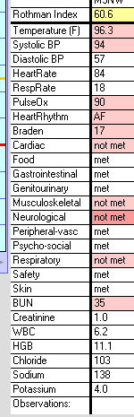

Supplemental Figure S4: An example of ANN with input, hidden and output layers.

Input layer
Hidden layer
Output Layer

