SUPPLEMENTAL DATA
For
HYDROGEL-BASED MICROFLUIDIC DEVICE WITH MULTIPLEXED 3D IN VITRO CELL CULTURE
¹Allison Clancy, ²Dayi Chen, ¹Joseph Bruns, ¹Jahnavi Nadella, ¹Samuel Stealey, ²Yanjia Zhang ^{2,}*Aaron Timperman, ^{1,}*Silviya P Zustiak
¹Department of Biomedical Engineering, Saint Louis University, St Louis, MO,
²Department of Bioengineering, and Biochemistry and Biophysics, University of Pennsylvania, Philadelphia, PA

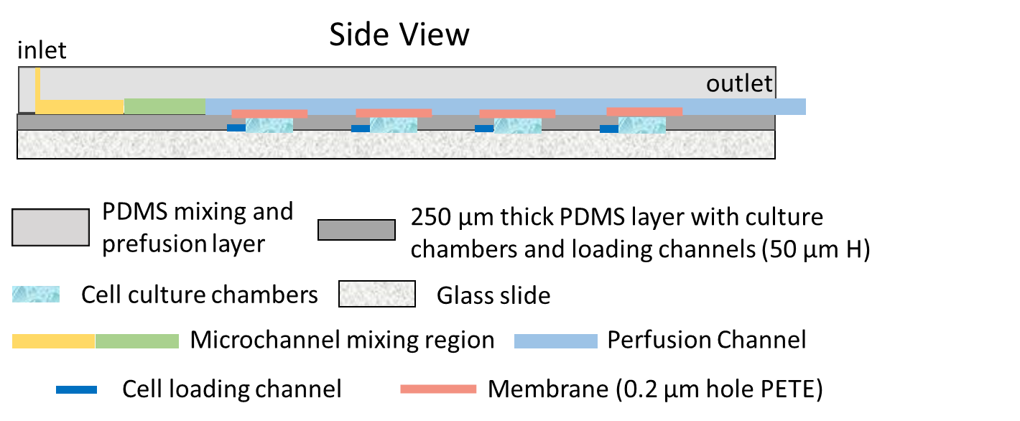
Supplemental Figure S1: A detailed schematic of the side view of the fabricated microfluidic device.

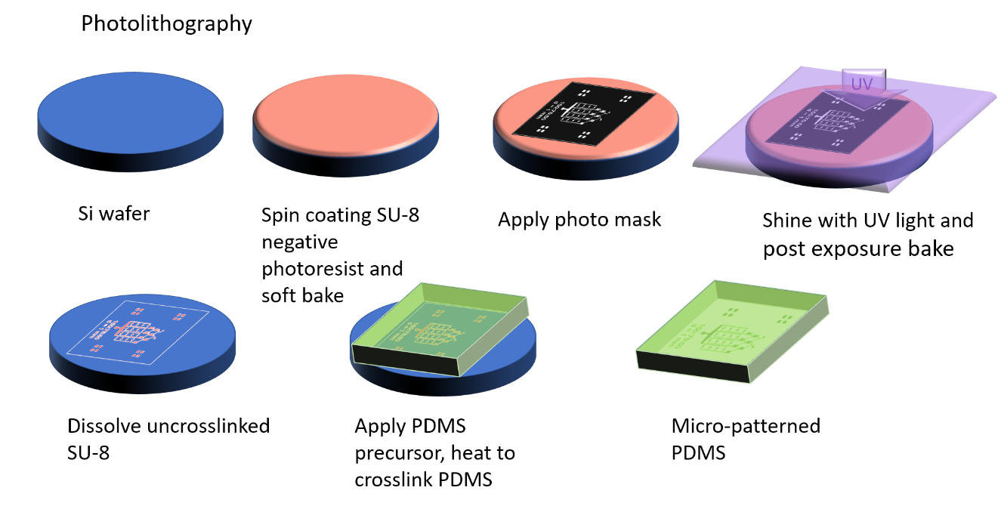
Spin coating SU-8 negative photoresist on Si wafer and soft bake
Apply photo mask
Shine with UV light and post exposure bake
Dissolve uncrosslinked SU-8
Apply PDMS precursor, heat to crosslink PDMS
x
x
Micro-patterned PDMS
x
x

Supplemental Figure S2. Photolithography process used to create the micro-patterned PDMS layers of the microfluidic device. In a first step, an SU-8 negative photoresist is spun-coated on a silicon wafer and baked. The photoresist is then illuminated with UV light through a photo mask, baked and dissolved to achieve device mold. PDMS precursor solution is then poured onto the mold and crosslinked to result in a micro-patterned PDMS device.

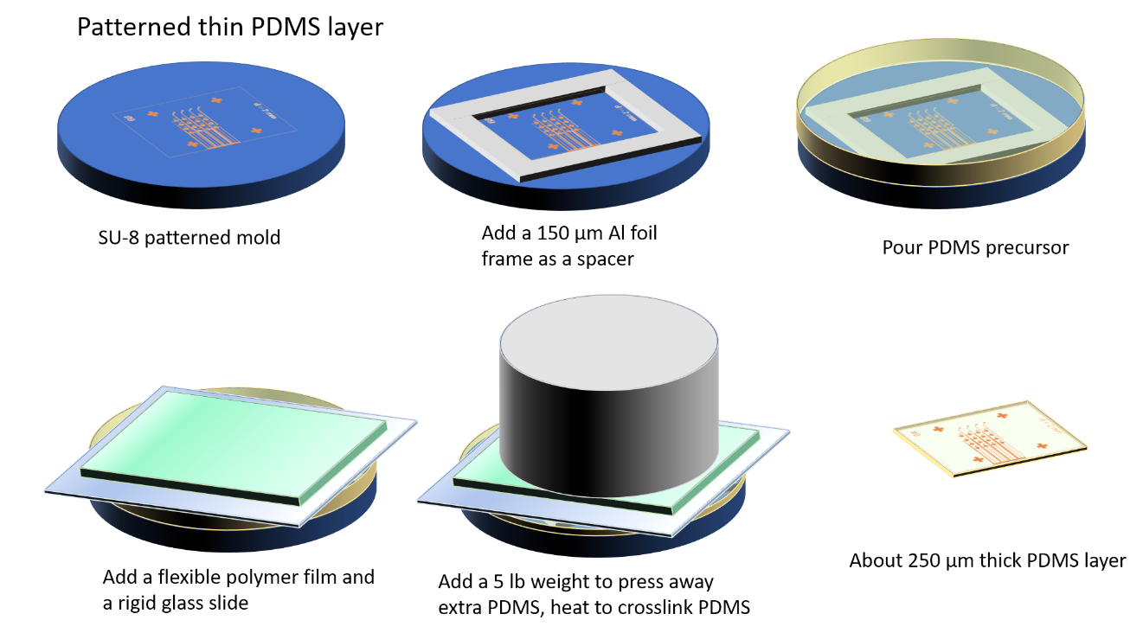
SU-8 patterned mold
Add a 150 𝜇m Al foil frame as a spacer
Pour PDMS precursor
About 250 𝜇m thick PDMS layer
Add a 5 lb weight to press away extra PDMS, heat to crosslink PDMS
Add a flexible polymer film and a rigid glass slide
Add a flexible polymer film and a rigid glass slide
About 250 𝜇m thick PDMS layer
Add a 5 lb weight to press away extra PDMS, heat to crosslink PDMS

Supplemental Figure S3. Photolithography process used to create the bottom micro-patterned PDMS layer of the microfluidic device.

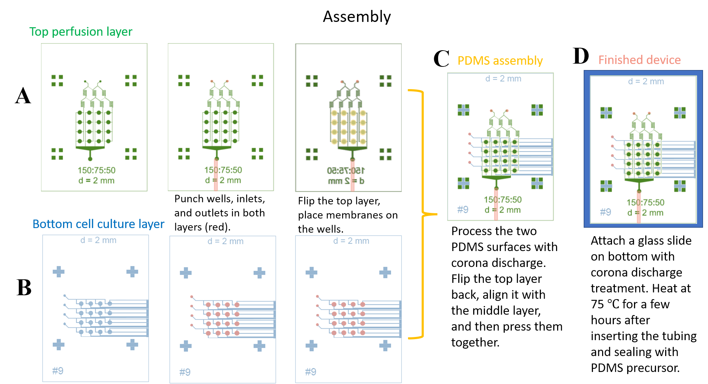

Supplemental Figure S4. Assembling process (step by step from left to right) of the microfluidic devices. A) Assembly of the top perfusion PDMS layer. B) The bottom PDMS cell culture layer. C) Assembly of the two layers of PDMS. D) Assembly of the finished device with a glass slide bottom.

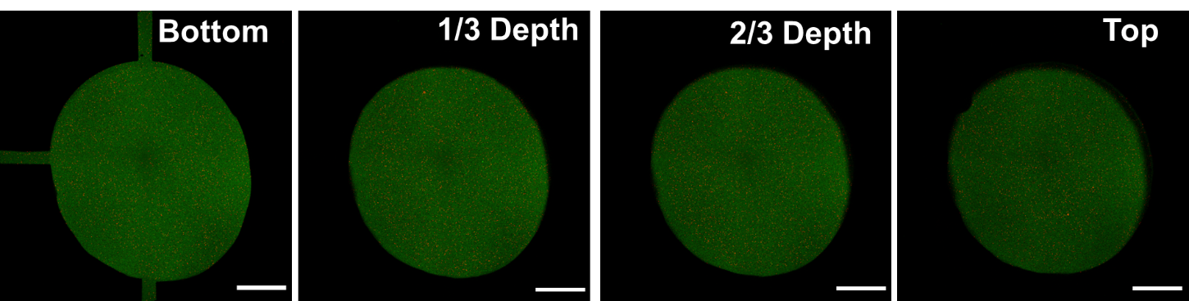

Supplemental Figure S5: Images of the bottom, one-third, two-thirds, and the top of a 4-arm PEG-Ac hydrogel when loaded in a cell culture microwell. The hydrogels are labelled with green fluorescence via tethering of FITC-modified ligands to the 4-arm PEG-Ac as described in the methods. Scale bar = 500 µm.

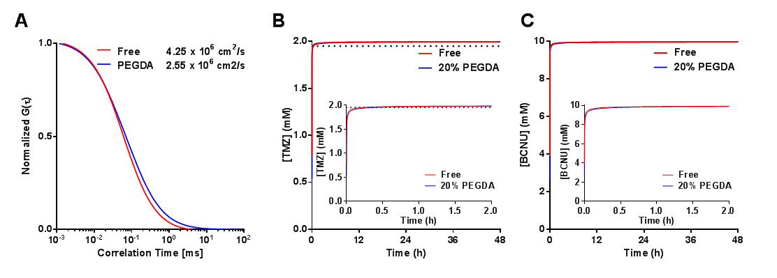
Supplemental Figure S6: Drug penetration through a PEGDA hydrogel. A) Normalized autocorrelation curve for G(t) for a model fluorescent dye (Atto 655) in a PEGDA hydrogel compared to media only. B) Calculated TMZ concentration at full depth of the hydrogel (250 µm). Black dotted line indicates 1.95 mM TMZ. C) Calculated BCNU concentration at full depth of the hydrogel (250 µm). The data was modeled using diffusion coefficients at day 1 measured via FCS, using a Fick’s 2nd law and 1-D geometry.

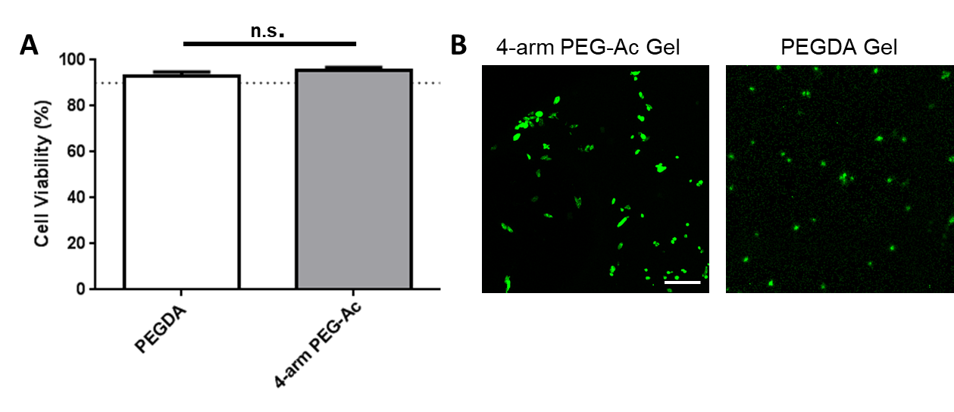
Supplemental Figure S7: A) Cell viability in 4-arm PEG-Ac and PEGDA is >90% at day 4 of culture (as measured by live/dead staining). B) Representative fluorescent images of cell spreading in degradable adhesive 4-arm PEG-Ac hydrogels and cells remaining round in non-degradable, non-adhesive PEGDA hydrogels. Cells were stained with DiOC (green) and cultured in the microfluidic device for 4 days. Scale bar is 100 µm.

