Supplementary Information, file 1

Phase 1 safety trial of a natural product cocktail with antibacterial activity in human volunteers

Table S1. Incidence of salve-related adverse effects by (a) gender; (b) batch number used.
a) | Female N | Male N | Non-binary N | Total
No AE | 52 | 39 | 1 | 92
≥1 AE | 9 | 5 | 0 | 14
Total | 61 | 44 | 1 | 106
b) | Batch 1 | Batch 2 | Total
No AE | 49 | 43 | 92 | -
≥1 AE | 6 | 8 | 14 | -
Total | 54 | 51 | 106 | -

Figure S1. Examples of (a) a skin reaction to the dressing adhesive only and (b) a skin reaction to the eyesalve

Figure S1a. Figure S1b.
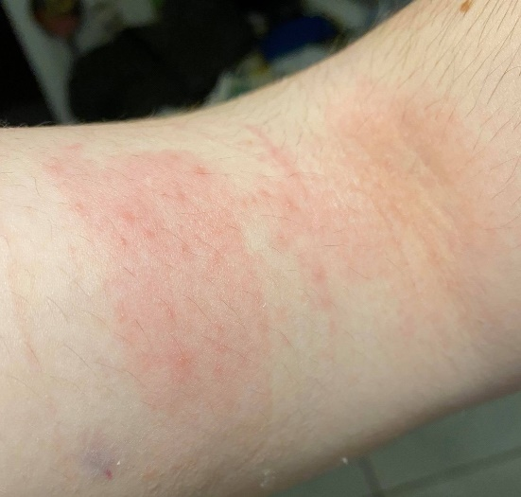
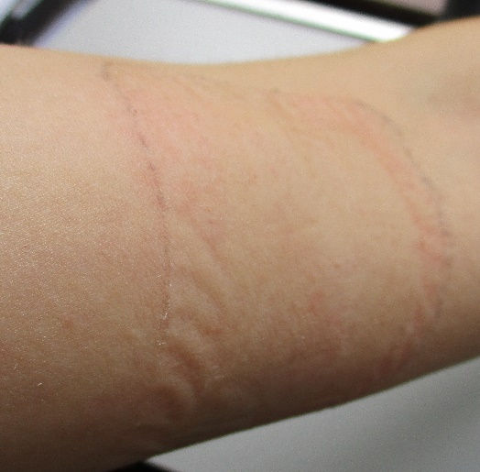

Figure S2. Median (inter-quartile) age distribution of participants by salve-related AEs
