Supporting information:
Synergy of R-(-)Carvone and Cyclohexenone-based Carbasugar Precursors with Antibiotics to Enhance Antibiotic Potency and Inhibit Biofilm Formation.

Oliver Riester ^{1,2}, Pia Burkhardtsmaier ¹, Yuna Gurung ¹, Stefan Laufer ^{2,3}, Hans-Peter Deigner ^{1,4,5,#}, Magnus S. Schmidt ^{1,*,#}
¹ Institute of Precision Medicine, Furtwangen University, Jakob-Kienzle-Strasse 17, Villingen-Schwenningen, 78054, Germany
² Institute of Pharmaceutical Sciences, Department of Pharmacy and Biochemistry, Eberhard-Karls-University Tuebingen, Auf der Morgenstelle 8, Tuebingen, 72076, Germany
³ Tuebingen Center for Academic Drug Discovery & Development (TüCAD2), 72076 Tuebingen, Germany
⁴ Faculty of Science, Eberhard-Karls-University Tuebingen, Auf der Morgenstelle 8, Tuebingen, 72076, Germany
⁵ EXIM Department, Fraunhofer Institute IZI (Leipzig), Schillingallee 68, Rostock, 18057, Germany
* Corresponding author: smag@hs-furtwangen.de
# Both authors share senior authorship

Table of content

Biocompatibility - Figure S1 | Biocompatibility of the compounds rac-7 and 3. S2
Microbial growth - Figure S2 | Effects of the compounds rac-7 and 3 on the bacterial growth S3
Biofilm - Figure S3 | Evaluation of biofilm formation in the presence of compounds rac-7 and 3. S4
NMR Spectra - Figure S4 | ¹H-NMR spectrum of compound 2. S5
NMR Spectra - Figure S5 | ¹³C-NMR spectrum of compound 2. S5
NMR Spectra - Figure S6 | ¹H-NMR spectrum of compound 3. S6
NMR Spectra - Figure S7 | ¹³C-NMR spectrum of compound 3. S6
NMR Spectra - Figure S8 | COSY spectrum of compound 3. S7
NMR Spectra - Figure S9 | NOESY spectrum of compound 3 with indicated crosscoupling. S7
NMR Spectra - Figure S10 | ¹H-NMR spectrum of compound 6. S8
NMR Spectra - Figure S11 | ¹³C-NMR spectrum of compound 6. S8
NMR Spectra - Figure S12 | ¹H-NMR spectrum of compound 7. S9

Biocompatibility

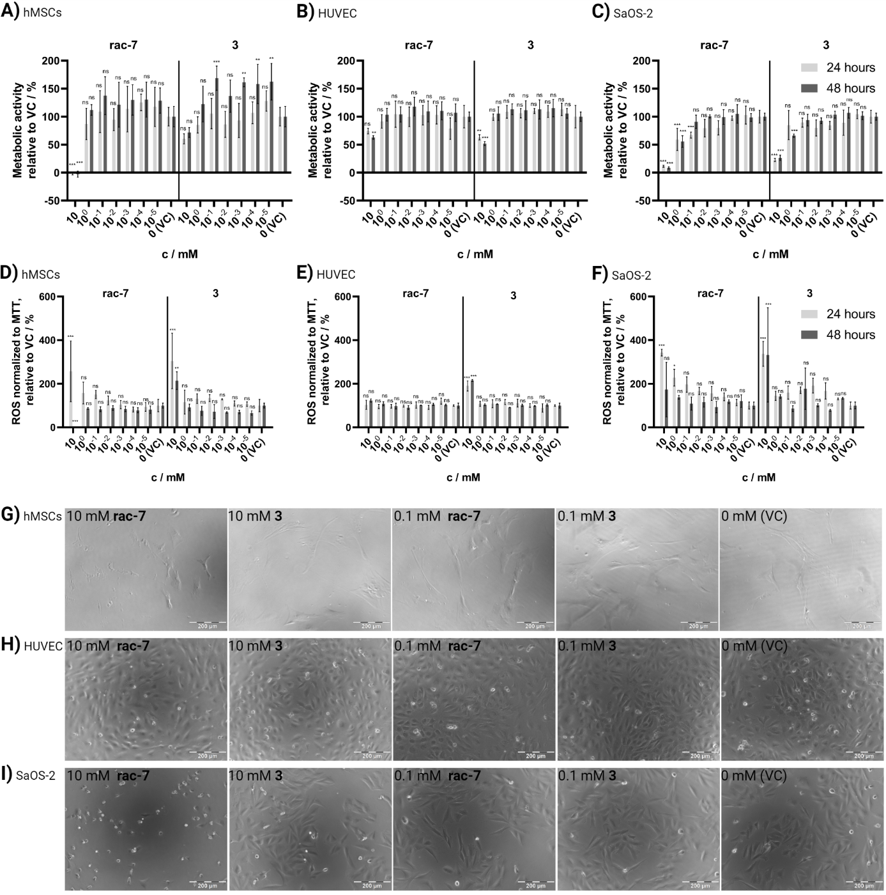
Figure S1 | Biocompatibility of the compounds rac-7 and 3. Human mesenchymal stem cells (hMSC), human umbilical vein endothelial cells (HUVEC) and SaOS-2 human osteogenic sarcoma cells treated for 24 and 48 hours. A - C Evaluation of metabolic activity at different concentrations of CSPs with MTT – assay in comparison to vehicle control (VC). D – F Cellular reactive oxygen species (ROS) normalized to MTT – assay and compared to VC. VC was treated with same volume of PBS without CSPs. Values are shown as mean ± SD (n = 3). Statistical significance was analyzed with Two-way ANOVA and Dunnett post-hoc test against respective VC (ns, not significant; * p < 0.05; ** p < 0.01; *** p < 0.001). G – I Representative microsopic images of hMSCs, HUVECs and SaOS-2 cells treated with compounds rac-7 or 3. Scale bar measures 200 µm.

Microbial growth

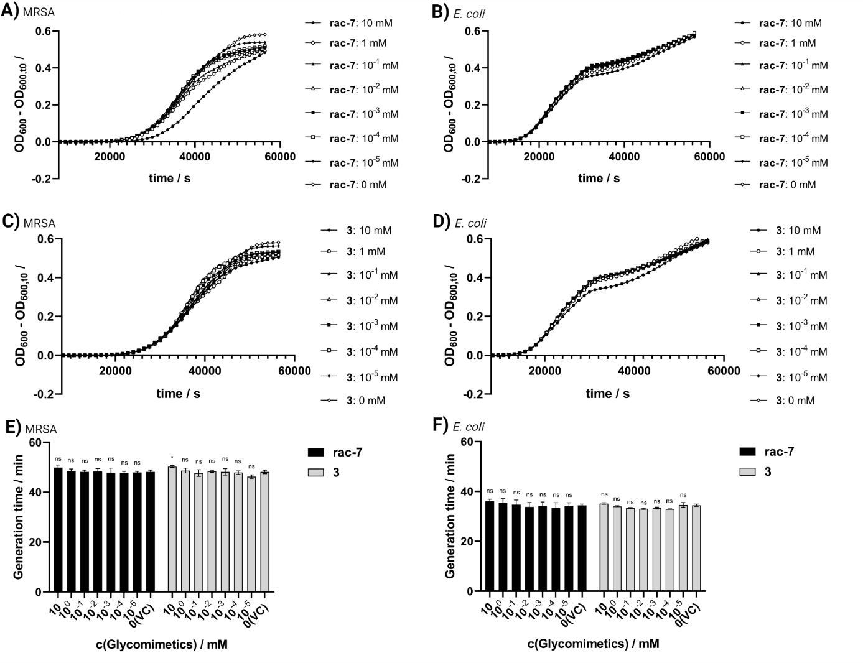 Figure S2 | Effects of the compounds rac-7 and 3 on the bacterial growth of Escherichia coli (E. coli; B, D, F) and methicillin-resistant Staphylococcus aureus (MRSA; A, C, E). Measured optical density at 600 nm (OD₆₀₀) showing the growth curves treated with several concentrations of the carbasugar precursors (CSPs) rac-7 (A, B) and 3 (C, D) in LB medium. Concentration-dependent influence of CSPs on the generation time of E. coli (F) and MRSA (E) in LB medium (additional concentrations to Figure 3). Values are shown as mean (A - D: n = 3) or mean ± SD (E, F: n = 3). Statistical significance was analyzed with Two-way ANOVA and Dunnett post-hoc test against respective vehicle control (VC) (ns, not significant; * p < 0.05; ** p < 0.01; *** p < 0.001).

Biofilm

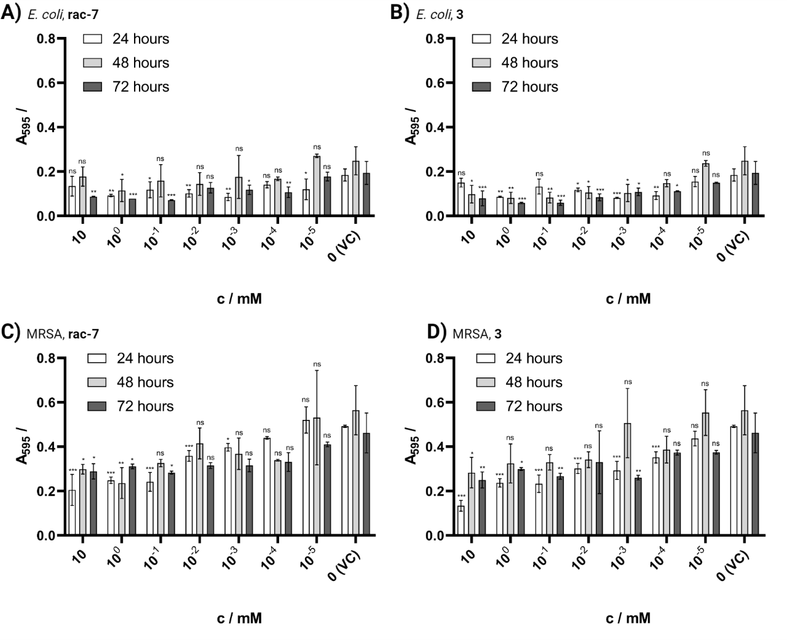
Figure S3 | Evaluation of biofilm formation in the presence of compounds rac-7 and 3. Biofilm formation of Escherichia coli (E. coli; A – B) and methicillin-resistant Staphylococcus aureus (MRSA; C – D) after 24, 48 and 72 hours of incubation in the presence of 10 mM to 10 nM carbasugar precursors. Absolute values are shown as mean ± SD (n = 2). Statistical significance was analyzed with Two-way ANOVA and Dunnett post-hoc test against respective vehicle control (n s, not significant; * p < 0.05; ** p < 0.01; *** p < 0.001).

NMR Spectra
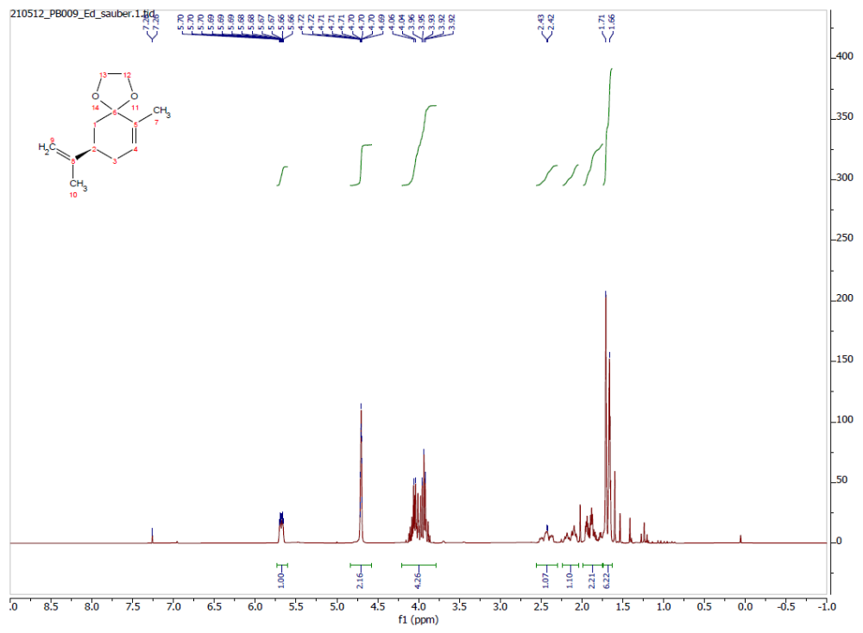
Figure S4 | ¹H-NMR spectrum of compound 2.
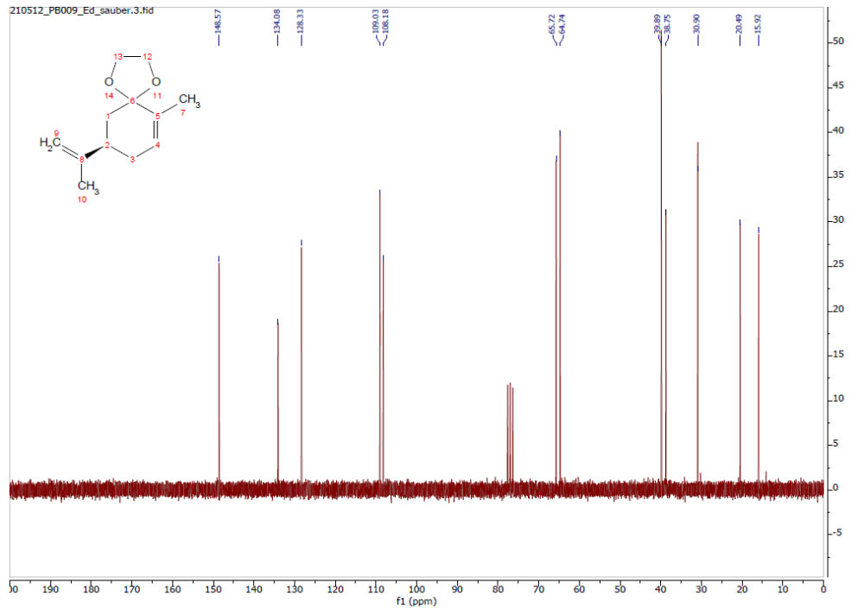
Figure S5 | ¹³C-NMR spectrum of compound 2.
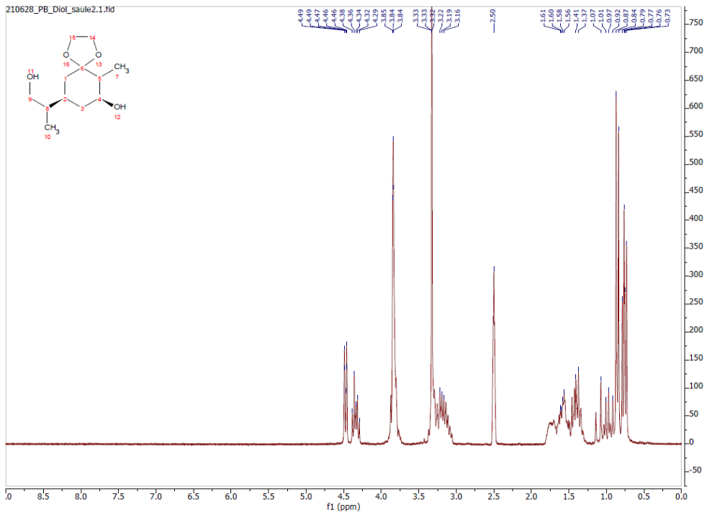
Figure S6 | ¹H-NMR spectrum of compound 3.
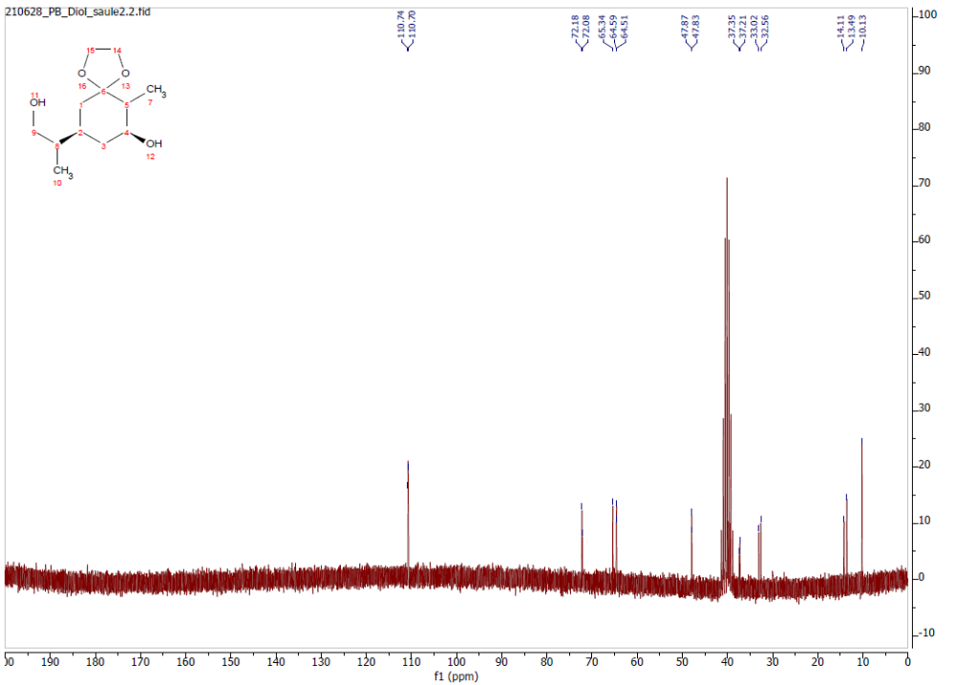
Figure S7 | ¹³C-NMR spectrum of compound 3.
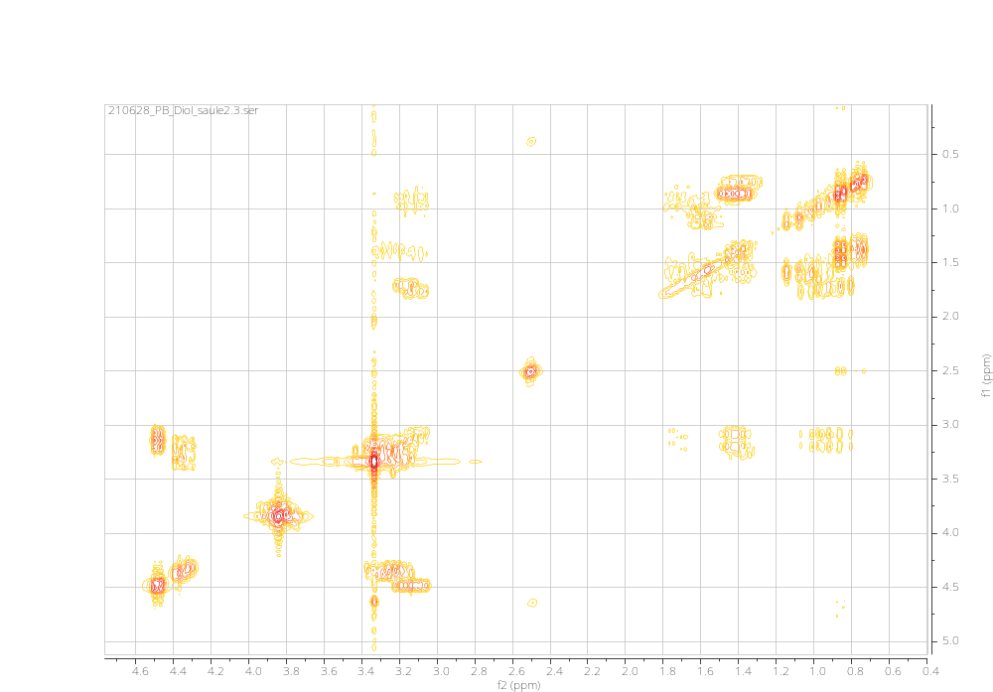
Figure S8 |COSY spectrum of compound 3.
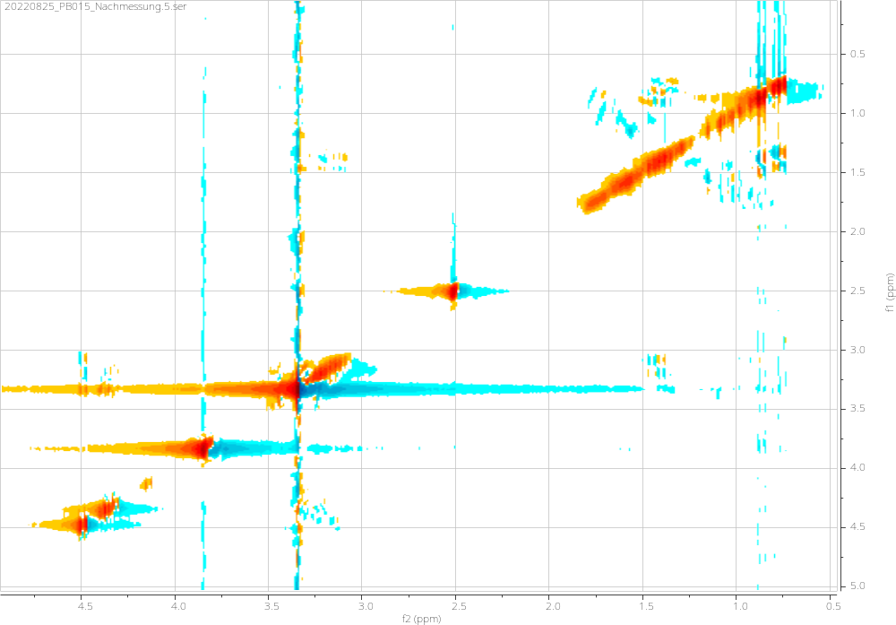
Figure S9: NOESY spectrum of compound 3 with indicated crosscoupling.

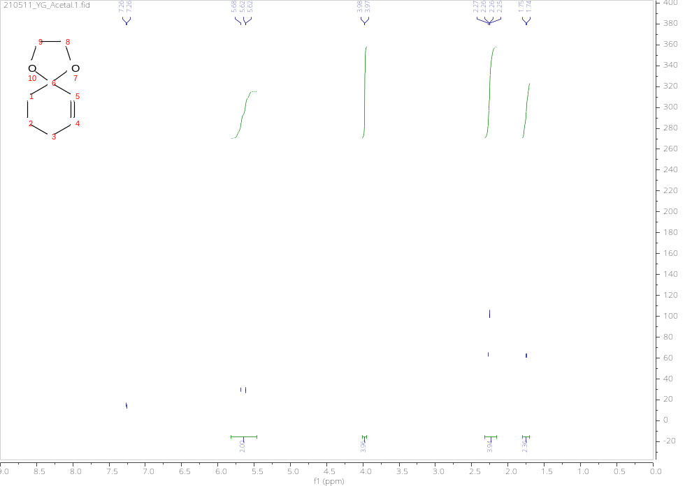
Figure S10 | ¹H-NMR spectrum of compound 6.
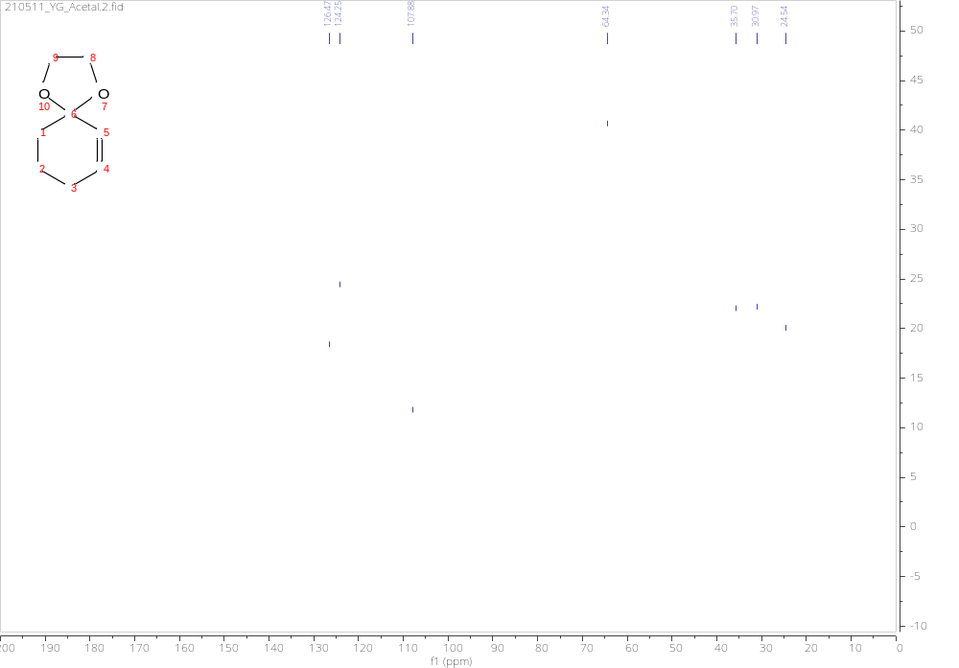
Figure S11 | ¹³C-NMR spectrum of compound 6.
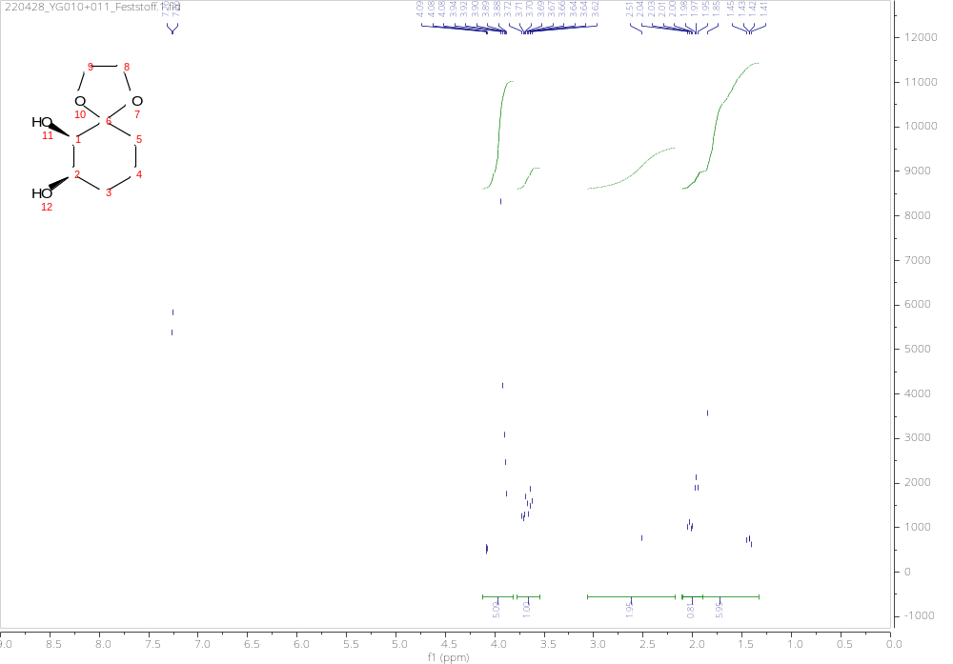
Figure S12 | ¹H-NMR spectrum of compound 7.

