Tab. S1 Primer sequences for candidate reference genes.

Gene symbol | Gene description | Primers/sequence source | Primer sequence 5’→3’ | Amplicon size (bp)
ARF | ADP-ribosylation factor | XM_044532078.1 PREDICTED: Triticum aestivum ADP-ribosylation factor 1-like (LOC123111312), transcript variant X2, mRNA | F: GCCATGAATGCGGCTGAAA | 113
ARF | ADP-ribosylation factor |  | R: AGTCCCTCGTACAATCCCTC | 113
CYP | Cyclophilin | EU035525.1 Triticum aestivum cyclophilin mRNA, complete cds | F: ATGGCCAACCCCAAGGTCT | 145
CYP | Cyclophilin | EU035525.1 Triticum aestivum cyclophilin mRNA, complete cds | R: TCTTGCCCACGCCCTTCTC | 145
EF1A | Elongation factor 1-alpha | (Wrzesińska et al. 2016)  KT153026.1 Avena fatua elongation factor 1-alpha (EF1) mRNA, partial cds | F: CAGGCAGATGATCTGCTGCT | 158
EF1A | Elongation factor 1-alpha |  | R: CCTCAAAGCCAGAGATTGGAA | 158
EIF4A | Eukaryotic initiation factor 4A-3, | (Yang et al. 2020)  Locus_3892_Transcript_3/4_Confi- dence_0.667_Length_1160 | F: TCTCGCAGGATACGGATGTCG | 88
EIF4A | Eukaryotic initiation factor 4A-3, |  | R: TCCATCGCATTGGTCGCTCT | 88
GAPDH | Glyceraldehyde-3-phosphate dehydrogenase | (Wrzesińska et al. 2016)  KT153027.1 Avena fatua glyceraldehyde-3-phosphate dehydrogenase (GAPDH) mRNA, partial cds | F: CGTCAGGAACCCTGAAGAAA | 146
GAPDH | Glyceraldehyde-3-phosphate dehydrogenase |  | R: CTTTGCTAGGGGCTGAAATG | 146
HNR | Heterogeneous nuclear ribonucleoprotein 27C | (Yang et al. 2020)  Locus_4951_Transcript_1/4_Confi- dence_0.667_Length_1455 | F: ATTGGGTTTGTCACTTTCCGTAG | 134
HNR | Heterogeneous nuclear ribonucleoprotein 27C |  | R: CTTGGAGGGTGTCTCGCATCT | 134
HSP70 | Heat shock protein | XM_003578850.3 PREDICTED: Brachypodium distachyon heat shock cognate 70 kDa protein 2 (LOC100843308), mRNA | F: ATCGACGCTGCCATTCAGTG | 109
HSP70 | Heat shock protein |  | R: TCTTGGCGATGATGGGGTTG | 109
TBP | TATA box binding protein | L07604.1 Triticum aestivum DNA-binding protein (TFIID) mRNA, complete cds | F: GATGAGGCAGCCGAAGATTG | 102
TBP | TATA box binding protein |  | R: TCCAAAGTCAACCATCATTGCT | 102
TUA | Tubulin alpha | KT153029.1 Avena fatua alpha-tubulin (TUA) mRNA, partial cds | F: CGCCGCTCCCTTGATATTGA | 151
TUA | Tubulin alpha | KT153029.1 Avena fatua alpha-tubulin (TUA) mRNA, partial cds | R: TTGGGTAGGGCACCAGATTG | 151
UBC | Ubiquitin conjugating enzyme (E2) | XM_044536383.1 PREDICTED: Triticum aestivum ubiquitin-conjugating enzyme E2 2 (LOC123115130), mRNA | F: CTGTGCGACCCGAATCCAAA | 103
UBC | Ubiquitin conjugating enzyme (E2) |  | R: GCTCCACGATCTCACGAACT | 103
PAL | Phenylalanine ammonia lyase | (Tajti et al. 2021)  MT150275.1  Triticum aestivum phenylalanine ammonia-lyase (PAL) mRNA, complete cds | F: GCAACTTCCAGGGCACCC | 95
PAL | Phenylalanine ammonia lyase |  | R: CTCCGAGAACTGAGCGAACAT | 95

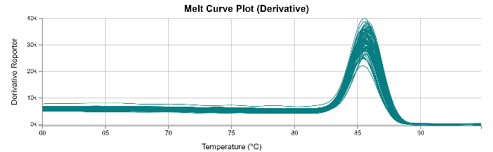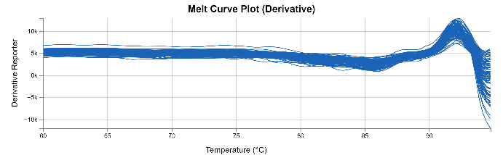
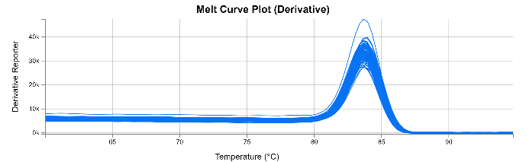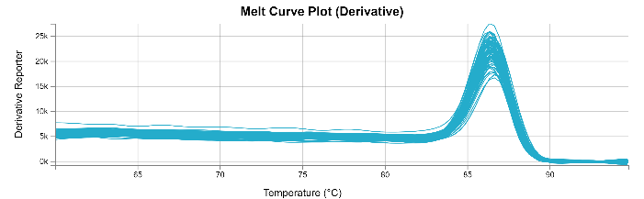
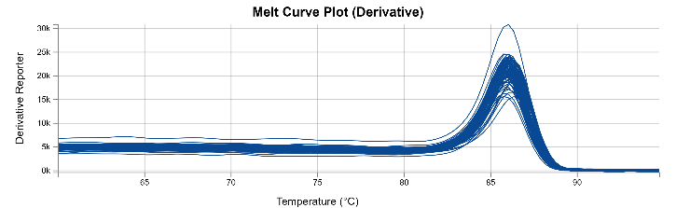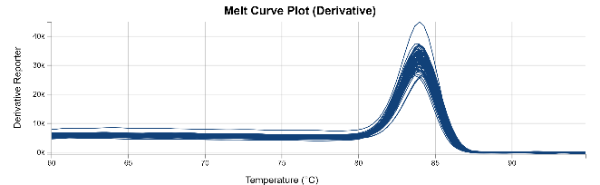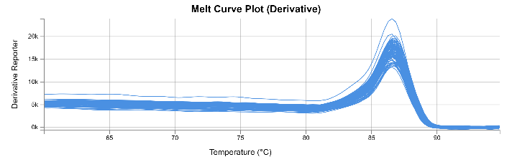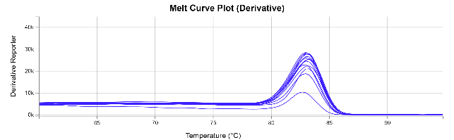
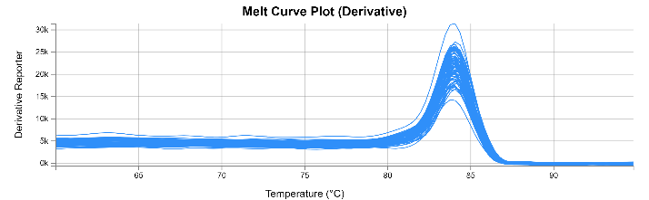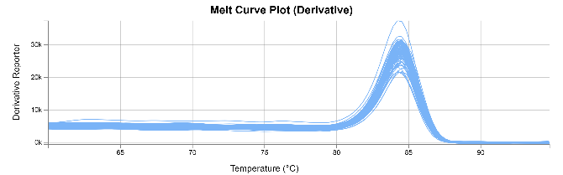
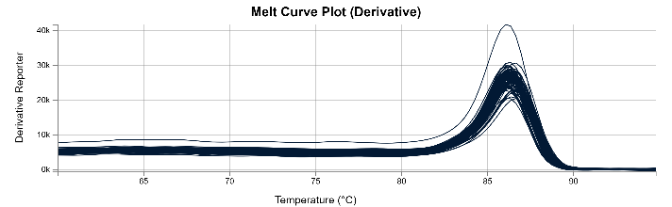

Fig. S1 Melt curves forRT‐qPCR amplification of tested reference genes.
ARF - ADP-ribosylation factor, CYP - cyclophilin, EF1A - elongation factor 1-alpha, EIF4A - eukaryotic initiation factor 4A-3, GAPDH - glyceraldehyde-3-phosphate dehydrogenase, HNR - heterogeneous nuclear ribonucleoprotein 27C, HSP70 - heat shock protein, TUA - alpha tubulin, UBC - ubiquitin conjugating enzyme (E2),PAL - Phenylalanine ammonia lyase.

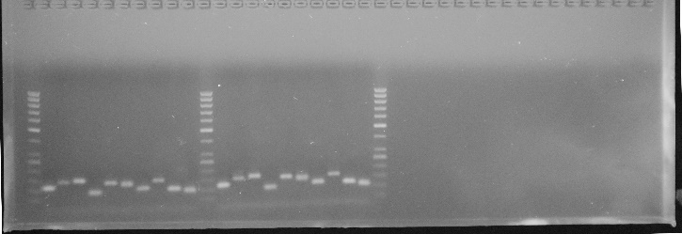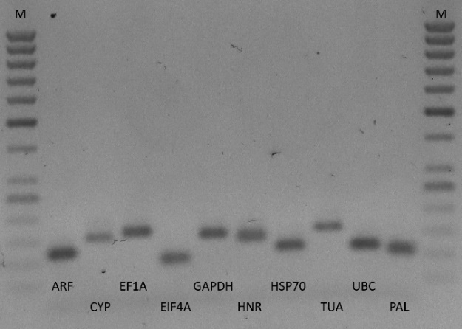

Fig. S2 qPCR products of candidate reference genes and the gene of interest (PAL - Phenylalanine ammonia lyase) on agarose gel.
ARF-ADP-ribosylation factor, CYP -cyclophilin, EF1A - elongation factor 1-alpha,EIF4A -eukaryotic initiation factor 4A-3, GAPDH - glyceraldehyde-3-phosphate dehydrogenase,HNR - heterogeneous nuclear ribonucleoprotein 27C,HSP70 - heat shock protein,TUA - alpha tubulin,UBC - ubiquitin conjugating enzyme (E2).
M- 50bp Gene Ruler DNA ladder (Thermo Fisher Scientific Inc., USA).

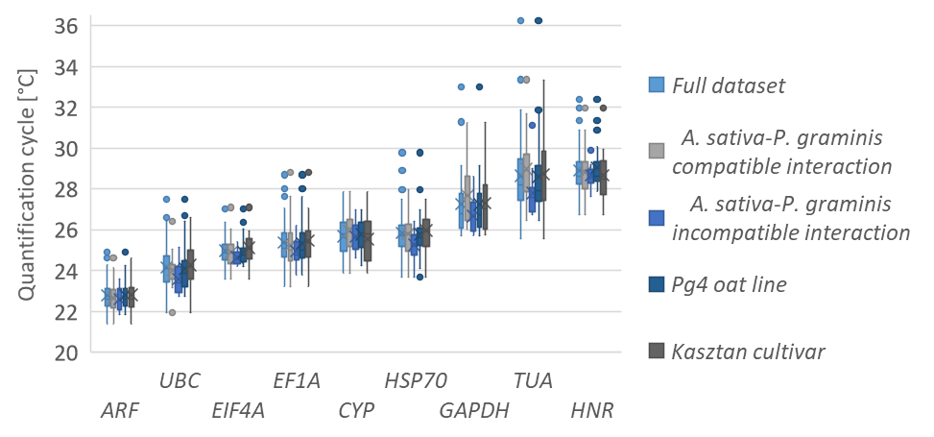
Fig. S3Cq values for nine candidate reference genes across experimental samples. A line across the box is depicted as the median. The box indicates the 25th and 75th percentiles, the dots represent outlier values.
ARF - ADP-ribosylation factor, CYP - cyclophilin, EF1A - elongation factor 1-alpha, EIF4A - eukaryotic initiation factor 4A-3, GAPDH - glyceraldehyde-3-phosphate dehydrogenase, HNR - heterogeneous nuclear ribonucleoprotein 27C, HSP70 - heat shock protein, TUA - alpha tubulin, UBC - ubiquitin conjugating enzyme (E2).

Tab. S2 Expression stability of tested RGs determined by BestKeeper,ΔCt, geNorm and NormFinder algorithms for full dataset, compatible interaction dataset, incompatible interaction dataset, Pg4 oat line dataset and Kasztan cultivar dataset.

 |  | <:::: Least stable genes Most stable genes ::::>
a. |  | CYP | HSP70 | ARF | TUA | UBC | GAPDH | EIF4A | EF1A | HNR
BestKeeper  Correlation coefficients (r) | Full dataset | 0.665 | 0.889 | 0.887 | 0.928 | 0.894 | 0.911 | 0.947 | 0.956 | 0.963
BestKeeper  Correlation coefficients (r) | A. sativa – P. graminis compatible interaction | 0.815 | 0.916 | 0.943 | 0.937 | 0.916 | 0.95 | 0.957 | 0.973 | 0.976
BestKeeper  Correlation coefficients (r) | A. sativa – P. graminis incompatible interaction | 0.63 | 0.656 | 0.844 | 0.757 | 0.927 | 0.875 | 0.928 | 0.925 | 0.903
BestKeeper  Correlation coefficients (r) | Pg4 oatline | 0.686 | 0.898 | 0.914 | 0.931 | 0.95 | 0.932 | 0.963 | 0.947 | 0.978
BestKeeper  Correlation coefficients (r) | Kasztan cultivar | 0.658 | 0.877 | 0.848 | 0.925 | 0.796 | 0.873 | 0.95 | 0.974 | 0.987
 | Mean | 0.6908 | 0.8472 | 0.8872 | 0.8956 | 0.8966 | 0.9082 | 0.949 | 0.955 | 0.9614
b. |  | TUA | GAPDH | EF1A | HSP70 | HNR | UBC | CYP | ARF | EIF4A
BestKeeper  standard deviation (SD) | Full dataset | 1.379 | 1.122 | 0.849 | 0.820 | 0.789 | 0.819 | 0.794 | 0.582 | 0.505
BestKeeper  standard deviation (SD) | A. sativa – P. graminis compatible interaction | 1.581 | 1.245 | 0.951 | 0.935 | 0.931 | 0.745 | 0.771 | 0.591 | 0.552
BestKeeper  standard deviation (SD) | A. sativa – P. graminis incompatible interaction | 0.798 | 0.629 | 0.469 | 0.553 | 0.492 | 0.634 | 0.568 | 0.439 | 0.300
BestKeeper  standard deviation (SD) | Pg4 oatline | 1.399 | 1.093 | 0.791 | 0.778 | 0.736 | 0.795 | 0.698 | 0.550 | 0.451
BestKeeper  standard deviation (SD) | Kasztan cultivar | 1.316 | 1.174 | 0.934 | 0.871 | 0.897 | 0.838 | 0.971 | 0.641 | 0.554
 | Mean | 1.295 | 1.053 | 0.799 | 0.791 | 0.769 | 0.766 | 0.760 | 0.561 | 0.472
c. |  | TUA | CYP | GAPDH | HSP70 | UBC | ARF | EIF4A | EF1A | HNR
ΔCt  average standard deviation (mean SD) | Full dataset | 1.26 | 1.07 | 0.97 | 0.84 | 0.79 | 0.77 | 0.74 | 0.7 | 0.69
ΔCt  average standard deviation (mean SD) | A. sativa – P. graminis compatible interaction | 1.38 | 0.94 | 0.94 | 0.82 | 0.77 | 0.76 | 0.76 | 0.69 | 0.67
ΔCt  average standard deviation (mean SD) | A. sativa – P. graminis incompatible interaction | 0.96 | 0.73 | 0.64 | 0.75 | 0.55 | 0.53 | 0.52 | 0.5 | 0.53
ΔCt  average standard deviation (mean SD) | Pg4 oatline | 1.3 | 1.01 | 0.92 | 0.8 | 0.68 | 0.72 | 0.71 | 0.66 | 0.61
ΔCt  average standard deviation (mean SD) | Kasztan cultivar | 1.2 | 1.16 | 1.05 | 0.9 | 0.94 | 0.84 | 0.76 | 0.73 | 0.7
 | Mean | 1.22 | 0.982 | 0.904 | 0.822 | 0.746 | 0.724 | 0.698 | 0.656 | 0.64
d. |  | TUA | CYP | GAPDH | HSP70 | UBC | HNR | EF1A | ARF | EIF4A
geNorm  stability value (M) | Full dataset | 0.870 | 0.757 | 0.673 | 0.542 | 0.482 | 0.452 | 0.429 | 0.271 | 0.271
geNorm  stability value (M) | A. sativa – P. graminis compatible interaction | 0.852 | 0.627 | 0.708 | 0.538 | 0.502 | 0.476 | 0.452 | 0.244 | 0.244
geNorm  stability value (M) | A. sativa – P. graminis incompatible interaction | 0.597 | 0.448 | 0.380 | 0.508 | 0.316 | 0.217 | 0.217 | 0.267 | 0.289
geNorm  stability value (M) | Pg4 oatline | 0.824 | 0.688 | 0.605 | 0.472 | 0.407 | 0.358 | 0.383 | 0.232 | 0.232
geNorm  stability value (M) | Kasztan cultivar | 0.920 | 0.839 | 0.746 | 0.596 | 0.524 | 0.237 | 0.237 | 0.467 | 0.432
 | Mean | 0.812 | 0.672 | 0.622 | 0.531 | 0.446 | 0.348 | 0.343 | 0.296 | 0.293
e. |  | TUA | CYP | GAPDH | HSP70 | UBC | ARF | EIF4A | EF1A | HNR
NormFinder  stability value  (SV) | Full dataset | 0.335 | 0.298 | 0.259 | 0.221 | 0.186 | 0.199 | 0.153 | 0.127 | 0.147
NormFinder  stability value  (SV) | A. sativa – P. graminis compatible interaction | 0.403 | 0.301 | 0.269 | 0.247 | 0.223 | 0.201 | 0.210 | 0.121 | 0.102
NormFinder  stability value  (SV) | A. sativa – P. graminis incompatible interaction | 0.508 | 0.363 | 0.245 | 0.460 | 0.255 | 0.219 | 0.217 | 0.215 | 0.085
NormFinder  stability value  (SV) | Pg4 oatline | 0.556 | 0.567 | 0.397 | 0.318 | 0.278 | 0.255 | 0.215 | 0.268 | 0.119
NormFinder  stability value  (SV) | Kasztan cultivar | 0.559 | 0.676 | 0.532 | 0.451 | 0.527 | 0.371 | 0.305 | 0.248 | 0.180
 | Mean | 0.472 | 0.441 | 0.340 | 0.339 | 0.294 | 0.249 | 0.220 | 0.196 | 0.127

Fig. S4 Relative expression of the PAL gene following P. graminis f. sp. avenae inoculation. Analysis was performed for A. sativa Pg4 - P. graminis compatible (a) and incompatible (b) interaction against two sets of best performing RGs (HNR + ARF + EF1A and HNR + EIF4A + EF1A) separately or together as well as against worst performing RGs (CYP and TUA).
Data are shown as mean ± SD.
* indicate that the difference in expression between untreated (0 h) and inoculated data subgroups is significant at P ≤ 0.05 as determined by Student’s t-test.

