Supplementary Information

to

Structure of the human heterodimeric transporter 4F2hc-LAT2 in complex with Anticalin, an alternative binding protein for applications in single-particle cryo-EM

Jean-Marc Jeckelmann^{1,2}, Thomas Lemmin¹, Martin Schlapschy³, Arne Skerra³ and Dimitrios Fotiadis^{1,2}

¹ Institute of Biochemistry and Molecular Medicine, and ² Swiss National Centre of Competence in Research (NCCR) TransCure, University of Bern, Bern, Switzerland
³ Lehrstuhl für Biologische Chemie, Technische Universität München, Freising, Germany

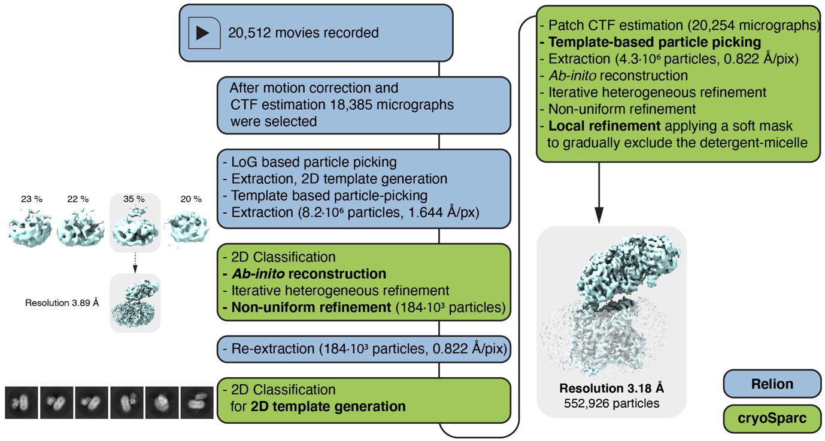

Supplementary Figure S1. Cryo-EM data processing flow chart. A graphical representation of the processing steps as described in the Materials and Methods section is shown. Calculations were performed using either Relion ^{1,2} or cryoSPARC ^{3,4} (corresponding software highlighted in light blue and green). Displayed cryo-EM 3D maps and 2D-class averages refer to individual steps during data processing and are written in bold face-type. Abbreviations are: CTF, contrast transfer function; LoG, Laplacian-of-Gaussian filter. Volume representations were prepared using UCSF ChimeraX (version 1.3, see Materials and Methods). The figure was assembled and labeled using Adobe Illustrator 26.5 (https://adobe.com/products/illustrator).

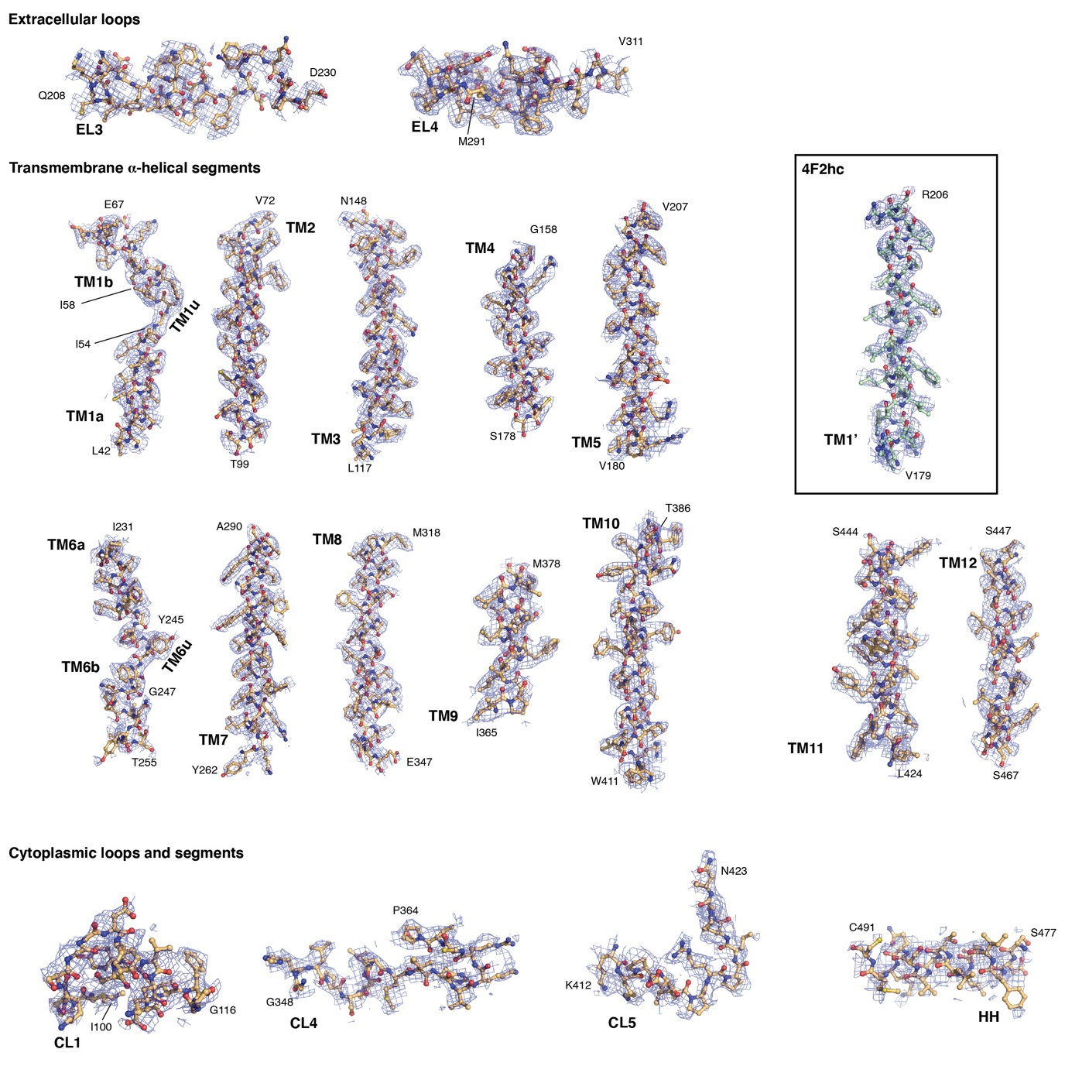

Supplementary Figure S2. Cryo-EM density of 4F2hc-LAT2 structural elements. Elements are displayed as sticks (TM1’ of 4F2hc, carbon atoms green; LAT2 elements, carbon atoms orange) and the cryo-EM density as mesh (blue) at a threshold level of 0.125. Shown are all elements indicated in Figure 3c of the main manuscript: TM, transmembrane α-helical segment; EL, extracellular loop; CL, cytoplasmic loop; HH, horizonal α-helix. N- and C-terminal residues are labeled, and the structural element labels are given N-terminally in bold face type. Volume and structural representations were prepared using PyMol (version v2.5.2; The PyMol Molecular Graphics System, Schrödinger). The figure was assembled and labeled using Adobe Illustrator 26.5 (https://adobe.com/products/illustrator).

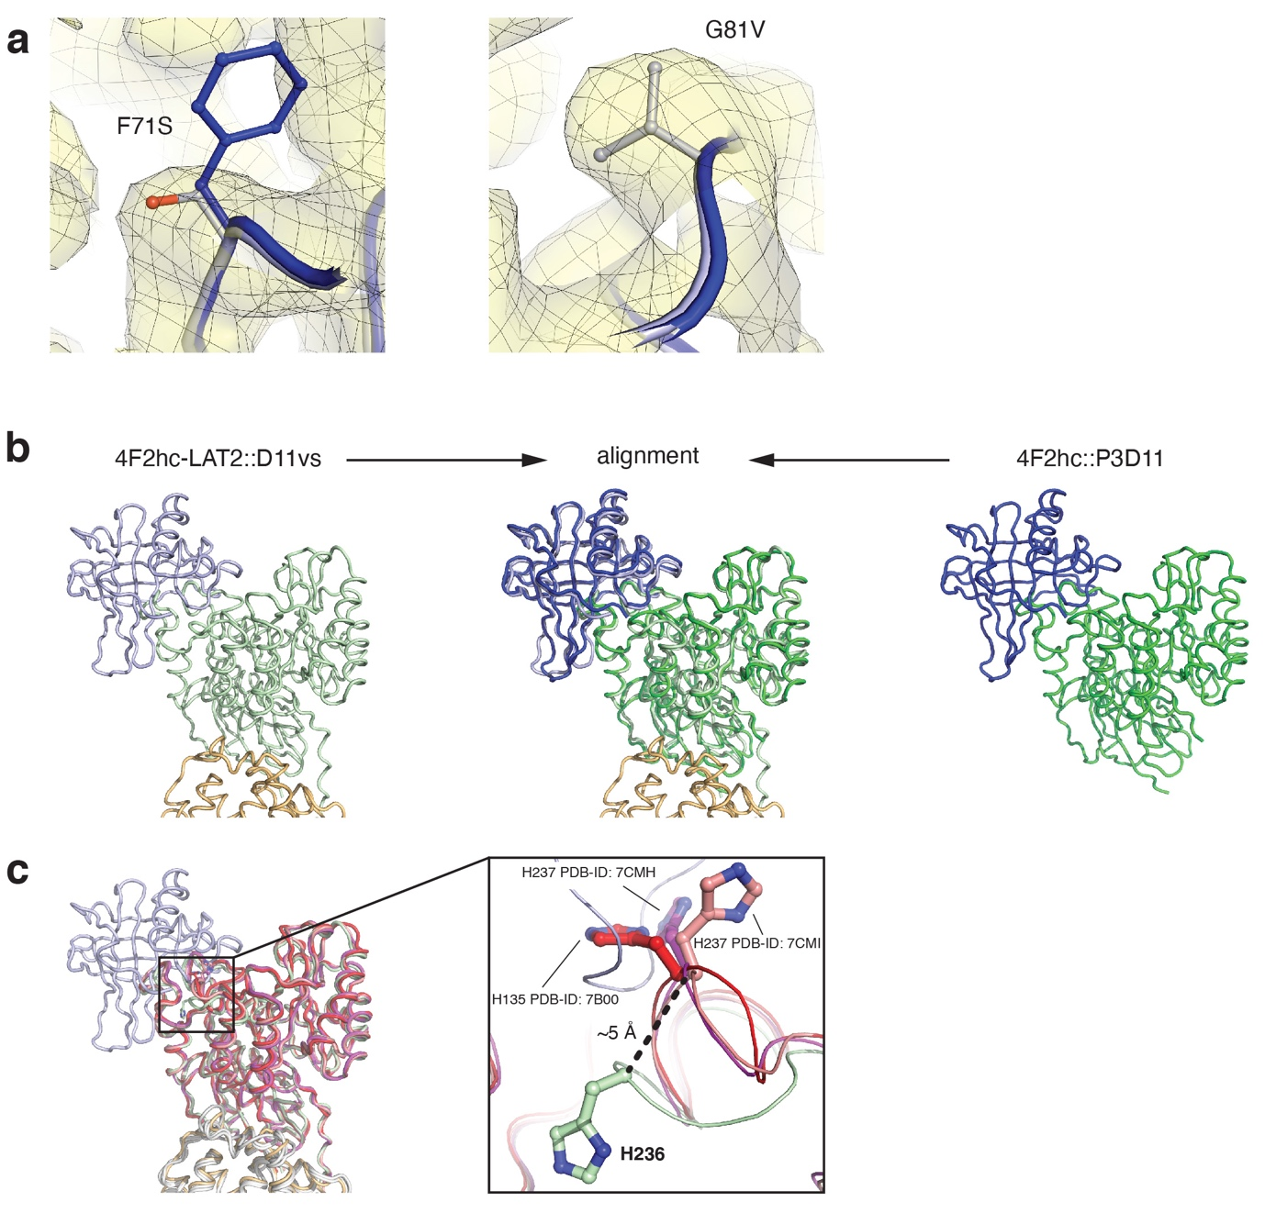

Supplementary Figure S3. Anticalin binding to the human 4F2hc ectodomain (4F2hc-ED). (a) Displayed is the cryo-EM density at the locations of the point mutations from P3D11 to D11vs, F71S (left) and G81V (right). (b) 4F2hc-ED based structural superposition of 4F2hc-ED::P3D11 (chain B of PDB-ID: 6S8V) onto 4F2hc-LAT2::D11vs (this work). (c) 4F2hc-based structural superposition of published 4F2hc-LAT2 cryo-EM structures [PDB-ID: 7B00 (red); 7CMI (pink) and 7CMH (magenta)] onto 4F2hc-LAT2::D11vs (this work). Highlighted on the right is the ~5 Å Cα-atomic displacement of H236 upon complexation of 4F2hc with D11vs. R.m.s.d values of the alignments are shown in Table 1 of the main manuscript. Structural representations were prepared using PyMol (version v2.5.2; The PyMol Molecular Graphics System, Schrödinger). The figure was assembled and labeled using Adobe Illustrator 26.5 (https://adobe.com/products/illustrator).

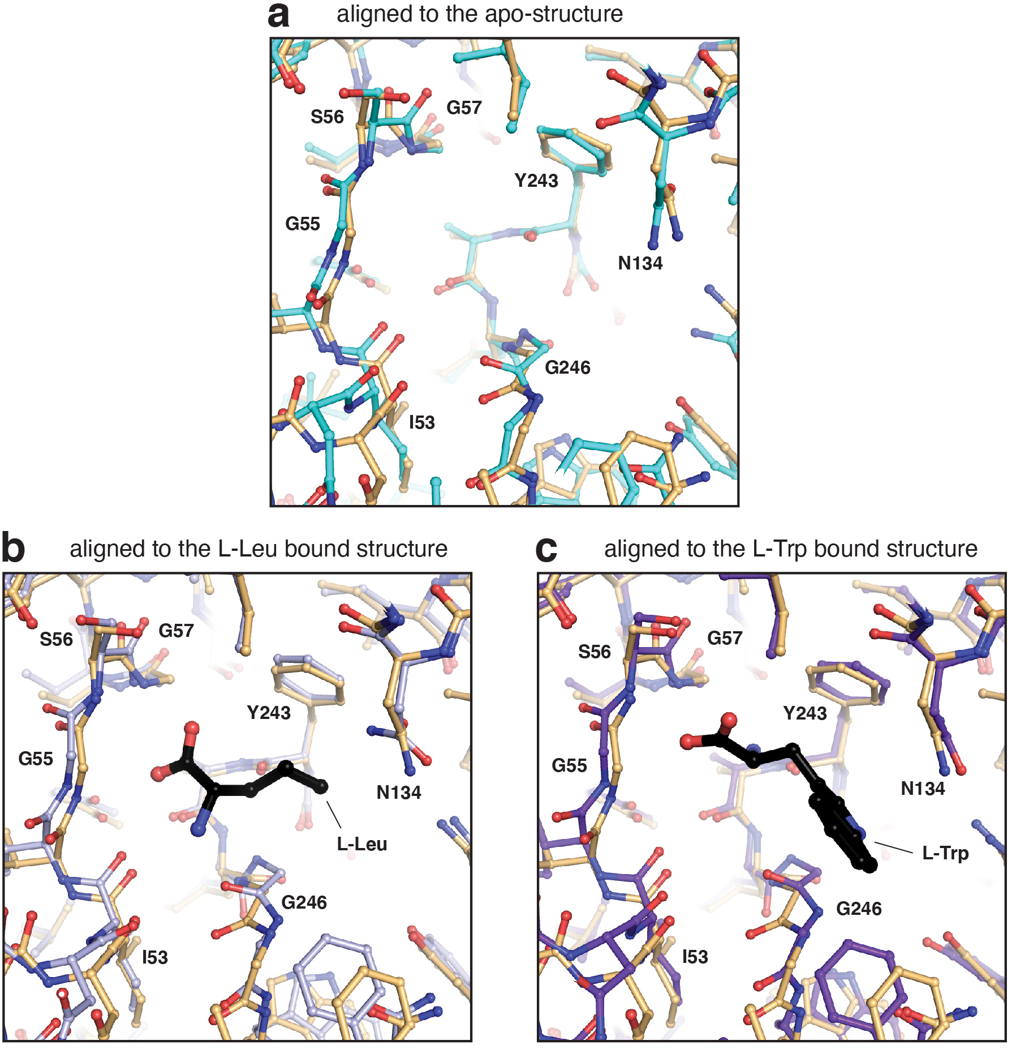

Supplementary Figure S4. Detailed view into the substrate binding pocket of human 4F2hc-LAT2. Structural alignments of 4F2hc-LAT2::D11vs (orange, this work) with (a) the apo-structure (cyan, PDB-ID: 7B00), (b) the L-Leu bound structure (light blue, PDB-ID: 7CMI) and (c) the L-Trp bound structure (violet, PDB-ID: 7CMH). Compared to Fig. 4 of the main manuscript, a more detailed structural view is shown by applying a sticks-only representation. Amino acid residues are labeled in the one-letter code. The bound substrates L-Leu (panel b) and L-Trp (panel c) are labeled in the three-letter code and highlighted as black sticks. Structural representations were prepared using PyMol (version v2.5.2; The PyMol Molecular Graphics System, Schrödinger). The figure was assembled and labeled using Adobe Illustrator 26.5 (https://adobe.com/products/illustrator).

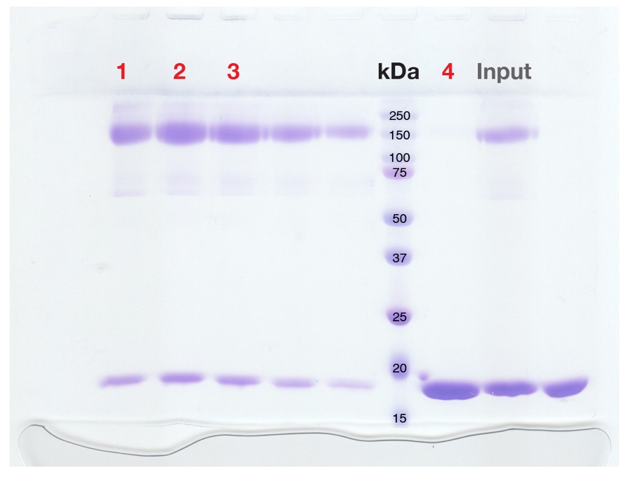

Supplementary Figure S5. Uncropped picture of the SDS-PAGE shown in Fig. 1 of the main manuscript. The lanes used for Fig. 1 are labeled accordingly. Molecular weights of the markers used are also indicated in kDa.

Supplementary Table S1. Data acquisition and processing information

Data collection and processing |  |  | Model building and validation
Microscope | Titan Krios G3 |  | Software | Phenix 1.20-4459
Voltage (kV) | 300 |  | Model composition
Camera | Gatan Quantum-K3 |  | Non-hydrogen atoms | 8,477
Magnification | 105,000 |  | Protein residues | 1,079
Pixel size (Å) | 0.822 |  | Ligand residues | 4
Energy filter | Gatan |  | MolProbity score ª | 1.24
Energy filter slit width (eV) | 20 |  | All-atom clashscore | 4.05
Collection software | Serial EM |  | Rotamer
Defocus range (µm) | -0.8 to -1.8 |  | Favored (%) | 98.13
Movies recorded | 20,512 |  | Outliers (%) | 0
Frames per movie | 40 |  | Ramachandran
Camera dose rate (e⁻/px/s) | 15 to 20 |  | Favored (%) | 97.76
Exposure rate (e⁻/Å²/frame) | 1.255 |  | Outliers (%) | 0
Exposure time (s) | 1.491 |  | Z-score | 0.8 ± 0.26
Cumulative exposure (e⁻/Å²) | 50.2 |  | R.m.s. deviations
Software used for processing | Relion 3.1.1 |  | Bond length (Å) | 0.006
 |  |  | Bond angles (°) | 1.046
 |  |  | Mean B-factors
 |  |  | Protein (Å²) | 59.98
Refinement |  |  | Ligand (Å²) | 61.55
Software | cryoSPARC v3.3.1 |  | CaBLAM outliers (%) | 2.81
Initial particle images (no.) | 4,985,077 |  | Cβ outliers (%) | 0
Final particle images (no.) | 552,926 |  | EM-Ringer score ^{b} | 2.76
Symmetry | C₁ |  | 0.5 FSC model resolution (Å) | 3.29
0.143 FSC half map (Å) | 3.18 |  | Map CC (mask) ^{c} | 0.81
Map sharpening B-factor (Å²) | -149.5 |  | Map CC (peaks) ^{c} | 0.59
 |  |  | Map CC (volume) ^{c} | 0.79
ª Model statistics were calculated using MolProbity ⁵.
^{b} Calculated based on local fit of side chains to map according to Barad et al. ⁶.
^{d} Real-space correlation coefficients of model-to-map fit as described in Afonine et al. ⁷.

References
1 Zivanov, J. et al. New tools for automated high-resolution cryo-EM structure determination in RELION-3. Elife 7, e42166, doi:10.7554/eLife.42166 (2018).
2 Scheres, S. H. W. RELION: Implementation of a Bayesian approach to cryo-EM structure determination. J. Struct. Biol. 180, 519-530, doi:10.1016/J.JSB.2012.09.006 (2012).
3 Punjani, A., Zhang, H. W. & Fleet, D. J. Non-uniform refinement: adaptive regularization improves single-particle cryo-EM reconstruction. Nat. Methods 17, 1214-1221, doi:10.1038/s41592-020-00990-8 (2020).
4 Punjani, A., Rubinstein, J. L., Fleet, D. J. & Brubaker, M. A. cryoSPARC: algorithms for rapid unsupervised cryo-EM structure determination. Nat. Methods 14, 290-296, doi:10.1038/Nmeth.4169 (2017).
5 Williams, C. J. et al. MolProbity: More and better reference data for improved all-atom structure validation. Protein Sci. 27, 293-315, doi:10.1002/pro.3330 (2018).
6 Barad, B. A. et al. EMRinger: side chain-directed model and map validation for 3D cryo-electron microscopy. Nat. Methods 12, 943-946, doi:10.1038/nmeth.3541 (2015).
7 Afonine, P. V. et al. Real-space refinement in PHENIX for cryo-EM and crystallography. Acta Crystallogr. D Struct. Biol. 74, 531-544, doi:10.1107/S2059798318006551 (2018).

