Sugars |  | Organic acid | Amino acids |  | Fermentation markers |  | Others
Fructose | Melezitose | Citric acid | Alanine | Valine | 2,3-butanediol | Lactic acid | Dihydroxyacetone
Glucose | Maltotriose | Malic Acid | Aspartic acid | Tyrosine | 5-HMF | Formic acid | Methylglyoxal
Sucrose | Gentiobiose | Quinic acid | Glutamine | Phenylalanine | Acetic acid | Fumaric acid
Turanose | Raffinose | Shikimic acid | Leucine |  | Acetoin | Pyruvic acid
Maltose | Mannose | 3-phenyllactic acid | Proline |  | Ethanol | Succinic acid

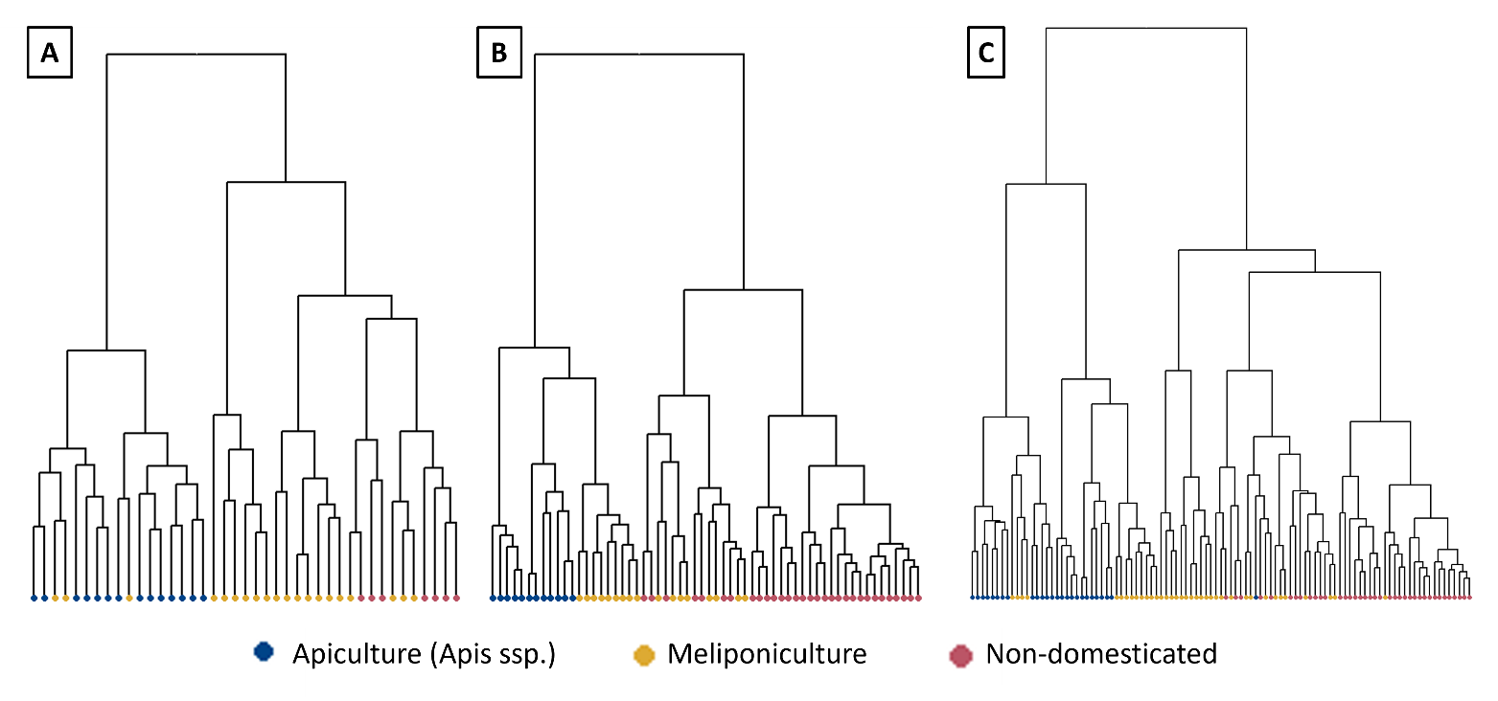
Supplementary Table S1 : Compounds identified and quantified by H1 NMR spectroscopy in each honey samples

Supplementary Figure S2 : Dendogram of hierarchical clustering (Ward D2 method) illustrating the Bray-Curtis distances among each sample colored according to the domestication state of the bee species comprising samples from Mexico (a), Thailand (b) and from both countries (C).

Country | Region | Latitude (°) | Longitude (°) | Honey samples
 |  |  |  | Apis spp. | Meliponiculture | Non-domesticated
Thailand | Chanthaburi | 12.7655 | 102.193378 | 5 | 5 | 1
Thailand | Chiangmai | 19.7296333 | 99.1184694 | 0 | 8 | 2
Thailand | Patthalung | 7.8062167 | 100.017169 | 5 | 3 | 25
Thailand | Ratchaburi | 13.590325 | 99.5072028 | 2 | 0 | 0
Thailand | Saraburi | 14.5225278 | 101.024942 | 0 | 1 | 3
Mexico | Altotonga | 19.783810 | -97.111098 | 1 | 1 | 2
Mexico | Atzalán | 19.875556 | -97.012222 | 0 | 2 | 0
Mexico | Conkal | 21.075145 | -89.520158 | 0 | 1 | 0
Mexico | Cuanixtepec | 20.134935 | -97.725639 | 0 | 2 | 1
Mexico | Cuetzalan | 20.026002 | -97.486833 | 0 | 4 | 0
Mexico | Huehuetán | 14.977895 | -92.333857 | 1 | 0 | 0
Mexico | Huixtla | 15.230425 | -92.467388 | 0 | 2 | 0
Mexico | Mérida | 20.977222 | -89.654500 | 0 | 3 | 2
Mexico | Pucnachén | 20.366827 | -90.219171 | 0 | 1 | 0
Mexico | Tixkokob | 20.951833 | -89.306194 | 0 | 3 | 1
Mexico | Tuzantán | 15.146703 | -92.422417 | 1 | 1 | 1
Mexico | Xcunyá | 21.133109 | -89.617642 | 1 | 0 | 0
Supplementary Table S3 : Geographical distribution of the honey samples collected from honey bees. and stingless bees in Thailand (n=60) and Mexico (n=31)

