Supplementary Materials
Figure S1:

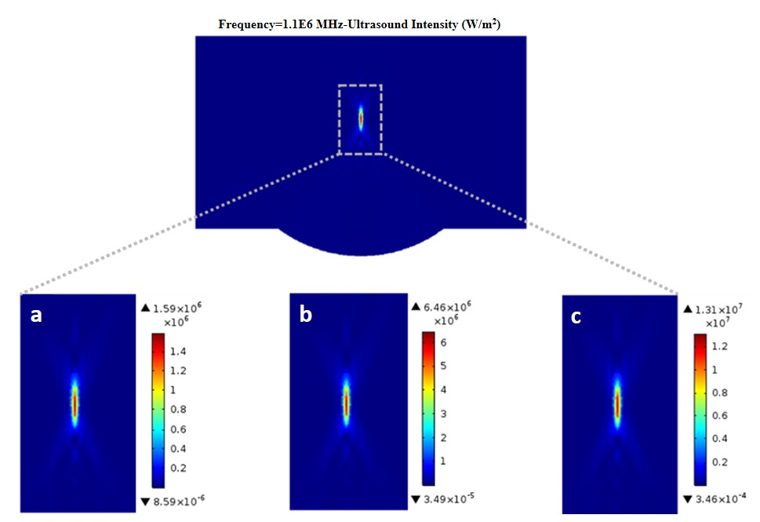

Figure S2:

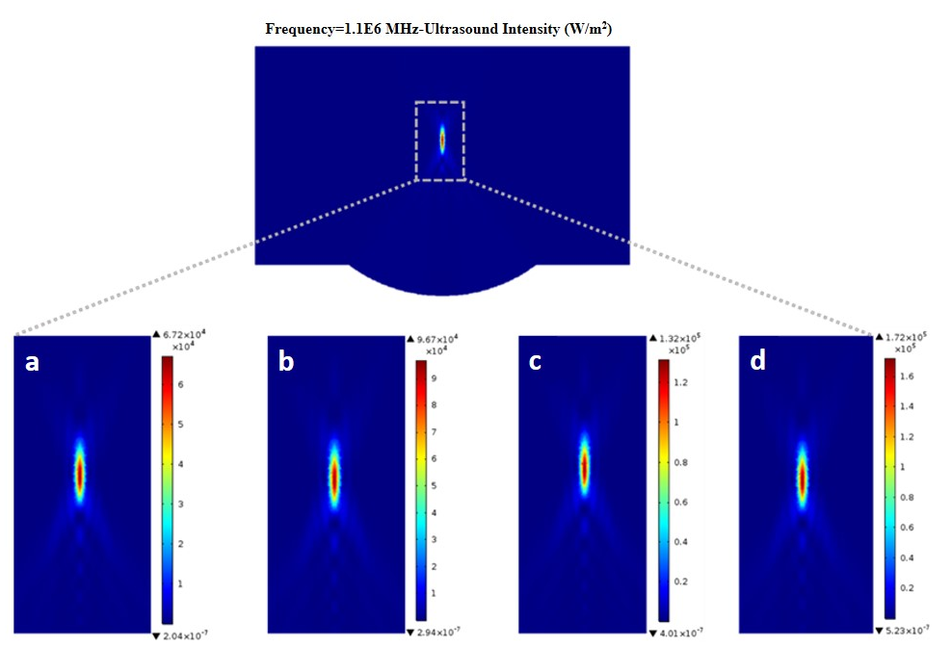

Figure S3:

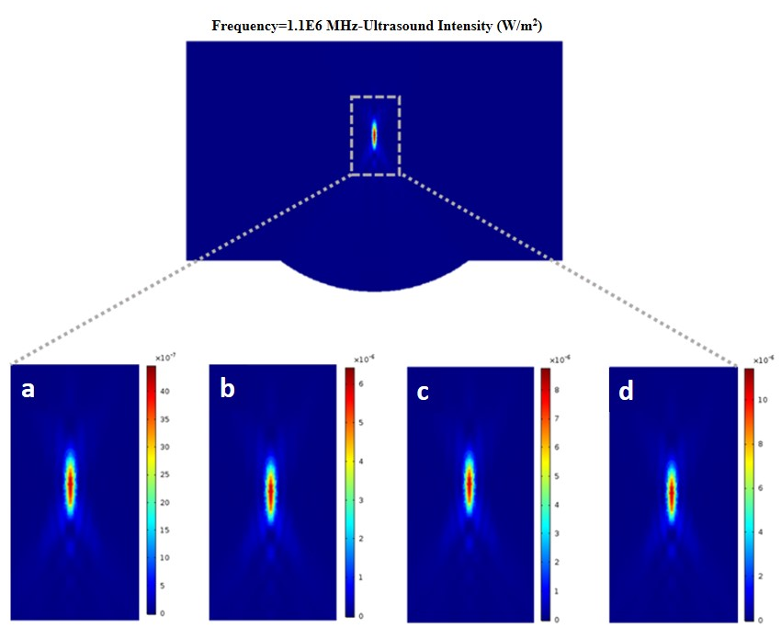

Table S1
Frequency | $$1 MHz$$
Internal Resistance ($R_{0}$) | $$≤2 Ω$$
Internal capacitance ($C_{p})$ | $$1nf±30\%$$
Thickness piezoelectric coefficient ($d33$) | $$≥300 Pc/N$$
Weight | $$1.443 g$$

Table S2
Parameter | Value
Attenuation coefficient ($α$) | 0.16 $1/cm$
Density ($ρ$) | 1000 $kg/m^{3}$
Speed of sound ($c$) | 1600 $m/s$
Hydraulic conductivity ($K$) | 2×10⁻¹⁰ $m^{4}/N$
Porosity ($ε$) | 0.2

Supplementary Figure legends:

Supplementary Figure 1. Ultrasound intensity profiles. The maximum values were adjusted to match the values reported by El ghamrawy et al ²⁵, i.e., 159, 646, 1317 W/cm²
Supplementary Figure 2. Ultrasound intensity profiles. The maximum values were adjusted to match the values of the experiments.
Supplementary Figure 3. Acoustic streaming profiles for each FUS strength applied in this study. (a), (b), (c), and (d) are the results of acoustic streaming for ultrasound intensities of 6.72, 9.76, 13.20, and 17.20 W/cm², respectively.

Supplementary Table legends:

Supplementary Table 1. Detailed characteristics of each of the disk transducers
Supplementary Table 2. Acoustic properties of tissue and drug. The speed of sound, density, and attenuation coefficient of the drug solution and the agarose gel are assumed to be identical.

