Scientific Reports

Is Carpophilus truncatus invading the world? On the razor's edge between an outbreak and a pest invasion in progress

Flavia de Benedetta, Simona Gargiulo, Fortuna Miele, Laura Figlioli, Michele Innangi, Paolo Audisio, Francesco Nugnes, Umberto Bernardo

*Address correspondence to
Umberto Bernardo: umberto.bernardo@ipsp.cnr.it
National Research Council, (Institute for Sustainable Plant Protection - IPSP-CNR),
P.le E. Fermi, 1
80055 Portici (NA)
Italy

Fig. S1 Damage caused by sap beetle larvae on walnut fruit

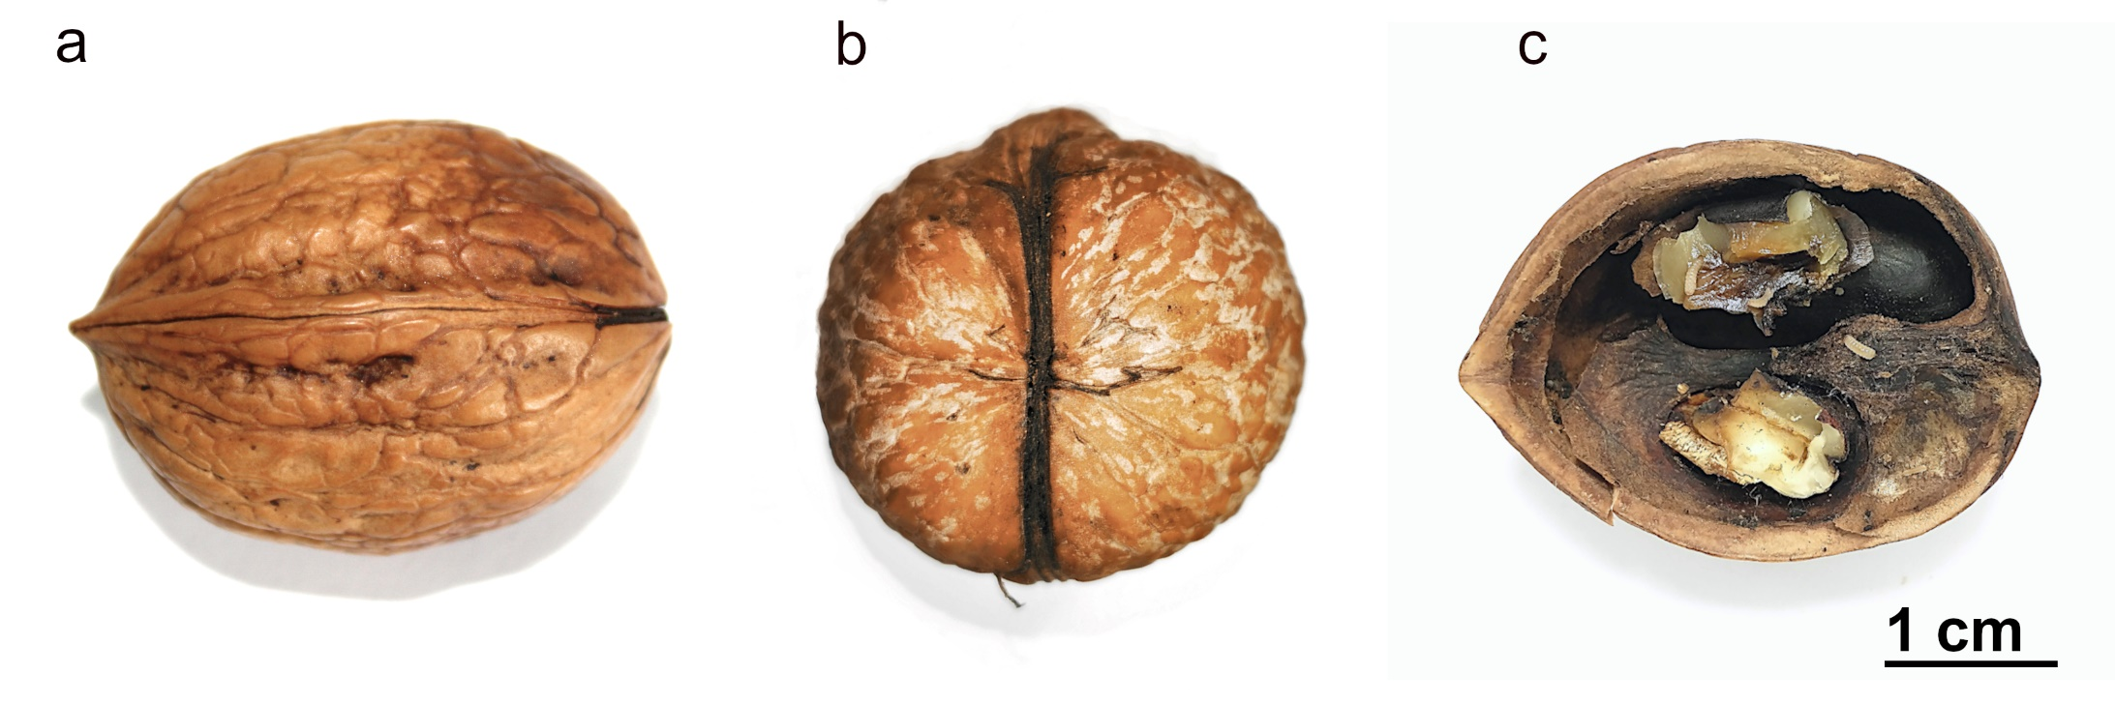
Fig. S2 A damaged walnut. a) - b) longitudinal and orthogonal view, of apparently undamaged fruit; c) Walnut with larvae, completely damaged and unmarketable.

Fig. S3 Eight important characteristics useful to correctly identify C. truncatus. Upper part: general aspect of body and pubescence. Lower part: small details where * indicate the species-specific, distinctive characters
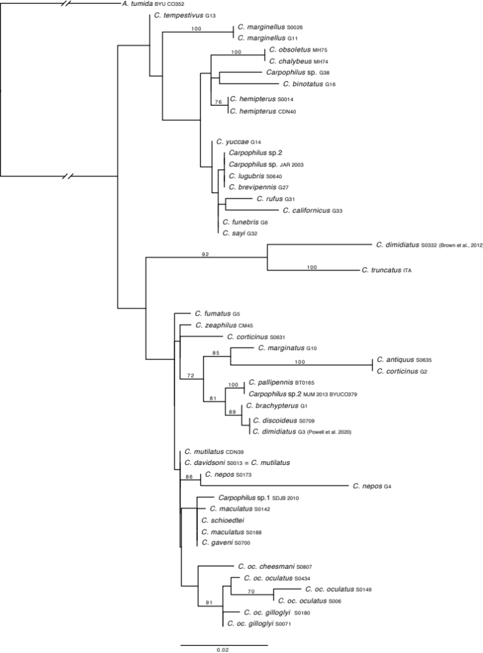
Fig. S4 ML consensus tree based on 10,000 rapid pseudoreplicates for the nuclear portion 28S-D2 of the Carpophilus species. Bootstrap values of >70% are shown above branches

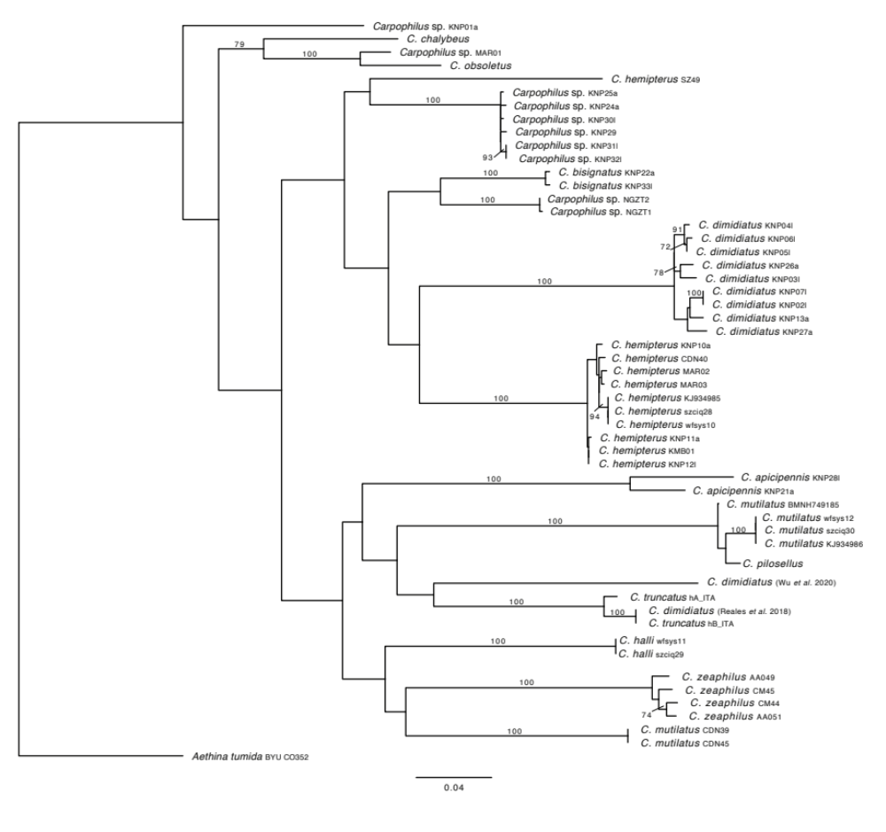
Fig. S5 ML consensus tree based on 10,000 rapid pseudoreplicates for the mitochondrial portion C1-J-2183/TL2-N-3014 of the Carpophilus species. Bootstrap values of >70% are shown above branches

