The visual workflow of the steps starting from the dataset
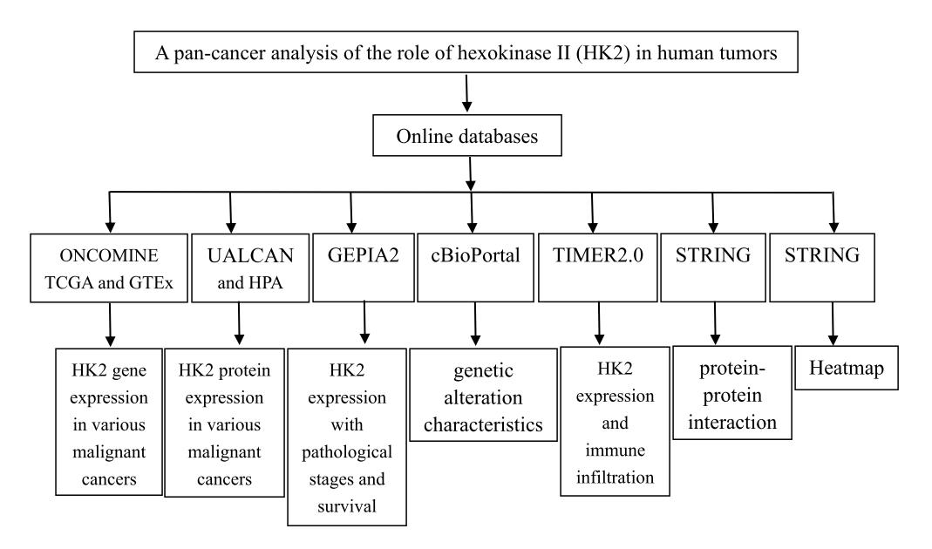
The visual workflow of the steps starting from the dataset. Gene expression of HK2 was from TCGA and GTEx databases. Protein expression was from UALCAN and HPA databases. Data on the relationship between HK2 expression and pathological stages, survival was from GEPIA2 dataset. Gene alteration characteristics was from cBioPortal. Immune infiltration was from TIMER2.0. Protein-protein interaction and heatmap was from STRING.

