Supplementary information

A green protocol for the one-pot synthesis of 3,4-disubstituted isoxazole-5(4H)-ones using modified β-Cyclodextrin as a catalyst
Mahdieh Tajbakhsh ª, Mohammad Reza Naimi-Jamal ^{a, *}, Saeed Balalaie ^{b}, Mohadeseh Rezaeian ª

a. Research Laboratory of Green Organic Synthesis & Polymers, Department of Chemistry, Iran University of Science and Technology, P.O. Box 16846–13114 Tehran, Iran
b. Peptide Chemistry Research Institute, K. N. Toosi University of Technology, P. O. Box 15875-4416, Tehran, Iran
*Corresponding author E-mail: naimi@iust.ac.ir

Table of Content
FT-IR spectra of some products (4a, 4e, 4k, 4l) …………………………………………….……(S2-S5)
¹H-NMR spectra of some products (4a, 4k) …………………………………………………………(S6-S7)
FT-IR spectrum of the reused catalyst…………………………………………………………………S8

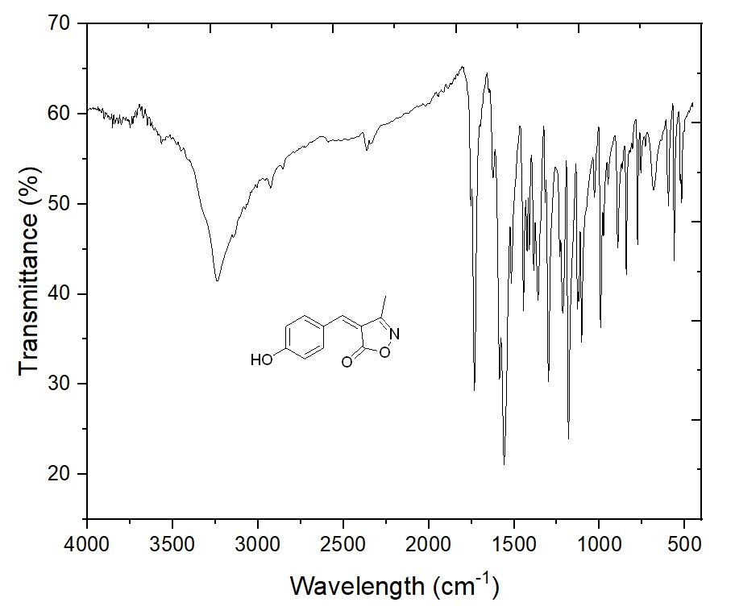
Figure S1: FT-IR spectrum of product 4a
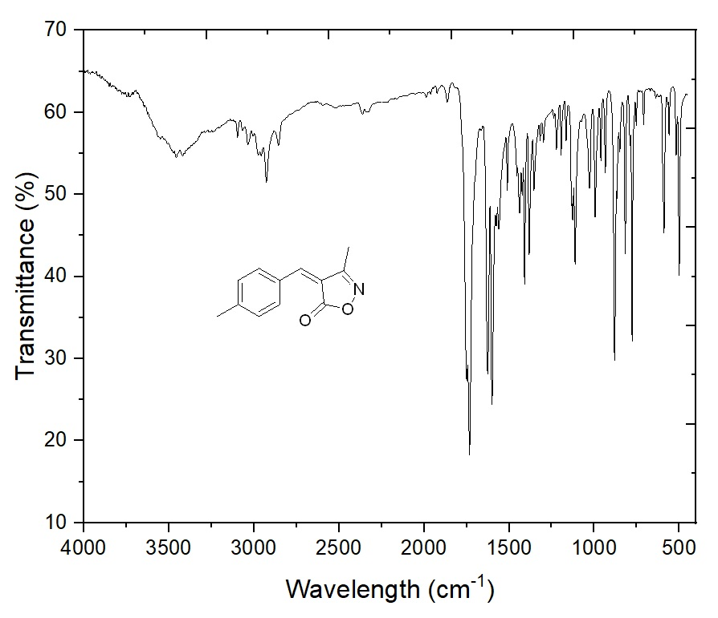
Figure S2: FT-IR spectrum of product 4e
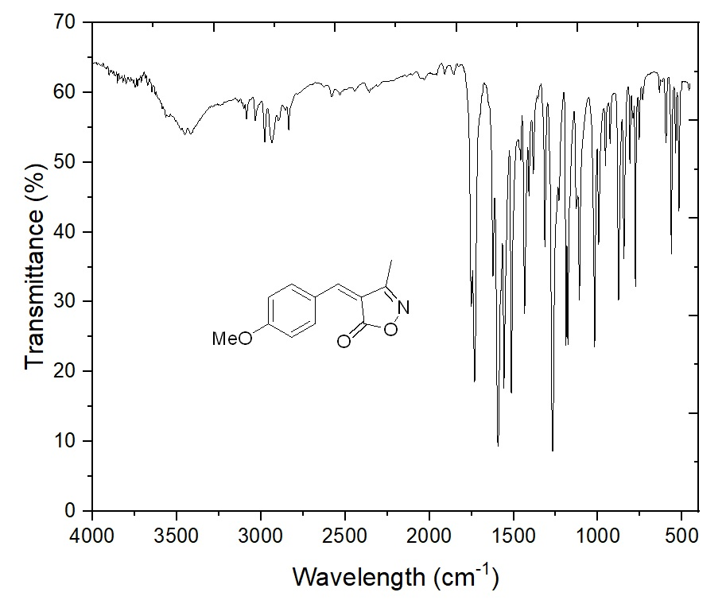
Figure S3: FT-IR spectrum of product 4k
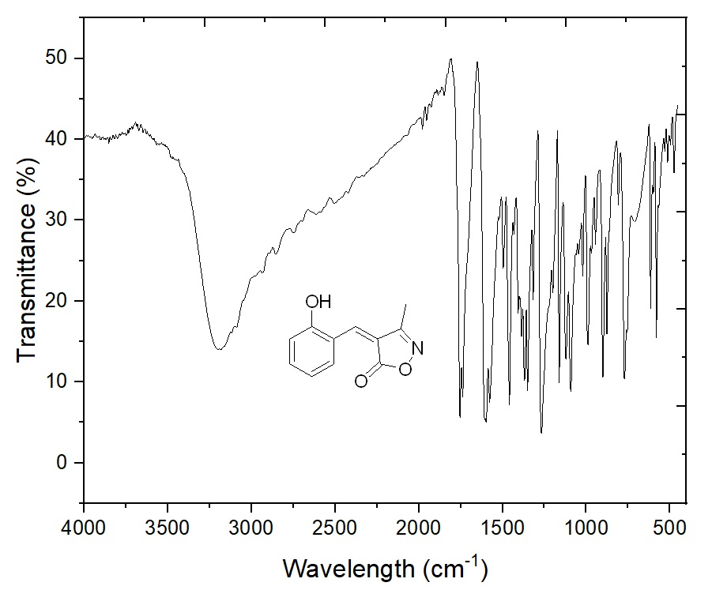
Figure S4: FT-IR spectrum of product 4l

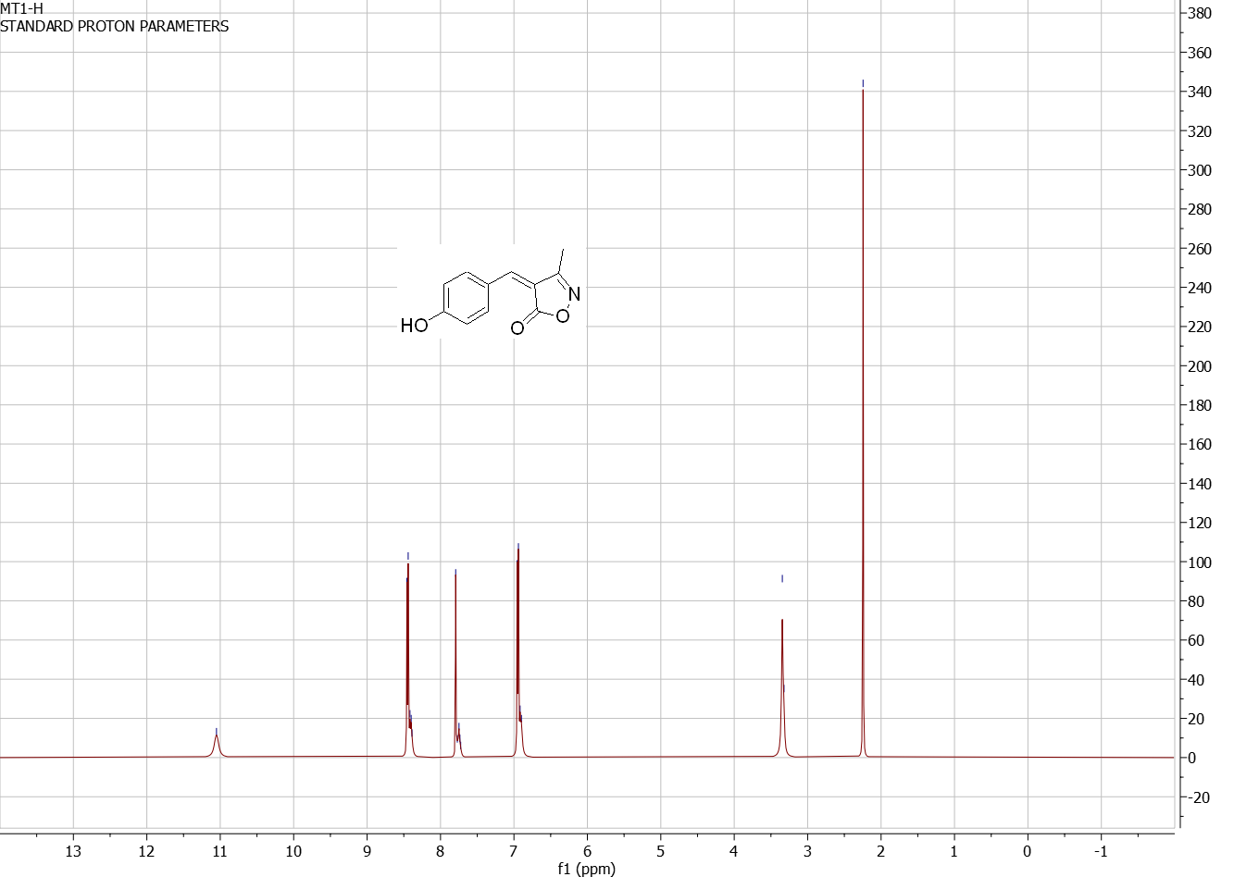
Figure S5: ¹H-NMR spectrum of product 4a

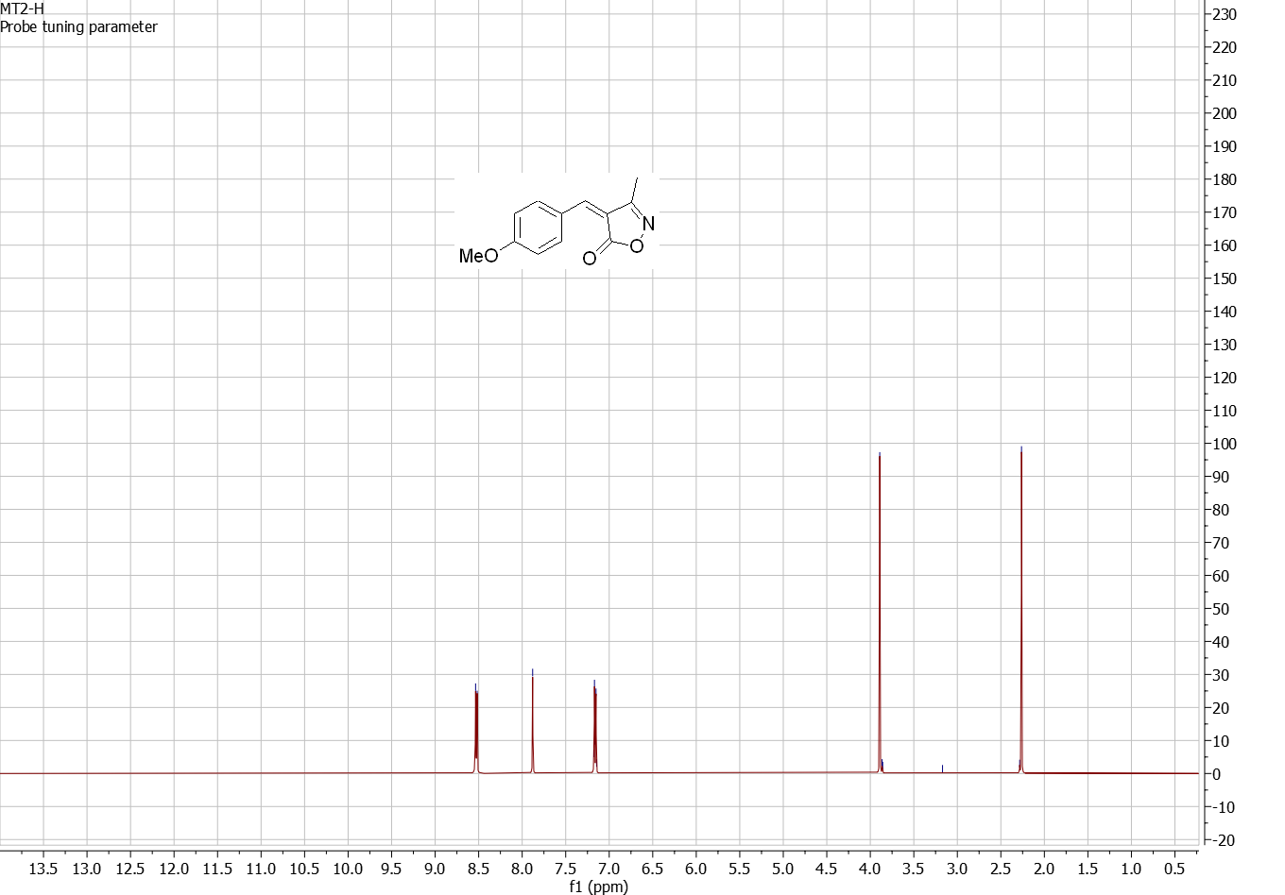
Figure S6: ¹H-NMR spectrum of product 4k

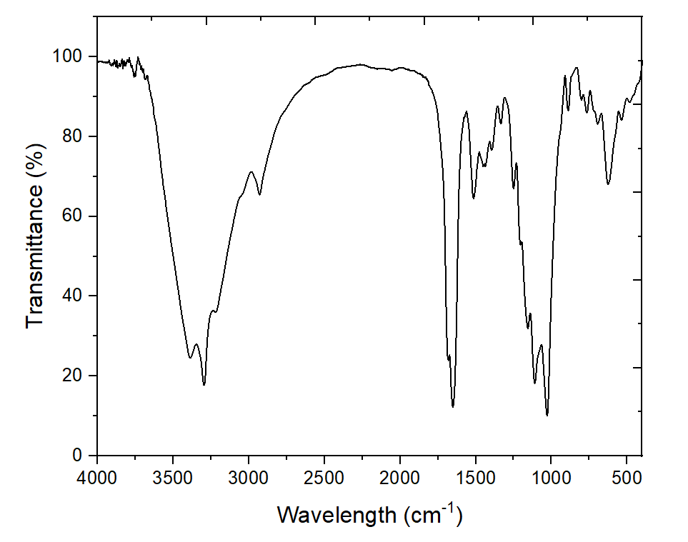
Figure S7: FT-IR spectrum of the reused catalyst

