Escherichia coli ST155 as a production-host of three different polyvalent phages and their characterisation with a prospect for wastewater disinfection
Amrita Salim¹, Ajith Madhavan^{1,*}, Suja Subhash¹, Megha Prasad¹, Bipin G. Nair¹, Sanjay Pal^{1,*}
¹ School of Biotechnology, Amrita Vishwa Vidyapeetham, Kerala – 690525, India
*Dr Sanjay Pal, sanjaypal@am.amrita.edu
*Dr Ajith Madhavan, ajithm@am.amrita.edu

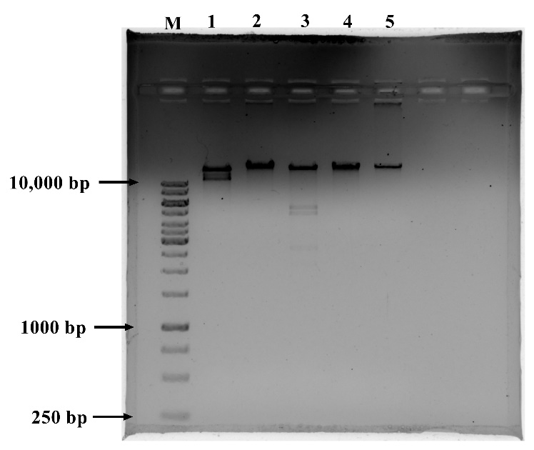
Figure S1: Restriction enzymes digested phage DNA of ϕPh_SE03 electrophoresed on a 1% agarose gel stained with ethidium bromide. M – Marker 1kb (GeneRuler, ThermoFisher Scientific), lane 1- Eco RI, lane 2- Hind III, lane 3- Bam HI and lane 4- Kpn I, lane 5- uncut phage DNA.
Figure S2: Restriction enzymes digested phage DNA of ϕPh_SD01 electrophoresed on a 1% agarose gel stained with ethidium bromide. M – Marker 1kb (GeneRuler, ThermoFisher Scientific), lane 1- Eco RI, lane 2- Hind III, lane 3- Bam HI and lane 4- Kpn I, lane 5- uncut phage DNA.
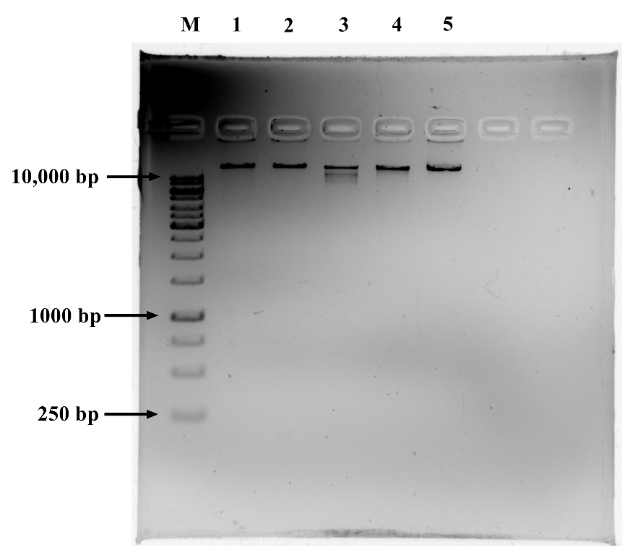
Figure S3: Restriction enzymes digested phage DNA of ϕPh_EC01 electrophoresed on a 1% agarose gel stained with ethidium bromide. M – Marker 1kb (GeneRuler, ThermoFisher Scientific), lane 1- Eco RI, lane 2- Hind III, lane 3- Bam HI and lane 4- Kpn I, lane 5- uncut phage DNA.
Figure S4: Induction of prophages in E. coli ST155 a. Mitomycin C induction of log-phase culture of E. coli ST155 at different concentrations for a time period of 24 h shows a reduction in the turbidity of the culture. b. Spot assay of the cell-free lysate collected following mitomycin induction from different concentrations shows no infective lysis/plaques against E. coli ST155 indicating the absence of functional prophages. SD represents the standard deviations of five replicates from independent experiments.
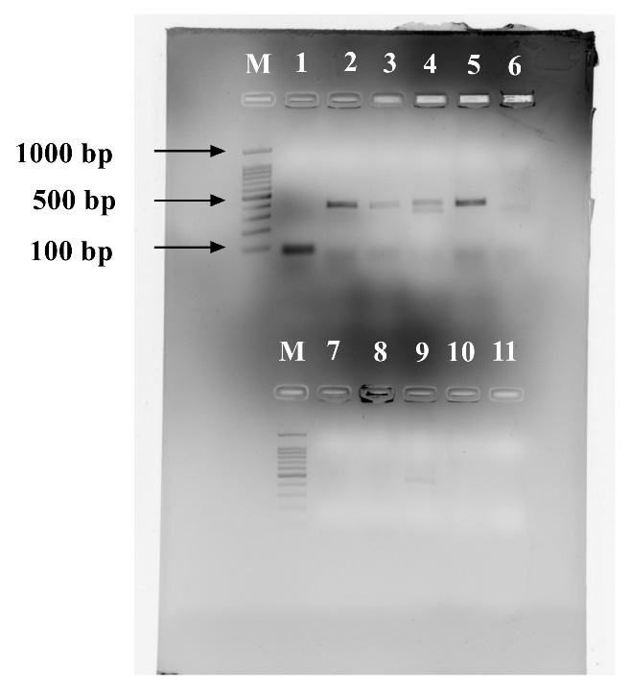
Figure S5: Agarose gel showing colony PCR amplification of invA gene (77 bp) from morphologically different colonies picked from the SS agar plate of the treatment setup to confirm the specific reduction in S. enterica colonies and to differentiate from the non-target bacteria in wastewater. M- Marker 100 bp, lane 1 - S. enterica (77 bp- highlighted in the white box), lane 2-10 - non-targets, lane 11 - non-template control.

